Reviewers/Editors Comments
Image summarizes the first rejection with possibility to resubmit after the bibliography is been handled.
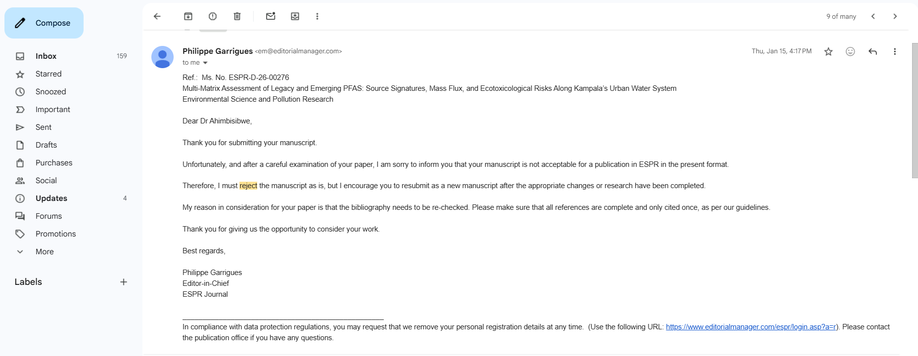

Author response where the changes in the references was made in the table below.
Reference | Change Type | Comment
Sridhar & Gidudu (2020) | Edited | In the latest list, a DOI link was added: https://doi.org/10.23953/cloud.ijarsg.474 (doi.org in Bing).
Bahati (2011) | Edited | In both lists, it is a dissertation/thesis. The latest version includes more detail: [Undergraduate thesis, Kampala International University]. Kampala International University Institutional Repository.
References edited and repetitions removed |  | - Coperchini et al. (2024)  - Ebbu et al. (2025)  - Ehsan et al. (2025)  - Eldridge et al. (2025)  - Miiro et al. (2025)  - Ogola (2025)  - Phillip (2025)  - Sapozhnikova & Stroski (2025)  - Vis & Chow (2025)

Review of the metadata
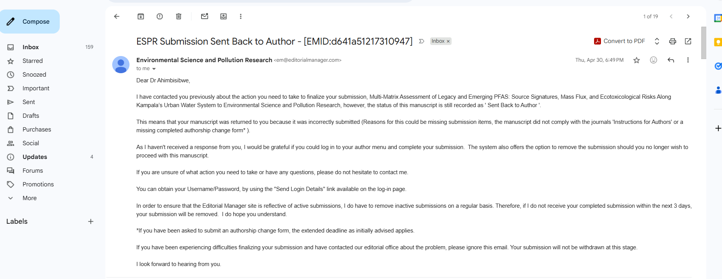

Authors Response, metadata harmonized

Alignment of metadata in the portal
