Quality of life after conservative versus elective surgical management of first-episode uncomplicated diverticulitis: a single-center prospective study

Giuseppe Quero^{1,2,3}, MD, PhD; Lodovica Langellotti¹, MD; Antonio Pio Tortorelli¹, MD; Vincenzo Tondolo^{2,4}, MD; Beatrice Biffoni¹, MD; Davide De Sio¹, MD; Marcello Covino^{2,5}, MD; Flavia Taglioni¹, MD; Ottavio Scrima¹, MD; Maria Chiara Blasi¹; Matteo Aulicino¹, Claudio Fiorillo^{1,2,3}, MD; Sergio Alfieri^{1,2,3}, MD; Roberta Menghi^{1,2,3}, MD

¹ Pancreatic Surgery Unit, Fondazione Policlinico Universitario “Agostino Gemelli” IRCCS, Rome, Italy
² Dipartimento di Medicina e Chirurgia Traslazionale, Università Cattolica del Sacro Cuore di Roma, Rome, Italy
³ Gemelli Pancreatic Center, CRMPG (Advanced Pancreatic Research Center) Fondazione Policlinico Universitario “Agostino Gemelli” IRCCS, Rome, Italy
⁴ General Surgery Unit, Fatebenefratelli Isola Tiberina—Gemelli Isola, Rome, Italy
⁵ Department of Emergency Medicine, Fondazione Policlinico Universitario Agostino Gemelli-IRCCS, 00168 Roma, Italy

Corresponding author.
Sergio Alfieri, MD
Pancreatic Surgery Unit
Department of Surgery, Fondazione Policlinico Universitario “Agostino Gemelli”, IRCCS
Largo Agostino Gemelli, 8
00168 Rome, Italy
tel.: +39 06 30 15 51 33
fax: +39 06 30 15 65 20
e-mail : sergio.alfieri@policlinicogemelli.it

Supplementary Materials - Index

Supplementary Figures
Figure S1 | pag. 3
Table S1 | pag. 4

Supplementary Figure

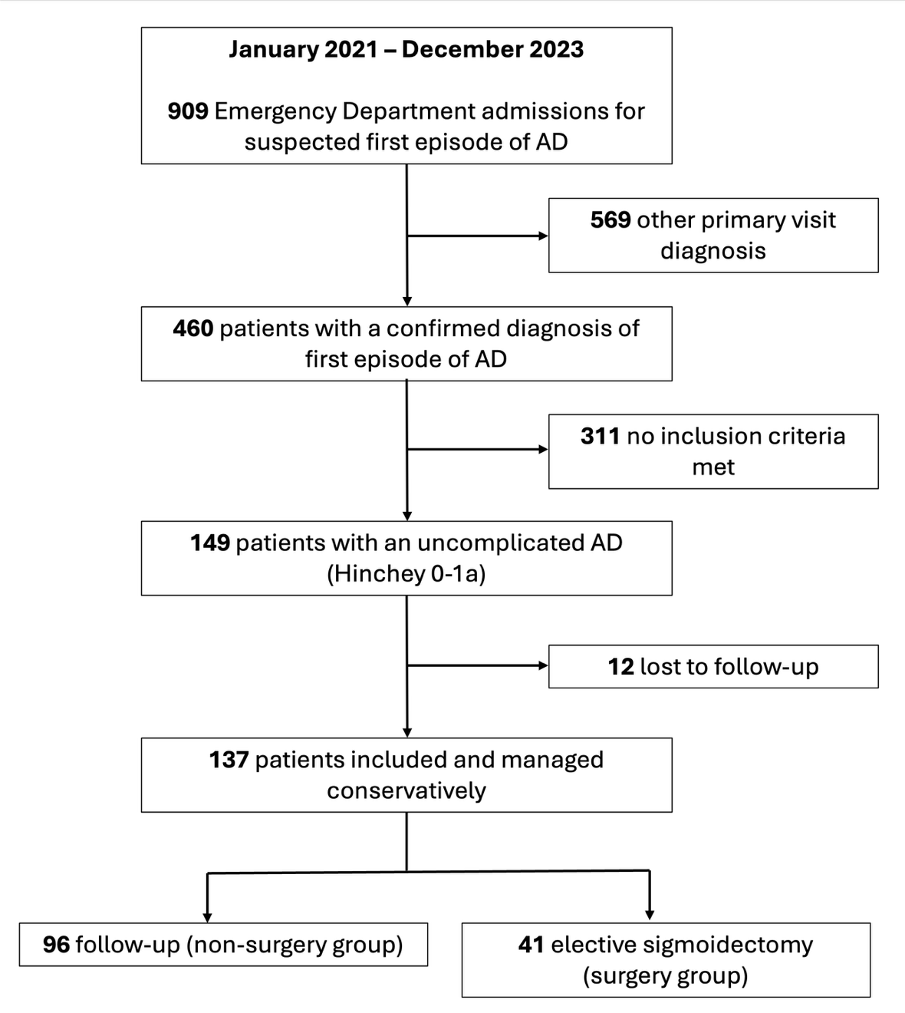

Figure S1. Study cohort flow diagram

Table S1: Longitudinal comparison of DV-QoL subdomains between the non-surgery and surgery cohorts
 | Non-surgery group (n=96) | Surgery group (n=41) | p
One-month comparison
Physical symptoms, mean (+SD) | 5.8 (+6.09) | 1.05 (+1.43) | < 0.001
P1 – bloated, mean (+SD) | 1.81 (+1.94) | 0.12 (+0.45) | < 0.001
P2 – watery stools, mean (+SD) | 0.77 (+1.33) | 0.27 (+0.73) | < 0.001
P3 – bowel movements, mean (+SD) | 0.94 (+1.65) | 0.44 (+0.88) | < 0.001
P4 – nausea, mean (+SD) | 0.32 (+0.87) | 0.02 (+0.15) | < 0.001
P5 – abdominal pain, mean (+SD) | 1.68 (+1.84) | 0.20 (+0.59) | < 0.001
Normalized physical symptoms, mean (+SD) | 2.19 (+2.44) | 0.42 (+0.57) | < 0.001
Concerns, mean (+SD) | 4.23 (+4.71) | 0 (0) | < 0.001
C1 – Fear of flare-up, mean (+SD) | 1.42 (+1.73) | 0.07 (+0.34) | < 0.001
C2 – Fear of body damage, mean (+SD) | 1.32 (+1.52) | 0.05 (+0.32) | < 0.001
C3 – Fear of something seriously wrong, mean (+SD) | 1.32 (+1.52) | 0.05 (+0.32) | < 0.001
Normalized concerns, mean (+SD) | 3.52 (+3.92) | 0 (0) | < 0.001
Feelings, mean (+SD) | 2.82 (+4.30) | 0 (0) | < 0.001
F1 – frustration, mean (+SD) | 0.69 (+1.34) | 0 (0) | < 0.001
F2 – anxiety, mean (+SD) | 0.69 (+1.34) | 0 (0) | < 0.001
F3 – irritation, mean (+SD) | 0.69 (+1.34) | 0 (0) | < 0.001
F4 – feeling looked down upon, mean (+SD) | 0.57 (+1.07) | 0 (0) | < 0.001
Normalized feelings, mean (+SD) | 1.76 (+2.67) | 0 (0) | < 0.001
Behavioral changes, mean (+SD) | 5.03 (+4.68) | 0 (0) | < 0.001
B1 – eat less or differently, mean (+SD) | 2.66 (+1.34) | 0 (0) | < 0.001
B2 – dress differently, mean (+SD) | 0.34 (+0.8) | 0 (0) | < 0.001
B3 – avoid social events, mean (+SD) | 0.82 (+1.43) | 0 (0) | < 0.001
B4 – sleep, mean (+SD) | 0.57 (+1.07) | 0 (0) | < 0.001
B5 – miss work or important events, mean (+SD) | 0.63 (+1.17) | 0 (0) | < 0.001
Normalized behavioral changes, mean (+SD) | 2.52 (+2.34) | 0 (0) | < 0.001
Six-month comparison
Physical symptoms, mean (+SD) | 4.52 (+5.43) | 0.59 (1.08) | < 0.001
P1 – bloated, mean (+SD) | 1.41 (+1.75) | 0.07 (0.34) | < 0.001
P2 – watery stools, mean (+SD) | 0.69 (+1.34) | 0.17 (0.62) | < 0.001
P3 – bowel movements, mean (+SD) | 0.72 (+1.46) | 0.27 (0.66) | < 0.001
P4 – nausea, mean (+SD) | 0.23 (+0.78) | 0.02 (0.15) | < 0.001
P5 – abdominal pain, mean (+SD) | 1.45 (+1.66) | 0.05 (0.31) | < 0.001
Normalized physical symptoms, mean (+SD) | 1.81 (+2.17) | 0.23 (0.43) | < 0.001
Concerns, mean (+SD) | 3.55 (+4.28) | 0 (0) | < 0.001
C1 – Fear of flare-up, mean (+SD) | 1.47 (+1.25) | 0.06 (+0.24) | < 0.001
C2 – Fear of body damage, mean (+SD) | 1.45 (+1.25) | 0.05 (+0.12) | < 0.001
C3 – Fear of something seriously wrong, mean (+SD) | 1.23 (+1.19) | 0.07 (+0.22) | < 0.001
Normalized concerns, mean (+SD) | 2.95 (+3.56) | 0 (0) | < 0.001
Feelings, mean (+SD) | 2.46 (+3.85) | 0 (0) | < 0.001
F1 – frustration, mean (+SD) | 0.55 (+1.19) | 0 (0) | < 0.001
F2 – anxiety, mean (+SD) | 0.69 (+1.34) | 0 (0) | < 0.001
F3 – irritation, mean (+SD) | 0.55 (+1.17) | 0 (0) | < 0.001
F4 – feeling looked down upon, mean (+SD) | 0.57 (+1.07) | 0 (0) | < 0.001
Normalized feelings, mean (+SD) | 1.53 (+1.39) | 0 (0) | < 0.001
Behavioral changes, mean (+SD) | 4.21 (+3.94) | 0 (0) | < 0.001
B1 – eat less or differently, mean (+SD) | 2.43 (+1.45) | 0 (0) | < 0.001
B2 – dress differently, mean (+SD) | 0.22 (+0.71) | 0 (0) | < 0.001
B3 – avoid social events, mean (+SD) | 0.68 (+1.18) | 0 (0) | < 0.001
B4 – sleep, mean (+SD) | 0.35 (+0.89) | 0 (0) | < 0.001
B5 – miss work or important events, mean (+SD) | 0.42 (+0.79) | 0 (0) | < 0.001
Normalized behavioral changes, mean (+SD) | 2.11 (+1.97) | 0 (0) | < 0.001
Twelve-month comparison
Physical symptoms, mean (+SD) | 3.83 (+5.10) | 0.10 (+0.64) | < 0.001
P1 – bloated, mean (+SD) | 1.24 (+1.64) | 0.02 (+0.15) | < 0.001
P2 – watery stools, mean (+SD) | 0.55 (+1.16) | 0 (0) | < 0.001
P3 – bowel movements, mean (+SD) | 0.66 (+1.39) | 0.17 (+0.49) | < 0.001
P4 – nausea, mean (+SD) | 0.15 (+0.65) | 0.02 (+0.15) | 0.04
P5 – abdominal pain, mean (+SD) | 1.24 (+1.59) | 0 (0) | < 0.001
Normalized physical symptoms, mean (+SD) | 1.53 (+2.04) | 0.09 (+0.25) | < 0.001
Concerns, mean (+SD) | 3.25 (+4.03) | 0 (0) | < 0.001
C1 – Fear of flare-up, mean (+SD) | 1.35 (+1.17) | 0.05 (+0.14) | < 0.001
C2 – Fear of body damage, mean (+SD) | 1.45 (+1.25) | 0.05 (+0.13) | < 0.001
C3 – Fear of something seriously wrong, mean (+SD) | 1.23 (+1.19) | 0.05 (+0.22) | < 0.001
Normalized concerns, mean (+SD) | 2.70 (+3.35) | 0 (0) | < 0.001
Feelings, mean (+SD) | 2.23 (+3.75) | 0 (0) | < 0.001
F1 – frustration, mean (+SD) | 0.55 (+1.19) | 0 (0) | < 0.001
F2 – anxiety, mean (+SD) | 0.23 (+1.05) | 0 (0) | < 0.001
F3 – irritation, mean (+SD) | 0.55 (+1.17) | 0 (0) | < 0.001
F4 – feeling looked down upon, mean (+SD) | 0.57 (+1.07) | 0 (0) | < 0.001
Normalized feelings, mean (+SD) | 1.38 (+2.33) | 0 (0) | < 0.001
Behavioral changes, mean (+SD) | 3.91 (+3.87) | 0 (0) | < 0.001
B1 – eat less or differently, mean (+SD) | 2.27 (+1.48) | 0 (0) | < 0.001
B2 – dress differently, mean (+SD) | 0.22 (+0.71) | 0 (0) | < 0.001
B3 – avoid social events, mean (+SD) | 0.60 (+1.12) | 0 (0) | < 0.001
B4 – sleep, mean (+SD) | 0.40 (+0.82) | 0 (0) | < 0.001
B5 – miss work or important events, mean (+SD) | 0.41 (+0.78) | 0 (0) | < 0.001
Normalized behavioral changes, mean (+SD) | 1.97 (+1.96) | 0 (0) | < 0.001

