Supplemental information
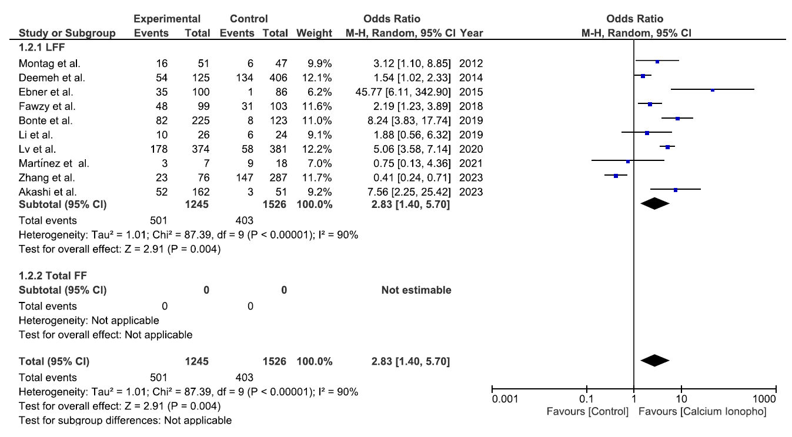
Supplementary figure S1. Forest plot for fertilization failure type subgroup analysis of clinical pregnancy rate.

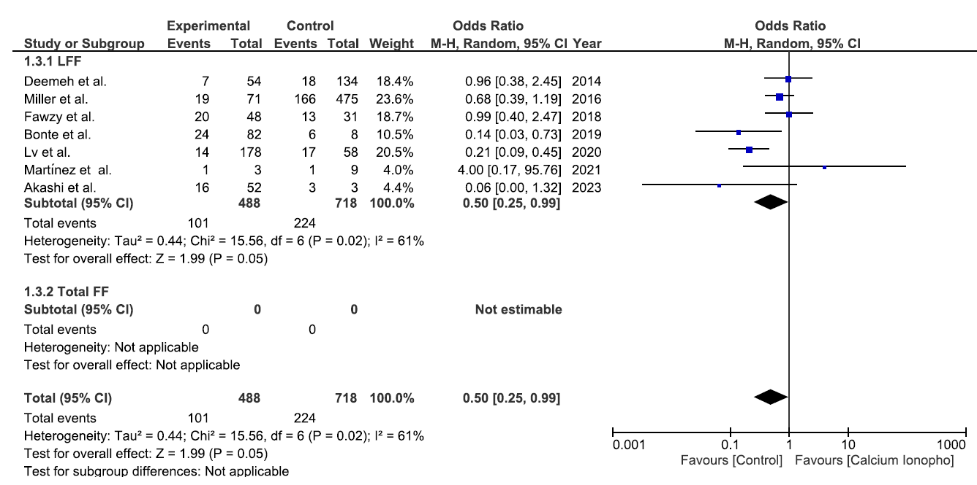
Supplementary figure S2. Forest plot for fertilization failure type subgroup analysis of miscarriage rate.
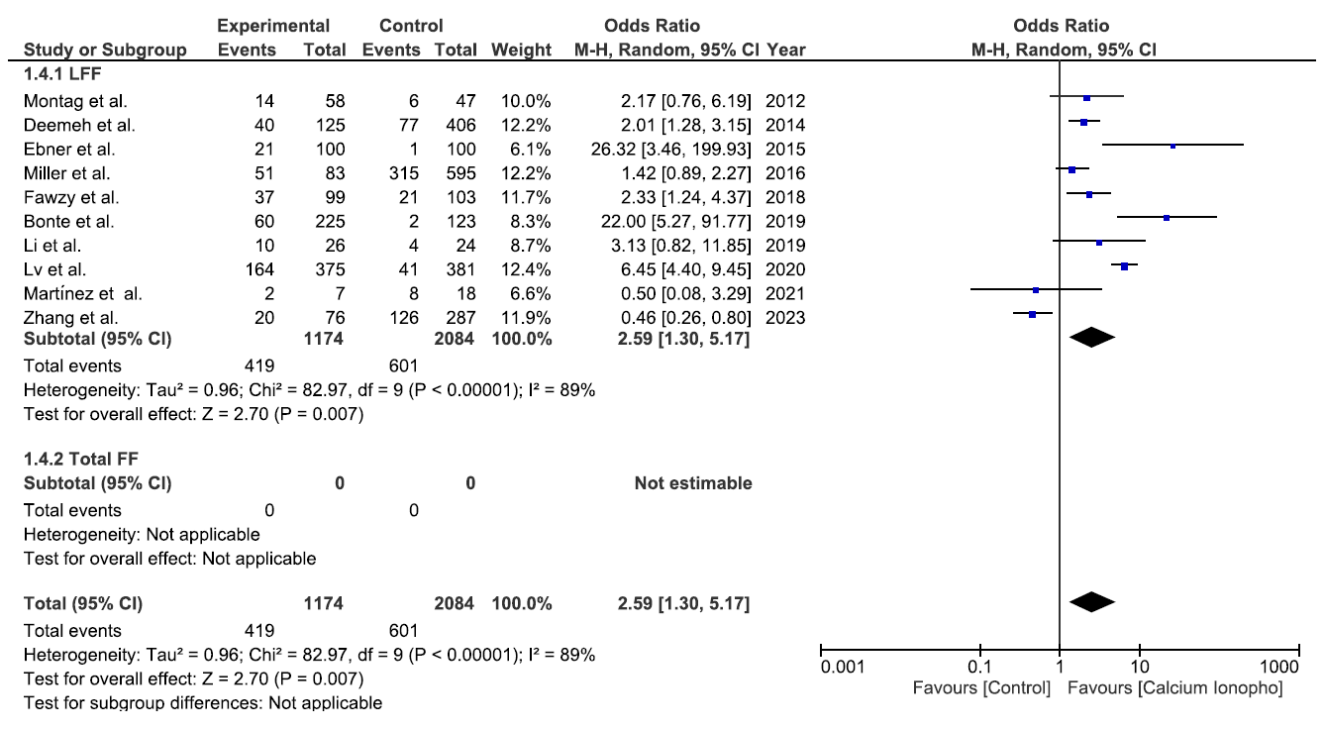
Supplementary figure S3. Forest plot for fertilization failure type subgroup analysis of live birth rate.
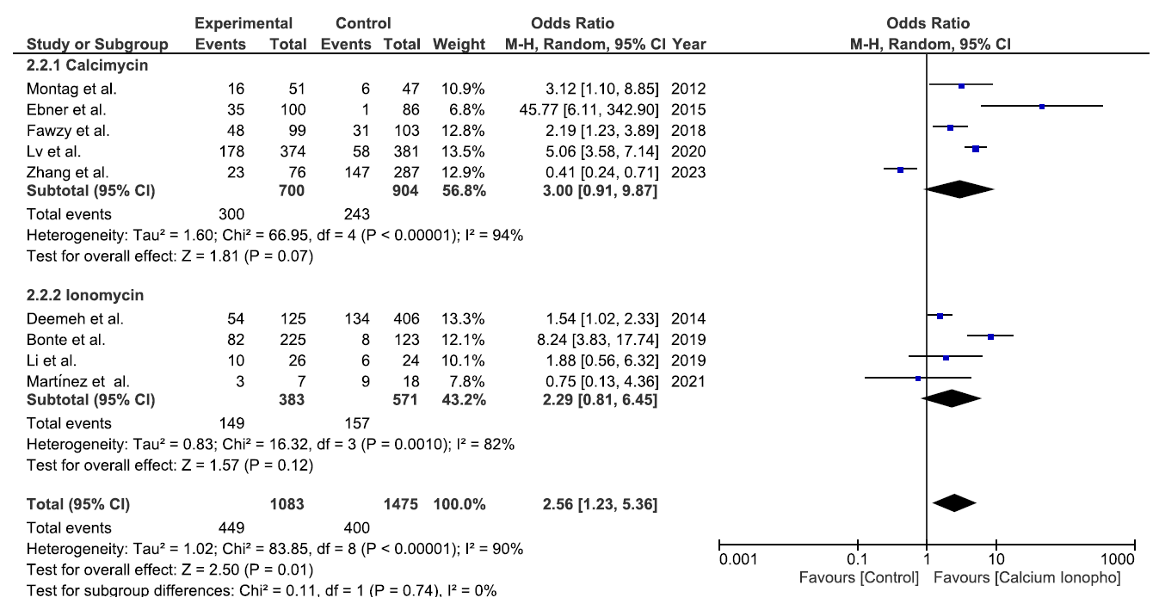
Supplementary figure S4. Forest plot for ionophore type subgroup analysis of clinical pregnancy rate.
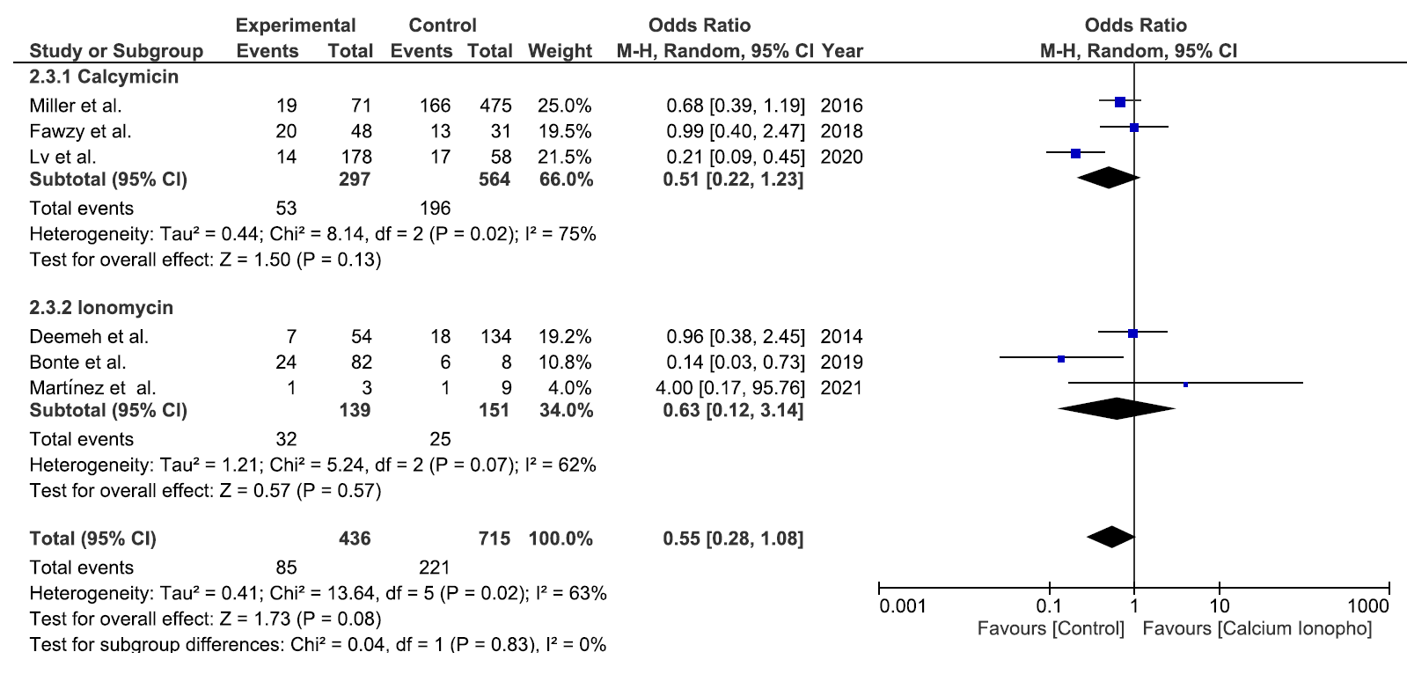
Supplementary figure S5. Forest plot for ionophore type subgroup analysis of miscarriage rate.

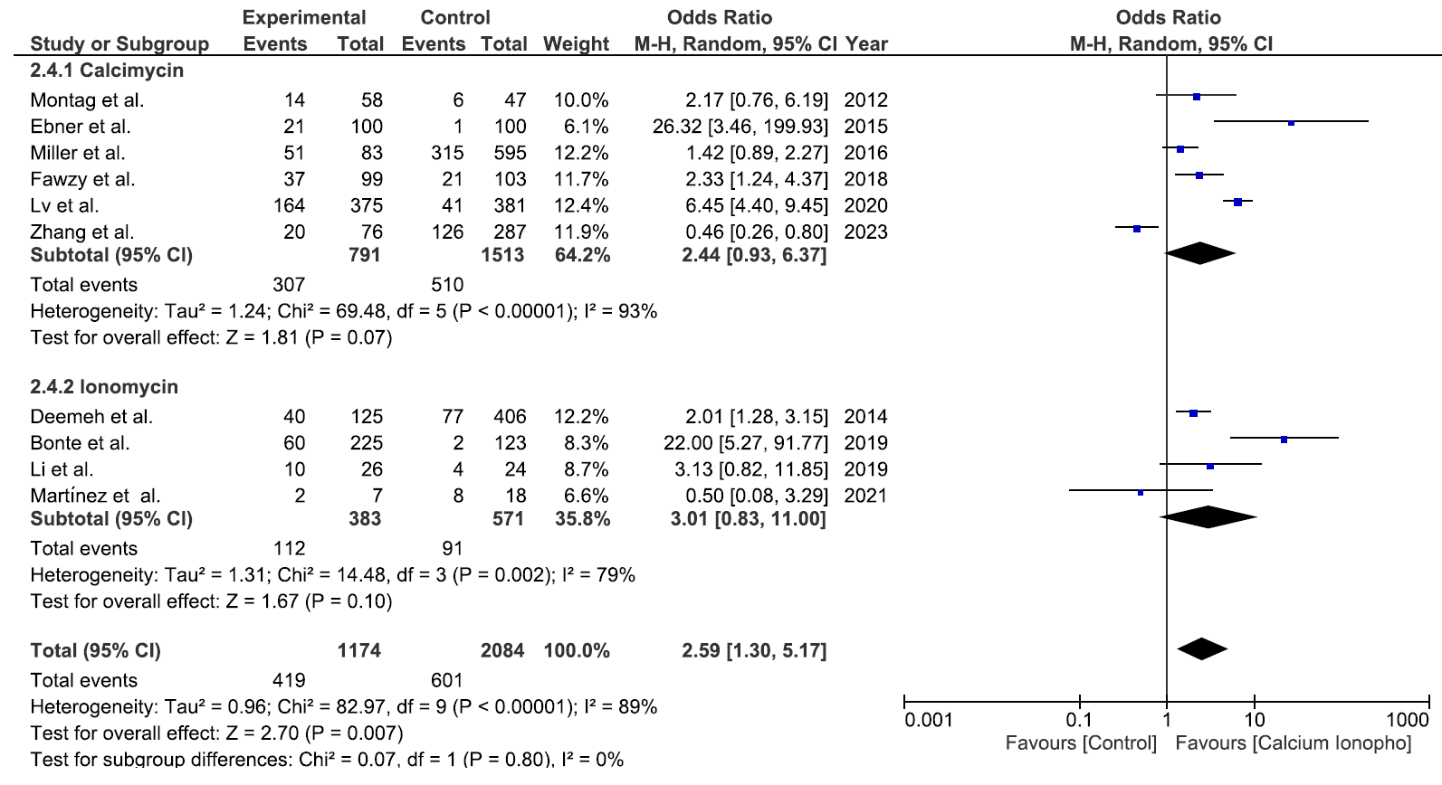
Supplementary figure S6. Forest plot for ionophore type subgroup analysis of live birth rate.
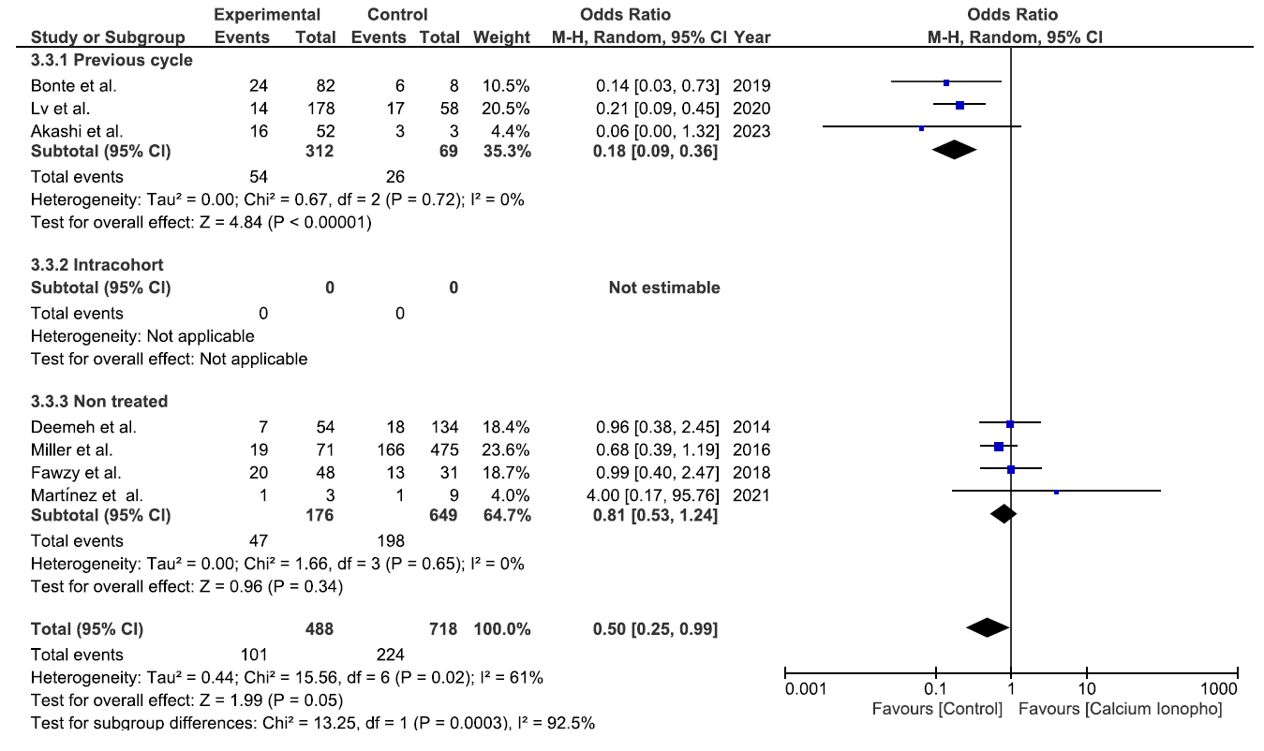
Supplementary figure S7. Forest plot for control type subgroup analysis of miscarriage rate.
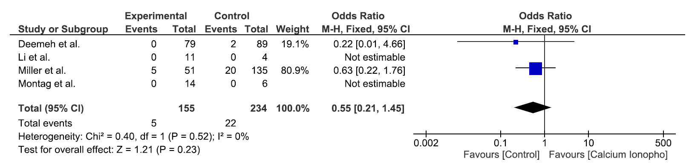
Supplementary figure S8. Forest plot for perinatal malformations.

