Graphical abstract
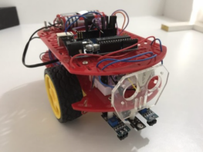
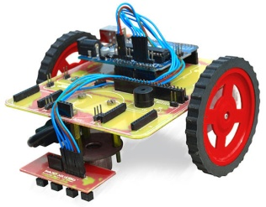
Goal: Green and sustainable design of line-follower educational mobile robots
Criteria / Objectives:
- Low Robot Cost
- Low Energy consumption
- High Eco-friendly nature
- High Green computing
Attributes: 14 components of mobile robot

Solutions: Designer has 16 solutions in Example 1 & 8 solutions in Example 2

Methods: MICMAC analysis, ISM, ANP

MICMAC analysis – Priorities of Attributes

ISM - Attributes relationship model

ANP - Relationship model & Ranks of solutions

Results

