Table 1 Patient characteristics
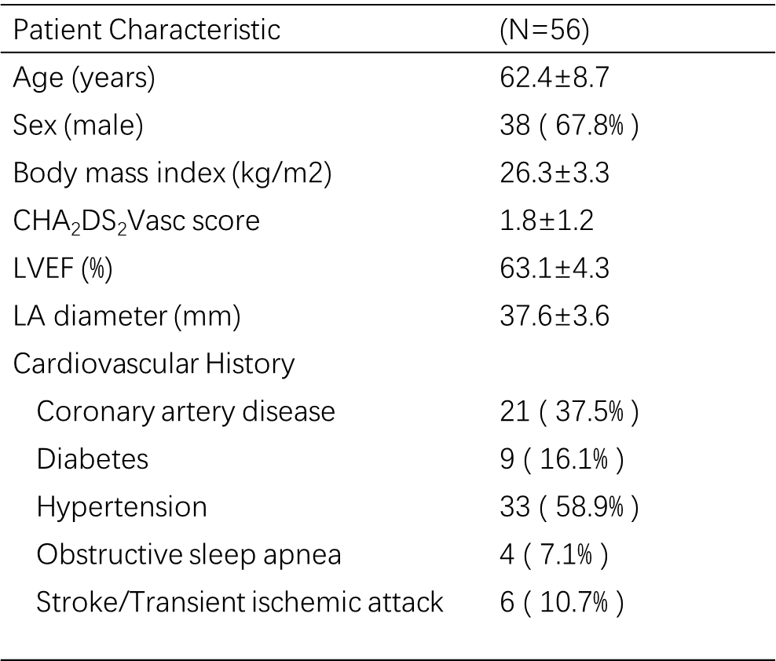

Table 2 Procedural characteristics
LA, left atrial. Total procedure time is defined as first venous puncture to the time either groin sheaths were pulled. LA dwell time is defined is defined as time PFBalloon catheter entered the LA to the time PFBalloon catheter exited the LA. Transpired ablation time is defined as time of first PFA therapy application to last PFA therapy application.

Table 3 The reasons for effectiveness endpoint failure
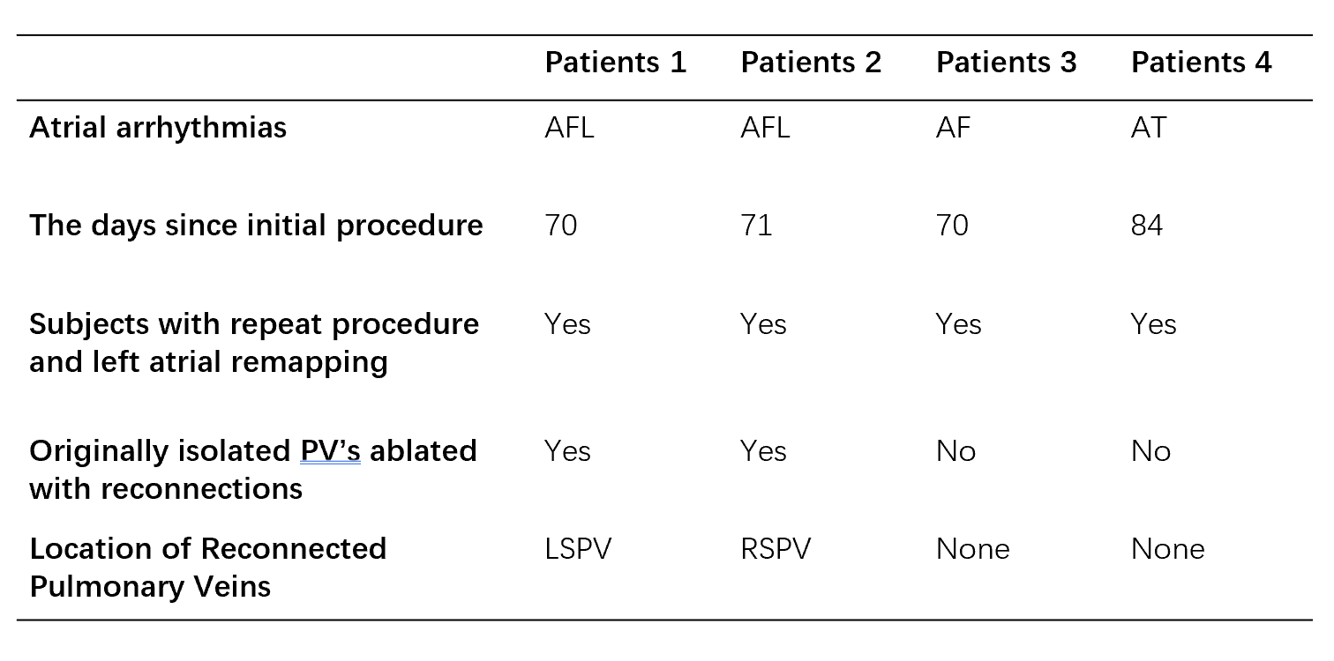

Table 4 Primary safety endpoint events
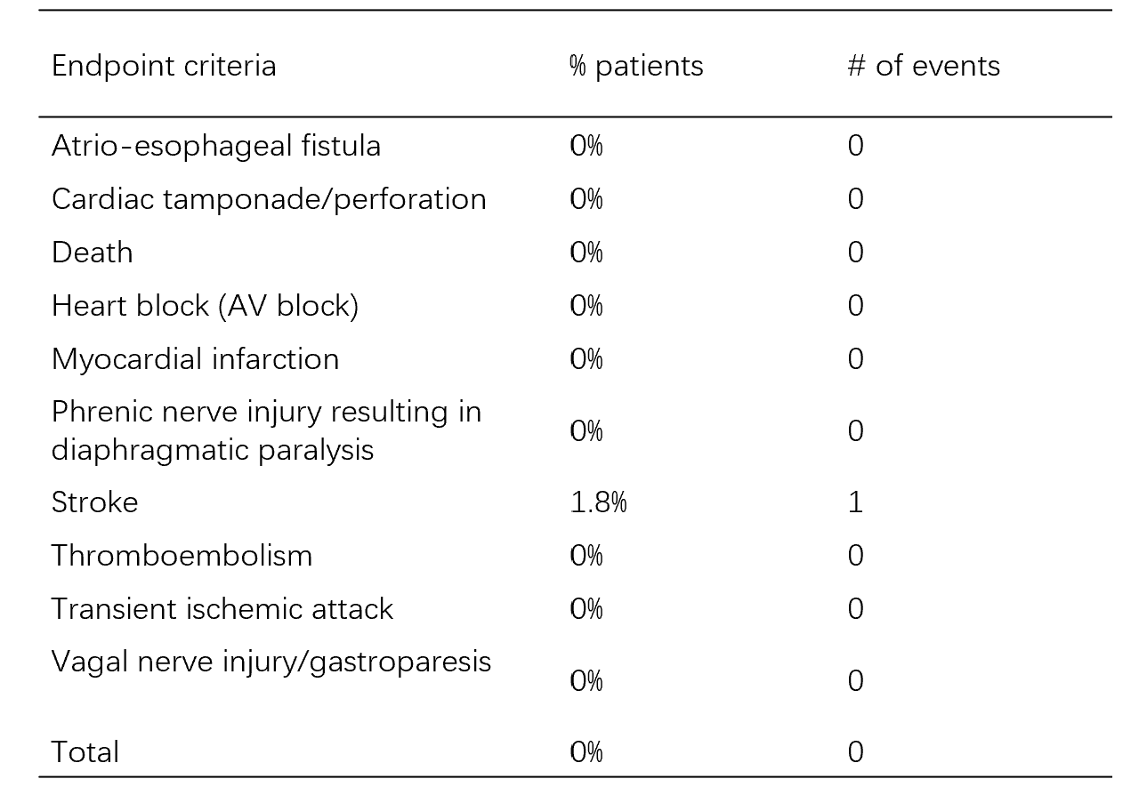

Table 5 Hematological and biochemical tests before and after ablation (data presented as median and inter quartile range).
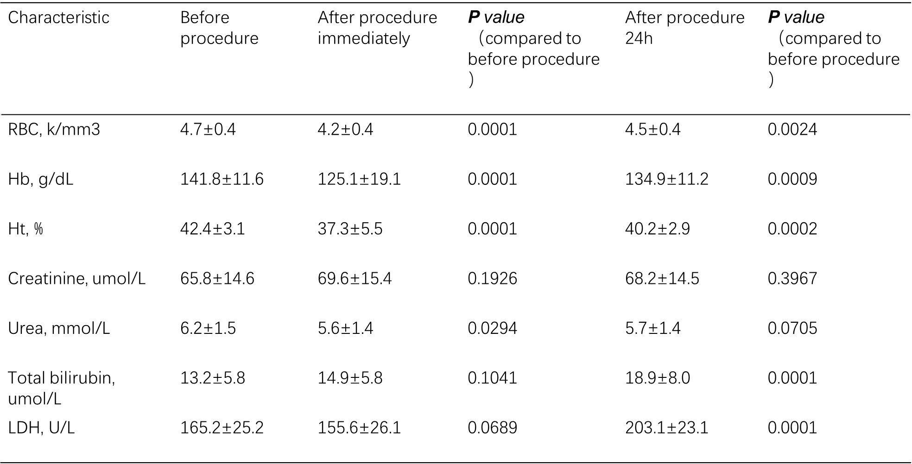
Note: ontinuous variables are shown as mean ± standard deviation (SD) or median and (inter quartile range) (IQR). Discrete variables are presented as numbers and percentages (%). Hematological and biochemical test before and after ablation procedure in study population (median and inter quartile range).
Abbreviations: Hb, hemoglobin, Ht, hematocrit; LDH, lactate dehydrogenases; SD, standard deviation; RBC, red blood cells.

