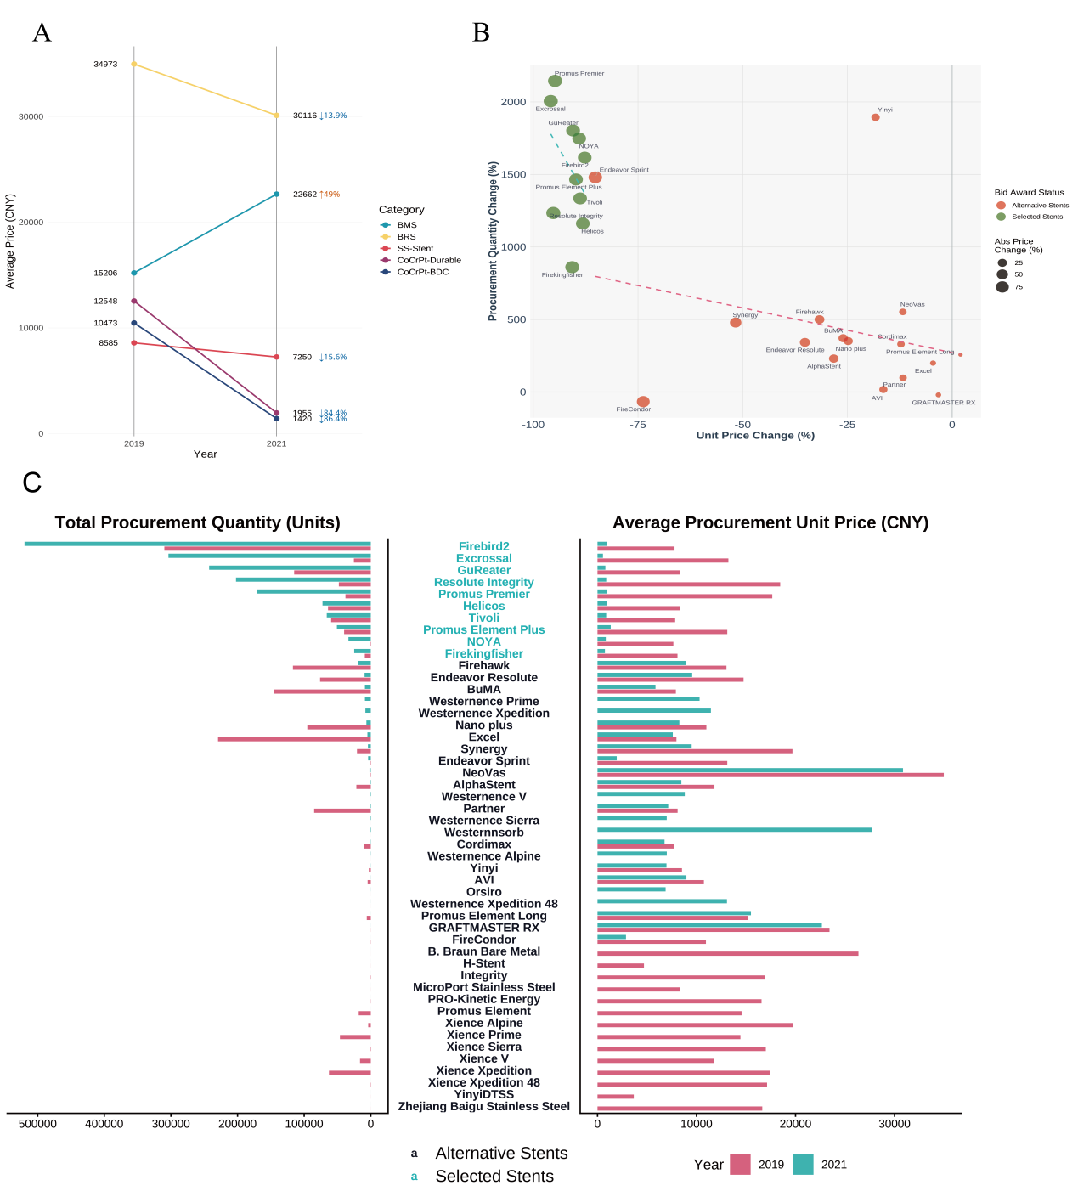
Supplementary Figure 1. Impact of the VBP policy on the price, market structure, and procurement patterns of coronary stents.
Note:(A) Trends in average unit prices by stent category (B)Scatter plot of stent model performance regarding price and quantity changes.(C) Comparison of total procurement quantity and average unit price by stent model.

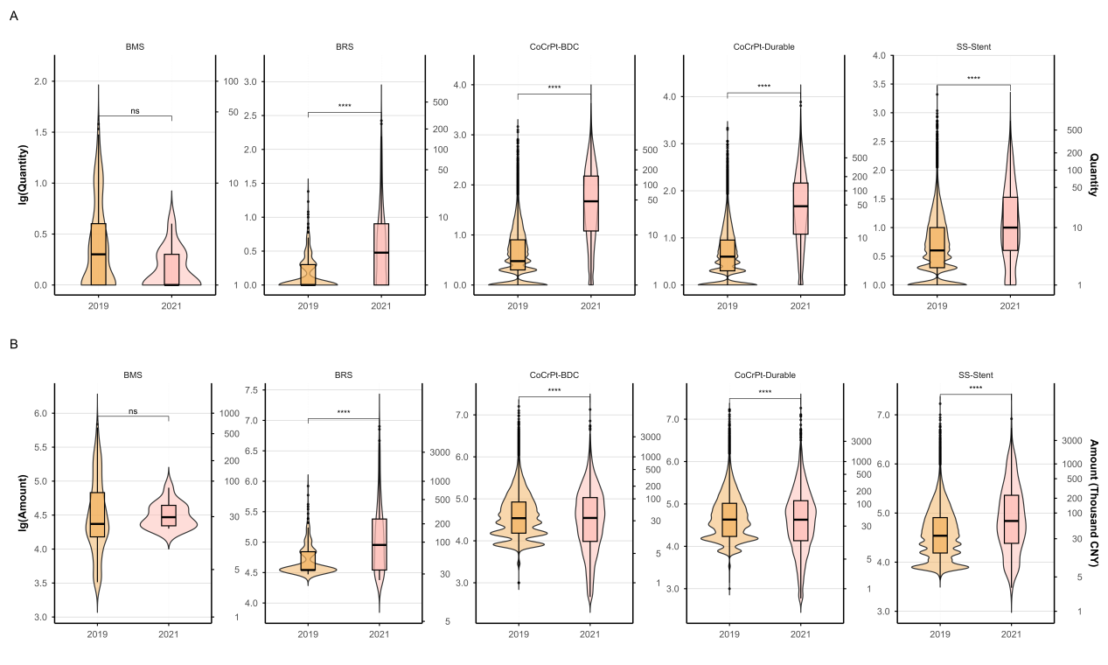Supplementary Figure 2. Distribution of procurement volume and procurement amount for coronary stents by category
Note:(A) Distribution of procurement quantity by stent category.(B) Distribution of procurement amount by stent category.Abbreviation list:BMS:Bare-Metal Stent;BRS:Bio-Resorbable Scaffold (Absorbable Stent);CoCrPt-BDC:Cobalt-Chromium-Pt Alloy Stent with Bio-degradable Coating;CoCrPt-Durable:Cobalt-Chromium-Pt Alloy Stent with Durable Coating;SS-Stent:Stainless Steel Stent.

