Supplementary information for “Large-scale photonic interferometric complex-valued processors capable of wavelength division multiplexing.”
†Shota Kita^{1,2}, †Kohei Ikeda^{1,2}, Kengo Nozaki^{1,2}, Kenta Takata^{1,2}, Kazuo Aoyama³, Guangwei Cong⁴, Keijiro Suzuki⁴, Yuriko Maegami⁴, Morifumi Ohno⁴, Noritsugu Yamamoto⁴, Koji Yamada⁴, Hiroshi Sawada³, Akihiko Shinya^{1,2}, and Masaya Notomi^{1,2}
¹ NTT Nanophotonics Center, NTT, Inc., 3-1 Wakamiya, Morinosato, Atsugi, Kanagawa, 243-0198, Japan
² Basic Research Laboratories, NTT, Inc., 3-1 Wakamiya, Morinosato, Atsugi, Kanagawa, 243-0198, Japan
³ Communication Science Laboratories, NTT, Inc., 2-4, Hikaridai, Seika-cho, Soraku-gun, Kyoto-fu, 619-0237, Japan
⁴ National Institute of Advanced Industrial Science & Technology (AIST), 16-1 Onogawa, Tsukuba, Ibaraki 305-8569, Japan
E-mail: shota.kita@ntt.com, kohei.ikeda@ntt.com

S1. Comparison with other reports
Table S1 compares our work with other state-of-the-art photonic computing platforms. Our approach shows a clear advantage by demonstrating that a programmable photonic interferometric vector–matrix multiplier (PIVMM) can carry out matrix-matrix multiplications (MMs) on a complex 16×16 Clements mesh with 64-wavelength division multiplexing (WDM), and by experimentally realizing purely on-chip neural-network (NN) inference driven only by photonic computing (achieving almost the same MNIST accuracy as an ideal circuit with 0% electronic contribution). Whereas existing interference-mesh systems are either limited to sizes of 10×10 or smaller without WDM (# of WDM = 1), or require off-chip electronics for a substantial portion of the computation, we suppress crosstalk via calibration based on iterative disorder-aware circuit-model learning (CPL), stably operate a large-scale chip with 288 control pins, and achieve both WDM-based throughput scaling and purely optical computation. To the best of our knowledge, this is the first experimental demonstration of an on-chip photonic computing platform that simultaneously combines a large interferometric mesh, multi-wavelength parallelism, and an electronics-independent MNIST inference demonstration.

Recently, a power-efficient photonic–electronic converged VMM processor with a 128 × 128 × 4 architecture has been demonstrated¹. In the referenced work, photonic circuits are used only for the generation of optical signals and their duplication (fan-out), while all subsequent multiply–accumulate operations are carried out in the electrical domain. As a result, WDM cannot be efficiently exploited in the matrix computation stage, and scaling the matrix size requires a proportional increase in circuit complexity. In contrast, in our architecture, matrix operations at multiple wavelengths are performed simultaneously within a single interferometer. As described in the main text, the availability of multi-wavelength input/output enables the extension of WDM to the matrix computation itself much more efficiently. Other approaches implement WDM weighting using microring-filter banks^{2–6}, or WDM crossbar arrays with deposited phase-change materials^{7–10}. These schemes are attractive for density, but the required resonant filtering and additional material loss mean that they are not optimal for maximizing power throughput.

With respect to the WDM operation reported by Yu et al.¹¹ , it is important to clarify the actual extent of the experimental validation. Their demonstrated circuit scale is 5×5, which is still far from the matrix sizes needed for practically relevant on-chip photonic computing. Although the paper highlights “100-wavelength” parallelism, the consistency/compensation study is performed on only 20 wavelengths (as listed in Table S1) and is validated for just three random matrices, which is insufficient to support a strong scalability claim. The reported random-matrix fidelity of 0.907 is obtained at the calibrated wavelength, and no convincing experimental evidence is provided that comparable fidelity is maintained across a truly broadband, 100-channel regime. Finally, no NN task based on VMM operations is experimentally demonstrated, so the benchmarking for the analog VMM and MMM operations is insufficient.

S2. Deterministic calibration for binary-valued matrix operation
Even with an identical optical routing design, fabrication induces initial phase offsets and nonuniform PS efficiencies, so we first performed deterministic calibration (Fig. S1(a)). Phase modulation efficiencies and initial phase errors of all Mach-Zehnder interferometers (MZIs) were extracted by sinusoidally fitting the output intensity of a specified port versus the heater power of the target phase shifter (PS). We calibrated the input-unit PSs first, then calibrated θ PSs by opening a specific input unit (assuming all MZIs were initially near the cross state), and similarly calibrated φ PSs by opening two specific input units under the same assumption, proceeding from elements closest to the input and tapping ports. After this calibration, we measured transmittance variations before and after the mesh and applied them as diagonal scaling matrices T_{in} and T_{out} at the input and output of the Clements-type to normalize matrix operations: T_{out} was estimated by keeping only the first input MZI open and routing light to each output port in turn, whereas T_{in} was estimated by opening each input MZI one at a time and routing light to the first output port. Although these diagonal corrections do not capture path-dependent loss differences, the residual errors are later compensated by CPL. Using the calibrated phases and transmittance compensation, we then implemented the identity and random permutation matrices as binary-valued operations (Figs. S1(b, c)), achieving explicit crossbar behavior with extinction ratios >20 dB; thanks to the crossbar θ settings, such binary operations were robust to phase fluctuations, required no further calibration, and did not use φ PSs, making crosstalk negligible compared with analog operations that rely on arbitrary phase settings.

S3. Variation of phase error and modulation efficiency of MZIs
Figure S2 summarizes the example of the variation for the phase error and the modulation efficiency of PSs. The definitions of these variations are illustrated in Fig. S2(a). Figures S2(b) and (c) show histograms of the initial phase errors (measured at the inner ports of the MZIs) and the effective π-shift voltage V_{π} extracted during calibration, which characterize the PS distribution and overall device yield. Here, V_{π} was calculated from the heater power consumption and resistance. The mean initial phase error was 0.14 rad with a standard deviation of 0.48 rad, while the mean effective V_{π} was 2.16 V with a standard deviation of 0.053 V. From these statistics, we estimate that the phase errors correspond to an effective optical path-length mismatch of about 50 nm per MZI. Considering the total MZI arm length of ~828 µm, this mismatch is just 0.006% and it is considered to be small enough to achieve a larger PIVMM with higher fidelity than other reports. On the other hand, the standard deviation of the MZI arm length after the calibration in the main text is denoted as <30 nm. The circuit model generated by the proposed iterative disorder-aware CPL is a model that is insensitive to phase changes that take dynamic crosstalk into account and is therefore thought to be also insensitive to wavelength changes in the MNIST classification task.

S4. Crosstalk between control signals and its estimation
As circuit dimensions increase, predicting the output optical-power distribution becomes challenging, not only due to fabrication imperfections but also because unintended crosstalk perturbs phase shifters (PSs) that are not being targeted. This presents a significant problem because crosstalk generates coupled, mutually dependent responses among control signals (Fig. S3(a)), and its severity depends on factors such as the power-supply scheme, circuit layout, and electrical routing. In heater-based PSs, proximal waveguides are heated simultaneously, inducing unintended phase shifts via thermal crosstalk. Furthermore, under voltage control, the wiring resistance of a shared ground (approximately 10 Ω at critical points) causes voltage drops correlated with other channels, introducing electrical crosstalk. Figure S3(b) illustrates simulation results showing how circuit-model fidelity degrades when the phase configuration is updated away from the initial phase setting used during data acquisition, due to crosstalk effects (see Iterative disorder-aware CPL in Methods for a detailed explanation of the schematic phase-space representation). In the absence of crosstalk (left), the coefficient of determination (R²) remains high over the entire phase-configuration space, reflecting the independence of the control signals. In contrast, when crosstalk is included in the simulation (right), R² progressively decreases as the phase configuration θ_{set}(σ) deviates from its initial state θ_{set}(0). This behavior indicates that, in the presence of crosstalk, the learned circuit model is only valid within a limited neighborhood around the phase configuration at which the training data were acquired. Consequently, reliable phase optimization requires restricting each phase update to a small deviation from the current operating point and performing the optimization iteratively.

This trend is also observed experimentally, as shown in Fig. S3(c). After performing CPL using a dataset acquired with compressed MNIST inputs at a randomly selected initial phase configuration θ_{init}, we gradually increased the magnitude of random phase perturbations σ in θ_{set}(σ). The resulting monotonic decrease in R² confirms that crosstalk significantly compromises the fidelity of complex-valued matrix computations as the phase configuration moves away from the training point, thereby necessitating explicit compensation strategies. We note that the absolute level of fidelity degradation differs between Fig. S3(b) and Fig. S3(c) because the crosstalk model used in the simulation is intentionally simplified compared with the experimental system.

S5. Impact of thermal crosstalk on matrix-implementation fidelity
We simulated how matrix fidelity degrades with increasing matrix size under varying levels of thermal crosstalk in a Clements-type configuration. We considered crosstalk arising from the thermo-optic (TO) effect among nearby phase shifters (PSs), incorporating distance-dependent coupling. The coupling was modeled to decay with the center-to-center distance d via an exponential kernel:

$K\left(d\right)= K_{0}exp⁡\left(-\frac{d-d_{0}}{L}\right)$ (S2)

where K₀ denotes the nearest-neighbor coupling magnitude at separation d₀, and L is the thermal decay length. For simplicity, we assumed that L is independent of the matrix size and the center-to-center distance between PSs scales linearly with the difference in their indices. Based on this kernel, we constructed a crosstalk matrix C, where off-diagonal elements are defined as C_{ij} = K(d_{ij}) for neighboring pairs, and diagonal elements are set to zero because self-heating corresponds to the intended phase response of each PS and is not treated as crosstalk. As an illustrative example, Fig. S4(a) shows the crosstalk matrix for N = 8 and K₀ = 0.03. In Fig. S4(b), we compare three crosstalk strengths, of which K₀ = 0.02 serves as a representative value within the realistic range for our platform. For each matrix size N and crosstalk level, we sampled 100 random phase configurations, computed the implemented matrix under the crosstalk model, and evaluated the amplitude fidelity

$F=\frac{{\left|Tr\left(U^{†}\hat{U}\right)\right|}^{2}}{N^{2}}$ (S3)

reporting the mean (and standard deviation) over the 100 trials. Across all conditions, the fidelity decreases monotonically with matrix size, and at any fixed size, stronger crosstalk yields lower fidelity, highlighting thermal crosstalk as a key scalability bottleneck. Suppressing or compensating crosstalk is therefore essential to maintain high fidelity for larger meshes.

S6. Influence on fidelity by parameter updates on different approaches
Figure S5 compares the correlation between experimental and simulated outputs under different conditions, to evaluate how circuit model fidelity changes after phase parameter updates in the MNIST experiments of Figs. 3(c) and 3(d). In the iterative CPL case (Fig. S5(a)), the initial correlation is high (R² = 0.913, as in Fig. 2(b)), but it drops noticeably after the phase parameters are updated. This decline indicates that the learned circuit model is not robust to phase perturbations, consistent with the lower MNIST accuracy of 68.3%. By contrast, in iterative disorder-aware CPL, R² remains nearly unchanged—or even improves—after updates, showing that the model is much more resilient to phase perturbations (Fig. S5(b)). The improved R² stability directly explains the higher classification accuracy and confirms the effectiveness of the disorder-aware iterative approach. It should be noted that the R² after CPL is lower for iterative disorder-aware CPL (R² = 0.872) than for standard iterative CPL (R² = 0.913). This difference arises because disorder-aware CPL intentionally introduces random phase perturbations during data acquisition, effectively averaging circuit responses over a distribution of phase configurations rather than fitting a single fixed operating point. As a result, the learned model sacrifices peak fidelity at one specific phase setting in exchange for improved robustness over a broader phase space. This trade-off leads to a slightly reduced R² when evaluated at a fixed phase configuration, while enabling significantly greater stability under subsequent phase updates and yielding higher MNIST classification accuracy.

S7. Simulation results of wavelength dependence in MNIST classification with experimental couplers
We investigated the wavelength dependence of MNIST classification accuracy by constructing a circuit model incorporating varying degrees of fabrication error and examining how accuracy responds to changes in input wavelength. The circuit model accounts for optical path length differences at two positions, corresponding to the PS locations, following a Gaussian distribution. The standard deviation (σ) ranges from 10⁻⁵ to 10⁻⁹. Each MZI in the model included directional couplers (DCs) with an experimental wavelength-dependent splitting ratio modeled as linear. Following the experimental calibration procedure, we optimized the PS settings at a single wavelength to maximize MNIST classification accuracy. The PS settings were calculated considering the TO effect. After optimization, the input wavelength was swept away from the calibrated wavelength. Variations in wavelength introduced the corresponding phase shifts based on the optical path length differences. The phase shift δ was calculated using the following equation:

$δ=\frac{2πn_{eff}L}{λ}$ (S4),

where n_{eff} is the effective refractive index, L is the optical path length difference, and λ is the input wavelength. The simulation results are shown in Fig. S6(a). In regions with significant optical path length variance, the tolerance to wavelength variations improved as the optical path length difference decreased. This trend continued until the wavelength dependence of the DC became the limiting factor. As shown in Fig. S6(b), by comparing the reduction in classification accuracy with our experimental data (Fig. 4 in the main text), represented as a horizontal blue line, we estimate that the actual path length fluctuation in our device is on the order of tens of nanometers. This value aligns with the estimation derived from the initial phase error fluctuation in Fig. S2(b).

Table S1 Comparison with other reports.

Reports | Scheme | # of WDM | Size | Type | # of  pins | Fidelity | Calibration | Verification task (contribution ratio photo./elec.*) | Others
Our work | Interference | 86 | Complex  16 x 16 | Clements | 288 | 0.913 | Circuit model | MNIST 79% (256/0) | Resolved crosstalk, complex encoding/real detection
Tang et al. (2024)¹² | Interference | 1 | Complex  10 x 10 | Clements  (robust) | 190 | - | In-situ | MNIST 97% (180/8372) | Phase encoding /real detection, robust MZI
Bandyopadhyay et al. (2024)¹³ | Interference | 1 | Complex  6 x 6 x 3 | Clements | 114 | 0.989 | Circuit model  or In-situ | 6 vowel classes 92.5% (114/0) | 3-layer NN with OEOs, coherent detection
Zhang et al.  (2022)¹⁴ | Interference | 1 | Complex  8 x 8 (6x6?) | Reck | 72 | N/A | In-situ | MNIST 90.5% (64/3176) | complex encoding/complex detection
Yu et al.  (2025)¹¹ | Interference | 20 | Real  5 x 5 | Reck | 25 | 0.907 | Deterministic  and loop compensation | N/A | Micro-comb, DAC/ADC, no NN demonstration
Tang et al. (2021)¹⁵ | Interference | 1 | Phase  10 x 10 | MDC | 140 | N/A | In-situ | N/A | Multiple directional coupler
Shen et al. (2017)¹⁶ | Interference | 1 | 4 x 4 | Reck | 16 | N/A | Deterministic | 4 vowel class | First paper demonstrating NN task with a PIVMM
Feldmann et al. (2020)⁸ | WDM-crossbar | 9 | Real  9 x 4 | Crossbar | N/A | N/A | In-situ | Image processing (CNN) | WDM＋Phase change materials
Hua et al. (2025)¹⁷ | PD-crossbar | 1 | Real  64 x 64 | photo-current crossbar | 8,192 | N/A | Deterministic  and in-situ | Ising/Max-cut | Full integration
Tang et al. (2025)¹⁸ | Waveguide multiplexing | 4 | Real  4 x 4 | WDM-crossbar | 20 | 0.991 | Deterministic | f-MNIST 90.53% (almost electronic) | Waveguide multiplexing with multiport PDs
* the ratio of the number of optimization parameters for photonics and electronics.

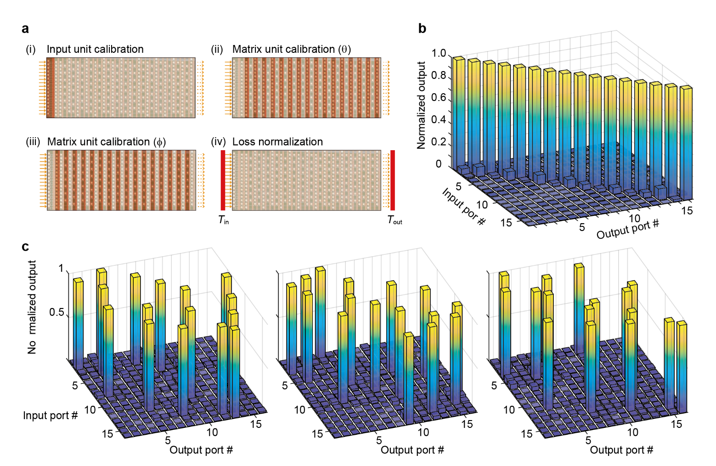
Fig. S1 Deterministic calibration and binary-valued matrix operations. (a) Schematic of the deterministic calibration flow for binary-valued operations. (b) Input and output correlation against the identity matrix setting (input wavelength: 1,526 nm). (c) Input and output correlations against the three random permutation matrix settings.

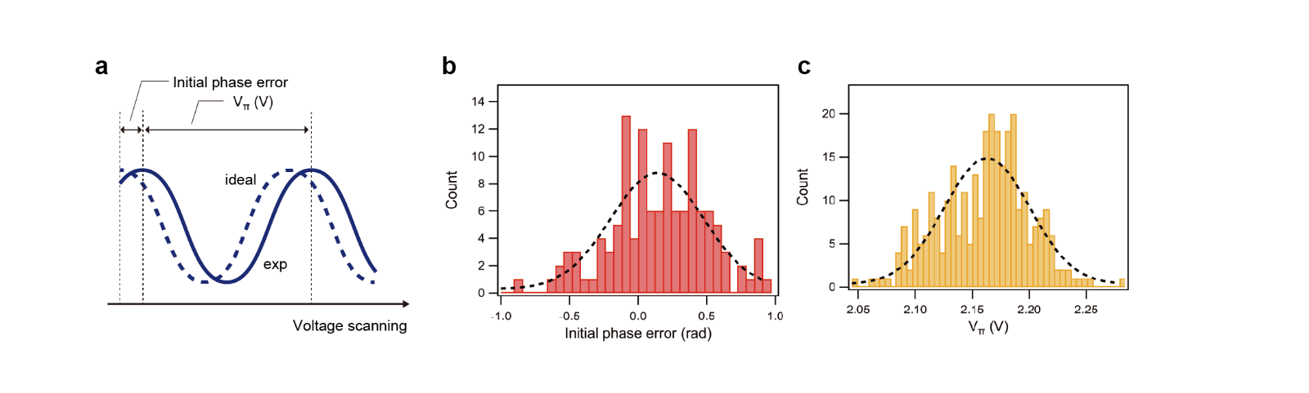
Fig. S2 Calibration for all phase shifters (PSs) in MZIs and their variation. (a) Schematic illustration of the waveform obtained during the calibration process. Histograms of (b) initial phase errors in the inner PSs in MZIs and (c) applied voltages for a π phase shift.

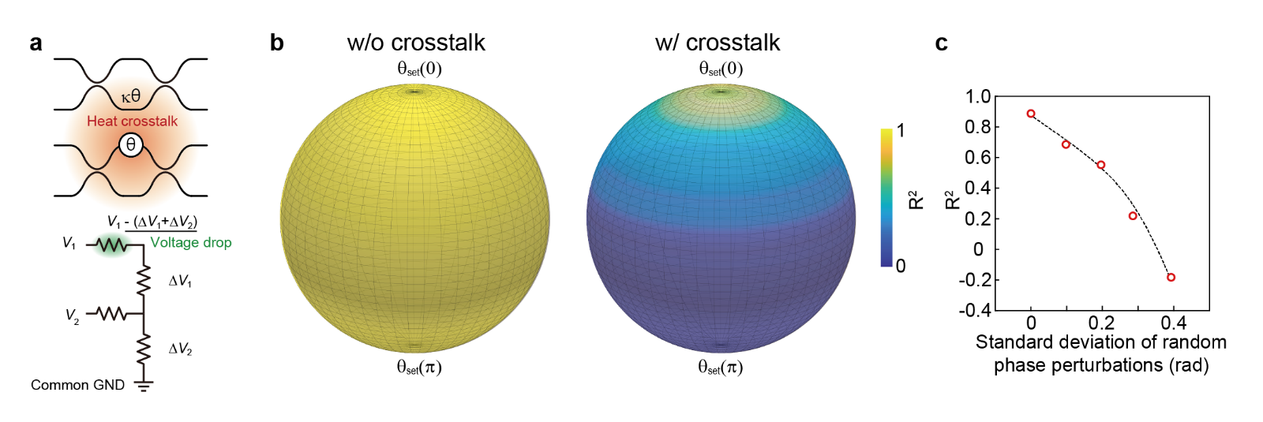
Fig. S3 Crosstalk in PIVMM control. (a) Illustrations of the heat crosstalk caused by the heater phase shifters and the voltage drop due to the wiring resistance at the common ground wire. (b) Simulated model-fidelity landscape without (left) and with (right) crosstalk, shown as a function of the phase configuration θ_{set}(σ). (c) Experimental R² as a function of the standard deviation σ of the random phase perturbations in θ_{set} (σ).

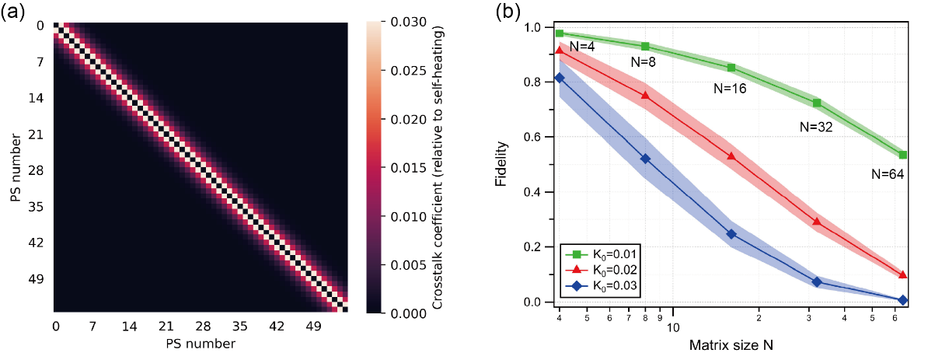
Fig. S4 Simulated matrix implementation fidelity under the realistic thermal crosstalk assumption. (a) Example crosstalk matrix (56 × 56) for N = 8 and K₀=0.03. (b) Fidelity versus matrix size for three crosstalk strengths, K₀ = 0.01, 0.02, 0.03 (increasing from weak to strong). Curves show the mean fidelity; shaded bands indicate the standard deviation across 100 random phase configurations.

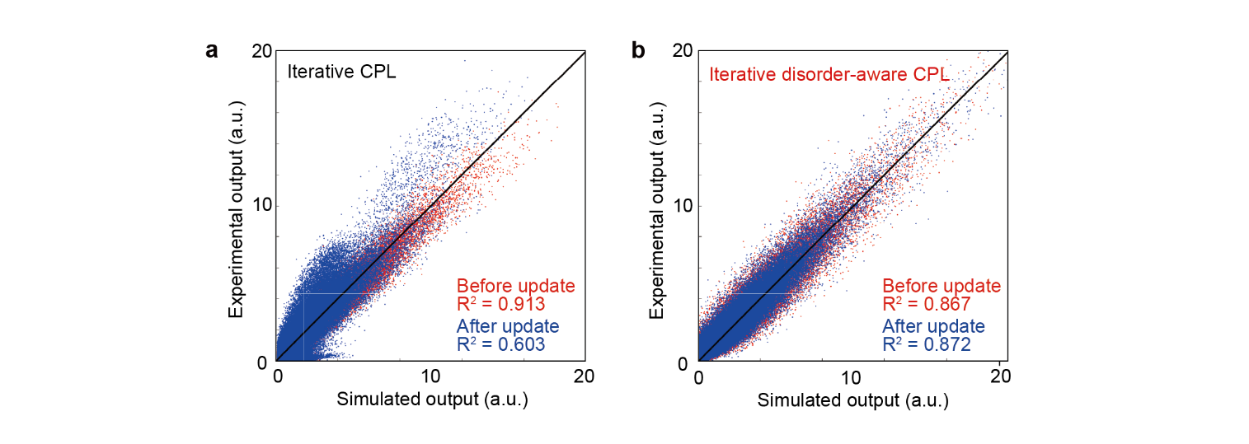
Fig.S5 Comparison of correlation plots between experimental and simulated output before and after phase parameter update for MNIST classification. (a) Correlation plot in the case of iterative CPL. (b) Correlation plot in the case of iterative disorder-aware CPL.

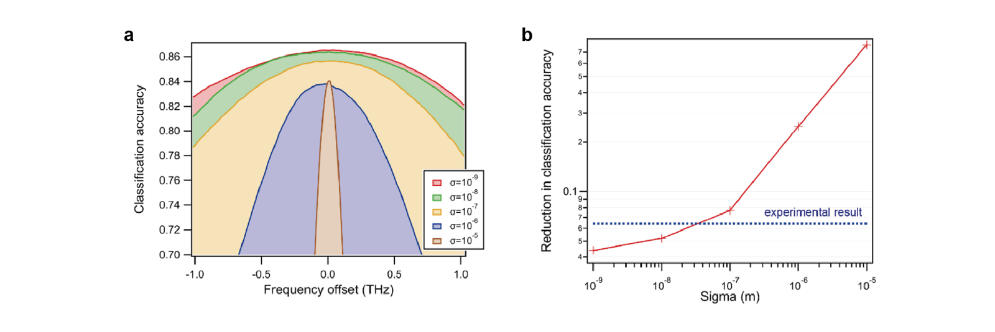
Fig. S6 Simulated frequency dependence on the MNIST classification accuracy. (a) Simulation results illustrating the wavelength dependence of MNIST classification accuracy, accounting for various levels of fabrication error. (b) Simulated reduction in MNIST classification accuracy within the ±1 THz range. The dotted blue line represents the experimentally obtained value.

Supplementary references

1. Ahmed, S. R. et al. Universal photonic artificial intelligence acceleration. Nature 640, 368–374 (2025).
2. Shastri, B. J. et al. Photonics for artificial intelligence and neuromorphic computing. Nat. Photonics 15, 102–114 (2021).
3. Huang, C. et al. Prospects and applications of photonic neural networks. Adv. Phys.: X 7, 1981155 (2021).
4. Nahmias, M. A. et al. Photonic Multiply-Accumulate Operations for Neural Networks. IEEE J. Sel. Top. Quantum Electron. 26, 1–18 (2019).
5. Tait, A. N. et al. Neuromorphic photonic networks using silicon photonic weight banks. Sci. Rep. 7, 7430 (2017).
6. Ohno, S., Tang, R., Toprasertpong, K., Takagi, S. & Takenaka, M. Si Microring Resonator Crossbar Array for On-Chip Inference and Training of the Optical Neural Network. ACS Photonics 9, 2614–2622 (2022).
7. Geler-Kremer, J. et al. A ferroelectric multilevel non-volatile photonic phase shifter. Nat. Photonics 16, 491–497 (2022).
8. Feldmann, J. et al. Parallel convolutional processing using an integrated photonic tensor core. Nature 589, 52–58 (2020).
9. Feldmann, J., Youngblood, N., Wright, C. D., Bhaskaran, H. & Pernice, W. H. P. All-optical spiking neurosynaptic networks with self-learning capabilities. Nature 569, 208–214 (2019).
10. Wuttig, M., Bhaskaran, H. & Taubner, T. Phase-change materials for non-volatile photonic applications. Nat. Photonics 11, 465–476 (2017).
11. Yu, X. et al. Parallel optical computing capable of 100-wavelength multiplexing. eLight 5, 10 (2025).
12. Tang, S., Chen, C., Qin, Q. & Liu, X. Reconfigurable Integrated Photonic Unitary Neural Networks With Phase Encoding Enabled by In-Situ Training. IEEE Photonics J. 16, 1–11 (2024).
13. Bandyopadhyay, S. et al. Single-chip photonic deep neural network with forward-only training. Nat. Photonics 18, 1335–1343 (2024).
14. Zhang, H. et al. An optical neural chip for implementing complex-valued neural network. Nat. Commun. 12, 457 (2021).
15. Tang, R., Tanomura, R., Tanemura, T. & Nakano, Y. Ten-Port Unitary Optical Processor on a Silicon Photonic Chip. ACS Photonics 8, 2074–2080 (2021).
16. Shen, Y. et al. Deep learning with coherent nanophotonic circuits. Nat. Photonics 11, 441–446 (2017).
17. Hua, S. et al. An integrated large-scale photonic accelerator with ultralow latency. Nature 640, 361–367 (2025).
18. Tang, R. et al. Waveguide-multiplexed photonic matrix–vector multiplication processor using multiport photodetectors. Optica 12, 812 (2025).

