Figure 1
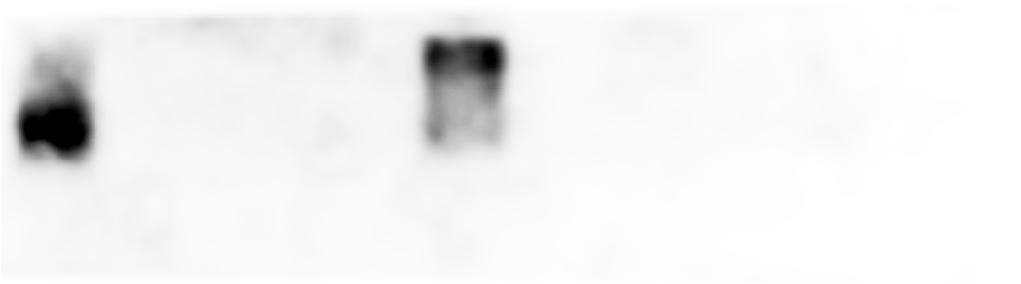
4 3 M 1 2
gEGF
Fig. 1 Analysis of gEGF produced by the recombinant strain. Lane 1: 20 μl/well of the supernatant from the LL-pNZ8149 fermentation product, Lane 2: 20 μl/well of the supernatant from LL-pNZ8149-gEGF fermentation product, Lane M: Spectra Multicolor Low Range Protein Ladder (it’s invisible in the PVDF membrane), Lane 3: 20 μl/well of the supernatant from the LL-pNZ8149 fermentation product, Lane 4: 20 μl/well of another protein containing His tag (as positive control). The recombinant gEGF is marked by an arrowhead.

Figure 2
M 1 2 3 4 5 6 7
Fig. 2 Analysis of gEGF expression by LL-pNZ8149-gEGF induced with different concentrations of nisin for 9 h. The LL-pNZ8149 and LL-pNZ8149-gEGF cultures were induced with 0, 1, 2.5, 5, 10, 20, 40 ng/ml nisin for 6 h when the optical density of 600 nm of the bacterial cultures reached 0. 4. Lane M: Spectra Multicolor Low Range Protein Ladder (it’s invisible in the PVDF membrane), Lanes 1‒7: 20 μl/well of supernatant from each of the induced cultures, respectively.

Figure 3
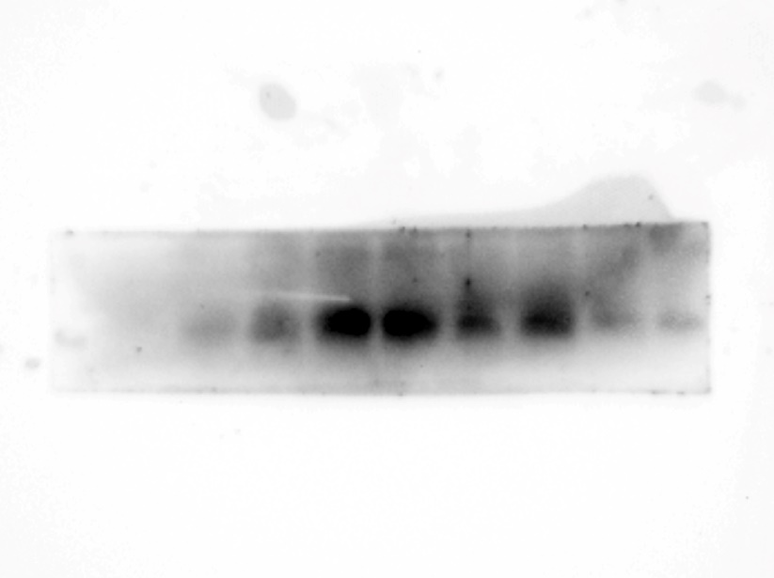
M 1 2 3 4 5 6 7 8 9
Fig. 3 Analysis of gEGF expression by LL-pNZ8149-gEGF induced for different induction times with 10 ng/ml nisin. The LL-pNZ8149 and LL-pNZ8149-gEGF were induced with 10 ng/ml nisin for 0, 3, 6, 9, 12, 15, 18, 21, 24 h when the optical density of 600 nm of the bacterial cultures reached 0.4. Lane M: Spectra Multicolor Low Range Protein Ladder (it’s invisible in the PVDF membrane), Lanes 1-9: 20 μl/well of the supernatant from each of the induced cultures, respectively.

Figure 4
40
25
14
k Da
10
gEGF
4.6
1 2
Fig. 4 Analysis of the purified gEGF by Tricine-SDS-PAGE. Lane 1: Spectra Multicolor Low Range Protein Ladder. Lane 2: 20 μl/well of protein purified from the supernatant of 300 ml LL-pNZ8149-gEGF cultures. The recombinant gEGF is marked with an arrowhead at 7 kDa.

Figure 5
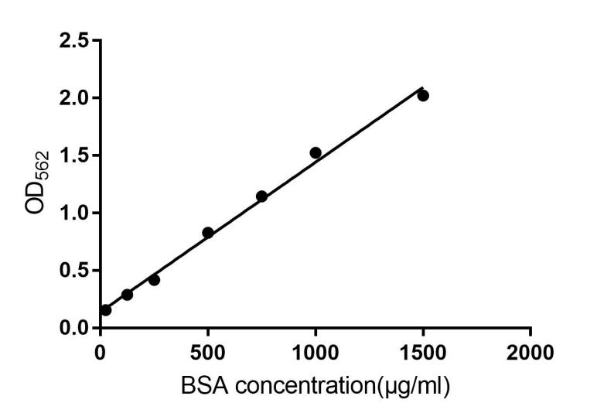
Fig. 5 The standard curve for bovine serum albumin (BSA).

Figure 6

。
Fig. 6. Effect of gEGF of 1‒20 μg/ml on DF-1 proliferation. Values are mean ± SD (n = 5). Bars with different letters are significantly different (p < 0.05).

