Supplementary Tables
Supplementary Table 1. Summary of multiple regression model results of PCr/iP vs. SWI CNR values
Analysis of Variance | SS | DF | MS | F | p-value
Regression | 84.03 | 4 | 21.01 | F(4,57) = 2.70 | P = .0393*
SWI: putamen (CNR) | 51.38 | 1 | 51.38 | F(1,57) = 6.61 | P = .0128*
SWI: caudate (CNR) | 30.52 | 1 | 30.52 | F(1,57) = 3.93 | P = .0524
SWI: globus pallidus (CNR) | 35.18 | 1 | 35.18 | F(1,57) = 4.53 | P = .0377*
SWI: thalamus (CNR) | 0.00 | 1 | 0.00 | F(1,57) = 0.00 | P = .9924
Residual | 443 | 57 | 7.78
Total | 527 | 61

Parameter Estimates | Variable | Estimate | SE | 95% CI | T | p-value
β0 | Intercept | 4.47 | 1.59 | 1.28; 7.66 | 2.81 | P = .0069**
β1 | SWI: putamen (CNR) | 8.09 | 3.15 | 1.79, 14.39 | 2.57 | P = .0128*
β2 | SWI: caudate (CNR) | 1.05 | 0.53 | 0.01; 2.12 | 1.98 | P = .0524
β3 | SWI: globus pallidus (CNR) | 0.65 | 0.31 | 0.04; 1.27 | 2.13 | P = .0377*
β4 | SWI: thalamus (CNR) | 0.00 | 0.25 | -0,50; 0,51 | 0.01 | P = .9924

Goodness of Fit
DF | 57
Multiple R | 0.40
R² | 0.16
R²_{adj} | 0.10
SS | 443
RMSE | 2.79

Multicollinearity | Variable | VIF | R² with other variables
β0 | Intercept
β1 | SWI: putamen (CNR) | 1.59 | 0.37
β2 | SWI: caudate (CNR) | 1.18 | 0.15
β3 | SWI: globus pallidus (CNR) | 1.29 | 0.22
β4 | SWI: thalamus (CNR) | 1.21 | 0.17

Normality of Residuals | Statistics | p-value | Passed normality test (𝛂 = .05)?
Anderson–Darling(42) | 0.68 | P = .07 | Yes
D'Agostino–Pearson omnibus(43) | 5.90 | P = .05 | Yes
Shapiro–Wilk(44) | 0.95 | P = .02* | No
Kolmogorov–Smirnov (distance)(45) | 0.09 | P > .10 | Yes

The table summarizes the multiple regression model of PCr/iP vs. SWI CNR values, including descriptive analyses. Apart from the overall significance test of the model, parameter estimates, goodness of fit, and necessary assumptions for multiple regression models were tested (absence of multicollinearity and normality of residuals). */**/***/***: significance levels (*: P ≤ 0.05, **: P ≤ 0.01, ***: P ≤ 0.001; ****: P ≤ 0.0001). CI: confidence interval. CNR: contrast-to-noise ratio. DF: degrees of freedom. MS: mean square. R²: coefficient of determination. R²_{adj}: adjusted coeffcient of determination. RMSE: root mean square error. SE: standard error. SS: sum of squares. SWI: susceptibility-weighted imaging. T: t-statistic. F: f-Statistic. VIF: variance inflation factor.

Supplementary Figures
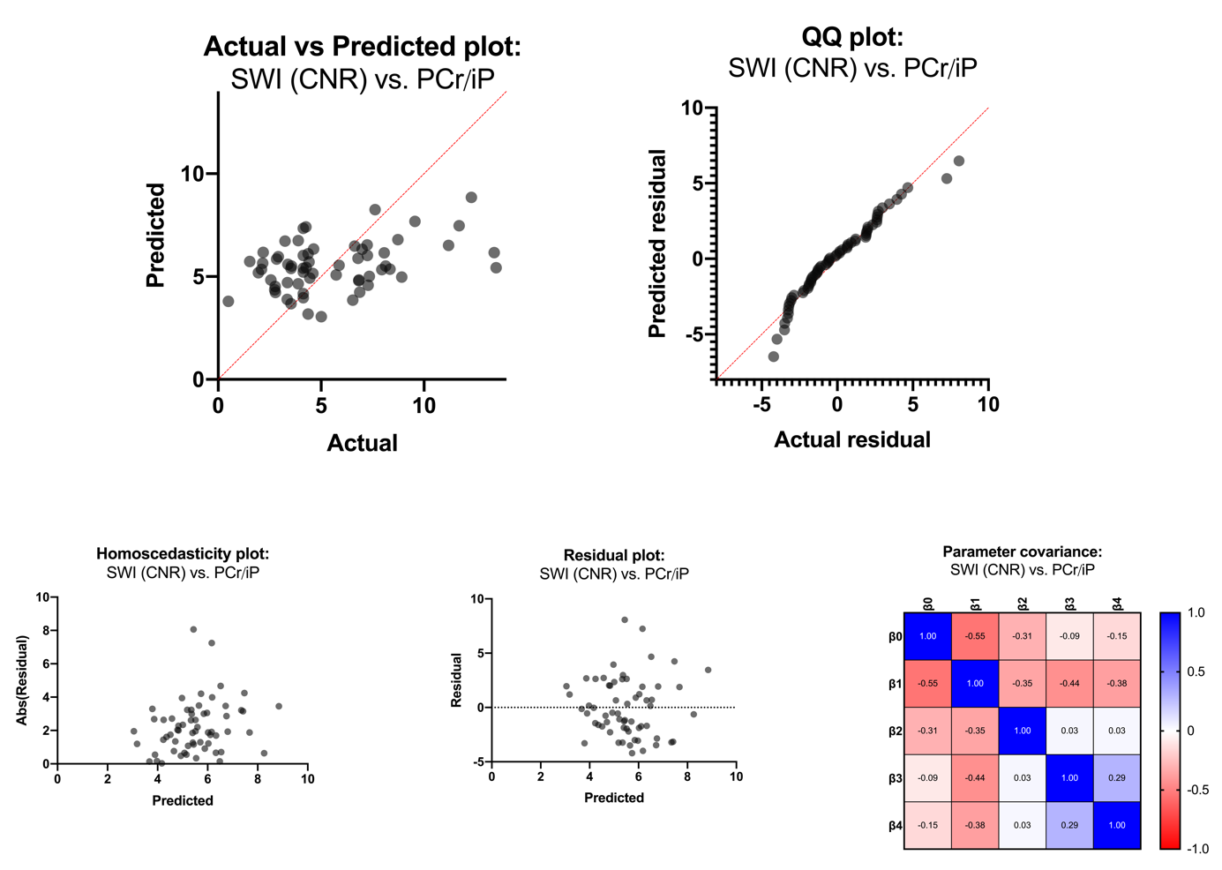Supplementary Figure 1. Graphical representation of the multiple linear regression model of PCr/iP vs. SWI CNR values. The validity of the respective multiple regression model is shown in the actual v. predicted plot (highlighted in red is the line of identity). We demonstrated the fulfillment of necessary assumptions for multiple linear regression models using a QQ plot (normality of residuals), homoscedasticity plot (evenness of residuals' variance), residual plot (residuals are not themselves predictive), and parameter covariance matrix (selected parameters are not concerningly intertwined). Abs(Residual): absolute value of residuals. CNR: contrast-to-noise ratio. iP: inorganic phosphate. PCr: phosphocreatinine. SWI: susceptibility-weighted imaging.

