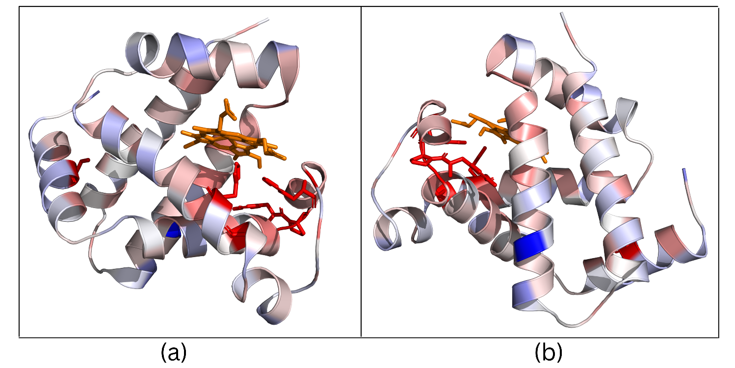

Supplementary Figure 1: Structural Mapping of Mutation-Intolerant Residues in HBB. (a) front-face orientation (b) back-face orientation. Heatmap summarizing structural characteristics of the 15 most mutation-intolerant residues in HBB. Features include relative buriedness, distance to the heme group, and normalized mutation intolerance. Hotspots predominantly exhibit increased burial and, in several cases, proximity to the heme-binding pocket, consistent with structural and functional constraint.

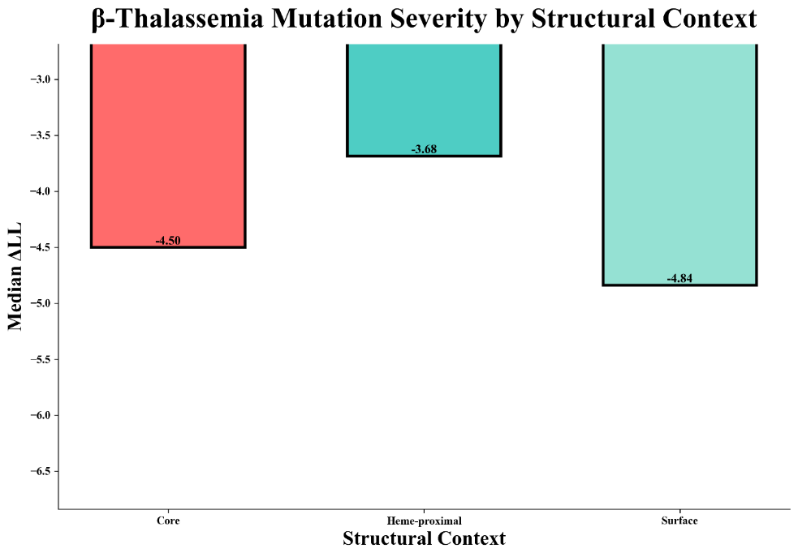

Supplementary Figure 2: β-Thalassemia Mutation Severity by Structural Context. Median Δlog-likelihood values of β-thalassemia mutations stratified by structural classification: core (n = 14), heme-proximal (n = 3), and surface (n = 3). While differences between groups are modest and not statistically significant due to small sample sizes, the majority of β-thalassemia mutations localize to structurally constrained core or heme-proximal regions.

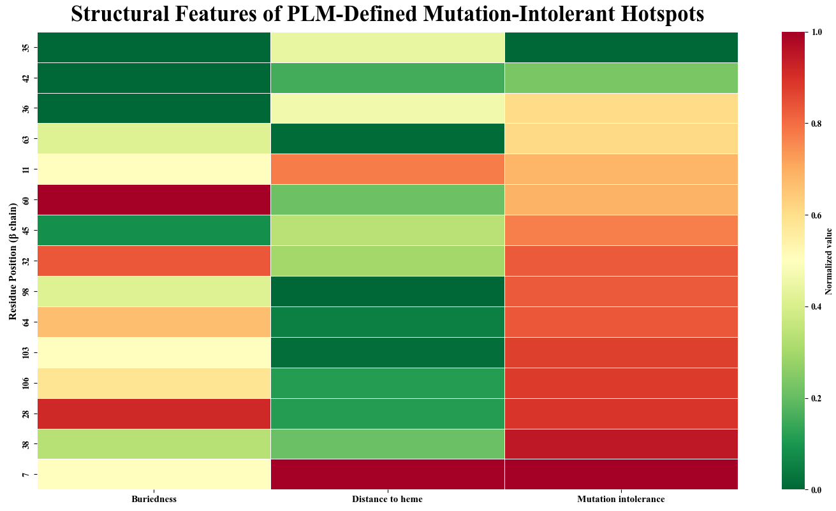

Supplementary Figure 3: Structural Features of PLM-Defined Mutation-Intolerant Hotspots. Heatmap summarizing structural characteristics of the 15 most mutation-intolerant residues in HBB. Features include relative buriedness, distance to the heme group, and normalized mutation intolerance. Hotspots predominantly exhibit increased burial and, in several cases, proximity to the heme-binding pocket, consistent with structural and functional constraint.

