Supplemental Information (SI)
Supplementary Figures
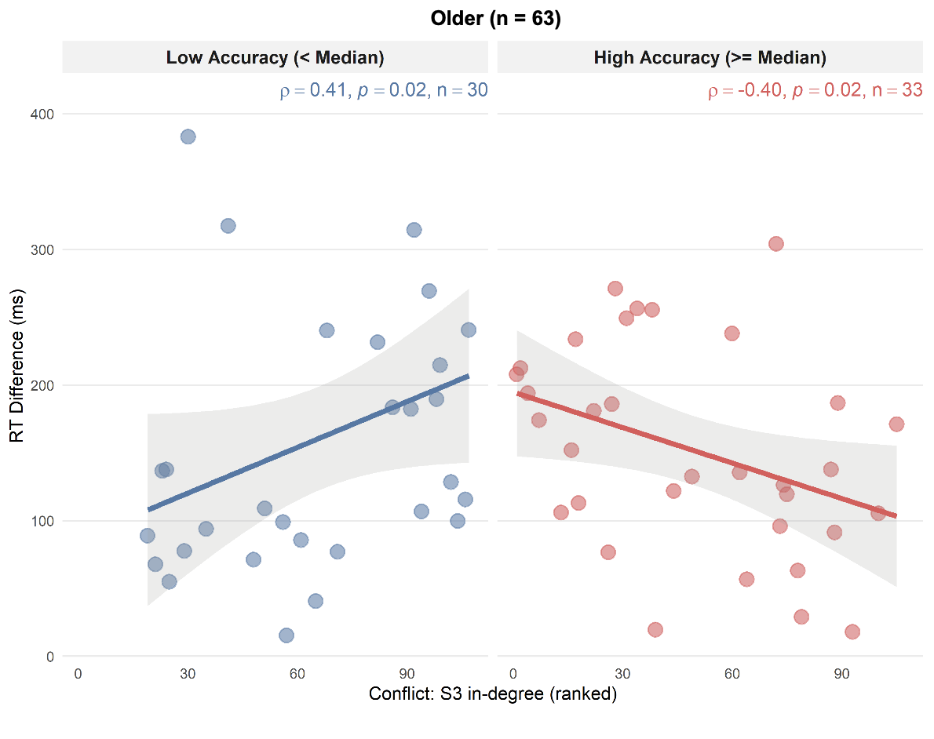
Fig. S1. Accuracy-stratified association between S3 in-degree and RT Difference in older adults. Older adults were split at the median of conflict accuracy into Low accuracy (n = 30) and High accuracy (n = 33) subgroups. Within each subgroup, the association between S3 in-degree and RT Difference (conflict cost) was examined using Spearman rank correlations (two-tailed, α = 0.05). Left panel (Low accuracy): S3 in-degree positively correlates with RT Difference, ρ = 0.41, p = 0.02. Right panel (High accuracy): S3 in-degree negatively correlates with RT Difference, ρ = −0.40, p = 0.02. This crossover pattern is consistent with the simple-slope estimates from the interaction model in older adults, which showed a positive slope at −1 SD accuracy and a negative slope at +1 SD accuracy (Table S9A). Scatterplots display individual participants; solid lines depict ordinary-least-squares linear fits with 95% confidence bands for visualization only. Reported statistics are Spearman’s ρ and corresponding two-tailed p values.

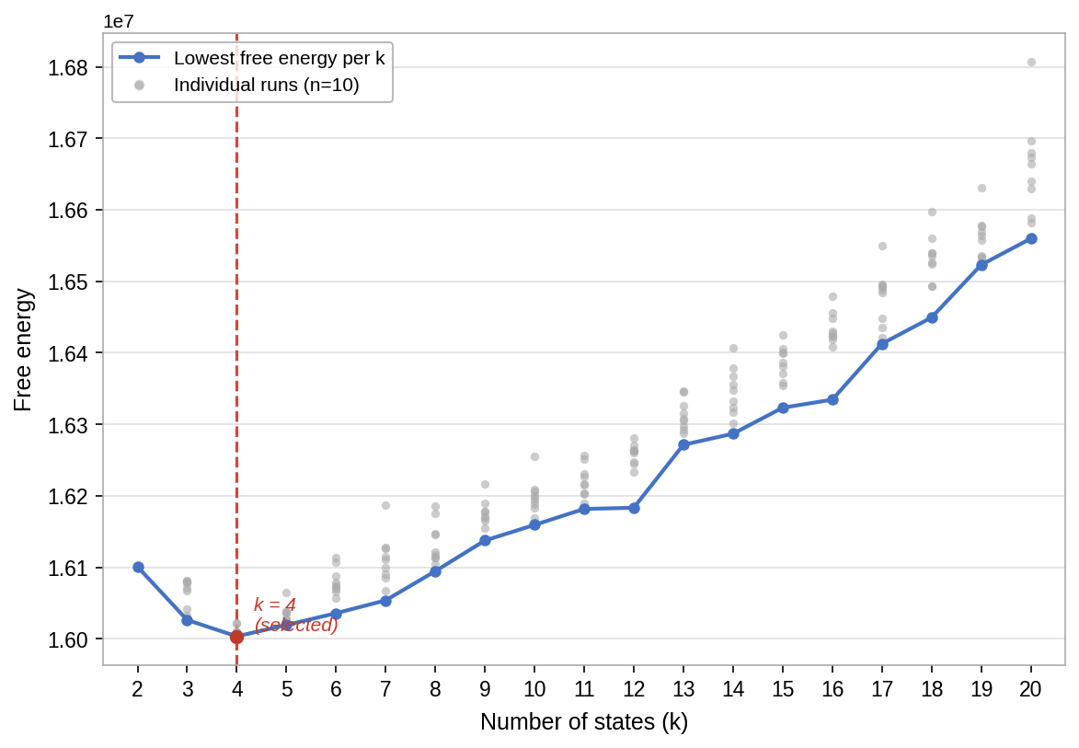
Fig. S2. HMM model selection: free energy across state numbers (k = 2–20) and repeated runs. The HMM was estimated with k = 2 to 20 states. For each k value, 10 independent runs were initialized randomly; the run with the lowest free energy per k is shown as the blue connected line, and individual run values are shown as gray dots. Free energy was minimized at k = 4 (red dashed line), which was accordingly selected for all subsequent analyses. The narrow spread of individual runs at k = 4 (range = 18,565) relative to higher k values indicates stable convergence of the 4-state solution.

Supplementary Tables
Table S1. Linear mixed-model (LMM) fixed-effects F tests for behavioral performance in the Stroop task.
- Reaction Time (RT)
Effect | F | df1 | df2 | p
(Intercept) | 1193.64 | 1 | 113.72 | < 0.001
Age Group | 5.62 | 1 | 120.82 | 0.02
Stroop Condition | 98.19 | 1 | 102.00 | < 0.001
Years of Education (z‑score) | 0.49 | 1 | 100.00 | 0.49
Gender | 0.32 | 1 | 100.00 | 0.57
Age Group × Stroop Condition | 1.13 | 1 | 102.00 | 0.29
- Accuracy (arcsin√p)
Effect | F | df1 | df2 | p
(Intercept) | 2796.37 | 1 | 167.45 | < 0.001
Age Group | 8.84 | 1 | 188.29 | 0.003
Stroop Condition | 46.96 | 1 | 102.00 | < 0.001
Years of Education (z‑score) | 2.36 | 1 | 100.00 | 0.128
Gender | 0.02 | 1 | 100.00 | 0.903
Age Group × Stroop Condition | 6.70 | 1 | 102.00 | 0.011

C. Inverse Efficiency Score (IES)
Effect | F | df1 | df2 | p
(Intercept) | 417.98 | 1 | 135.52 | < 0.001
Age Group | 5.43 | 1 | 152.07 | 0.021
Stroop Condition | 55.40 | 1 | 102.00 | < 0.001
Years of Education (z‑score) | 1.90 | 1 | 100.00 | 0.172
Gender | 0.02 | 1 | 100.000 | 0.899
Age Group × Stroop Condition | 0.01 | 1 | 102.00 | 0.941
Note. p values are reported as obtained. Accuracy was transformed using the arcsine square-root to address right-skew. Each model included Age Group, Stroop Condition, and their interaction as fixed effects, with standardized Years of Education (z-score) and Gender as covariates. Subject-specific random intercepts were included. Denominator degrees of freedom (df2) were estimated using the Kenward–Roger method.
Table S2. Standardized fixed-effects coefficients (β) with 95% confidence intervals from LMMs for behavioral performance in the Stroop task.
- Reaction Time (RT)
Parameter | Std. Coef. | 95% Confidence Interval
Age Group (Older vs. Young) | 0.43 | [0.07, 0.79]
Stroop Condition (Conflict vs. Control) | 0.86 | [0.69, 1.04]
Years of Education (z‑score) | -0.06 | [-0.21, 0.10]
Gender (Male vs. Female) | -0.10 | [-0.43, 0.24]
Age Group × Stroop Condition | 0.12 | [-0.10, 0.34]
- Accuracy (arcsin√p)
Parameter | Std. Coef. | 95% Confidence Interval
Age Group (Older vs. Young) | -0.55 | [-0.92, -0.19]
Stroop Condition (Conflict vs. Control) | -1.20 | [-1.55, -0.86]
Years of Education (z‑score) | 0.10 | [-0.03, 0.24]
Gender (Male vs. Female) | -0.02 | [-0.30, 0.27]
Age Group × Stroop Condition | 0.58 | [0.14, 1.03]
- Inverse Efficiency Score (IES)
Parameter | Std. Coef. | 95% Confidence Interval
Age Group (Older vs. Young) | 0.42 | [0.06, 0.77]
Stroop Condition (Conflict vs. Control) | 0.97 | [0.71, 1.23]
Years of Education (z‑score) | -0.10 | [-0.24, 0.04]
Gender (Male vs. Female) | -0.02 | [-0.33, 0.29]
Age Group × Stroop Condition | 0.01 | [-0.32, 0.34]
Note. Accuracy (arcsin√p) refers to accuracy transformed using the arcsine square-root to address right-skew; Coefficients are standardized. Reference levels were Young (Age Group), Control (Stroop Condition), and Female (Gender).
Table S3. ART ANOVA results for brain state in-degree under full conditions: rest (eyes open), rest (eyes closed), task (Stroop control), task (Stroop conflict)
State | Source of Effect | F | df1 | df2 | p | ηp²
S1 | Age | 10.93 | 1 | 102 | < 0.001 | 0.10
S1 | Condition | 98.43 | 3 | 306 | < 0.001 | 0.49
S1 | Age × Condition | 3.59 | 3 | 306 | 0.010 | 0.03
S2 | Age | 16.29 | 1 | 102 | < 0.001 | 0.14
S2 | Condition | 151.57 | 3 | 306 | < 0.001 | 0.60
S2 | Age × Condition | 10.43 | 3 | 306 | < 0.001 | 0.09
S3 | Age | 4.32 | 1 | 102 | 0.040 | 0.04
S3 | Condition | 3.98 | 3 | 306 | 0.010 | 0.04
S3 | Age × Condition | 14.4 | 3 | 306 | < 0.001 | 0.12
S4 | Age | 21.76 | 1 | 102 | < 0.001 | 0.18
S4 | Condition | 134.96 | 3 | 306 | < 0.001 | 0.57
S4 | Age × Condition | 10.71 | 3 | 306 | < 0.001 | 0.10
Note. S1–S4 denote brain states; the dependent variable is state in-degree. Age corresponds to age group (young, older). All models are adjusted for sex and years of education. p values are Benjamini–Hochberg adjusted across the four state models. df1 = numerator degrees of freedom; df2 = denominator degrees of freedom.

Table S4. ART ANOVA results for brain state in-degree under specific conditions: rest (eyes open) vs. task (Stroop conflict)
State | Source of Effect | F | df1 | df2 | p | Partial η²
S1 | Age | 13.74 | 1 | 102 | < 0.001 | 0.12
S1 | Condition | 154.89 | 1 | 102 | < 0.001 | 0.60
S1 | Age × Condition | 9.87 | 1 | 102 | 0.002 | 0.09
S2 | Age | 12.61 | 1 | 102 | < 0.001 | 0.11
S2 | Condition | 183.36 | 1 | 102 | < 0.001 | 0.64
S2 | Age × Condition | 13.45 | 1 | 102 | < 0.001 | 0.12
S3 | Age | 5.74 | 1 | 102 | 0.020 | 0.05
S3 | Condition | 0.79 | 1 | 102 | 0.376 | 0.01
S3 | Age × Condition | 20.17 | 1 | 102 | < 0.001 | 0.17
S4 | Age | 23.19 | 1 | 102 | < 0.001 | 0.19
S4 | Condition | 136.12 | 1 | 102 | < 0.001 | 0.57
S4 | Age × Condition | 18.94 | 1 | 102 | < 0.001 | 0.16
Note. Conventions are identical to Table S3. All models are adjusted for sex and years of education; p values are Benjamini–Hochberg adjusted across states.

Table S5. Post hoc pairwise comparisons of brain state in-degree under full conditions: rest (eyes open), rest (eyes closed), task (Stroop control), task (Stroop conflict)
- Non-significant within-rest and within-task comparisons
State | Contrast | Estimate | SE | df | t | BH-adjusted p
S1 | Eyes-open − Eyes-closed | 11.27 | 12.83 | 306 | 0.88 | 1
S1 | Stroop control − Stroop conflict | 11.65 | 12.83 | 306 | 0.91 | 1
S2 | Eyes-open − Eyes-closed | 11.98 | 11.01 | 306 | 1.09 | 0.96
S2 | Stroop control − Stroop conflict | 1.66 | 11.01 | 306 | 0.15 | 1
S3 | Eyes-open − Eyes-closed | 14.90 | 14.29 | 306 | 1.04 | 0.98
S3 | Stroop control − Stroop conflict | -24.68 | 14.29 | 306 | -1.73 | 0.48
S4 | Eyes-open − Eyes-closed | -24.34 | 11.14 | 306 | -2.18 | 0.22
S4 | Stroop control − Stroop conflict | 16.61 | 11.14 | 306 | 1.49 | 0.66
Note. All effects are covariate-adjusted for sex and years of education. p-values are Benjamini–Hochberg adjusted within each state’s family of pairwise tests.
- Significant rest–task comparisons (rest: eyes-open/eyes-closed vs. task: Stroop control/Stroop conflict)
State | Contrast | Estimate | SE | df | t | BH-adjusted p
S1 | Eyes-open − Stroop control | 155.34 | 12.83 | 306 | 12.10 | < 0.001
S1 | Eyes-open − Stroop conflict | 166.99 | 12.83 | 306 | 13.01 | < 0.001
S1 | Eyes-closed − Stroop control | 144.06 | 12.83 | 306 | 11.23 | < 0.001
S1 | Eyes-closed − Stroop conflict | 155.72 | 12.83 | 306 | 12.13 | < 0.001
S2 | Eyes-open − Stroop control | -160.60 | 11.01 | 306 | -14.59 | < 0.001
S2 | Eyes-open − Stroop conflict | -158.95 | 11.01 | 306 | -14.44 | < 0.001
S2 | Eyes-closed − Stroop control | -172.58 | 11.01 | 306 | -15.68 | < 0.001
S2 | Eyes-closed − Stroop conflict | -170.93 | 11.01 | 306 | -15.53 | < 0.001
S3 | Eyes-open − Stroop control | 48.15 | 14.29 | 306 | 3.37 | 0.009
S4 | Eyes-open − Stroop control | 136.70 | 11.14 | 306 | 12.27 | < 0.001
S4 | Eyes-open − Stroop conflict | 153.31 | 11.14 | 306 | 13.76 | < 0.001
S4 | Eyes-closed − Stroop control | 161.04 | 11.14 | 306 | 14.45 | < 0.001
S4 | Eyes-closed − Stroop conflict | 177.65 | 11.14 | 306 | 15.94 | < 0.001
Note. Positive estimates indicate higher in-degree for the first condition listed. All effects are covariate-adjusted for sex and years of education. p values are Benjamini–Hochberg adjusted within each state’s family of pairwise tests.

Table S6. Subset post hoc pairwise comparisons under the rest–task contrast: rest (eyes open) vs. task (Stroop conflict)
State | Contrast | Estimate | SE | df | t | BH-adjusted p
S1 | Age (Young − Older) | 29.493 | 7.955 | 102 | 3.71 | < 0.001
S1 | Older: Eyes-open − Stroop conflict | 73.921 | 8.078 | 102 | 9.15 | < 0.001
S1 | Young: Eyes-open − Stroop conflict | 84.488 | 10.014 | 102 | 8.44 | < 0.001
S2 | Age (Young − Older) | 28.506 | 8.028 | 102 | 3.55 | < 0.001
S2 | Older: Eyes-open − Stroop conflict | −69.484 | 7.826 | 102 | −8.88 | < 0.001
S2 | Young: Eyes-open − Stroop conflict | −98.134 | 9.701 | 102 | −10.12 | < 0.001
S3 | Age (Young − Older) | −19.508 | 8.142 | 102 | −2.40 | 0.03
S3 | Older: Eyes-open − Stroop conflict | 1.246 | 9.917 | 102 | 0.13 | 1.00
S3 | Young: Eyes-open − Stroop conflict | 49.939 | 12.293 | 102 | 4.06 | < 0.001
S4 | Age (Young − Older) | −38.612 | 8.018 | 102 | −4.82 | < 0.001
S4 | Older: Eyes-open − Stroop conflict | 80.532 | 7.564 | 102 | 10.65 | < 0.001
S4 | Young: Eyes-open − Stroop conflict | 66.232 | 9.377 | 102 | 7.06 | < 0.001
Note. Comparisons correspond to effects emphasized in Fig. 4. Age differences (Young − Older) and within-group rest–task contrasts (Eyes-open − Stroop conflict) are reported for each state. All effects are covariate-adjusted for sex and years of education. p values are Benjamini–Hochberg adjusted across the selected subset of pairwise comparisons.

Table S7. Linear mixed-effects model (LMM) results for brain–behavior relationships

Table S7A. S3 in-degree × accuracy interaction by age group
Parameter | b | SE | t (df = 94) | p | ηp²
(Intercept) | 149.51 | 12.73 | 11.74 | < 0.001
S3 in-degree (ranked) | −0.04 | 0.37 | −0.12 | 0.91 | 0.0085
Accuracy (logit-transformed) | −4.81 | 14.08 | −0.34 | 0.73 | 0.0200
Age group (Young vs. Older) | −2.32 | 19.41 | −0.12 | 0.91 | 0.0100
Gender (Male vs. Female) | −18.27 | 19.41 | −0.94 | 0.35 | 0.0070
Years of education (z-score) | −3.80 | 4.36 | −0.87 | 0.39 | 0.0075
S3 in-degree × Accuracy | −1.09 | 0.39 | −2.77 | 1.00 | 0.0800
S3 in-degree × Age group | 0.36 | 0.65 | 0.56 | 0.57 | 0.0065
Accuracy × Age group | −9.67 | 21.94 | −0.44 | 0.66 | 0.0026
S3 in-degree × Accuracy × Age group | 0.50 | 0.76 | 0.65 | 0.52 | 0.0045
Model fit: R² = 0.13; Adjusted R² = 0.05; F(9, 94) = 1.63; p = 0.119

Table S7B. S2 in-degree × accuracy interaction by age group
Parameter | b | SE | t (df = 94) | p | ηp²
(Intercept) | 151.48 | 12.92 | 11.73 | < 0.001
S2 in-degree (ranked) | 0.04 | 0.37 | 0.10 | 0.93 | 0.0059
Accuracy (logit-transformed) | −7.06 | 14.15 | −0.50 | 0.62 | 0.0200
Age group (Young vs. Older) | −5.96 | 19.67 | −0.30 | 0.76 | 0.0100
Gender (Male vs. Female) | −17.78 | 19.41 | −0.92 | 0.36 | 0.0073
Years of education (z-score) | −3.70 | 4.43 | −0.83 | 0.41 | 0.0074
S2 in-degree × Accuracy | 0.91 | 0.40 | 2.28 | 0.03 | 0.0600
S2 in-degree × Age group | −0.20 | 0.66 | −0.30 | 0.77 | 0.0019
Accuracy × Age group | −9.51 | 22.17 | −0.43 | 0.67 | 0.0022
S2 in-degree × Accuracy × Age group | −0.18 | 0.76 | −0.24 | 0.81 | 0.0006
Model fit: R² = 0.15; Adjusted R² = 0.03; F(9, 94) = 1.36; p = 0.22
Note. Columns report unstandardized coefficients (b), standard errors (SE), t statistics with denominator degrees of freedom (df = 94), two-tailed p values, and partial η². RT Difference is the behavioral outcome and measured in milliseconds. Accuracy is logit-transformed; years of education are within-sample z-standardized. Age group and gender reference levels follow the main text. Models test the interaction effect between state in-degree (rank-normalized) and accuracy (logit-transformed, mean-centered) on RT Difference during Stroop conflict. Covariates and random-effects structure are identical to those described in the Methods.
Table S8. Nonparametric bootstrap (BCa) robustness of significant interaction terms (5,000 nonparametric resamples)

Model | Interaction | b | BCa 95% CI | Interpretation
S3 | S3 in-degree × Accuracy | -1.09 | (-2.04, -0.23) | Significant
S2 | S2 in-degree × Accuracy | 0.91 | (-0.04, 1.82) | Not significant (CI crosses 0)
Note. BCa confidence intervals were computed for interaction terms identified in Table S7. b denotes the original unstandardized interaction estimate. “Significant (robust)” indicates that the 95% CI excludes 0; “Not significant” indicates that the CI includes 0. Model S3 tests the interaction between S3 in-degree (rank-normalized) and accuracy (logit-transformed, centered) during Stroop conflict predicting RT Difference (ms) in a linear mixed-effects model. Model S2 is identical in structure but replaces the predictor with S2 in-degree during Stroop conflict. Covariates (age group, gender, years of education z-score) and random-effects structure are identical to those reported in Table S7.
Table S9. Simple-slopes analyses of in-degree × accuracy interactions within age groups
Table S9A. Simple slopes for S3 in-degree across levels of accuracy within age groups
Age group | Accuracy level | b | SE | t (df = 94) | p
Older adults | −1 SD (−0.89) | 0.93 | 0.54 | 1.71 | 0.09
Older adults | Mean (0.01) | -0.05 | 0.38 | -0.13 | 0.90
Older adults | +1 SD (0.90) | -1.02 | 0.50 | -2.03 | 0.05
Young adults | −1 SD (−0.86) | 0.81 | 0.85 | 0.95 | 0.35
Young adults | Mean (−0.01) | 0.27 | 0.55 | 0.49 | 0.62
Young adults | +1 SD (0.84) | -0.26 | 0.70 | -0.37 | 0.71
Johnson–Neyman results. For older adults, the simple slope of S3 in-degree was significant (p < 0.05) when conflict accuracy (logit-transformed, centered) fell outside the interval [−1.24, 0.88]. No significant region was detected for young adults.
Note. Values in parentheses indicate the centered logit-accuracy values used for estimation. “±1 SD” refers to the within-group standard deviation. b denotes the unstandardized effect of in-degree on RT Difference at the specified moderator level. Estimates are derived from the full S3 model reported in Table S7.
Table S9B. Simple slopes for S2 in‑degree across levels of accuracy within age groups
Age group | Accuracy level | b | SE | t (df = 94) | p
Older adults | −1 SD (−0.89) | -0.77 | 0.55 | -1.38 | 0.17
Older adults | Mean (0.01) | 0.04 | 0.38 | 0.10 | 0.92
Older adults | +1 SD (0.90) | 0.85 | 0.51 | 1.66 | 0.10
Young adults | −1 SD (−0.86) | -0.77 | 0.81 | -0.94 | 0.35
Young adults | Mean (−0.01) | -0.11 | 0.55 | -0.21 | 0.84
Young adults | +1 SD (0.84) | 0.54 | 0.70 | 0.76 | 0.45
Johnson–Neyman results. For older adults, the simple slope of S2 in-degree was significant (p < 0.05) when conflict accuracy (logit-transformed, centered) fell outside the interval [−2.94, 1.59]. No significant region was detected for young adults.
Note. Formatting conventions follow Table S7. Columns report unstandardized coefficients (b), standard errors (SE), t statistics with denominator degrees of freedom (df = 94), and two-tailed p values. Estimates are derived from the full S2 model reported in Table S7.

