Supplementary Information for “Water alone did not sustain early humans in the desert” Dellmour et al.

Contents
- Quaternary Facies
- Palaeohydrology
- Correlation with published palaeolakes
- Oman archaeological survey data
- Spatial modelling of human occupation potential
- Chronology of palaeolakes and archaeological sites
- Colonisation dynamics in dual-resource landscapes
- References

- Quaternary Facies
The Rub’ al Khali crossing expedition documented Quaternary surface facies at 126 localities along the transect (Supplementary Data 1; Fig. S1). These observations form the empirical basis for the geological assessment of lithic raw material availability presented in the main text. Five main types of sedimentary facies, including rare bedrock outcrops embedded in and partially covered by aeolian sands, were recorded and grouped as: (1) Cretaceous & Eocene bedrock outcrops; (2) fluvial–alluvial gravel and debris; (3) lacustrine limestones and shales (freshwater); (4) lacustrine dolomitic microbial build-ups (saline/hypersaline); (5) sabkha (evaporitic). The distribution of these facies along the transect reflects the regional Quaternary stratigraphic architecture of the Rub’ al Khali basin, in which Mesozoic–Eocene formations containing chert-bearing lithologies dip eastward beneath a thick sequence of Neogene to Quaternary siliciclastic, carbonatic, and evaporitic basin fill^{23,24}, forming a large structural syncline below the central Rub’ al Khali. These lithologies reach the surface again at the eastern end of the transect.

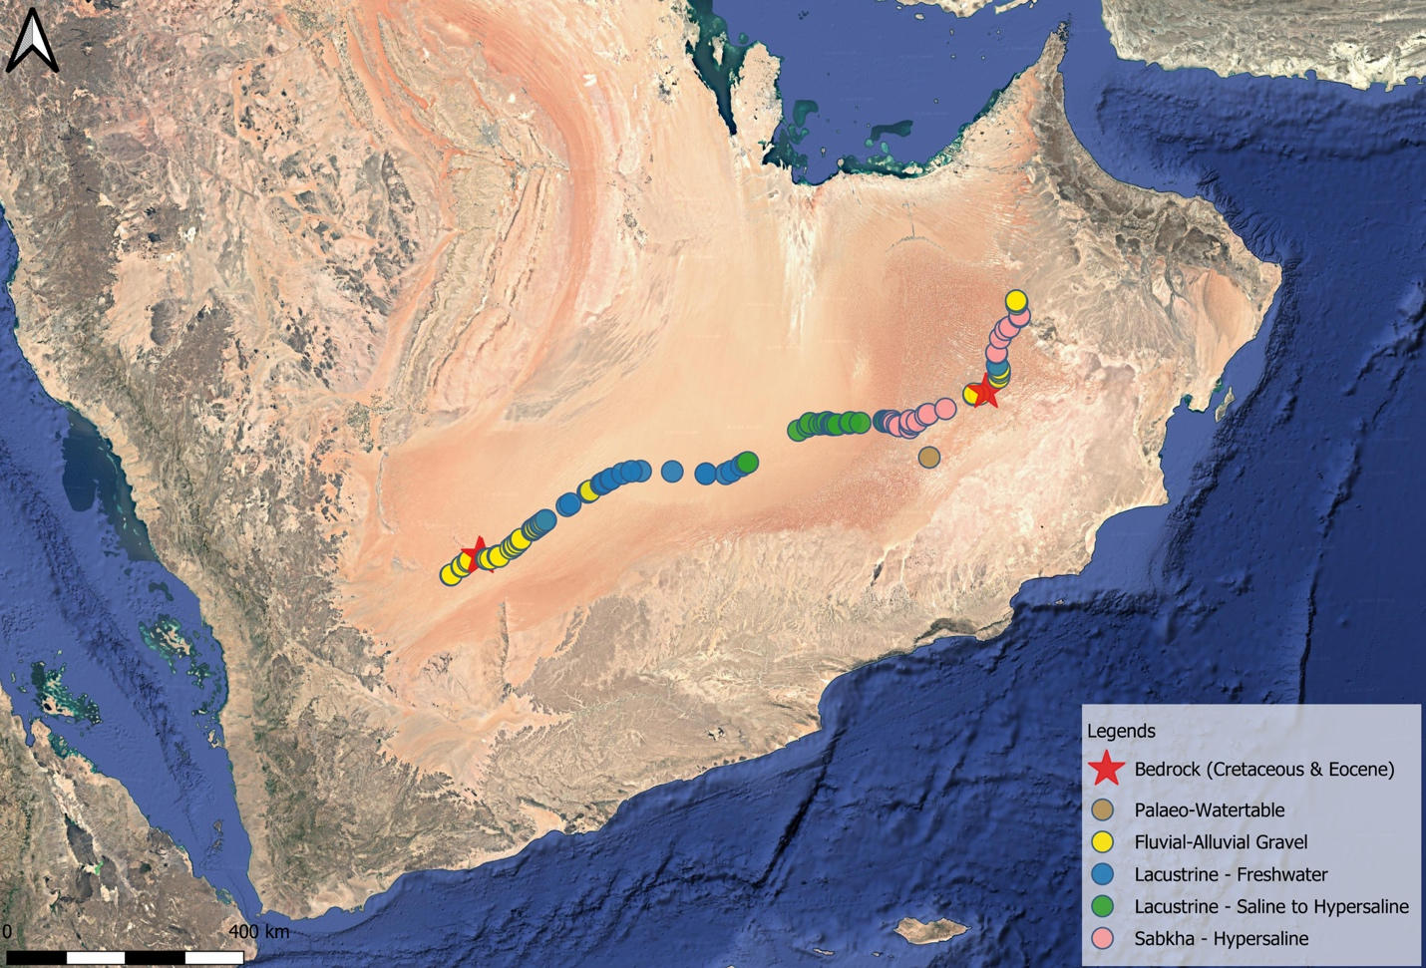
Fig. S1 | Quaternary facies distribution along the Rub’ al Khali crossing transect. Coloured symbols indicate dominant surface facies recorded at 126 localities: bedrock outcrops (Lower Cretaceous Wasia and Eocene Dammam formations; red stars), fluvial–alluvial gravel (yellow), freshwater lacustrine deposits (blue), exhumed palaeowatertable (brown), saline to hypersaline microbial build-ups (green), and sabkha evaporites (pink). The transect extends ~1,300 km from the Mundafan palaeolake basin (southwest) to the Hajar mountain piedmont (northeast). No knappable lithic raw material was recorded at any locality between the Wasia Formation outcrops (~46.8°E) and the Dammam Formation exposures (~54.7°E), an interval of ~800 km. Map produced in QGIS 3.28.

1.1 Western margin (Sites 1-9; ~46.3°-46.8°E)
The transect begins in the vicinity of the Mundafan palaeolake basin, where isolated outcrops of Jurassic Hanifa Formation are flanked by siliciclastic gravels of fluvial-alluvial origin. Surface lithologies at these localities are dominated by lag deposits overlying older fluvial units, consistent with the distal extent of Wadi ad Dawasir’s alluvial system^{51,52}. The westernmost palaeolake deposits (Sites 2, 5-7) are comprised of limestone and gypcrete in lacustrine freshwater settings, with Melanoides tuberculata and ostrich eggshell fragments recorded at several localities. Approximately 80 km northeast of Mundafan, Sites 8-9 expose outcrops of the Lower Cretaceous Wasia Formation (Fig. S2), yielding heavily weathered silicified sandstones, representing the only bedrock-derived lithic raw material encountered on the western half of the transect, though of limited knapping quality. East of these outcrops, Mesozoic formations dip beneath the Neogene-Quaternary basin fill and no further bedrock exposures were observed until the eastern margin of the desert.

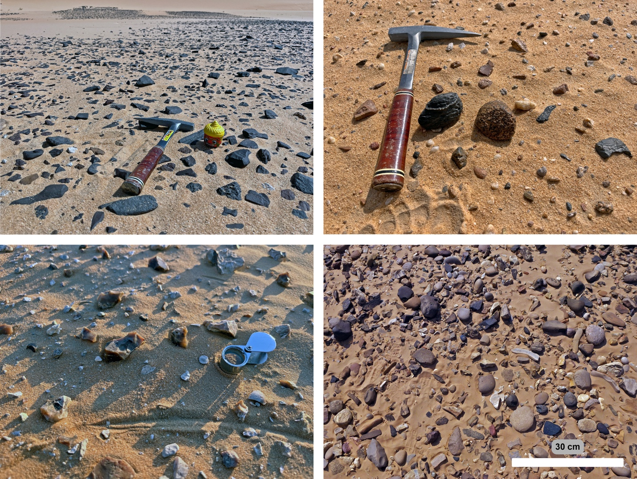
Fig. S2 | Lithic raw material occurrences along the Rub’ al Khali crossing transect | Top left: Heavily weathered silicified sandstone of the Lower Cretaceous Wasia Formation at the westernmost bedrock exposures (Sites 8-9, ~46.8°E), representing the only knappable bedrock encountered on the western half of the transect. Top right: Siliciclastic gravels with mixed lithologies at Site 34 (~48°E), characteristic of deflated fluvial-alluvial lag surfaces in the western-central interior; no clasts of knappable quality were observed. Bottom left: In situ chert nodules weathering out of Eocene Dammam Formation carbonates on the eastern margin (~54.9°E), the first bedrock-derived knappable lithology east of the Wasia outcrops and ~800 km from them. Bottom right: Rounded to sub-rounded chert clasts of the Miocene Dam Formation (Fars Group) dispersed across the Umm as Samim basin, reworked from Late Cretaceous obducted ophiolitic nappes. Hammer (33 cm) and hand lens (5 cm) for scale.

1.2 Western interior (Sites 10-47; ~47.0°-48.9°E)
East of the Wasia outcrops, the transect enters the dune-dominated interior. Interdunal exposures in this zone are characterised by two facies associations. The first comprises siliciclastic gravel lags and mixed gravel-dune surfaces, representing deflated remnants of older fluvial-alluvial deposits overlain by aeolian sands. The second, and volumetrically dominant, association consists of palaeolake deposits in two distinct facies: (1) freshwater limestone and gypcrete (n = 21), and (2) dolomitic and gypsiferous microbial build-ups (n = 27), characterised by polygonal laminated structures interbedded with gypsum crusts. The "limestone facies" described by Matter et al.¹⁶ consisting of beige micrites up to 270 cm thick with bioturbation and abundant M. tuberculata, corresponds to our freshwater limestone facies. The microbial build-up facies records a shallow, periodically desiccated lake environment in which microbial mats precipitated dolomitic carbonates, subsequently replaced or interbedded with gypsiferous evaporites during terminal drying phases. Both facies are exclusively associated with elevated groundwater levels and the formation of palaeolake deposits up to several metres thick. Unlike the Mundafan lake, which was fed primarily by wadi inflow into a regional depression^{8,11}, the western interior palaeolakes were groundwater-fed systems lacking fluvial connectivity. Neither facies contains lithologies suitable for stone tool manufacture.

1.3 Central interior and salt lake zone (Sites 48-90; ~49.0°-53.0°E)
The central portion of the transect traverses the lowest elevations of the basin, where active and palaeosabkha deposits become the dominant surface facies. Active salt lakes (n = 13) with halite crusts and brine pools occur in the ‘Uruq al-Mu’taridah depression, where the groundwater table lies within 1-2 m of the surface. These are flanked by extensive evaporitic sabkha flats (n = 20) characterised by gypcrete pavements, gypsum rosettes, and lenticular gypsum crystals—the characteristic “sabkha facies” of Matter et al.¹⁶. Exhumed palaeowater table surfaces (n = 3) are preserved as carbonate-encrusted former capillary fringes within palaeodune sands, recording the position of the water table during past humid intervals (Supplementary Information Section 2). The sedimentary lithologies throughout this zone are exclusively carbonatic and evaporitic. No siliceous bedrock, transported siliceous clasts, or chert-bearing formations were observed at any locality.

1.4 Eastern margin (Sites 91-125; ~53.0°-55.2°E)
The eastern margin of the transect encompasses the Umm as Samim, a large endorheic sabkha basin at the northeastern terminus of the Rub' al Khali that receives drainage from the Hajar mountain front. The transect exits the dune fields onto a Quaternary distal fan surface comprising siliciclastic gravels and consolidated aeolian sands (n = 6). East of the basin, alluvial gravels containing carbonatic clasts (n = 4) become progressively more common. Knappable raw material reappears at Site 107 (~54.7°E) in the form of fluvially transported chert gravels. Site 111 exposes in situ Eocene Dammam Formation carbonates containing chert nodules, which are the first bedrock-derived knappable lithology encountered since the Wasia Formation outcrops ~800 km to the west. From Site 107 eastward to the end of the transect at Site 125, eight of 19 localities yielded knappable raw material, all within Dam Formation-derived alluvial gravels or Dammam Formation exposures.
The chert gravels redistributed into the Umm as Samim basin are most plausibly sourced from the Miocene Dam Formation of the Fars Group. The Dam Formation contains chert clasts ultimately derived from the obducted ophiolitic nappes across northern Oman during the Late Cretaceous, subsequently uplifted and reworked during Late Cenozoic tectonic phases associated with the Oman Mountains and redistributed across interior basins including Umm as Samim. Because this chert has undergone multiple phases of transport, uplift, and redeposition, it occurs as rounded to sub-rounded clasts rather than fresh in situ nodules, and is of variable but generally knappable quality. This material is not transported southwest beyond Umm as Samim and therefore provides no source of knappable raw material for the central Rub' al Khali interior.

1.5 Summary
Of 126 documented localities, knappable lithic raw material was present at only 10 (8%), restricted entirely to the western and eastern margins of the transect: two Wasia Formation outcrops at ~46.7°-46.8°E and eight eastern margin localities at ~54.7°-55.2°E (one Dammam Formation bedrock exposure and seven alluvial gravels carrying reworked Dam Formation chert). Across the intervening ~800 km of the interior Rub’ al Khali basin, surface lithologies consist exclusively of carbonatic, evaporitic, and siliciclastic (quartz sand) facies, none of which possess the conchoidal fracture properties required for stone tool manufacture. This distribution is a direct consequence of the basin’s stratigraphy: the Palaeocene–Eocene chert-bearing formations (Umm Er Radhuma, Rus, and Dammam Formations) that crop out at the basin margins are progressively buried beneath Neogene–Quaternary basin fill toward the interior (Fig. 3b). Furthermore, the groundwater-fed character of interior palaeolakes (Supplementary Information Section 2) precluded fluvial transport of siliceous clasts from distant highland sources, ensuring that no secondary mechanism could introduce knappable material into the central basin.

- Palaeohydrology
Direct sedimentary evidence confirms that interior palaeolakes were groundwater-fed systems lacking fluvial connectivity. Along the entire 1,300 km transect, no fluvial sediment input into the palaeolake depressions was observed. Had fluvial environments existed contemporaneously in adjacent areas, their proximity to the topographically low palaeolake basins would have produced diagnostic sedimentary signatures such as coarse clastic input, gravel lenses, or current-generated structures, none of which were recorded at any locality. Fluvial and alluvial sediments were observed only at the western and eastern ends of the transect, in neither case in stratigraphic association with palaeolake deposits.
Exhumed palaeowater table surfaces provide positive evidence for groundwater discharge. All observed outcrops of palaeowater tables occur exclusively within the zone of dolomitic–gypsiferous microbial build-ups in the central portion of the transect (Fig. 2). These surfaces are preserved as carbonate-encrusted former capillary fringes within palaeodune sands (Fig. S3), recording the position of the water table during past humid intervals. The present-day water table is substantially lower: at the approximate location 19.108°N, 50.112°E (Umm al Melh, "mother of salt"), groundwater was reported at ~63 m depth in a freshwater well (S. al Melh, pers. comm., 23 November 2023), consistent with modern hydrogeological assessments showing deep water tables across the central Rub' al Khali interior^{53,54}.

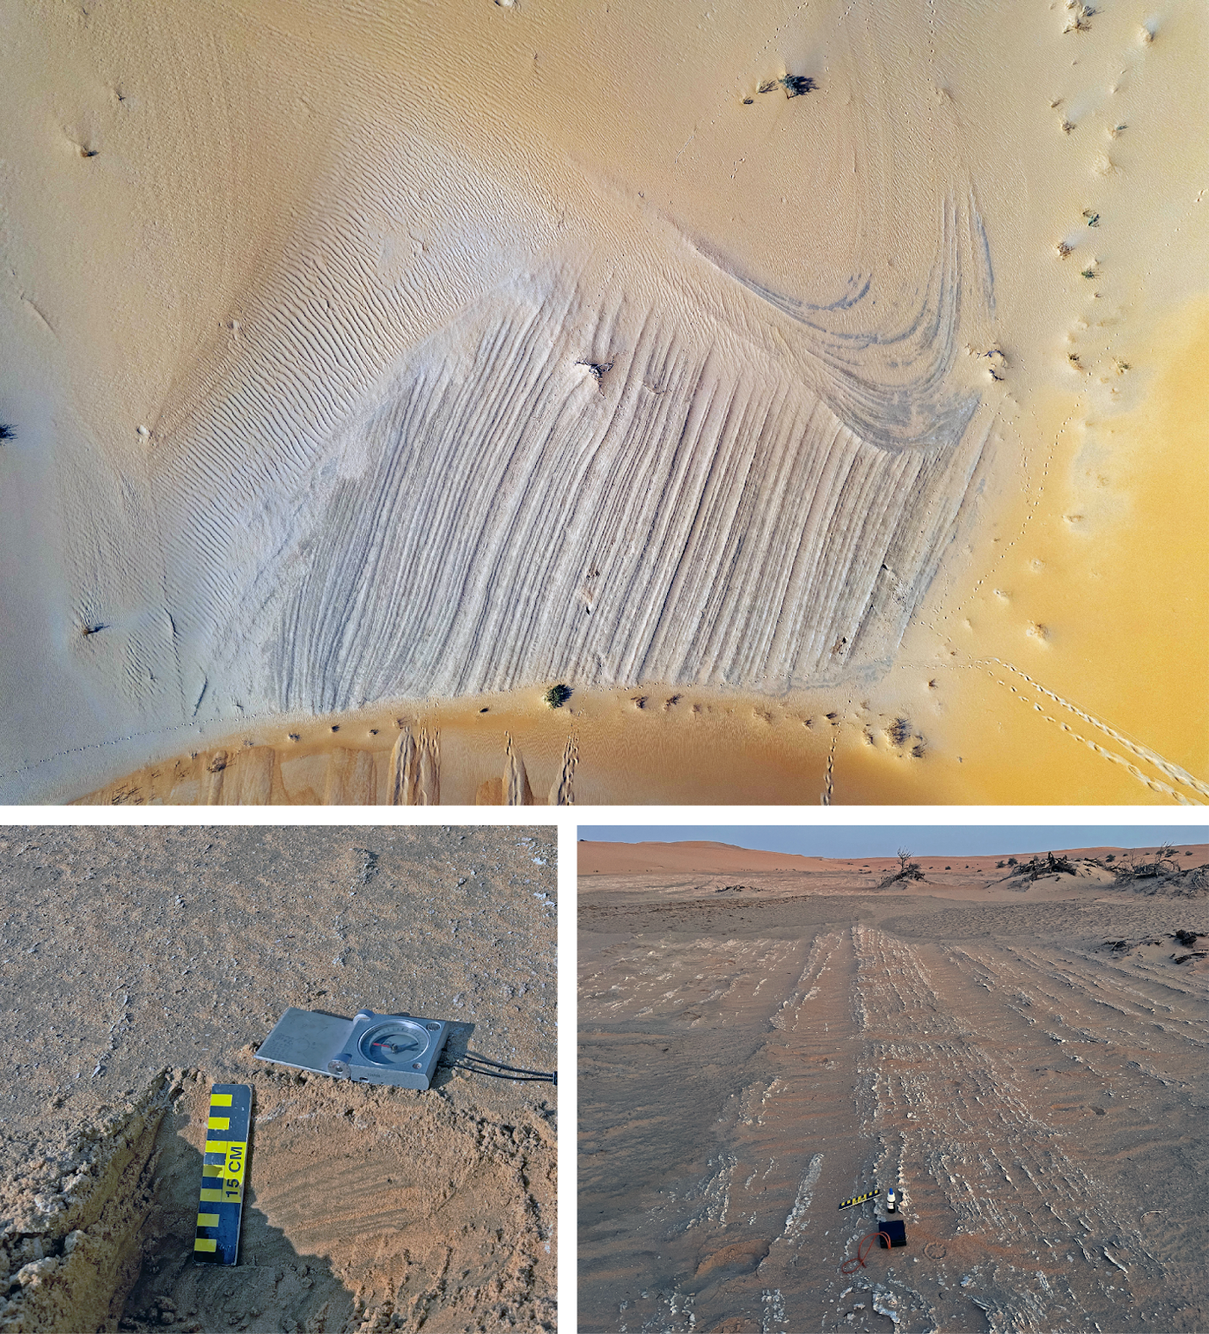
Fig. S3 | Exhumed palaeowater table at 20.315 N, 52.063 E. Top: Aerial view (fox tracks for approximate scale in lower right). The exposed surface marks the former capillary fringe within a palaeodune, preserved by carbonate encrustation at the air–water interface. E–W-trending linear features are south-dipping cross-strata (strike/dip: 170/32°); parabolic laminae dipping <5° SW indicate a prevailing northerly to northeasterly palaeowind direction. Overlying aeolian sands were removed by deflation, exposing this surface. Bottom left: Detail showing mm-scale stratification of palaeodune sands deposited prior to exhumation of palaeowater table; darker laminae are heavy-mineral-enriched bases of individual aeolian cycles (confirmed by magnetic test). Scale bar: 15 cm, compass is oriented North (right) - South (left). Bottom right: Ground-level view toward east showing the lateral extent of the exhumed surface. Several palaeolake deposits documented during the 2023 survey overlie comparable exhumed palaeowater table surfaces, consistent with observations at Mundafan⁸. Drone photography: T. Bresenhuber 2023.

- Correlation with published palaeolakes
This section documents the spatial and stratigraphic relationship between palaeolake localities surveyed during the Rub’ al Khali crossing expedition and the independently dated lake deposits published by Matter et al.¹⁶. The correlation establishes the chronological framework for our archaeological observations.

3.1 Topographic and hydrological context
The interior Rub' al Khali comprises a series of shallow, groundwater-fed lake basins arranged along regional drainage gradients that slope from the Arabian Shield toward the Sabkha Matti lowlands in the northeast. Palaeolake deposits in the surveyed transect occur at progressively lower elevations from west to east, reflecting this regional topographic structure. The relationship between longitude and elevation across all documented palaeolake localities is highly linear (R² = 0.913, p < .001), with elevation decreasing approximately 71 m per degree of longitude eastward. This consistent gradient indicates that the surveyed palaeolakes occupy positions within a coherent hydrological system rather than isolated, unrelated depressions.
Groundwater recharge during humid phases was derived from the Asir Mountains and Arabian Shield to the west, with flow directed through regional aquifer systems toward the interior basins^{54,55}. Hydrogeological studies document this east-directed subsurface flow pattern⁵⁶, which explains both the systematic elevation gradient and the groundwater-fed (phreatic) character of the lacustrine deposits, as evidenced by their distinctive carbonatic lithology, absence of fluvial and deltaic facies, and presence of freshwater mollusc assemblages.

3.2 Elevation-based stratigraphic correlation
Standard principles of palaeolake reconstruction hold that lake deposits at equivalent elevations within the same hydrological basin represent coeval lake stands. This approach provides the basis for correlating our survey localities to the previously dated sections, supported by different lines of evidence: (1) survey localities occur within 2-30 km of dated OSL sampling sites; (2) localities at equivalent distance along the regional gradient exhibit consistent elevation ranges (typically ±20 m, within the expected variance for coeval lake deposits subject to differential post-depositional deflation); and (3) sedimentary facies at survey localities are consistent with those described at dated sections, including bioturbated limestone layers, carbonate platforms with microbial build-ups, and freshwater mollusc assemblages dominated by Melanoides tuberculata.
Tables S1-S2 and Extended Data Fig. 1 present the spatial correlation between previously dated localities and survey sites documented during the Rub’ al Khali crossing expedition. For each dated palaeolake deposit, we list all survey localities within 30 km, their distances, and their elevations. Coordinates for dated sites extracted from publication figures¹⁶. Elevations derived from SRTM 30m DEM.

Table S1 | Summary of surveyed palaeolakes in the central Rub‘ al Khali interior corresponding to dated deposits. Localities correspond to palaeolake deposits dated by Matter et al.¹⁶. Survey duration (minutes), and recorded palaeoenvironmental and archaeological evidence are shown (M=molluscs, O=ostrich eggshell, A=artefacts, L=lithic raw material). All localities represent erosionally fragmented remnants of palaeolakes within 70 km of a dated deposit.

Site ID | Lat (°N) | Long (°E) | Elev (masl) | Matter et al. Palaeolake | OSL age (ka) | Duration (min) | Evidence
39 | 19.243 | 48.463 | 399 | 12.2 | 111 ± 9 | 60 | —
40 | 19.250 | 48.475 | 399 | 12.2 | 111 ± 9 | 60 | M, O
43 | 19.369 | 48.675 | 375 | 12.2 | 111 ± 9 | 60 | M
44 | 19.384 | 48.704 | 373 | 12.2 | 111 ± 9 | 60 | M
45 | 19.397 | 48.725 | 371 | 12.2 | 111 ± 9 | 300 | M, O
46 | 19.447 | 48.822 | 351 | 12.2 | 111 ± 9 | 60 | M
47 | 19.457 | 48.839 | 352 | 12.2 | 111 ± 9 | 15 | M, O
61 | 19.545 | 50.691 | 252 | 15.3 | 96 ± 6 | 10 | M
62 | 19.585 | 50.782 | 238 | 15.1 | 103 ± 13 | 120 | M
63 | 19.667 | 50.940 | 236 | 14.3 | 122 ± 6, 118 ± 10, 67 ± 9 | 120 | M
64 | 19.709 | 51.014 | 218 | 14.3 | 122 ± 6, 118 ± 10, 67 ± 9 | 120 | —
65 | 19.721 | 51.045 | 224 | 14.3 | 122 ± 6, 118 ± 10, 67 ± 9 | 30 | —

Table S2 | Spatial correlation of surveyed localities to dated palaeolake deposits. Distances calculated for each 2023 surveyed palaeolake to closest palaeolake reported by Matter et al.¹⁶
Site ID | Latitude | Longitude | Elevation | Nearest Matter et al. palaeolake | Distance | Palaeolake elevation | Elevation differential
33 | 18.7511 | 47.7194 | 511 | 11.2 | 23.2 | 526 | -15
34 | 18.7819 | 47.7605 | 505 | 11.2 | 23.7 | 526 | -21
35 | 18.8046 | 47.7913 | 492 | 11.2 | 24.8 | 526 | -34
36 | 18.9366 | 47.9802 | 486 | C-3 | 37.8 | 529 | -43
37 | 19.0317 | 48.13 | 451 | C-3 | 52.8 | 529 | -78
38 | 19.065 | 48.1833 | 443 | C-3 | 58.7 | 529 | -86
39 | 19.2428 | 48.4635 | 399 | 12.2 | 62.2 | 399 | 0
40 | 19.25 | 48.4753 | 399 | 12.2 | 61.9 | 399 | 0
43 | 19.3692 | 48.6755 | 375 | 12.2 | 61.6 | 399 | -24
44 | 19.3843 | 48.7039 | 373 | 12.2 | 62.1 | 399 | -26
45 | 19.3975 | 48.7247 | 371 | 12.2 | 62.9 | 399 | -28
46 | 19.4467 | 48.8217 | 351 | 12.2 | 66.3 | 399 | -48
47 | 19.457 | 48.8387 | 352 | 12.2 | 67.3 | 399 | -47
48 | 19.5372 | 49.0145 | 333 | I-3 | 68.7 | 316 | 17
51 | 19.5743 | 49.1606 | 340 | I-3 | 61.2 | 316 | 24
50 | 19.5795 | 49.3112 | 335 | I-3 | 60.8 | 316 | 19
52 | 19.5771 | 49.8232 | 285 | 12.1 | 38.1 | 283 | 2
59 | 19.5438 | 50.3671 | 252 | 12.1 | 26.7 | 283 | -31
58 | 19.5461 | 50.3681 | 269 | 12.1 | 26.9 | 283 | -14
61 | 19.5454 | 50.6905 | 252 | 15.3 | 7.8 | 254 | -2
62 | 19.5845 | 50.7819 | 238 | 15.1 | 1.8 | 241 | -3
63 | 19.6669 | 50.9399 | 236 | 14.3 | 13.8 | 226 | 10
64 | 19.7093 | 51.0136 | 218 | 14.3 | 16.3 | 226 | -8
65 | 19.7208 | 51.0445 | 224 | 14.3 | 17.9 | 226 | -2

3.3 Sedimentary facies correlation
The lacustrine deposits at survey localities exhibit the same diagnostic facies described by Matter et al.¹⁶ at their dated sections: grey to buff laminated marls deposited in shallow standing water; indurated carbonate platforms representing phreatic discharge zones; microbial build-ups (stromatolitic structures) indicating prolonged stable water levels; and freshwater mollusc assemblages dominated by Melanoides tuberculata and Corbicula fluminalis. The consistent facies architecture across all localities supports their interpretation as deposits of the same regional lake system active during MIS 5 humid intervals.

3.4 Uncertainty assessment
Several sources of uncertainty affect the correlation: (1) SRTM DEM vertical accuracy is ±5-10 m in flat terrain; (2) post-depositional deflation of exposed lacustrine surfaces may have lowered original shoreline elevations by 1-5 m; (3) lake levels oscillated within humid phases, producing lake deposits across elevation ranges of 10-20 m at any given time. The observed elevation ranges within each geographic cluster (typically 20-35 m) are consistent with these combined uncertainties and with expected shoreline variability during lake highstands. Four of the five OSL-dated Matter et al.¹⁶ localities (14.3, 14.7, 15.1, 15.3) have survey coverage within 30 km, with new palaeolake deposits documented near previously dated localities.
- Oman archaeological survey data

4.1 Overview of survey programme
The archaeological site database used in Extended Data Fig. 2 derives from 44 field expeditions conducted across Oman between 2002 and 2024 by J.I.R. (Table S3, Extended Data 2). These campaigns encompassed reconnaissance surveys, research-driven investigations and commercial environmental impact assessments (EIAs), collectively providing geographic coverage across seven governorates throughout the country: Dhofar, Dakhliyah, Wusta, Dhahirah, Rub’ al Khali, Sharqiyah, and Musandam. Research campaigns (n = 13) focused primarily on the Dhofar Nejd plateau and adjacent regions under permits issued by the Ministry of Heritage and Tourism, Sultanate of Oman (formerly Ministry of Heritage and Culture). EIA campaigns (n = 27) were contracted by development companies and conducted across diverse regions of the country, often in areas not targeted by research programmes. This combination of research and commercial survey provides broader geographic representation than either would alone and reduces sampling bias.
Table S3 | Archaeological survey campaigns in Oman, 2002–2024. Summary of 44 field campaigns contributing to the archaeological site database used in Extended Data Fig. 2. Unpublished reports are held by J.I.R. and available upon reasonable request.

Year | Month(s) | Region(s) | Area(s) | Type | Reference
2002 | July | Dhofar, Dakhliyah | Dhofar mountains / eastern Nejd plateau / northern Wahiba desert / Hajar mountain piedmont | Reconnaissance | 72
2003 | December | Dhofar, Dakhliyah | northern Huqf depression / Hajar mountain piedmont / eastern Nejd plateau | Research | 73,74
2004 | January - March | Dhofar, Wusta, Dakhliyah | eastern Nejd plateau / Duqm escarpment / northern Huqf depression / Qarat al Kibrit salt dome | Research | 73,74,75
2006 | May | Dhofar | Hajar mountain piedmont | Reconnaissance | —
2007 | April | Dhofar, Dakhliyah | Wadi Tanuf / Al Hatab rockshelter / Ras Ain Noor | Research | 75,76
2007 | September | Dhofar | Al Hatab rockshelter | Research | 75,76
2007 | September | Dhahirah | Hamra ad Duru foothills | EIA | Unpublished report
2007 | December | Musandam | Ras al Jebel mountains | Research | Unpublished report
2008 | January | Dhofar | Al Hatab rockshelter | Research | 75,76
2009 | October | Dhofar | Salalah plain / Nejd plateau | Reconnaissance | —
2010 | January - March | Dhofar | Salalah plain / Dhofar mountains / Nejd plateau / Aybut Auwal | Research | 18,58,76,77
2010 | April | Dakhliyah | northern Huqf depression | EIA | Unpublished report
2011 | January - March | Dhofar | Salalah plain / Dhofar mountains / Nejd plateau | Research | 18,41,58,78,79
2012 | January - March | Dhofar | Salalah plain / Dhofar mountains / Nejd plateau / southern Rub’ al Khali desert | Research | 14, 56, 77, 78
2012 | July | Dakhliyah | northern Huqf depression | EIA | Unpublished report
2012 | October | Dakhliyah | northern Huqf depression | EIA | Unpublished report
2012 | September | Dhahirah | Umm as Samim sabkha | EIA | Unpublished report
2013 | January - March | Dhofar | western Nejd plateau / southern Rub’ al Khali desert / Matafah | Research | 41, 58, 79, 80, 81
2014 | October | Dakhliyah | northern Huqf depression | EIA | Unpublished report
2014 | November | Dakhliyah, Sharqiyah | northern Huqf depression / Bar al Hikman lagoon | EIA | Unpublished report
2014 | April | Dakhliyah, Wusta | Huqf depression / Jiddat al Harassis plain | EIA | Unpublished report
2014 | September | Dhofar | southern Rub’ al Khali desert | EIA | Unpublished report
2014 | April | Dhofar | eastern Nejd plateau | EIA | Unpublished report
2015 | February | Dakhliyah | central Huqf depression | EIA | Unpublished report
2015 | October | Dhofar | western Nejd plateau | EIA | Unpublished report
2015 | July | Dhofar, Wusta | southeastern Nejd plateau / Jazer plain | EIA | Unpublished report
2016 | June | Dakhliyah | northern Huqf depression | EIA | Unpublished report
2016 | October | Dakhliyah, Dhahirah | northern Huqf depression / western Hajar mountain piedmont | EIA | Unpublished report
2016 | November | Dakhliyah | central Huqf depression | EIA | Unpublished report
2017 | May | Wusta | southern Huqf depression | EIA | Unpublished report
2019 | October | Sharqiyah | southern Ja’alan coast | EIA | Unpublished report
2019 | January | Sharqiyah | southern Ja’alan coast, Wahiba desert | EIA | Unpublished report
2019 | January | Dhofar | southern Rub’ al Khali desert | EIA | Unpublished report
2020 | April | Dhofar | southern Nejd plateau | Reconnaissance | Unpublished report
2021 | February | Dhofar | southern Rub’ al Khali desert | EIA | Unpublished report
2021 | June | Dhofar | southern Rub’ al Khali desert | Research | In prep
2021 | March | Dhahirah | western Hajar mountain piedmont | EIA | Unpublished report
2021 | April | Wusta | southern Huqf depression / Jazer plain / Jiddat al Harassis plain | EIA | Unpublished report
2021 | June | Dhofar | eastern Nejd plateau | EIA | Unpublished report
2022 | January - February | Dhofar | southern Rub’ al Khali desert / western Nejd plateau | Research | 5
2022 | October | Dhahirah | western Hajar mountain piedmont | EIA | Unpublished report
2022 | April | Wusta | southern Huqf depression / Jazer plain / Jiddat al Harassis plain | EIA | Unpublished report
2023 | January - February | Dhofar | southern Rub’ al Khali desert / western Nejd plateau | Research | 5
2024 | January | Dhahirah | western Hajar mountain piedmont | EIA | Unpublished report

The cumulative dataset comprises >1,200 lithic findspots spanning the Lower Palaeolithic through Neolithic, of which the MP component used in Extended Data Fig. 2 is drawn. Coordinates for all findspots were recorded using handheld GPS (typical accuracy ±5 m). The dataset has been compiled in GIS software and georeferenced against 1:250,000 geological mapping⁵⁷. A published subset of the survey data appears in Rose et al.⁵⁸.

4.2 Survey methodology
Survey methods varied across campaigns in response to research objectives, landscape conditions, and logistical constraints. Three primary approaches were employed:
Systematic pedestrian survey. During dedicated research campaigns, transects were walked by surveyors spaced approximately 10 m apart, typically oriented perpendicular to wadi channels to sample site distributions relative to drainage systems. Transects ranged from 1 to 5 km in length and were positioned to sample the full range of geomorphic and ecological zones within the survey region.
Driving reconnaissance. Extensive areas were surveyed by vehicle along wadi systems, gravel plains, and desert tracks, with stops for pedestrian inspection at exposures of geological or archaeological interest. This approach maximised geographic coverage across the expansive Omani landscape and was particularly effective for identifying raw material outcrops and documenting the presence or absence of lithic material in relation to surface geology.
Environmental impact assessment. EIA surveys were conducted within defined concession areas to professional standards as required by the contracting authority, with survey intensity calibrated to available time and concession size. All EIA fieldwork was conducted by J.I.R. and adhered to International Finance Corporation (IFC) Performance Standard 8, ensuring consistent identification criteria and recording systems across the combined dataset.
The deflationary landscapes that characterise much of the Omani interior provide exceptional archaeological visibility. Across the Nejd plateau, the Jiddat al Harasis, and deflated interdunal surfaces, ground visibility typically exceeds 95%, ensuring that the absence of lithic material from surveyed localities reflects genuine absence rather than preservation or visibility bias.

4.3 Survey coverage and potential bias
The dataset's heterogeneous origins, having been accumulated over two decades through campaigns with varying objectives, durations, and intensities, provide broader geographic and geological coverage than any single research programme could achieve. EIA campaigns were frequently situated on geological formations lacking knappable raw materials (Quaternary alluvium in Dakhliyah, gravel plains on the Jiddat al Harassis, sabkhah deposits in Umm as Samim, aeolian sands in the Rub' al Khali), providing independent confirmation of archaeological absence in these contexts. Research campaigns contributed high-intensity coverage of the Dhofar Nejd plateau and adjacent regions, where the relationship between site density and raw material proximity is most clearly expressed⁵⁸. The combination ensures that both presence and absence of Palaeolithic occupation are documented across diverse surface geologies.
- Spatial modelling of human occupation potential

5.1 Water source reconstruction
The drainage network was obtained from the HydroRIVERS dataset of the HydroSHEDS database⁴⁷, cropped to the boundaries of Oman and filtered to include only rivers with a total upstream area of at least 1,000 km², following the conservative threshold adopted by Breeze et al.⁶ for identifying major drainage systems. Rivers were buffered based on their Strahler stream order to estimate channel width, using an exponential function derived from global river width observations⁴⁸.

5.2 Distance-to-water analysis
The spatial relationship between archaeological sites and modelled water features was quantified by calculating the Euclidean distance from each site to the nearest water feature (buffered rivers). A kernel density estimate of observed distances was computed to characterise the empirical distance-decay pattern.
To assess whether the observed distance distribution differed from random expectation, a Monte Carlo simulation was performed. For each of 999 iterations, a set of random points equal in number to the observed sites was generated within the Oman study area. Distances to the nearest water feature were calculated for each simulated point set and converted to kernel density estimates. Density values from all iterations were interpolated onto a shared distance axis, producing an ensemble of simulated distance-decay curves. At each distance increment, a 95% confidence envelope was calculated from the ensemble and compared to the observed curve. This approach provides a non-parametric assessment of site–water relationships while accounting for the geometry of the study area and the spatial distribution of water resources (Fig. S4).
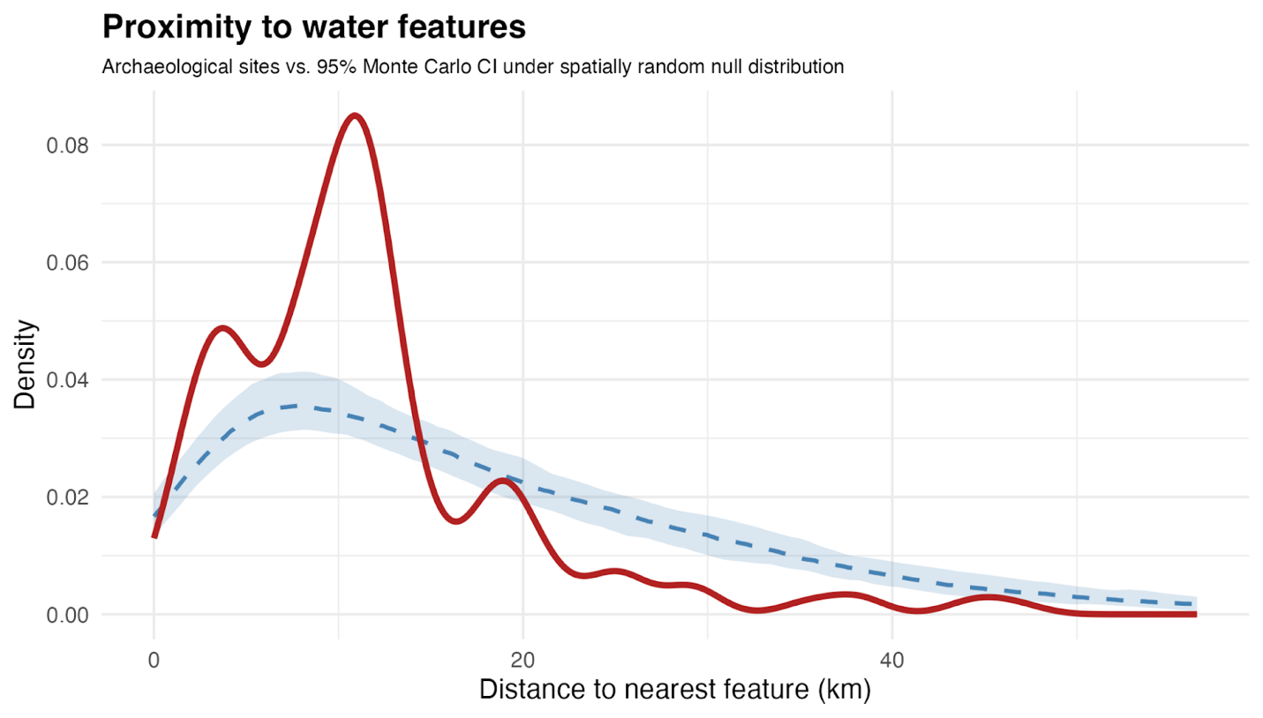
Fig. S4 | Density distribution of distance to water from known MSA sites in Oman (n = 278; solid red line) compared with 95% Monte Carlo confidence interval (blue dashed line and shading) expected under a spatially random null distribution. Sites are significantly closer to water features than would be expected for the null model.

5.3 Raw material probability modelling
The spatial probability of knappable raw material occurrence was modelled as a function of geological context using a Weights-of-Evidence (WoE) approach⁵⁹. Raw material occurrences were compiled from a dataset of surveyed localities with noted raw material presence (see above). Site locations were rasterised onto a common analysis grid, producing a binary event raster (presence/absence of raw material occurrence).
Geological polygon data (1:250,000 mapping)⁵⁷ were converted to the common raster grid and classified by stratigraphic subseries (or series/system where subseries data were unavailable). Each geological unit was transformed into a binary evidence raster. Positive and negative weights were calculated following standard WoE formulations: positive weights quantify the strength of spatial association between raw material occurrences and the presence of a given geological unit; negative weights quantify the association with its absence. Weights were computed as the natural logarithm of the ratio between conditional probabilities, with small constants included to prevent undefined values in cases of zero counts.
Binary geological evidence rasters were multiplied by their corresponding positive weights and summed across all units to produce a continuous predictive score surface representing combined geological favourability for raw material occurrence. The summed log-odds surface was transformed using a logistic function to create a continuous probability surface bounded between 0 and 1.
The association between Middle Stone Age (MSA) sites and predicted raw material probability was assessed using the same Monte Carlo framework described above. Predicted probabilities were sampled at known site locations and compared against an ensemble of 999 random point sets. A 95% confidence envelope was calculated at each probability increment to test whether sites occur in areas of higher modelled raw material probability than expected by chance (Fig. S5).

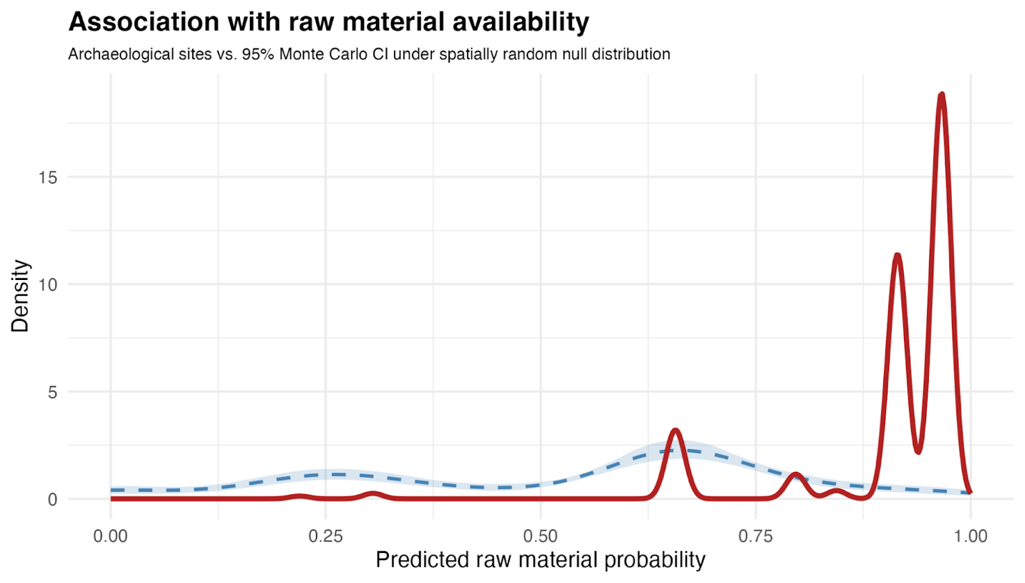
Fig. S5 | Density distribution of raw material probabilities at known MSA sites in Oman (n = 278; solid red line) compared with 95% Monte Carlo confidence interval (blue dashed line and shading) expected under a spatially random null distribution. Sites are significantly over-represented in geological areas with highest raw material probabilities.

5.4 Combined human occupation potential model
Human occupation potential was classified independently for each resource layer before combination. Water-based potential was defined using empirically derived distance thresholds corresponding to the 50th, 75th, and 95th percentiles of observed site-to-water distances, producing three classification bands (high, medium, and low potential). All modelled water features were reprojected into UTM Zone 40N for accurate distance buffering. Raw material potential was classified as high where predicted WoE probability exceeded 0.85, as medium with predicted probabilities greater than 0.75 and as low with probabilities greater than 0.60; these thresholds were derived from the observed distribution of modelled probabilities at known MSA site locations.
The two layers were combined into a single human occupation potential surface by multiplying together the water-based potential and raw material availability-based potential. Both scales for human occupation potential range from 1 (low potential) to 3 (high potential), so the combined human occupation potential ranges from 1 to 9. Unlike additive methods, this approach ensures that a high value in one parameter cannot fully compensate for a deficiency in the other, thereby prioritising locations where both resources are simultaneously accessible. The combined surface was subsequently reclassified as follows: low potential (1-3) represents areas where at least one resource is at its minimum, or both are low; medium potential (4-6) represents locations where both resources are mid-range or one resource is high but the other remains low; and high potential (7-9) where both parameters are high, or one is high and the other is at least moderate.
Validation of the combined model followed the Monte Carlo approach described above. For each of 999 iterations, modelled human occupation potential values were extracted at random point locations and converted to kernel density estimates. The 95% confidence envelope from the ensemble of simulated distributions was compared to the observed distribution of potential values at known MSA sites in Oman (Extended Data Fig. 2d).

5.5 Human occupation potential for the Arabian Peninsula
Human occupation potential for the entire Arabian Peninsula was classified following a similar approach as described for Oman.
Water availability potential was defined using empirically derived distance thresholds corresponding to the 50th, 75th, and 95th percentiles of observed site-to-water distances, producing three classification bands (high, medium, and low potential). Due to the current lack of data on estimated extents for palaeolakes, water sources were limited to the HydroRIVERS drainage network, filtered to include only rivers with a total upstream area of at least 1,000 km² and to exclude modelled rivers in places with dunes (Quaternary aeolian geology), following methods outlined by Breeze et al.⁶.
Raw material availability was classified by the presence or absence of raw material resources in particular geological contexts. Surface geology was derived from the USGS digital geological map of Arabia, which was digitised from the 1:2,000,000-scale USGS–Arabian American Oil Company Geologic Map of the Arabian Peninsula⁴⁹. The original paper maps were traced onto mylar, scanned at 300 dpi, vectorised through ARC/INFO, and projected in Lambert Conformal Conic with an RMS error not exceeding 0.5 mm at source scale, equivalent to ~1 km on the ground. Polygons in the digital dataset are attributed only by generalised geological age (e.g. Tertiary, Cretaceous, Quaternary) without subdivision into formations or members. To enable raw material classification at the formation level, we returned to the original 1:2,000,000 source map⁵⁰ and reclassified each generalised age polygon by its constituent lithostratigraphic units, using the formation descriptions and map legends of the original source sheets, supplemented by published stratigraphic summaries^{23,24,60}.
Each classified formation was then assessed for the presence or absence of knappable raw materials based on published lithological descriptions and, where available, field verification from the Rub’ al Khali crossing expedition and 44 Oman survey campaigns (Supplementary Information Section 4). Formations were classified as containing workable raw material if published accounts document the occurrence of any of the following cryptocrystalline or fine-grained lithologies exhibiting conchoidal fracture: chert, chalcedony, quartzite, vein quartz, rhyolite, or silicified limestone/sandstone. Formations described as comprising exclusively carbonates, evaporites, marls, loose siliciclastic sediments, or coarse-grained crystalline rocks without reported siliceous components were classified as lacking knappable material. This classification is necessarily conservative at the peninsula scale, as some formations that are mapped as lacking raw material at 1:2,000,000 resolution may contain localised siliceous occurrences not captured at that scale; conversely, the presence of a formation containing chert does not guarantee surface accessibility in all mapped areas. Bedrock geology and drainage layers were combined (Fig. 4a) using the same multiplicative approach as in the Oman dual-resource model (Extended Data Fig. 2c). However, because raw material availability is coded as presence/absence, the final model of human occupation potential is effectively limited to where raw materials are present and scaled by proximity to water resources.
Validation of the combined model followed the Monte Carlo approach described above. For each of 999 iterations, modelled human occupation potential values were extracted at random point locations and converted to kernel density estimates. The 95% confidence envelope from the ensemble of simulated distributions was compared to the observed distribution of potential values at known MSA sites (Fig. 4b).

5.6 Software and data availability
All spatial analyses were conducted in R (version 4.5.2) using the terra, sf, and whitebox packages⁶¹⁻⁶³. Drainage data were obtained from HydroSHEDS (https://www.hydrosheds.org)⁴⁷. Geological mapping for Oman follows Béchennec et al.⁵⁷; Peninsula-scale geology follows Bramkamp et al.⁵⁰ via the USGS digital compilation⁴⁹. The archaeological site database, geological raw material classifications, modelled probability surfaces, and the complete R analytical notebook are archived at https://osf.io/4mw23/ under a CC-BY 4.0 licence. The modular structure of the workflow (geological classification of raw material potential, independent water proximity modelling, multiplicative combination, and Monte Carlo validation) is directly transferable with published geological maps and reconstructed drainage networks, enabling assessment of Palaeolithic human occupation potential worldwide.
- Chronology of palaeolakes and archaeological sites
Fig. 1b displays OSL ages from lacustrine deposits in the central Rub' al Khali, derived from Matter et al.¹⁶, as well as from documented Middle Palaeolithic (MP) and Middle Stone Age (MSA) sites surrounding the Rub’ al Khali. Throughout the manuscript, we use the term MSA to designate assemblages of African affinity and MP for those of western Asian affinity; MP/MSA denotes Peninsula-wide scope.
Locations of geological investigation during the survey correspond to palaeolake sites 14.3, 14.7, 15.1, and 15.3 from the Saudi Arabian portion of the Rub' al Khali. The dated sites span three distinct humid phases: Site 14.3 (three samples: 122 ± 6 ka, 118 ± 10 ka, 111 ± 9 ka) corresponds to MIS 5e–5d; Sites 15.1 and 15.3 (107 ± 13 ka, 96 ± 6 ka) correspond to MIS 5c; and Site 14.7 (67 ± 9 ka) corresponds to MIS 5a-MIS 4. Error bars represent 1σ uncertainties. Points are plotted at mean ages with horizontal error bars extending to ±1σ. Site labels (14.3, 14.7, 15.1, 15.3) correspond to original designations in Matter et al.¹⁶.
Published chronometric ages from MP/MSA archaeological sites in the Arabian Peninsula represent early human habitation at the margins of the desert: Jebel Faya (UAE), Al Kharj (central Saudi Arabia), Mundafan (western Rub' al Khali margin), and Dhofar Nejd (southern Rub’ al Khali margin). These represent potential source populations for interior settlement.

Jebel Faya (United Arab Emirates)
Site FAY-NE1 at Jebel Faya (25.12°N, 55.85°E) is a rock shelter containing a stratified Palaeolithic sequence extending back to ~210 ka²². Older MP horizons (Assemblages D/VII and E/VIII) document occupation during MIS 7 and MIS 6 but are omitted from Fig. 1b, which plots only the MIS 5 interval relevant to the interior palaeolake chronology. Four MSA horizons from this interval are plotted: Assemblage C (125 ± 10 ka), Archaeological Horizon (AH) VI (134 ± 7 ka), AH V (123 ± 10 ka), and AH II (80 ± 5 ka). Ages are based on single-grain OSL dating of quartz from sandy sediments directly associated with lithic assemblages^{17,21,22}.

Al Kharj / Umm al-Sha'al (Central Saudi Arabia)
Site AK-31 at Umm al-Sha'al in the Al Kharj region (24.08°N, 47.29°E) preserves stratified MSA deposits associated with palaeolake sediments²⁰. Three OSL ages from the excavated sequence are included: 87 ± 10 ka, 81 ± 9 ka, and 71 ± 6 ka, spanning MIS 5b-a.

Mundafan (Western Rub' al Khali Margin)
The Mundafan palaeolake basin (18.52°N, 45.35°E) preserves MP surface scatters associated with lacustrine shoreline deposits^{11,12}. Although most lithic material occurs as surface scatters, site MDF-61 yielded stratified deposits dated by OSL. Four ages are plotted from the excavated sequence: 95.6 ± 5.9 ka, 89.7 ± 8.0 ka, 84.7 ± 8.9 ka, and 77.1 ± 8.0 ka (OSL samples 19, 14, 10, and 8 respectively).

Dhofar Nejd (Southern Oman)
The Nejd plateau of Dhofar, southern Oman (~17-18°N, 53-54°E), preserves an extensive distribution of MSA sites⁵⁸. Ten OSL ages from three stratified sites are included: Aybut Auwal (TH59: two ages, 106 ± 9 ka and 107 ± 9 ka), Aybut Hills 5 (TH505: two ages, 106.2 ± 6.3 ka and 106.5 ± 6.4 ka), Aybut Hills 6 (TH584: five ages ranging from 95.3 ± 5.7 ka to 101.3 ± 6.0 ka), and Upper Amut 1 (TH571: one age, 104.5 ± 7.1 ka). Bayesian phase modelling of all ages yields a combined estimate of 109-95 ka (95% CI; mean 102 ± 3 ka), constraining the Dhofar Nubian industry to MIS 5c^{5,18}.

Table S4. Chronometric ages for MP/MSA archaeological sites in Arabia plotted in Fig. 1b.
Site | Sample/Layer | Age (ka) | ±1σ (ka) | Method | Region | Reference
Aybut Auwal | TH59-1 | 106 | 9 | OSL | Dhofar Nejd | 18
Aybut Auwal | TH59-2 | 107 | 9 | OSL | Dhofar Nejd | 18
Aybut Hills 5 | TH505-1 | 106.2 | 6.3 | OSL | Dhofar Nejd | 5
Aybut Hills 5 | TH505-2 | 106.5 | 6.4 | OSL | Dhofar Nejd | 5
Aybut Hills 6 | TH584-1 | 95.3 | 5.7 | OSL | Dhofar Nejd | 5
Aybut Hills 6 | TH584-2 | 100.8 | 6.4 | OSL | Dhofar Nejd | 5
Aybut Hills 6 | TH584-3 | 99.9 | 5.5 | OSL | Dhofar Nejd | 5
Aybut Hills 6 | TH584-4 | 101.3 | 6 | OSL | Dhofar Nejd | 5
Aybut Hills 6 | TH584-5 | 100.6 | 5.7 | OSL | Dhofar Nejd | 5
Upper Amut 1 | TH571 | 104.5 | 7.1 | OSL | Dhofar Nejd | 5
Mundafan Al-Buhayrah | MDF-61 OSL19 | 95.6 | 5.9 | OSL | Mundafan | 12
Mundafan Al-Buhayrah | MDF-61 OSL14 | 89.7 | 8 | OSL | Mundafan | 12
Mundafan Al-Buhayrah | MDF-61 OSL10 | 84.7 | 8.9 | OSL | Mundafan | 12
Mundafan Al-Buhayrah | MDF-61 OSL8 | 77.1 | 8 | OSL | Mundafan | 12
Umm al-Sha'al | AK-31-3 | 87 | 10 | OSL | Al Kharj | 22
Umm al-Sha'al | AK-31-4 | 71 | 6 | OSL | Al Kharj | 22
Umm al-Sha'al | AK-31-5 | 81 | 9 | OSL | Al Kharj | 22
Jebel Faya | Assemblage C | 125 | 10 | OSL | Jebel Faya | 17
Jebel Faya | AH VI | 134 | 7 | OSL | Jebel Faya | 22
Jebel Faya | AH V | 123 | 10 | OSL | Jebel Faya | 22
Jebel Faya | AH II | 80 | 5 | OSL | Jebel Faya | 21
All ages are reported as thousands of years before present (ka).
OSL = Optically Stimulated Luminescence

- Colonisation dynamics in dual-resource landscapes
The systematic absence of MP/MSA occupation from the Rub' al Khali interior, despite abundant freshwater evidence and contemporary human presence at the desert margins, invites consideration of complementary explanations beyond the dual-resource pattern documented in the main text.
Demographic factors. Human dispersal across the Arabian Peninsula was, like other Pleistocene dispersals, likely a complex, historically contingent process influenced by multiple factors^{64,65}. If MP/MSA populations dispersing into Arabia were small, as might be expected for colonising human foragers entering unfamiliar territory^{66,67}, then settlement in a favourable region with sufficient resources, such as the dual-resource zones of Dhofar or the western Rub' al Khali margin, may not have generated sufficient demographic pressure to push groups into neighbouring regions lacking essential resources. In this scenario, foragers were 'pulled' into attractive dual-resource zones rather than 'pushed' into the interior⁶⁴.
Landscape knowledge. We consider it unlikely that MP/MSA populations were simply unaware of the Rub' al Khali interior over the ~50-thousand-year span of documented margin occupation. Foragers actively accumulate and transmit landscape knowledge^{68,69}, and such knowledge would have been especially important for reducing risk and uncertainty among human groups colonising the Arabian Peninsula^{70,71}. Knowledge of the interior's lack of knappable raw material may itself have functioned as a deterrent, reinforcing the pull of dual-resource zones at the margins.
Potential for future discoveries. It remains possible that future fieldwork may document small logistical, exploratory, or resource procurement sites in the Rub' al Khali interior. However, the systematic pattern of absence documented across 55 palaeolake localities spanning the full extent of the ~1,300 km transect, combined with >95% ground visibility and the confirmed absence of knappable raw materials throughout the interior basin, indicates that any such discoveries would represent exceptional events against a background of genuine non-occupation rather than evidence for sustained settlement.
These alternative explanations are not mutually exclusive with the dual-resource pattern. Rather, they suggest that the lithic archipelago structure of the Arabian Peninsula operated in concert with demographic dynamics and landscape learning to draw MP/MSA populations into favourable zones and away from the resource-poor interior.

- References

- Timmermann, A., & Friedrich, T. Late Pleistocene climate drivers of early human migration. Nature 538, 92–95 (2016).
- Beyer, R. M., Krapp, M., Eriksson, A. & Manica, A. Climatic windows for human migration out of Africa in the past 300,000 years. Nat. Commun. 12, 4889 (2021).
- Breeze, P. S. et al. Palaeohydrological corridors for hominin dispersals in the Middle East ~250–70 ka. Quat. Sci. Rev. 144, 155–185 (2016).
- Groucutt, H. S. et al. Multiple hominin dispersals into Southwest Asia over the past 400,000 years. Nature 597, 376–380 (2021).
- Rose, J. I. et al. A failed human expansion out of Africa 100,000 years ago. Preprint at https://doi.org/10.21203/rs.3.rs-8751643/v1 (2026).
- Breeze, P. S. et al. Remote sensing and GIS techniques for reconstructing Arabian palaeohydrology and identifying archaeological sites. Quat. Int. 382, 98–119 (2015).
- McClure, H. A. Radiocarbon chronology of late Quaternary lakes in the Arabian desert. Nature 263, 755–756 (1976).
- Rosenberg, T. M. et al. Humid periods in southern Arabia: windows of opportunity for modern human dispersal. Geology 39, 1115–1118 (2011).
- Rosenberg, T. M. et al. Middle and Late Pleistocene humid periods recorded in palaeolake deposits of the Nafud desert, Saudi Arabia. Quat. Sci. Rev. 70, 109–123 (2013).
- Nicholson, S. L. et al. Pluvial periods in southern Arabia over the last 1.1 million years. Quat. Sci. Rev. 229, 106112 (2020).
- Crassard, R. et al. Middle Palaeolithic and Neolithic occupations around Mundafan palaeolake, Saudi Arabia: Implications for climate change and human dispersals. PLoS ONE 8, e69665 (2013).
- Groucutt, H. S. et al. Human occupation of the Arabian Empty Quarter during MIS 5: evidence from Mundafan Al-Buhayrah, Saudi Arabia. Quat. Sci. Rev. 119, 116–135 (2015).
- Kuhn, S. L. The Evolution of Paleolithic Technologies. (Routledge, 2020).
- Kuhn, S. L. Neanderthal technoeconomics: an assessment and suggestions for future developments. In Neanderthal Lifeways, Subsistence and Technology: One Hundred Fifty Years of Neanderthal Study, 99–110 (Springer, 2011).
- Muller, A. & Clarkson, C. Identifying major transitions in the evolution of lithic cutting edge production rates. PLoS ONE 11, e0167244 (2016).
- Matter, A., Neubert, E., Preusser, F., Rosenberg, T. & Al-Wagdani, K. Palaeo-environmental implications derived from lake and sabkha deposits of the southern Rub' al-Khali, Saudi Arabia and Oman. Quat. Int. 382, 120–131 (2015).
- Armitage, S. J. et al. The southern route 'out of Africa': evidence for an early expansion of modern humans into Arabia. Science 331, 453–456 (2011).
- Rose, J. I. et al. The Nubian Complex of Dhofar, Oman: An African Middle Stone Age industry in southern Arabia. PLoS ONE 6, e28239 (2011).
- Groucutt, H. S. et al. Homo sapiens in Arabia by 85,000 years ago. Nat. Ecol. Evol. 2, 800–809 (2018).
- Crassard, R. et al. Middle Palaeolithic occupations in central Saudi Arabia during MIS 5 and MIS 7: new insights on the origins of the peopling of Arabia. Archaeol. Anthropol. Sci. 11, 3101–3120 (2019).
- Bretzke, K. et al. Archaeology, chronology, and sedimentological context of the youngest Middle Palaeolithic assemblage from Jebel Faya, United Arab Emirates. Archaeol. Anthropol. Sci. 17, 60 (2025).
- Bretzke, K. et al. Multiple phases of human dispersal into Arabia between 210,000 and 120,000 years ago. Sci. Rep. 12, 1600 (2022).
- Stewart, S. A. Structural geology of the Rub' Al-Khali Basin, Saudi Arabia. Tectonics 35, 2417–2438 (2016).
- Edgell, H. S. Arabian Deserts: Nature, Origin and Evolution. (Springer, 2006).
- Kazak, E. S. et al. Origin of Umm Al Heesh lake in the Rub' Al Khali desert, Saudi Arabia. Sci. Rep. 15, 34850 (2025).
- Clark-Wilson, R. et al. Assessing the intensity of Late Quaternary humid phases in the Nefud Desert. J. Quat. Sci. (2025).
- Herrero-Alonso, D. et al. Neanderthal mobility over very long distances: the case of El Castillo cave (northern Spain) and the 'Vasconian' Mousterian. J. Hum. Evol. 205, 103715 (2025).
- Merrick, H. V. & Brown, F. H. Obsidian sources and patterns of source utilization in Kenya and northern Tanzania: some initial findings. Afr. Archaeol. Rev. 2, 129–152 (1984).
- Nash, D. J. et al. Provenancing silcrete in the Cape coastal zone: implications for Middle Stone Age research in South Africa. J. Hum. Evol. 65, 682-688 (2013).
- Chlachula, D. et al. Evidence of Middle Palaeolithic human occupation in south-central Oman. Antiquity 99, e9 (2025).
- Eren, M. I. et al. Examining the distribution of Middle Palaeolithic Nubian cores relative to chert quality in southern (Nejd, Dhofar) and south-central (Duqm, Al Wusta) Oman. J. Palaeolit. Archaeol. 7, 25 (2025).
- Groucutt, H. S. et al. Middle Palaeolithic raw material procurement and early stage reduction at Jubbah, Saudi Arabia. Archaeol. Res. Asia 9, 44–62 (2017).
- Petraglia, M. D. et al. Hominin dispersal into the Nefud Desert and Middle Palaeolithic settlement along the Jubbah palaeolake, northern Arabia. PLoS ONE 7, e49840 (2012).
- Cancellieri, E., Cremaschi, M., Zerboni, A. & di Lernia, S. Climate, environment, and population dynamics in Pleistocene Sahara. In Africa from MIS 6-2: Population Dynamics and Paleoenvironments (eds Jones, S. C. & Stewart, B. A.) 123–145 (Springer, 2016).
- Yang, Z., et al. Terminal Pleistocene human occupation of the Qomolangma Region: New evidence from the Su-re Site. Land 13, 1064 (2024).
- Leplongeon, A., Ménard, C., Bonilauri, S. & Gobeil, C. Raw-material exploitation in the Earlier and Middle Stone Age in the Eastern Desert of Egypt. Antiquity 98, 1–18 (2024).
- Van Peer, P., Vermeersch, P. M. & Paulissen, E. Chert Quarrying, Lithic Technology and a Modern Human Burial at the Palaeolithic Site of Taramsa 1, Upper Egypt. Egyptian Prehistory Monographs 5 (Leuven University Press, 2010).
- Will, M. et al. Specialised and persistent raw material procurement by humans in the Middle Pleistocene. Nat. Commun. 17, 2702 (2026).
- Miller, G. L. et al. Hunter-gatherer gatherings: stone-tool microwear from the Welling Site (33-Co-2), Ohio, U.S.A. supports Clovis use of outcrop-related base camps during the Pleistocene Peopling of the Americas. World Archaeol. 51, 47–75 (2019).
- Foley, R. A. & Mirazón Lahr, M. Lithic landscapes: early human impact from stone tool production on the central Saharan environment. PLoS ONE 10, e0116482 (2015).
- Rose, J. I. et al. Lithic miniaturization and technological innovation on the Southern Dispersal Route out of Africa. J. Palaeolith. Archaeol. 8, 40 (2025).
- Field, J. S., Petraglia, M. D. & Lahr, M. M. The southern dispersal hypothesis and the South Asian archaeological record: examination of dispersal routes through GIS analysis. J. Anthropol. Archaeol. 26, 88–108 (2007).
- Jennings, R. P. et al. The greening of Arabia: Multiple opportunities for human occupation of the Arabian Peninsula during the Late Pleistocene inferred from an ensemble of climate model simulations. Quat. Int. 382, 181–199 (2015).
- Féblot-Augustins, J. Mobility strategies in the Late Middle Palaeolithic of central Europe and western Europe: elements of stability and variability. J. Anthropol. Archaeol. 12, 211–265 (1993).
- Brantingham, P. J. Measuring forager mobility. Curr. Anthropol. 47, 435–459 (2006).
- Brantingham, P. J. A neutral model of stone raw material procurement. Am. Antiq. 68, 487–509 (2003).
- Lehner, B. & Grill, G. Global river hydrography and network routing: baseline data and new approaches to study the world’s large river systems. Hydrol. Process. 27, 2171–2186 (2013).
- Downing, J. A. et al. Global abundance and size distribution of streams and rivers. Inland Waters 2, 229–236 (2012).
- Pollastro, R. M., Karshbaum, A. S. & Viger, R. J. Map showing geology, oil and gas fields and geologic provinces of the Arabian Peninsula. U.S. Geological Survey Open-File Report OFR-97-470-B, version 2 (U.S. Geological Survey, 1999).
- Bramkamp, R. A., Ramirez, L. F., Brown, G. F., Pocock, A. E. & Sander, N. J. Geologic Map of the Arabian Peninsula. U.S. Geological Survey Miscellaneous Investigations Map I-270A, scale 1:2,000,000 (U.S. Geological Survey, 1963).
- Matter, A. et al. Reactivation of the Pleistocene trans-Arabian Wadi ad Dawasir fluvial system (Saudi Arabia) during the Holocene humid phase. Geomorphology 270, 88–101 (2016).
- Zaki, A. S. et al. Monsoonal imprint on late Quaternary landscapes of the Rub’ al Khali Desert. Commun. Earth Environ. 6, 255 (2025).
- Sultan, M. et al. Geochemical, isotopic, and remote sensing constraints on the origin and evolution of the Rub Al Khali aquifer system, Arabian Peninsula. J. Hydrol. 356, 70–83 (2008).
- Elmahdy, S., Ali, T. & Mohamed, M. Regional mapping of groundwater potential in Ar Rub Al Khali, Arabian Peninsula using the classification and regression trees model. Remote Sens. 13, 2300 (2021).
- Awadh, S. M., Al-Mimar, H. & Yaseen, Z. M. Groundwater availability and water demand sustainability over the upper mega aquifers of Arabian peninsula and west region of Iraq. Environ. Dev. Sustain. 23, 1–21 (2021).
- UN-ESCWA, BGR (United Nations Economic and Social Commission for Western Asia; Bundesanstalt für Geowissenschaften und Rohstoffe), 2013. Inventory of Shared Water Resources in Western Asia. Beirut.
- Béchennec, F., Le Métour, J., Platel, J.-P. & Roger, J. Geological Map of the Sultanate of Oman, scale 1:250,000. Directorate General of Minerals, Ministry of Petroleum and Minerals, Sultanate of Oman (1993).
- Rose, J. I. et al. Prehistoric settlement patterns in southern Oman from the Lower Palaeolithic to the Neolithic. Paléorient 49, 83–108 (2023).
- Duke, C. & Steele, J. Geology and lithic procurement in Upper Palaeolithic Europe: a weights-of-evidence based GIS model of lithic resource potential. J. Archaeol. Sci. 37, 813–824 (2010).
- Powers, R. W., Ramirez, L. F., Redmond, C. D. & Elberg, E. L. Jr. Geology of the Arabian Peninsula: sedimentary geology of Saudi Arabia. U.S. Geological Survey Professional Paper 560-D, 1–147 (1966).
- Conrad, O. et al. System for Automated Geoscientific Analyses (SAGA) v. 2.1.4. Geosci. Model Dev. 8, 1991–2007 (2015).
- Wu, Q. & Brown, A. whitebox: WhiteboxTools R Frontend. R package (2025).
- Pawley, S. RSAGA: SAGA Geoprocessing and Terrain Analysis. R package (2024).
- Anthony, D. W. Migration in archeology: the baby and the bathwater. Am. Anthropol. 92, 895–914 (1990).
- Rockman, M. & Steele, J. (eds) The Colonization of Unfamiliar Landscapes: The Archaeology of Adaptation (Routledge, 2003).
- Meltzer, D. J. What do you do when no one's been there before? Thoughts on the exploration and colonization of new lands. In The First Americans: The Pleistocene Colonization of the New World (ed. Jablonski, N. G.) 27–58 (University of California Press, 2002).
- Meltzer, D. J. Lessons in landscape learning. In The Colonization of Unfamiliar Landscapes (eds Rockman, M. & Steele, J.) 246–262 (Routledge, 2003).
- Kelly, R. L. Colonization of new land by hunter-gatherers: expectations and implications based on ethnographic data. In The Colonization of Unfamiliar Landscapes (eds Rockman, M. & Steele, J.) 44–58 (Routledge, 2003).
- Whallon, R., Lovis, W. A. & Hitchcock, R. K. Information and Its Role in Hunter-Gatherer Bands. (Cotsen Institute of Archaeology Press, 2011).
- Rockman, M. Knowledge and learning in the archaeology of colonization. In The Colonization of Unfamiliar Landscapes (eds Rockman, M. & Steele, J.) 27–43 (Routledge, 2003).
- Meltzer, D. J. Modeling the initial colonization of the Americas: issues of scale, demography, and landscape learning. In The Settlement of the American Continents: A Multidisciplinary Approach to Human Biogeography (eds Barton, C. M., Clark, G. A., Yesner, D. R. & Pearson, G. A.) 123–137 (University of Arizona Press, 2004).
- Rose, J. I. The question of Upper Pleistocene connections between East Africa and South Arabia. Curr. Anthropol. 45, 551–555 (2004).
- Rose, J. I. Among Arabian Sands: Defining the Palaeolithic of Southern Arabia. PhD dissertation, Southern Methodist University (2006).
- Rose, J. I. The Arabian Corridor Migration Model: archaeological evidence for hominin dispersals into Oman during the Middle and Upper Pleistocene. Proc. Semin. Arab. Stud. 37, 219–237 (2007).
- Rose, J. I. & Usik, V. I. The 'Upper Paleolithic' of South Arabia. In The Evolution of Human Populations in Arabia: Paleoenvironments, Prehistory and Genetics (eds Petraglia, M. D. & Rose, J. I.) 169–185 (Springer, 2009).
- Hilbert, Y. H. et al. Archaeological evidence for indigenous human occupation of southern Arabia at the Pleistocene/Holocene transition: the case of Al Hatab in Dhofar, southern Oman. Paléorient 41, 31–49 (2015).
- Hilbert, Y. H. et al. Terminal Pleistocene and Early Holocene archaeology and stratigraphy of the southern Nejd, Oman. Quat. Int. 382, 250–263 (2015).
- Usik, V. I., Rose, J. I., Hilbert, Y. H., Van Peer, P. & Marks, A. E. Nubian Complex reduction strategies in Dhofar, southern Oman. Quat. Int. 300, 244–266 (2013).
- Rose, J. I., Hilbert, Y. H., Marks, A. E. & Usik, V. I. The First Peoples of Oman: Palaeolithic Archaeology of the Nejd Plateau (Archaeopress, 2019).
- Rose, J. I., Hilbert, Y. H., Usik, V. I., Marks, A. E., Jaboob, M. M., Černý, V., Crassard, R. & Preusser, F. 30,000-year-old geometric microliths reveal glacial refugium in Dhofar, southern Oman. J. Palaeolith. Archaeol. 2, 338–357 (2019).
- Rose, J. I. et al. Mapping lateral stratigraphy at Palaeolithic surface sites: a case study from Dhofar, Oman. J. Archaeol. Sci. 173, 106117 (2025).

