Supplementary Information

Supplementary Table 1. Three-level risk stratification using development cohort tertiles
Risk group | n | Event rate (%) | Mean POD1 total calcium (mmol/L) | Mean POD1 phosphate (mmol/L) | Mean length of stay (days)
Low | 33 | 36.4 | 2.35 | 1.53 | 6.18
Intermediate | 17 | 41.2 | 2.21 | 1.42 | 6
High | 14 | 64.3 | 2.01 | 1.49 | 6.64
Data are presented as n, event rate (%), and mean values. Tertile thresholds were derived from the development cohort predicted-risk distribution. POD1 = postoperative day 1.

Supplementary Table 2. Sensitivity analyses for model discrimination under different assumptions
Analysis | AUC | 95% CI
Primary model (binary surgical extent) | 0.629 | 0.488–0.770
Surgical extent as three-level classification | 0.624 | 0.482–0.766
Missing outcomes imputed as no event | 0.618 | 0.477–0.760
Missing outcomes imputed as event | 0.625 | 0.491–0.758
AUC = area under the curve; CI = confidence interval. Data are presented as AUC with 95% CI. The primary model refers to the main multivariable model with binary surgical extent classification.

Supplementary Table 3. Comparison of discrimination between the POD1 total calcium-only model and the main multivariable model
Model | AUC | 95% CI
POD1 total calcium only | 0.625 | 0.484–0.766
Main multivariable model | 0.629 | 0.488–0.770
AUC = area under the curve; CI = confidence interval; POD1 = postoperative day 1. Discrimination was assessed in the temporal validation cohort (2025, n = 73 with non-missing outcomes).

Supplementary Table 4. Comparison of temporal validation and 10-fold cross-validation for the main model
Validation method | AUC | 95% CI | Brier score
Temporal validation (2025 cohort) | 0.629 | 0.488–0.770 | 0.254
10-fold cross-validation | 0.617 | 0.555–0.679 | 0.210
AUC = area under the curve; CI = confidence interval. Temporal validation was performed in the 2025 validation cohort (n = 73 with non-missing outcomes). Ten-fold cross-validation was performed in the development cohort complete-case sample (n = 321).

Supplementary Figures and Legends

Supplementary Fig. 1
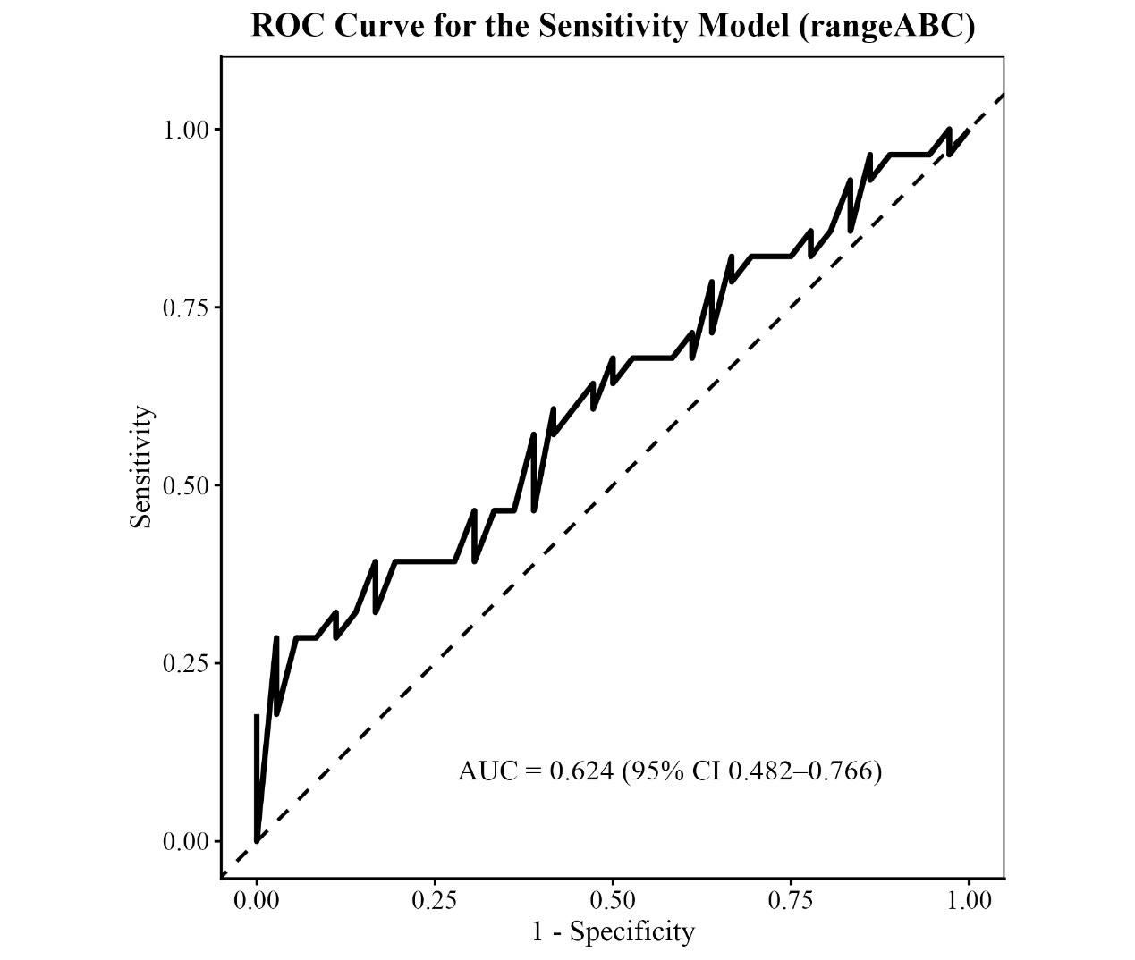
Supplementary Fig 1. ROC curve for the sensitivity model using three-level surgical extent classification (rangeABC) in the validation cohort. Temporal validation of the model using the three-level surgical extent classification yielded an area under the curve (AUC) of 0.624 (95% CI 0.482–0.766).

Supplementary Fig. 2
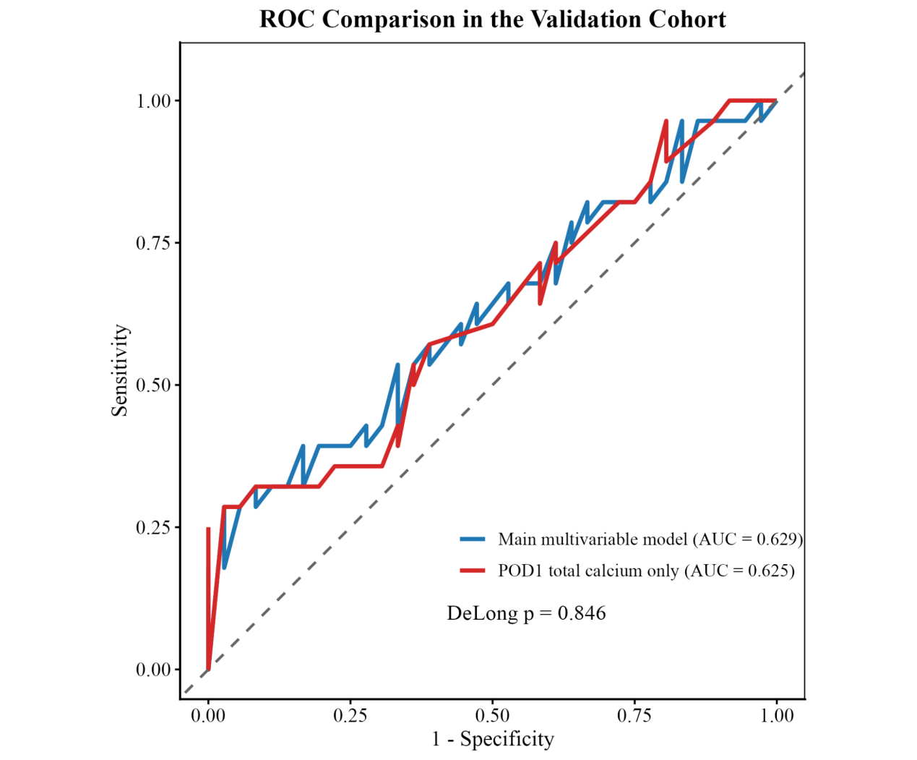
Fig. S2. ROC curves comparing the POD1 total calcium-only model and the main multivariable model in the validation cohort. Receiver operating characteristic (ROC) curves for the POD1 total calcium-only model and the main multivariable model in the temporal validation cohort (2025). The area under the curve (AUC) was 0.625 (95% CI 0.484–0.766) for the POD1 total calcium-only model and 0.629 (95% CI 0.488–0.770) for the main multivariable model. Discrimination was similar between the two models.

Supplementary Fig. 3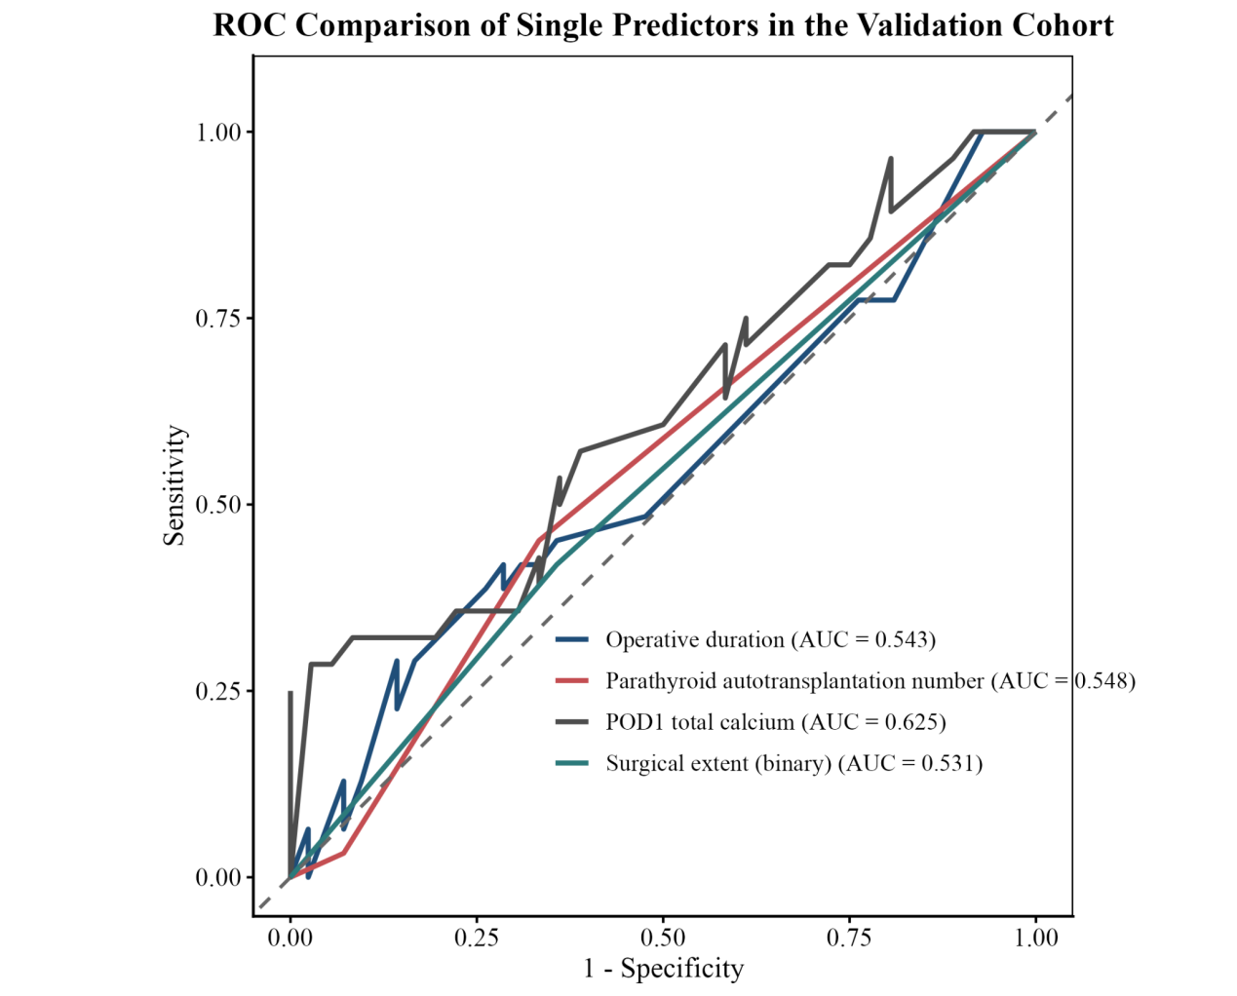
Fig. S3. ROC curves comparing single predictors in the validation cohort. Receiver operating characteristic (ROC) curves comparing single predictors in the temporal validation cohort. Discrimination performance was evaluated for postoperative day 1 (POD1) total calcium, parathyroid autotransplantation number, operative duration, and binary surgical extent. POD1 total calcium showed the highest discrimination among single predictors, although overall performance remained modest.

Supplementary Fig. 4
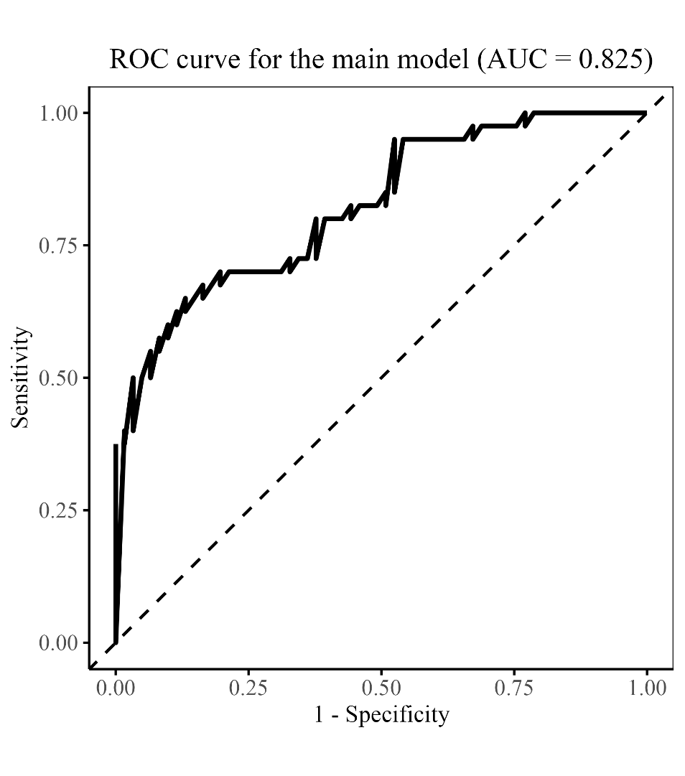
Fig. S4. Receiver operating characteristic (ROC) curves for different models in the supplementary same-center cross-surgeon cohort (n = 101). The POD1 total calcium-only model achieved an AUC of 0.722; operative duration alone gave an AUC of 0.739; the refitted main multivariable model yielded an AUC of 0.825; the refitted three-level surgical extent model also gave an AUC of 0.825. These apparent performance estimates are higher than those observed in the temporal validation cohort, suggesting potential overfitting or differences in case mix.

