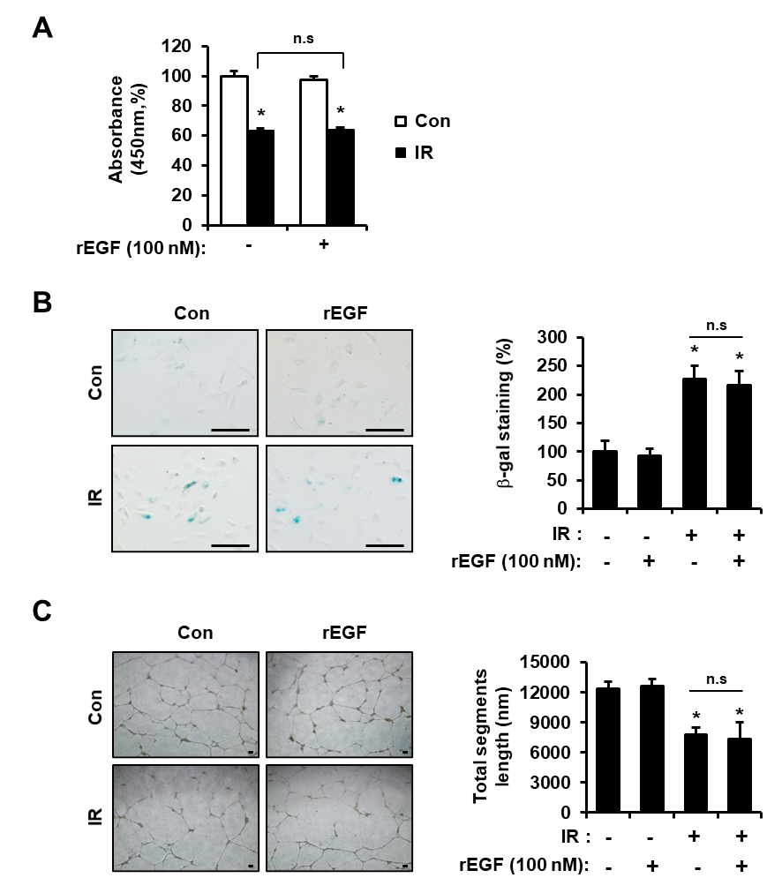
Supplement Fig. 1. Epidermal growth factor does not influence repair of radiation-induced endothelial cell damage. (A) Determination of proliferation of HUVECs after treatment with or without recombinant epidermal growth factor (rEGF; 100 nM). The effect of rEGF on HUVEC proliferation was assessed by CCK-8 assay. Bars represent the percentage of proliferated cells normalized to that of the corresponding control. (B) Determination of senescent activity by rEGF. HUVECs were irradiated and treated with or without rEGF. Senescent HUVECs were quantified by performing a β-galactosidase assay. Quantified senescent HUVECs were plotted as a bar graph (right). (C) Determination of angiogenic activity. HUVECs were re-seeded onto Matrigel-coated wells in the presence or absence of rEGF. Total segments length per five fields were quantified and plotted as a bar graph (right). Data are presented as the means ± standard deviation of the mean. Images are representative of 3 independent experiments. *p <0.05 vs. negative control (Con). #p < 0.05 vs. irradiated control (IR). Scale bar = 100 μm.

