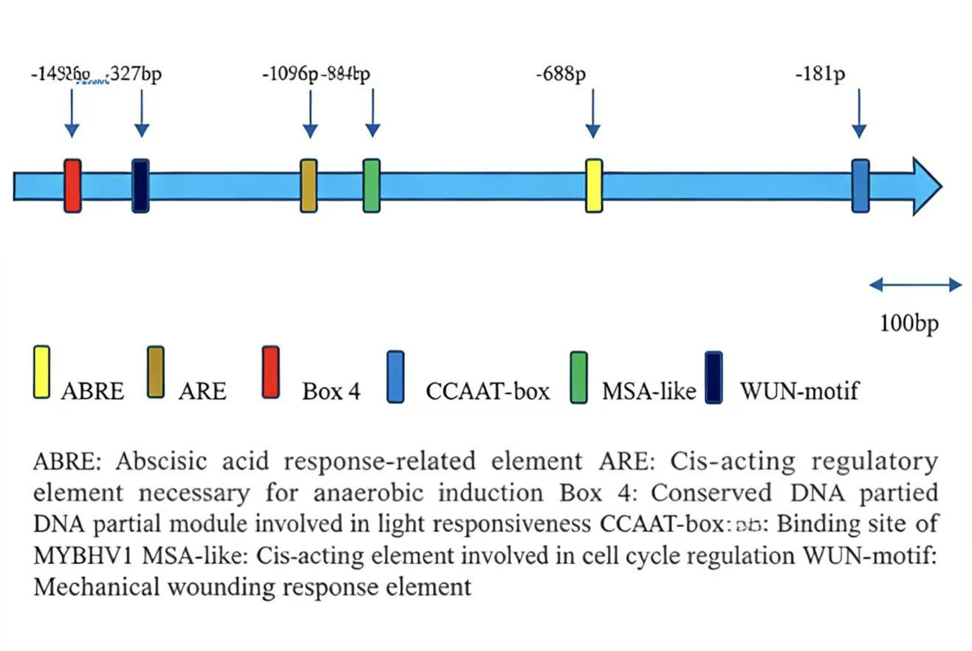
Figure S1 Analysis of cis-acting elements on the CaHT1 promoter

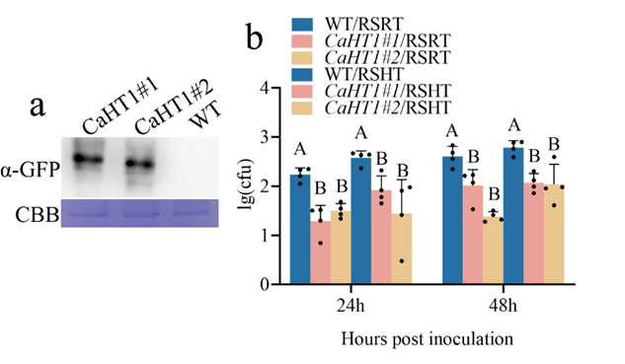
Figure S2 Effect of CaHT1 transgenic tobacco plants on resistance to Ralstonia solanacearum under different treatments.
a) Western blot analysis verifying the successful expression of the target gene in CaHT1-#1 and CaHT1-#2 transgenic tobacco. b) Determination of Ralstonia solanacearum colony-forming units (CFU) in WT and CaHT1 transgenic tobacco lines after 24 h and 48 h of RSRT and RSHT treatments. c) Phenotypes of WT and CaHT1 transgenic tobacco lines treated with RTHH, RSRT, HTHH, and RSHT. d) Disease index of WT and CaHT1-#1 and CaHT1-#2 transgenic tobacco lines.

Primer | primer sequence
CaHT1-RT-F | ACTTACCGTTGGATGGCACC
CaHT1-RT-R  Primers used for CaHT1 VIGS study-F  Primers used for CaHT1 VIGS study -R | CAGCCACCATTTCCCACAGA  GGGGACAAGTTTGTACAAAAAAGCAG  GCTTCGGAAGATCTCCTGGTTCAAG  GGGGACCACTTTGTACAAGAAAGCTG  GGTCTCCAATTTCGTCATCATCTG
CaPYRx-RT-F | CCAGCTGCTACGAGTACTGAAA
CaPYRx-RT-R | TCCTCCGTATTCCCTTCAGGT
CaXa21-RT-F | GTGAAATGTGGGAAGGGCCA
CaXa21-RT-R | GTGGCATTTCCAACCGAAGG
CaWRKY22-RT-F | GGGATCTACATGCCGTGGTC
CaWRKY22-RT-R | GTAGAGCCCCTCTGCAATGT
CaBHLH35-RT-F | GCTGCTTCGATGAGGCAAT
CaBHLH35-RT-R | TGGGACCACAGCTCTAAGTG
CaActin-F | AGGGATGGGTCAAAAGGATGC
CaActin-R | GAGACAACACCGCCTGAATAGC
CaPR1-RT-F | GCCGTGAAGATGTGGGTCAATGA
CaPR1-RT-R | TGAGTTACGCCAGACTACCTGAGTA
CaMgst3-RT-F | TCCAGCTTTTCGCACTCTCT
CaMgst3-RT-R | CGAGATCTCGCCACCCAATT
CaPRP1-RT-F | ACCAAACTCGGATATTCCAACT
CaPRP1-RT-R | GAGGAATCCTCGGAACCAAGT
Table S1 Primer names and sequences used

