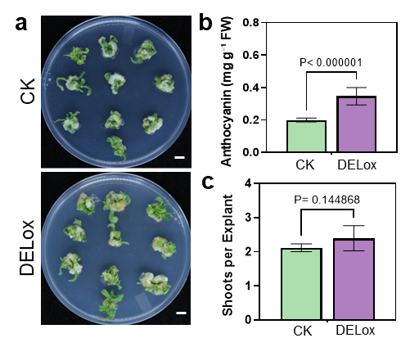
Supplementary Fig. 1 Plant regeneration is retained in stable transgenic tomato lines overexpressing DELILA. a, Representative regeneration phenotypes of control (CK) and DELILA overexpression (DELox) tomato lines during in vitro culture. Scale bars, 1 cm. b, Anthocyanin content (mg g⁻¹ FW) in CK and DELox tissues at week 3 (n = 4 biological replicates; three technical replicates per biological replicate). c, Shoots per explant in CK and DELox lines at week 3. Data are presented as mean ± s.d. (n = 5 biological replicates; 20 explants per replicate). Statistical significance was assessed using two-tailed Student’s t-tests; P-values are indicated.

Supplementary Fig. 2 Repeated trials show consistent reduction in regeneration in stable transgenic petunia lines overexpressing ROSEA1. a, Time-course of regeneration from week 1 to week 3 in petunia explants for control (CK, top) and ROSEA1 overexpression (ROSox-2 in Fig. 5, bottom) lines, showing reduced plantlet formation in ROSox. b, Representative close-up views of regenerating tissues at week 2 and week 3 for CK and ROSox. c, Explant area quantified from week 1 to week 3 (CK, green; ROSox-2, purple). Data are presented as mean ± s.d. (n = 20 biological replicates). d, Regeneration frequency (%) at week 2 and week 3 in CK and ROSox-2 lines (n = 4 biological replicates; 20 explants per replicate). e, Representative anthocyanin extracts from CK and ROSox tissues collected at week 3. f, Anthocyanin content (mg g⁻¹ FW) at week 3 in CK and ROSox tissues (n = 4 biological replicates; three technical replicates per biological replicate). Statistical significance was assessed using two-tailed Student’s t-tests; P-values are indicated. Scale bars, 1 cm (a) and 5 mm (b).

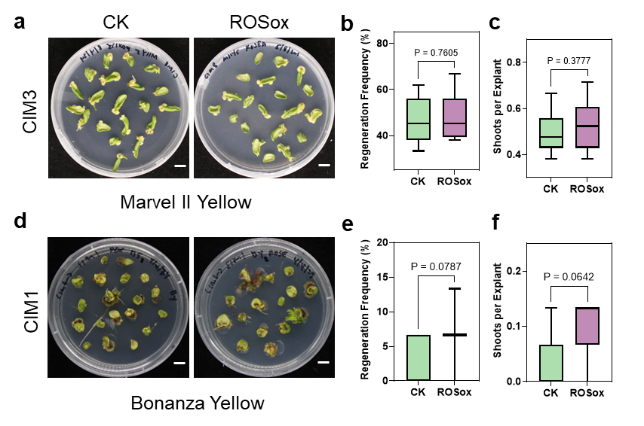
Supplementary Fig. 3 The ROSEA1-associated regeneration penalty is not detectable in marigold under high-cytokinin conditions or in the low-regenerating genotype ‘Bonanza Yellow’. a, Representative Petri dishes of ‘Marvel II Yellow’ explants under control (CK, left) and ROSEA1 (ROSox, right) treatments. b,c, Regeneration frequency (%) (b) and shoots per explant (c) for ‘Marvel II Yellow’ (CK, green; ROSox, purple). d, Representative Petri dishes of ‘Bonanza Yellow’ explants under CK (left) and ROSox (right) treatments on CIM1. e,f, Regeneration frequency (%) (e) and shoots per explant (f) for ‘Bonanza Yellow’ (CK, green; ROSox, purple). Data are presented as mean ± s.d. (n = 4 biological replicates; 15 explants per replicate). Statistical significance was assessed using two-tailed Student’s t-tests; P-values are indicated. Scale bars, 1 cm (a,d).

Supplementary Table 1 List of primers for qRT-PCR analysis
Gene name | Forward primer sequence （5'→3'） | Reverse primer sequence（5'→3'） | Note
SlACTIN2 | TTGCTGACCGTATGAGCAAG | GGACAATGGATGGACCAGAC | qRT-PCR  in tomato
ROSEA1 | ACGTTACTTGGCCGAGAGAA | AACTTCATCTTGTGGCGACG | qRT-PCR  in tomato
SlCHI | TGCAACAATGGAAGGGCAAA | CGACTTCTGCTAAGCGATCG | qRT-PCR  in tomato
SlF3H | CGGTTTGACATGTCTGGTGG | CGCCAGTCTTGAACCACTTC | qRT-PCR  in tomato
SlF3'5'H | GGTTCAATGCCACATGTTGC | GCAACAACCATCCCACATGT | qRT-PCR  in tomato
SlDFR | GCTGGAGCGATTTGGACTTC | CAGCCTTCTCTGCCAGTATCTT | qRT-PCR  in tomato
SlPLT5 | GTGGCTTGGCTTCTCACTTT | GCTTGGAAGAGGGAAAGTTGT | qRT-PCR  in tomato
SlWUS | TGTGCAGGCAAAGTAGTAGC | TGTTCAGCAGTTGGAGACCT | qRT-PCR  in tomato
SlLBD16 | TGTTACACGTTCCTGTCCCC | AACTTTGTGCCAGCTGAGTC | qRT-PCR  in tomato

