Supplementary Material

Table S1. Specific Parameter input for the model
Parameter | Values |  | Units | Reference
Species group | Grouper  (e.g. Cephalopholis argus) | Parrotfish  (e.g. Chlorurus bleekeri)
Population
Natural mortality, M | 0.1703 | 0.5711 | year⁻¹ | (Pauly 1980)
Growth
Intrinsic growth, k | 0.075 | 0.34 | year⁻¹ | Grouper: (Donovan et al. 2013)  Parrotfish: (Bucol et al. 2021)
Asymptotic length, L∞ | 50.6 | 36.6 | cm | Grouper:(Donovan et al. 2013)  Parrotfish: (Bejarano et al. 2013)
Age at size zero, a₀ | -6.5 | -0.464 | years | Grouper:(Donovan et al. 2013)  Parrotfish: Estimated using the Fishbase life history tool
Coefficient for weight to length conversion, c | 0.02 | 0.0171 | g/cm | Grouper:(Donovan et al. 2013)  Parrotfish: (Muallil et al. 2023)
Power for weight to length conversion, f | 2.99 | 3.0418 | N/A | Grouper:(Donovan et al. 2013)  Parrotfish :(Muallil et al. 2023)
Reproduction
Maximum relative recruitment rate, R_{o} | 0.25 | 4 | Average relative recruits per year per km² | (Brown et al. 2015; Sjahruddin 2023)
Fish growth compensation ratio, G | 4 (10) | 4 (10) |  | (Brown et al. 2015; Sjahruddin 2023)
Age at maturity, A_{mat} | 4 | 2 | years | Grouper:(Bucol et al. 2021)  Parrotfish:(Bucol et al. 2021)
Age at sex-change, A_{turn} | 12 | N/A | years | (Bucol et al. 2021)
Intercept for body length to egg production conversion exponential model, g | 0.268429 | -0.966866 | N/A | (Bucol et al. 2021)
Coefficient for body length to egg production conversion exponential model, h | 0.015677 | 0.021138 | mm⁻¹ | (Bucol et al. 2021)
Movement
Home range, H | 1 | 0.1 | km | Grouper:(Shpigel and Fishelson 1991)  Parrotfish:(Green et al. 2015)
Dispersal
Amplitude of Dispersal Kernel, | 1 | 1 | N/A
Fishery
Age fishing begins, A_{f} | 2 | 1 | years | (Brown et al. 2015; Sjahruddin 2023)
Optimal effort, () | 0.0883 | 0.2029 | N/A
Fishing pressure multiple | 2.2622 | 2.1597 | N/A
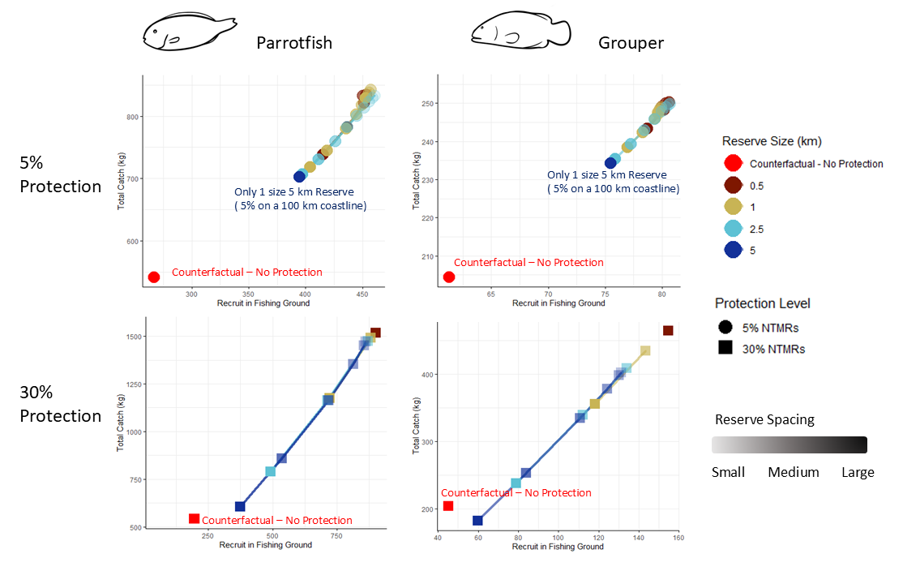
Fig.S1 Compare between reserve number of recruits and fishery yield for parrotfish and grouper 50 years after reserve implementation. Point colour indicates reserve size (0.5–5 km). Point transparency indicates reserve spacing, scaled within each size x protection level configuration, darker points indicate larger spacing within that configuration. The red point denotes the reserve-free counterfactual scenario. Results for individual spatial configurations are provided in Supplementary Table S2.
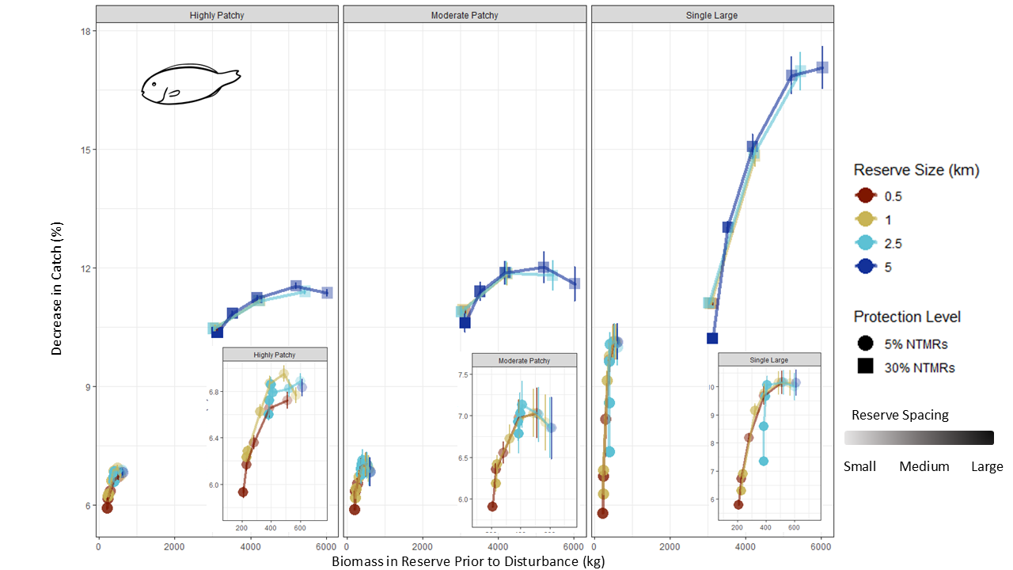
Fig.S2 Disturbance impacts on parrotfish fisheries, shown as mean catch decline (%), under three disturbance scenarios compare against biomass in reserve prior to disturbance (kg). Point colour indicates reserve size. Point transparency indicates reserve spacing, scaled within each size x protection level configuration, darker points indicate larger spacing within that configuration. Point shape indicates protection level. Inset shows the 5% protection scenario at expanded scale. Results for individual spatial configurations are provided in Supplementary Table S2.
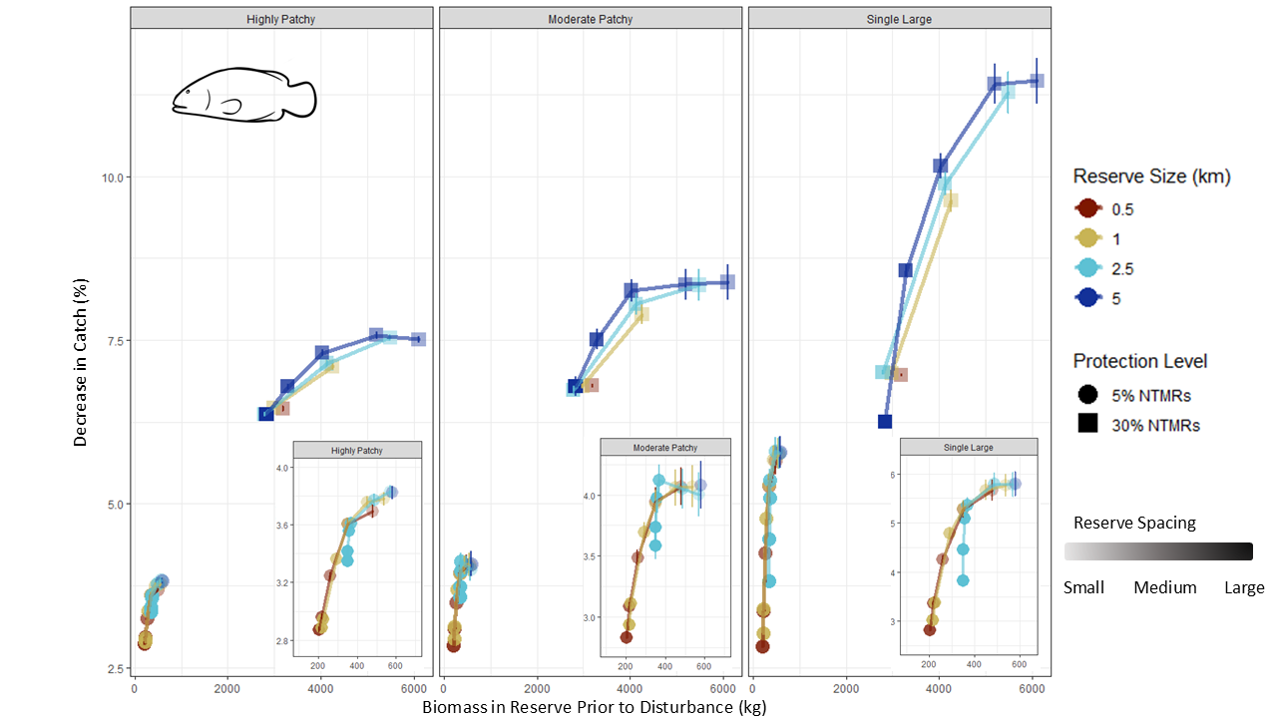
Fig.S3 Disturbance impacts on grouper fisheries, shown as mean catch decline (%), under three disturbance scenarios compare against biomass in reserve prior to disturbance (kg). Point colour indicates reserve size. Point transparency indicates reserve spacing, scaled within each size x protection level configuration, darker points indicate larger spacing within that configuration. Point shape indicates protection level. Inset shows the 5% protection scenario at expanded scale. Results for individual spatial configurations are provided in Supplementary Table S3.
Table S2. Modelled outputs for individual spatial reserve configurations for the parrotfish fishery. F
Protection Level | Size (km) | Spacing (km) | Catch (kg) | Biomass Reserve (kg) | Recruit FG | Disturbance  Type | Impact (%) | Impact SE (±) | Recovery Time (yrs) | Recovery Time SE (±)
5% | 0.5 | 1 | 734.7 | 512.5 | 415.2 | Highly Patchy | 6.7 | 0.07 | 11.7 | 0.14
5% | 0.5 | 2.5 | 779.1 | 386.8 | 436.5 | Highly Patchy | 6.7 | 0.08 | 11.9 | 0.2
5% | 0.5 | 5 | 833.9 | 282.5 | 451 | Highly Patchy | 6.4 | 0.06 | 12.1 | 0.17
5% | 0.5 | 7.5 | 858.1 | 229.1 | 453.4 | Highly Patchy | 6.2 | 0.05 | 12.1 | 0.2
5% | 0.5 | 9.5 | 858.8 | 209.3 | 450.5 | Highly Patchy | 5.9 | 0.05 | 11.6 | 0.22
5% | 1 | 1 | 711.5 | 570.2 | 403.8 | Highly Patchy | 6.8 | 0.07 | 11.7 | 0.13
5% | 1 | 2.5 | 742.2 | 487.7 | 418.4 | Highly Patchy | 7 | 0.07 | 12.1 | 0.12
5% | 1 | 5 | 786.5 | 388.8 | 435.2 | Highly Patchy | 6.9 | 0.06 | 12.4 | 0.12
5% | 1 | 7.5 | 819.6 | 323.7 | 444.4 | Highly Patchy | 6.6 | 0.06 | 12.4 | 0.13
5% | 1 | 15 | 874.8 | 239.1 | 455.7 | Highly Patchy | 6.3 | 0.05 | 12.5 | 0.17
5% | 1 | 17.5 | 881.4 | 229.7 | 457 | Highly Patchy | 6.2 | 0.05 | 12.5 | 0.17
5% | 2.5 | 1 | 698.5 | 601.5 | 397 | Highly Patchy | 6.9 | 0.07 | 11.9 | 0.11
5% | 2.5 | 5 | 725.8 | 523.9 | 411.2 | Highly Patchy | 6.8 | 0.08 | 11.7 | 0.16
5% | 2.5 | 15 | 787.7 | 410.2 | 436.6 | Highly Patchy | 6.8 | 0.07 | 12.2 | 0.15
5% | 2.5 | 20 | 810.2 | 396.6 | 444.8 | Highly Patchy | 6.9 | 0.06 | 12.6 | 0.12
5% | 2.5 | 30 | 841.4 | 386.5 | 455.6 | Highly Patchy | 6.7 | 0.05 | 12.8 | 0.12
5% | 2.5 | 40 | 857.3 | 383.9 | 460.4 | Highly Patchy | 6.6 | 0.05 | 12.6 | 0.13
5% | 5 | 1 | 694 | 611.4 | 394.6 | Highly Patchy | 6.8 | 0.08 | 11.7 | 0.15
30% | 0.5 | 1 | 1520.4 | 3133.9 | 901.2 | Highly Patchy | 10.4 | 0.07 | 12.2 | 0.06
30% | 1 | 1 | 1175.4 | 4242.9 | 721.3 | Highly Patchy | 11.2 | 0.08 | 11.7 | 0.05
30% | 1 | 2 | 1494.5 | 3072.9 | 881.1 | Highly Patchy | 10.5 | 0.08 | 12.4 | 0.06
30% | 2.5 | 1 | 789.5 | 5446.2 | 492.4 | Highly Patchy | 11.4 | 0.08 | 11.4 | 0.05
30% | 2.5 | 2.5 | 1163.4 | 4223.2 | 712.7 | Highly Patchy | 11.2 | 0.08 | 11.7 | 0.05
30% | 2.5 | 5 | 1478.9 | 3026.8 | 869.3 | Highly Patchy | 10.5 | 0.06 | 12.3 | 0.05
30% | 5 | 1 | 606.2 | 6029.5 | 374 | Highly Patchy | 11.4 | 0.1 | 11.6 | 0.05
30% | 5 | 2.5 | 858.4 | 5210.7 | 535.8 | Highly Patchy | 11.5 | 0.08 | 11.4 | 0.05
30% | 5 | 5 | 1165.8 | 4179.2 | 717.2 | Highly Patchy | 11.2 | 0.07 | 11.7 | 0.05
30% | 5 | 7.5 | 1354.2 | 3526.3 | 813.2 | Highly Patchy | 10.9 | 0.07 | 12 | 0.05
30% | 5 | 12 | 1474.5 | 3127.9 | 862.2 | Highly Patchy | 10.4 | 0.06 | 12.2 | 0.05
5% | 0.5 | 1 | 734.7 | 512.5 | 415.2 | Moderate Patchy | 7 | 0.3 | 11.5 | 0.5
5% | 0.5 | 2.5 | 779.1 | 386.8 | 436.5 | Moderate Patchy | 7 | 0.21 | 12.1 | 0.42
5% | 0.5 | 5 | 833.9 | 282.5 | 451 | Moderate Patchy | 6.6 | 0.13 | 12.1 | 0.39
5% | 0.5 | 7.5 | 858.1 | 229.1 | 453.4 | Moderate Patchy | 6.4 | 0.07 | 12.7 | 0.25
5% | 0.5 | 9.5 | 858.8 | 209.3 | 450.5 | Moderate Patchy | 5.9 | 0 | 12 | 0
5% | 1 | 1 | 711.5 | 570.2 | 403.8 | Moderate Patchy | 6.9 | 0.34 | 11.3 | 0.53
5% | 1 | 2.5 | 742.2 | 487.7 | 418.4 | Moderate Patchy | 7 | 0.29 | 11.6 | 0.49
5% | 1 | 5 | 786.5 | 388.8 | 435.2 | Moderate Patchy | 7 | 0.23 | 11.9 | 0.44
5% | 1 | 7.5 | 819.6 | 323.7 | 444.4 | Moderate Patchy | 6.7 | 0.17 | 11.9 | 0.42
5% | 1 | 15 | 874.8 | 239.1 | 455.7 | Moderate Patchy | 6.4 | 0.1 | 12.6 | 0.35
5% | 1 | 17.5 | 881.4 | 229.7 | 457 | Moderate Patchy | 6.2 | 0.1 | 12 | 0.37
5% | 2.5 | 1 | 698.5 | 601.5 | 397 | Moderate Patchy | 6.9 | 0.36 | 11 | 0.57
5% | 2.5 | 5 | 725.8 | 523.9 | 411.2 | Moderate Patchy | 7 | 0.33 | 11.6 | 0.53
5% | 2.5 | 15 | 787.7 | 410.2 | 436.6 | Moderate Patchy | 7.1 | 0.28 | 12.2 | 0.51
5% | 2.5 | 20 | 810.2 | 396.6 | 444.8 | Moderate Patchy | 7 | 0.24 | 12.5 | 0.49
5% | 2.5 | 30 | 841.4 | 386.5 | 455.6 | Moderate Patchy | 6.8 | 0.24 | 12.2 | 0.54
5% | 2.5 | 40 | 857.3 | 383.9 | 460.4 | Moderate Patchy | 6.9 | 0.24 | 12.7 | 0.55
5% | 5 | 1 | 694 | 611.4 | 394.6 | Moderate Patchy | 6.8 | 0.37 | 11 | 0.57
30% | 0.5 | 1 | 1520.4 | 3133.9 | 901.2 | Moderate Patchy | 10.9 | 0.06 | 12.7 | 0.05
30% | 1 | 1 | 1175.4 | 4242.9 | 721.3 | Moderate Patchy | 11.9 | 0.29 | 12.1 | 0.16
30% | 1 | 2 | 1494.5 | 3072.9 | 881.1 | Moderate Patchy | 11 | 0.07 | 12.6 | 0.05
30% | 2.5 | 1 | 789.5 | 5446.2 | 492.4 | Moderate Patchy | 11.8 | 0.39 | 11.2 | 0.22
30% | 2.5 | 2.5 | 1163.4 | 4223.2 | 712.7 | Moderate Patchy | 11.9 | 0.29 | 12 | 0.15
30% | 2.5 | 5 | 1478.9 | 3026.8 | 869.3 | Moderate Patchy | 10.9 | 0.09 | 12.6 | 0.07
30% | 5 | 1 | 606.2 | 6029.5 | 374 | Moderate Patchy | 11.6 | 0.43 | 11.3 | 0.26
30% | 5 | 2.5 | 858.4 | 5210.7 | 535.8 | Moderate Patchy | 12 | 0.4 | 11.3 | 0.23
30% | 5 | 5 | 1165.8 | 4179.2 | 717.2 | Moderate Patchy | 11.9 | 0.3 | 12 | 0.17
30% | 5 | 7.5 | 1354.2 | 3526.3 | 813.2 | Moderate Patchy | 11.4 | 0.24 | 12.3 | 0.15
30% | 5 | 12 | 1474.5 | 3127.9 | 862.2 | Moderate Patchy | 10.6 | 0.23 | 12.3 | 0.2
5% | 0.5 | 1 | 734.7 | 512.5 | 415.2 | Single Large | 10.2 | 0.42 | 15.5 | 0.62
5% | 0.5 | 2.5 | 779.1 | 386.8 | 436.5 | Single Large | 9.7 | 0.32 | 16.1 | 0.53
5% | 0.5 | 5 | 833.9 | 282.5 | 451 | Single Large | 8.2 | 0.16 | 15.8 | 0.35
5% | 0.5 | 7.5 | 858.1 | 229.1 | 453.4 | Single Large | 6.7 | 0.05 | 14.1 | 0.13
5% | 0.5 | 9.5 | 858.8 | 209.3 | 450.5 | Single Large | 5.8 | 0 | 11 | 0
5% | 1 | 1 | 711.5 | 570.2 | 403.8 | Single Large | 10.1 | 0.45 | 15.1 | 0.62
5% | 1 | 2.5 | 742.2 | 487.7 | 418.4 | Single Large | 10.1 | 0.41 | 15.6 | 0.61
5% | 1 | 5 | 786.5 | 388.8 | 435.2 | Single Large | 9.8 | 0.33 | 15.8 | 0.56
5% | 1 | 7.5 | 819.6 | 323.7 | 444.4 | Single Large | 9.2 | 0.25 | 16.5 | 0.44
5% | 1 | 15 | 874.8 | 239.1 | 455.7 | Single Large | 6.9 | 0.07 | 14.1 | 0.17
5% | 1 | 17.5 | 881.4 | 229.7 | 457 | Single Large | 6.3 | 0.04 | 12.7 | 0.11
5% | 2.5 | 1 | 698.5 | 601.5 | 397 | Single Large | 10 | 0.47 | 14.8 | 0.66
5% | 2.5 | 5 | 725.8 | 523.9 | 411.2 | Single Large | 10.2 | 0.44 | 15.5 | 0.62
5% | 2.5 | 15 | 787.7 | 410.2 | 436.6 | Single Large | 10.1 | 0.31 | 16.8 | 0.41
5% | 2.5 | 20 | 810.2 | 396.6 | 444.8 | Single Large | 9.7 | 0.26 | 17 | 0.35
5% | 2.5 | 30 | 841.4 | 386.5 | 455.6 | Single Large | 8.6 | 0.16 | 16.3 | 0.23
5% | 2.5 | 40 | 857.3 | 383.9 | 460.4 | Single Large | 7.3 | 0.04 | 14.6 | 0.1
5% | 5 | 1 | 694 | 611.4 | 394.6 | Single Large | 10.1 | 0.47 | 15 | 0.65
30% | 0.5 | 1 | 1520.4 | 3133.9 | 901.2 | Single Large | 11.1 | 0.03 | 12.8 | 0.04
30% | 1 | 1 | 1175.4 | 4242.9 | 721.3 | Single Large | 14.8 | 0.27 | 13.3 | 0.09
30% | 1 | 2 | 1494.5 | 3072.9 | 881.1 | Single Large | 11.1 | 0.04 | 12.8 | 0.04
30% | 2.5 | 1 | 789.5 | 5446.2 | 492.4 | Single Large | 17 | 0.49 | 13.5 | 0.16
30% | 2.5 | 2.5 | 1163.4 | 4223.2 | 712.7 | Single Large | 14.9 | 0.28 | 13.3 | 0.1
30% | 2.5 | 5 | 1478.9 | 3026.8 | 869.3 | Single Large | 11.1 | 0.06 | 12.7 | 0.05
30% | 5 | 1 | 606.2 | 6029.5 | 374 | Single Large | 17.1 | 0.54 | 13.8 | 0.18
30% | 5 | 2.5 | 858.4 | 5210.7 | 535.8 | Single Large | 16.9 | 0.48 | 13.5 | 0.16
30% | 5 | 5 | 1165.8 | 4179.2 | 717.2 | Single Large | 15.1 | 0.31 | 13.2 | 0.11
30% | 5 | 7.5 | 1354.2 | 3526.3 | 813.2 | Single Large | 13 | 0.16 | 13.1 | 0.08
30% | 5 | 12 | 1474.5 | 3127.9 | 862.2 | Single Large | 10.2 | 0.11 | 12.3 | 0.1

Table S3. Modelled outputs for individual spatial reserve configurations for the grouper fishery.
Protection Level | Size (km) | Spacing (km) | Catch (kg) | Biomass Reserve (kg) | Recruit FG | Disturbance  Type | Impact (%) | Impact SE (±) | Recovery Time (yrs) | Recovery Time SE (±)
5% | 0.5 | 1 | 252.7 | 478 | 78.6 | Highly Patchy | 3.7 | 0.0004 | 5 | 0
5% | 0.5 | 2.5 | 266.1 | 351.2 | 80.2 | Highly Patchy | 3.6 | 0.0004 | 5 | 0
5% | 0.5 | 5 | 279.2 | 259 | 80.6 | Highly Patchy | 3.2 | 0.0003 | 5 | 0
5% | 0.5 | 7.5 | 284.3 | 218.1 | 80.3 | Highly Patchy | 3 | 0.0002 | 5 | 0
5% | 0.5 | 9.5 | 284 | 202.9 | 80 | Highly Patchy | 2.9 | 0.0002 | 5 | 0
5% | 1 | 1 | 244.1 | 537.4 | 76.9 | Highly Patchy | 3.8 | 0.0005 | 5 | 0
5% | 1 | 2.5 | 251.9 | 450.7 | 78.3 | Highly Patchy | 3.8 | 0.0004 | 5 | 0
5% | 1 | 5 | 262.6 | 351.4 | 79.4 | Highly Patchy | 3.6 | 0.0004 | 5 | 0
5% | 1 | 7.5 | 270.1 | 291.7 | 79.7 | Highly Patchy | 3.4 | 0.0003 | 5 | 0
5% | 1 | 15 | 282.2 | 224.4 | 79.8 | Highly Patchy | 2.9 | 0.0002 | 5 | 0
5% | 1 | 17.5 | 283.6 | 217.7 | 79.9 | Highly Patchy | 2.9 | 0.0002 | 5 | 0
5% | 2.5 | 1 | 239 | 570 | 75.8 | Highly Patchy | 3.8 | 0.0004 | 5 | 0
5% | 2.5 | 5 | 246 | 487.5 | 77.2 | Highly Patchy | 3.8 | 0.0004 | 5 | 0
5% | 2.5 | 15 | 261.8 | 369.7 | 79.3 | Highly Patchy | 3.6 | 0.0004 | 5 | 0
5% | 2.5 | 20 | 267.7 | 357.4 | 80 | Highly Patchy | 3.6 | 0.0003 | 5 | 0
5% | 2.5 | 30 | 275.9 | 351.1 | 80.5 | Highly Patchy | 3.4 | 0.0003 | 5 | 0
5% | 2.5 | 40 | 280.1 | 350.4 | 80.7 | Highly Patchy | 3.3 | 0.0003 | 5 | 0
5% | 5 | 1 | 237.2 | 580.5 | 75.4 | Highly Patchy | 3.8 | 0.0005 | 5 | 0
30% | 0.5 | 1 | 497.1 | 3186.7 | 154.6 | Highly Patchy | 6.5 | 0.0004 | 12.7 | 0.12
30% | 1 | 1 | 368.7 | 4256.5 | 118.2 | Highly Patchy | 7.1 | 0.0005 | 12.8 | 0.12
30% | 1 | 2 | 465.8 | 2978.2 | 143.4 | Highly Patchy | 6.5 | 0.0004 | 12.7 | 0.13
30% | 2.5 | 1 | 241 | 5488.2 | 78.8 | Highly Patchy | 7.5 | 0.0005 | 12.7 | 0.1
30% | 2.5 | 2.5 | 350.9 | 4129.4 | 112.2 | Highly Patchy | 7.1 | 0.0005 | 12.7 | 0.11
30% | 2.5 | 5 | 438.4 | 2789.9 | 134 | Highly Patchy | 6.4 | 0.0004 | 12.3 | 0.12
30% | 5 | 1 | 183.1 | 6104.9 | 59.9 | Highly Patchy | 7.5 | 0.0006 | 12.7 | 0.1
30% | 5 | 2.5 | 257.7 | 5196.6 | 84 | Highly Patchy | 7.6 | 0.0005 | 12.6 | 0.1
30% | 5 | 5 | 346 | 4034 | 110.7 | Highly Patchy | 7.3 | 0.0005 | 12.7 | 0.1
30% | 5 | 7.5 | 397.8 | 3290.6 | 124.3 | Highly Patchy | 6.8 | 0.0004 | 12.5 | 0.11
30% | 5 | 12 | 429.3 | 2833.3 | 131.1 | Highly Patchy | 6.4 | 0.0004 | 12.4 | 0.13
5% | 0.5 | 1 | 252.7 | 478 | 78.6 | Moderate Patchy | 4.1 | 0.0015 | 7.6 | 0.48
5% | 0.5 | 2.5 | 266.1 | 351.2 | 80.2 | Moderate Patchy | 3.9 | 0.0011 | 6 | 0.31
5% | 0.5 | 5 | 279.2 | 259 | 80.6 | Moderate Patchy | 3.5 | 0.0006 | 5 | 0
5% | 0.5 | 7.5 | 284.3 | 218.1 | 80.3 | Moderate Patchy | 3.1 | 0.0003 | 5 | 0
5% | 0.5 | 9.5 | 284 | 202.9 | 80 | Moderate Patchy | 2.8 | 0 | 5 | 0
5% | 1 | 1 | 244.1 | 537.4 | 76.9 | Moderate Patchy | 4.1 | 0.0017 | 8.5 | 0.55
5% | 1 | 2.5 | 251.9 | 450.7 | 78.3 | Moderate Patchy | 4.1 | 0.0015 | 7.3 | 0.46
5% | 1 | 5 | 262.6 | 351.4 | 79.4 | Moderate Patchy | 3.9 | 0.0011 | 6.2 | 0.33
5% | 1 | 7.5 | 270.1 | 291.7 | 79.7 | Moderate Patchy | 3.7 | 0.0008 | 5.2 | 0.14
5% | 1 | 15 | 282.2 | 224.4 | 79.8 | Moderate Patchy | 3.1 | 0.0005 | 5 | 0
5% | 1 | 17.5 | 283.6 | 217.7 | 79.9 | Moderate Patchy | 2.9 | 0.0004 | 5 | 0
5% | 2.5 | 1 | 239 | 570 | 75.8 | Moderate Patchy | 4 | 0.0018 | 8.8 | 0.58
5% | 2.5 | 5 | 246 | 487.5 | 77.2 | Moderate Patchy | 4 | 0.0016 | 7.6 | 0.51
5% | 2.5 | 15 | 261.8 | 369.7 | 79.3 | Moderate Patchy | 4.1 | 0.0013 | 7.7 | 0.51
5% | 2.5 | 20 | 267.7 | 357.4 | 80 | Moderate Patchy | 4 | 0.0012 | 7.1 | 0.46
5% | 2.5 | 30 | 275.9 | 351.1 | 80.5 | Moderate Patchy | 3.7 | 0.0011 | 6.3 | 0.38
5% | 2.5 | 40 | 280.1 | 350.4 | 80.7 | Moderate Patchy | 3.6 | 0.0011 | 5.8 | 0.28
5% | 5 | 1 | 237.2 | 580.5 | 75.4 | Moderate Patchy | 4.1 | 0.0019 | 9.3 | 0.63
30% | 0.5 | 1 | 497.1 | 3186.7 | 154.6 | Moderate Patchy | 6.8 | 0.0003 | 13.7 | 0.08
30% | 1 | 1 | 368.7 | 4256.5 | 118.2 | Moderate Patchy | 7.9 | 0.0016 | 14 | 0.31
30% | 1 | 2 | 465.8 | 2978.2 | 143.4 | Moderate Patchy | 6.8 | 0.0004 | 13.6 | 0.11
30% | 2.5 | 1 | 241 | 5488.2 | 78.8 | Moderate Patchy | 8.3 | 0.0024 | 13.4 | 0.4
30% | 2.5 | 2.5 | 350.9 | 4129.4 | 112.2 | Moderate Patchy | 8.1 | 0.0016 | 14 | 0.3
30% | 2.5 | 5 | 438.4 | 2789.9 | 134 | Moderate Patchy | 6.7 | 0.0006 | 13.2 | 0.17
30% | 5 | 1 | 183.1 | 6104.9 | 59.9 | Moderate Patchy | 8.4 | 0.0028 | 13.6 | 0.44
30% | 5 | 2.5 | 257.7 | 5196.6 | 84 | Moderate Patchy | 8.3 | 0.0024 | 13.3 | 0.39
30% | 5 | 5 | 346 | 4034 | 110.7 | Moderate Patchy | 8.3 | 0.0018 | 14.2 | 0.3
30% | 5 | 7.5 | 397.8 | 3290.6 | 124.3 | Moderate Patchy | 7.5 | 0.0015 | 13.7 | 0.35
30% | 5 | 12 | 429.3 | 2833.3 | 131.1 | Moderate Patchy | 6.8 | 0.0015 | 13.4 | 0.42
5% | 0.5 | 1 | 252.7 | 478 | 78.6 | Single Large | 5.7 | 0.0022 | 15 | 0.8
5% | 0.5 | 2.5 | 266.1 | 351.2 | 80.2 | Single Large | 5.3 | 0.0016 | 12.9 | 0.73
5% | 0.5 | 5 | 279.2 | 259 | 80.6 | Single Large | 4.3 | 0.0008 | 5.1 | 0.09
5% | 0.5 | 7.5 | 284.3 | 218.1 | 80.3 | Single Large | 3.4 | 0.0002 | 5 | 0
5% | 0.5 | 9.5 | 284 | 202.9 | 80 | Single Large | 2.8 | 0 | 5 | 0
5% | 1 | 1 | 244.1 | 537.4 | 76.9 | Single Large | 5.8 | 0.0023 | 15.6 | 0.82
5% | 1 | 2.5 | 251.9 | 450.7 | 78.3 | Single Large | 5.7 | 0.0021 | 14.8 | 0.81
5% | 1 | 5 | 262.6 | 351.4 | 79.4 | Single Large | 5.3 | 0.0017 | 12.7 | 0.77
5% | 1 | 7.5 | 270.1 | 291.7 | 79.7 | Single Large | 4.8 | 0.0013 | 9.9 | 0.61
5% | 1 | 15 | 282.2 | 224.4 | 79.8 | Single Large | 3.4 | 0.0003 | 5 | 0
5% | 1 | 17.5 | 283.6 | 217.7 | 79.9 | Single Large | 3 | 0.0001 | 5 | 0
5% | 2.5 | 1 | 239 | 570 | 75.8 | Single Large | 5.8 | 0.0024 | 16 | 0.83
5% | 2.5 | 5 | 246 | 487.5 | 77.2 | Single Large | 5.8 | 0.0023 | 15.3 | 0.85
5% | 2.5 | 15 | 261.8 | 369.7 | 79.3 | Single Large | 5.4 | 0.0016 | 12 | 0.83
5% | 2.5 | 20 | 267.7 | 357.4 | 80 | Single Large | 5.1 | 0.0013 | 10.2 | 0.75
5% | 2.5 | 30 | 275.9 | 351.1 | 80.5 | Single Large | 4.5 | 0.0007 | 6.9 | 0.47
5% | 2.5 | 40 | 280.1 | 350.4 | 80.7 | Single Large | 3.8 | 0.0002 | 5 | 0
5% | 5 | 1 | 237.2 | 580.5 | 75.4 | Single Large | 5.8 | 0.0024 | 16.1 | 0.83
30% | 0.5 | 1 | 497.1 | 3186.7 | 154.6 | Single Large | 7 | 0.0002 | 14 | 0.05
30% | 1 | 1 | 368.7 | 4256.5 | 118.2 | Single Large | 9.6 | 0.0017 | 16.5 | 0.23
30% | 1 | 2 | 465.8 | 2978.2 | 143.4 | Single Large | 7 | 0.0003 | 14.2 | 0.06
30% | 2.5 | 1 | 241 | 5488.2 | 78.8 | Single Large | 11.3 | 0.0031 | 17 | 0.32
30% | 2.5 | 2.5 | 350.9 | 4129.4 | 112.2 | Single Large | 9.9 | 0.0018 | 16.7 | 0.24
30% | 2.5 | 5 | 438.4 | 2789.9 | 134 | Single Large | 7 | 0.0004 | 14 | 0.1
30% | 5 | 1 | 183.1 | 6104.9 | 59.9 | Single Large | 11.5 | 0.0035 | 17.3 | 0.38
30% | 5 | 2.5 | 257.7 | 5196.6 | 84 | Single Large | 11.4 | 0.0031 | 16.9 | 0.34
30% | 5 | 5 | 346 | 4034 | 110.7 | Single Large | 10.2 | 0.0019 | 16.7 | 0.25
30% | 5 | 7.5 | 397.8 | 3290.6 | 124.3 | Single Large | 8.6 | 0.001 | 15.9 | 0.18
30% | 5 | 12 | 429.3 | 2833.3 | 131.1 | Single Large | 6.2 | 0.0007 | 12.3 | 0.22

Reference
Bejarano S, Golbuu Y, Sapolu T, Mumby PJ (2013) Ecological risk and the exploitation of herbivorous reef fish across Micronesia. Marine ecology Progress series (Halstenbek) 482:197-215
Brown CJ, Abdullah S, Mumby PJ (2015) Minimizing the short-term impacts of marine reserves on fisheries while meeting long-term goals for recovery. Conservation Letters 8:180-189
Bucol AA, Abesamis RA, Stockwell BL, Lowe JR, Russ GR (2021) Development of reproductive potential in protogynous coral reef fishes within Philippine no‐take marine reserves. Journal of fish biology 99:1561-1575
Donovan MK, Friedlander AM, DeMartini EE, Donahue MJ, Williams ID (2013) Demographic patterns in the peacock grouper (Cephalopholis argus), an introduced Hawaiian reef fish. Environmental biology of fishes 96:981-994
Green AL, Maypa AP, Almany GR, Rhodes KL, Weeks R, Abesamis RA, Gleason MG, Mumby PJ, White AT (2015) Larval dispersal and movement patterns of coral reef fishes, and implications for marine reserve network design. Biological Reviews 90:1215-1247
Hasieb H, Mohammed-AbdAllah E, Said R, Osman A (2024) Age and growth of the blackspot snapper Lutjanus ehrenbergii (Family: Lutjanidae), from the Red Sea and the Arabian Gulf. Egyptian Journal of Aquatic Biology and Fisheries 28:1115-1132
Muallil RN, Tambihasan AM, Enojario MJ, Tarabasa RT, Habibuddin AA, Injani AS, Ammang MAT, Aksa AS, Nañola Jr CL (2023) Data on the length-weight relationship of 161 species of commercially important coral reef fishes in Tawi-Tawi islands, Southern Philippines. Data in brief 50:109537-109537
Pauly D (1980) On the interrelationships between natural mortality, growth parameters, and mean environmental temperature in 175 fish stocks [freshwater fishes, marine fish]. Journal du conseil - Conseil international pour l'exploration de la mer 39:175-192
Shpigel M, Fishelson L (1991) Territoriality and associated behaviour in three species of the genus Cephalopholis (Pisces: Serranidae) in the Gulf of Aqaba, Red Sea. Journal of fish biology 38:887-896
Sjahruddin FF (2023) Optimising fisheries management to sustain tropical reef fisheries. The University of Queensland, School of Biological Sciences

