One-sided hydrogenation for carbonyl coupling
Hua An¹, Yani Ding^{1,4}, Di Xu¹, Geng Sun³, Philippe Saute^{5,6}, Ning Yan^{1,2}
¹Department of Chemical and Biomolecular Engineering, National University of Singapore, Singapore 117585, Singapore.
²Centre for Hydrogen Innovations, National University of Singapore, Singapore 117580, Singapore.
³School of Chemistry and Chemical Engineering, Chongqing University, Chongqing 401331, China.
⁴State Key Laboratory of Multiphase Flow in Power Engineering, International Research Center for Renewable Energy, School of Energy and Power Engineering, Xi’an Jiaotong University, Xi’an, Shaanxi, 710049 P.R. China.
⁵Department of Chemical and Biomolecular Engineering, University of California, Los Angeles, Los Angeles, California 90095, USA.
⁶Department of Chemistry and Biochemistry, University of California, Los Angeles, Los Angeles, California 90095, USA.
*Corresponding author. Email: sungengemail@cqu.edu.cn, ning.yan@nus.edu.sg

Materials and catalyst preparation
Chemicals and materials. Benzaldehyde (C₇H₆O, 99.5%), benzyl alcohol (C₇H₈O, 99%), 2-chlorobenzaldehyde (ClC₇H₅O, 99%), 4-hydroxybenzaldehyde (C₇H₆O₂, 98%), 4-hydroxybenzyl alcohol (C₇H₈O₂, 98%) 4-chlorobenzaldehyde (ClC₇H₅O, 97%), 4-chlorobenzyl alcohol (ClC₇H₅O, 99%), 4-fluorobenzaldehyde (FC₇H₅O, 98%), p-tolualdehyde (C₈H₈O, 97%), 4-methylbenzyl alcohol (C₈H₁₀O, 97%), p-Anisaldehyde (C₈H₈O₂, 98%), 4-methoxybenzyl alcohol (C₈H₁₀O₂, 98%), 4-formylbenzoic acid (C₈H₆O₃, 97%), 2-methylbenzaldehyde (C₈H₈O, 97%), cinnamaldehyde (C₉H₈O, 95%), 2-chlorobenzaldehyde (ClC₇H₅O, 99%), cinnamyl alcohol (C₉H₁₀O, 98%), furfural (C₅H₄O₂, 99%), furfuryl alcohol (C₅H₆O₂, 98%), 5-methylfurfural (C₆H₆O₂, 98%), 4-methylacetophenone (C₉H₁₀O, 95%), 4᾽-methoxyacetophenone (C₉H₁₀O₂, 99%), formaldehyde solution (CH₂O, 37 wt% in H₂O), 1-Phenyl-1,2-ethanediol (C₈H₁₀O₂, 97%), acetaldehyde (C₂H₄O, 99.5%), allyl bromide (C₃H₅Br, 97%), 4-Phenyl-1-buten-4-ol (C₁₀H₁₂O, 97%), tungsten(IV) sulfide (WS₂, powder, 2μm, 99%), titanium(IV) carbide (TiC, powder, 2μm, 98%), molybdenum(IV) sulfide (MoS₂, powder, 2μm, 99%), chromium carbide (Cr₃C₂, 325 mesh), molybdenum (VI) oxide (MoO₃, 99%), sulfuric acid (H₂SO₄, 95%-98%), critic acid (C₆H₈O₇, ACS reagent, 99.0%) and sodium phosphate (Na₃PO₄, 96%) were obtained from Sigma Aldrich and were used as received. Acetonitrile (C₂H₃N, 99.9%), acetone (C₂H₆O, 99.9%), methanol (CH₃OH, 99.9%), isopropanol (C₃H₈O, 99%), ethyl acetate (C₄H₈O₂, 99%), cyclohexene (C₆H₁₀, 99%) and ethanol (C₂H₅OH, 99.9%) were purchased from VWR chemicals and used as received. (±)-Hydrobenzoin (C₁₄H₁₄O₂, 98%) was obtained from Tokyo Chemical Industry (TCI) Co., Ltd. Hydrofuroin (C₁₀H₁₀O₄, 98%) was obtained from BLD Pharmatech Ltd. Boric acid (H₃BO₄, 99%) was purchased from Amresco. Deuterium oxide (D₂O, 99.9 atom %D) and sulfuric acid-D2 (D₂SO₄, 99.9 atom %D) were obtained from Cambridge Isotope Laboratories. Mixture gas of 80% H₂ and 20% CH₄, forming gas (5% hydrogen, balance nitrogen) and deuterium (D₂, High Purity) were purchased from Air Liquide.
Catalyst preparation. For preparing ball-milled MoS₂ (bm-MoS₂), 0.2 g commercial MoS₂ (com-MoS₂) powder together with 1 mL acetone and 100 zirconium oxide (ZrO₂) balls (radius 0.25 cm) was added to a zirconium oxide ball-mill chamber (45 mL). Ball milling (Pulverisette 7, Fritsch) was carried out at 600 rpm for 8 hours. The ball milling process was paused for 10 min after every 30 min of grinding to avoid overheating. After ball milling, the balls were washed with acetone and the powder was obtained by centrifugal separation, and then the collected powder was oven-dried at 60 °C overnight, resulting in the bm-MoS₂. Then 0.05 g bm-MoS₂ was calcined in a tube furnace at 600 °C for 1 minute with a heating rate of 10 °C∙min⁻¹ under forming gas (5% H₂, balanced by N₂) to obtain the bmh-MoS₂. For preparing Mo₂C, 0.1 g Molybdenum (VI) oxide was calcined in a tube furnace at 800 °C for 2 hours with a heating rate of 5 °C∙min⁻¹ under mixture gas of 80% H₂ and 20% CH₄.

Hydrogenation test
Hydrogenation test in batch reactor. In a batch reactor, 4 mg catalyst (com-MoS₂, bm-MoS₂, bmh-MoS₂, Mo₂C, WS₂, Cr₃C₂ or TiC), 3.6 mL water, 0.4 mL ethanol and 0.2 mmol benzaldehyde, and a magnetic stirrer were loaded into a Teflon-line (10 mL) which was subsequently put into the reactor (total volume ~20 mL). The reactor was sealed, then purged with pure H₂ gas for several times and pressurized to 20 bar. After that, the reactor was placed into an oven with a preset temperature (50, 80, 100 or 140 °C) for 2 h reaction under vigorous stirring (800 rpm). If adding surfactant, 20 μmol surfactant (Propionamide, Pentanamide, Octanamide, Decanamide, Dodecanamide, Octadecanamide, Polyvinylpyrrolidone (20 mg), 1-Octanol, Trimethyloctylammonium bromide or Sodium octane-1-sulfonate) was added to the liquid mixture and other procedures were same. After reaction, the reactor was quickly cooled down to room temperature using cool water and the high pressure H₂ was slowly released. After that, the mixture was filtered through 0.22 μm PTFE membrane, and the liquid product was analyzed by HPLC.
Hydrogenation test with different substrates. In this experiment, 20 mg com-MoS₂, 2 mL water, 2 mL ethanol and 0.2 mmol substrate were put into a reactor with a Teflon-line (10 ml). The reactor was purged with pure H₂ gas for several times and pressurized with 20 bar. And then the reactor was placed into an oven at 100 °C for 4 h reaction under vigorous stirring (800 rpm). The liquid product was analyzed by HPLC after filtration through 0.22 μm PTFE membrane. The experiment was also conducted similarly using 4 mg bmh-MoS₂ as catalyst at 80 °C for 4 h. For formaldehyde and acetaldehyde coupling, 0.2 mL formaldehyde (CH₂O, 37 wt% in H₂O) or 0.2 mL acetaldehyde, 3.8 mL water and 4 mg bmh-MoS₂ were put into the reactor, and the reaction was conducted under 140 °C for 4 h.
Cross-coupling and Barbier reaction. In this experiment, 4 mg bmh-MoS₂, 3.6 mL water, 0.4 mL ethanol, 0.2 mmol benzaldehyde and 2 mmol formaldehyde or 2 mmol allyl bromide were put into a reactor with a Teflon-line (10 ml). The reactor was purged with pure H₂ gas for several times and pressurized with 20 bar. And then the reactor was placed into an oven at 80 °C for 4 h reaction under vigorous stirring (800 rpm). The liquid product was analyzed by HPLC after filtration through 0.22 μm PTFE membrane.
Stereo control test. In this experiment, 4 mg bmh-MoS₂, 3.6 mL water, 0.4 mL ethanol and 0.2 mmol benzaldehyde, 20 μmol surfactant (Octanamide, Propionamide, Pentanamide, Polyvinylpyrrolidone (20 mg), 1-Octanol, Trimethyloctylammonium bromide or Sodium octane-1-sulfonate), and a magnetic stirrer were loaded into a Teflon-line (10 mL) which was subsequently put into the reactor (total volume ~20 mL). The reactor was sealed, then purged with pure H₂ gas for several times and pressurized to 20 bar. After that, the reactor was placed into an oven with a preset temperature 50 °C for 2 h reaction under vigorous stirring (800 rpm). The products were analyzed using HPLC. For furfural coupling, the mixture solvent of 3.8 mL water and 0.2 mL ethanol was used.

Reaction kinetic test
Hydrogenation test in different solvent. This experiment was conducted at 140 °C for 4 h using com-MoS₂ as the catalyst, but the solvent was used pure protic solvent (water, ethanol or isopropanol) or aprotic solvent (ethyl acetate, cyclohexene or hexane). Other procedures were same like that in hydrogenation test in batch reactor.
The reaction order test of H₂ and benzaldehyde. This experiment was conducted at 140 °C using com-MoS₂ as the catalyst, and the procedure of this experimental is almost same like to that of hydrogenation test in batch reactor, but different H₂ pressure or benzaldehyde concentration was used.
The reaction order test of proton. The conditions of this experiment is same to the reaction order test of H₂, but the pure water is replaced by 3.6 mL buffer solution. Before conducting experiment, the pH of solvent was recorded by a pH meter. The buffer solution contains a certain ratio of A solution (0.05 mol∙L⁻¹ critic acid and 0.2 mol∙L⁻¹ Boric acid) and B solution (0.1 moI∙L⁻¹ sodium phosphate), and its pH is adjustable from 2-12.
Isotope experiment. (H⁺/D⁺) This experiment was conducted at 140 °C using com-MoS₂ as the catalyst, and the procedure of this experimental is almost same like that of hydrogenation test in batch reactor, but 20 μL H₂SO₄ or D₂SO₄ was added to the solution before starting reaction. (H₂/D₂) This experiment was also conducted at 140 °C using com-MoS₂ as the catalyst, but H₂ or D₂ was used as the hydrogen source, respectively. (H₂O/D₂O) This experiment was conducted using com-MoS₂ as the catalyst, but 3.6 mL H₂O or D₂O was used as solvent, respectively.
H₂/D₂ exchange experiment. This experiment was conducted in a tube furnace with a preset temperature of 100 °C. 10 mg catalyst was put into a glass tube and fixed by quartz wool, and then put into tube furnace. The mixture gas of 2.5 mL∙min⁻¹ pure deuterium and 50 mL∙min⁻¹ forming gas (5% H₂, balanced by N₂) flowed through the tube and the outlet gas was analyzed by a mass spectroscopy (Hiden Analytical).
Electrochemical impedance spectroscopy (EIS) test. 10 mg catalyst, 1 mL ethanol and 20 uL Nafion solution (5 wt%) were mixed via supersonic treatment about 30 min, and then 20 uL mixture was dropped onto a glassy carbon electrode. Then the EIS test was finished on electrochemical workstation (Gamry reference 3000) from 1-100000 Hz under a bias potential of 1.2V.

Capture experiment
Electron capture experiment. Electron capture experiment was conducted using K₂S₂O₈ or AgNO₃ as electron scavengers in the batch reactor. In general, 0.01 mmol AgNO₃, 4 mg com-MoS₂, 3.6 mL water, 0.4 mL ethanol and a magnetic stirrer bar were loaded into a Teflon-line (10 mL) which was subsequently put into reactorand pressurized by H₂, and the capture experiment was conducted at 140 °C for 2 hours. The morphology and the chemical state of Ag were observed by TEM and XPS. When using K₂S₂O₈ as electron scavenger, 0.01 mmol K₂S₂O₈, 4 mg com-MoS₂, 3.6 mL water, 0.4 mL ethanol and 0.2 mmol benzaldehyde, and a magnetic stirrer bar were loaded into a Teflon-line which was subsequently put into the reactor, and then the hydrogenation was conducted at 140 °C for 2 hours. The effect of electron to the reaction rate can be quantified by the rate with and without adding K₂S₂O₈.
Radical capture experiment. Radica capture experiment was conducted using 2,2,6,6-Tetramethyl-1-piperidinyloxy (TEMPO) as radical capture in the batch reactor. Generally, 0.01 mmol TEMPO, 4 mg com-MoS₂, 3.6 mL water, 0.4 mL ethanol and 0.2 mmol benzaldehyde, and a magnetic stirrer bar were loaded into a reactor, and then the hydrogenation was conducted at 140 °C for 2 hours. The effect of radical to the reaction rate can be quantified by the rate with and without adding TEMPO. The Electrospray ionization mass spectra (ESI-MS) of final solution was analyzed by a Bruker Micro TOF-Q system using a negative model.

Product quantification
HPLC test. The product quantification of all reactions were finished by HPLC (Shimadzu, Nexera X2) with SB-C18 Column (Poroshell 120 SB-C18, 4.6×150 mm, 2.7micron). The products of benzaldehyde coupling can be analyzed by Diode array detector (280 nm) under mobile phase of 55%A (5mmol∙L⁻¹ sulfuric acid solution) and 45 %B (acetonitrile), with flow rate of 0.4 mL∙min⁻¹ and oven temperature of 30 °C. For other substrates, the products separation and identification were realized via changing the ratio of mobile phase.
1H NMR experiments. 1H NMR experiment was conducted on a Bruker Ascend 400 MHz NMR spectrometer. 0.3 mL liquid sample was mixed with 0.3 mL deuterium oxide (D₂O) solution (contained 4-aminobenzaldehyde as the internal standard), and then the mixture was analyzed directly.

Catalyst characterization
The morphology and microstructures of electrodes were observed using a field emission transmission electron microscope (FETEM) (JEOL 2100). The X-ray photoelectron spectroscopy (XPS) (ESCALAB 250Xi) was used to analyze the composition of catalysts. The crystal structure was analyzed by X-ray diffraction analysis (XRD Bruker D8 Advance), where 2θ ranged from 10° to 80° with a scan rate of 5 °/min. The specific surface areas were measured by nitrogen adsorption/desorption based on the Brunauer-Emmett-Teller (BET, NOVAtouch NT 4LX-1) method. Electron paramagnetic resonance (EPR) spectra of materials were acquired on a JEOL FA200 ESR spectrometer. Hydrogen temperature-programmed desorption (H₂-TPD) measurements were conducted on a Quantachrome instrument under pure He flow when heating the sample at the rate of 10 °C∙min⁻¹ to 800 °C.

DFT calculation
The density functional theory (DFT) calculations were carried out using the Vienna Ab Initio Simulation Package (VASP) except where noted otherwise. The exchange-correlational interactions are described by the generalized gradient approximation (GGA) framework, using the Perdew-Burke-Ernzerhof (PBE) functional. The effective potential of nuclei and core electrons are described by the projector augmented wave (PAW) method, and the wavefunctions of valence electrons were expanded in a plane-wave basis sets up to 400 eV. For Brillouin zone sampling, Gamma-centered k-mesh of 2×2×1 is used for the MoS₂(100) surface, and Gamma-centered k-mesh of 3×3×1 is used for the MoS₂(0001) surface. Spin-polarized calculations are used throughout this work. For structural optimizations, BFGS/FIRE algorithms as implemented in the Atomic Simulation Environment (ASE) package are exploited using VASP as the backend calculator. The structure optimizations are conducted until the maximum force residue on all atoms is below 0.03 eV/Angstrom. To simulate the solvated environment, we employed the implicit solvation model implemented in the VASPsol++ package (https://gitlab.com/cplaisance/vaspsol_pp), using a dielectric constant of 78.4 to represent aqueous conditions.^{S1-S4} For calculating the free energy change of reactions, B3LYP+D3 functional was exploited instead of PBE+D3 to obtain energies of molecules, and the thermal correction for these molecules was computed using VASPKIT1.2 at 373 K and corresponding saturated vapor pressure (the value was obtained from https://www.chemspider.com/ and as seen in Table S1). No solvation effect was considered in this calculations.

Molecular dynamics (MD) simulation. The molecular dynamics (MD) simulations presented in Figure 1C were performed using the GPAW package. The wavefunctions were expanded in atomic-like orbitals within the linear combination of atomic orbitals (LCAO) mode, employing double-zeta basis sets (DZP). Only the Gamma point was used for sampling the Brillouin zone. The Perdew-Burke-Ernzerhof (PBE) functional was applied to describe electron exchange-correlation interactions, while Grimme’s D3 dispersion correction was included to account for van der Waals (vdW) interactions. For the MD simulations, an explicit solvation model was adopted, with a benzaldehyde molecule and 19 water molecules placed in the simulation box. To simulate a sulfur vacancy, one sulfur atom was removed from the system.

Equations.
$$Rate=\frac{n_{Meso}+n_{Race}}{time}$$
$$Selectivity=\frac{2(n_{Meso}+n_{Race})}{2(n_{Meso}+n_{Race})+n_{alcohol}}$$
$$Racemic selectivity=\frac{n_{Race}}{n_{Meso}+n_{Race}}$$
Where $n_{Meso}$, $n_{Race}$ and $n_{alcohol}$ are the productivity of mesomer, racemates and alcohol.

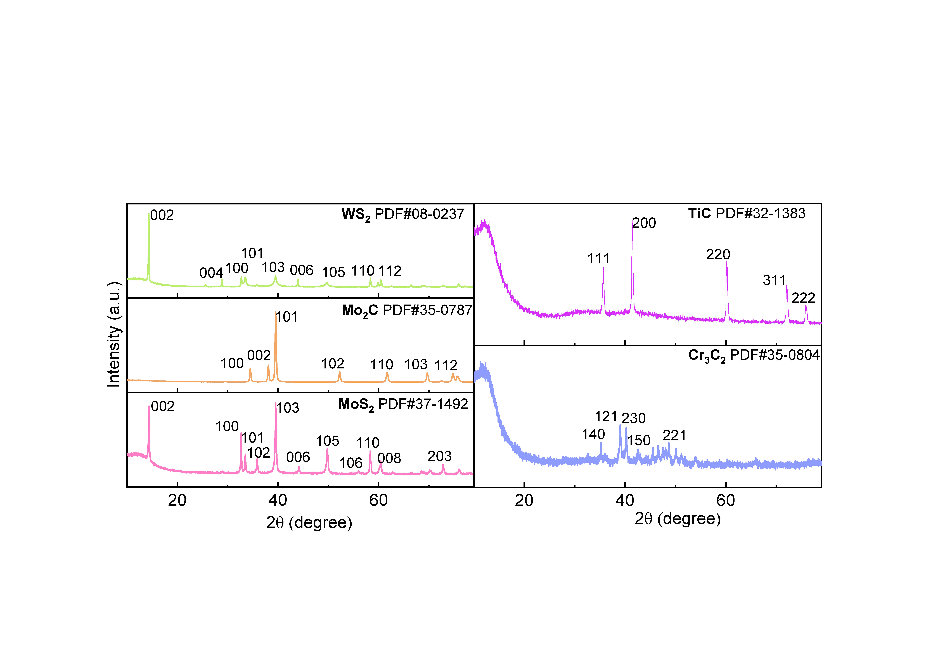
Figure S1. XRD patterns of com-MoS₂, Mo₂C, WS₂, Cr₃C₂ and TiC.

Figure S2. XPS spectra of (A) Mo 3d and S 2p of com-MoS₂, (B) Mo 3d and C 1s of Mo₂C, (C) W 4f and S 2p of WS₂, (D) Cr 3p and C 1s of Cr₃C₂ and (E) Ti 2p and C 1s of TiC.

Figure S3. Gibbs free energy diagrams of hydrogen adsorption on (100) surface and (0001) surface (with S or C vacancy) of MoS₂, Mo₂C, and WS₂ at 413 K. The thermal correction (413K) for H adsorption was computed using VASPKIT1.2. The Mo/W-edge of MoS₂/WS₂ (100) surface was used with 50%-S cover. Please note that in this calculations, the implicit solvation was accounted by VASPSOL module (https://github.com/henniggroup/VASPsol).
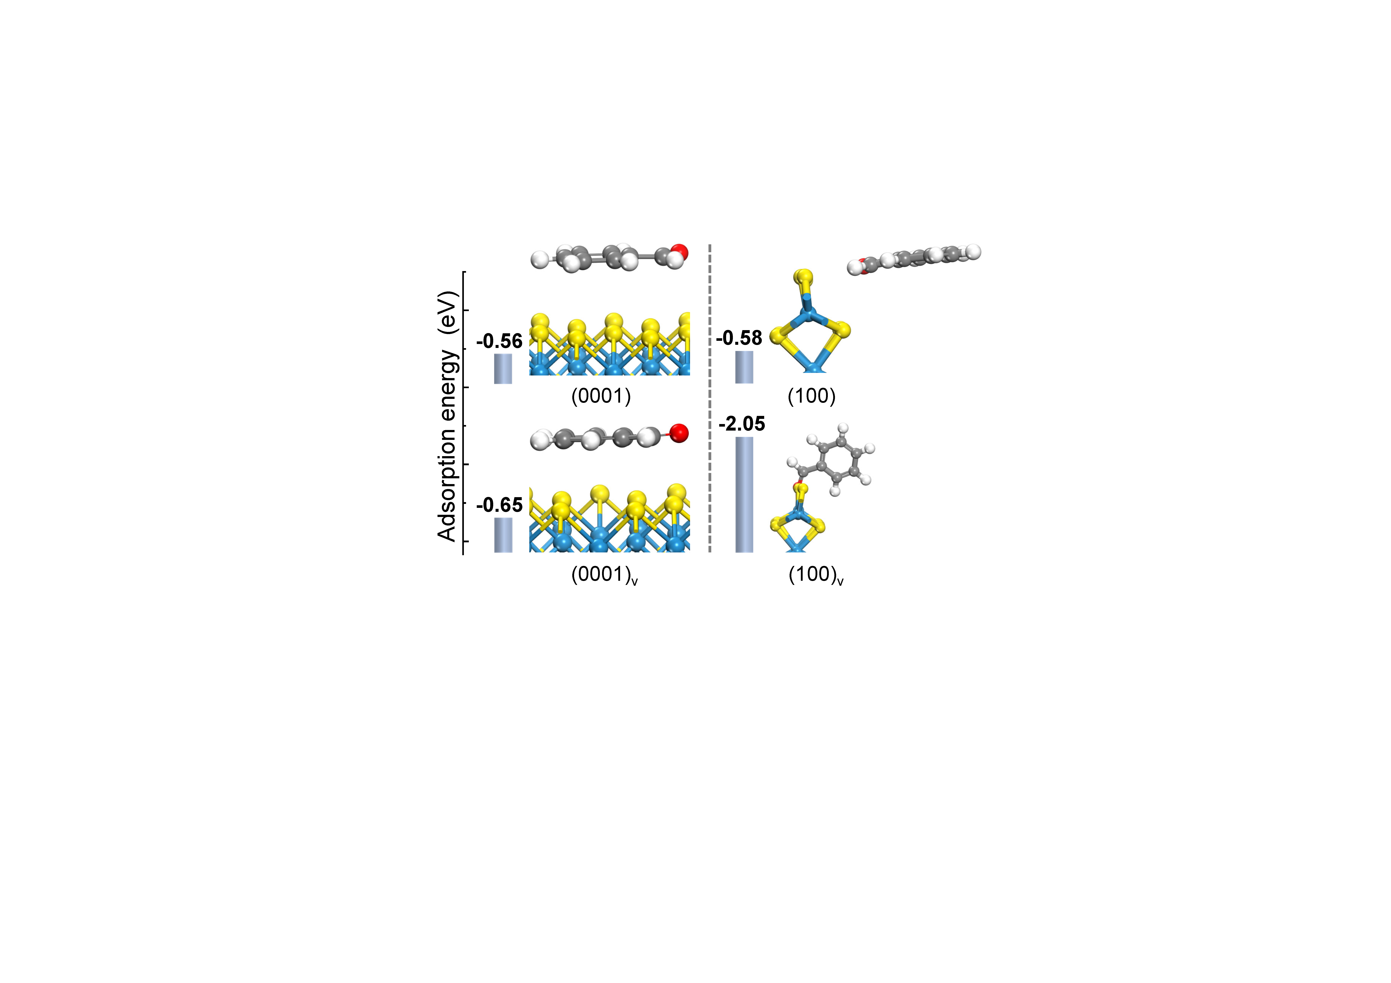
Figure S4. Calculated adsorption configurations and adsorption energies of benzaldehyde on WS₂ (0001) (left) and (100) (right, W edge with 50%-S cover) surface with and without S vacancy. The red, dark, small white, yellow, and blue spheres correspond to O, C, H, S, and W atoms. Please note that in this calculations, the implicit solvation was accounted by VASPSOL module (https://github.com/henniggroup/VASPsol).
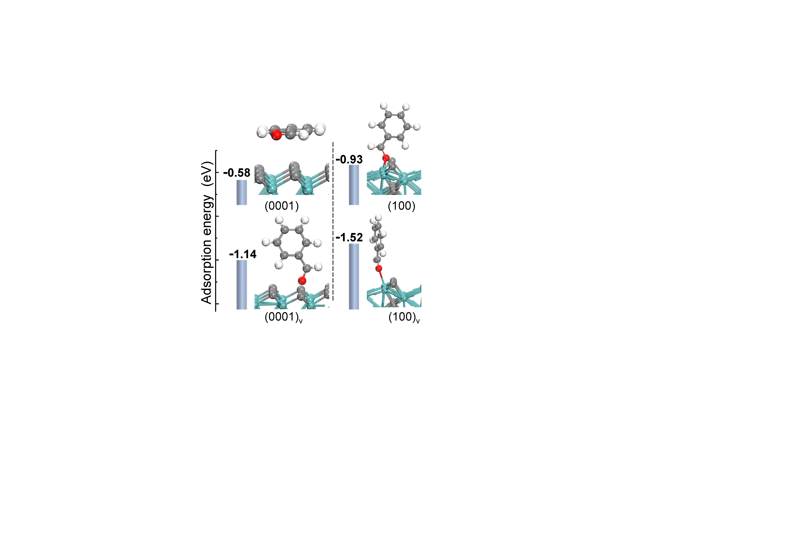
Figure S5. Calculated adsorption configurations and adsorption energies of benzaldehyde on Mo₂C (0001) (left) and (100) (right) surface with and without C vacancy. The red, dark, small white, and green spheres correspond to O, C, H, and Mo atoms. Please note that in this calculations, the implicit solvation was accounted by VASPSOL module (https://github.com/henniggroup/VASPsol).

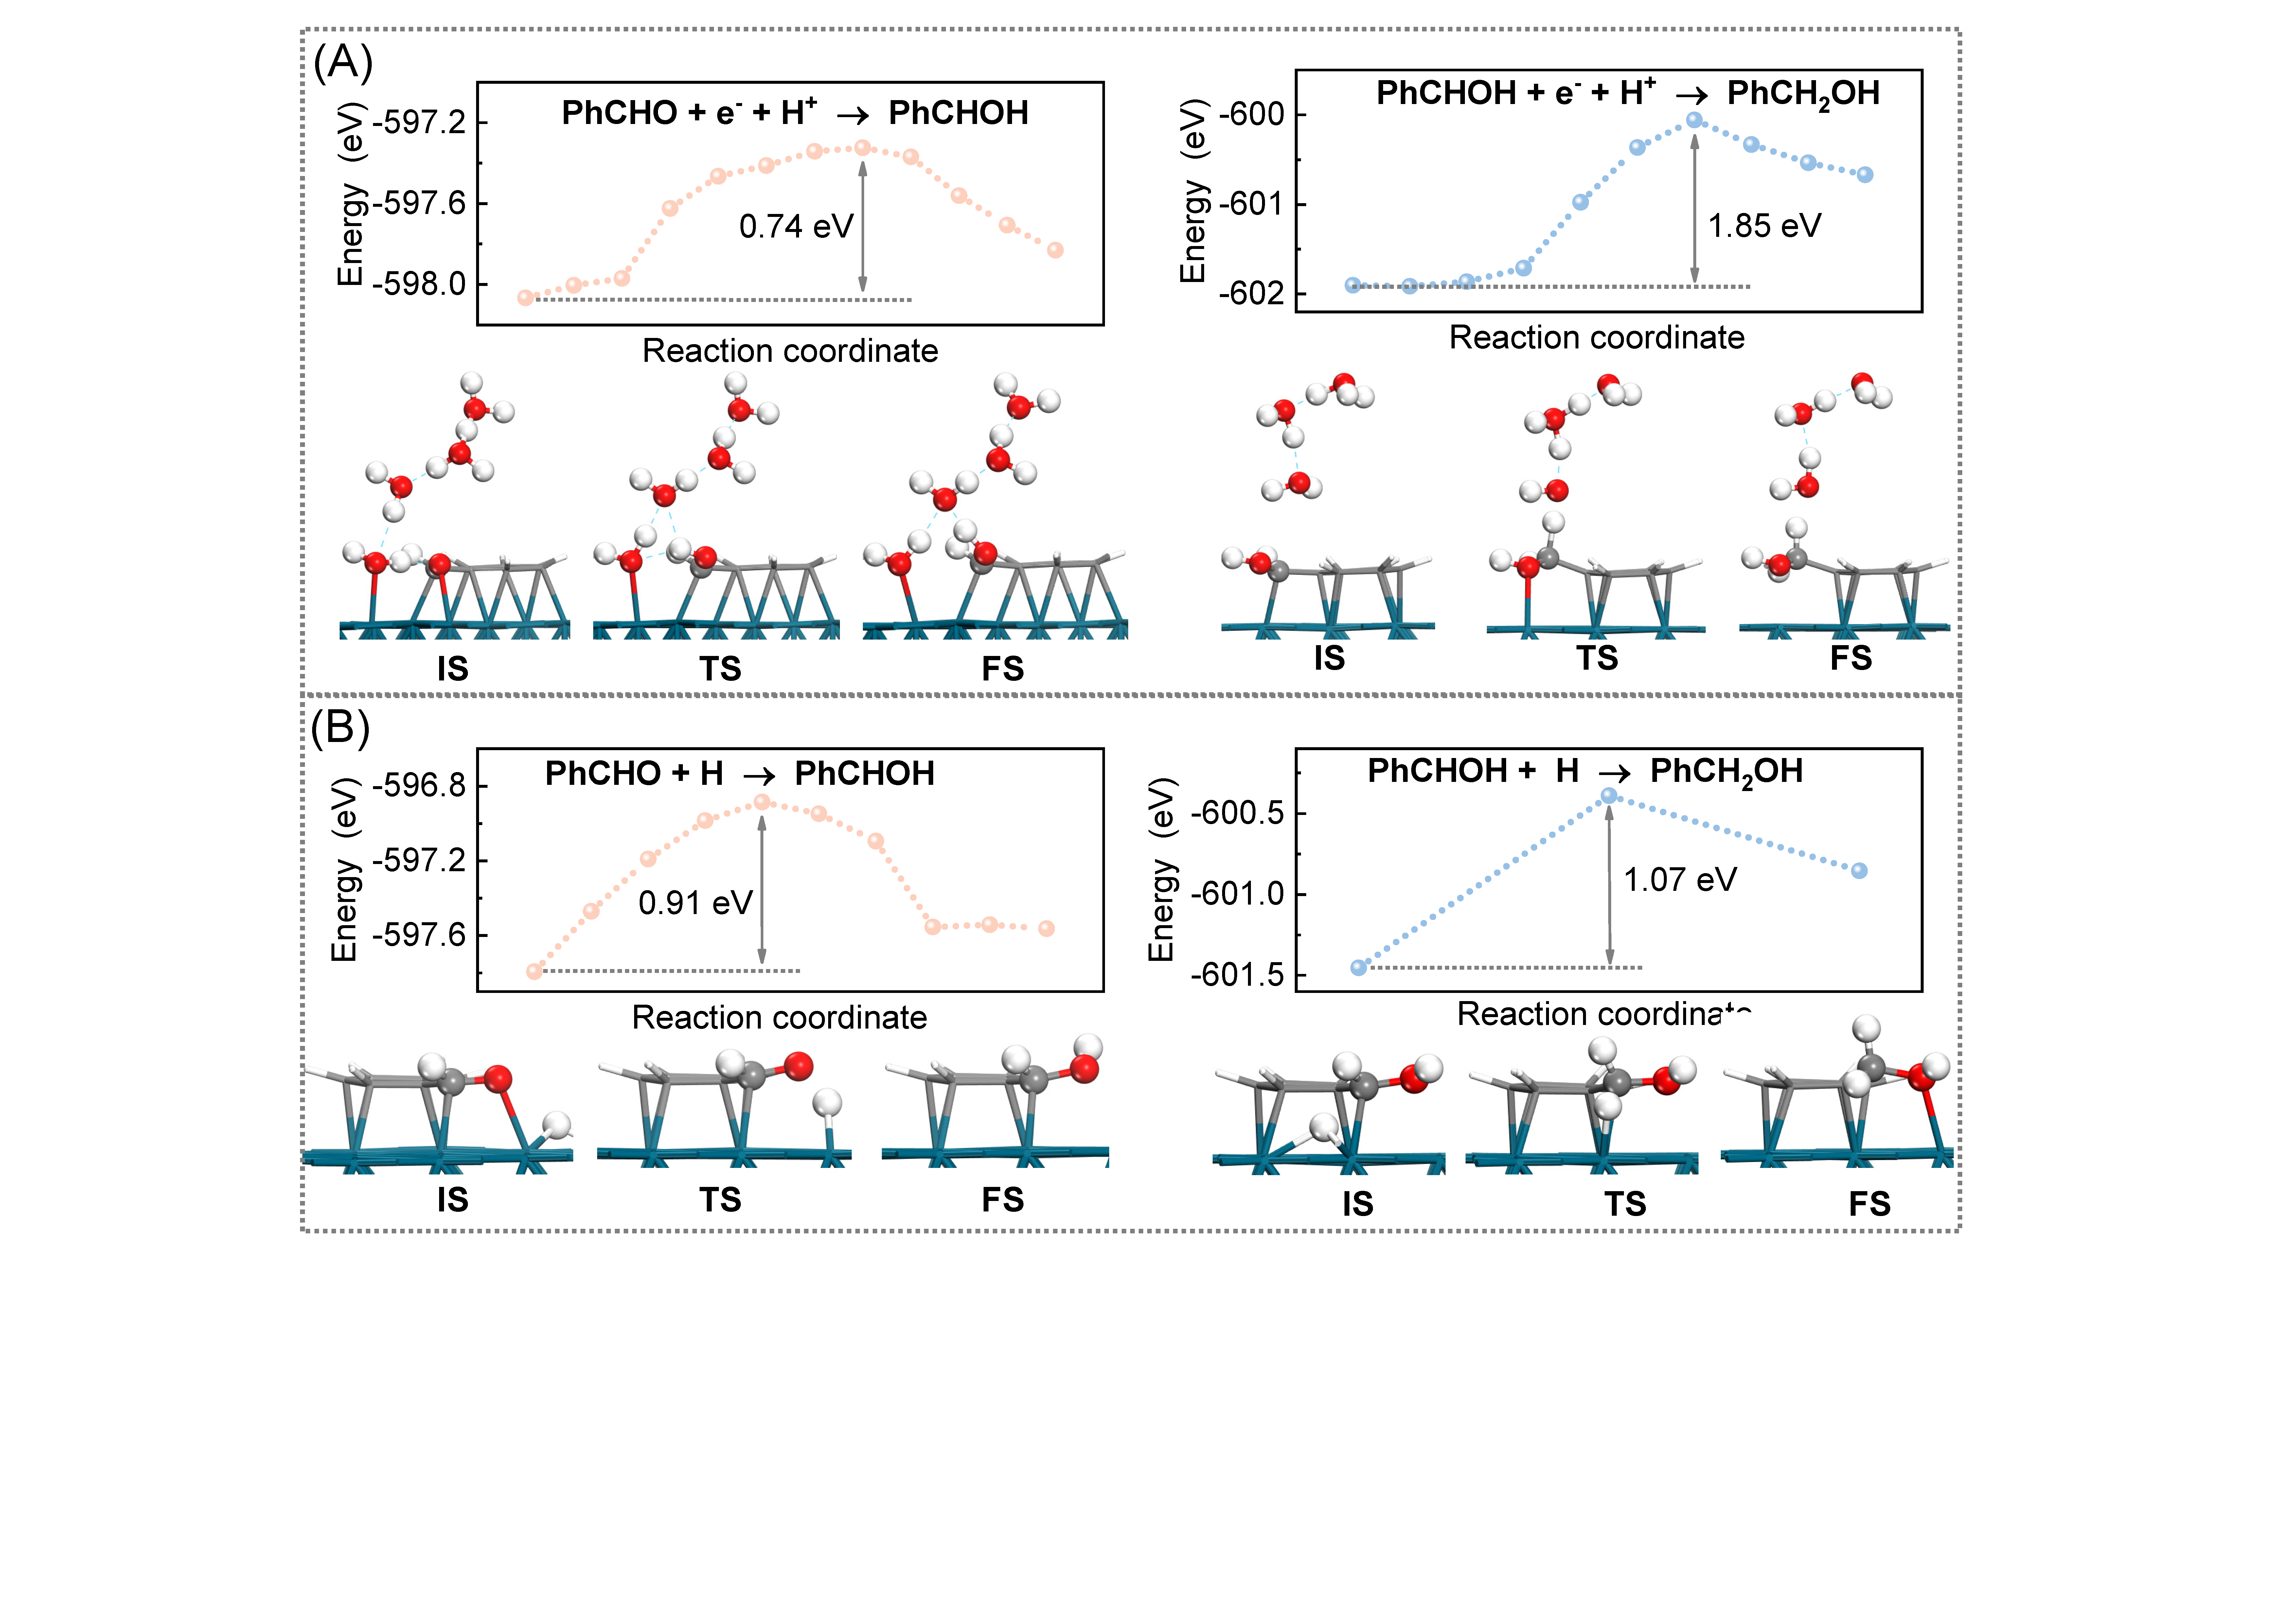
Figure S6. Calculated energy barriers of benzaldehyde hydrogenation to benzyl alcohol on Pd (111) surface via (A) electron-proton addition and (B) H atom addition in water. (Only water molecules that assist the reaction are drawn with ball and stick models while others are not shown. IS: initial state, TS: transition state, FS: final state)

For the data in Figure S6, we investigate the hydrogenation of benzaldehyde to benzyl alcohol on Pd(111) via two competing mechanisms: proton-coupled electron transfer and surface hydrogen addition, using the GPAW package. The Pd(111) surface is modeled as a 3-layer slab in an orthogonal simulation box (11.003 Å × 9.529 Å in the a and b directions), with the bottom two layers fixed during calculations. The system includes one benzaldehyde molecule adsorbed on the surface, along with either a solvated proton (for PCET) or adsorbed hydrogen atom (for H addition), and 21 explicit water molecules to account for solvent effects. The reaction barriers are computed using grand canonical DFT within the solvated jellium method (SJM) implementation in GPAW, with an applied electrode potential of 0.55 V vs SHE (near the reaction's equilibrium potential). We employ the PBE+D3 functional to describe electronic exchange-correlation and van der Waals interactions. Wavefunctions are expanded using LCAO with dzp basis sets, and Brillouin zone integration uses a 2×4×1 Monkhorst-Pack k-point mesh.

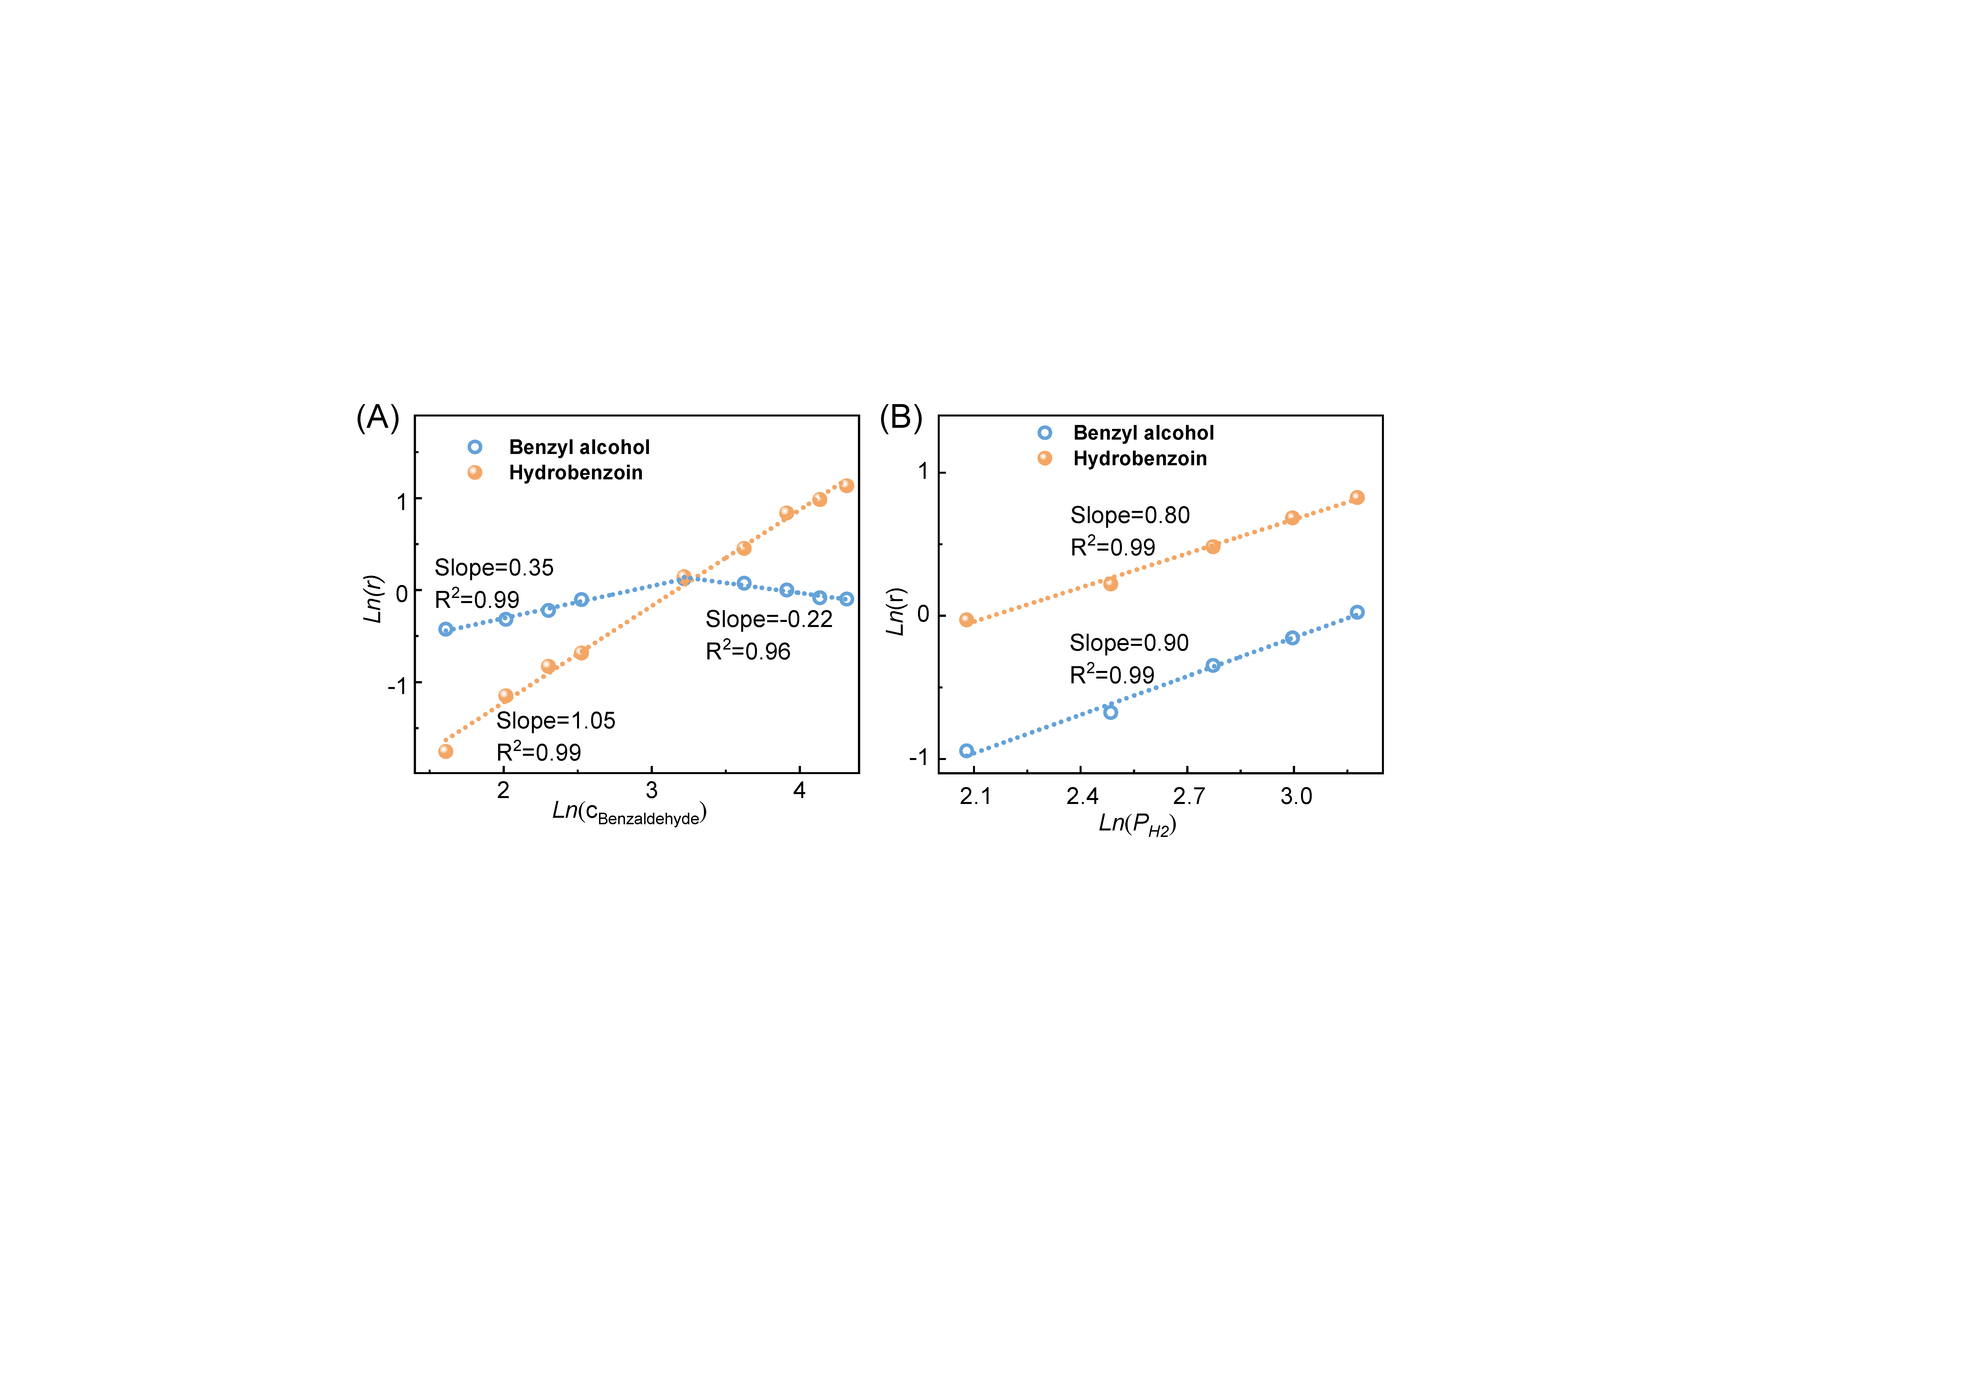
Figure S7. Reaction orders of (A) benzaldehyde and (B) hydrogen for benzyl alcohol and hydrobenzoin generation over com-MoS₂ catalyst.
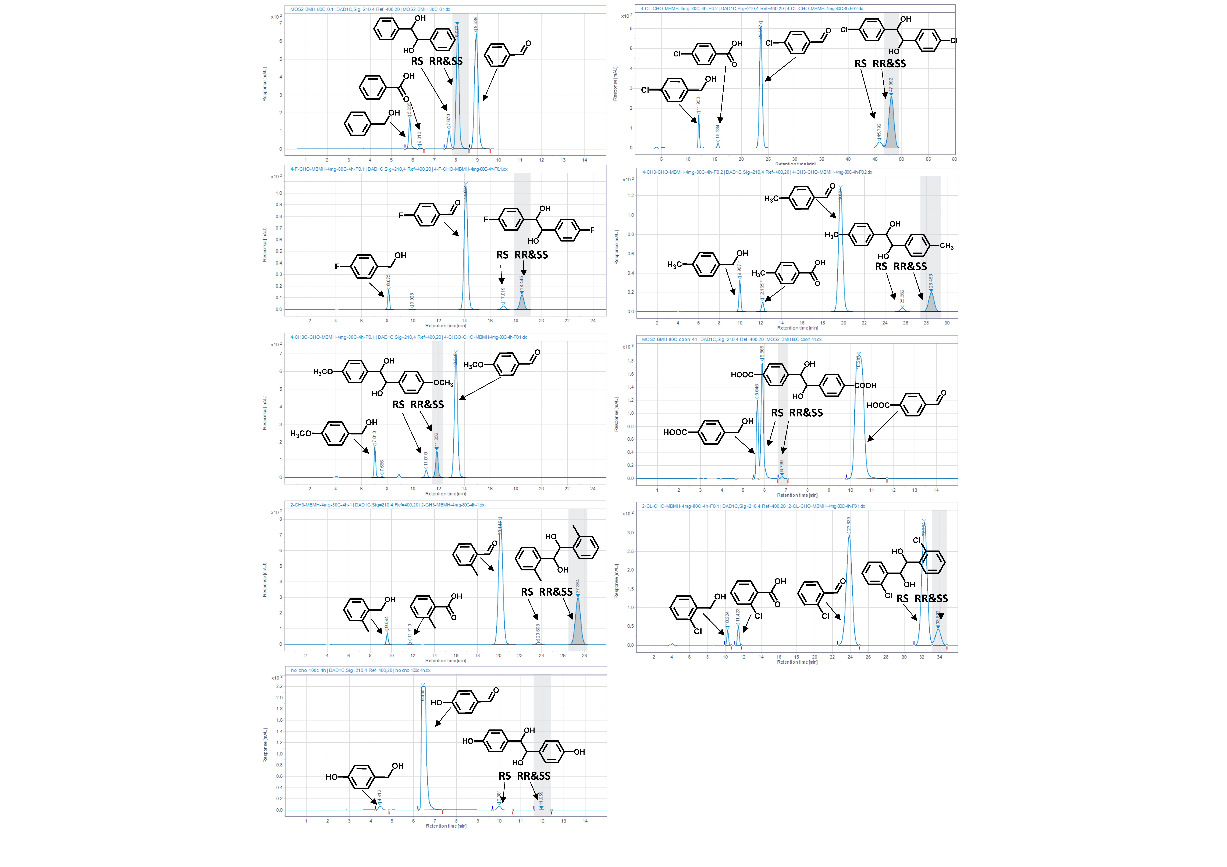
Figure S8. Original HPLC data of product analysis for different substrates. Benzaldehyde (55% A phase, 45% A phase, 0.4 mL∙min⁻¹), 4-chlorobenzaldehyde (65% A phase, 35% A phase, 0.4 mL∙min⁻¹), 4-fluorobenzaldehyde (65% A phase, 35% A phase, 0.4 mL∙min⁻¹), p-tolualdehyde (65% A phase, 35% A phase, 0.4 mL∙min⁻¹), p-Anisaldehyde (65% A phase, 35% A phase, 0.4 mL∙min⁻¹), 4-formylbenzoic acid (75% A phase, 25% A phase, 0.4 mL∙min⁻¹), 2-methylbenzaldehyde(65% A phase, 35% A phase, 0.4 mL∙min⁻¹), 2-chlorobenzaldehyde(65% A phase, 35% A phase, 0.4 mL∙min⁻¹), 4-hydroxybenzaldehyde (65% A phase, 35% A phase, 0.4 mL∙min⁻¹). A phase: 5 mmol∙L⁻¹ sulfuric acid solution, B phase: acetonitrile.

Figure S9. Relationship between the natural logarithm of activity and the substituent constant.
Figure S10. Electrospray ionization mass spectra (ESI-MS) of the solution after radical capture experiment.

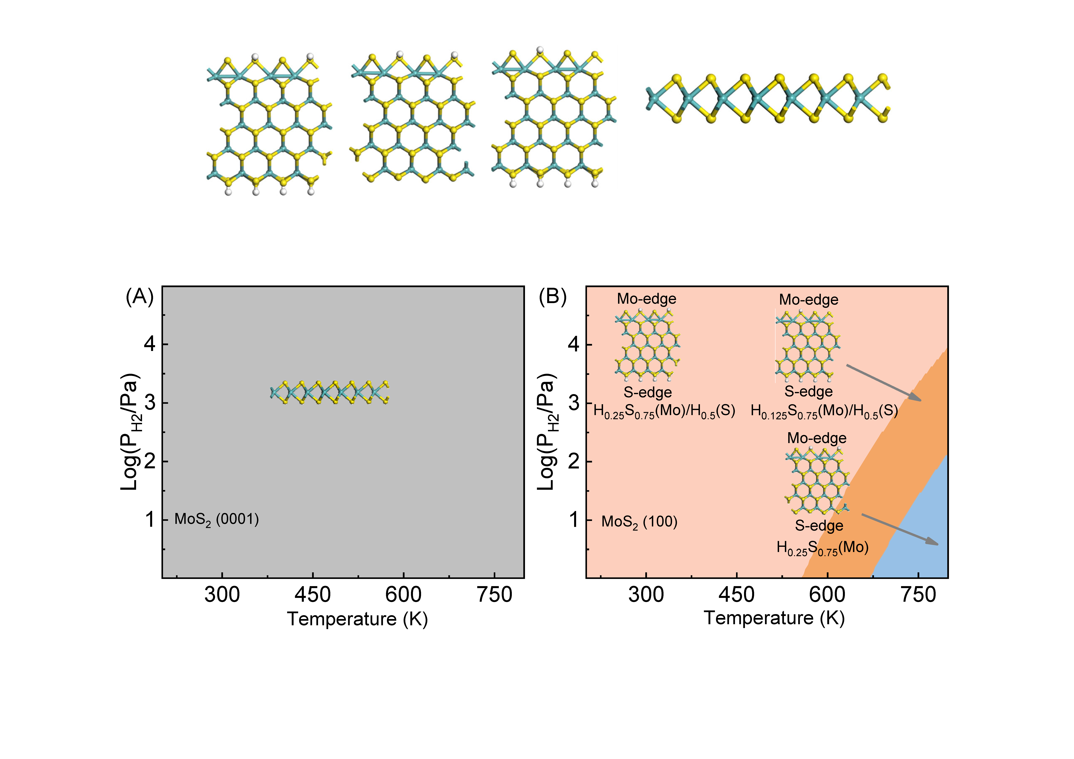
Figure S11. Phase diagrams and structures of two MoS₂ Surfaces. (A) Basal Plane (MoS₂(0001)): The pristine MoS₂(0001) surface remains hydrogen-free across a wide range of H₂ pressures and temperatures. (B) Edge Sites (MoS₂(100)): The Mo edge is sulfur-terminated with a coverage θ_{s} of 0.75. Under typical reaction conditions (T=100℃ and P_{H2}=20 bar), the phase diagram reveals partial hydrogenation of the S-terminated MoS₂ (100) surface (θ_{H}=0.5), while the S-covered Mo edge exhibits a lower hydrogen coverage (θ_{H}=0.25). The corresponding top and bottom views of the atomic models are presented as insets in the figure.

Two MoS₂ surfaces were considered in the calculations: the basal plane (MoS₂(0001)) and the edge sites (MoS₂(100)). For the basal plane, a single S-Mo-S triatomic layer with the stoichiometry Mo₁₆S₃₂ was employed, separated by a thick vacuum layer along the z-direction to prevent periodic interactions. The edge model consisted of a MoS₂ nanoribbon, where the MoS₂ (100) surface featured a sulfur-terminated bottom edge and a molybdenum-terminated top edge. In line with previous studies, 75% sulfur coverage was assumed on the Mo edge.

Given the high hydrogen partial pressure under reaction conditions, assessing the hydrogenation of surface sulfur was critical to mimic the electronic structure of the MoS₂. To this end, varying numbers of hydrogen atoms were introduced onto the dangling bonds of surface sulfur atoms. The resulting phase diagram revealed that the MoS₂ (0001) surface remained hydrogen-free. Half of the sulfur atoms on the S edge of MoS₂ (100) surface were hydrogenated, whereas on the S-covered Mo edge, only isolated sulfur atoms were hydrogenated.

Figure S12. Calculated energy barrier of two radical combination in water.

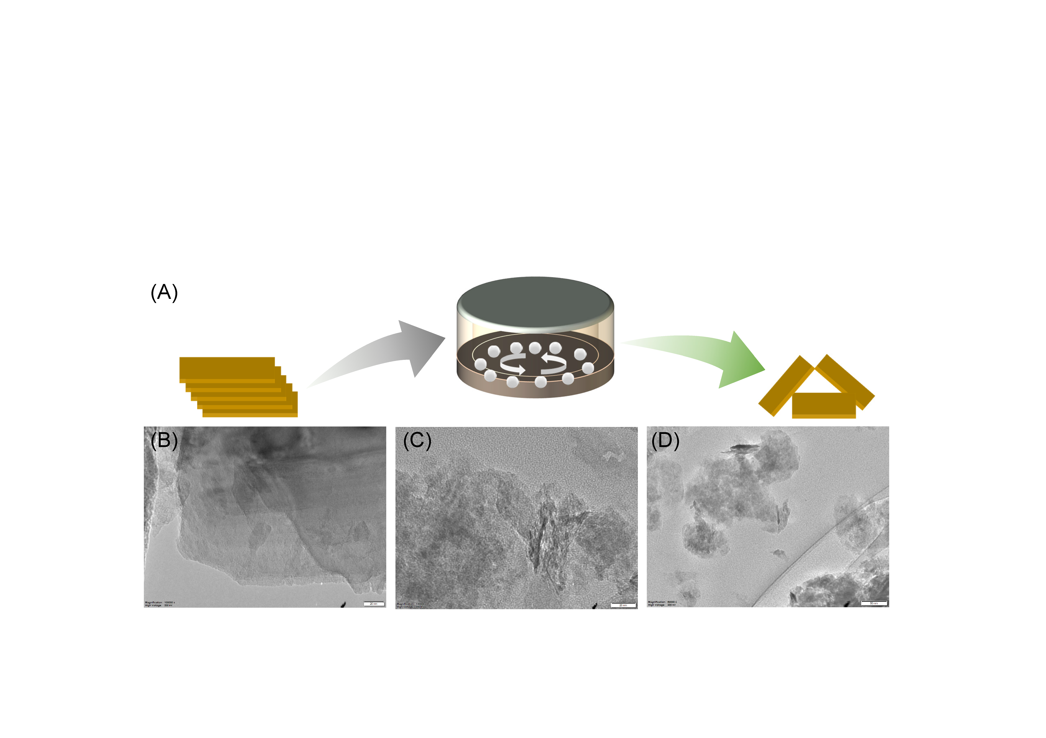
Figure S13. (A) Diagram illustration of ball-milling process, and TEM image of (B) com-MoS₂, (C) bm-MoS₂ and (D) bmh-MoS₂.

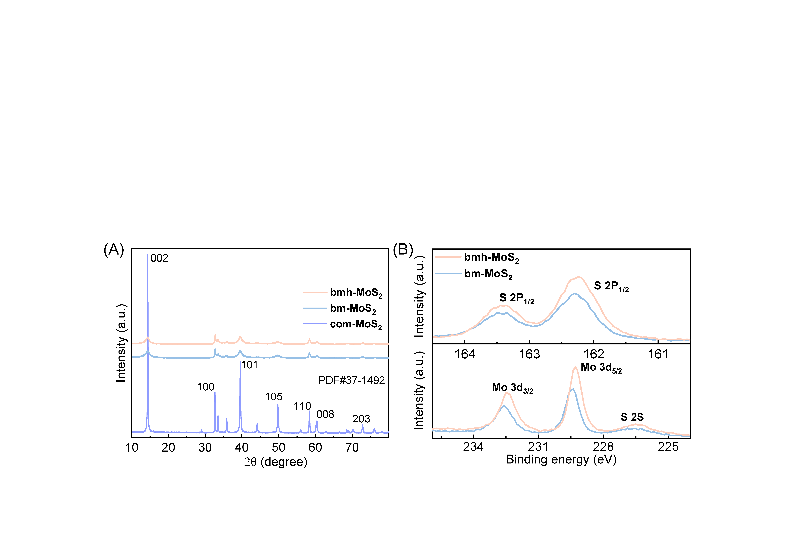
Figure S14. (A) XRD patterns of com-MoS₂, bm-MoS₂ and bmh-MoS₂ and (B) the XPS spectra of Mo 3d and S 2p of com-MoS₂, bm-MoS₂ and bmh-MoS₂.
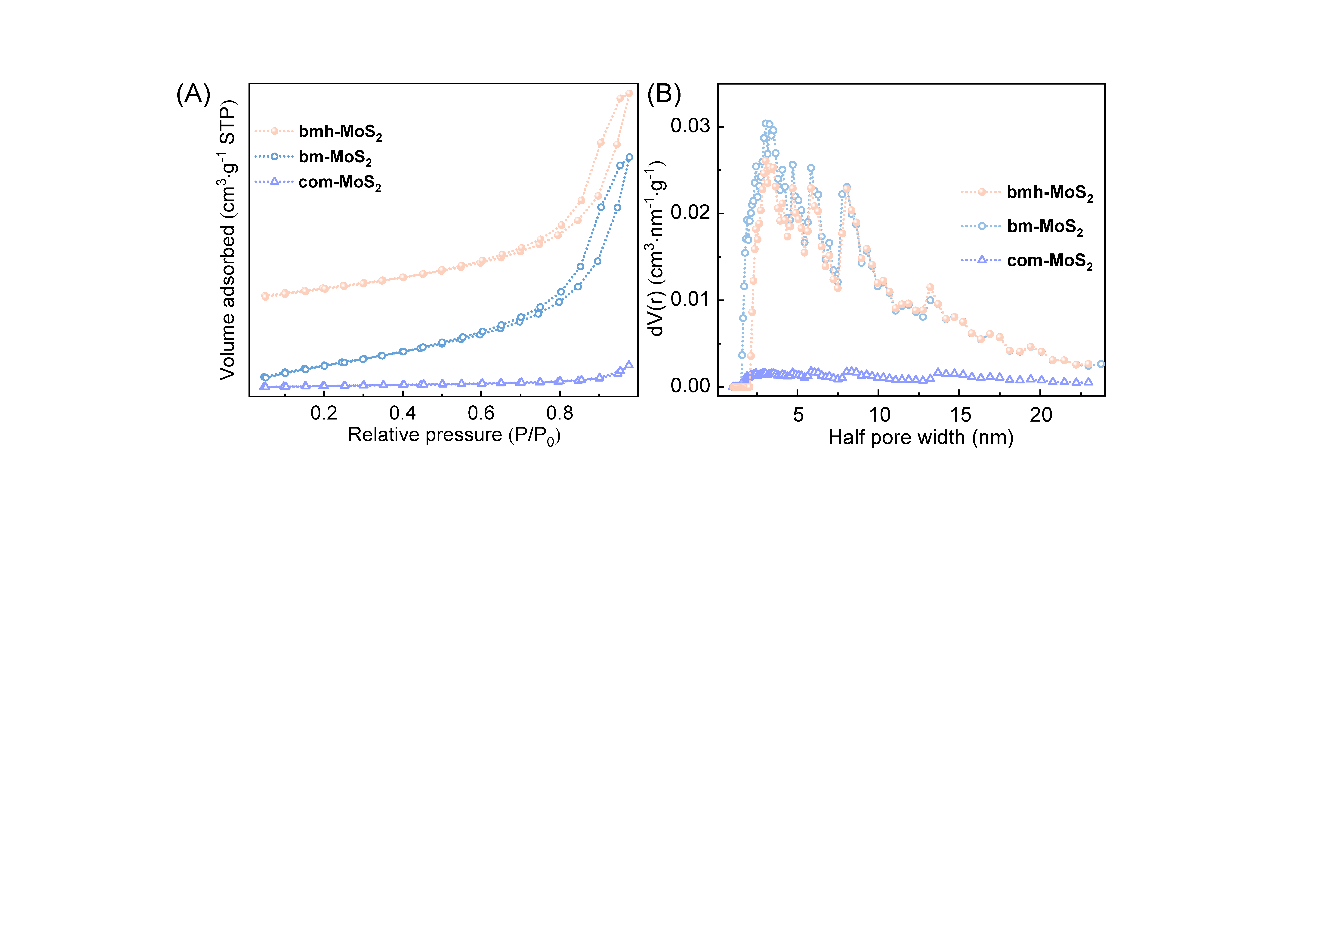
Figure S15. (A) N₂ adsorption-desorption isotherms and (B) Corresponding DFT method-pore size distribution of com-MoS₂, bm-MoS₂ and bmh-MoS₂.

Figure S16. Hydrogen temperature-programmed desorption (TPD) of com-MoS₂, bm-MoS₂ and bmh-MoS₂.

Figure S17. Electron paramagnetic resonance spectra (EPR) of com-MoS₂, bm-MoS₂ and bmh-MoS₂.
ESR spectroscopy revealed that calcination partially suppressed the paramagnetic signals,^{S5,S6} corresponding to Mo-S dangling bonds and Mo⁵⁺ centers introduced during ball milling. These suggest effective passivation of excess defects via heat treatment.
Figure S18. H₂/D₂ exchange experiment of com-MoS₂, bm-MoS₂ and bmh-MoS₂.

Figure S19. Electrochemical impedance spectroscopy (EIS) of com-MoS₂, bm-MoS₂ and bmh-MoS₂.
The EIS spectra were fitted using a two-time-constant equivalent circuit, incorporating solution resistance (Rs), charge transfer resistance (Rct), interfacial resistance between the glassy carbon and the catalyst (Rc), and two constant phase elements (CPEs).^{S7-11} In the Nyquist plots, the larger semicircle at lower frequencies corresponds to Rct, indicative of the electron transfer in materials. For com-MoS₂, Rct was measured at 980 Ω. Ball milling reduced this value to 842 Ω, while subsequent calcination further decreased Rct to 425 Ω, attributed to defect healing, enhanced crystallinity, and better interfacial contact. The overall drop in Rct reflects a pronounced enhancement in the material’s ability to shuttle electrons efficiently.
Figure S20. Activity test (mixture solvent of 10 vol% ethanol and 90 vol% H₂O, 20 bar H₂, 80°C) of com-MoS₂, bm-MoS₂ and bmh-MoS₂.

Figure S21. Performance of bm-MoS₂. r_{H/D}, the reaction rate for H/D exchange reaction; S_{BET}, the specific surface area; G the conductance of material; Sel.,the selectivity of hydrobenzoin; r_{diol}, the generation rate of hydrobenzoin. r_{H/D}, S_{BET}, G and r_{diol} are normalized by the highest value among these values of com-MoS₂, bm-MoS₂ and bmh-MoS₂.
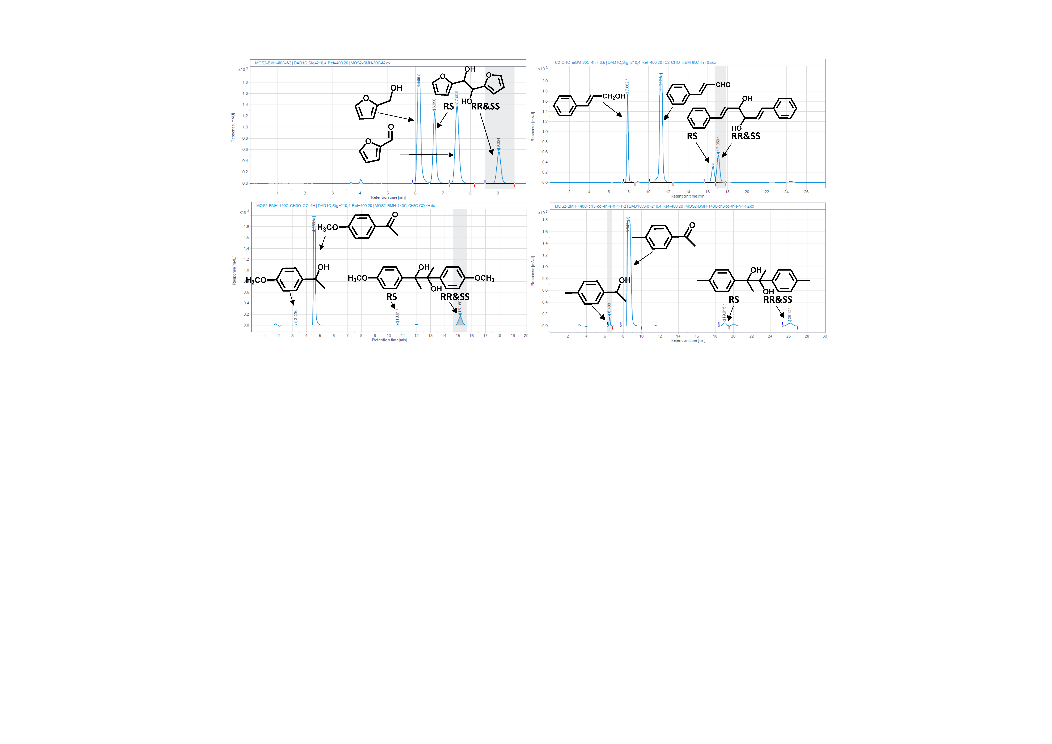
Figure S22. Original HPLC data of product analysis for different substrates, including furfural (75% A phase, 25% A phase, 0.4 mL∙min⁻¹), cinnamaldehyde (55% A phase, 45% A phase, 0.8 mL∙min⁻¹), 4᾽-methoxyacetophenone (55% A phase, 45% A phase, 0.8 mL∙min⁻¹)，4-methylacetophenone (45% A phase, 55% A phase, 0.4 mL∙min⁻¹). A phase: 5 mmol∙L⁻¹ sulfuric acid solution, B phase: acetonitrile.

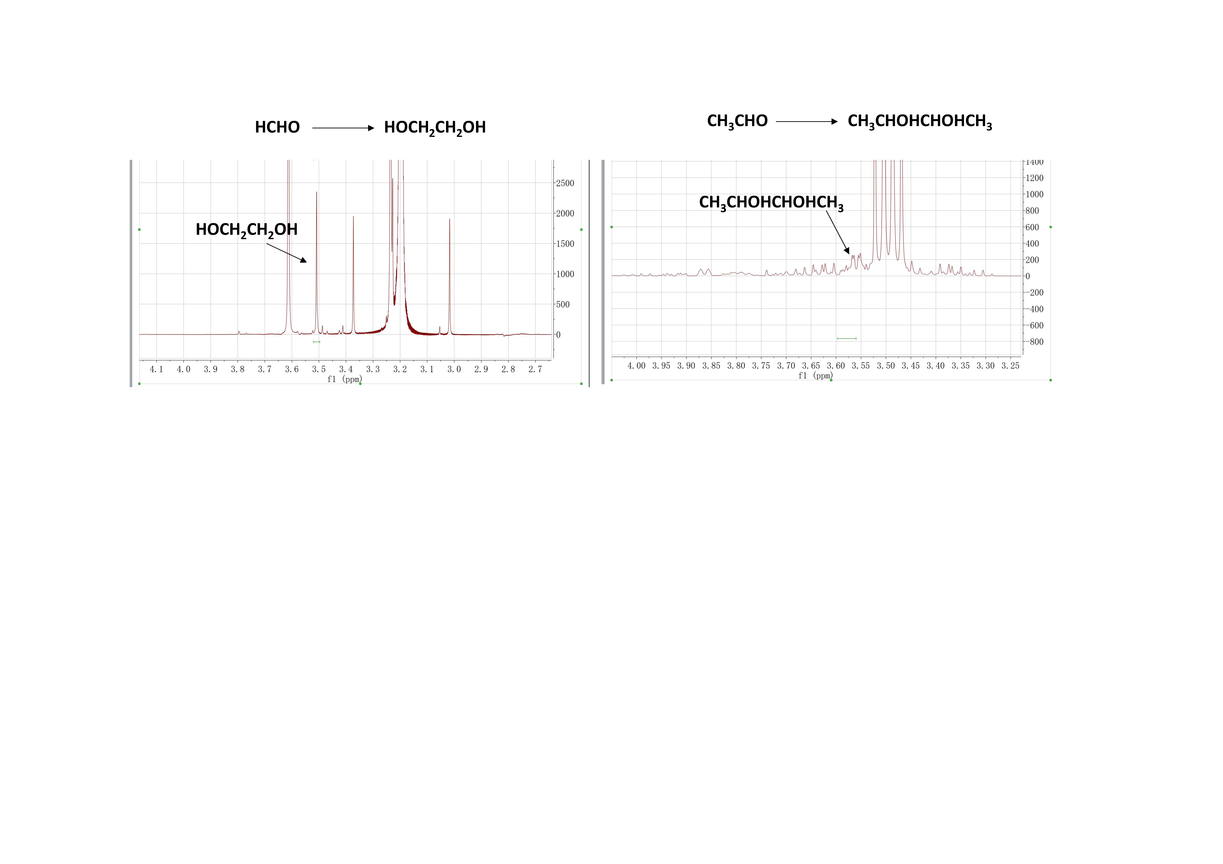
Figure S23. Original NMR data of product analysis for formaldehyde and acetaldehyde coupling using 4-aminobenzaldehyde as the internal standard.
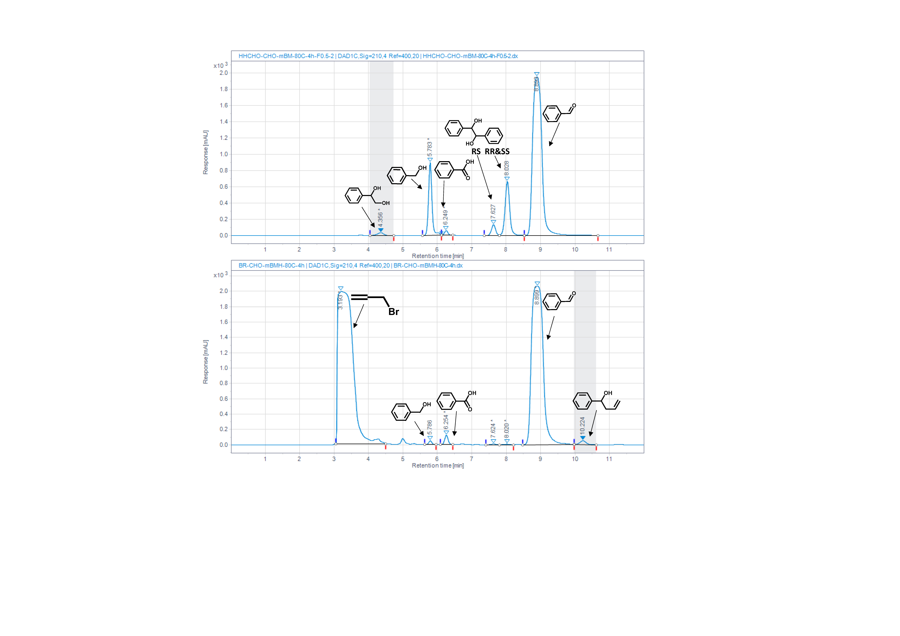
Figure S24. The original HPLC data of product analysis for cross-coupling between formaldehyde and benzaldehyde (55% A phase, 45% A phase, 0.4 mL∙min⁻¹), and Barbier reaction between Allyl bromide and bezaldehyde (55% A phase, 45% A phase, 0.4 mL∙min⁻¹).
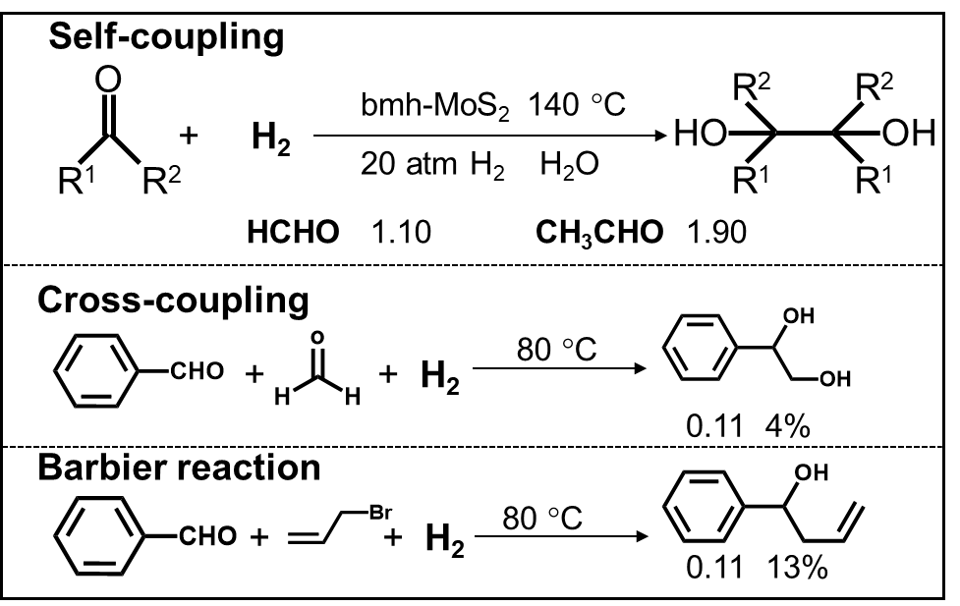
Figure S25. The productivity and selectivity of thermocatalytic coupling of aliphatic aldehydes, cross-coupling and barbier reaction. Productivity (μmol∙h⁻¹) and selectivity (%, on the basis of benzaldehyde units) are indicated beside or below each compound.

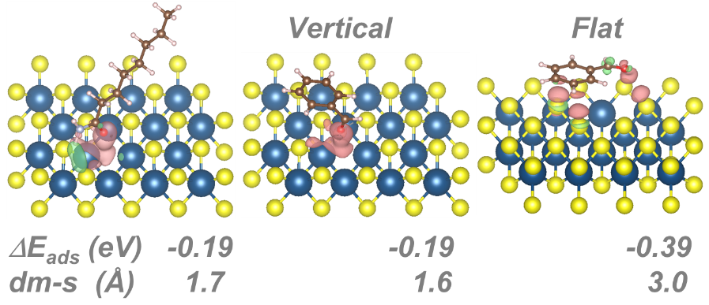
Figure S26. The calculated adsorption configurations and energy of benzaldehyde and octanamide on S vacancy based on MoS₂ (002) surface using PBE-D3 method (the light red zone represents electron accumulation and the green zone means electron depletion in the ball-and-stick model. d_{m-s} represents the distance between benzaldehyde and catalyst surface). Please note that in this calculations, the implicit solvation was accounted by VASPSOL module (https://github.com/henniggroup/VASPsol).

Figure S27. The product distribution and racemic selectivity of benzaldehyde coupling with different compounds as surface modifiers (C3N: Propionamide, C5N: Pentanamide, C8N: Octanamide, C10N: Decanamide, C12N: Dodecanamide, C18N: Octadecanamide, C8S⁻: Sodium octyl sulfate, C8OH: 1-Octanol, C8N⁺: Octyltrimethylammonium bromide, PVP: Polyvinylpyrrolidone).

Table S1. The saturated vapor pressure and the calculated free energy change of reactions using B3LYP+D3 method at100 °C.
Substituent | P_{s} (bar) aldehyde | P_{s} (bar) diol | ΔG (eV)
p-Cl | 0.0337 | 1.31*10⁻⁵ | -0.82
p-CH₃ | 0.0445 | 4.28*10⁻⁵ | -0.67
p-OH | 0.0103 | 1.64*10⁻⁶ | -0.57
p-OCH₃ | 0.0118 | 6.77*10⁻⁶ | -0.59
p-F | 0.0881 | 1.25*10⁻⁴ | -0.90
p-H | 0.0971 | 1.35*10⁻⁴ | -0.66
o-Cl | 0.0357 | 2.29*10⁻⁵ | -0.75
o-CH₃ | 0.0497 | 4.12*10⁻⁵ | -0.70

Table S2. The textural properties of com-MoS₂, bm-MoS₂ and bmh-MoS₂.
Sample | Surface area (m²/g) | Pore volume (cm³/g) | Average Pore radius (nm) | Average Particle radius (nm)
com-MoS₂ | 7.53 | 0.0248 | 6.59 | 181
bm-MoS₂ | 100.5 | 0.259 | 5.16 | 13.6
bmh-MoS₂ | 74.2 | 0.234 | 6.31 | 18.4

Table S3. The fitting resistance of com-MoS₂, bm-MoS₂ and bmh-MoS₂.
Sample | R_{s} (ohm) | R_{ct} (ohm) | R_{w} (ohm)
com-MoS₂ | 33.2 | 980.3 | 31.36
bm-MoS₂ | 44.9 | 841.8 | 242.7
bmh-MoS₂ | 38.1 | 424.9 | 53.1

Reference
(S1) Mathew, K.; Sundararaman, R.; Letchworth-Weaver, K.; Arias, T. A.; Hennig, R. G. Implicit solvation model for density-functional study of nanocrystal surfaces and reaction pathways. J. Chem. Phys. 2014, 140 (8).
(S2) Lu, Y.; Li, H.; Zhu, X.; Zhu, W.; Liu, H. How does halogen bonding behave in solution? A theoretical study using implicit solvation model. J. Phys. Chem.A 2011, 115 (17), 4467-4475.
(S3) VandeVondele, J.; Hutter, J. Gaussian Basis Sets for Accurate calculations on molecular systems in gas and condensed phases. J. Chem. Phys. 2007, 127 (11).
(S4) Grimme, S.; Antony, J.; Ehrlich, S.; Krieg, H. A Consistent and accurate ab initio parametrization of density functional dispersion correction (DFT-D) for the 94 Elements H-Pu. J. Chem. Phys. 2010, 132 (15).
(S5) Yin, Y.; Han, J.; Zhang, Y.; Zhang, X.; Xu, P.; Yuan, Q.; Samad, L.; Wang, X.; Wang, Y.; Zhang, Z.; Zhang, P.; Cao, X.; Song, B.; Jin, S. Contributions of phase, sulfur vacancies, and edges to the hydrogen evolution reaction catalytic activity of porous molybdenum disulfide nanosheets. J. Am. Chem. Soc. 2016, 138, 7965-7972.
(S6) Bau, J. A.; Emwas, A.; Nikolaienko, P.; Aljarb, A. A.; Tung, V.; Rueping, M. Mo³⁺ hydride as the common origin of H₂ evolution and selective NADH regeneration in molybdenum sulfide electrocatalysts. Nat. Catal. 2022, 5, 397-404.
(S7) Chen, W.; Wang, C.; Sasaki, K.; Marinkovic, N.; Xu, W.; Muckerman, J. T.; Zhu, Y.; Adzic, R. R. Highly active and durable nanostructured molybdenum carbide electrocatalysts for hydrogen production. Energy Environ. Sci. 2013, 6, 943.
(S8) Vrubel, H.; Moehl, T.; Grätzel, M.; Hu, X. Revealing and accelerating slow electron transport in amorphous molybdenum sulphide particles forhydrogen evolution reaction. Chem. Commun. 2013, 49, 8985.
(S9) Feng, L.; Vrubel, H.; Bensimon M.; a Hu, X. Easily-prepared dinickel phosphide (Ni₂P) nanoparticles as an efficient and robust electrocatalyst for hydrogen evolution. Phys. Chem. Chem. Phys. 2014, 16, 5917.
(S10) Murthy, A. P.; Theerthagiri, J.; Madhavan, J.; Murugan, K. Highly active MoS₂/carbon electrocatalysts for the hydrogen evolution reaction-insight into the effect of the internal resistance and roughness factor on the Tafel slope. Phys. Chem. Chem. Phys. 2017, 19, 1988.
(S11) Yu, X.; Yang, P.; Chen, S.; Zhang, M.; Shi, G. NiFe alloy protected silicon photoanode for efficient water splitting. Adv. Energy Mater. 2017, 7, 1601805.

