Mechanistic investigation of flavonoid-mediated inhibition of N-methyl-N-nitrosourea-induced mutagenicity via noncovalent DNA binding
Chisato Matsuoka, Nao Takatama, Takuya Muraoka and Keiko Inami*

Contents
Figure S1. | UV-Visible spectra of the test compounds with increasing DNA concentration | S1
Table S1 | Noncovalent binding constants for the compound-DNA complexes at various temperature | S2
Table S2 | Free energy values for the compound-DNA complexes at various temperature | S2
Table S3 | Thermodynamic parameter for the compound-DNA complexes | S2
Table S4 | Mutagenicity of licoricidin against MNU in S. typhimurium TA1535 | S2
Table S5 | Mutagenicity of isoliquiritigenin MNU in S. typhimurium TA1535 | S3
Table S6 | Mutagenicity of 4’,6,7-trihydroxyisoflavone against MNU in S. typhimurium TA1535 | S3
Table S7 | Mutagenicity of glycyrrhetinic acid against MNU in S. typhimurium TA1535 | S3
Table S8 | Mutagenicity of ethidium bromide against MNU in S. typhimurium TA1535 | S4
Table S9 | Mutagenicity of Hoechst 33258 against MNU in S. typhimurium TA1535 | S4
Table S10 | LC instrument conditions for DNA adducts | S4
Table S11 | MS instrument conditions for DNA adducts | S5
Table S12 | Stability of DNA adducts in the presence of the compounds | S5
Table S13 | Stability of DNA adducts under acid hydrolysis conditions | S6
Table S14 | Quantification of O⁶-MeG and N³-MeA in the reaction mixture of MNU and licoricidin | S6
Table S15 | Quantification of O⁶-MeG and N³-MeA in the reaction mixture of MNU and isoliquiritigenin | S6
Table S16 | Quantification of O⁶-MeG and N³-MeA in the reaction mixture of MNU and 4’,6,7-trihydroxyisoflavone | S7
Table S17 | Quantification of O⁶-MeG and N³-MeA in the reaction mixture of MNU and glycyrrhetinic acid | S7
Table S18 | Quantification of O⁶-MeG and N³-MeA in the reaction mixture of MNU and ethidium bromide | S7
Table S19 | Quantification of O⁶-MeG and N³-MeA in the reaction mixture of MNU and Hoechst 33258 | S8
Table S20 | Decrease of MNU | S8
Table S21 | Decrease of MNU in the presence of licoricidin or isoliquiritigenin | S8
Table S22 | Decrease of MNU in the presence of 4’,6,7-trihydroxyisoflavone or glycyrrhetinic acid | S9
Table S23 | Decrease of MNU in the presence of ethidium bromide or Hoechst 33258 | S9
Figure S2. | Plots of ln (MNU) versus time | S10
Table S24 | Quantification of the remaining licoricidin in the presence and absence of MNU | S11
Table S25 | Quantification of the remaining isoliquiritigenin in presence and absence of MNU | S11
Table S26 | Quantification of the remaining 4’,6,7-trihydroxyisoflavone in the presence and absence of MNU | S12
Table S27 | Quantification of the remaining glycyrrhetinic acid in presence and absence of MNU | S12
References |  | S12

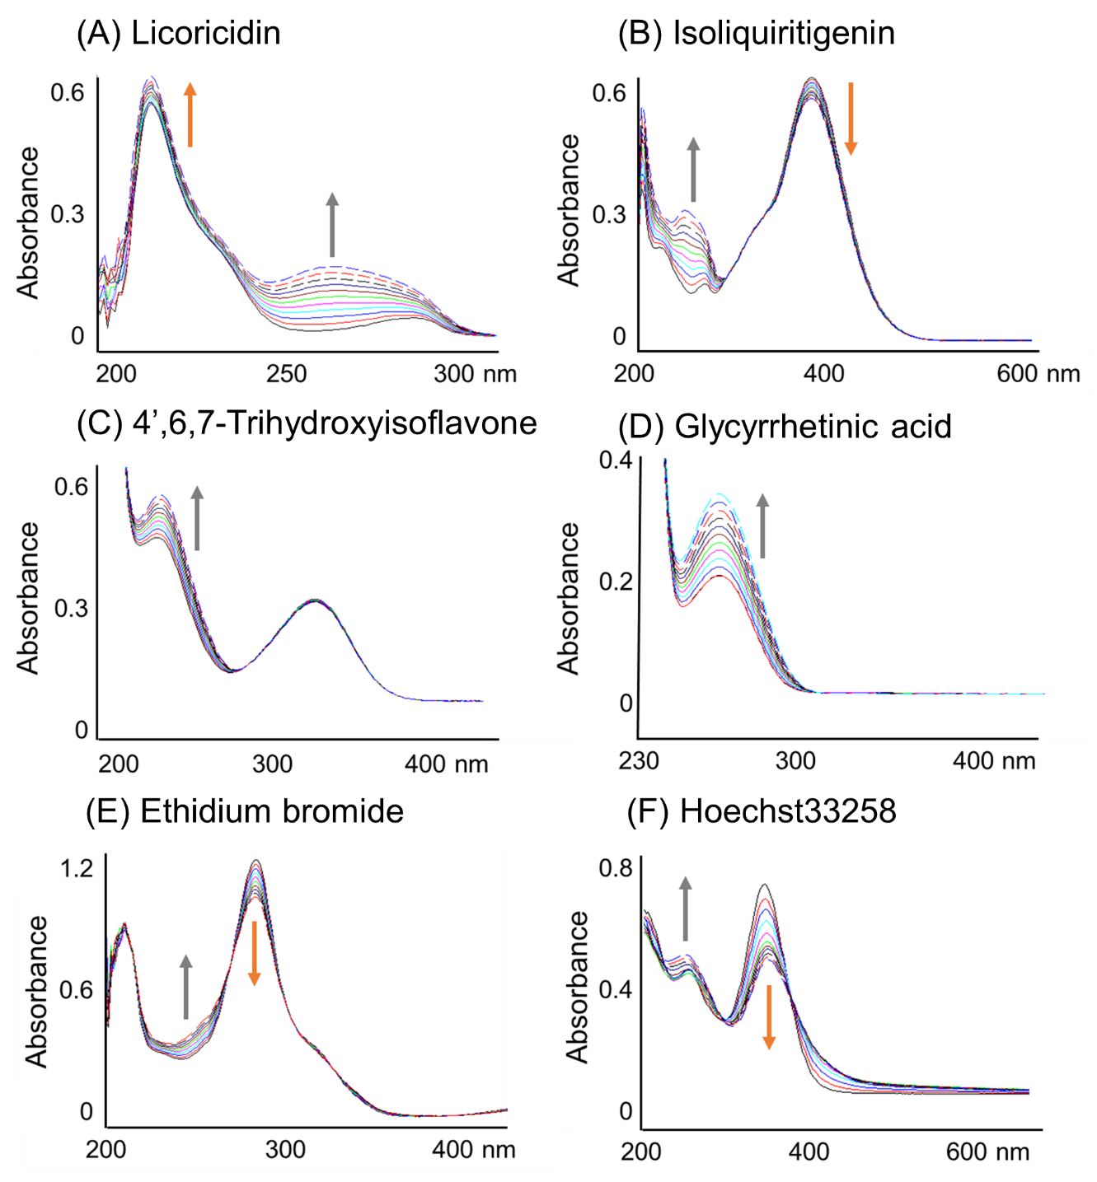

Figure S1. UV-Visible spectra of the test compounds with increasing DNA concentration
Arrows indicates direction of absorbance changes upon increasing amounts of DNA.
Table S1 Noncovalent binding constants (M⁻¹) for compound-DNA complexes at various temperature
Temp. (K) | Licoricidin  (λ= 210 nm) | Isoliquiritigenin  (λ= 395 nm) | ethidium bromide  (λ= 285 nm) | Hoechst 33258  (λ= 340 nm)
293 | 1.32×10⁵±0.11 | 8.66×10⁴±0.20 | 7.86×10⁴±0.15 | 4.84×10⁵±0.21
298 | 1.19×10⁵±0.09 | 8.27×10⁴±0.55 | 8.14×10⁴±0.03 | 3.78×10⁵±0.32
310 | 1.09×10⁵±0.04 | 8.77×10⁴±0.51 | 8.43×10⁴±0.16 | 2.83×10⁵±0.11
313 | 8.80×10⁴±0.04 | 8.69×10⁴±0.29 | 8.79×10⁴±0.13 | 2.07×10⁵±0.22
318 | 7.48×10⁴±0.08 | 8.63×10⁴±0.09 | 9.14×10⁴±0.09 | 1.40×10⁵±0.21

Table S2 Free energy values for compound-DNA complexes at various temperature
温度 (K) | ΔG (kJ/mol)
温度 (K) | licoricidin | isoliquiritigenin | ethidium bromide | Hoechst 33258
293 | -12.83 | -27.73 | -27.45 | -31.88
298 | -12.75 | -28.20 | -28.00 | -31.77
303 | -12.66 | -28.68 | -28.55 | -31.66
310 | -12.53 | -29.34 | -29.32 | -31.50
318 | -12.39 | -30.01 | -30.19 | -31.33

Table S3 Thermodynamic parameters for compound-DNA complexes
 | licoricidin | isoliquiritigenin | ethidium bromide | Hoechst 33258
ΔH (kJ/mol) | -17.99 | 0.05 | 4.69 | -38.33
ΔS (J/mol) | -17.60 | 94.64 | 109.70 | -22.02

Table S4 Mutagenicity of licoricidin against MNU in S. typhimurium TA1535
Concentration | Revertants/plate | Survival (%) |  | MF
(µmol/plate) | Colonies ± SE | Colonies ± SE | Survival rate (%) | (%)
0 | 1496 ± 22 | 536 ± 14 | 100.0 | 100.0
0.05 | 1205 ± 15 | 511 ± 3 | 95.3 | 84.5
0.1 | 917 ± 51 | 508 ± 41 | 94.8 | 64.7
0.2 | 494 ± 87 | 480 ± 16 | 89.5 | 36.9
0.4 | 263 ± 56 | 509 ± 21 | 95.0 | 18.5
0.5 | 166 ± 24 | 508 ± 20 | 94.8 | 11.7
DMSO | 4 ± 3 | 525 ± 17 | 97.9
MNU (1.5 µmol/plate)

Table S5 Mutagenicity of isoliquiritigenin against MNU in S. typhimurium TA1535
Concentration | Revertants/plate | Survival (%) |  | MF
(µmol/plate) | Colonies ± SE | Colonies ± SE | Survival rate (%) | (%)
0 | 1517 ± 41 | 503 ± 20 | 100.0 | 100.0
0.25 | 1336 ± 75 | 501 ± 40 | 99.6 | 89.0
0.5 | 1175 ± 111 | 513 ± 12 | 102.0 | 75.9
1.0 | 459 ± 152 | 492 ± 16 | 97.8 | 30.7
1.5 | 99 ± 22 | 493 ± 26 | 97.9 | 6.6
2.0 | 44 ± 2 | 503 ± 29 | 99.9 | 2.9
DMSO | 13 ± 1 | 483 ± 20 | 96.0
MNU (1.5 µmol/plate)

Table S6 Mutagenicity of 4’,6,7-trihydroxyisoflavone against MNU in S. typhimurium TA1535
Concentration | Revertants/plate | Survival (%) |  | MF
(µmol/plate) | Colonies ± SE | Colonies ± SE | Survival rate (%) | (%)
0 | 1482 ± 42 | 483 ± 24 | 100.0 | 100.0
1.0 | 1472 ± 94 | 452 ± 9 | 93.7 | 106.0
2.0 | 1545 ± 101 | 462 ± 19 | 95.6 | 109.0
4.0 | 1660 ± 36 | 469 ± 15 | 97.1 | 115.3
6.0 | 1429 ± 60 | 466 ± 26 | 96.5 | 99.9
8.0 | 1533 ± 31 | 467 ± 35 | 96.8 | 106.9
DMSO | 9 ± 3 | 461 ± 36 | 95.4
MNU (1.5 µmol/plate)

Table S7 Mutagenicity of glycyrrhetinic acid against MNU in S. typhimurium TA1535
Concentration | Revertants/plate | Survival (%) |  | MF
(µmol/plate) | Colonies ± SE | Colonies ± SE | Survival rate (%) | (%)
0 | 1270 ± 51 | 495 ± 23 | 100.0 | 100.0
0.5 | 1290 ± 48 | 523 ± 46 | 105.7 | 96.1
1.0 | 1218 ± 13 | 486 ± 24 | 98.2 | 97.6
2.0 | 1220 ± 16 | 488 ± 20 | 98.6 | 95.8
2.5 | 1223 ± 32 | 503 ± 30 | 101.8 | 94.6
3.0 | 1085 ± 59 | 471 ± 15 | 95.1 | 89.7
DMSO | 14 ± 2 | 544 ± 24 | 109.9
MNU (1.5 µmol/plate)

Table S8 Mutagenicity of ethidium bromide against MNU in S. typhimurium TA1535
Concentration | Revertants/plate | Survival (%) |  | MF
(µmol/plate) | Colonies ± SE | Colonies ± SE | Survival rate (%) | (%)
0 | 1546 ± 60 | 476 ± 15 | 100.0 | 100.0
0.25 | 1687 ± 36 | 496 ± 8 | 104.3 | 104.6
0.5 | 1729 ± 99 | 509 ± 10 | 107.0 | 104.5
1.0 | 699 ± 103 | 482 ± 46 | 101.3 | 44.6
1.5 | 91 ± 17 | 460 ± 39 | 96.9 | 6.1
2.0 | 10 ± 3 | 454 ± 41 | 95.4 | 0.7
DMSO | 14 ± 5 | 490 ± 29 | 102.9
MNU (1.5 µmol/plate)

Table S9 Mutagenicity of Hoechst 33258 against MNU in S. typhimurium TA1535
Concentration | Revertants/plate | Survival (%) |  | MF
(µmol/plate) | Colonies ± SE | Colonies ± SE | Survival rate (%) | (%)
0 | 1517 ± 38 | 437 ± 19 | 100.0 | 100.0
0.25 | 1364 ± 46 | 434 ± 10 | 99.2 | 90.7
0.5 | 1021 ± 87 | 414 ± 7 | 94.7 | 71.1
1.0 | 890 ± 33 | 386 ± 9 | 88.3 | 66.5
1.5 | 783 ± 7 | 367 ± 9 | 84.0 | 61.4
2.0 | 363 ± 33 | 364 ± 12 | 83.2 | 28.8
DMSO | 8 ± 2 | 450 ± 16 | 103.0
MNU (1.5 µmol/plate)

Table S10 LC Instrument conditions for DNA adducts
LC | Agilent Technologies 1260 Infinity II System
Analytical column | Phenomenex Luna HILIC, 4.6 mm×150 mm (5 µm)
Column temperature | 40°C
Injection volume | 1 µL
Mobile phase | A) 80% Water containing 0.1% formic acid
 | B) 20% Methanol containing 0.1% formic acid
Flow rate | 0.2 mL/min
Stop time | 10 min
Post time | 10 min
Detection | Guanine, Adenine; 260 nm

Table S11 MS Instrument conditions for DNA adducts^{1,2)}
MS | Agilent 6470 Triple quadruple LC/MS System
Gas temperature | 120°C
Gas flow | 12 L/min
Nebulizer | 50 psi
Sheath gas temperature | 400°C
Sheath gas flow | 12 L/min
Capillary voltage | 3500 V
Nozzle voltage | 0 V
Cycle time | 500 ms
Total MRMs | 10
Mass transitions  (precursor to product) | O⁶-MeG; m/z 166.1 > 149.0  N³-MeA; m/z 150.0 > 123.0

【Stability of DNA adducts (O⁶-MeG, N³-MeA) in the presence of the test compounds 】
O⁶-MeG (5 mM) and N³-MeA (5 mM) were dissolved in methanol. The each solutions were diluted with 5% aqueous formic acid solution to make 10 μM concentrations.
O⁶-MeG (3.6 μM in 5% aqueous formic acid solution), N³-MeA (3.6 μM in 5% aqueous formic acid solution), a test compound (3.6 μM in DMSO) were prepared. Each solution (100 μL; final concentration 1.2 μM) were mixed and incubated for 16 h at 37°C. DMSO (100 μL) was used instead of the compound solution as a control. The solutions were analyzed LC-MS/MS (Table S10 and S11).

Table S12 Stability of DNA adducts in the presence of the compounds
 | O ⁶-MeG (%) | N ³-MeA (%)
Control | 100.0 | 100.0
+ Licoricidin | 98.7 | 98.7
+ Isoliquiritigenin | 97.8 | 98.9
+ 4’,6,7-Trihydroxyisoflavone | 98.1 | 97.8
+ Glycyrrhetinic acid | 98.8 | 96.9
+ Ethidium bromide | 97.5 | 95.4
+ Hoechst 33258 | 97.0 | 94.2

【Stability of DNA adducts (O⁶-MeG, N³-MeA) under acid hydrolysis conditions】
O⁶-MeG (5 mM) and N³-MeA (5 mM) were dissolved in methanol. The each solutions were diluted with 5% aqueous formic acid solution to prepare 1.0 μM concentrations.
Each solution (50 μL, final concentration 0.5 μM) were mixed and heated for 1 h at 85°C. The solutions were analyzed LC-MS/MS (Table S11 and S13).

Table S13 Stability of DNA adducts under acid hydrolysis conditions
 | O ⁶-MeG (%) | N ³-MeA (%)
Control | 100.0 | 100.0
Acid hydrolysis conditions | 97.0 | 99.3

Table S14 Quantification of DNA adducts in the reaction mixture of MNU and licoricidin
Concentration | O⁶-MeG |  | N³-MeA
(µmol/50 µL) | Adducts 10⁵ ± SE | Percentage (%) | Adducts 10⁵ ± SE | Percentage (%)
0 | 5691 ± 185 | 100.0 | 372 ± 18 | 100.0
0.05 | 5137 ± 131 | 90.3 | 317 ± 10 | 85.4
0.25 | 4870 ± 199 | 85.6 | 268 ± 24 | 72.0
0.5 | 4643 ± 194 | 81.7 | 253 ± 7 | 68.1
0.75 | 4896 ± 121 | 86.1 | 243 ± 12 | 65.5
1.0 | 4502 ± 217 | 79.2 | 210 ± 12 | 56.6

Table S15 Quantification of DNA adducts in the reaction mixture of MNU and isoliquiritigenin
Concentration | O⁶-MeG |  | N³-MeA
(µmol//50 µL) | Adducts 10⁵ ± SE | Percentage (%) | Adducts 10⁵ ± SE | Percentage (%)
0 | 6615 ± 359 | 100.0 | 459 ± 12 | 100.0
0.05 | 6084 ± 102 | 93.5 | 417 ± 9 | 90.9
0.25 | 4518 ± 437 | 69.2 | 309 ± 13 | 67.3
0.5 | 4058 ± 50 | 62.4 | 268 ± 2 | 58.5
1.0 | 3497 ± 162 | 53.7 | 217 ± 3 | 47.2
2.0 | 2579 ± 130 | 39.6 | 159 ± 10 | 34.7

Table S16 Quantification of DNA adducts in the reaction mixture of MNU and 4’,6,7-trihydroxyisoflavone
Concentration | O⁶-MeG |  | N³-MeA
(µmol//50 µL) | Adducts 10⁵ ± SE | Percentage (%) | Adducts 10⁵ ± SE | Percentage (%)
0 | 6163 ± 125 | 100.0 | 539 ± 23 | 100.0
0.05 | 4954 ± 167 | 80.4 | 400 ± 13 | 74.3
0.25 | 3831 ± 99 | 62.2 | 272 ± 13 | 50.6
0.5 | 3249 ± 33 | 52.7 | 199 ± 2 | 36.9
0.75 | 3416 ± 114 | 55.4 | 188 ± 8 | 34.9
1.0 | 3343 ± 114 | 54.2 | 176 ± 6 | 32.8

Table S17 Quantification of DNA adducts in the reaction mixture of MNU and glycyrrhetinic acid
Concentration | O⁶-MeG |  | N³-MeA
(µmol//50 µL) | Adducts 10⁵ ± SE | Percentage (%) | Adducts 10⁵ ± SE | Percentage (%)
0 | 3918 ± 95 | 100.0 | 341 ± 11 | 100.0
0.05 | 3560 ± 25 | 91.6 | 280 ± 6 | 81.9
0.25 | 3348 ± 41 | 85.5 | 293 ± 8 | 85.8
0.5 | 3237 ± 106 | 82.6 | 303 ± 10 | 88.8
1.0 | 3774 ± 66 | 96.3 | 300 ± 18 | 87.9
2.0 | 3491 ± 111 | 89.1 | 302 ± 11 | 88.6

Table S18 Quantification of DNA adducts in the reaction mixture of MNU and
ethidium bromide
Concentration | O⁶-MeG |  | N³-MeA
(µmol//50 µL) | Adducts 10⁵ ± SE | Percentage (%) | Adducts 10⁵ ± SE | Percentage (%)
0 | 4850 ± 87 | 100.0 | 377 ± 12 | 100.0
0.005 | 7795 ± 362 | 160.7 | 292 ± 3 | 77.5
0.01 | 8927 ± 560 | 184.1 | 221 ± 12 | 58.7
0.05 | 4740 ± 117 | 97.7 | 55 ± 5 | 14.6
0.25 | 1530 ± 26 | 31.5 | ― | ―
0.5 | 502 ± 96 | 10.3 | ― | ―

Table S19 Quantification of DNA adducts in the reaction mixture of MNU and Hoechst 33258
Concentration | O⁶-MeG |  | N³-MeA
(µmol//50 µL) | Adducts 10⁵ ± SE | Percentage (%) | Adducts 10⁵ ± SE | Percentage (%)
0 | 1291 ± 180 | 100.0 | 199 ± 22 | 100.0
0.05 | 1320 ± 255 | 102.3 | 211 ± 19 | 105.9
0.25 | 1192 ± 105 | 92.4 | 158 ± 10 | 79.2
0.5 | 821 ± 87 | 63.6 | 81 ± 4 | 40.6
1.0 | 507 ± 159 | 39.3 | 54 ± 13 | 27.0
2.0 | 251 ± 42 | 19.5 | 25 ± 7 | 12.4

Table S20 Decrease of MNU
Time (min) | MNU alone | Licoricidin | Isoliquiritigenin
0 | 175558.3 ± 7896.2 | 186675.3 ± 10774.6 | 173462.3 ± 1596.9
20 | 107837.7 ± 4537.8 | 103709.0 ± 6308.3 | 96584.0 ± 1519.8
40 | 63616.0 ± 5772.3 | 62003.3 ± 11960.2 | 56391.0 ± 1920.1
60 | 37865.7 ± 3515.9 | 36875.3 ± 3694.6 | 32932.3 ± 2396.6
80 | 20973.3 ± 3777.3 | 20709.7 ± 3682.1 | 18763.3 ± 1051.9
100 | 12135.3 ± 2244.5 | 11387.0 ± 2546.2 | 10113.3 ± 873.8
120 | 7136.3 ± 686.2 | 6369.0 ± 1518.6 | 5630.0 ± 67.9

Table S21 Decrease of MNU in the presence of licoricidin or isoliquiritigenin
Time (min) | Licoricidin | Isoliquiritigenin
0 | 186675.3 ± 10774.6 | 173462.3 ± 1596.9
20 | 103709.0 ± 6308.3 | 96584.0 ± 1519.8
40 | 62003.3 ± 11960.2 | 56391.0 ± 1920.1
60 | 36875.3 ± 3694.6 | 32932.3 ± 2396.6
80 | 20709.7 ± 3682.1 | 18763.3 ± 1051.9
100 | 11387.0 ± 2546.2 | 10113.3 ± 873.8
120 | 6369.0 ± 1518.6 | 5630.0 ± 67.9

Table S22 Decrease of MNU in the presence of 4’,6,7-trihydroxyisoflavone or glycyrrhetinic acid
Time (min) | 4’,6,7-Trihydroxyisoflavone | Glycyrrhetinic acid
0 | 157257.0 ± 13302.5 | 145948.0 ± 10659.0
20 | 68648.3 ± 9372.2 | 89414.3 ± 6621.8
40 | 31237.0 ± 6760.7 | 50378.7 ± 2558.8
60 | 13780.7 ± 3810.3 | 28778.3 ± 5580.2
80 | 5751.0 ± 1730.6 | 20998.3 ± 1934.9
100 | ND | 14948.0 ± 567.4
120 | ND | 8706.0 ± 2970.2

Table S23 Decrease of MNU in the presence of ethidium bromide or Hoechst 33258
Time (min) | Ethidium bromide | Hoechst 33258
0 | 172754.7 ± 7584.7 | 173418.7 ± 3655.5
20 | 69844.0 ± 3882.6 | 103208.0 ± 13574.7
40 | 31257.7 ± 4255.3 | 58691.0 ± 9930.3
60 | 11832.0 ± 1882.6 | 32956.7 ± 6688.4
80 | 4863.3 ± 813.7 | 18418.0 ± 2877.1
100 | ND | 9699.7 ± 1636.8
120 | ND | 5426.7 ± 853.3
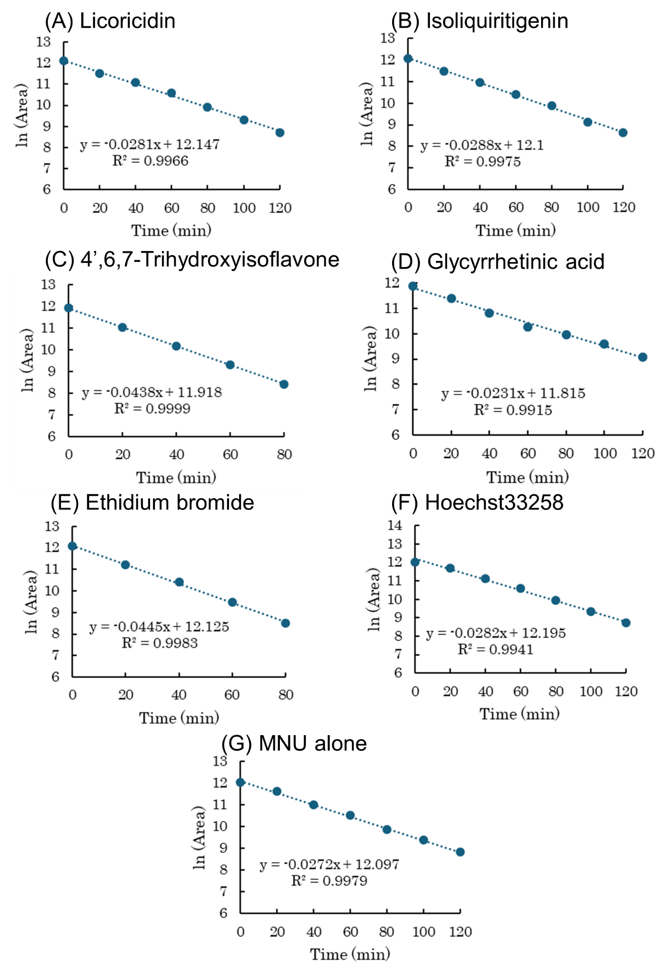

Figure S2. Plots of ln (MNU) versus time

Table S24 Quantification of the remaining licoricidin in the presence or absence of MNU
Time | MNU (－) |  | MNU (+)
(h) | Area | Remaining (%) | Area | Remaining (%)
0 | 138423 ± 4356 | 100.0 ± 0.0 | 149243 ± 15732 | 100.0 ± 0.0
1 | 138522 ± 5093 | 100.1 ± 0.7 | 147852 ± 11785 | 99.8 ± 2.7
2 | 136177 ± 3684 | 98.4 ± 0.6 | 146932 ± 12416 | 99.1 ± 2.2
3 | 134811 ± 6326 | 97.4 ± 1.7 | 147511 ± 14674 | 99.0 ± 0.9
4 | 133674 ± 4154 | 96.6 ± 0.2 | 148183 ± 15560 | 99.3 ± 0.4
5 | 131523 ± 3874 | 95.0 ± 1.4 | 142661 ± 12740 | 96.0 ± 1.7
6 | 129923 ± 3697 | 93.6 ± 0.5 | 143843 ± 12855 | 96.8 ± 1.4
24 | 126511 ± 8645 | 91.4 ± 3.4 | 136447 ± 13947 | 91.5 ± 2.0

Table S25 Quantification of the remaining isoliquiritigenin in the presence or absence and of MNU
Time | MNU (－) |  | MNU (+)
(h) | Area | Remaining (%) | Area | Remaining (%)
0 | 222886 ± 18519 | 100.0 ± 0.0 | 222879 ± 18514 | 100.0 ± 0.0
1 | 220540 ± 33374 | 97.3 ± 6.7 | 230822 ± 35331 | 101.7 ± 8.3
2 | 231212 ± 27480 | 102.9 ± 3.7 | 221341 ± 34088 | 97.6 ± 8.9
3 | 228409 ± 32091 | 101.0 ± 5.8 | 249281 ± 21748 | 102.5 ± 3.8
4 | 220680 ± 37711 | 97.3 ± 9.1 | 236406 ± 37017 | 104.3 ± 10.6
5 | 225881 ± 28550 | 100.2 ± 4.4 | 226162 ± 37749 | 99.3 ± 8.9
6 | 216309 ± 35156 | 95.1 ± 7.8 | 234905 ± 37088 | 103.4 ± 9.3
24 | 222090 ±32769 | 98.2 ± 6.4 | 216094 ± 29762 | 95.6 ± 5.9

Table S26 Quantification of the remaining 4’,6,7-trihydroxyisoflavone in the presence or absence of MNU
Time | MNU (－) |  | MNU (+)
(h) | Area | Remaining (%) | Area | Remaining (%)
0 | 121580 ± 4356 | 100.0 ± 0.0 | 139239 ± 18514 | 100.0 ± 0.0
1 | 117414 ± 5093 | 97.0 ± 2.9 | 126311± 35331 | 91.0 ± 1.9
2 | 121024 ± 3684 | 99.8 ± 2.3 | 115991 ± 34088 | 84.1 ± 5.0
3 | 121599 ± 6326 | 100.1 ± 0.7 | 116729 ± 21748 | 84.3 ± 2.8
4 | 120114 ± 4154 | 99.0 ± 1.8 | 115947 ± 37017 | 83.5 ± 1.6
5 | 121445 ± 3874 | 100.1 ± 1.4 | 118077 ± 37749 | 85.1 ± 2.2
6 | 122007 ± 3697 | 100.5 ± 1.8 | 114530± 37088 | 82.5 ± 1.7
24 | 116421 ± 8645 | 96.0 ± 0.6 | 107623 ± 29762 | 77.6 ± 2.3

Table S27 Quantification of the remaining glycyrrhetinic acid in the presence or absence of MNU
Time | MNU (－) |  | MNU (+)
(h) | Area | Remaining (%) | Area | Remaining (%)
0 | 9213188 ± 291900 | 100.0 ± 0.0 | 9004170 ± 200746 | 100.0 ± 0.0
1 | 8572393 ± 130607 | 93.2 ± 1.6 | 9142155 ± 119624 | 101.7 ± 2.2
2 | 9160857 ± 212929 | 99.6 ± 2.9 | 8820081 ± 166809 | 98.0 ± 0.3
3 | 9337042 ± 356112 | 101.4 ± 2.4 | 9371942 ± 64427 | 104.1 ± 1.6
4 | 8949650 ± 395606 | 97.1 ± 2.1 | 9246317 ± 116036 | 102.7 ± 2.8
5 | 9216296 ± 296150 | 100.2 ± 3.3 | 9077629 ± 82486 | 100.8 ± 2.4
6 | 9249813 ± 393978 | 100.4 ± 3.0 | 9228687 ± 28111 | 102.6 ± 2.3
24 | 9398528 ± 255443 | 102.2 ± 2.9 | 9173247 ± 184407 | 101.9 ± 1.9

References
- Hu C, Lin B, Chao M. Quantitative determination of urinary N³-methyladenine by isotope-dilution LC–MS/MS with automated solid-phase extraction. Int. J. Mass Spectrom. 2011; 304: 68–73.

- Zhang F, Bartels MJ, Pottenger LH, Gollapudi BB, Schisler MR. Simultaneous quantitation of 7-methyl- and O⁶-methylguanine adducts in DNA by liquid chromatography–positive electrospray tandem mass spectrometry. J. Chromatogr. B. 2006; 833: 141–8.

