Table S1 Primers used in the study
Primer name | Usage | Sequence (5'-3') | Product Length (bp)
CmoCh03G013920-gDNA | Gene amplification | CAGAGTCCCCATCGAAGGTATA | 1115
CmoCh03G013920-gDNA | Gene amplification | CCGTTTTGTATTCCCACCAGG | 1115
CmoCh03G013920-RT | RT- qPCR | GGGGAACATACAGACCCACA | 287
CmoCh03G013920-RT | RT- qPCR | TCCCCCTCTGCTAAAACCTG | 287
CmoEF1a | RT- qPCR | ACGGTGATGCTGGTATGGTTA | 211
CmoEF1a | RT- qPCR | CATTGTTGTTGGTTGGCTTATT | 211
Cp4.1LG10g05910 -pro | Promoter  Amplification | gacggtatcgataagcttGTAGATCTCGGCGTCTGCTCT | 2100
Cp4.1LG10g05910 -pro | Promoter  Amplification | tctagaactagtggatccGGCGGCTTATAGAATCAAAGCGTT | 2100
CmoCh03G013920-pro | Promoter  Amplification | gacggtatcgataagcttTCTGTCCGTCACAAACTGCG | 2091
CmoCh03G013920-pro | Promoter  Amplification | tctagaactagtggatccGGCGGCTTATAGAATGAAAGCGT | 2091

Table S2 Differentially expressed genes within the Sd-1 mapping region
ID | 400E_fpkm | 400M_fpkm | 408E_fpkm | 408M_fpkm | 21037E_fpkm | 21037M_fpkm | Description
CmoCh03G013880 | 6.65 | 5.38 | 6.36 | 6.37 | 3.53 | 3.53 | unnamed protein product [Linum tenue]
CmoCh03G013920 | 2.99 | 2.08 | 4.87 | 1.68 | 0.24 | 0.24 | gibberellin 2-beta-dioxygenase [Cucurbita moschata]
CmoCh03G013940 | 5.68 | 3.11 | 5.06 | 3.18 | 6.19 | 6.19 | glucan endo-1,3-beta-glucosidase 11-like [Cucurbita moschata]
CmoCh03G013950 | 17.58 | 16.79 | 16.22 | 20.87 | 11.46 | 11.46 | uncharacterized protein LOC111433180 [Cucurbita moschata]
CmoCh03G014000 | 0.24 | 0.39 | 0.50 | 0.25 | 4.21 | 4.21 | protein TIFY 5A [Cucurbita moschata]
Note: 400E and 400M, early-stage and mid-stage of dwarf NIL; 408E and 408M, early-stage and mid-stage of dwarf NIL; 400E and 400M, early-stage and mid-stage of dwarf NIL; 21037E and 21037M, early-stage and mid-stage of long-vine line D205.

Table S3 Differentially accumulated metabolites between different lines
Index | Compounds | Class | 400E | 400M | 408E | 408M | 21037E | 21037M
ABA | Abscisic acid | ABA | 8.903 | 49.844 | 11.363 | 87.284 | 10.272 | 41.723
IAA-Trp | Indole-3-acetyl-L-tryptophan | Auxin | 0.000 | 0.000 | 0.000 | 0.121 | 0.000 | 0.000
IAA-Val-Me | Indole-3-acetyl-L-valine methyl ester | Auxin | 0.014 | 0.034 | 0.032 | 0.000 | 0.007 | 0.026
IAA-Glu | Indole-3-acetyl glutamic acid | Auxin | 0.295 | 0.860 | 0.000 | 0.000 | 0.334 | 0.653
OxIAA | 2-oxindole-3-acetic acid | Auxin | 2.042 | 0.000 | 0.000 | 40.407 | 0.000 | 0.000
ILA | Indole-3-lactic acid | Auxin | 0.000 | 0.000 | 0.000 | 1.190 | 0.000 | 1.224
ICAld | Indole-3-carboxaldehyde | Auxin | 0.000 | 0.000 | 0.000 | 0.634 | 0.000 | 0.000
TRA | Tryptamine | Auxin | 0.041 | 0.201 | 0.176 | 0.000 | 0.054 | 0.000
IAA | Indole-3-acetic acid | Auxin | 14.173 | 15.311 | 16.129 | 27.832 | 12.994 | 14.198
IAA-Asp | Indole-3-acetyl-L-aspartic acid | Auxin | 6.858 | 14.235 | 1.068 | 2.154 | 6.107 | 11.230
IAN | 3-Indoleacetonitrile | Auxin | 0.418 | 0.431 | 0.487 | 0.636 | 0.423 | 0.478
MEIAA | Methyl indole-3-acetate | Auxin | 0.566 | 0.565 | 0.720 | 0.909 | 0.496 | 0.568
Indole | Indole | Auxin | 130.200 | 2030.489 | 2014.263 | 16312.932 | 156.068 | 1787.980
TRP | L-tryptophan | Auxin | 1483.719 | 5028.975 | 7665.243 | 54654.650 | 1561.737 | 4466.587
iP7G | N6-Isopentenyl-adenine-7-glucoside | CK | 0.298 | 0.883 | 0.640 | 0.940 | 0.348 | 0.748
tZR | trans-Zeatin riboside | CK | 1.388 | 0.365 | 0.600 | 1.370 | 0.779 | 0.489
tZ | trans-Zeatin | CK | 0.283 | 0.245 | 0.341 | 0.459 | 0.245 | 0.227
cZR | cis-Zeatin riboside | CK | 0.000 | 0.422 | 0.000 | 0.528 | 0.000 | 0.401
pTR | para-Topolin riboside | CK | 0.045 | 0.533 | 0.133 | 0.368 | 0.050 | 0.521
2CltZ | 2-Chloro-trans-zeatin | CK | 0.000 | 0.000 | 0.000 | 0.067 | 0.000 | 0.000
DHZROG | Dihydrozeatin-O-glucoside riboside | CK | 0.011 | 0.046 | 0.012 | 0.055 | 0.000 | 0.003
cZROG | cis-Zeatin-O-glucoside riboside | CK | 0.169 | 0.274 | 0.000 | 0.000 | 0.000 | 0.239
tZRMP | 9-Ribosyl-trans-zeatin 5'-monophosphate | CK | 14.704 | 5.430 | 9.383 | 21.704 | 11.487 | 7.279
IPR | N6-isopentenyladenosine | CK | 0.226 | 0.190 | 0.319 | 0.476 | 0.190 | 0.318
iP9G | N6-Isopentenyl-adenine-9-glucoside | CK | 0.000 | 0.000 | 0.000 | 0.557 | 0.000 | 0.000
IP | N6-isopentenyladenine | CK | 0.072 | 0.080 | 0.101 | 0.125 | 0.071 | 0.095
2MeScZ | 2-Methylthio-cis-zeatin | CK | 0.000 | 0.045 | 0.000 | 0.000 | 0.000 | 0.000
2MeScZR | 2-Methylthio-cis-zeatin riboside | CK | 0.000 | 0.023 | 0.025 | 0.107 | 0.000 | 0.029
iPRMP | N-6-iso-pentenyladenosine-5'-monophosphate | CK | 5.642 | 4.044 | 7.273 | 9.683 | 5.454 | 4.926
ACC | 1-Aminocyclopropanecarboxylic acid | ETH | 66.668 | 88.366 | 119.506 | 248.089 | 51.103 | 76.343
GA29 | Gibberellin A29 | GA | 13.170 | 29.449 | 18.087 | 39.765 | 11.443 | 22.727
GA24 | Gibberellin A24 | GA | 3.095 | 0.760 | 3.612 | 2.422 | 2.349 | 0.934
GA15 | Gibberellin A15 | GA | 4.286 | 1.038 | 5.516 | 5.008 | 3.323 | 1.434
GA34 | Gibberellin A34 | GA | 3.949 | 2.380 | 5.230 | 6.852 | 2.693 | 1.984
GA51 | Gibberellin A51 | GA | 11.522 | 0.000 | 9.600 | 9.230 | 0.000 | 0.000
GA9 | Gibberellin A9 | GA | 0.368 | 0.000 | 0.401 | 0.525 | 0.000 | 0.000
GA7 | Gibberellin A7 | GA | 0.034 | 0.035 | 0.000 | 0.000 | 0.000 | 0.000
GA4 | Gibberellin A4 | GA | 0.000 | 0.000 | 0.000 | 1.451 | 0.000 | 0.000
JA | Jasmonic acid | JA | 7.655 | 16.857 | 5.842 | 12.602 | 11.158 | 9.176
JA-ILE | Jasmonoyl-L-isoleucine | JA | 0.464 | 2.412 | 0.364 | 1.480 | 0.874 | 1.243
OPDA | cis(+)-12-Oxophytodienoic acid | JA | 7.086 | 10.881 | 8.600 | 16.726 | 9.958 | 5.120
OPC-4 | 3-oxo-2-(2-(Z)-Pentenyl) cyclopentane-1-butyric acid | JA | 3.837 | 7.293 | 0.000 | 6.609 | 6.856 | 0.000
JA-Phe | N-[(-)-Jasmonoyl]-(l)-phenalanine | JA | 0.000 | 0.007 | 0.084 | 0.037 | 0.006 | 0.052
JA-Val | N-[(-)-Jasmonoyl]-(L)-valine | JA | 0.000 | 0.091 | 0.000 | 0.042 | 0.005 | 0.041
SA | Salicylic acid | SA | 59.591 | 210.100 | 167.757 | 236.987 | 50.119 | 403.526
Phe | L-Phenylalanine | SA | 1871.297 | 2531.680 | 3106.068 | 3102.680 | 1763.988 | 2977.720
2-Coumarate | 2-Coumarate | SA | 19.993 | 0.000 | 0.000 | 0.000 | 17.558 | 0.000
MeSAG | 2-Methoxycarbonylphenyl beta-D-glucopyranoside | SA | 0.000 | 254.079 | 54.999 | 372.768 | 0.000 | 273.925
t-CA | trans-Cinnamic acid | SA | 0.000 | 0.000 | 0.000 | 91.294 | 0.000 | 0.000
SAG | Salicylic acid 2-O-β-glucoside | SA | 299.885 | 31499.289 | 52178.732 | 62421.385 | 332.801 | 62055.419

Table S4 DEGs associated with SA pathway, IAA pathway and cell wall modification
ID | Name | Predictive function | 400E | 400M | 408E | 408M | 21037E | 21037M
CmoCh18G005190 | NPR1 | SA perception and defense-Related | 3.17 | 6.82 | 3.29 | 7.14 | 3.29 | 7.14
CmoCh11G004110 | PR1 | Defense-Related | 55.00 | 48.34 | 67.03 | 60.54 | 34.97 | 23.75
CmoCh11G004120 | PR1 | Defense-Related | 4.38 | 2.97 | 6.91 | 4.13 | 1.48 | 4.66
CmoCh19G005420 | PR1 | Defense-Related | 0.21 | 1.67 | 0.46 | 8.63 | 2.05 | 0.51
CmoCh02G003350 | SAUR23 | Auxin responsive | 2.55 | 1.01 | 3.04 | 3.30 | 4.99 | 3.64
CmoCh03G001110 | SAUR32 | Auxin responsive | 2.17 | 1.83 | 3.65 | 4.55 | 3.20 | 2.62
CmoCh20G007870 | SAUR24 | Auxin responsive | 2.21 | 1.36 | 1.91 | 3.38 | 3.49 | 4.19
CmoCh20G007840 | SAUR24 | Auxin responsive | 0.54 | 0.68 | 0.58 | 1.45 | 0.95 | 1.40
CmoCh20G007770 | SAUR23 | Auxin responsive | 3.08 | 2.78 | 3.69 | 5.56 | 5.96 | 6.43
CmoCh19G010930 | XTH1 | Xylan modification (cell wall rigidification) | 85.28 | 195.64 | 36.13 | 81.06 | 52.51 | 196.63
CmoCh19G010940 | XTH1 | Xylan modification (cell wall rigidification) | 25.14 | 38.19 | 11.00 | 13.30 | 12.04 | 22.84
CmoCh19G010950 | XTH1 | Xylan modification (cell wall rigidification) | 17.74 | 19.53 | 5.76 | 5.20 | 4.57 | 5.41
CmoCh04G009080 | XTH6 | Xylan modification (cell wall loosening) | 313.58 | 44.48 | 337.85 | 123.08 | 280.85 | 45.36
CmoCh16G007900 | XTH6 | Xylan modification (cell wall loosening) | 230.75 | 154.16 | 263.52 | 332.57 | 165.21 | 57.38

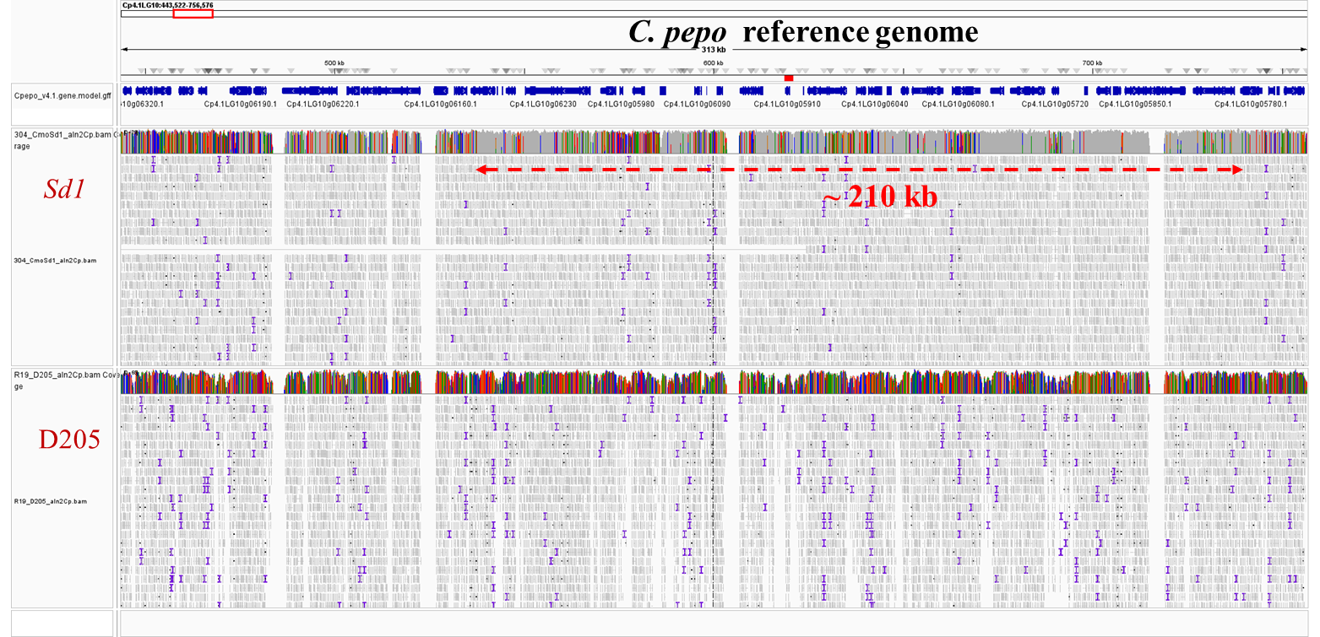

Fig. S1 IGV visualization of Sd1 and D205 align to C. pepo reference genome

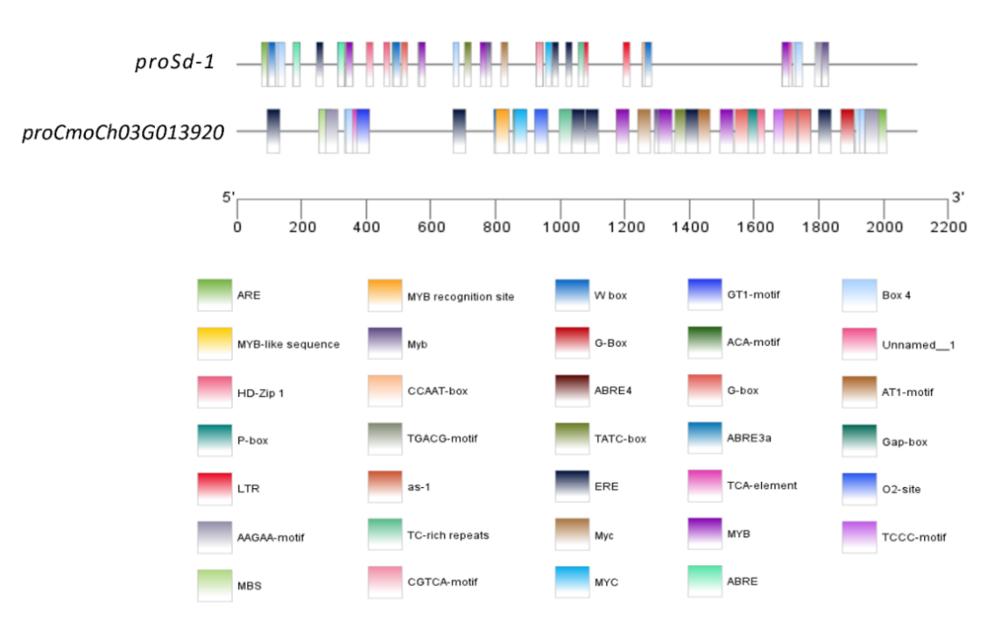

Fig. S2 cis-acting elements in the Sd-1 and CmoCh03G013920 putative promoter region.

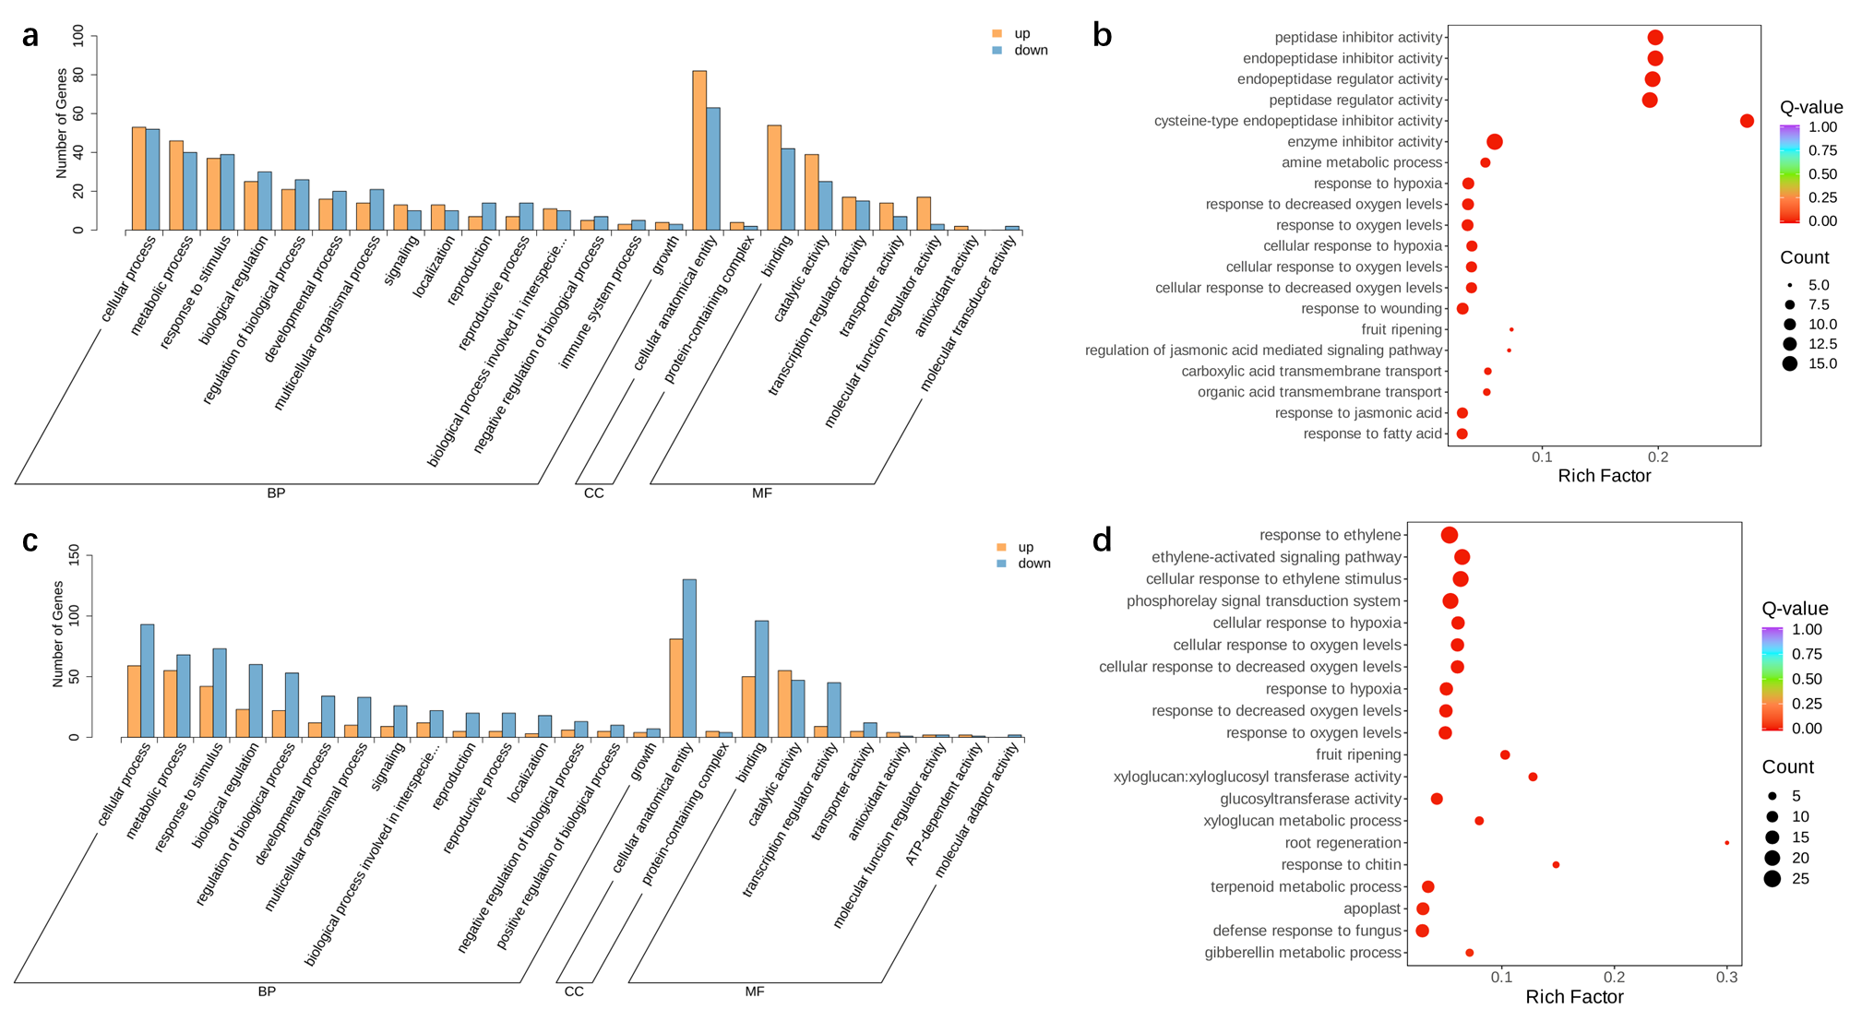

Fig. S3 GO enrichment of DEGs between semi-dwarf and dwarf NILs at the early (a-b) and mid (c-d) stages.

