Supplemental Figures and Legends
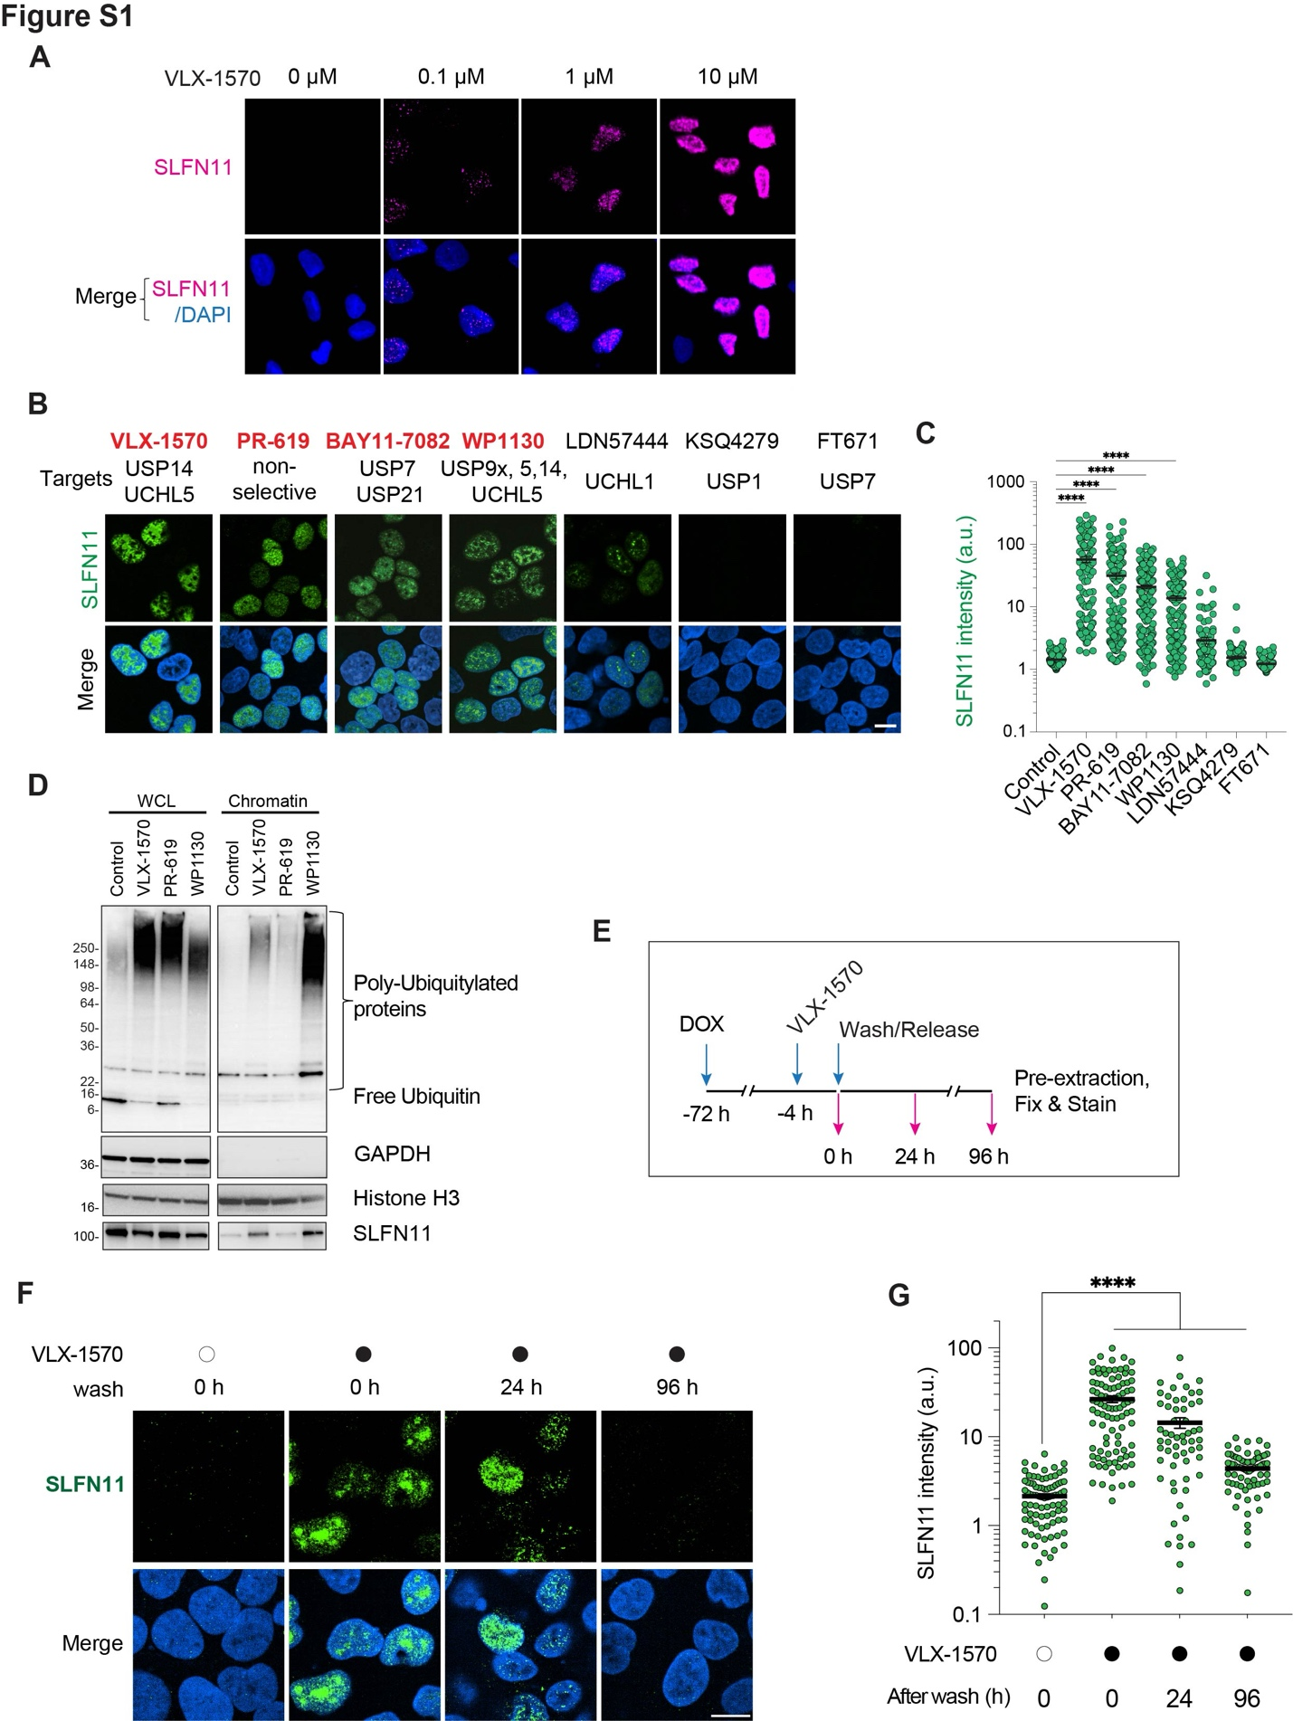
Fig. S1. Concentration-, time- and drug-dependent chromatin recruitment of SLFN11 by DUB inhibitors
(A) Representative immunofluorescence images of the VLX-1570 treated cells in the drug screen. Scale bar: 10 µm.
(B) Representative immunofluorescence images of chromatin-bound SLFN11 with a panel of DUB inhibitors (10 µM, 2 hrs). Chromatin-bound SLFN11 is in green and DAPI in blue. Scale bar: 20 µm. Known targets of each DUB inhibitor are shown.
(C) Quantification of chromatin-bound SLFN11 in individual cells treated with different DUB inhibitors as in panel B (n = 117-202 cells per condition). ****p < 0.0001 (one-way ANOVA). a.u., arbitrary units.
(D) SLFN11 and Ubiquitin immunoblots of whole-cell lysate (WCL) and chromatin (CHR) fractions. DOX-inducible SLFN11-expressing U2OS cells were treated with indicated DUB inhibitors (10 µM, 2 hrs), lysed, and fractionated. GAPDH and Histone H3 were used as control.
(E) Treatment protocol. DOX-inducible SLFN11-expressing U2OS cells were treated with VLX-1570 (1 µM, 4 hrs) and washed with PBS. Cells were incubated with drug-free media at the indicated time points before collection.
(F) Representative immunofluorescence images showing chromatin-bound SLFN11 (green) and DAPI (blue). Scale bar: 5 µm.
(G) Quantification of chromatin-bound SLFN11 signals in individual cells for the indicated treatments (n = 59 – 95 cells per condition). ****p < 0.0001 (one-way ANOVA). a.u., arbitrary units.

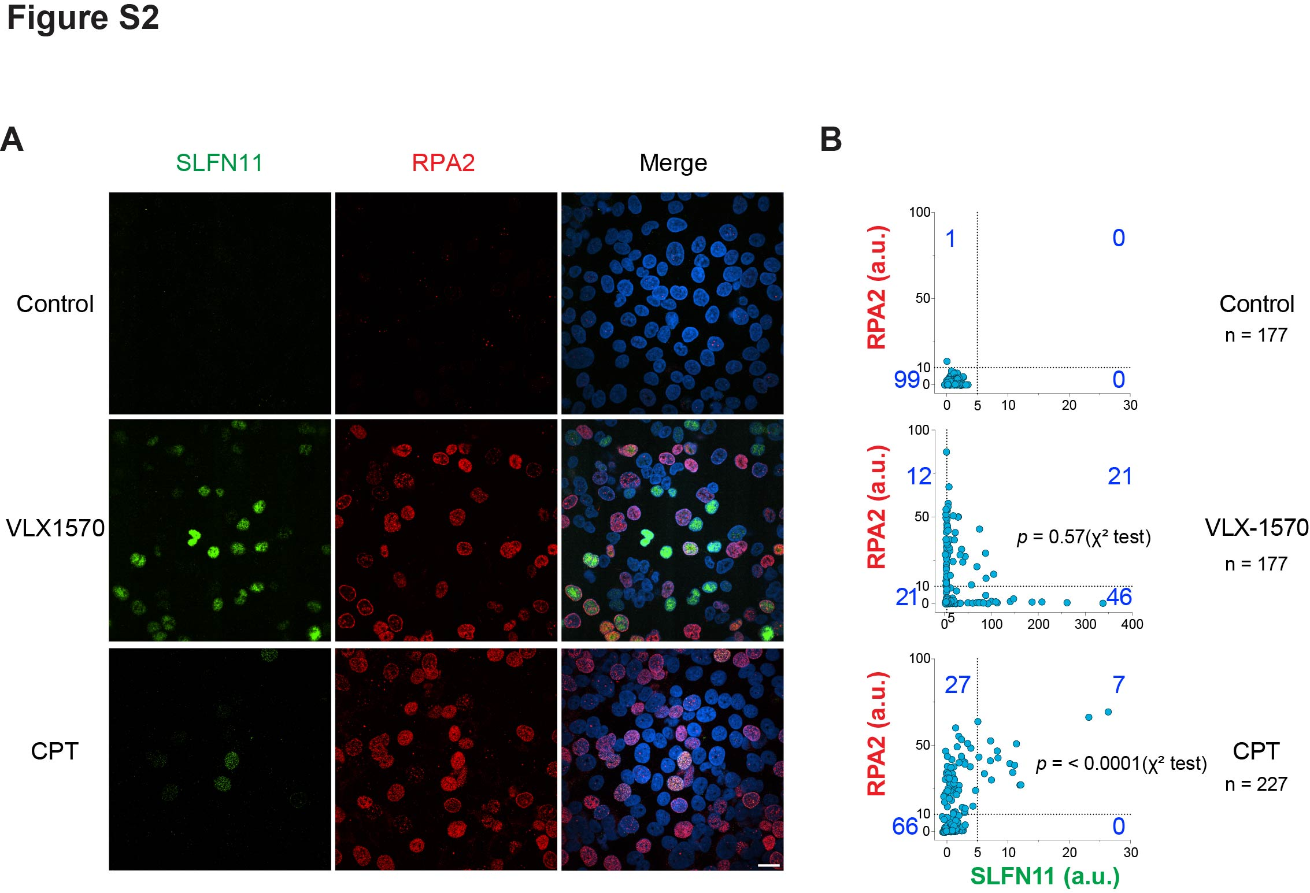

Fig. S2. Chromatin recruitment of SLFN11 by VLX-1570 is less dependent on RPA2
(A) Representative wide-field view immunofluorescence images with chromatin-bound SLFN11 (green) and RPA2 (red) in Fig. 2B. Nuclei are stained with DAPI (blue). Scale bar: 20 µm.
(B) Correlation between chromatin-bound SLFN11 and RPA2 signals in individual cells for the indicated treatments shown in panel A. Thresholds for RPA2 (10) and SLFN11 (5) were set from distributions in the control experiment. P value was calculated using Pearson’s chi-square test. a.u., arbitrary units.

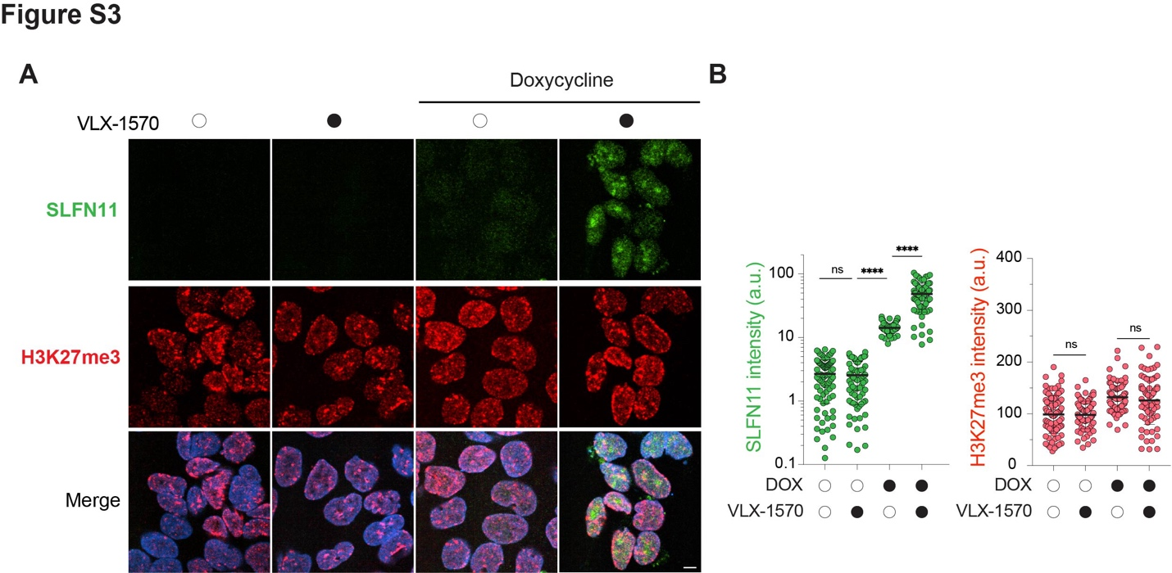

Fig. S3. Chromatin-bound SLFN11 does not localizes in heterochromatin regions and SLFN11 sensitize cells to VLX-1570 treatment.
(A) Representative immunofluorescence images showing chromatin-bound SLFN11 (green), H3K27me3 (red) and DAPI (blue). Scale bar: 5 µm. DOX-inducible SLFN11-expressing U2OS cells were treated with VLX-1570 (1 µM, 4 hrs) followed by pre-extraction and staining.
(B) Quantification of chromatin-bound SLFN11 and H3K27me3 signals in individual cells for the indicated treatments depicted in panel A (n = 69 – 92 cells per condition). ns, non-significant. ****p < 0.0001 (one-way ANOVA). a.u., arbitrary units.

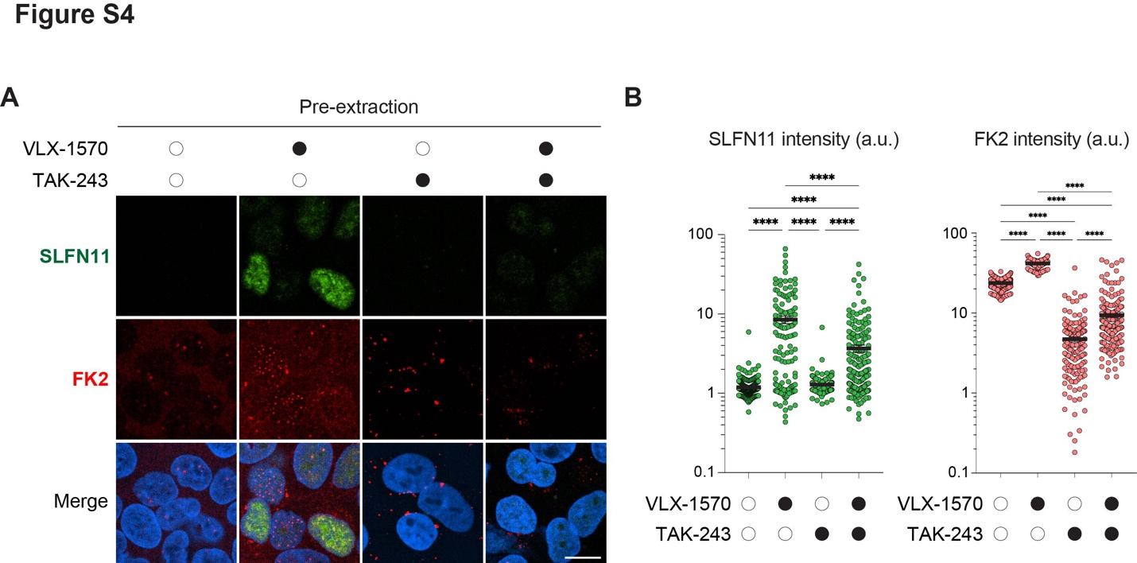

Fig. S4. Chromatin bound ubiquitinated proteins in VLX-1570-treated cells
(A) Representative immunofluorescence images showing chromatin-bound SLFN11 (green), FK2 (red) and DAPI (blue). FK2 recognizes both monoubiquitinated and polyubiquitinated proteins. Scale bar: 10 µm. DOX-inducible SLFN11-expressing U2OS cells were treated with VLX-1570 (1 µM, 4 hrs) with or without 1 hr pre-treatment with TAK243 (2 µM) as indicated in Fig. 4B.
(B) Quantification of chromatin-bound SLFN11 and FK2 signals in individual cells for the indicated treatments (n = 134 – 274 cells per condition). ****p < 0.0001 (one-way ANOVA). a.u., arbitrary units.

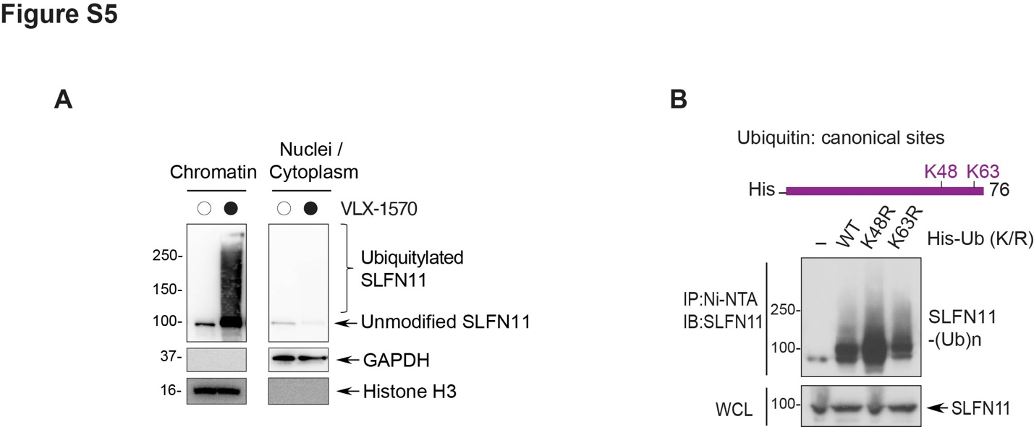

Fig. S5. SLFN11 ubiquitination is dependent on RNF168-mediated K27 ubiquitin linkage.
(A) SLFN11 immunoblots of chromatin-insoluble and soluble (Nuclei/Cytoplasm) fractions. DOX-inducible SLFN11-expressing U2OS cells were treated with VLX-1570 (10 µM, 2 hrs) after DOX induction (72 hrs), lysed and fractionated with pre-extraction buffer. GAPDH and Histone H3 were used as loading controls.
(B) Linkage-specific ubiquitylation of SLFN11 in the canonical His-Ub K/R mutants (K48R and K63R) carrying a single K/R substitution.

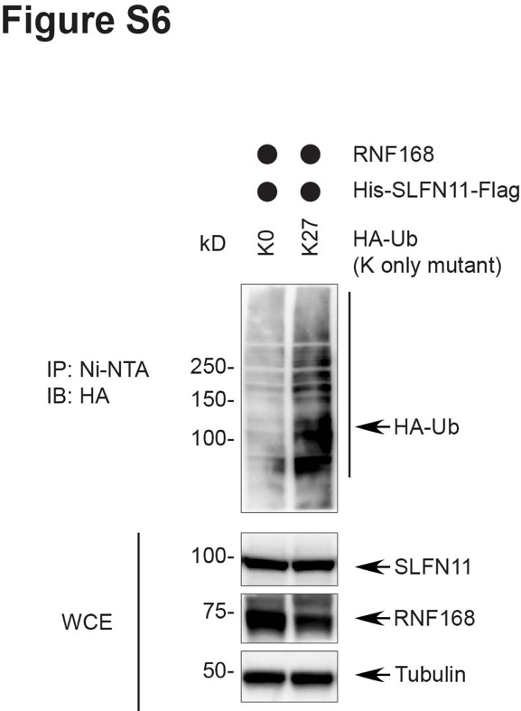

Fig. S6. K27-dependent ubiquitylation of SLFN11 by RNF168
Linkage-specific ubiquitylation of SLFN11 in HA-Ub K0 and K27 only mutants. 293T cells were transfected with His-SLFN11-Flag, RNF168, and HA-Ub (K0 and K27 only). Cells were lysed and immunoprecipitated with Ni-NTA beads. Ubiquitylated SLFN11 was detected with anti-HA antibody.

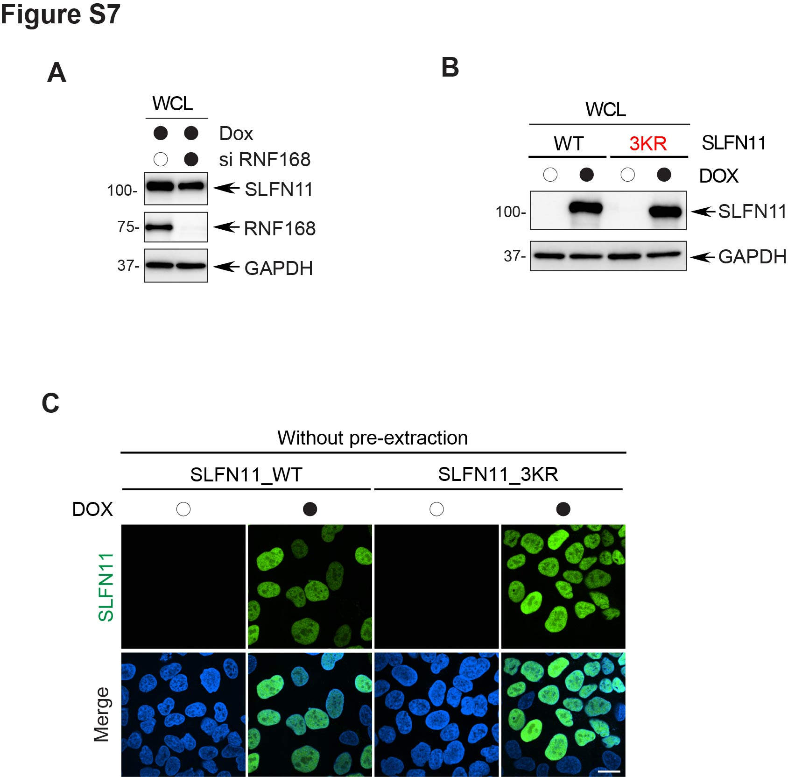

Fig. S7. RNF168 and ubiquitylation of SLFN11 in its linker domain promote the chromatin recruitment of SLFN11
(A) Control SLFN11 and RNF168 immunoblots of whole-cell lysate. DOX-inducible SLFN11-expressing U2OS cells were lysed after the DOX induction and transfection with siRNF168. Related to Fig. 7A.
(B) Control SLFN11 immunoblots of whole-cell lysates. U2OS cells constructed to express DOX-inducible SLFN11 WT and SLFN11-3KR mutant were lysed after the DOX induction (72 hrs). Both WT and the 3KR mutant were expressed at the same level. Related to Fig. 7D.
(C) Representative immunofluorescence images showing similar expression of SLFN11 WT and SLFN11-3KR (green) without pre-extraction. DOX-inducible SLFN11 clones (WT, 3KR) of U2OS cells were treated with DOX for induction (72 hrs). Nuclei are stained with DAPI (blue). Scale bar: 10 µm.

