Supplementary material
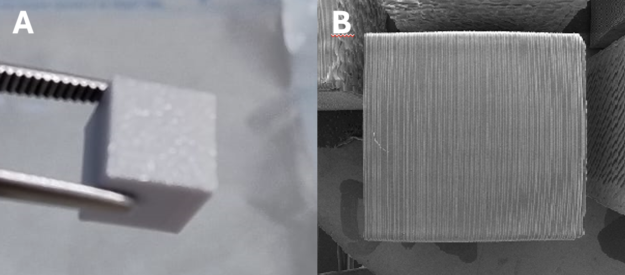
Figure S1: Representative image of the polyurethane printed model for biofilm tests with A. baumannii

Figure FTIR (S2):
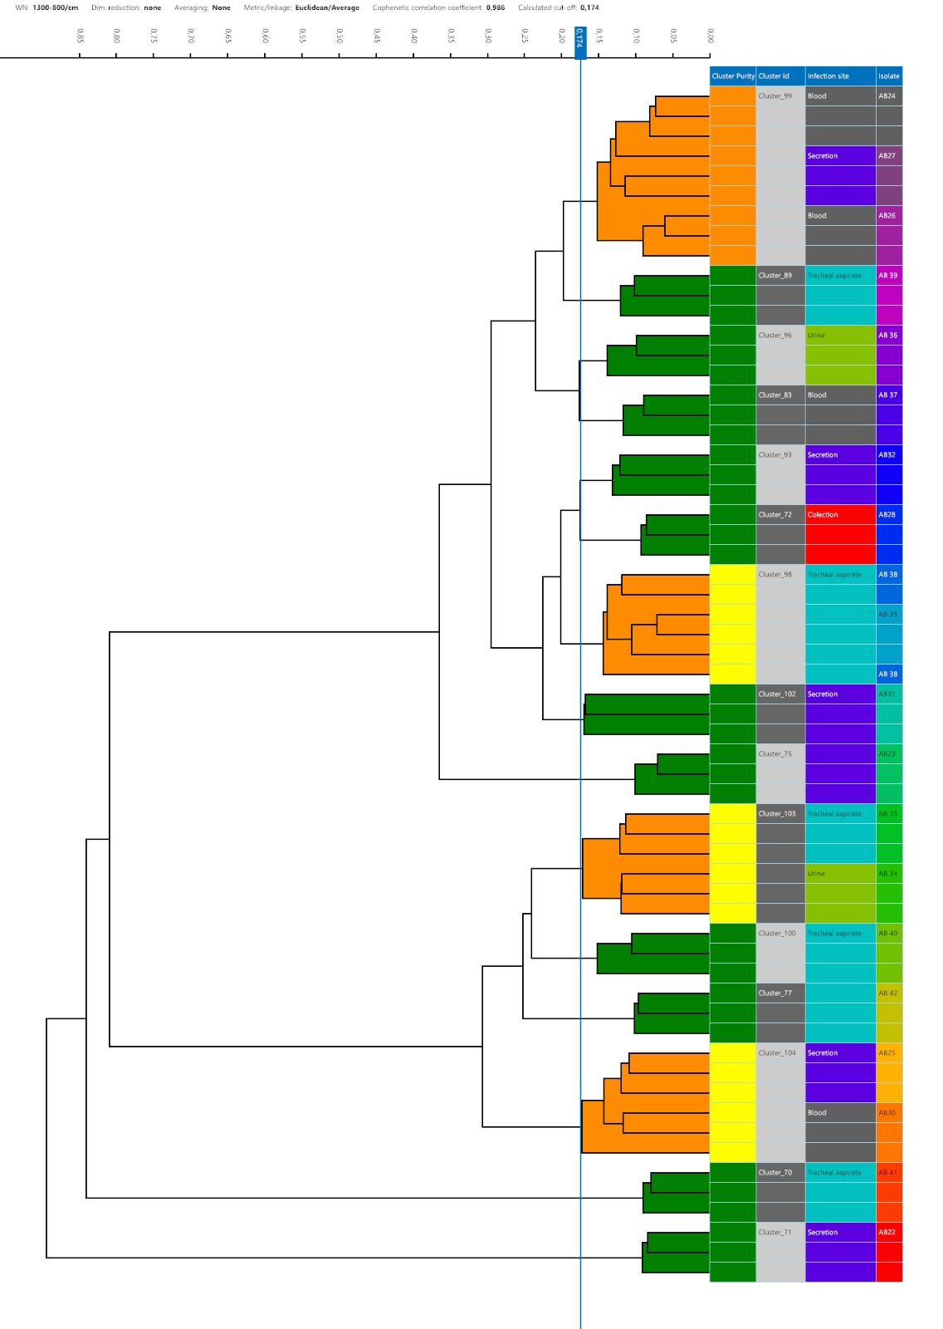
Figure FTIR: Hierarchical dendrogram representation of A. baumannii clones generated by Fourier-Transform Infrared Spectroscopy (FT-IR) using the IR Biotyper (Bruker, Bremen, Germany).

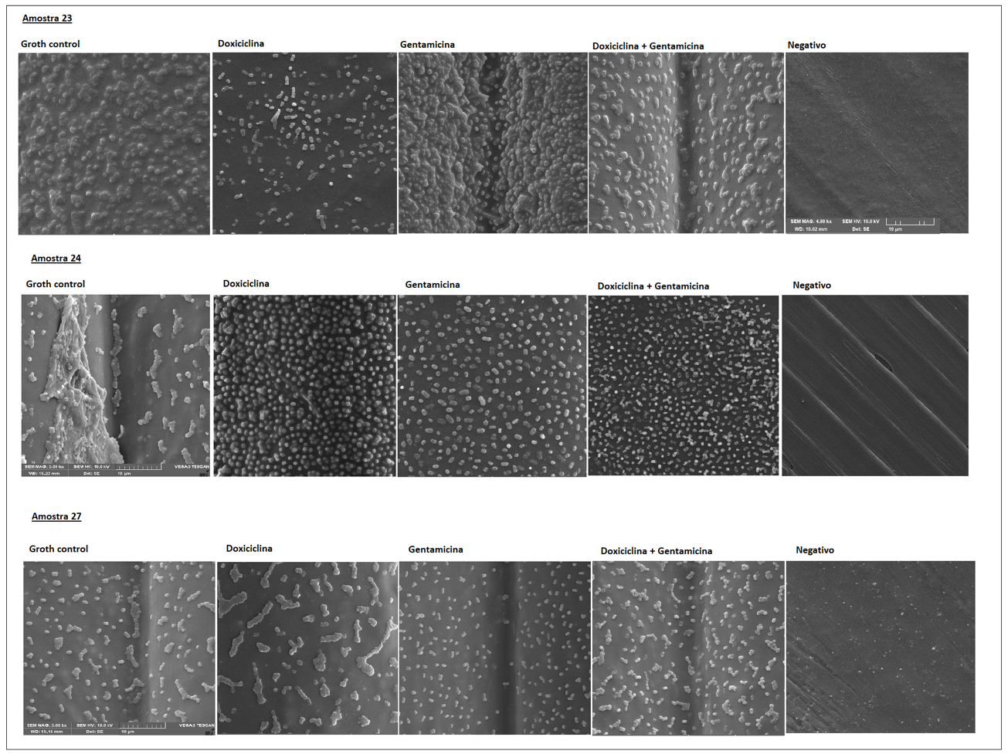
Figure SEM: Scanning electron microscopy of biofilm formation on polyurethane in presence of antibiotics.

