Supplemental text for “First Autonomous eDNA Survey Using a Self-Righting, Solar-Powered Surface Vehicle in an Estuarine Hope Spot”

Results

Sample and Data Quality
After quality control, more than 10 million reads were used for downstream analysis from each of the MiFish and Elas02 libraries, and more than 30 million from the CO1 library (Supplementary Table 1), representing 52 unique taxa in the MiFish library, 6 unique taxa in the Elas02 library, and 993 unique taxa in the CO1 library. For comparison, the manually collected eDNA samples are presented alongside those from the DX/RoCSI (Supplementary Table 1). These manual eDNA samples include those collected during a crewed expedition from a vessel on Sept. 10th, coincident with Deployment 1, and those collected in shallow areas from a skiff on Sept. 16th, coincident with Deployment 6, and resulted in similar species detections: 44 unique taxa in the MiFish library, 7 unique taxa in the Elas02 library, and 1,035 in the CO1 library. Top taxa from each eDNA library were similar between the manually collected samples and the DX/RoCSI samples (Supplementary text and Supplementary Fig. 1). Results from trawling conducted on Sept. 10th, traditionally deployed to monitor biodiversity in monitoring programs, resulted in fewer species than either eDNA method: 33 unique teleosts and 2 unique elasmobranch species.

To compare the impact of the DX/RoCSI collection and preservation on eDNA, we compared the most abundant species to those eDNA samples collected manually from a vessel (Supplementary Figure 1). The top 2 species from the Elas02 library comprised 91% and 93% of all reads collected manually and by USV, respectively. These two species were the same for both methods: cownose ray and smooth dogfish. The top 12 species from the MiFish libraries comprised 77% and 84% of all reads collected manually and by USV, respectively. Among the top 12, there was an overlap of 9 species according to both methods. USV- and manually collected samples both indicated that anchovies, Atlantic menhaden, Atlantic silverside, black sea bass, northern sennet, Scombriformes, spot, summer flounder, and tautog were among the 12 most abundant taxa. For comparison, the CO1 libraries were filtered to only teleost and elasmobranch species. Among the top 12, there was an overlap of 8 species according to both collection methods: anchovies, Atlantic menhaden, Atlantic silverside, cownose ray, mummichog, seaboard goby, spot, and summer flounder.

There were 17 instances in which two samples were collected in immediate succession at the same location. These were considered field replicates and used to determine the quality of field replication using the DX/RoCSI system. For all 3 libraries, the average Aitchison distance between replicates was an order of magnitude less than the average Aitchison distance between all samples (Supplementary Table 2), indicating field replicates were significantly more similar to each other than any other paired samples from across the study. Furthermore, the average Atchison distance between samples from the same station was greater than between replicates but slightly less than between all samples, suggesting that for a single location, community composition varied over the two-week study, but there was likely some site fidelity at unique locations.

Positive control samples were also collected via the DX/RoCSI system. Water from a tropical fish aquarium was pumped from a sterile bucket through the apparatus and preserved. Known species in the aquarium tank included: short bigeye, dotterel filefish, bandtail puffer, lookdown, spotfin butterflyfish, banded butterflyfish, and Bermuda blue angelfish. Of these 7 species, 4 were detected by the MiFish and CO1 primers, respectively, with some overlap (Supplementary Figure 2) while none were detected by Elas02, as expected (not shown). Between MiFish and CO1, 5 of the 7 unique species were detected to the species level. Additionally “pufferfish” were detected but the pipeline was not able to make a species-level assignment. A small number of Atlantic menhaden reads were also detected in the positive controls, likely due to the use of baywater in the aquarium tank.

Negative control samples, consisting of distilled water, were also collected by the DX/RoCSI system in a similar manner as the positive controls. No reads were detected by Elas02 while reads in the MiFish and CO1 libraries included typical contamination such as human and mouse DNA. These reads were removed from all samples in the quality control steps, resulting in 0 ASVs and 0 species in the negative controls after processing through the pipeline.

Multivariate Analyses
For PCA, the first two axes explained 14.4% and 11.8% of the variability for MiFish, 65.4% and 18.7% for Elas02, and 24% and 6.2% for CO1, respectively (Supp. Fig 8). Salinity was an important factor correlated with the community composition for all 3 libraries (Supp. Table 2a-c: MiFish r = 0.09, p = 0.02; Elas02 r = 0.20, p < 0.01; and CO1 r = 0.51, p <0.001). The categorical variables, night vs. day, were important for shaping community composition of both Elas02 (r = 0.06, p = 0.04) and CO1 (r = 0.14, p < 0.001). And both temperature ( r = 0.34, p < 0.01) and geographic location variables (latitude: r = 0.34, p < 0.001, longitude: r = 0.34, p < 0.001, east vs. west: r = 0.29, p <0.001, and habitat type: r = 0.14, p < 0.01) were all significantly correlated in the envfit for CO1 community composition (Supp. Table 3a-c).

Two-dimensional NMDS resulted in stress measures that were slightly worse than using 3 axes (0.17 vs. 0.11 for MiFish; 0.04 vs 0.01 for Elas02; 0.14 vs. 0.09 for CO1), so NMDS analyses proceeded with 3 axes. envfit was run on all 3 pairs of axes for each of the 3 libraries (Supp. Table 4a-c). Here we consider a variable important if it was correlated in more than 1 of the 3 projections at the p=0.05 level. For MiFish, no variables were consistently correlated to the NMDS projections. For Elas02, geographic position variables (latitude, longitude, east vs. west, and habitat type) were correlated to 2 of the 3 NMDS axes projections. For CO1, date, temperature, salinity, and the geographic parameters longitude, habitat type, and night vs. day were all correlated to at least 2 of the 3 NMDS projections.

Methods

Sample Collection
Sample filtration volume for the RoCSI was initially set to 1000mL, but was later lowered to 700mL due to overpressure issues experienced during the first deployment. Once each of the cartridges was engaged in the instrument, filtration began and continued until either 1) the full volume was filtered (a “complete” sample), 2) the pressure sensor indicated an “overpressure” flag, or 3) the RoCSI had been attempting to filter for 20 minutes (a “timeout”). An “overpressure” flag indicated the filter was clogging and, therefore, the RoCSI terminated filtration, but often these samples were preserved and usually sufficient water volume was filtered to be usable . A “timeout” indicated the RoCSI did not engage a filter and was unable to pull any water.

eDNA samples were also manually collected as part of the ongoing eDNA sample collection for the ShiRP program, detailed in Sciorilli et al.¹ Briefly, water was collected into bottles from aboard a trawl boat or skiff, kept on ice, filtered at the lab within 24 hours, and filters were frozen until extraction. No RNAlater preservative was used.

PCR & Sequencing
The MiFish amplicon library was generated with a 30-cycle PCR using the HotStarTaq Plus Master Mix Kit (Qiagen, USA) under the following conditions: 95°C for 5 minutes, 30 cycles of 95°C for 30 seconds, 53°C for 40 seconds, and 72°C for 1 minute, after which a final elongation step at 72°C for 10 minutes was performed. The conditions for the Elas02 PCR were: 95°C for 5 minutes, 35 cycles of 95°C for 30 seconds, 65°C for 40 seconds, 72°C for 1 minute, and a final annealing step of 72°C for 10 minutes. The conditions for the CO1 PCR were: 95°C for 5 minutes, 33 cycles of 95°C for 30 seconds, 53°C for 40 seconds and 72°C for 1 minute, and a final annealing step of 72°C for 10 minutes.

Amplicons were visualized in a 2% agarose gel with SYBR Safe (Thermo Fisher Scientific), pooled, purified with Aline Bioscience PCRClean DX, and prepared for sequencing using the TruSeq DNA Nano LP Kit (Illumina). Libraries were then sequenced by paired ends for 500 cycles using the Illumina NovaSeq 6000 system. Basecalling was performed with the Illumina Real-Time Analysis software and demultiplexing was done with Illumina’s bcl2fastq software.

Occupancy Model Inputs and Covariates
Data were formatted for input in the spOccupancy package. The response variable was a 3-dimensional array of detection/nondetection data (1 = detected, 0 = not detected) structured as a matrix [species, site, replicate], derived from taxon-level presence/absence. Replicates corresponded to sampling replicates within each site. Occupancy covariates included both continuous and categorical variables that are characteristics of environmental variability: habitat type (open water, eelgrass, oyster reef, or clam sanctuary), depth (meters), salinity (psu), temperature (°C), turbidity (NTU), chlorophyll a (µg/L), geographic region (east vs. west side), and time-of-day (night or day). Detection covariates, including time of day, calendar day, and sample volume (liters), reflect how sampling conditions or effort influence the probability of detecting eDNA from a species if it is present. All continuous covariates were standardized (centered and scaled with the scale function in R) prior to running the model. Categorical variables were converted to factor format with open water set as the reference for habitat type, eastern bay as the reference for east vs. west, and day as the reference for day vs. night . The models generate occupancy estimates at both the community level and taxon level. For both, effects were assessed using posterior means and 95% credible intervals (CIs). Covariate effects were considered significant when the CI did not overlap zero. Posterior predictive checks were run using the ppcOcc function and only ASVs with p-values inside the 95% interval were included for further interpretation.

Model diagnostics supported good overall fit and convergence for all 3 chosen models. Most parameters had Rhat values close to 1.00 and high ESS values (>500), indicating good MCMC performance. Posterior predictive checks using Freeman-Tukey statistics showed community-level Bayesian p-values of 0.32 (site level) and 0.30 (replicate level) for Elas02, 0.38 and 0.43 for MiFish, and 0.38 and 0.43 for CO1, suggesting good fits.

 | RocSI/DX eDNA Samples  (98 samples) |  |  | Manual eDNA Samples  (27 samples) |  |  | Trawling  (12 samples)
 | MiFish | Elas02 | CO1 | MiFish | Elas02 | CO1 | Teleosts | Elasmobranchs
Total reads after QC | 10,586,263 | 18,235,253 | 35,013,768 | 3,952,477 | 6,948,758 | 8,556,526
Unique ASVs | 423 | 448 | 39,617 | 200 | 235 | 34,216
Unique Taxa | 52 | 6 | 993 | 44 | 7 | 1,035 | 33 | 2

Supplementary Table 1: Sequencing statistics for the 3 different libraries (MiFish, Elas02, CO1) compared to the eDNA samples collected manually. Total reads after quality control (QC) are presented. QC included removal of unknowns, removal of non-target reads such as those annotated to human or bacteria, and removal of instances of ASVs with low abundance (<500). Quality controlled reads were then used to infer the total unique amplicon sequence variants (ASVs) and total unique taxa for each sequencing library. Total unique teleosts and elasmobranchs captured in the September 10th trawl samples are also presented for comparison.
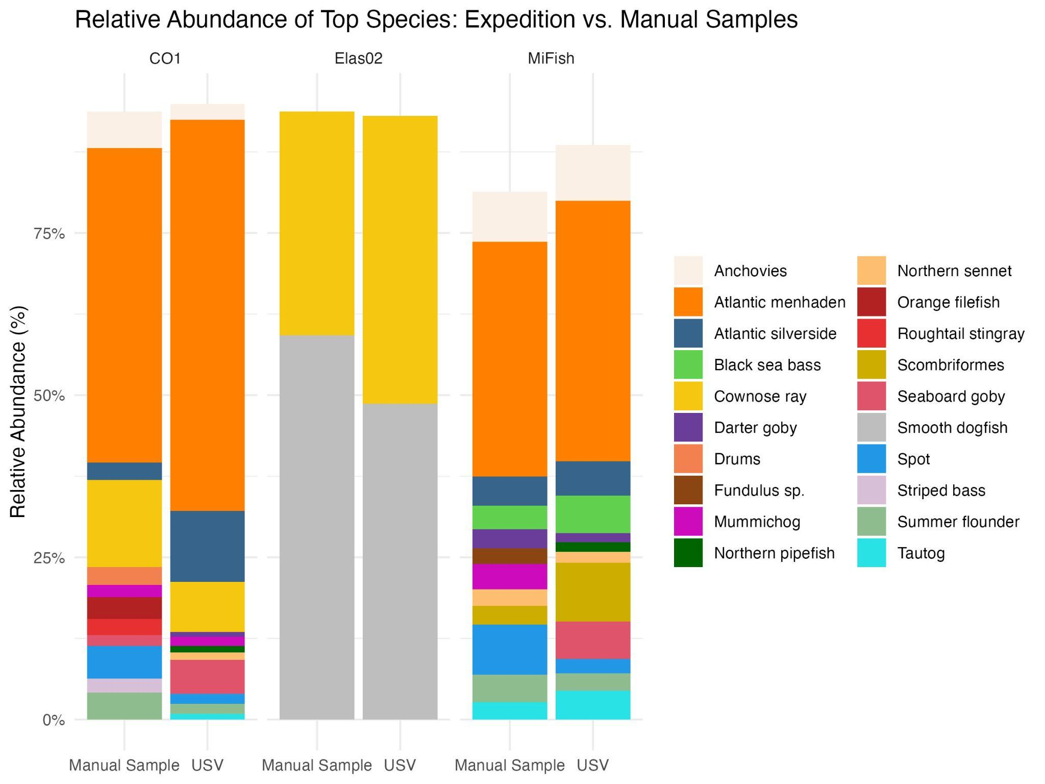
Supplementary Figure 1: Relative abundance of the top 2 taxa from the Elas02 library and top 12 taxa from the MiFish and CO1 libraries collected by USV and manually during the expedition. USV samples include all of those collected during the 8 USV deployments between Sept. 9th-19th, 2024. Manual samples include all of those collected during the crewed expeditions on Sept. 10th and 16th. CO1 libraries were filtered to teleosts and elasmobranch taxa only for direct comparison.

 | Mean Aitchison distance: Between replicates | Mean Aitchison distance: Between samples from the same station | Mean Aitchison distance: Between all pairs of samples
Mifish | 47.1 ± 6.1 | 99.7 ± 16.9 | 101.5 ± 0.2
Elas02 | 5.8 ± 2.5 | 161.9 ± 23.7 | 168.0 ± 0.4
CO1 | 218.1 ± 9.2 | 1031.8 ± 216.0 | 1134.0 ± 2.5

Supplementary Table 2: Average Aitchison distance between 1) replicated field samples, 2) samples taken from the same stations over the 2-week study, and 3) between all samples from the whole dataset.

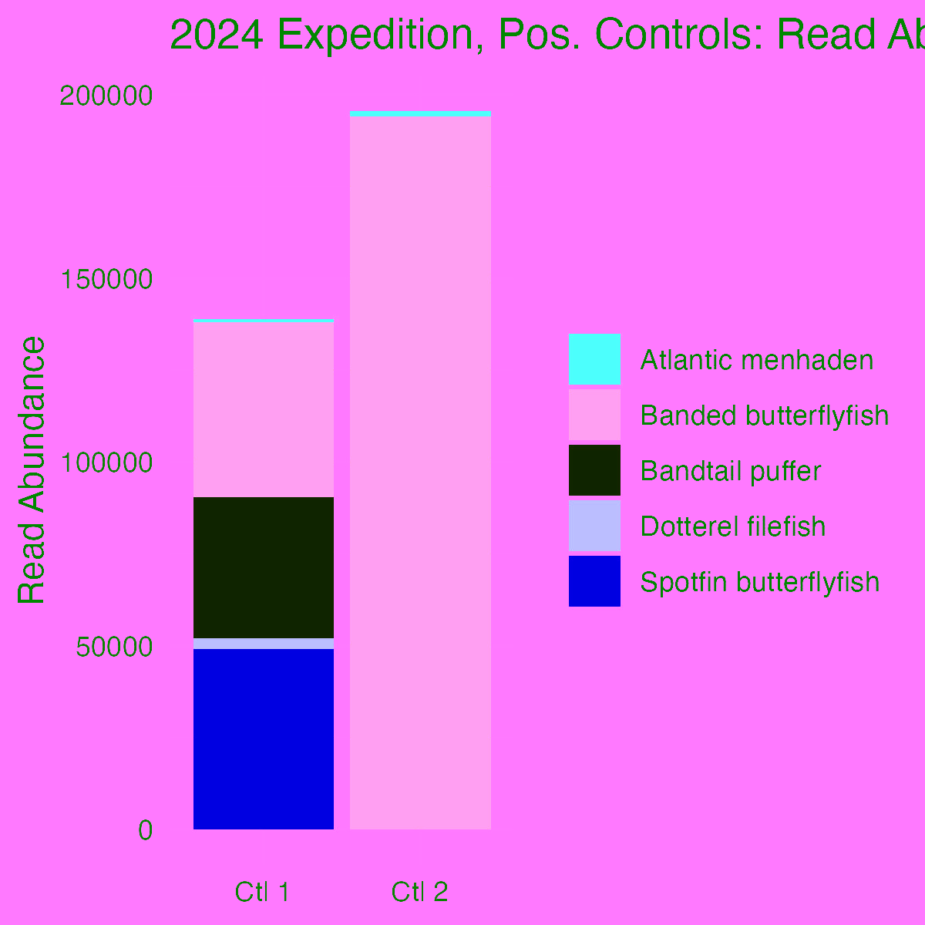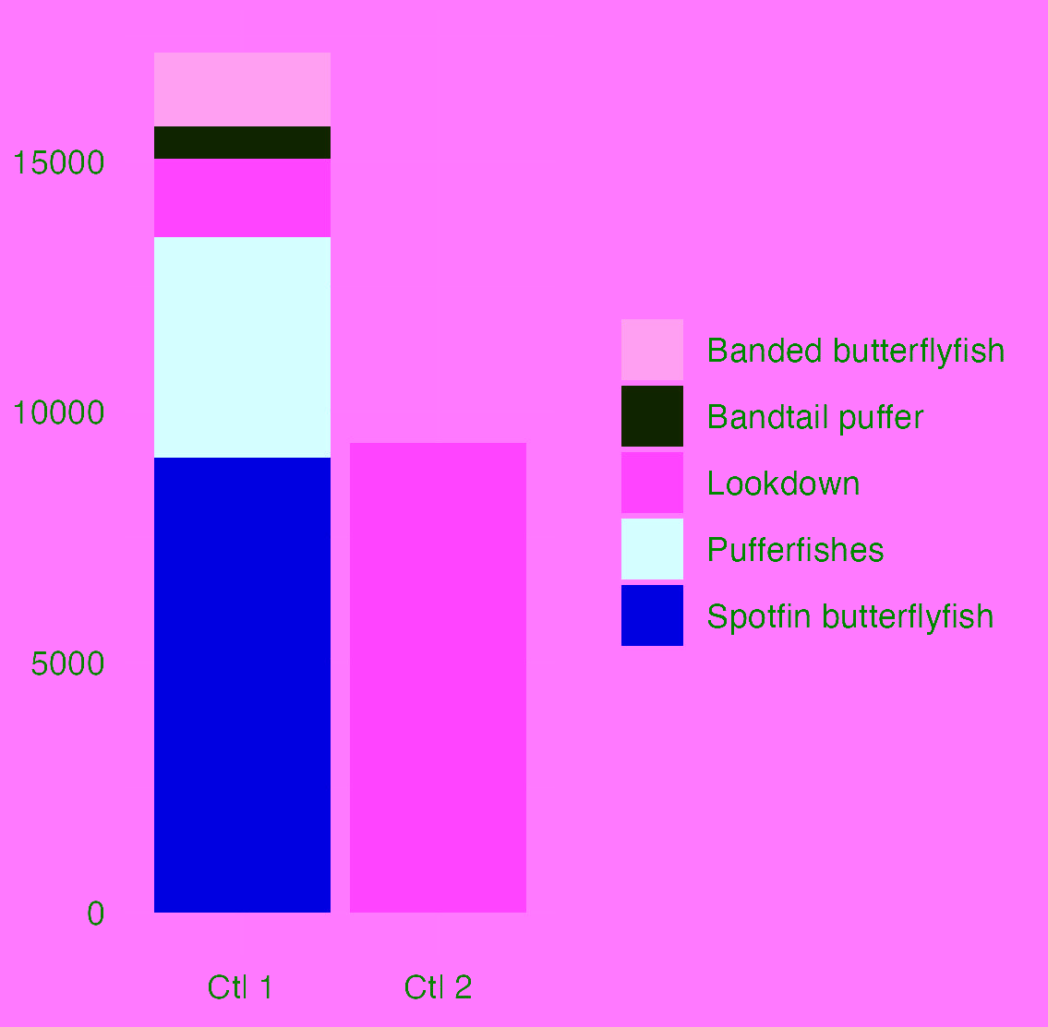

Supplementary Figure 2: Read abundances from positive control samples for MiFish (left) and CO1 (right).



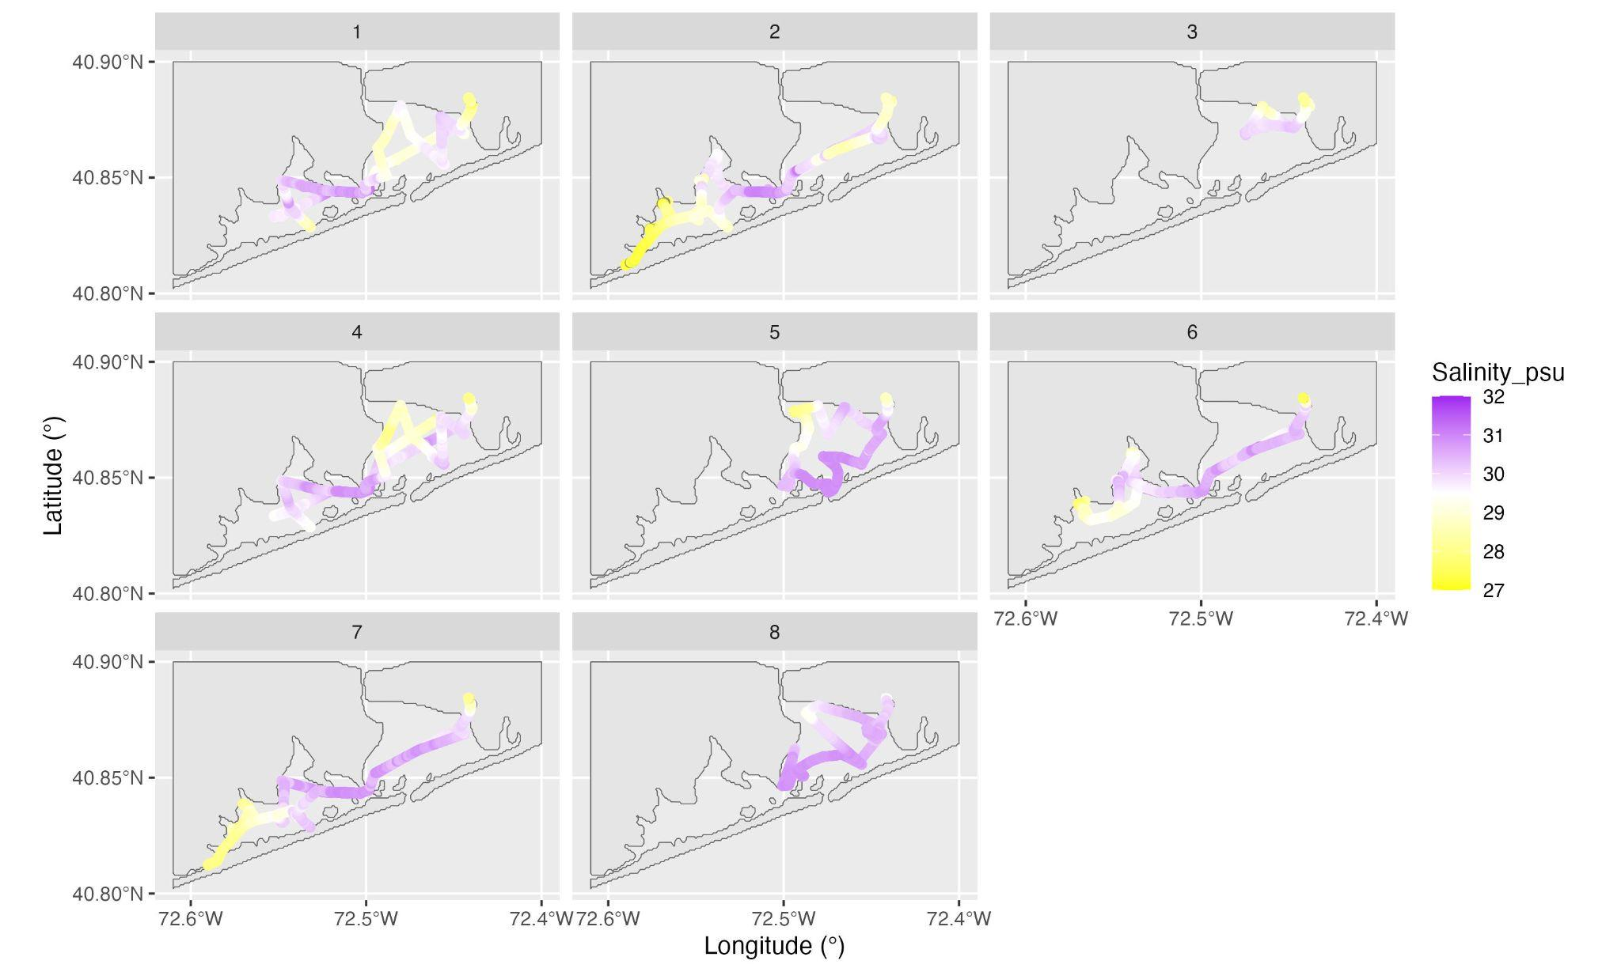
Supplementary Figure 3: Salinity, measured by USV’s CTD, during each of the deployments. Biocultural (BC) and Traditional Knowledge (TK) notices created by Local Contexts are placed at the bottom of the figure to signify these samples were collected from Shinnecock waters.

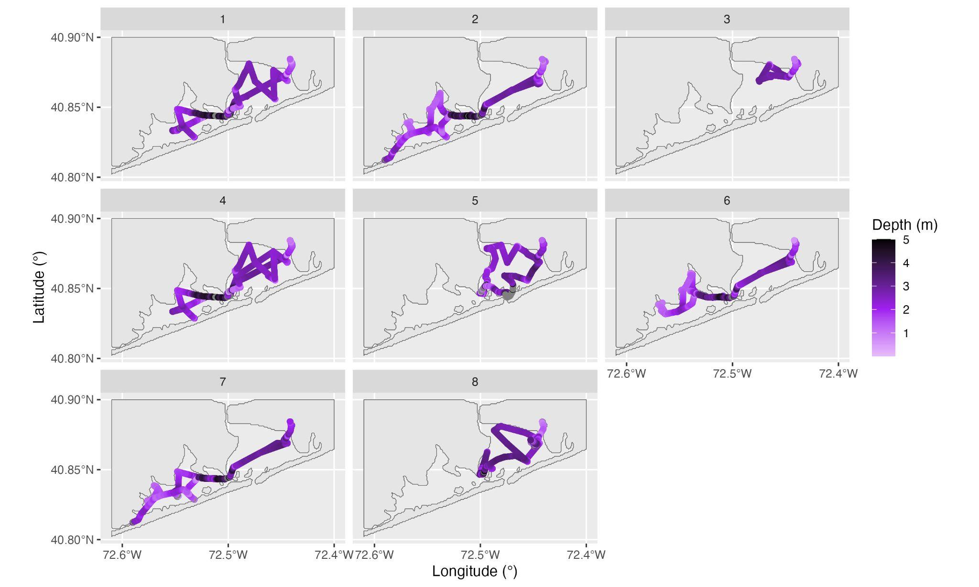
Supplementary Figure 4: Depth, measured by the USV’s CTD, during each of the expedition’s 8 deployments. Biocultural (BC) and Traditional Knowledge (TK) notices created by Local Contexts are placed at the bottom of the figure to signify these samples were collected from Shinnecock waters.

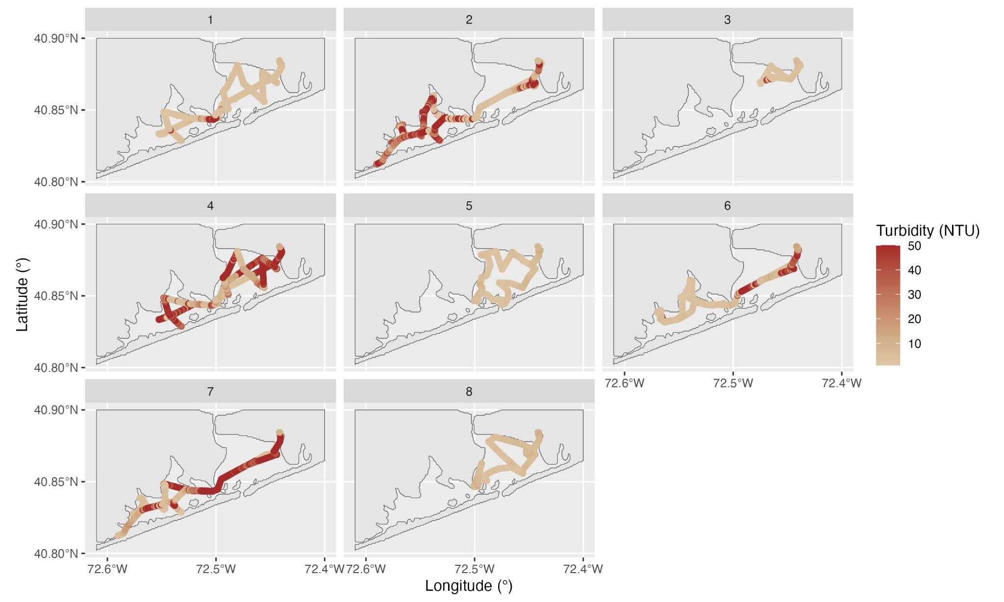
Supplementary Figure 5: Turbidity, measured by USV sensors, during each of the expedition’s 8 deployments. Biocultural (BC) and Traditional Knowledge (TK) notices created by Local Contexts are placed at the bottom of the figure to signify these samples were collected from Shinnecock waters.
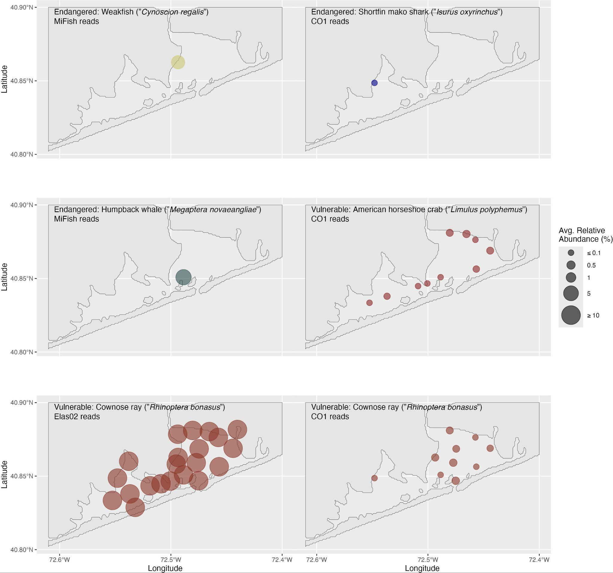

Figure continued on next page

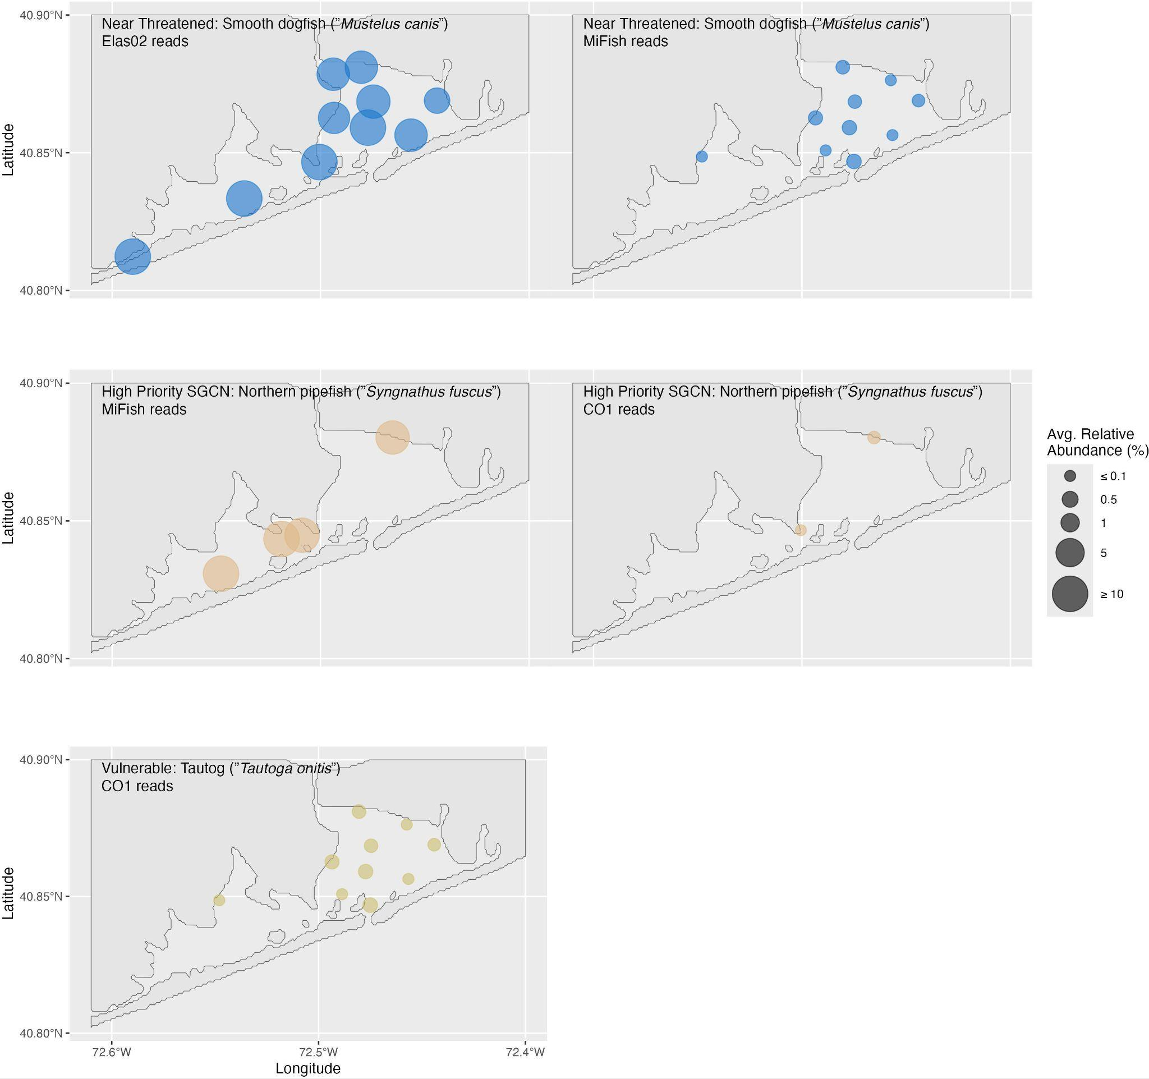

Supplementary Figure 6: Additional priority species maps. Bubbles are average relative abundance across the two-week study. Biocultural (BC) and Traditional Knowledge (TK) notices created by Local Contexts are placed at the bottom of the figure to signify these samples were collected from Shinnecock waters.

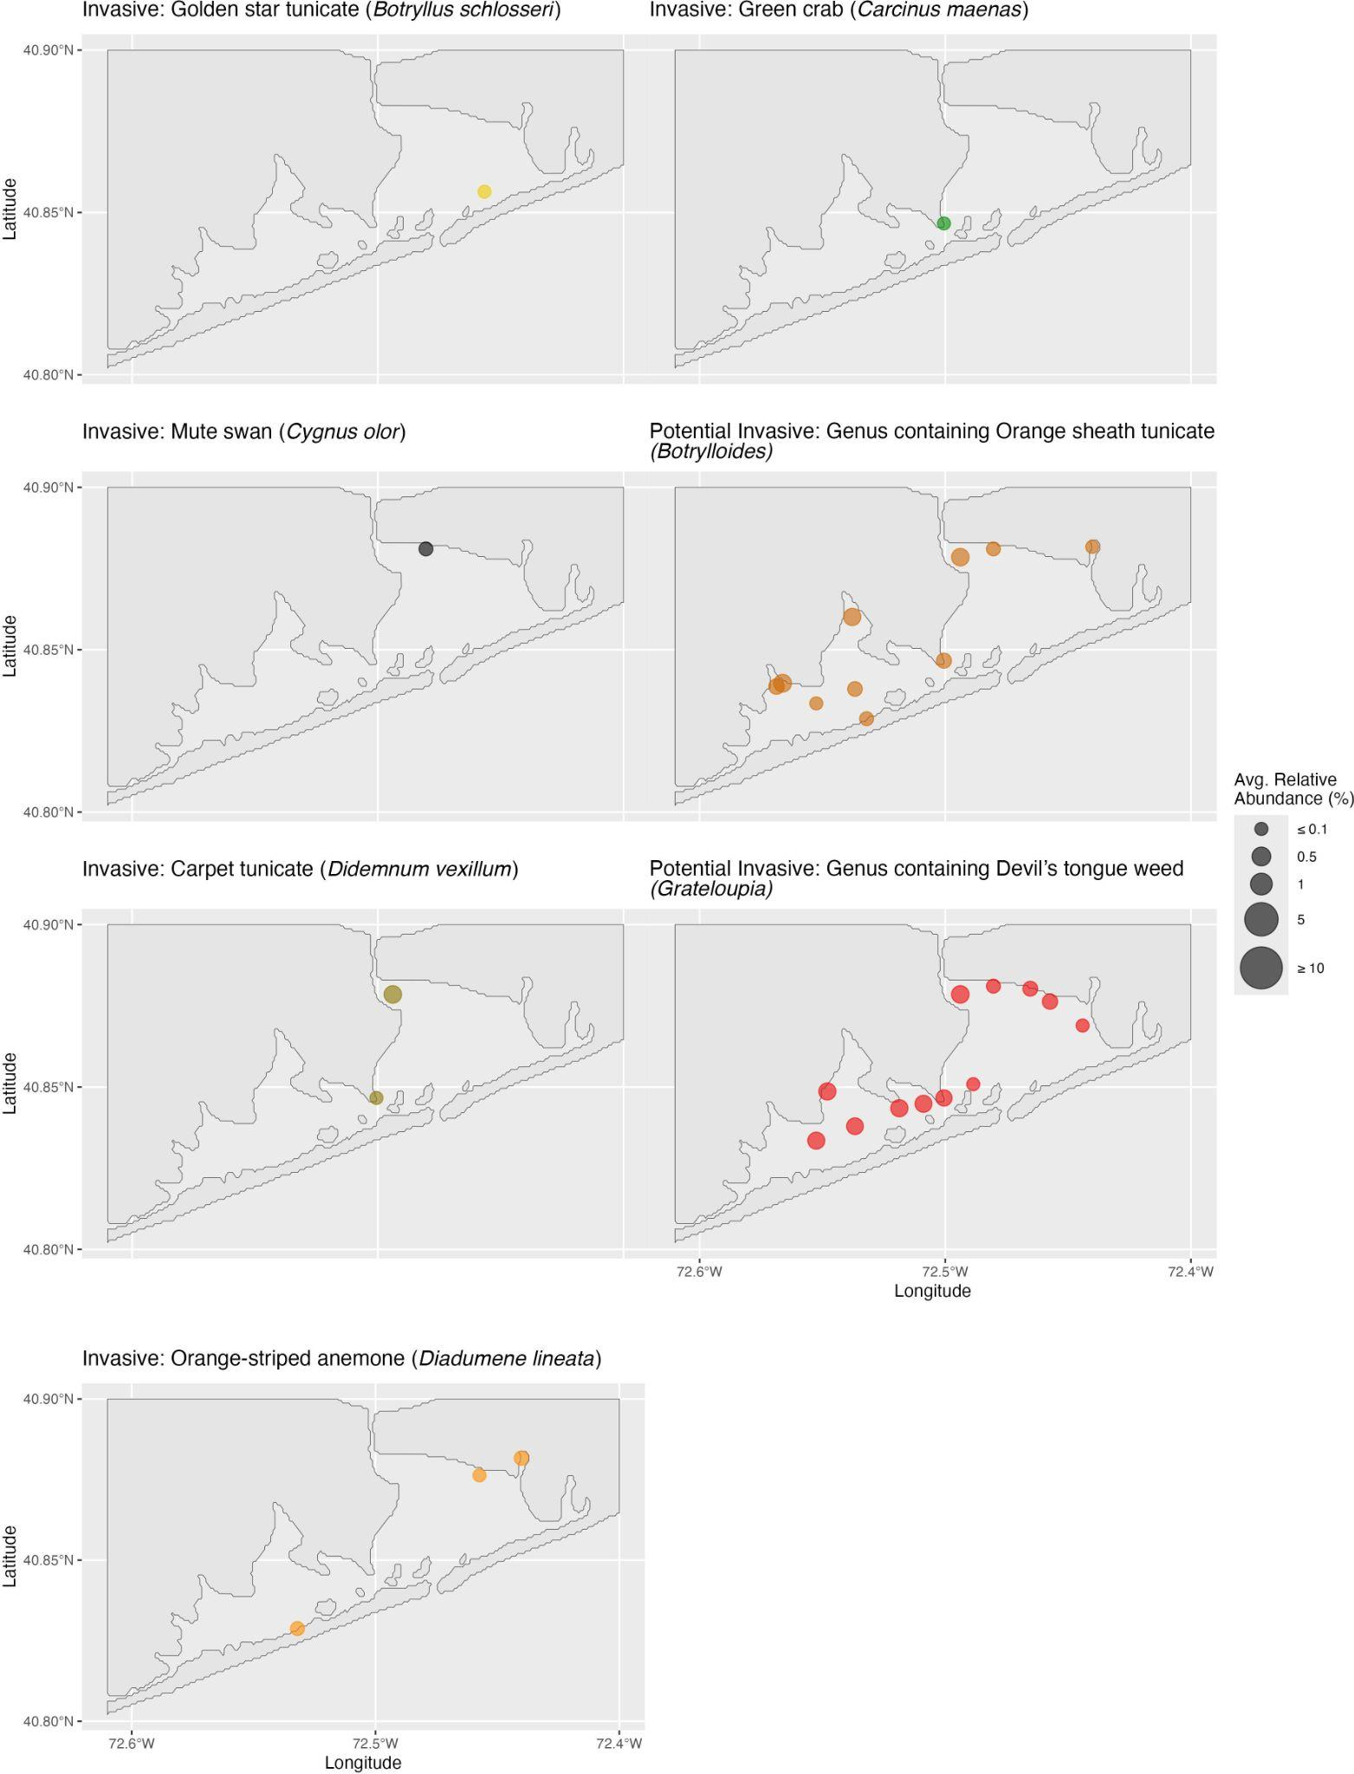
Supplementary Figure 7: Additional invasive species maps. Bubbles are average relative abundance across the two-week study. Biocultural (BC) and Traditional Knowledge (TK) notices created by Local Contexts are placed at the bottom of the figure to signify these samples were collected from Shinnecock waters.

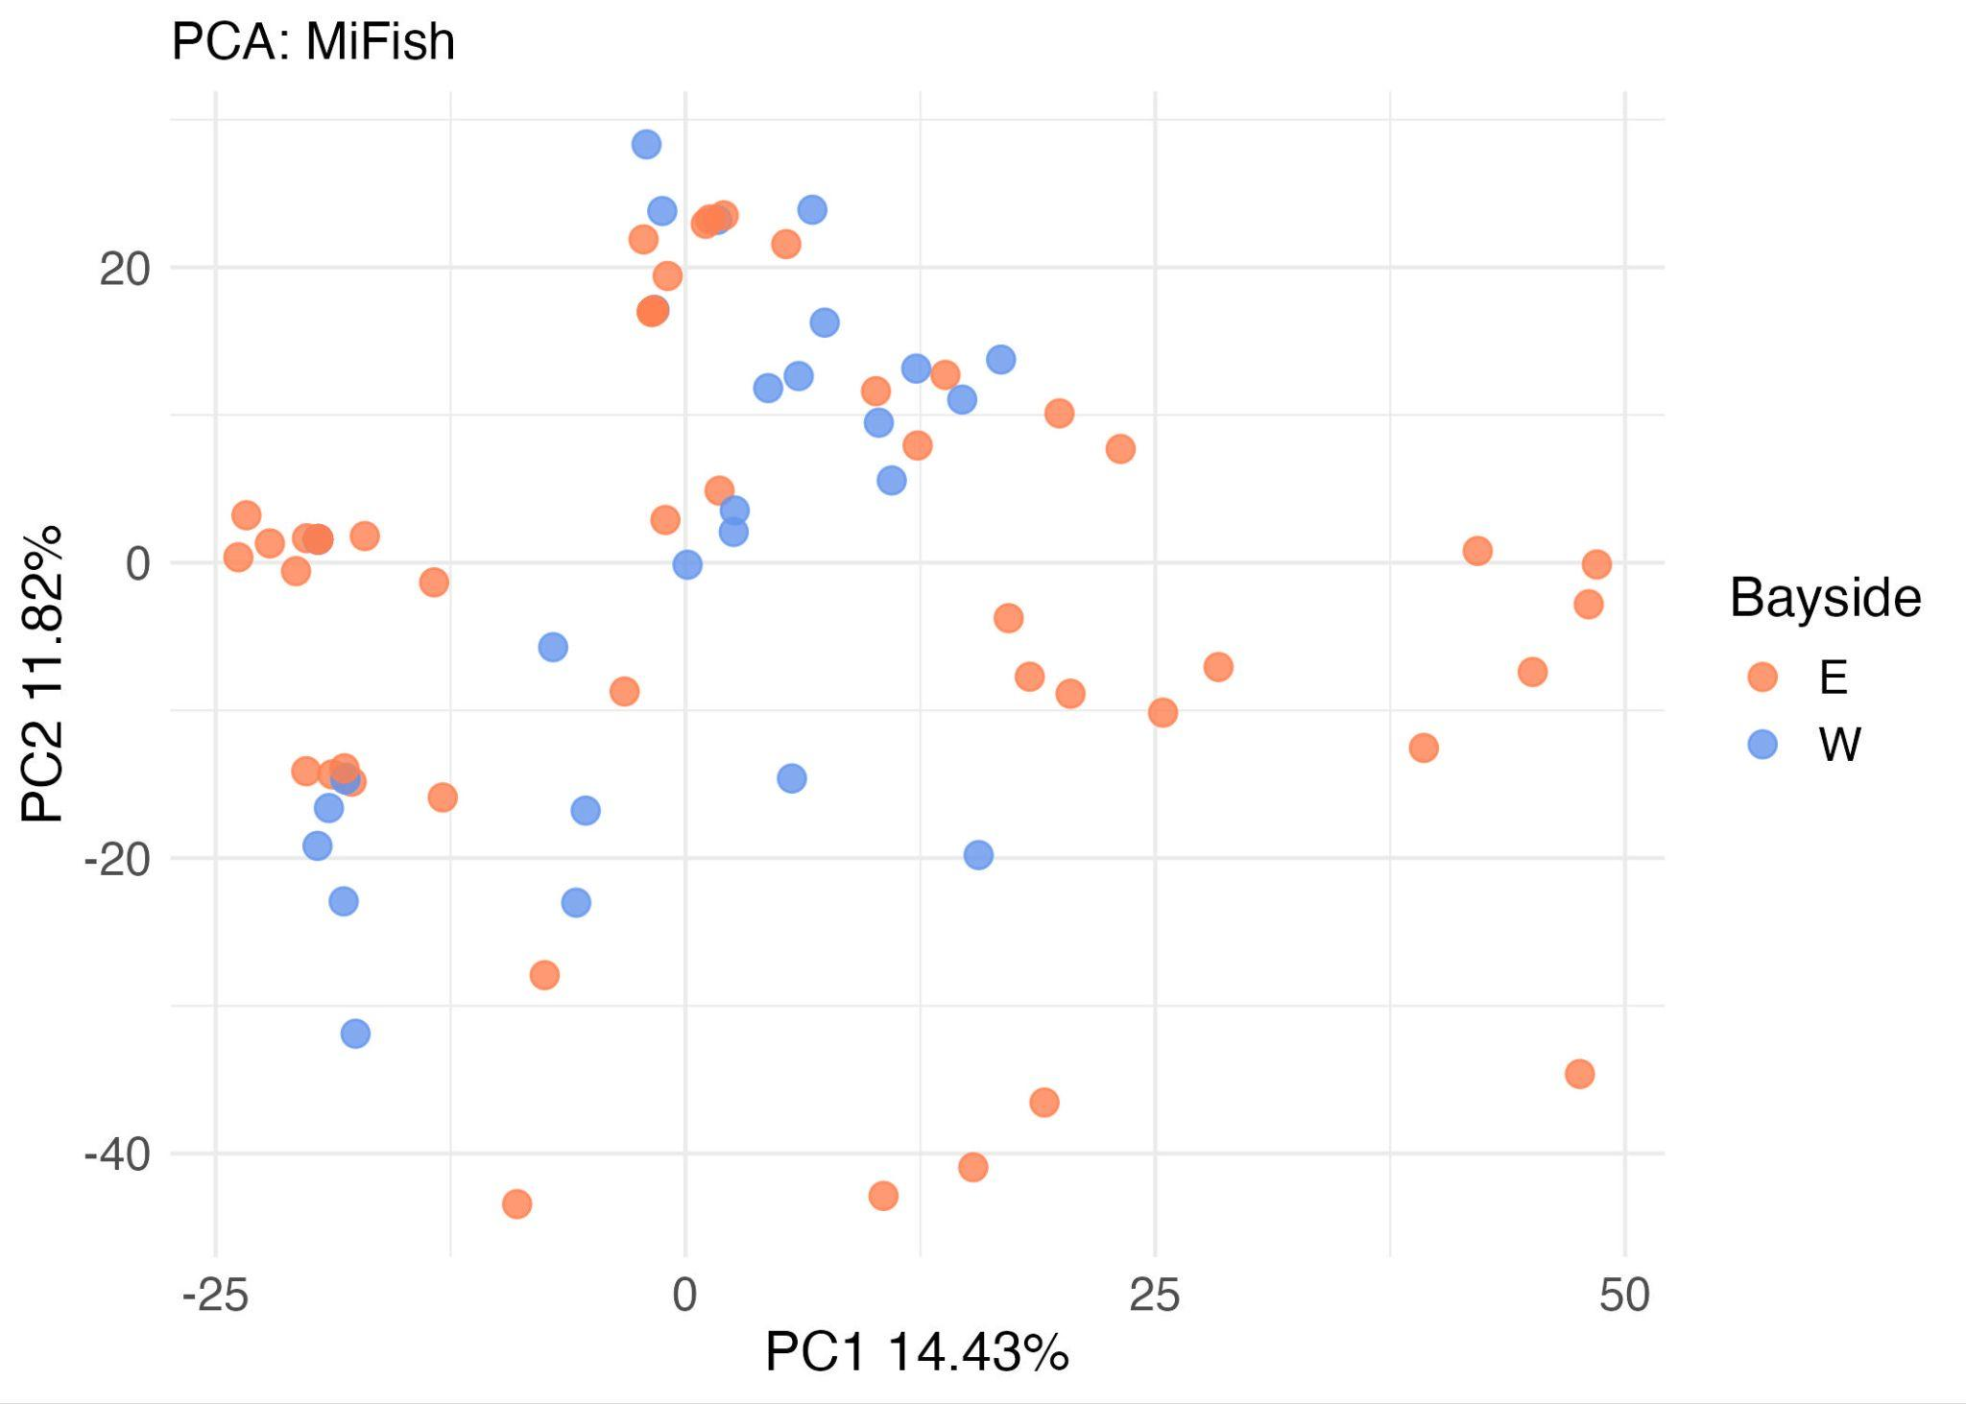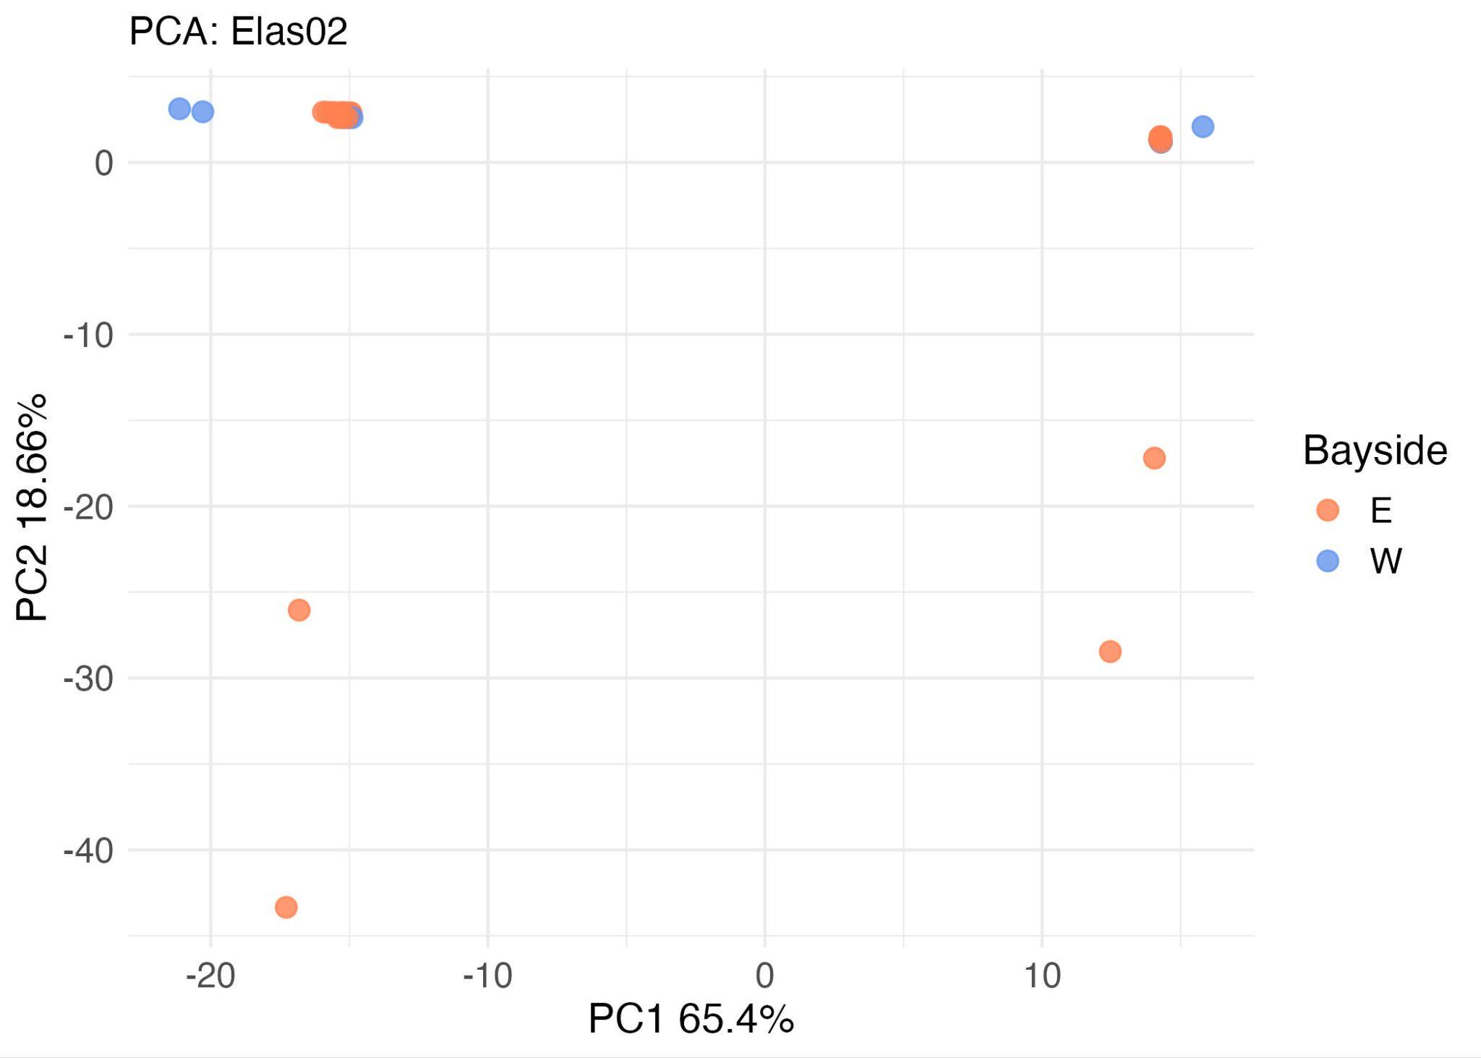

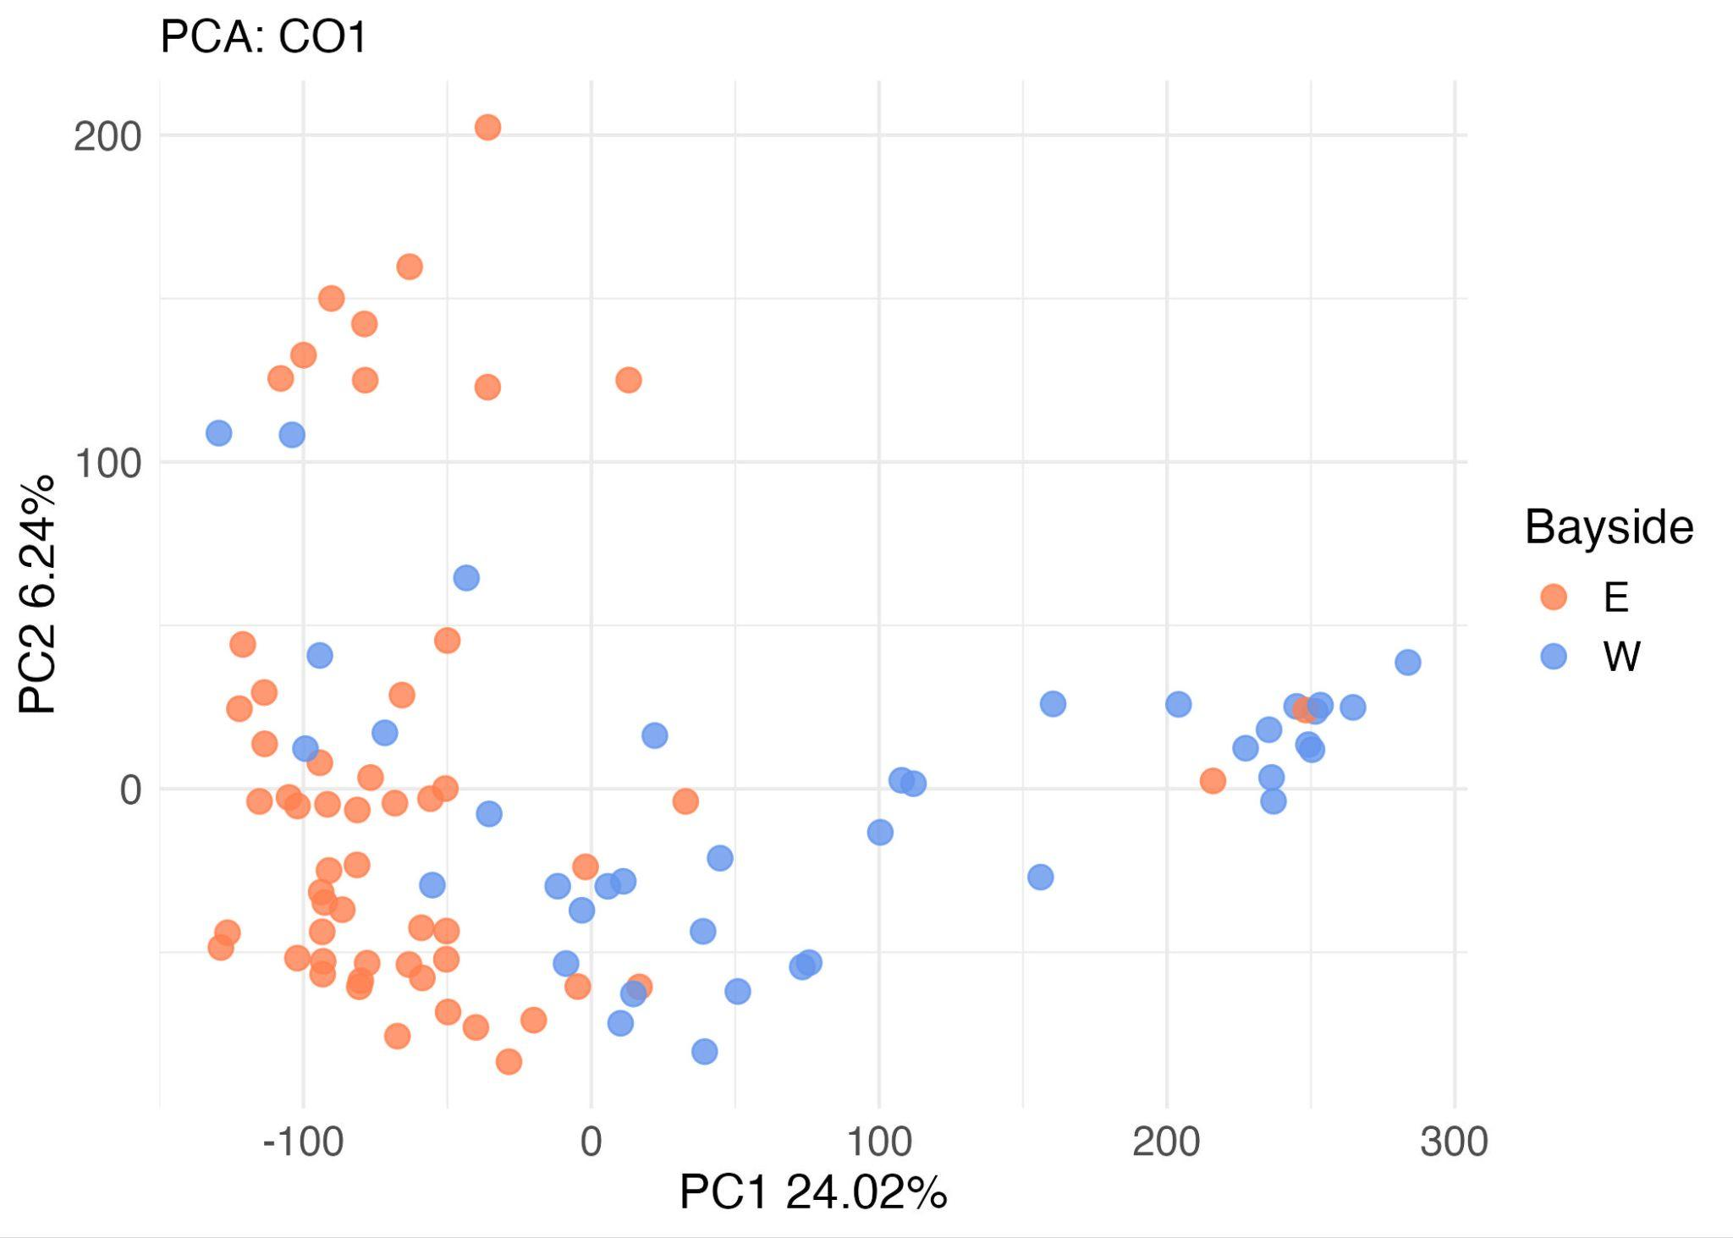

Supplementary Figure 8: Results of the PCA on the a) MiFish, b) Elas02, and c) CO1 libraries. Points representing each sample are color-coded by geographic location (eastern or western side of the bay). The percentage of variability explained by the first 2 axes are listed in the axes captions.

See attached files

Supplementary Table 3a-c: The results of the envfit on the PCA of a) MiFish, b) Elas02, and c) CO1 communities.

See attached files

Supplementary Table 4a-c: The results of the envfit on the NMDS of a) MiFish, b) Elas02, and c) CO1 communities. envfit is calculated on 2D spaces so for 3D NMDS, the envfit was calculated 3 times: on axes 1 vs 2, 1 vs 3, and 2 vs. 3.

Library | Metric | Mantel r | p-value  (*significant)
Elas02 | Jaccard | –0.004 | 0.511
Elas02 | Bray-Curtis | 0.265 | < 0.0001*
Elas02 | Aitchison | 0.268 | < 0.0001*
MiFish | Jaccard | –0.092 | 0.999
MiFish | Bray-Curtis | –0.034 | 0.807
MiFish | Aitchison | 0.017 | 0.307
CO1 | Jaccard | 0.263 | < 0.0001*
CO1 | Bray-Curtis | 0.310 | < 0.0001*
CO1 | Aitchison | 0.285 | < 0.0001*

Supplementary Table 5: Results of Mantel tests, comparing geographic distance to compositional distance for all 3 primer libraries. Three metrics for compositional distance were used: Jaccard dissimilarity, Bray-Curtis dissimilarity, and Aitchison distance.

 | Elas02 | MiFish | CO1
Non-spatial | 71.3* | 1,494.6* | 47,311.9
Spatial | 85.4 | 1,535.0 | 44,723.7*

Supplementary Table 6: Model fitting parameter, WAIC, for the different multi-species occupancy models built with spOccupancy. The non-spatial models were run with the msPGOcc function and the spatial models were run with the sfMsPGOcc function. For each library, the model with the lower WAIC (*) was chosen for further analysis.

See attached files

Supplementary Table 7a-f: Regression parameters and convergence statistics of the occupancy models for Elas02 (a), MiFish (b), and CO1 (c) at the community-level, and for Elas02 (d), MiFish (e), and CO1 (f) at the species-level. The mean, standard deviation, and 95% confidence interval of the logit score are reported as well as the direction of the effect (positive, negative, or ambiguous), the probability that the effect is positive or negative (Ppos and Pneg), ΔP , the percent chance the community or ASV is associated with that covariate, the 89% confidence interval of ΔP, the Rhat, ESS, and a flag for whether the model converged well or not based on Rhat and ESS.

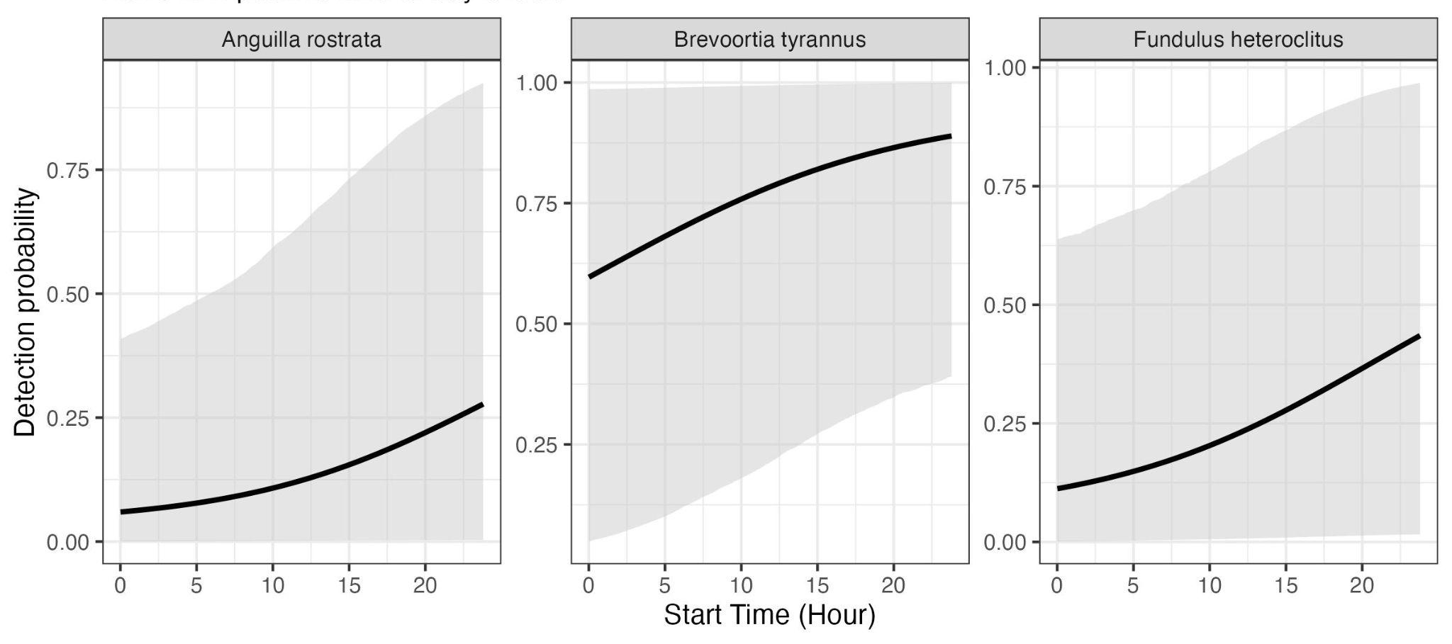
Supplementary Figure 9: Effect of sampling time on eDNA detections. Species from the CO1 library which were shown to have significantly positive effects are shown.

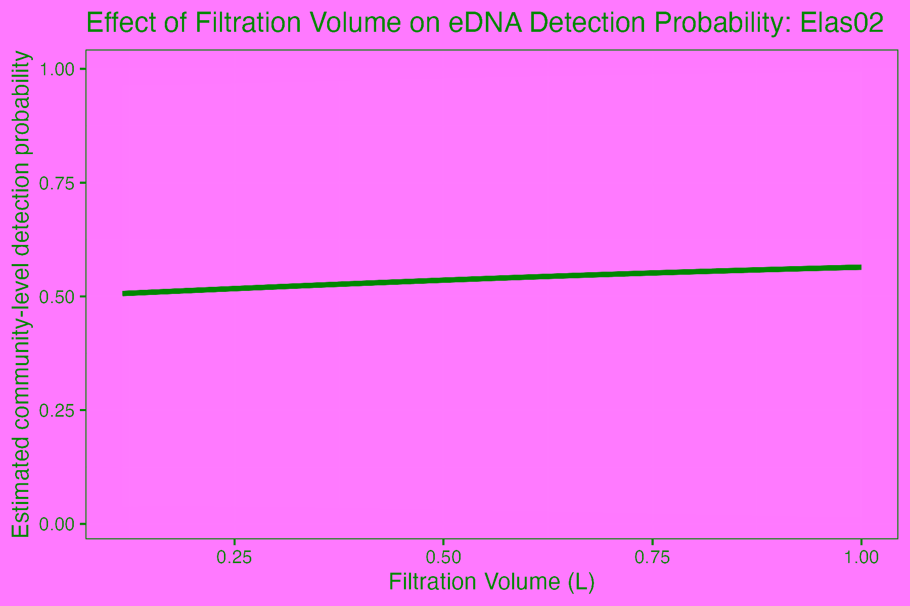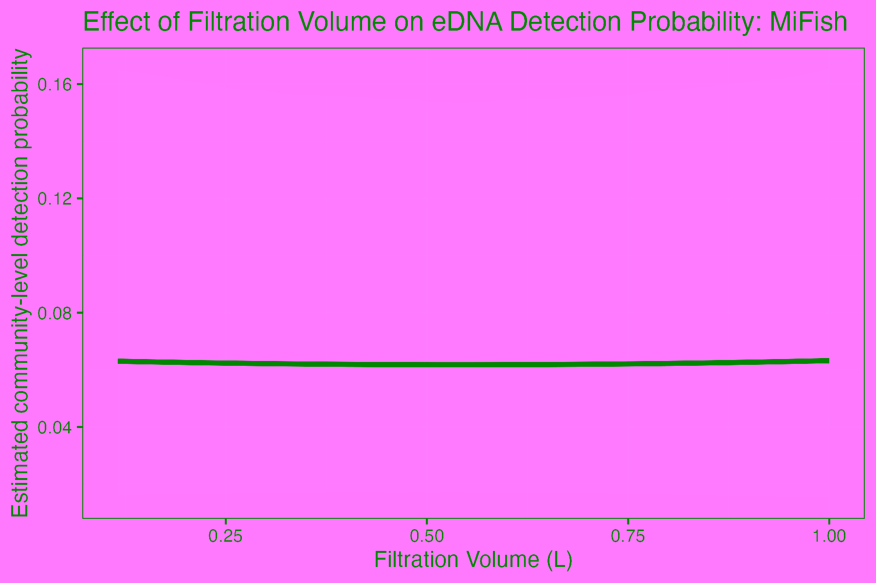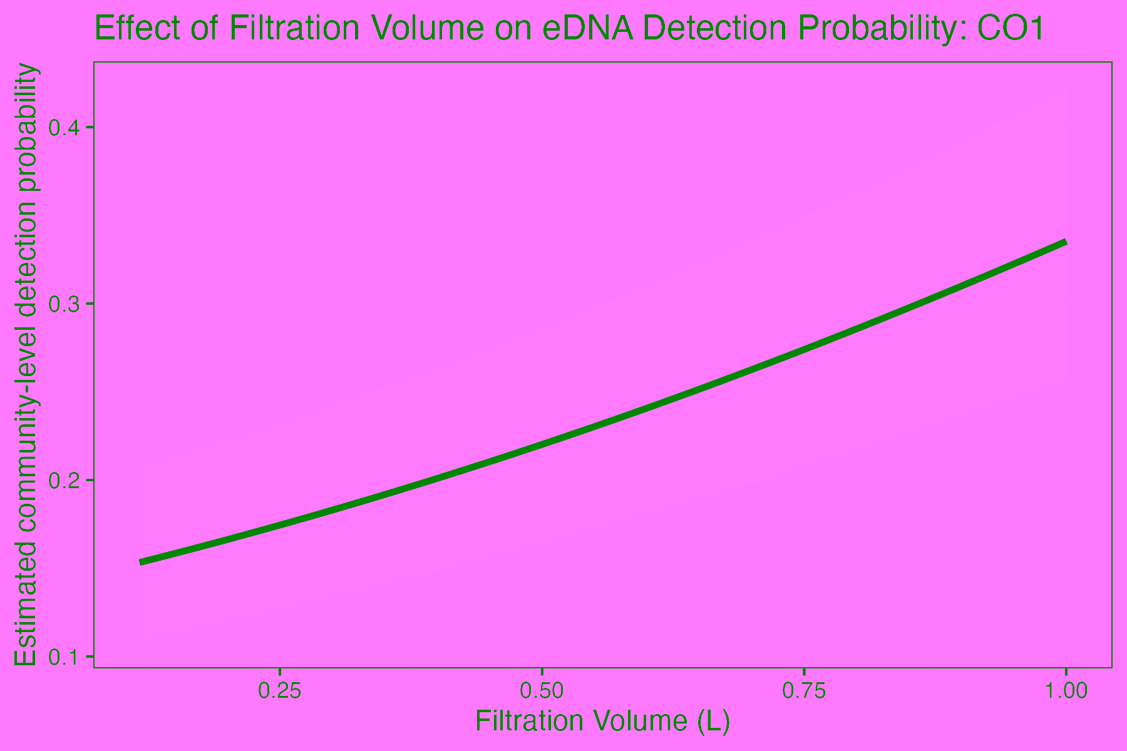
Supplementary Figure 10: Impact of filtration volume on eDNA detection probability for all libraries.

