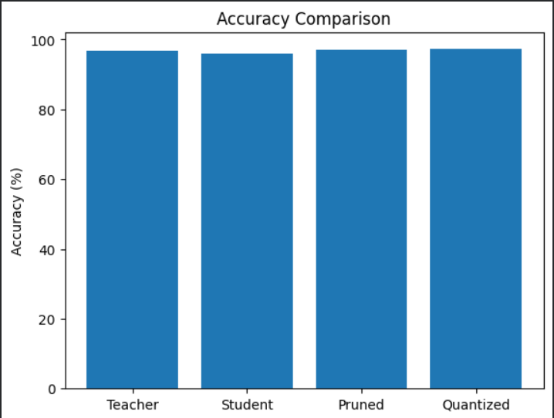

Chart 1: Accuracy Comparison of MNIST

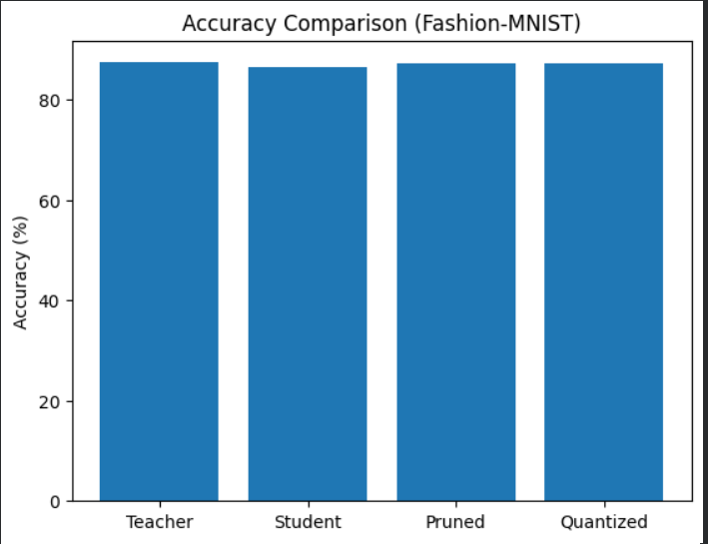

Chart 2: Accuracy Comparison of Fashion-MNIST

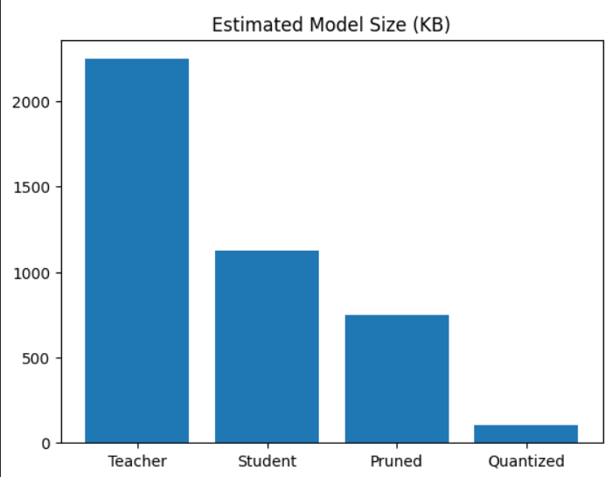

Chart 3: Comparison of Model Size in each stage for MNIST Dataset
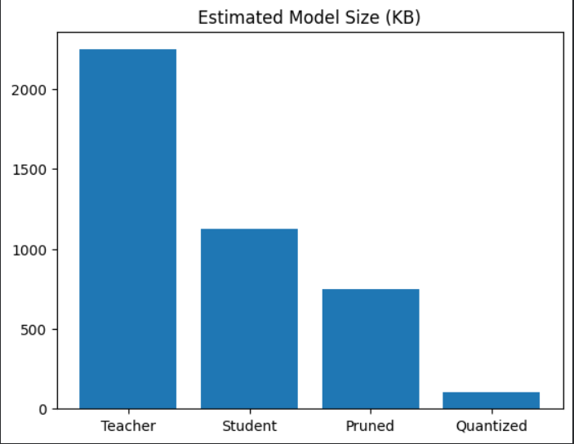

Chart 4: Comparison of Model Size in each stage for Fashion-MNIST Dataset

