Supplementary Data
Figure S1: TRAP risk perception study design. Items in bold were tested in the regression analysis or SEM.
Transport-Related Pollution Risk Perception

Socio-demographic Variable
- Age
- Income
- Rurality
- Ethnicity
- Health condition
- Religion
TRAP Risk Related Variable
- TRAP Risk Characteristics
  - Likelihood / Perceived probability of exposure and receiving contamination.
  - Consequences / Perceived probability receiving Impacts
  - Perceived severity of catastrophic consequences
  - Levels of exposure
  - Shift Length
  - Road Type (soil/marram or tarmac)
  - Time riding and time in Kampala
- Risk salience
  - Previous experience
  - Time in Kampala
  - Proximity of other pollutants
  - Environmental knowledge
  - Least favarable factor
Personal Cognitive and Affective Variable
- Sensitivity to Air Pollution
- Political attitude
- Attitude towards TRAP
- Social Trust
- Demand and support for TRAP risk mitigation
- Preventive and coping behaviours
- GDP growth verses loses of health due to air pollution
- Perceived Environmental Knowledge
- Road Type

Table S1: Set of 11 constructs used to construct the composite variable- TRAP Risk Perception:
Perception variable | Questions Used to assess Variable
Knowledge | I know that cars and/ or motorcycles cause air pollution  Have you or other members of your household ever suffered from illnesses or health problems that you believe were caused or worsened by exposure to air pollution?  I can avoid being affected by air pollution from cars and/ or motorcycles with my own efforts  How large is your risk of personally being affected by the TRAP?  How severe would you say is air pollution in Kampala/ your community from (Dust, Vehicle emissions, Industrial emissions, cooking fuels, Burning trash, Smelly sewage, Cigarette smoking, other sources)?
Voluntariness | Whether air pollution from cars and/ or motorcycles will cause damage to me or not is up to me?  When you go out from your house or place of work, do you pay attention to the quality of the air you are breathing?
Severity | Air pollution from cars and/ or motorcycles can cause a fatality?
Dread | I feel more afraid dying by air pollution from cars and/ or motorcycles than other risk
Immediacy | Air pollution from cars and/ or motorcycles can cause actual damage immediately
Personal & Social Effects | Air pollution from cars and/ or motorcycles exposure risk can happen to my family and me  Air pollution from cars and/ or motorcycles can cause damage to the overall public?
Newness | Regardless of my personal knowledge, I think there is enough research on the causes and impacts of air pollution from cars and/ or motorcycles
Controllability | How likely will you reduce motorcycle driving to abate air pollution?  How likely is it that you think other motorcycle owners will drive less to reduce air pollution?  To what extent do you think reducing motorcycle driving creates inconvenience in your everyday life?
Trust in government and others | I would contribute part of my income if I were certain that the money would be used to prevent air pollution?  I do not mind an increase in taxes if the extra money is used to prevent further atmospheric pollution.  To what extent do you think the public should be responsible for air pollution?  Are you satisfied with accessibility and availability of health services to manage TRAP health effects?
Information Availability | Do you feel well informed about TRAP?  How available to you is the information that you need in your day-to-day life?  According to your personal judgement, have you made attempts to seek information about TRAP?  Are you satisfied with how your religion helps you with how to manage TRAP and related health effects?
Coping and protective actions | During the last month, and due to air pollution, have you ever used a face mask?  Due to air pollution, how often have you used a helmet with face shield visor over your face?  How confident are you that wearing a helmet protects your health from effect of air pollution?  How confident are you that wearing a face mask protects your health from effects of air pollution?  Due to the level of air pollution in Kampala, I only drive during specific times of the day?  Due to the level of air pollution in Kampala, I drive on selected routes?  Due to the level of air pollution in Kampala, I drive for a short time?  Maintaining good eating habits (breakfast, lunch, dinner/ super) helps me against effects of air pollution from cars and/ or motorcycles?

Figure S2: Spearman’s Correlation Matrix of constructs used to define the composite dependent variable- TRAP Risk Perception:

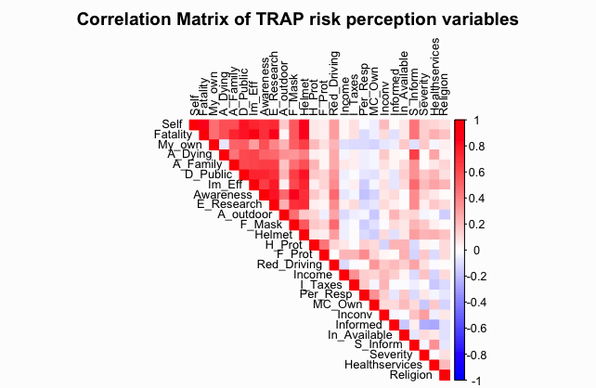

Figure S3: Heatmap of constructs used to construct the composite dependent variable- TRAP Risk Perception:

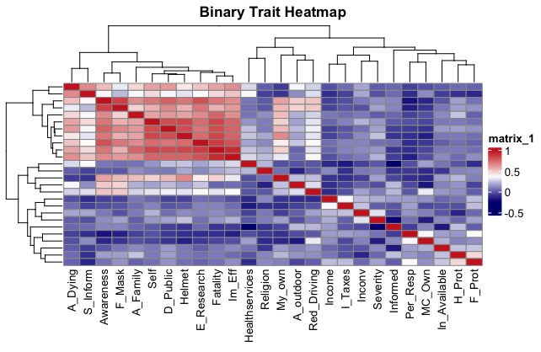
Table S2: Heatmap of constructs used to construct the composite dependent variable- TRAP Risk Perception:

Parameter | Factor Loadings
Parameter | 1 | 2 | 3 | 4 | 5 | 6 | 7
Severity | 0.79
Immediacy | 0.9
Personal & Social Effects | 0.74
Trust Government & Others |  | 0.95
Controllability |  |  | 0.95
Information Availability |  |  |  | 0.92
Coping and Protective actions |  |  |  |  | 0.52
Knowledge |  |  |  |  | 0.86
Voluntariness |  |  |  |  | 0.64
Dread |  |  |  |  |  | 0.9
Newness |  |  |  |  |  |  | 0.82

Table S3. Collapsed Constructs Used in Final Analysis
Construct | Factor(s) Collapsed | Justification
Sociodemographic | 2,4 | Based on demographic variables
TRAP-specific | 5,6 | Exposure-focused
Psychological & Cognitive | 1,3,7 | Reflect cognitive/affective traits

Table S4. Correlation matrix between the dependent and the independent variables
 | 1 | 2 | 3 | 4
- TRAP Risk Perception | 1
- Social Demographic | 0.08 | 1
- Risk Specific Variable | 0.31* | - 0.01 | 1
- Psychological, Personal Cognitive Variable | 0.39*** | - 0.20 | 0.26 | 1

Table S5. Factor loadings of factors associated with TRAP risk perception
Parameter | Factor Loadings
Parameter | 1 | 2 | 3 | 4 | 5 | 6 | 7
Govt Responsibility | -0.62
Social Trust | -0.75
Demand for mitigation measures | 0.72
Age |  | -0.45
Ethnicity |  | -0.61
Religion |  | 0.42
Self-Reported Health |  | 0.64
Serious Health Problem |  |  | 0.83
Most Exposed to TRAP pollution |  |  | 0.83
Environmental Attitude |  |  | 0.36
Highest Education Level |  |  |  | -0.60
Rurality |  |  |  | -0.69
Enough Income |  |  |  | 0.45
Time in Kampala |  |  |  |  | 0.48
Other Pollutants Index |  |  |  |  | -0.37
Time Riding |  |  |  |  | 0.65
Shift Length/ ADD_{2.5} |  |  |  |  | -0.56
Home Location/ Residence |  |  |  |  |  | -0.50
Environmental Knowledge |  |  |  |  |  | -0.71
Least Favourable factor |  |  |  |  |  |  | 0.68
Sensitivity to Air Pollution |  |  |  |  |  |  | 0.64
Road Type |  |  |  |  |  |  | -0.58

Figure S4. Relationship between social demographic variable with TRAP risk perception

Figure S5. Association between risk specific variable with TRAP risk perception

Figure S6. Relationship between the TRAP risk perception and risk specific variable after adding ADD PM2.5/PM10

Figure S7. Association between psychological personal cognitive and affective variables with TRAP risk perception.

