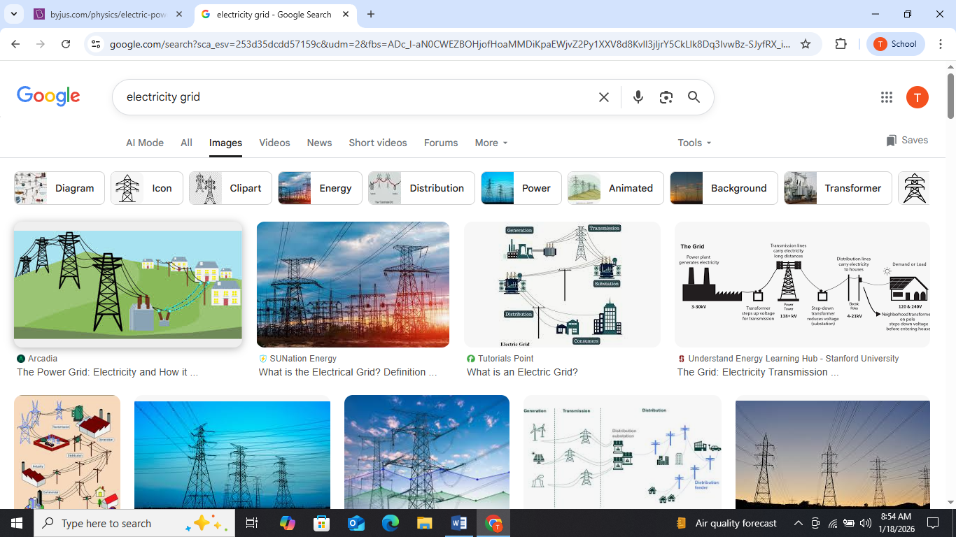
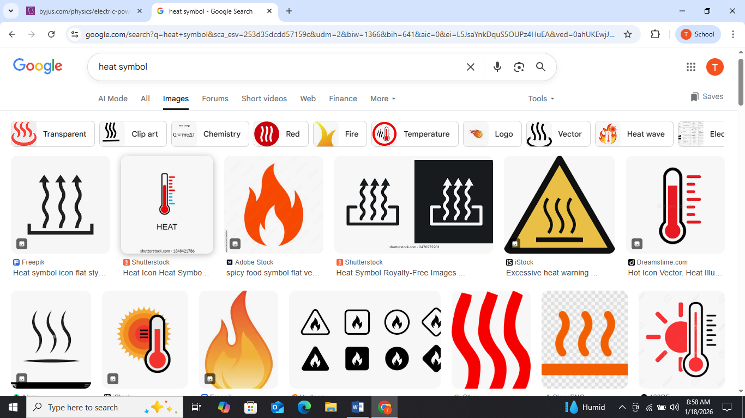
water recycle/reuse
receiving water body

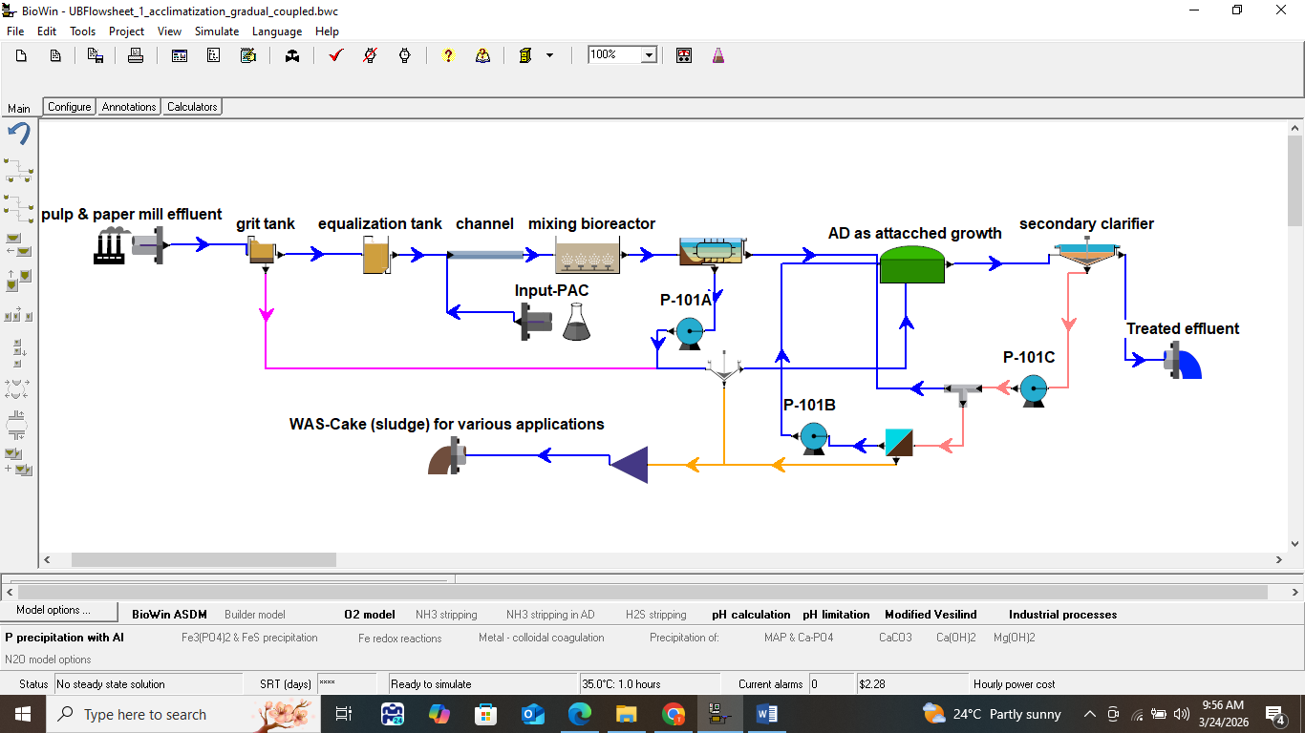

Graphical Abstract (GA) for the configuration, base case (BC) plus chemically enhanced primary treatment (CEPT) - BC+CEPT. Note: images here are not subject to copy right restrictions

