Supplementary material

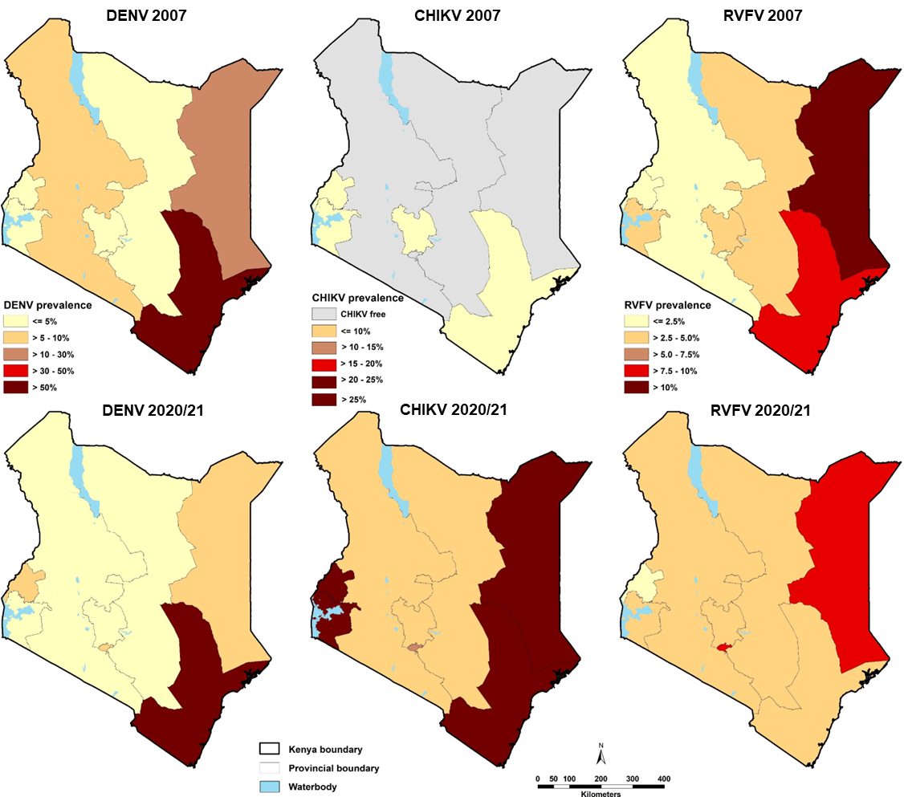
Supplementary Figure 1. DENV, CHIKV and RVFV seroprevalence by region in Kenya in 2007 (top panel) compared to 2020/21(bottom panel)

Supplementary Table 1. Characteristics of the study population and sample classification
Population | Number | Date | Location | Participant group | Utility
Adult volunteers | 10 | 2023 | Kenya, Uganda and Tunisia | Pool sera to assess the suitability for the candidate anti-RVFV WHO International Standard | RVFV controls
Adult cross-sectional survey | 147 | 2018 | Coastal Kenya | Adults investigated in the annual malaria cross-sectional survey | RVFV/ CHIKV FRNT and arbo-plex MIA testing
KIPMAT | 76 | 2012-2016 | Coastal Kenya | Mothers and newborns investigated for risk factors for severe morbidity and mortality | DENV FRNT and arbo-plex MIA testing
CPGH | 57 |  | Coastal Kenya | Anonymous presumed healthy, adult volunteer donors | DENV FRNT and arbo-plex MIA testing
Nairobi HDSS | 843 | 2022 | Nairobi | Adults and children investigated for SARS-CoV-2 seroprevalence | Arbo-plex MIA and commercial ELISAs comparison
Kilifi HDSS | 795 | 2022 | Kilifi | Adults and children investigated for SARS-CoV-2 seroprevalence | Arbo-plex MIA and commercial ELISAs comparison
Adult blood donors | 11420 | 2020/2021 | Countrywide | Adults investigated for blood transfusion safety | Seroprevalence estimates

Supplementary Table 2. Seroprevalence of RVF, CHIKV and DENV IgG antibodies showing crude, Bayesian population weighted (BPW) and Bayesian population weighted, test adjusted (BPWTA) estimates across age group, sex and counties of Kenya
 |  | RVFV |  |  |  | CHIKV |  |  |  | DENV
County | All sample () | Pos | Crude% (95 CI) | BPW% (95 CI) | BPWTA%  (95 CI) | Pos | Crude%  (95 CI) | BPW%  (95 CI) | BPWTA%  (95 CI) | Pos | Crude%  (95 CI) | BPW%  (95 CI) | BPWTA%  (95 CI)
Mombasa | 1827 (16.4) | 44 | 2.4(1.8–3.2) | 2.5(1.9-3.3) | 0.6(0.0-1.6) | 808 | 44.2(42–46.5) | 43.4(41.0-45.8) | 43.3(39.3-47.9) | 1343 | 73.5(71.4–75.5) | 72.6(70.4-74.8) | 75.5(72.5-78.9)
Nairobi | 1089 (9.8) | 87 | 8.0(6.5–9.8) | 7.8(6.3-9.5) | 6.7(4.7-9.0) | 202 | 18.5(16.3–21.0) | 18.8(16.4-21.2) | 15.2(11.4-19.1) | 62 | 5.7(4.5–7.2) | 6.2(4.8-7.8) | 4.7(3.0-6.6)
Embu | 1028 (9.2) | 26 | 2.5(1.7–3.7) | 2.7(1.8-3.7) | 0.8(0.0-2.0) | 122 | 11.9(10.0–14.0) | 11.5(9.7-13.6) | 7.0(3.4-10.5) | 15 | 1.5(0.9–2.4) | 1.7(1.0-2.6) | 0.4(0.0-1.2)
Nakuru | 950 (8.5) | 33 | 3.5, 2.5–4.9) | 3.5(2.5-4.8) | 1.6(0.3-3.1) | 97 | 10.2(8.4–12.3) | 9.8(8.1-11.8) | 5.1(1.8-8.5) | 17 | 1.8(1.1–2.9) | 1.9(1.2-2.9) | 0.5(0.0-1.4)
Kilifi | 957 (8.6) | 53 | 5.5(4.2–7.2) | 5.4(4.1-7.0) | 3.7(2.0-5.7) | 294 | 30.7(27.9–33.7) | 28.4(25.5-31.5) | 26.1(21.9-30.4) | 361 | 37.7(34.7–40.8) | 35.6(32.3-39.0) | 36.3(32.6-40.2)
Uasin Gishu | 746 (6.7) | 13 | 1.7(1.0–3.0) | 2.1(1.3-3.2) | 0.5(0.0-1.5) | 79 | 10.6(8.6–13.0) | 10.3(8.3-12.6) | 5.8(2.3-9.3) | 25 | 3.4(2.3–4.9) | 3.4(2.2-4.9) | 1.5(0.2-3.2)
Kisumu | 484 (4.4) | 15 | 3.1(1.8–5.1) | 3.3(2.0-5.0) | 1.3(0.1-3.1) | 155 | 32(28.0–36.3) | 31.2(27.3-35.4) | 29.5(24.0-35.1) | 17 | 3.5(2.2–5.6) | 3.8(2.3-5.8) | 2.0(0.3-4.2)
Kwale | 464 (4.2) | 12 | 2.6(1.4–4.5) | 2.9(1.7-4.5) | 1.0(0.0-2.6) | 213 | 45.9(41.4–50.5) | 43.2(38.6-47.9) | 43.1(37.0-49.6) | 159 | 34.3(30.1–38.7) | 32.3(28.1-36.7) | 33.0(28.3-37.9)
Kiambu | 452 (4.1) | 5 | 1.1(0.4–2.6) | 1.8(0.9-3.1) | 0.5(0.0-1.6) | 31 | 6.9(4.8–9.6) | 7.2(5.1-9.8) | 2.8(0.4-6.1) | 10 | 2.2(1.2–4.1) | 2.7(1.4-4.5) | 0.8(0.0-2.6)
Kisii | 409 (3.7) | 7 | 1.7(0.8–3.6) | 2.3(1.2-3.8) | 0.7(0.0-2.1) | 36 | 8.8(6.4–12) | 10.0(7.2-13.4) | 4.9(1.0-9.4) | 8 | 2.0(0.9–3.9) | 3.0(1.5-5.3) | 1.0(0.0-3.2)
Machakos | 382 (3.4) | 35 | 9.2(6.6–12.5) | 8.4(6.0-11.3) | 7.5(4.4-11.1) | 78 | 20.4(16.7–24.8) | 19.7(16.0-23.8) | 16.1(10.9-21.3) | 10 | 2.6(1.4–4.8) | 2.9(1.5-4.9) | 0.9(0.0-2.8)
Tana River | 315 (2.8) | 27 | 8.6(5.9–12.2) | 7.8(5.3-10.9) | 6.9(3.6-10.9) | 50 | 15.9(12.2–20.3) | 15.1(11.7-19.2) | 10.9(5.9-16.2) | 89 | 28.3(23.6–33.5) | 27.1(22.4-32.2) | 27.8(22.5-33.3)
Nyeri | 294 (2.6) | 19 | 6.5(4.1–9.9) | 5.9(3.8-8.8) | 4.4(1.5-7.9) | 90 | 30.6(25.6–36.1) | 30.1(25.1-35.4) | 28.4(21.9-35.3) | 8 | 2.7(1.3–5.4) | 3.5(1.7-6.2) | 1.4(0.0-4.2)
Meru | 231 (2.1) | 9 | 3.9(2.0–7.3) | 3.9(2.2-6.5) | 1.9(0.2-4.9) | 29 | 12.6(8.8–17.5) | 13.5(9.5-18.3) | 9.1(3.4-15.1) | 8 | 3.5(1.7–6.8) | 4.7(2.2-8.3) | 2.2(0.1-6.3)
Lamu | 215 (1.9) | 12 | 5.6(3.1–9.6) | 5.1(2.9-8.2) | 3.2(0.6-6.8) | 95 | 44.2(37.7–50.9) | 41.0(34.7-47.6) | 40.7(32.5-49.3) | 120 | 55.8(49.1–62.3) | 53.7(47.2-60.1) | 56.3(49.2-63.8)
Taita Taveta | 163 (1.5) | 9 | 5.5(2.8–10.3) | 5.0(2.7-8.3) | 3.1(0.4-7.1) | 21 | 12.9(8.5–19) | 12.8(8.6-18.1) | 8.1(2.6-14.6) | 32 | 19.6(14.2–26.4) | 18.5(13.3-24.7) | 18.5(12.5-25.0)
West Pokot | 101 (0.9) | 12 | 11.9(6.8–19.8) | 8.8(4.9-14.6) | 9.4(3.4-17.1) | 29 | 28.7(20.8–38.2) | 28.5(20.3-37.6) | 26.7(16.6-37.7) | 6 | 5.9(2.5–12.6) | 6.9(2.9-13.2) | 5.9(1.0-12.9)
Kirinyaga | 112 (1.0) | 2 | 1.8(0.1–6.7) | 2.9(1.3-5.8) | 1.2(0.1-3.9) | 6 | 5.4(2.2–11.4) | 7.1(3.6-12.2) | 3.3(0.5-8.0) | 1 | 0.9(0–5.4) | 1.9(0.5-5.2) | 0.9(0.0-3.5)
Siaya | 105 (0.9) | 4 | 3.8(1.2–9.7) | 3.9(1.9-7.4) | 1.9(0.1-5.9) | 42 | 40(31.1–49.6) | 38.0(29.4-47.2) | 37.8(27.2-49.0) | 3 | 2.9(0.6–8.4) | 3.5(1.1-8.0) | 1.9(0.0-6.5)
Tharaka-Nithi | 105 (0.9) | 2 | 1.9(0.1–7.1) | 3.0(1.3-6.0) | 1.3(0.1-4.1) | 11 | 10.5(5.8–17.9) | 11.1(6.4-17.5) | 6.1(1.1-13.1) | 1 | 1(0–5.7) | 1.9(0.5-5.6) | 0.9(0.0-3.8)
Trans nzioa | 51 (0.5) | 1 | 2(0–11.3) | 3.4(1.4-7.3) | 1.7(0.1-5.6) | 12 | 23.5(13.9–36.9) | 21.9(13.0-33.2) | 18.4(7.2-31.4) | 1 | 2(0–11.3) | 2.9(0.6-8.7) | 1.6(0.0-6.5)
Muranga | 80 (0.7) | 2 | 2.5(0.2–9.2) | 3.4(1.5-6.9) | 1.6(0.1-5.2) | 6 | 7.5(3.2–15.7) | 9.3(4.7-16.3) | 4.6(0.6-11.5) | 1 | 1.3(0–7.4) | 2.4(0.6-7.3) | 1.2(0.0-5.0)
Nandi | 38 (0.3) | 5 | 13.2(5.3–27.8) | 7.2(3.3-14.8) | 7.6(0.8-19.2) | 8 | 21.1(10.8–36.6) | 20.8(11.3-33.8) | 16.6(4.4-32.1) | 0 | 0(0–10.9) | 2.1(0.3-8.3) | 1.4(0.0-6.3)
Bungoma | 68 (0.6) | 1 | 1.5(0–8.6) | 3.1(1.2-6.5) | 1.4(0.1-4.6) | 27 | 39.7(28.9–51.6) | 36.7(26.2-47.9) | 36.6(24.1-50.0) | 5 | 7.4(2.8–16.5) | 7.5(2.9-14.8) | 6.3(0.6-14.8)
Kericho | 43 (0.4) | 2 | 4.7(0.4–16.3) | 4.3(1.8-9.4) | 2.6(0.2-8.7) | 7 | 16.3(7.8–30.3) | 18.0(9.4-30.2) | 13.4(2.6-27.7) | 2 | 4.7(0.4–16.3) | 6.0(1.5-15.4) | 3.9(0.1-14.4)
Homabay | 61 (0.6) | 3 | 4.9(1.1–14) | 4.4(1.9-9.0) | 2.7(0.2-8.2) | 33 | 54.1(41.7–66.0) | 49.2(37.5-61.1) | 51.9(38.0-66.5) | 1 | 1.6(0–9.6) | 2.7(0.6-8.1) | 1.6(0.0-6.3)
Garissa | 58 (0.5) | 5 | 8.6(3.3–19) | 6.0(2.8-11.6) | 4.6(0.4-12.5) | 13 | 22.4(13.5–34.8) | 20.4(12.3-30.7) | 16.9(6.9-29.0) | 5 | 8.6(3.3–19) | 7.1(2.9-14.4) | 5.4(0.3-13.2)
Makueni | 45 (0.4) | 3 | 6.7(1.6–18.5) | 5.0(2.1-10.4) | 3.3(0.2-10.2) | 14 | 31.1(19.5–45.7) | 26.8(16.6-39.4) | 24.8(12.0-39.6) | 3 | 6.7(1.6–18.5) | 5.6(1.8-12.9) | 4.3(0.2-12.0)
Kitui | 40 (0.4) | 3 | 7.5(1.9–20.6) | 5.2(2.3-11.0) | 3.7(0.2-11.6) | 4 | 10(3.4–23.6) | 11.7(5.3-21.6) | 7.4(1.0-18.0) | 0 | 0(0–10.4) | 2.0(3.2-7.1) | 1.2(0.0-5.3)
Wajir | 37 (0.3) | 4 | 10.8(3.7–25.3) | 6.3(2.7-13.3) | 5.6(0.5-15.7) | 15 | 40.5(26.3–56.5) | 34.0(21.3-48.4) | 33.7(18.2-50.7) | 3 | 8.1(2.1–22) | 6.7(2.1-15.7) | 6.0(0.5-15.6)
Migori | 28 (0.3) | 0 | 0(0–14.3) | 3.3(1.2-7.7) | 1.6(0.1-5.7) | 12 | 42.9(26.5–60.9) | 37.2(22.9-53.3) | 38.7(20.0-59.3) | 0 | 0(0–14.3) | 2.4(0.4-9.5) | 1.6(0.0-7.4)
Turkana | 28 (0.3) | 3 | 10.7(2.9–28) | 5.8(2.4-12.7) | 5.2(0.4-16.1) | 12 | 42.9(26.5–60.9) | 35.8(21.6-51.9) | 36.5(18.6-55.9) | 6 | 21.4(9.9–39.9) | 17.8(7.5-33.2) | 19.5(6.0-36.9)
Vihiga | 28 (0.3) | 0 | 0(0–14.3) | 3.3(1.2-7.6) | 1.6(0.1-5.9) | 4 | 14.3(5.1–32.1) | 15.7(7.1-28.7) | 10.7(1.5-25.0) | 0 | 0(0–14.3) | 2.5(0.4-9.9) | 1.7(0.0-7.5)
Busia | 25 (0.2) | 1 | 4(0–21.1) | 4.1(1.6-9.6) | 2.3(0.1-8.5) | 8 | 32(17.1–51.7) | 27.0(14.4-43.1) | 25.5(9.2-45.5) | 1 | 4(0–21.1) | 4.3(0.9-13.9) | 2.6(0.0-11.6)
Marsabit | 20 (0.2) | 2 | 10(1.6–31.3) | 5.2(2.1-12.2) | 4.1(0.2-14.4) | 3 | 15(4.4–36.9) | 16.0(6.6-30.8) | 11.6(0.8-17.8) | 0 | 0(0–19.0) | 2.5(0.4-10.3) | 1.8(0.0-8.5)
Kajiado | 16 (0.1) | 1 | 6.3(0–30.3) | 4.4(1.7-10.8) | 3.1(0.2-11.9) | 0 | 0(0–22.7) | 9.5(3.0-22.0) | 6.1(0.8-19.7) | 0 | 0(0–22.7) | 2.7(0.4-11.3) | 2.0(0.0-9.4)
Laikipia | 14 (0.1) | 0 | 0(0–25.1) | 3.6(1.3-9.1) | 2.1(0.1-8.4) | 0 | 0(0–25.1) | 10.1(3.2-24.2) | 6.8(0.8-19.7) | 0 | 0(0–25.1) | 3.2(0.4-13.8) | 2.5(0.0-12.1)
Isiolo | 8 (0.1) | 0 | 0(0–37.2) | 3.8(1.4-9.9) | 2.4(0.1-9.8) | 2 | 25(6.3–59.9) | 20.5(7.9-42.6) | 17.8(2.4-45.0) | 1 | 12.5(0.1–49.2) | 7.6(1.3-26.8) | 7.9(0.1-30.0)
Kakamega | 5 (<0.1) | 0 | 0(0–48.9) | 3.9(1.4-10.7) | 2.6(0.1-11.1) | 1 | 20(2.0–64.0) | 19.3(6.6-42.3) | 16.4(1.6-45.9) | 1 | 20(2–64.0) | 9.9(1.7-35.0) | 11.2(0.1-43.7)
Narok | 2 (<0.1) | 0 | 0(0–71.0) | 4.1(1.4-11.0) | 3.0(0.1-13.4) | 1 | 50(9.5–90.5) | 24.0(7.9-55.4) | 24.2(2.3-66.3) | 0 | 0(0–71.0) | 4.8(0.6-27.5) | 5.9(0.0-33.5)

