Supplementary Information
Yolk-Shell Zeolite Nanoreactors Enable Multi-Poison Resistance for NO_{x} Reduction
Yonglong Li,^{a, b‡} Guobo Li,^{a‡} Rongxing Li,ª Jian Ji,ª Xiaonan Hu,ª Fengbo Yu,ª Wenming Liu,^{c} Hongmei Li,^{d} Min Liu,^{d, e} and Honggen Peng^{a, c*}
ª Engineering Research Center of Watershed Carbon Neutrality of Ministry of Education and School of Resources and Environment, Nanchang University, Nanchang, Jiangxi, 330031, China
^{b} School of Life Sciences, Jinggangshan University, Ji’an, Jiangxi, 343009, China
^{c} School of Chemistry and Chemical Engineering, Nanchang University, Nanchang, Jiangxi, 330031, China
^{d} Hunan Joint International Research Center for Carbon Dioxide Resource Utilization, State Key Laboratory of Powder Metallurgy, School of Physics, Central South University, Changsha, Hunan, 410083, China
^{e} School of Metallurgy and Environment, Central South University, Changsha, Hunan, 410083, China
‡ These authors contributed equally to this work.
∗ Corresponding author, E-mail: penghonggen@ncu.edu.cn (H.G. Peng)

(This Supplementary Information includes 89 pages, 61 figures, and 7 tables)
List of Content
Supplementary Experimental Details 1
Catalyst preparation 1
Catalytic test 5
Kinetic test 5
Catalyst characterization 7
DFT calculation 9
Supplementary Figures 11
Figure S1. SEM images of the ZSM-5 zeolite. 11
Figure S2. TEM images of the ZSM-5 zeolite. 12
Figure S3. SEM images of the supported MnFeO_{x}/ZSM-5 sample. 13
Figure S4. (A, B) TEM images, (C) HAADF-TEM image and (D–I) EDS elemental mappings of the supported MnFeO_{x}/ZSM-5 sample. 14
Figure S5. SEM images of the yolk-shell structured MnFeO_{x}@YS-ZSM-5 nanoreactor. 15
Figure S6. TEM images of the yolk-shell structured MnFeO_{x}@YS-ZSM-5 nanoreactor. 16
Figure S7. (A, B) HAADF-STEM, (C–H) EDS elemental mappings, and (I) line scan of the yolk-shell structured MnFeO_{x}@YS-ZSM-5 nanoreactor. 17
Figure S8. (A–E) iDPC images and (F) selected area electron diffraction (SAED) of the yolk-shell structured MnFeO_{x}@YS-ZSM-5 nanoreactor. 18
Figure S9. Pore-size distributions of ZSM-5 zeolite and yolk-shell structured MnFeO_{x}@YS-ZSM-5 samples derived from the isotherms. 19
Figure S10. Powder XRD patterns of as-prepared ZSM-5, S-1, MnFeO_{x}, MnFeO_{x}/ZSM-5, MnFeO_{x}/S-1, and MnFeO_{x}@YS-ZSM-5 samples. 20
Figure S11. (A, B) TEM, (C) HAADF-STEM, and (D) EDS elemental mappings of MnFeO_{x}@YS-ZSM-5 sample obtained after being hydrothermally treated in TPAOH solution at 170 °C for 1 h. 21
Figure S12. (A, B) TEM, (C) HAADF-STEM, and (D) EDS elemental mappings of the MnFeO_{x}@YS-ZSM-5 sample obtained after being hydrothermally treated in TPAOH solution at 170 °C for 2 h. 22
Figure S13. (A, B) TEM, (C) HAADF-STEM, and (D) EDS elemental mappings of the MnFeO_{x}@YS-ZSM-5 sample obtained after being hydrothermally treated in TPAOH solution at 170 °C for 4 h. 23
Figure S14. (A, B) TEM, (C) HAADF-STEM, and (D) EDS elemental mappings of the MnFeO_{x}@YS-ZSM-5 sample obtained after being hydrothermally treated in TPAOH solution at 170 °C for 8 h. 24
Figure S15. (A, B) TEM, (C) HAADF-STEM, and (D) EDS elemental mappings of the MnFeO_{x}@YS-ZSM-5 sample obtained after being hydrothermally treated in TPAOH solution at 170 °C for 12 h. 25
Figure S16. (A, B) TEM, (C) HAADF-STEM, and (D) EDS elemental mappings of the MnFeO_{x}@YS-ZSM-5 sample obtained after being hydrothermally treated in TPAOH solution at 170 °C for 24 h. 26
Figure S17. (A, B) TEM, (C) HAADF-STEM, and (D) EDS elemental mappings of the MnFeO_{x}@YS-ZSM-5 sample obtained after being hydrothermally treated in TPAOH solution at 170 °C for 48 h. 27
Figure S18. N₂ adsorption-desorption isotherms of MnFeO_{x}@YS-ZSM-5 obtained after being hydrothermally treated in TPAOH solution at 170 °C with varying durations. 28
Figure S19. Powder XRD patterns of MnFeO_{x}@YS-ZSM-5 obtained after being hydrothermally treated in TPAOH solution at 170 °C with varying durations. 29
Figure S20. Si 2p and Al 2p XPS spectra of the supported MnFeO_{x}/ZSM-5 and yolk-shell structured MnFeO_{x}@YS-ZSM-5 samples 30
Figure S21. Formation mechanism of yolk-shell structured MnFeO_{x}@YS-ZSM-5 nanoreactor. 31
Figure S22. (A–C) TEM images, (D) HAADF-STEM, and (E, F) EDS elemental mappings of the yolk-shell structured MnCoO_{x}@YS-ZSM-5 nanoreactor. 33
Figure S23. (A, B) TEM images, (C) HAADF-STEM, and (D) EDS elemental mappings of the yolk-shell structured MnCeO_{x}@YS-ZSM-5 nanoreactor. 34
Figure S24. N₂ adsorption-desorption isotherms of supported MnCoO_{x}/ZSM-5 and yolk-shell structured MnCoO_{x}@YS-ZSM-5 nanoreactor. 35
Figure S25. N₂ adsorption-desorption isotherms of supported MnCeO_{x}/ZSM-5 and yolk-shell structured MnCeO_{x}@YS-ZSM-5 nanoreactor. 36
Figure S26. Powder XRD patterns of yolk-shell structured MnCoO_{x}@YS-ZSM-5 and MnCeO_{x}@ZSM-5 nanoreactors. 37
Figure S27. SEM images of the pure MnFeO_{x} metal oxides sample. 38
Figure S28. TEM images of the MnFeO_{x} metal oxides sample. 39
Figure S29. TEM images of the S-1 zeolite. 40
Figure S30. TEM images of the supported MnFeO_{x}/S-1 sample. 41
Figure S31. (A–C) TEM images, (D) HAADF-STEM, and (E–I) EDS elemental mappings of the supported MnFeO_{x}/S-1 sample. 42
Figure S32. N₂ adsorption-desorption isotherms of the pure MnFeO_{x}, S-1 zeolite, and supported MnFeO_{x}/S-1 samples. 43
Figure S33. N₂O concentration as a function of temperature in NH₃-SCR reaction over the MnFeO_{x}, MnFeO_{x}/ZSM-5, MnFeO_{x}/S-1 and yolk-shell structured MnFeO_{x}@YS-ZSM-5 catalysts.. 44
Figure S34. N₂ selectivity as a function of temperature in NH₃-SCR reaction over the MnFeO_{x}, MnFeO_{x}/ZSM-5, MnFeO_{x}/S-1 and yolk-shell structured MnFeO_{x}@YS-ZSM-5 catalysts.. 45
Figure S35. NO_{x} conversion as a function of temperature in NH₃-SCR reaction over the MnFeO_{x}@YS-ZSM-5 obtained after being hydrothermally treated in TPAOH solution at 170 °C with varying durations. 46
Figure S36. The active temperature windows (NO_{x} conversion higher than 80%) of the MnFeO_{x}-based NH₃-SCR catalysts reported in the literature. 47
Figure S37. Arrhenius plots of NO_{x} conversions in SCR over the over the MnFeO_{x}, MnFeO_{x}/ZSM-5, MnFeO_{x}/S-1 and MnFeO_{x}@YS-ZSM-5 catalysts.. 48
Figure S38. NO_{x} conversion as a function of temperature in NH₃-SCR reaction over the SO₂-MnFeO_{x}@YS-ZSM-5 and SO₂-MnFeO_{x}/ZSM-5 samples. 49
Figure S39. TEM images of the (A, B) hollow ZSM-5 zeolite and (C, D) supported MnFeO_{x}/Hollow-ZSM-5 sample. 50
Figure S40. N₂ adsorption-desorption isotherms of the hollow ZSM-5 zeolite and supported MnFeO_{x}/Hollow-ZSM-5 samples. 51
Figure S41. NO_{x} conversion as a function of temperature in NH₃-SCR reaction over the S-1 zeolite, ZSM-5 zeolite, and supported MnFeO_{x}/Hollow-ZSM-5 samples.. 52
Figure S42. SO₂ resistance performance over the supported MnFeO_{x}/Hollow-ZSM-5 and yolk-shell structured MnFeO_{x}@YS-ZSM-5 catalysts at 246 °C.. 53
Figure S43. NO_{x} conversion as a function of temperature in NH₃-SCR reaction over the K-MnFeO_{x}/ZSM-5 and MnFeO_{x}/ZSM-5 catalysts.. 54
Figure S44. NO_{x} conversion as a function of temperature in NH₃-SCR reaction over the K-MnFeO_{x}/S-1 and MnFeO_{x}/S-1 catalysts.. 55
Figure S45. NO_{x} conversion as a function of temperature in NH₃-SCR reaction over the K-MnFeO_{x}/ZSM-5 and K-MnFeO_{x}@YS-ZSM-5 catalysts under the 50 ppm SO₂ atmosphere.. 56
Figure S46. NH₃-TPD curves over the fresh S-1 zeolite, ZSM-5 zeolite, pure MnFeO_{x}, MnFeO_{x}/ZSM-5, MnFeO_{x}/S-1, and yolk-shell structured MnFeO_{x}@YS-ZSM-5 samples. 57
Figure S47. Py-IR spectra over the fresh ZSM-5 zeolite, supported MnFeO_{x}/ZSM-5, yolk-shell structured MnFeO_{x}@YS-ZSM-5, and related K-poisoning samples at 260 °C. 59
Figure S48. NH₃-TPD curves of the K-poisoned catalysts. 60
Figure S49. H₂-TPR profiles over the K-poisoned catalysts. 61
Figure S50. Mn 2p XPS spectra of pure MnFeO_{x} and S-MnFeO_{x} samples. 62
Figure S51. SO₂-TPD curves over the MnFeO_{x}, MnFeO_{x}/ZSM-5, and yolk-shell structured MnFeO_{x}@YS-ZSM-5 samples. 63
Figure S52. Mn 2p XPS spectra of the K-poisoned catalysts. 64
Figure S53. In situ DRIFT spectra of NH₃ adsorption over pure MnFeO_{x} catalyst at 200 °C. 65
Figure S54. In situ DRIFT spectra of pre-adsorbed NH₃ species reacted with NO + O₂ over the pure MnFeO_{x} catalyst at 200 °C. 66
Figure S55. In situ DRIFT spectra of NO + O₂ adsorption over the pure MnFeO_{x} catalyst at 200 °C. 67
Figure S56. In situ DRIFT spectra of pre-adsorbed NO + O₂ species reacted with NH₃ over the pure MnFeO_{x} catalyst at 200 °C. 68
Figure S57. NO-TPD curves of the pure MnFeO_{x} and yolk-shell structured MnFeO_{x}@YS-ZSM-5 samples. 69
Figure S58. Top view and side view of optimized MnFeO_{x} structure. 70
Figure S59. Top view and side view of optimized MnFeO_{x}@YS-ZSM-5 structure. 71
Figure S60. Optimized adsorption configurations of SO₂ gas molecules on Brønsted acid sites in ZSM-5 zeolite structure. 72
Figure S61. In situ Mn K-edge XANES spectra of the transient reaction over the yolk-shell structured MnFeO_{x}@YS-ZSM-5 catalyst after 0, 2 and 3 h treatment at 246 °C in an atmosphere of 250 ppm SO₂ + 5 vol.% O₂. 73
Supplementary Tables 74
Table S1. Specific surface area and pore volume of the samples. 74
Table S2. Comparison with literature about the performances of MnFeO_{x}-based catalysts for NH₃-SCR. 75
Table S3. The C_{M} over the various catalysts in NH₃-SCR performance. 76
Table S4. The C_{WP} over the various catalysts in NH₃-SCR performance. 77
Table S5. The C_{Me}. over the various catalysts in NH₃-SCR performance. 78
Table S6. The acidic properties of the fresh MnFeO_{x}, MnFeO_{x}/ZSM-5, MnFeO_{x}/S-1, MnFeO_{x}@YS-ZSM-5, and related K-poisoned catalysts. 79
Table S7. Surface component of different species from XPS data over different samples. 80
Supplementary References 81

Supplementary Experimental Details

Catalyst preparation
The ZSM-5 zeolite (Si/Al = 100) was synthesized using a hydrothermal method. Tetrapropylammonium hydroxide (TPAOH, 25%), tetraethoxysilane (TEOS, AR), and aluminum isopropoxide (98%) were used as the starting materials. Initially, 90.7 mL of TPAOH was combined with 94.5 mL of TEOS, and the resulting mixture was stirred at 35 °C for 3 h. A stoichiometric quantity of aluminum isopropoxide was then dissolved in 209 mL of water, and the resulting suspension was stirred at 85 °C for 3 h. Following this, the aluminum isopropoxide solution was added dropwise to the TPAOH-TEOS mixture. The combined solution was stirred at 35 °C for 3 h, then heated at 85 °C for an additional hour to remove the alcohols formed during the hydrolysis of aluminum isopropoxide and TEOS. Water was subsequently added to adjust the volume, and the mixed solution underwent hydrothermal treatment at 170 °C for 72 h. The product was then washed with water, dried at 110 °C for 12 h, and calcined at 540 °C for 6 h (2 °C min⁻¹).
The supported MnFeO_{x}/ZSM-5 catalyst was prepared via an impregnation method. FeCl₃·6H₂O and MnCl₂·4H₂O served as the precursors. The total MnO₂ and Fe₂O₃ active components constituted 15% with a Mn/Fe molar ratio of 1:1. Initially, add appropriate amounts of the two metal precursors to 20 ml of ethanol solution, stir to dissolve, then add 2.0 g of ZSM-5 zeolite and continue stirring at room temperature for 12 h. Following this, the mixture was dried under stirring at 50 °C for 20 h. Finally, the resulting yellow powder was calcined at 500 °C for 4 h (2 °C min⁻¹). It should be noted that the sample calcined once for 4 h was only used for the subsequent preparation of yolk-shell nanoreactors. Since the complete fabrication process of the yolk-shell nanoreactors described below involves two consecutive calcinations at 500 °C for 4 h each, to ensure the consistency of catalyst calcination conditions and the comparability of experiments, various supported catalysts (including MnFeO_{x}/ZSM-5, MnFeO_{x}/S-1, and MnFeO_{x}/Hollow-ZSM-5 below) subjected to two calcinations at 500 °C for 4 h were also prepared in parallel for all performance tests and characterization analyses.
The yolk-shell structured MnFeO_{x}@YS-ZSM-5 nanoreactor was synthesized by treating the MnFeO_{x}/ZSM-5 catalyst with an aqueous TPAOH solution. In the first step, 8.03 mL of TPAOH was mixed with 25.1 mL of water. Next, 1.66 g of MnFeO_{x}/ZSM-5 was introduced into the aqueous solution. The resulting mixture was then hydrothermally processed at 170 °C for 72 h. The product was washed with water, dried at 80 °C for 10 h, and subsequently calcined at 500 °C for 4 h (2 °C min⁻¹). The actual total MnO₂ and Fe₂O₃ content in the sample, determined by ICP, was approximately 15 wt.%.
The pure MnFeO_{x} metal oxides catalysts with a Mn/Fe molar ratio of 1:1 was synthesized using the co-precipitation method. Typically, moderate MnCl₂·4H₂O and FeCl₃·6H₂O were first dissolved in distilled water. After 3 h of stirring, diluted ammonia solution was slowly added to the above mixed solution under vigorous stirring until the pH was approximately 10. After stirring for 5 h, then the obtained suspension was filtered and washed with deionized water and ethanol several times. Finally, the precipitate was dried at 80 °C for 12 h and subsequently calcined, the calcination procedures were identical to that used for the preparation MnFeO_{x}@YS-ZSM-5 nanoreactor.
The preparation method of the S-1 zeolite was the same as that of the ZSM-5 zeolite, except that aluminum isopropoxide was not added during the preparation process. The preparation method of the hollow ZSM-5 zeolite was consistent with that of the MnFeO_{x}@YS-ZSM-5 nanoreactor, except that ZSM-5 was used instead of MnFeO_{x}/ZSM-5 for the TPAOH hydrothermal treatment. The supported MnFeO_{x}/S-1 and MnFeO_{x}/Hollow-ZSM-5 catalysts were prepared in the same method as the MnFeO_{x}/ZSM-5 catalyst, both by the impregnation method, and only the supports need to be changed.
The K-poisoning catalysts were obtained by wet impregnation method. Typically, fresh catalysts were added to an aqueous KNO₃ solution and stirred at 35 °C for 30 min. Subsequently, the mixture was stirred at 80 °C to evaporate the water to dryness. The dried powder was placed in a muffle furnace and calcined at 500 °C for 30 min (heating rate was 5 °C min⁻¹), yielding K-poisoned samples with a 0.5 wt.% K₂O loading. Catalysts after K poisoning were named with “K-” as the prefix, such as K-MnFeO_{x}@YS-ZSM-5.
To evaluate the SO₂ poisoning resistance of the catalysts, the long-term stability tests for SO₂ poisoning resistance was performed on the catalysts under the following conditions: at 246 °C, 100 mg of fresh catalyst was first exposed to NH₃-SCR reaction gas (500 ppm NO, 500 ppm NH₃, 5 vol.% H₂O, 5 vol.% O₂, with N₂ as the balance gas, total gas flow rate was controlled at 100 mL min⁻¹) for 1.5 h. Subsequently, SO₂ was introduced into the system (with a concentration of 50 ppm in the mixed gas), and the reaction was maintained stably for an additional 7.5 h. Thereafter, SO₂ was removed, allowing the catalyst to continue reacting in SO₂-free NH₃-SCR reaction gas for a further 10.5 h. The SO₂-poisoned catalyst obtained after the entire test was designated with the prefix “S-”, such as S-MnFeO_{x}@YS-ZSM-5. Furthermore, SO₂ pre-sulfation treatments were also carried on the catalysts. The detailed procedure is as follows: 100 mg of fresh catalyst was loaded into a quartz tube and fed with a pretreatment gas (gas composition: 50 ppm SO₂, 500 ppm NO, 500 ppm NH₃, 5 vol.% H₂O, 5 vol.% O₂, with N₂ as the balance gas), and the total gas flow rate was controlled at 100 mL min⁻¹. The pre-sulfation treatment was conducted at 200 °C for 3 h. After the pre-sulfation treatment, all gases were immediately shut off, and the catalyst was cooled to room temperature before testing its NH₃-SCR catalytic activity. Catalysts subjected to SO₂ pre-sulfation treatment were named with “SO₂-” as the prefix, such as SO₂-MnFeO_{x}@YS-ZSM-5.
To investigate the universality of the impregnation-dissolution-recrystallization (IDR) method for preparing yolk-shell structured nanoreactor materials, supported MnCoO_{x}/ZSM-5 and MnCeO_{x}/ZSM-5 samples were prepared, as well as the corresponding yolk-shell structured MnCoO_{x}@YS-ZSM-5 and MnCeO_{x}@YS-ZSM-5 nanoreactor materials, following the same experimental procedures. For reagent usage, the Mn source remained unchanged, while the Co source employed was CoCl₂·6H₂O and the Ce source was CeCl₃·7H₂O.

Catalytic test
NH₃-SCR performances were conducted through the use of a fixed-bed quartz flow reactor (with an inner diameter of 6 mm). The gas mixture comprised 500 ppm of NO, 500 ppm of NH₃, 5 vol. % O₂, 5 vol. % H₂O and N₂ as the balance gas, maintaining a total flow rate of 100 mL min⁻¹. 100 mg of catalyst (40–60 mesh) was used for each NH₃-SCR test, this arrangement led to a weight hourly space velocity (WHSV) of 60,000 mL g_{cat.}⁻¹ h⁻¹. The assessment of catalytic activity involved ramping up the fixed-bed temperature at a rate of 2 °C min⁻¹. The composition and concentration of the outlet gases were continuously monitored using Fourier transform infrared (FT-IR) spectroscopy with an Antaris IGS-Gas Analyzer (Thermo Fisher Scientific Inc., Waltham, MA, USA) equipped with a 2-meter gas cell. NO_{x} conversion and N₂ selectivity were figured out using the given equations:
NO_{x} conversion (${\text{X}}_{{\text{NO}}_{\text{x}}}$) and N₂ selectivity ($S_{N_{2}}$) were then calculated using the following equations:
$${\text{X}}_{{\text{NO}}_{\text{x}}}\text{=}\left(\text{1}-\frac{{{\text{[NO}}_{\text{x}}\text{]}}_{\text{outlet}}}{{{\text{[NO}}_{\text{x}}\text{]}}_{\text{inlet}}}\right)\text{×100\% } \text{ (1)}$$
$${\text{S}}_{{\text{N}}_{\text{2}}}\text{=}\left(\text{1}-\frac{{\text{2[N}}_{\text{2}}{\text{O]}}_{\text{outlet}}}{{{\text{[NO}}_{\text{x}}\text{]}}_{\text{inlet}}-{{\text{[NO}}_{\text{x}}\text{]}}_{\text{outlet}}\text{+}{{\text{[NH}}_{\text{3}}\text{]}}_{\text{inlet}}-{{\text{[NH}}_{\text{3}}\text{]}}_{\text{outlet}}}\right)\text{×100\% (2)}$$
where ${{\text{[NH}}_{\text{3}}\text{]}}_{\text{inlet}}$, ${{\text{[NO}}_{\text{x}}\text{]}}_{\text{outlet}}$, ${{\text{[NO}}_{\text{x}}\text{]}}_{\text{inlet}}$, ${{\text{[NO}}_{\text{x}}\text{]}}_{\text{outlet}}$, and ${\text{[N}}_{\text{2}}{\text{O]}}_{\text{outlet}}$ are the relative gas concentrations at the input and output, respectively.

Kinetic test
In the investigation of NH₃-SCR kinetics over MnFeO_{x}, MnFeO_{x}/S-1, MnFeO_{x}/ZSM-5, and MnFeO_{x}@YS-ZSM-5 catalysts, a fixed-bed quartz reactor was employed. Within a quartz tube of 6 mm inner diameter, 25 mg of catalyst (40–60 mesh) and 75 mg of inert quartz sand were packed. Although maintaining the same composition and concentration of reaction gases as NH₃-SCR, the total flow rate was adjusted to 350 mL min⁻¹, thereby fixing the WHSV at 840,000 mL g_{cat.}⁻¹ h⁻¹ and ensuring NO_{x} conversion rates remained below 18%. The low NO_{x} conversion and the absence of mass and heat transfer limitations confirm the occurrence of the reaction in the kinetic region. To further corroborate this, calculations of the Weisz-Prater criterion and the Mears criterion were undertaken^{[1,2]}, systematically excluding the influences of mass transport and heat transfer limitations, respectively. The determination of reaction rate ($\text{r}$, in mol g_{cat.}⁻¹ s⁻¹), reaction rate coefficient ($\text{k}$, in mol g_{cat.}⁻¹ s⁻¹) and apparent activation energy (${\text{E}}_{\text{a}}$, in kJ mol⁻¹) for the NH₃-SCR kinetic reactions involves conducting experiments at varying temperatures to derive the NO_{x} conversion using the following formulas:
$$\text{r}\text{=}\frac{{\text{X}}_{{\text{NO}}_{\text{x}}}{\text{F}}_{{\text{NO}}_{\text{x}}}}{{\text{m}}_{\text{cat.}}} \text{ (3)}$$
$$\text{k}\text{=}-\frac{{\text{F}}_{{\text{NO}}_{\text{x}}}}{{\text{m}}_{\text{cat.}}}\text{×}\text{ln}\left(\text{1}-{\text{X}}_{{\text{NO}}_{\text{x}}}\right) \text{ (4)}$$
$$\text{ln}{\text{k}}\text{=}-\frac{{\text{E}}_{\text{a}}}{{\text{R}}_{\text{g}}\text{T}}\text{+}\text{ln}{\text{A}}\text{ (5)}$$
Here, ${\text{F}}_{{\text{NO}}_{\text{x}}}$ represents the gas flow rate (in mol s⁻¹) of NO_{x}, ${\text{m}}_{\text{cat.}}$ is the mass of the catalyst (in g), $\text{A}$ is the pre-exponential factor, $\text{T}$ is the reaction temperature (in K), ${\text{R}}_{\text{g}}$ is the gas constant (in kJ mol⁻¹ K⁻¹). The reaction orders for NO and NH₃ are typically set as first and zero, respectively, and the ${\text{E}}_{\text{a}}$ can be calculated from the Arrhenius plots of the reaction rate coefficient.

Catalyst characterization
X-ray diffraction (XRD) patterns were recorded on an intelligent X-ray diffractometer (SmartLab9KW) produced by Rigaku Corporation of Japan, with Cu Kα radiation (40 kV and 30 mA) from 5–80°. N₂ adsorption and desorption isotherms were obtained on Kubo X1000 high-performance pore size-specific surface area analyzer (Builder, Beijing) after pretreating at 300 °C for 5 h. X-ray photoelectron spectra (XPS) were carried out on Thermo ESCALAB 250Xi system with Al Kα radiation, and the spectra was calibrated against the standardized C 1s peak at 284.8 eV. Transmission electron microscopy (TEM) and elemental mapping images were obtained using a JEOL 3000F TEM working at 300 kV equipped with an energy dispersive spectroscopy (EDS) detector. Before conducting TEM investigation, the sample needs to be sonicated in ethanol for dispersion treatment. The H₂ temperature programmed reduction (H₂-TPR) experiments were conducted on a PCA-1200 (Builder, Beijing) instrument. Normally, 100 mg of the catalyst underwent pretreatment in a pure He atmosphere at 300 °C for 1.5 h, followed by cooling to room temperature. Subsequently, the sample was raised to 1000 °C in a 10% H₂/Ar atmosphere with a flow rate of 30 mL min⁻¹ at a heating rate of 10 °C min⁻¹. The instrument used for temperature-programmed desorption of NH₃ (NH₃-TPD) is the same as that employed in the aforementioned catalytic activity tests, namely, the Antaris IGS gas analyzer. Prior to the NH₃-TPD experiments, 100 mg catalyst was pretreated under N₂ protection (50 mL min⁻¹) at 300 °C for 1 h and then cooled to 30 °C. Then, the sample was exposed to 1000 ppm NH₃/N₂ (50 mL min⁻¹) for 1 h at 30 °C, the physical adsorption of ammonia was removed by N₂ purging for 1 h at the same temperature. Finally, the temperature was raised to 800 °C with a ramping rate of 2 °C min⁻¹ in N₂ atmosphere (50 mL min⁻¹), and the desorbed NH₃ were detected by an Antaris IGS gas analyzer. The instrumentation and operational procedures employed for SO₂-TPD and NO-TPD characterizations were identical to those used for the aforementioned NH₃-TPD measurements. The sole difference was the replacement of the pre-adsorbed gas. The FTIR spectra that investigate the chemisorbed pyridine (Py-IR) were recorded on the FTIR spectrometer. Catalysts (20 mg) were pressed into a thin plate. The thin plates were heated to 350 °C for 1 h. Then, the cell was cooled to room temperature quickly by circulating water. The spectra measured at 260 °C were collected as references. When the temperature was cooled to 50 °C, the pyridine gas was filled into the cell for 30 min. The cell was pumped to vacuum for 1 h to remove the gaseous pyridine. Then, the cell was heated back to 260 °C and kept for 30 min. The FTIR spectra at this temperature are recorded. The in situ diffuse reflectance infrared Fourier transform spectroscopy (in situ DRIFTS) were acquired on an FTIR (Thermo Scientific Nicolet IS50) equipped with an MCT/A detector cooled by liquid nitrogen and an in situ DRIFTS reaction cell with ZnSe windows. Prior to each experiment, the sample was pretreated at 400 °C for 1.5 h with N₂ flow (50 mL min⁻¹). The reaction conditions were controlled as follows: 1000 ppm NH₃, 1000 ppm NO + 5 vol% O₂, N₂ balance with 50 mL min⁻¹. All spectra were recorded from 1000–4000 cm ⁻¹ in Kubelka-Munk format, accumulating 64 scans with a resolution of 4 cm⁻¹. X-ray absorption fine structure (XAFS) spectroscopy was carried out using the Rapid XAFS 2M (Anhui Absorption Spectroscopy Analysis Instrument Co., Ltd.) by transmission (or fluorescence) mode at 10 kV and 20 mA, and the Si (553) spherically bent crystal analyzer with a radius of curvature of 500 mm was used for Mn.

DFT calculation
In this study, Vienna Ab Initio Simulation Package (VASP) 5.6 was adopted for the DFT calculation^{[3,4]}. The projector augmented wave (PAW) method and the Perdew–Burke–Ernzerhof functional were used for calculation as exchange-correlation functional^{[5]}. The cut-off energy was set to 500 eV, and for the strong electronic correlation of transition metals and their oxide systems, we used the DFT + U method to solve^{[6,7]}. Hence, for the d orbitals of Mn, and Fe, a value of U = 4.5 and 4.0 eV was used^{[8,9]}, respectively. For the MnFeO_{x}-ZSM-5 calculations, the energies are converged with (2 × 1 × 3) K points in a Monkhorst–Pack grid, (3 × 1 × 3) was adopted for MnFeO_{x}-Fe₂O₃. The lowest energy structure can be determined when the change in total energy and the force acting on each ion is less than 10⁻⁵ eV and 10⁻³ eV Å⁻¹, respectively. An at least 20 Å thick vacuum layer in the z–direction is added to simulate the surfaces to ensure the reaction will not be influenced by next layer.
The adsorption energies (${\text{E}}_{\text{ads}}$) of reaction gas on the catalyst surface were calculated by using following formula:
$${\text{E}}_{\text{ads}}\text{=}{\text{E}}_{\text{gas-structure}}-\text{(}{\text{E}}_{\text{gas}}\text{+}{\text{E}}_{\text{structure}}\text{) (6)}$$
Where ${\text{E}}_{\text{ads}}$, ${\text{E}}_{\text{structure}}$ and${\text{E}}_{\text{gas}}$is the total energy of adsorbed reaction gas over the catalyst surface, interacting catalyst surface, and the isolated gas molecules in vacuum, respectively. For MnFeO_{x}@YS-ZSM-5, MnFeO_{x} composite metal oxide clusters are encapsulated on the (020) facets of ZSM-5 zeolite. As for MnFeO_{x} structure, MnO_{x} species are loaded on the Fe₂O₃ (104) facets.

Supplementary Figures
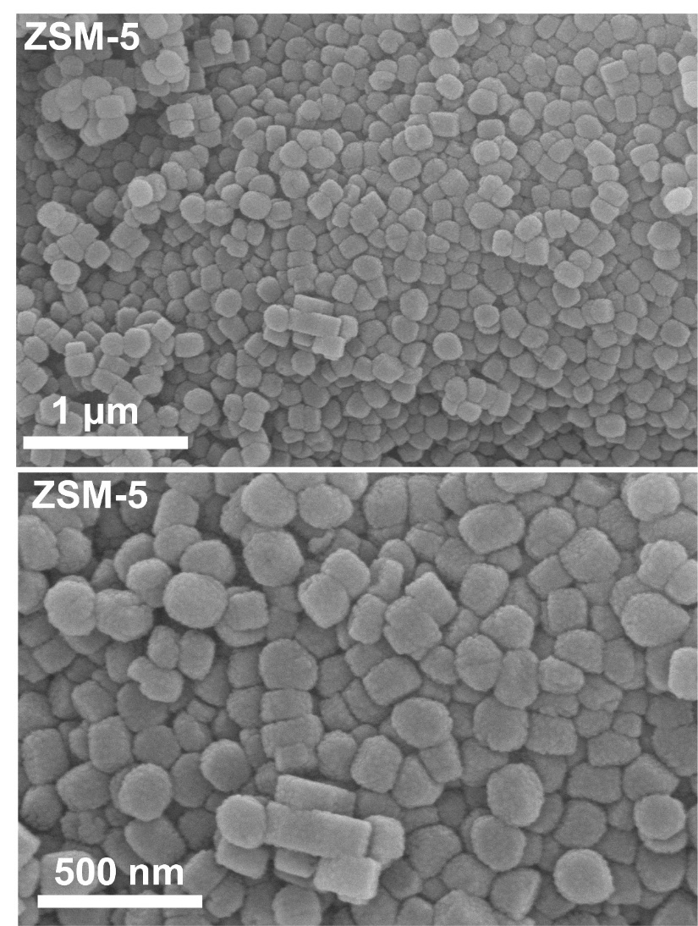

Figure S1. SEM images of the ZSM-5 zeolite.

Figure S2. TEM images of the ZSM-5 zeolite.

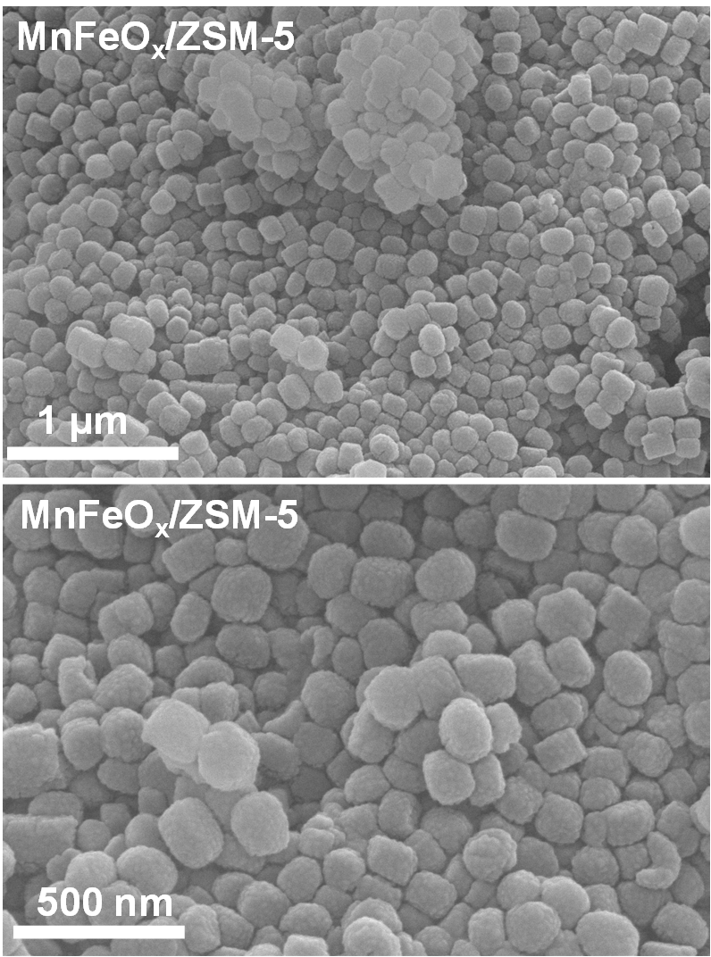

Figure S3. SEM images of the supported MnFeO_{x}/ZSM-5 sample.

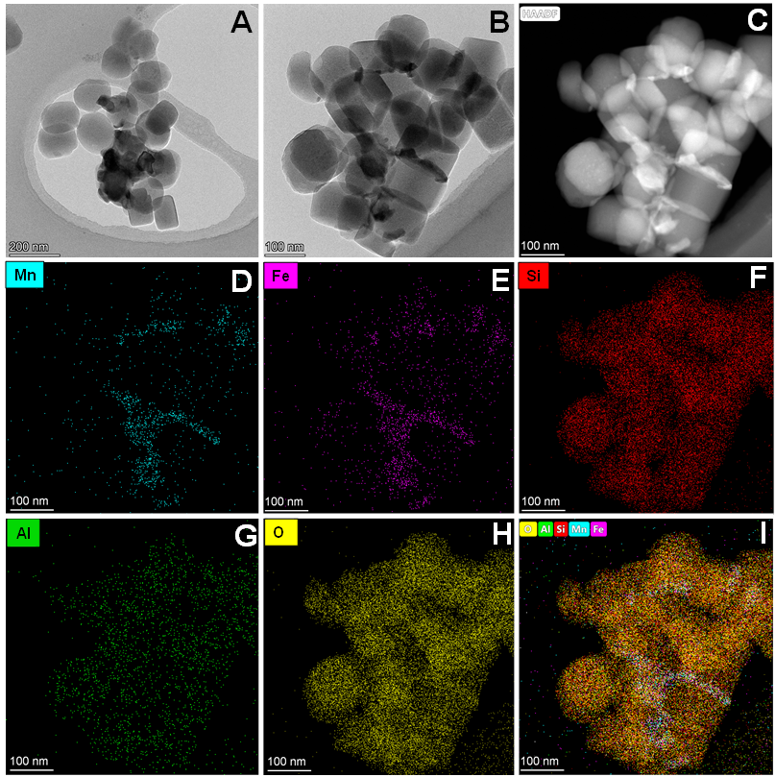

Figure S4. (A, B) TEM images, (C) HAADF-TEM image and (D–I) EDS elemental mappings of the supported MnFeO_{x}/ZSM-5 sample.

Figure S5. SEM images of the yolk-shell structured MnFeO_{x}@YS-ZSM-5 nanoreactor.

Figure S6. TEM images of the yolk-shell structured MnFeO_{x}@YS-ZSM-5 nanoreactor.

Figure S7. (A, B) HAADF-STEM, (C–H) EDS elemental mappings, and (I) line scan of the yolk-shell structured MnFeO_{x}@YS-ZSM-5 nanoreactor.

Figure S8. (A–E) iDPC images and (F) selected area electron diffraction (SAED) of the yolk-shell structured MnFeO_{x}@YS-ZSM-5 nanoreactor.

Figure S9. Pore-size distributions of ZSM-5 zeolite and yolk-shell structured MnFeO_{x}@YS-ZSM-5 samples derived from the isotherms.
Note: The pore-size distribution curves confirm the development of a large cavity inside the zeolite framework of MnFeO_{x}@YS-ZSM-5 nanoreactor.

Figure S10. Powder XRD patterns of as-prepared ZSM-5, S-1, MnFeO_{x}, MnFeO_{x}/ZSM-5, MnFeO_{x}/S-1, and MnFeO_{x}@YS-ZSM-5 samples.
Note: XRD patterns show that both MnFeO_{x}/ZSM-5 and MnFeO_{x}@YS-ZSM-5 exhibit characteristic reflections, consistent with the MFI topology of ZSM-5 zeolite (JCPDS 44-0003). These above results confirm that the zeolite framework remains intact after MnFeO_{x} encapsulation.

Figure S11. (A, B) TEM, (C) HAADF-STEM, and (D) EDS elemental mappings of MnFeO_{x}@YS-ZSM-5 sample obtained after being hydrothermally treated in TPAOH solution at 170 °C for 1 h.
Note: After 1 h of hydrothermal treatment, no visible changes are observed.
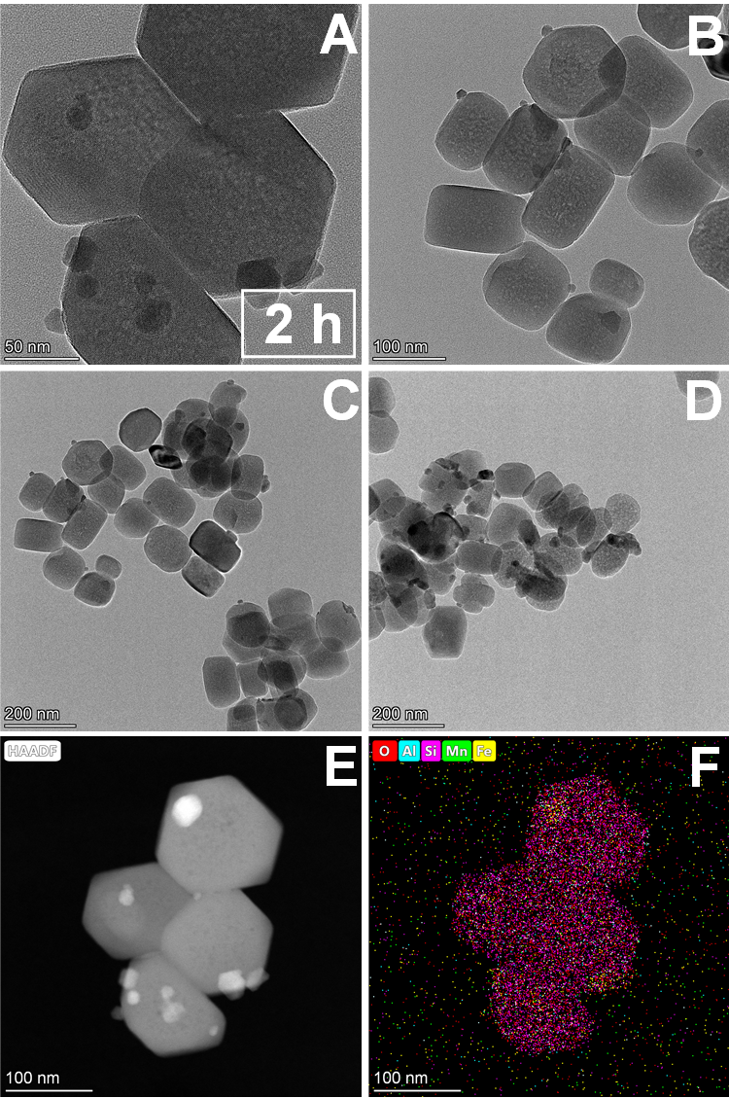

Figure S12. (A, B) TEM, (C) HAADF-STEM, and (D) EDS elemental mappings of the MnFeO_{x}@YS-ZSM-5 sample obtained after being hydrothermally treated in TPAOH solution at 170 °C for 2 h.
Note: After 2 h, small internal voids appeared at the center of the zeolite, indicating that dissolution initially occurs in the particle interior.
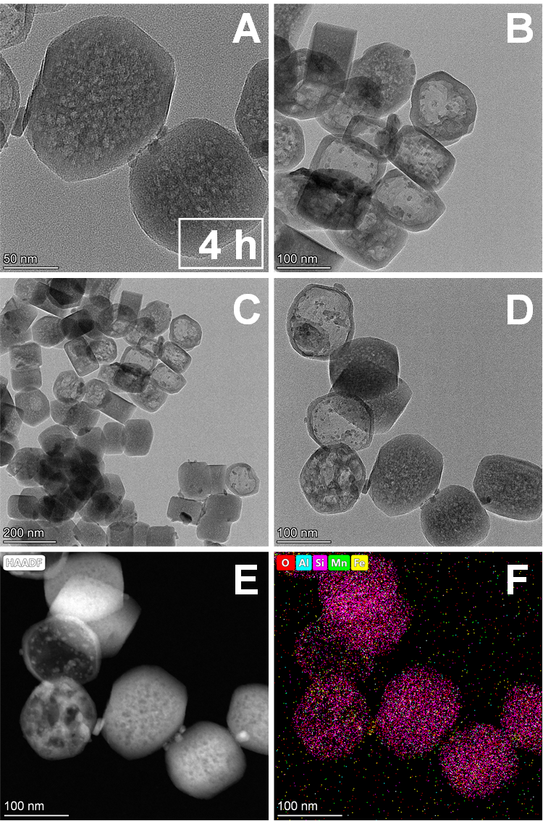

Figure S13. (A, B) TEM, (C) HAADF-STEM, and (D) EDS elemental mappings of the MnFeO_{x}@YS-ZSM-5 sample obtained after being hydrothermally treated in TPAOH solution at 170 °C for 4 h.
Note: At 4 h, voids expanded into vesicle-like cavities, while others remained small.
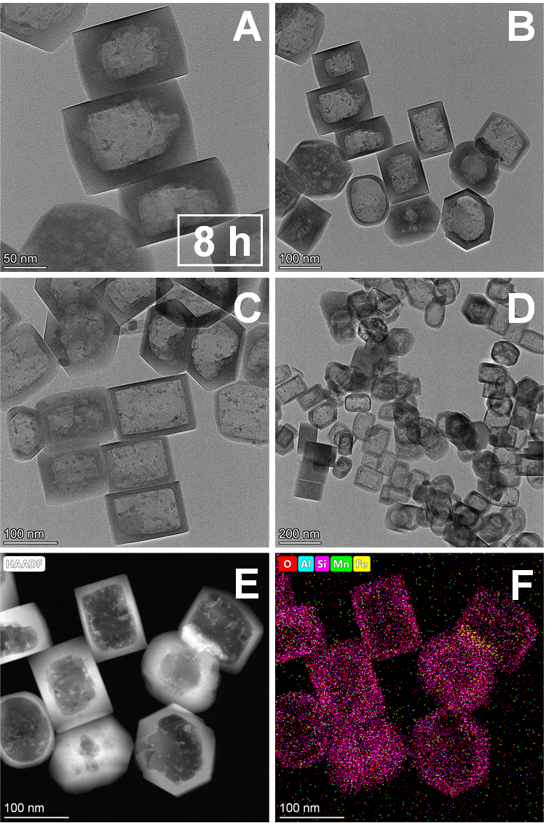

Figure S14. (A, B) TEM, (C) HAADF-STEM, and (D) EDS elemental mappings of the MnFeO_{x}@YS-ZSM-5 sample obtained after being hydrothermally treated in TPAOH solution at 170 °C for 8 h.
Note: After 8 h, a higher proportion of particles developed to form yolk-shell structures, though some retained solid interiors.
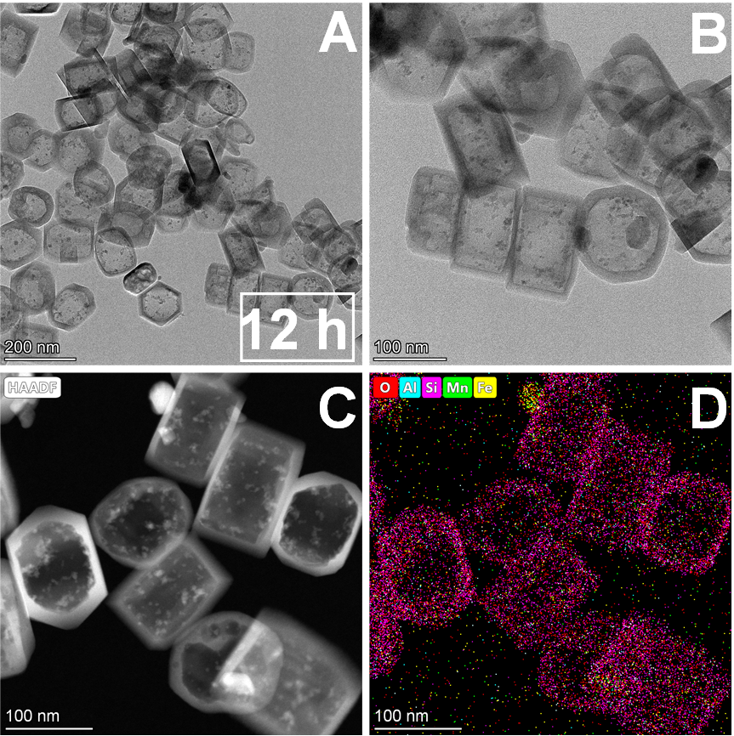

Figure S15. (A, B) TEM, (C) HAADF-STEM, and (D) EDS elemental mappings of the MnFeO_{x}@YS-ZSM-5 sample obtained after being hydrothermally treated in TPAOH solution at 170 °C for 12 h.
Note: With prolonged hydrothermal treatment for 12 h, an increasingly larger fraction of particles exhibited well-defined hollow interiors.

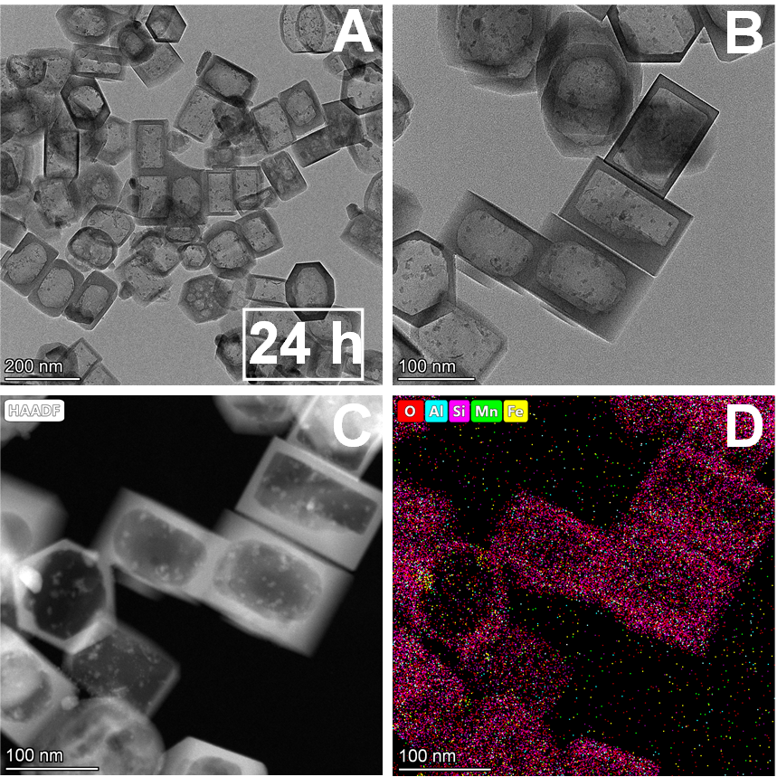

Figure S16. (A, B) TEM, (C) HAADF-STEM, and (D) EDS elemental mappings of the MnFeO_{x}@YS-ZSM-5 sample obtained after being hydrothermally treated in TPAOH solution at 170 °C for 24 h.
Note: With prolonged hydrothermal treatment for 24 h, an increasingly larger fraction of particles exhibited well-defined hollow interiors.

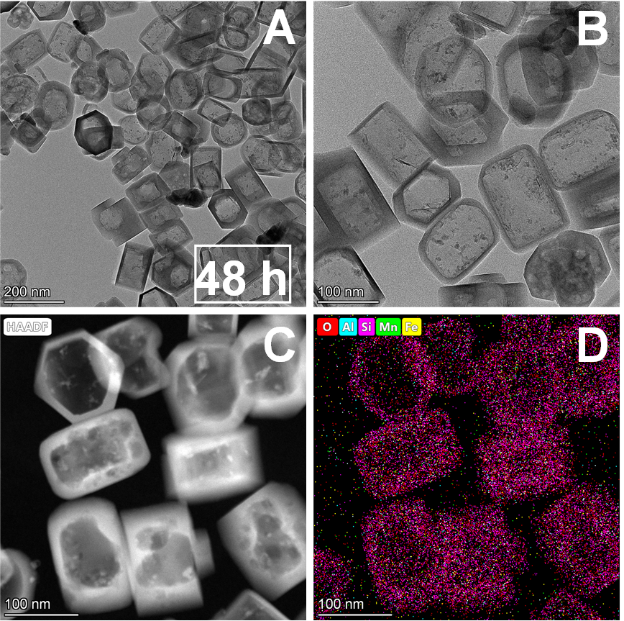

Figure S17. (A, B) TEM, (C) HAADF-STEM, and (D) EDS elemental mappings of the MnFeO_{x}@YS-ZSM-5 sample obtained after being hydrothermally treated in TPAOH solution at 170 °C for 48 h.
Note: With prolonged hydrothermal treatment for 48 h, an increasingly larger fraction of particles exhibited well-defined hollow interiors.

Figure S18. N₂ adsorption-desorption isotherms of MnFeO_{x}@YS-ZSM-5 obtained after being hydrothermally treated in TPAOH solution at 170 °C with varying durations.

Figure S19. Powder XRD patterns of MnFeO_{x}@YS-ZSM-5 obtained after being hydrothermally treated in TPAOH solution at 170 °C with varying durations.

Figure S20. Si 2p and Al 2p XPS spectra of the supported MnFeO_{x}/ZSM-5 and yolk-shell structured MnFeO_{x}@YS-ZSM-5 samples.

Figure S21. Formation mechanism of yolk-shell structured MnFeO_{x}@YS-ZSM-5 nanoreactor.
Note: Pristine ZSM-5 single crystals typically exhibit a compositional gradient: Si is enriched in the interior, while Al is concentrated at the external surface. In MnFeO_{x}/ZSM-5, Al exerts a shielding effect on neighboring Si atoms, making adjacent Si–O moieties less susceptible to alkaline etching. In addition, the internal region of the zeolite exhibits relatively lower crystallinity compared to the external surface, predisposing the particle interior to preferential dissolution. During alkaline treatment, hydroxide (OH⁻) anions penetrate the micropores and diffuse into the interior of MnFeO_{x}/ZSM-5, promoting dissolution of silicon species. This dissolution progresses from the inside toward the outside. In contrast, the sterically bulky tetrapropylammonium (TPA⁺) cations cannot pass through the microporous channels and instead adsorb on the external surface of the zeolite via electrostatic interactions. The dissolved silicate oligomers subsequently interact with surface-adsorbed TPA⁺ and recrystallize outwardly. Through this coupled dissolution-recrystallization process, the zeolite interior undergoes selective etching, and the encapsulated MnFeO_{x} nanoparticles become surrounded by newly crystallized zeolite layers. The metal oxide nanoparticles are in situ wrapped in the hollow zeolite cavity, similar to the cell phagocytosis processes, resulting in Si enrichment and Al depletion on the external surface compared to the parent ZSM-5 zeolite.

Figure S22. (A–C) TEM images, (D) HAADF-STEM, and (E, F) EDS elemental mappings of the yolk-shell structured MnCoO_{x}@YS-ZSM-5 nanoreactor.

Figure S23. (A, B) TEM images, (C) HAADF-STEM, and (D) EDS elemental mappings of the yolk-shell structured MnCeO_{x}@YS-ZSM-5 nanoreactor.

Figure S24. N₂ adsorption-desorption isotherms of supported MnCoO_{x}/ZSM-5 and yolk-shell structured MnCoO_{x}@YS-ZSM-5 nanoreactor.

Figure S25. N₂ adsorption-desorption isotherms of supported MnCeO_{x}/ZSM-5 and yolk-shell structured MnCeO_{x}@YS-ZSM-5 nanoreactor.

Figure S26. Powder XRD patterns of yolk-shell structured MnCoO_{x}@YS-ZSM-5 and MnCeO_{x}@ZSM-5 nanoreactors.

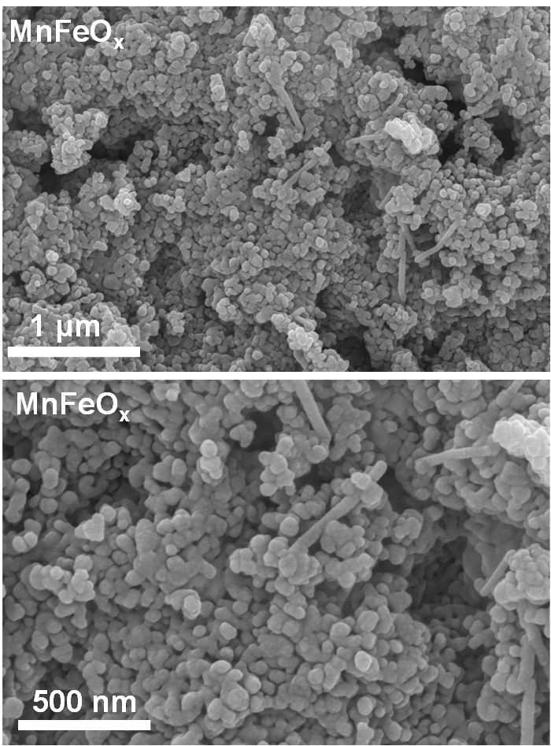

Figure S27. SEM images of the pure MnFeO_{x} metal oxides sample.
Note: Pure MnFeO_{x} sample prepared via the co-precipitation method is composed of stacked nanoparticles.

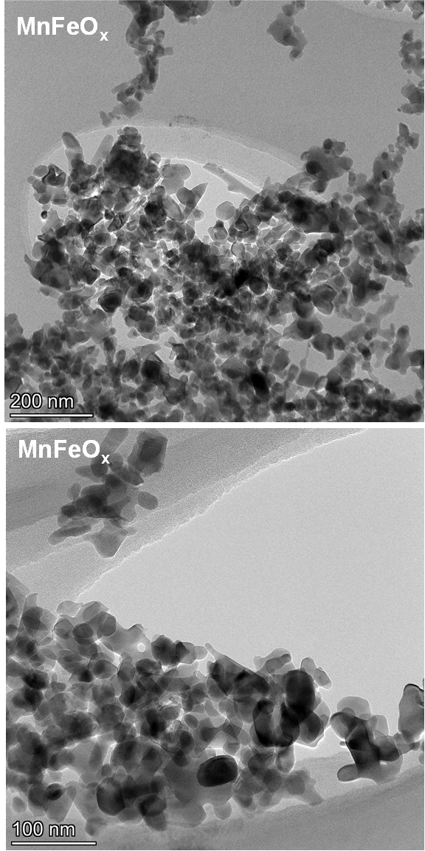

Figure S28. TEM images of the MnFeO_{x} metal oxides sample.

Figure S29. TEM images of the S-1 zeolite.
Note: S-1 zeolite exhibits a morphology similar to ZSM-5, with a clean surface and a primarily rod-shaped structure.

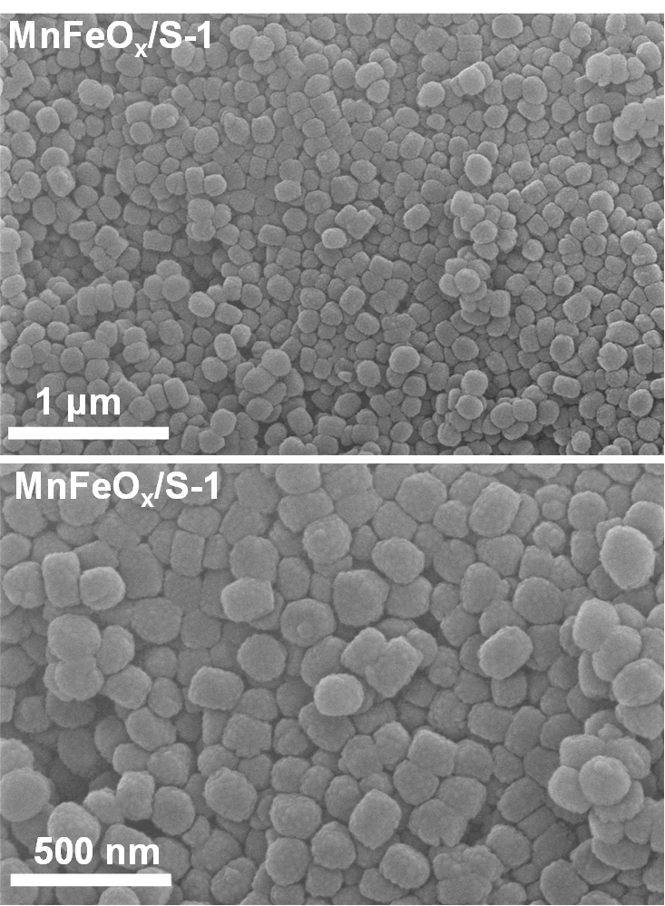

Figure S30. TEM images of the supported MnFeO_{x}/S-1 sample.
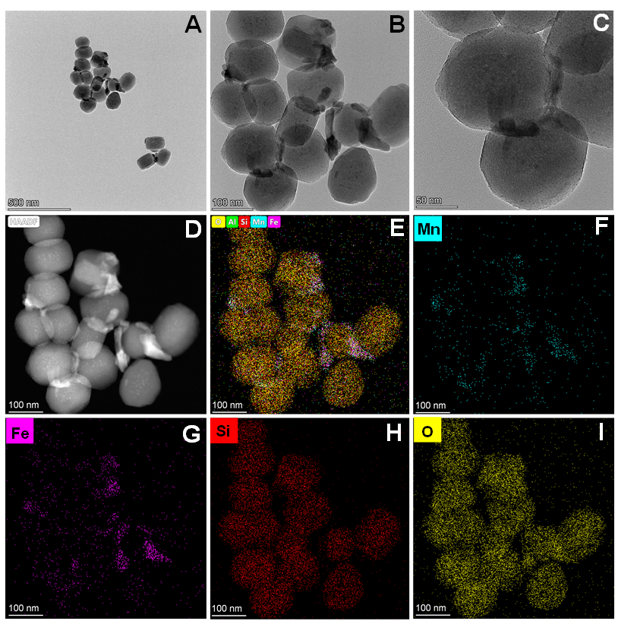

Figure S31. (A–C) TEM images, (D) HAADF-STEM, and (E–I) EDS elemental mappings of the supported MnFeO_{x}/S-1 sample.
Note: In the MnFeO_{x}/S-1 catalyst, MnFeO_{x} metal oxides aggregates are observed stacked on the surface of the S-1 support.

Figure S32. N₂ adsorption-desorption isotherms of the pure MnFeO_{x}, S-1 zeolite, and supported MnFeO_{x}/S-1 samples.

Figure S33. N₂O concentration as a function of temperature in NH₃-SCR reaction over the MnFeO_{x}, MnFeO_{x}/ZSM-5, MnFeO_{x}/S-1 and yolk-shell structured MnFeO_{x}@YS-ZSM-5 catalysts. Reaction conditions: 500 ppm NO, 500 ppm NH₃, 5 vol.% O₂, 5 vol.% H₂O, balance N₂, WHSV = 60,000 mL g_{cat.}⁻¹ h⁻¹.

Figure S34. N₂ selectivity as a function of temperature in NH₃-SCR reaction over the MnFeO_{x}, MnFeO_{x}/ZSM-5, MnFeO_{x}/S-1 and yolk-shell structured MnFeO_{x}@YS-ZSM-5 catalysts. Reaction conditions: 500 ppm NO, 500 ppm NH₃, 5 vol.% O₂, 5 vol.% H₂O, balance N₂, WHSV = 60,000 mL g_{cat.}⁻¹ h⁻¹.

Figure S35. NO_{x} conversion as a function of temperature in NH₃-SCR reaction over the MnFeO_{x}@YS-ZSM-5 obtained after being hydrothermally treated in TPAOH solution at 170 °C with varying durations. Reaction conditions: 500 ppm NO, 500 ppm NH₃, 5 vol.% O₂, 5 vol.% H₂O, balance N₂, WHSV = 60,000 mL g_{cat.}⁻¹ h⁻¹.

Figure S36. The active temperature windows (NO_{x} conversion higher than 80%) of the MnFeO_{x}-based NH₃-SCR catalysts reported in the literature.

Figure S37. Arrhenius plots of NO_{x} conversions in SCR over the over the MnFeO_{x}, MnFeO_{x}/ZSM-5, MnFeO_{x}/S-1 and MnFeO_{x}@YS-ZSM-5 catalysts. Reaction conditions: 500 ppm NO, 500 ppm NH₃, 5 vol.% O₂, 5 vol.% H₂O, balance N₂, WHSV = 840,000 mL g_{cat.}⁻¹ h⁻¹.

Figure S38. NO_{x} conversion as a function of temperature in NH₃-SCR reaction over the SO₂-MnFeO_{x}@YS-ZSM-5 and SO₂-MnFeO_{x}/ZSM-5 samples. The conditions for pre-sulfidation treatment: 100 mg of sample, 200 °C, 3 h; 50 ppm SO₂, 500 ppm NO, 500 ppm NH₃, 5 vol.% O₂, 5 vol.% H₂O, balance N₂, WHSV = 60,000 mL g_{cat.}⁻¹ h⁻¹. Reaction conditions: 500 ppm NO, 500 ppm NH₃, 5 vol.% O₂, 5 vol.% H₂O, balance N₂, WHSV = 60,000 mL g_{cat.}⁻¹ h⁻¹.
Note: The activity of MnFeO_{x}/ZSM-5 decreased significantly after SO₂ pre-sulfation treatment. Before SO₂ pre-sulfation treatment, its low-temperature activity was even slightly superior to that of the yolk-shell structured MnFeO_{x}@YS-ZSM-5 nanoreactor; however, after pre-sulfation treatment, its low-temperature activity became lower than that of SO₂-MnFeO_{x}@YS-ZSM-5.

Figure S39. TEM images of the (A, B) hollow ZSM-5 zeolite and (C, D) supported MnFeO_{x}/Hollow-ZSM-5 sample.
Note: Hydrothermal treatment of ZSM-5 zeolite with TPAOH successfully yields Hollow-ZSM-5 zeolite with a hollow structure. In the MnFeO_{x}/Hollow-ZSM-5 supported catalyst, MnFeO_{x} metal oxide nanoparticles are dispersed on the surface of the Hollow-ZSM-5 zeolite.

Figure S40. N₂ adsorption-desorption isotherms of the hollow ZSM-5 zeolite and supported MnFeO_{x}/Hollow-ZSM-5 samples.

Figure S41. NO_{x} conversion as a function of temperature in NH₃-SCR reaction over the S-1 zeolite, ZSM-5 zeolite, and supported MnFeO_{x}/Hollow-ZSM-5 samples. Reaction conditions: 500 ppm NO, 500 ppm NH₃, 5 vol.% O₂, 5 vol.% H₂O, balance N₂, WHSV = 60,000 mL g_{cat.}⁻¹ h⁻¹.
Note: MnFeO_{x}/Hollow-ZSM-5 exhibits NH₃-SCR activity comparable to that of the yolk-shell structured MnFeO_{x}@YS-ZSM-5 nanoreactor.

Figure S42. SO₂ resistance performance over the supported MnFeO_{x}/Hollow-ZSM-5 and yolk-shell structured MnFeO_{x}@YS-ZSM-5 catalysts at 246 °C. Reaction conditions: 500 ppm NO, 500 ppm NH₃, 5 vol.% O₂, 5 vol.% H₂O, 50 ppm SO₂ (when used), balance N₂, WHSV = 60,000 mL g_{cat.}⁻¹ h⁻¹.
Note: The SO₂ poisoning resistance over the supported MnFeO_{x}/Hollow-ZSM-5 catalyst is significantly lower than that of the yolk-shell structured MnFeO_{x}@YS-ZSM-5 catalyst. Upon introduction of 50 ppm SO₂ at 246 °C for 2 h, the NO_{x} conversion over MnFeO_{x}/Hollow-ZSM-5 decreased from an initial 98% to 43%, and remained consistently around 48% over the subsequent 5.5 h. After terminating SO₂ supply, the NO_{x} conversion efficiency only slightly increased to approximately 50%.

Figure S43. NO_{x} conversion as a function of temperature in NH₃-SCR reaction over the K-MnFeO_{x}/ZSM-5 and MnFeO_{x}/ZSM-5 catalysts. Reaction conditions: 500 ppm NO, 500 ppm NH₃, 5 vol.% O₂, 5 vol.% H₂O, balance N₂, WHSV = 60,000 mL g_{cat.}⁻¹ h⁻¹.

Figure S44. NO_{x} conversion as a function of temperature in NH₃-SCR reaction over the K-MnFeO_{x}/S-1 and MnFeO_{x}/S-1 catalysts. Reaction conditions: 500 ppm NO, 500 ppm NH₃, 5 vol.% O₂, 5 vol.% H₂O, balance N₂, WHSV = 60,000 mL g_{cat.}⁻¹ h⁻¹.
Note: The low-temperature activity of the alkali metal-poisoned K-MnFeO_{x}/S-1 catalyst decreases significantly; its activity in the medium-to-high temperature range drops even more sharply, and the active temperature window narrows drastically. This is primarily attributed to the weaker surface acidity of S-1 zeolite compared to ZSM-5 zeolite, which results in its inferior ability to resist K poisoning.

Figure S45. NO_{x} conversion as a function of temperature in NH₃-SCR reaction over the K-MnFeO_{x}/ZSM-5 and K-MnFeO_{x}@YS-ZSM-5 catalysts under the 50 ppm SO₂ atmosphere. Reaction conditions: 50 ppm SO₂, 500 ppm NO, 500 ppm NH₃, 5 vol.% O₂, 5 vol.% H₂O, balance N₂, WHSV = 60,000 mL g_{cat.}⁻¹ h⁻¹.
Note: It presents the performance results for SO₂/alkali metal co-poisoning resistance of the MnFeO_{x}/ZSM-5 and MnFeO_{x}@YS-ZSM-5 catalysts, specifically, the catalysts were first subjected to K poisoning, followed by NH₃-SCR performance testing with 50 ppm SO₂ in the reaction gas. From the figure, the yolk-shell structured MnFeO_{x}@YS-ZSM-5 nanoreactor exhibits excellent resistance to SO₂/alkali metal co-poisoning and shows higher low-temperature activity than the supported MnFeO_{x}/ZSM-5 catalyst.

Figure S46. NH₃-TPD curves over the fresh S-1 zeolite, ZSM-5 zeolite, pure MnFeO_{x}, MnFeO_{x}/ZSM-5, MnFeO_{x}/S-1, and yolk-shell structured MnFeO_{x}@YS-ZSM-5 samples.
Note: It is generally accepted that NH₃ desorption peaks below 200 °C are attributed to NH₃ desorption from weak acid sites, those in the range of 200–350 °C correspond to NH₃ desorption from medium-strong acid sites, and those peaks above 350 °C are ascribed to NH₃ desorption from strong acid sites^{[10]}. The pure MnFeO_{x} catalyst exhibits the weakest surface acidity and the lowest acid amount, which are far lower than those of the other three oxides-zeolite coupled catalysts (MnFeO_{x}/ZSM-5, MnFeO_{x}/S-1, and MnFeO_{x}@YS-ZSM-5). In contrast, the yolk-shell structured MnFeO_{x}@YS-ZSM-5 catalyst not only exhibits the highest total acid amount but also has the largest fraction of medium-strong acid sites.

Figure S47. Py-IR spectra over the fresh ZSM-5 zeolite, supported MnFeO_{x}/ZSM-5, yolk-shell structured MnFeO_{x}@YS-ZSM-5, and related K-poisoning samples at 260 °C.
Note: The infrared vibration peaks at wavenumbers of 1608 cm⁻¹ and 1455 cm⁻¹ are attributed to the adsorption of NH₃ on Lewis acid sites, the peak at 1542 cm⁻¹ to the adsorption of NH₃ on Brønsted acid sites, and the peak at 1488 cm⁻¹ to the co-adsorption of NH₃ on both Lewis and Brønsted acid sites^{[11]}. The Pyridine IR spectrum of the fresh MnFeO_{x} catalyst is almost a flat line, indicating extremely weak acidity. All oxides-zeolite coupled samples exhibit abundant and intense Lewis and Brønsted acid sites. The results of the Py-IR characterization corroborate those of the NH₃-TPD analysis; the abundant presence of medium-strong acid sites is conducive to enhancing the medium-to-high temperature NH₃-SCR activity of the catalysts.

Figure S48. NH₃-TPD curves of the K-poisoned catalysts.
Note: The total acid amount of the K-MnFeO_{x} catalyst decreases by 33% compared to the fresh MnFeO_{x} catalyst, whereas K-MnFeO_{x}/ZSM-5 and K-MnFeO_{x}@YS-ZSM-5 exhibit significantly smaller reductions in total acid amount. After K poisoning, the K-MnFeO_{x}@YS-ZSM-5 catalyst maintains the highest total acid amount—which is the key reason for its much better NH₃-SCR performance after K poisoning.

Figure S49. H₂-TPR profiles over the K-poisoned catalysts.
Note: Compared with the fresh catalyst, the reduction peaks of the K-MnFeO_{x} catalyst exhibit the largest shift toward higher temperatures. In contrast, the other K-poisoned catalysts show negligible changes in their reduction peak temperatures; thus, their oxidation capacity is maintained. The alkali metal K exerts a significant poisoning effect on the pure MnFeO_{x} metal oxide catalyst, and K poisoning impairs the oxidation performance of K-MnFeO_{x} catalyst.

Figure S50. Mn 2p XPS spectra of pure MnFeO_{x} and S-MnFeO_{x} samples.

Figure S51. SO₂-TPD curves over the MnFeO_{x}, MnFeO_{x}/ZSM-5, and yolk-shell structured MnFeO_{x}@YS-ZSM-5 samples.
Note: The yolk-shell structured MnFeO_{x}@YS-ZSM-5 exhibits the smallest SO₂ desorption peak area, indicating reduced sulfate formation on MnFeO_{x}@YS-ZSM-5 nanoreactor.

Figure S52. Mn 2p XPS spectra of the K-poisoned catalysts.

Figure S53. In situ DRIFT spectra of NH₃ adsorption over pure MnFeO_{x} catalyst at 200 °C.
Note: At 4 min of NH₃ adsorption, characteristic peaks at 1197 cm⁻¹ and 1295 cm⁻¹ are observed, both absorption peaks are attributed to NH₃ species adsorbed on Lewis acid sites (NH₃-L) over the catalyst surface^{[12,13]}. With increasing adsorption time, the intensities of these two characteristic peaks increase slowly and eventually reach saturation. After 40 min of adsorption, followed by N₂ purging for 30 min, a significant decrease in the peak intensities is observed, indicating weak acidity of the Lewis acid sites on the catalyst surface and their poor ability to adsorb NH₃.

Figure S54. In situ DRIFT spectra of pre-adsorbed NH₃ species reacted with NO + O₂ over the pure MnFeO_{x} catalyst at 200 °C.

Figure S55. In situ DRIFT spectra of NO + O₂ adsorption over the pure MnFeO_{x} catalyst at 200 °C.
Note: After adsorption of NO + O₂ on pure MnFeO_{x}, infrared characteristic peaks of monodentate nitrates (1544 cm⁻¹) and bridged nitrates (1232 cm⁻¹) rapidly form on its surface^{[14,15]}, and the intensities of these peaks increase rapidly with prolonged adsorption time.

Figure S56. In situ DRIFT spectra of pre-adsorbed NO + O₂ species reacted with NH₃ over the pure MnFeO_{x} catalyst at 200 °C.
Note: Upon introduction of NH₃, the intensity of the vibrational peaks corresponding to monodentate nitrates on the catalyst surface gradually decreases, and the peaks disappear completely after 6 min. Subsequently, NH₃-L species emerge on the catalyst surface. Thus, the reaction follows the typical Langmuir-Hinshelwood mechanism, wherein adsorbed NO species react with adsorbed NH₃ species.

Figure S57. NO-TPD curves of the pure MnFeO_{x} and yolk-shell structured MnFeO_{x}@YS-ZSM-5 samples.
Note: Pure MnFeO_{x} exhibits a larger NO desorption peak area, indicating that more NO is adsorbed onto the surface.

Figure S58. Top view and side view of optimized MnFeO_{x} structure.

Figure S59. Top view and side view of optimized MnFeO_{x}@YS-ZSM-5 structure.

Figure S60. Optimized adsorption configurations of SO₂ gas molecules on Brønsted acid sites in ZSM-5 zeolite structure.

Figure S61. In situ Mn K-edge XANES spectra of the transient reaction over the yolk-shell structured MnFeO_{x}@YS-ZSM-5 catalyst after 0, 2 and 3 h treatment at 246 °C in an atmosphere of 250 ppm SO₂ + 5 vol.% O₂.

Supplementary Tables

Samples | S_{BET}ª  (m² g⁻¹) | V_{total}^{b}  (cm³ g⁻¹)
ZSM-5 | 461 | 0.29
MnFeO_{x}/ZSM-5 | 341 | 0.33
MnFeO_{x}@YS-ZSM-5 | 344 | 0.41
MnFeO_{x} | 25 | 0.20
MnFeO_{x}/S-1 | 285 | 0.25
S-1 | 339 | 0.27

Table S1. Specific surface area and pore volume of the samples.
ª Calculated by BET method.
^{b} Determined by BJH method.
Note: The Brunauer-Emmett-Teller (BET) surface area remained nearly unchanged after the TPAOH hydrothermal treatment, whereas the total pore volume increased from 0.33 cm³ g⁻¹ for MnFeO_{x}/ZSM-5 to 0.41 cm³ g⁻¹ for MnFeO_{x}@YS-ZSM-5 nanoreactor. This increase can be attributed to the cavity formation during the hollowing of the ZSM-5 zeolite.

Table S2. Comparison with literature about the performances of MnFeO_{x}-based catalysts for NH₃-SCR.
Catalysts | Temperature window for  >80% NO_{x} conversion | References
MnFeO_{x}@YS-ZSM-5 | 280 °C | This work
MnFe-AC | 183 °C | [16]
MnFe | 166 °C | [17]
MnFe | 151 °C | [18]
MnFeO_{x} | 206 °C | [19]
MnFeO_{x} | 180 °C | [20]
MnO_{x}-FeO_{x} nanoneedles | 216 °C | [21]
Mn-Fe | 215 °C | [22]
SmMnFe-0.1 | 191 °C | [17]
Mn10Fe10/W5Ti | 240 °C | [23]
MnFeCe | 118 °C | [24]
MnFe-TOS | 200 °C | [25]
MnFeCeAl-Nb | 149 °C | [26]
5Fe–3Mn–S/TiO₂ | 200 °C | [27]
11.2Fe11Mn/SBA-15 | 169 °C | [28]
Fe-Mn/CeO₂ | 181 °C | [29]
Mn–Fe/TS-1(R-2) | 155 °C | [30]

Mass and Heat Transfer Calculations for NH₃-SCR upon different catalyst
For PBR reaction mode (0.05% NO/ 0.05% NH₃ / 5% O₂/ 94.9% N₂)
Mears Criterion for External Diffusion
The absence of mass transport resistances was checked by Mears’ criterion ($C_{M}$) for external diffusion:
$$C_{M}=\frac{rρ_{b}R_{p}n}{k_{c}C_{Ab}}<0.15$$
where $r=\frac{X_{{NO}_{x,m}}F_{{NO}_{x}}}{m_{cat.}}$, mol kg_{cat.} ⁻¹ s⁻¹;
$F_{{NO}_{x}}$ = gas flow rate of NO_{x}, mol s⁻¹;
$m_{cat.}$ = mass weight of the sample = 0.0250 g;
$T_{m}$ = the maximum temperatures during NH₃-SCR kinetic measurements, K;
$X_{{NO}_{x,m}}$ = the NO_{x} conversion at maximum temperatures;
n = reaction order = 1; $R_{p}$ = catalyst particle radius = 1.35$×$10⁻⁴ m;
$ρ_{c}$ = solid catalyst density, kg m⁻³;
$ρ_{b}$ = bulk density of catalyst bed, kg m⁻³
= (1-Φ) $ρ_{c}$ (Φ = porosity);
$ρ_{c}$ ≈ $ρ_{b}$≈ $ρ_{cat.}$;
$k_{c}$ = external mass transfer coefficient = 0.1 m s⁻¹; $C_{Ab}$ = bulk gas concentration of NO_{x} at maximum temperatures, mol m⁻³.
For the kinetic measurements, a total gas flow rate of 350 mL min⁻¹ and a catalyst particle size of 0.27 mm were employed. And the highest concentration of NO_{x} employed in the feed was 0.05%.

Table S3. The $C_{M}$ over the various catalysts in NH₃-SCR performance.
Catalysts | $$ρ_{b}$$ | $$T_{m}$$ | $$r$$ | $$X_{{NO}_{x,m}}$$ | $$C_{Ab}$$ | $$C_{M}$$
MnFeO_{x} | 2027 | 463.15 | 8.88$×$10⁻⁴ | 17.0% | 0.0185 | 0.1313
MnFeO_{x}/ZSM-5 | 748 | 463.15 | 6.79$×$10⁻⁴ | 13.0% | 0.0194 | 0.0353
MnFeO_{x}/S-1 | 782 | 433.15 | 3.40$×$10⁻⁴ | 6.5% | 0.0208 | 0.0172
MnFeO_{x}@YS-ZSM-5 | 733 | 473.15 | 4.56$×$10⁻⁴ | 8.7% | 0.0203 | 0.0221
$C_{M}<0.15$, therefore, external mass transfer effects can be neglected.
Weisz-Prater Criterion for Internal Diffusion
The absence of mass transport resistances was checked by Weisz-Prater criterion ($C_{WP}$) for internal diffusion:
$$C_{WP}=\frac{r_{obs}ρ_{c}R_{p}^{2}}{D_{eff}C_{As}}<1$$where $r_{obs}$ = observed reaction rate ≈ $r=\frac{X_{{NO}_{x,m}}F_{{NO}_{x}}}{m_{cat.}}$, mol kg_{cat.} ⁻¹ s⁻¹;
$F_{{NO}_{x}}$ = gas flow rate of NO_{x}, mol s⁻¹; $m_{cat.}$ = mass weight of the sample = 0.0250 g;
$T_{m}$ = the maximum temperatures during NH₃-SCR kinetic measurements, K;
$X_{{NO}_{x,m}}$ = the NO_{x} conversion at maximum temperatures;
n = reaction order = 1; $R_{p}$ = catalyst particle radius = 1.35$×$10⁻⁴ m;
$ρ_{c}$ = solid catalyst density, kg m⁻³;
$ρ_{b}$ = bulk density of catalyst bed, kg m⁻³
= (1-Φ) $ρ_{c}$ (Φ = porosity);
$ρ_{c}$ ≈ $ρ_{b}$≈ $ρ_{cat.}$; $D_{eff}$ = effective diffusivity = 8.9$×$10⁻⁶ m² s⁻¹;
$C_{As}$ = gas concentration of NO_{x} at the catalyst surface, mol m⁻³, $C_{As}$ ≈ $C_{Ab}$

Table S4. The $C_{WP}$ over the various catalysts in NH₃-SCR performance.
Catalysts | $$ρ_{c}$$ | $$T_{m}$$ | $$r_{obs}$$ | $$X_{{NO}_{x,m}}$$ | $$C_{As}$$ | $$C_{WP}$$
MnFeO_{x} | 2027 | 463.15 | 8.88$×$10⁻⁴ | 17.0% | 0.0185 | 0.1991
MnFeO_{x}/ZSM-5 | 748 | 463.15 | 6.79$×$10⁻⁴ | 13.0% | 0.0194 | 0.0536
MnFeO_{x}/S-1 | 782 | 433.15 | 3.40$×$10⁻⁴ | 6.5% | 0.0208 | 0.0261
MnFeO_{x}@YS-ZSM-5 | 733 | 473.15 | 4.56$×$10⁻⁴ | 8.7% | 0.0203 | 0.0336
$C_{WP}<1$, therefore, internal mass transfer effects can be neglected.

Mears Criterion for External (Interphase) Heat Transfer
The absence of heat transfer was checked by Mears’ criterion:
$$C_{Me.}=\left|\frac{-ΔHr_{obs}ρ_{b}R_{p}E_{a}}{h{T_{m}}^{2}R_{g}}\right|$$
Where $ΔH$ = heat of reaction, kJ mol⁻¹= $-$1.628$×$10³ kJ mol⁻¹
$r_{obs}$ = observed reaction rate ≈ $r=\frac{X_{{NO}_{x,m}}F_{{NO}_{x}}}{m_{cat.}}$, mol kg_{cat.} ⁻¹ s⁻¹;
$F_{{NO}_{x}}$ = gas flow rate of NO_{x}, mol s⁻¹; $m_{cat.}$ = mass weight of the sample = 0.0250 g;
$T_{m}$ = the maximum temperatures during NH₃-SCR kinetic measurements, K;
$X_{{NO}_{x,m}}$ = the NO_{x} conversion at maximum temperatures;
$R_{p}$ = catalyst particle radius = 1.35$×$10⁻⁴ m
$ρ_{b}$ = bulk density of catalyst bed, kg m⁻³
= (1-Φ) $ρ_{c}$ (Φ = porosity)
$E_{a}$ = activation energy, kJ mol⁻¹ (from Figure S),$h$= heat transfer coefficient between gas and pellet = 5.3 kJ m⁻² s⁻¹ K⁻¹, $R_{g}$= gas constant = 8.314 $×$10⁻³ kJ mol⁻¹ K⁻¹

Table S5. The $C_{Me.}$ over the various catalysts in NH₃-SCR performance.
Catalysts | $$ρ_{b}$$ | $$T_{m}$$ | $$r_{obs}$$ | $$X_{{NO}_{x,m}}$$ | $$E_{a}$$ | $$C_{Me.}$$
MnFeO_{x} | 2027 | 463.15 | 8.88$×$10⁻⁴ | 17.0% | 40.6 | 1.7$×$10⁻³
MnFeO_{x}/ZSM-5 | 748 | 463.15 | 6.79$×$10⁻⁴ | 13.0% | 19.1 | 2.3$×$10⁻⁴
MnFeO_{x}/S-1 | 782 | 433.15 | 3.40$×$10⁻⁴ | 6.5% | 19.6 | 1.4$×$10⁻⁴
MnFeO_{x}@YS-ZSM-5 | 733 | 473.15 | 4.56$×$10⁻⁴ | 8.7% | 20.9 | 1.6$×$10⁻⁴
$C_{Me.}<0.15$, therefore, external (interphase) heat transfer effects can be neglected.

Table S6. The acidic properties of the fresh MnFeO_{x}, MnFeO_{x}/ZSM-5, MnFeO_{x}/S-1, MnFeO_{x}@YS-ZSM-5, and related K-poisoned catalysts.
Samples | Total acid amount  (mmol g⁻¹) | Weak acid amount  (mmol g⁻¹) | Medium and strong acid (mmol g⁻¹) | The desorption peak temperature (°C) and the acid amount corresponding to this peak (mmol g⁻¹)
MnFeO_{x} | 0.055 | 0.044 | 0.011 | 108 (0.010), 171 (0.034), 263 (0.011)
MnFeO_{x}/ZSM-5 | 0.243 | 0.157 | 0.086 | 110 (0.048), 153 (0.109), 280 (0.086)
MnFeO_{x}/S-1 | 0.113 | 0.078 | 0.035 | 106 (0.033), 145 (0.045), 270 (0.035)
MnFeO_{x}@YS-ZSM-5 | 0.341 | 0.203 | 0.138 | 111 (0.031), 155 (0.172), 295 (0.138)
ZSM-5 | 0.237 | 0.170 | 0.067 | 115 (0.079), 158 (0.091), 352 (0.067)
S-1 | 0.085 | 0.071 | 0.014 | 103 (0.055), 135 (0.016), 222 (0.014)
K-MnFeO_{x} | 0.037 | 0.027 | 0.010 | 104 (0.008), 161 (0.019), 263 (0.010)
K-MnFeO_{x/}ZSM-5 | 0.199 | 0.136 | 0.063 | 107 (0.038), 144 (0.098), 246 (0.063)
K-MnFeO_{x}/S-1 | 0.068 | 0.052 | 0.016 | 109 (0.023), 144 (0.029), 237 (0.016)
K-MnFeO_{x}@YS-ZSM-5 | 0.227 | 0.183 | 0.044 | 115 (0.071), 161 (0.112), 318 (0.044)

Table S7. Surface component of different species from XPS data over different samples.
Catalysts | Atomic Concentration  (mol.%) |  |  |  |  |  |  | Surface species content (%)
Catalysts | Mn | Fe | Si | Al | O | K | S | Mn⁴⁺/Mn
MnFeO_{x} | 17.44 | 13.92 | - | - | 68.64 | - | - | 39.6
MnFeO_{x}/ZSM-5 | 5.80 | 8.74 | 23.79 | 1.62 | 60.05 | - | - | 32.3
MnFeO_{x}@YS-ZSM-5 | 5.70 | 7.24 | 21.71 | 1.55 | 63.8 | - | - | 29.4
S-MnFeO_{x} | 13.97 | 17.29 | - | - | 66.76 | - | 1.98 | 30.9
S-MnFeO_{x}/ZSM-5 | 7.21 | 20.23 | 20.23 | 1.11 | 60.7 | - | 1.42 | 24.5
S-MnFeO_{x}@YS-ZSM-5 | 5.45 | 8.31 | 23.87 | 1.31 | 60.59 |  | 0.47 | 28.3
K-MnFeO_{x} | 18.8 | 17.31 | - | - | 63.21 | 0.68 | - | 32.9
K-MnFeO_{x}/ZSM-5 | 6.48 | 7.33 | 22.76 | 1.48 | 61.24 | 0.71 | - | 32.4
K-MnFeO_{x}@YS-ZSM-5 | 7.22 | 6.43 | 20.12 | 1.32 | 64.3 | 0.61 | - | 29.5

Supplementary References
[1] H. Wang, M. Lin, T. Murayama, S. Feng, M. Haruta, H. Miura, T. Shishido, ACS Catal. 2021, 11, 8576-8584.
[2] S. T. Oyama, X. Zhang, J. Lu, Y. Gu, T. Fujitani, J. Catal. 2008, 257, 1-4.
[3] R. A, H. J, K. G, Journal of Physics: Condensed Matter. 2003, 15, 979.
[4] G. Kresse, J. Furthmüller, Comput. Mater. Sci. 1996, 6, 15-50.
[5] K. Burke, M. Ernzerhof, J. P. Perdew, Phys. Rev. Lett. 1996, 77, 3865-3868.
[6] S. L. Dudarev, G. A. Botton, S. Y. Savrasov, C. J. Humphreys, A. P. Sutton, Phys. Rev. B 1998, 57, 1505.
[7] O. Bengone, M. Alouani, P. Blöchl, J. Hugel, Phys. Rev. B. 2000, 62, 16392.
[8] B. Zhu, Q. Fang, Y. Sun, S. Yin, G. Li, Z. Zi, T. Ge, Z. Zhu, M. Zhang, J. Li, J. Mater. Sci. 2018, 53, 11500-11511.
[9] A. Bouzoubaa, D. Costa, B. Diawara, N. Audiffren, P. Marcus, Corros. Sci. 2010, 52, 2643-2652.
[10] Z. Jia, Y. Shen, T. Yan, H. Li, J. Deng, J. Fang, D. Zhang, Environ. Sci. Technol. 2022, 56, 2647-2655.
[11] C. Chen, Y. Wang, J. Li, F. Tian, W. Chen, C. Feng, Y. Pan, Y. Liu, Appl. Catal. B: Environ. Energy 2023, 338, 123086.
[12] J. Yang, S. Ren, Y. Zhou, Z. Su, L. Yao, J. Cao, L. Jiang, G. Hu, M. Kong, J. Yang, et al., Chem. Eng. J. 2020, 397, 125446.
[13] Z. Wang, R. Guo, X. Shi, X. Liu, H. Qin, Y. Liu, C. Duan, D. Guo, W. Pan, Chem. Eng. J. 2020, 381, 122753.
[14] F. Liu, H. He, Catal. Today. 2010, 153, 70-76.
[15] Z. Lian, F. Liu, H. He, X. Shi, J. Mo, Z. Wu, Chem. Eng. J. 2014, 250, 390-398.
[16] Z. Chen, S. Ren, X. Xing, X. Li, L. Chen, M. Wang, Fuel 2023, 335, 126986.
[17] Z. Chen, S. Ren, M. Wang, J. Yang, L. Chen, W. Liu, Q. Liu, B. Su, Fuel 2022, 321, 124113.
[18] C. Gao, B. Xiao, J. Shi, C. He, B. Wang, D. Ma, Y. Cheng, C. Niu, J. Catal. 2019, 380, 55-67.
[19] F. Zhao, G. Zhang, Z. Tang, F. Zha, Fuel 2022, 322, 124185.
[20] Z. Chen, R. Guo, S. Ren, L. Chen, X. Li, M. Wang, J. Mater. Chem. A 2022, 10, 21474-21491.
[21] Z. Fan, J. Shi, C. Gao, G. Gao, B. Wang, C. Niu, ACS Appl. Mater. Interfaces 2017, 9, 16117-16127.
[22] X. Tang, C. Wang, F. Gao, Y. Ma, H. Yi, S. Zhao, Y. Zhou, J. Environ. Chem. Eng. 2020, 8, 104399.
[23] J. Shi, Z. Zhang, M. Chen, Z. Zhang, W. Shangguan, Fuel 2017, 210, 783-789.
[24] Y. Wei, P. Liang, Y. Li, Y. Zhao, X. Min, P. Tao, J. Hu, T. Sun, J. Environ. Chem. Eng. 2022, 10, 107772.
[25] X. Huang, N. Fang, S. Wu, F. Dong, Y. Chu, Z. Tang, Appl. Catal. B: Environ. Energy 2024, 343, 123518.
[26] Y. Wei, W. Li, Q. Wang, M. Liu, P. Liang, L. Wang, T. Sun, J. Ind. Eng. Chem. 2023, 123, 209-219.
[27] J. Xu, T. Zheng, X. Zou, H. Shen, F. Guo, Q. Zhang, M. Duan, J. Energy Inst. 2024, 112, 101458.
[28] G. Li, B. Wang, H. Wang, J. Ma, W. Q. Xu, Y. Li, Y. Han, Q. Sun, Catal. Commun. 2018, 108, 82-87.
[29] L. Li, J. Ji, W. Tan, W. Song, X. Wang, X. Wei, K. Guo, W. Zhang, C. Tang, L. Dong, J. Rare Earths 2022, 40, 1454-1461.
[30] Y. Ma, W. Liu, Z. Li, Y. Sun, M. Shi, Z. Nan, R. Song, L. Wang, J. Guan, Molecules 2023, 28, 3068.

