Cross-Trait Genomic and Proteomic Analyses Identify Shared Risk Loci and Therapeutic Targets for Type 2 Diabetes and Coronary Artery Disease

Content:
Supplementary Figure 1. Univariate MiXeR analysis of T2D
Supplementary Figure 2. Univariate MiXeR analysis of CAD
Supplementary Figure 3. Scatter plots and leave-one-out analysis showing the effect of T2D on CAD in cell-type-specific Mendelian randomization (csMR).
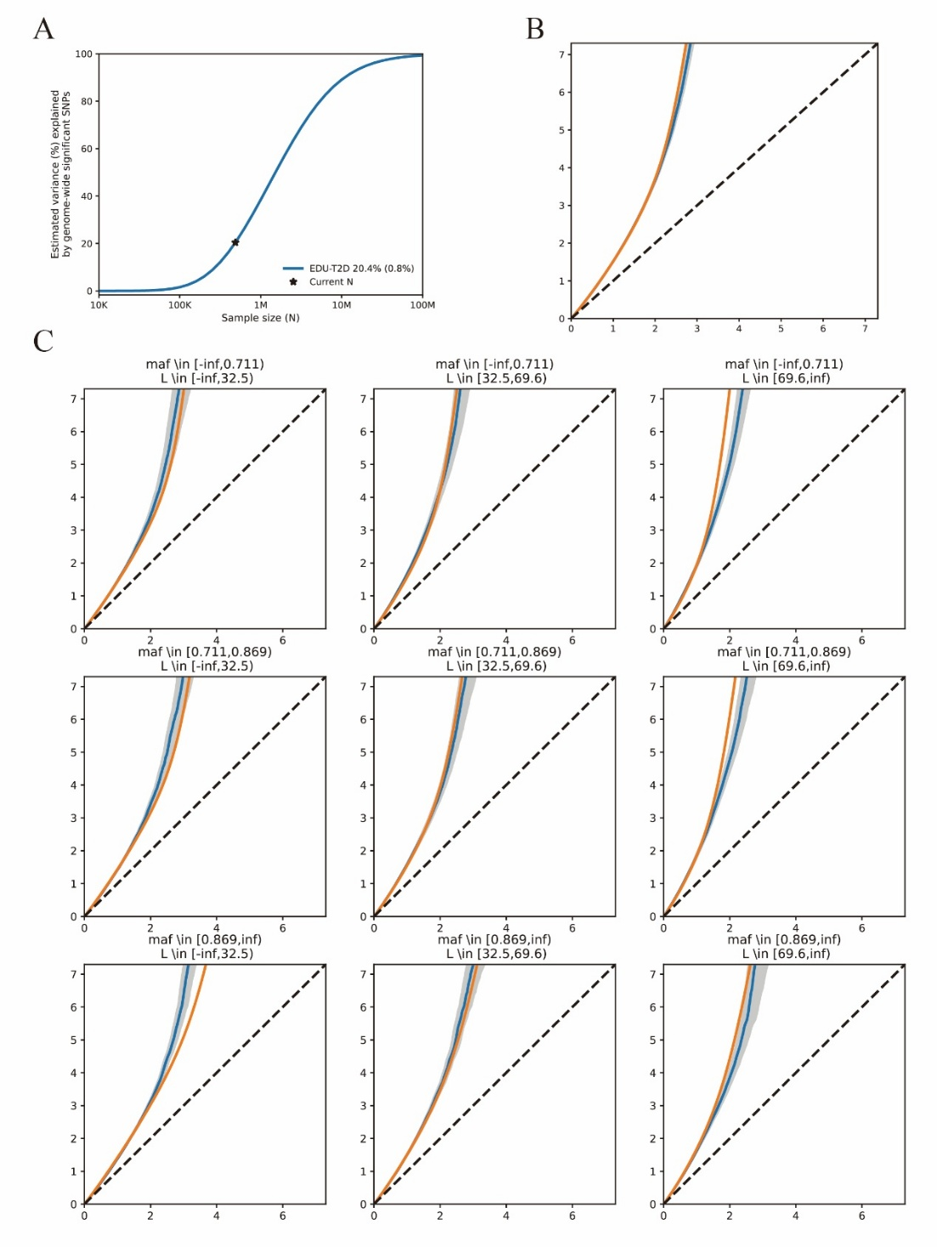
Supplementary Figure 1. Univariate MiXeR analysis of T2D. A. Univariate quantile–quantile (Q–Q) plot for T2D. The blue line shows the observed distribution of association statistics, the orange line shows the distribution predicted by the univariate MiXeR model, the grey shaded area indicates the 95% confidence interval, and the black dashed line indicates the expected distribution under the null hypothesis; B. Stratified Q–Q plots for T2D. Each panel corresponds to a bin defined by minor allele frequency (MAF) and total linkage disequilibrium (L), illustrating the agreement between the observed association statistics and the model fit across different MAF–LD strata; C. Power curve for T2D. The blue line shows the proportion of phenotypic variance explained by genome-wide significant SNPs as GWAS sample size increases, and the black star marks the current study sample size.
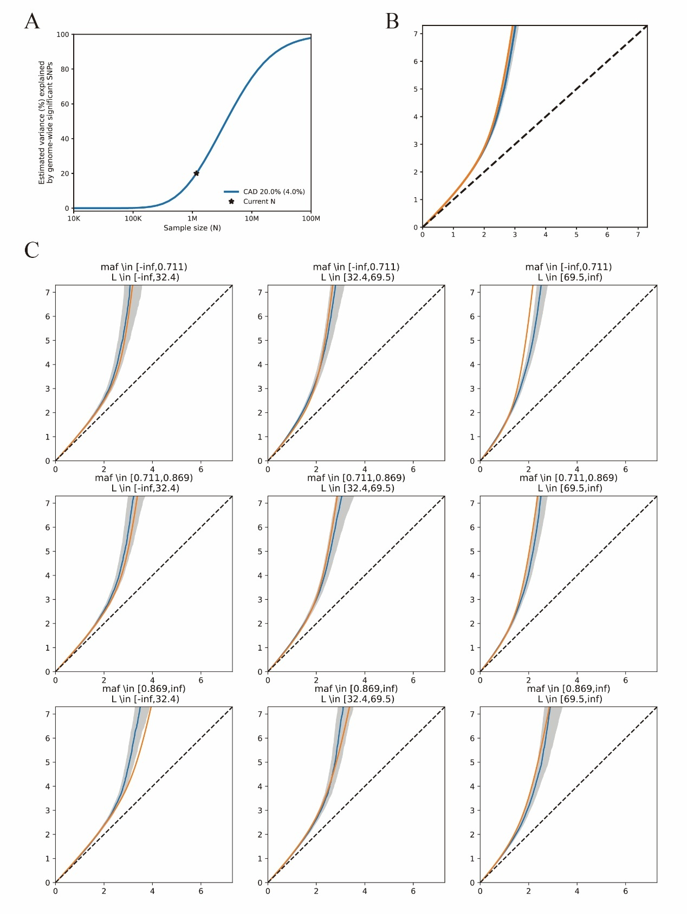
Supplementary Figure 1. Univariate MiXeR analysis of CAD. A. Univariate quantile–quantile (Q–Q) plot for CAD. The blue line shows the observed distribution of association statistics, the orange line shows the distribution predicted by the univariate MiXeR model, the grey shaded area indicates the 95% confidence interval, and the black dashed line indicates the expected distribution under the null hypothesis; B. Stratified Q–Q plots for CAD. Each panel corresponds to a bin defined by minor allele frequency (MAF) and total linkage disequilibrium (L), illustrating the agreement between the observed association statistics and the model fit across different MAF–LD strata; C. Power curve for CAD. The blue line shows the proportion of phenotypic variance explained by genome-wide significant SNPs as GWAS sample size increases, and the black star marks the current study sample size.
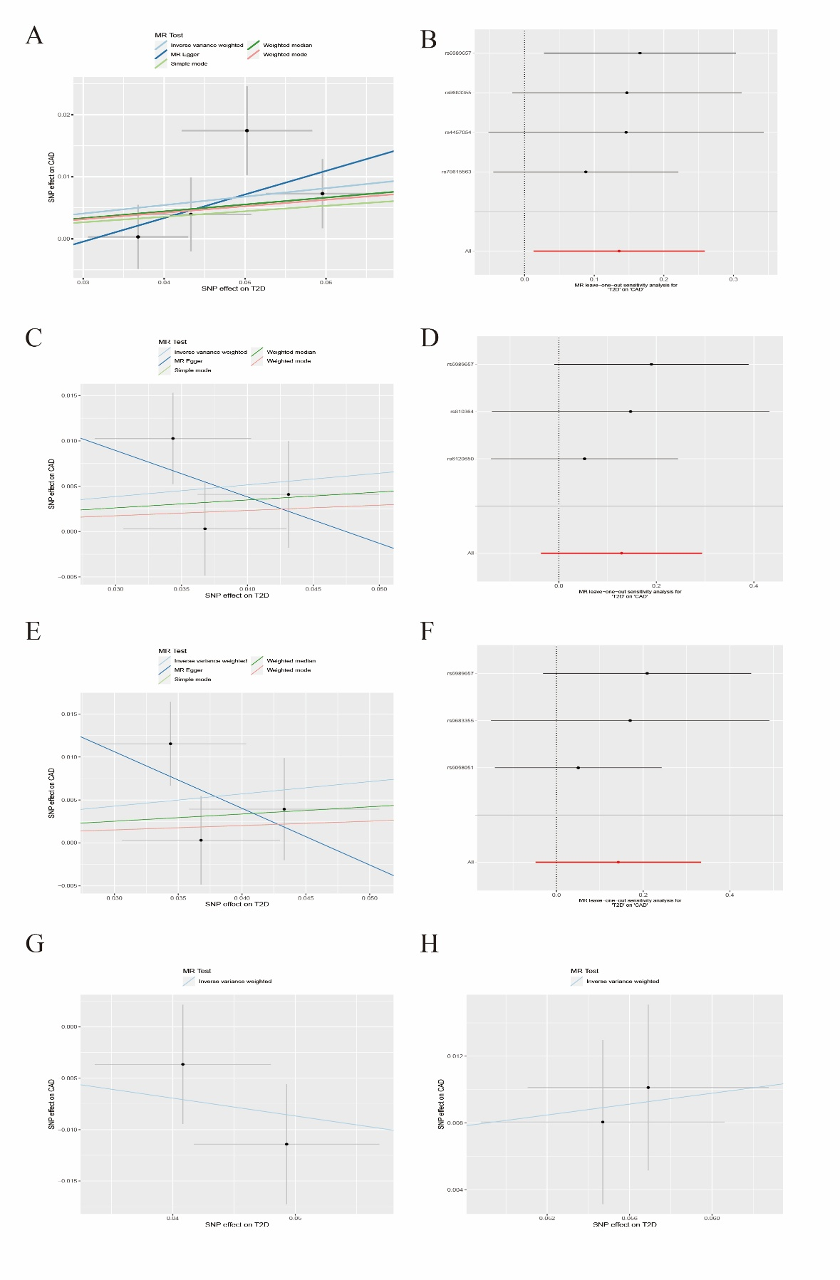
Supplementary Figure 3. Cell-type-specific Mendelian randomization (csMR) analysis of the causal effect of T2D on CAD.A–H. Scatter plots and leave-one-out analyses showing the causal effect of T2D on CAD across different brain cell types. A–B. Astrocytes; C–D. Excitatory neurons; E–F. Inhibitory neurons; G. Oligodendrocytes; H. Oligodendrocyte precursor cells.In the scatter plots, each point represents a genetic instrument, with the x-axis indicating the SNP effect on T2D and the y-axis indicating the corresponding SNP effect on CAD. Leave-one-out analysis was performed to assess the robustness of the results by excluding one SNP at a time; points denote the effect estimates after exclusion of the corresponding SNP, and horizontal lines indicate the 95% confidence intervals. Because of the limited number of instrumental variables, leave-one-out analysis could not be performed for oligodendrocytes or oligodendrocyte precursor cells.

