Supplementary Figure Legends

Supplementary figure S2. Full-length blots of Figure 2a and b.

 | Cytoplasm |  |  |  |  | Nucleus
ZIKV (MOI=1) | - | + | + | + |  | - | + | + | +
Hour post infection (h.p.i) | - | 24 | 48 | 72 |  | - | 24 | 48 | 72

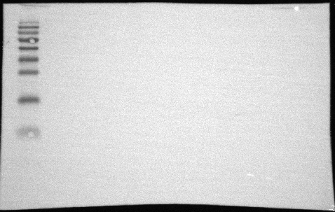
HMGB1
25, 30kDa

34 kDa
26 kDa

* The ladder used in this experiment was not chemiluminescence-based. Thus, the ladder image was not captured alongside the blots. The molecular mass of nuclear HMGB1 was ~25kDa, whereas the molecular mass of cytoplasm HMGB1 was~ 30 kDa, most likely due to acetylation.

Supplementary figure S2. Full-length blots of Figure 2a and b.

 | Nucleus |  |  |  |  | Cytoplasm
ZIKV (MOI=1) | - | + | + | + |  | - | + | + | +
Hour post infection (h.p.i) | - | 24 | 48 | 72 |  | - | 24 | 48 | 72

PARP-1
117 kDa
130 kDa
95 kDa
34 kDa
GAPDH
37 kDa

Supplementary figure S2. Full-length blots of Figure 2a and b.

