Supplementary Figure Legends

Supplementary figure S3. Full-length blots of Supplementary figure S1

shHMGB1 | - | +

HMGB1
25 kDa

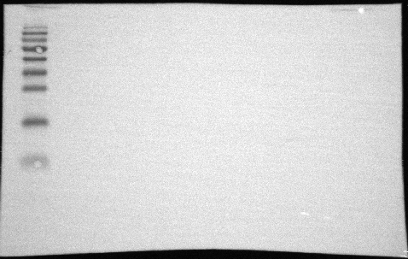
26 kDa

GAPDH
37 kDa

34 kDa

*HMGB1-knockdown cells were used to investigate the role of HMGB1 in ZIKV replication. Western blot analysis showed that the HMGB1-knockdown (shHMGB1) Huh7 cells infected with shRNA B (middle) lentivirus had the highest inhibition level of HMGB1 expression. Thus, the shHMGB1 B cells were used for the following experiments.

Supplementary figure S3. Full-length blots of Supplementary figure S1

