Appendix A: Figures and Tables
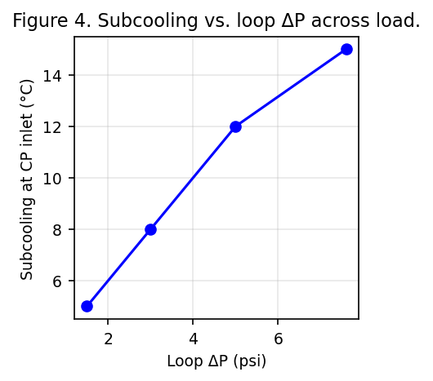
Figure 4. Subcooling vs. loop pressure drop across load.
Table 1. Pressure Drop Budget at Full Load (40 kW/rack)
Component | ΔP (psi) | Notes
Row manifold | 0.23 | At 36 LPM per rack
Rack manifolds & hoses | 0.8 | Representative average across rack
Loop (regulators + CPs) | 7.6 | At 7.2 LPM per loop
CDU condenser & internal piping | 27 | From CDU gauges at full flow
Total (CDU to loop exit) | 35 | Full-load, full-flow condition
Table 2. Test Matrix
Rack/Loop | Flow (LPM) | Heat (kW) | T_sat (°C) | Subcooling (°C)
Rack A / Loop 1 | 4.8 | 6 | 23 | 6
Rack A / Loop 2 | 4.8 | 8 | 23 | 9
Rack B / Loop 1 | 6.0 | 10 | 24 | 12
Rack C / Loop 3 | 5.6 | 8 | 23 | 10
Rack D / Loop 4 | 7.2 | 10 | 24 | 15
Rack D / Loop 2 | 4.0 | 4 | 22 | 5
Table 3. Refrigerant Options and Key Properties
Refrigerant | Safety Class | GWP | Notes
R-134a | A1 | 1430 | Benchmark HFC used in tests
R-515B (Solstice N15) | A1 | 299 | Low-GWP azeotrope; similar pressures to R-134a
R-1234yf | A2L | ~4 | Ultra-low GWP HFO; mildly flammable

Appendix B: Worked Calculations
B.1 Flow sizing (two-phase guideline)
Using the volumetric guideline for pumped two-phase direct-to-chip loops, ˙V ≈ 0.48–0.50 LPM per kW. For a 10 kW loop: ˙V = 0.48×10 = 4.8 LPM and 0.50×10 = 5.0 LPM.
B.2 Effective thermal resistance (R_th)
Definition: R_th = (T_case − T_sat) / Q
With T_case = 56.4 °C and T_sat = 23.0 °C: R_th,CP = (T_case − T_sat)/Q_CP = 33.4/2500 = 0.01336 K/W; R_th,loop = 33.4/10000 = 0.00334 K/W.
B.3 Row-manifold ΔP scaling vs. flow
Model: ΔP_row(F) = 0.23×(F/36)^2 [psi], based on ΔP_row(36 LPM) ≈ 0.23 psi.
Flow (LPM/rack) | ΔP_row (psi)
20 | 0.071
24 | 0.102
28 | 0.139
32 | 0.182
36 | 0.230
B.4 Loop ΔP reference points (measured)
Representative loop (hoses + regulators + CPs):
Loop flow (LPM/loop) | ΔP_loop (psi)
4.0 | 2.5
5.0 | 4.0
6.0 | 5.8
7.2 | 7.6
B.5 Reynolds and Nusselt (template)
Equations: Re = (ρ V D_h)/μ = (G D_h)/μ; Nu = h D_h / k.
Inputs required per cold plate: hydraulic diameter D_h, channel count and flow area (to compute V or G), and refrigerant properties (ρ, μ, k) at the test pressure/temperature.
To compute a sample h (boiling), select a validated two-phase correlation for mini/micro-channels (e.g., Kandlikar, Gungor–Winterton) with your channel geometry, mass flux, heat flux, and exit quality.

