Supplementary Information
For
Unique Digoldgermanes: Structural Characteristics, Dynamic Behaviour and Distinctive Reactions

Liliang Wang, Guorong Zhen, Yinhuan Li, Mitsuo Kira*, Xiao-Yong Chang*, Liping Yan, Lu Huang, and Zhifang Li*

Table of Contents
Experimental Section 2
a) VT NMR spectra and chemical shift of 3b 2
b) Crystallographic details 4
c) UV-visible spectroscopy 10
d) ¹H, ¹³C, ²⁹Si and ³¹P Spectra of products 11
Theoretical calculations 34

Experimental Section
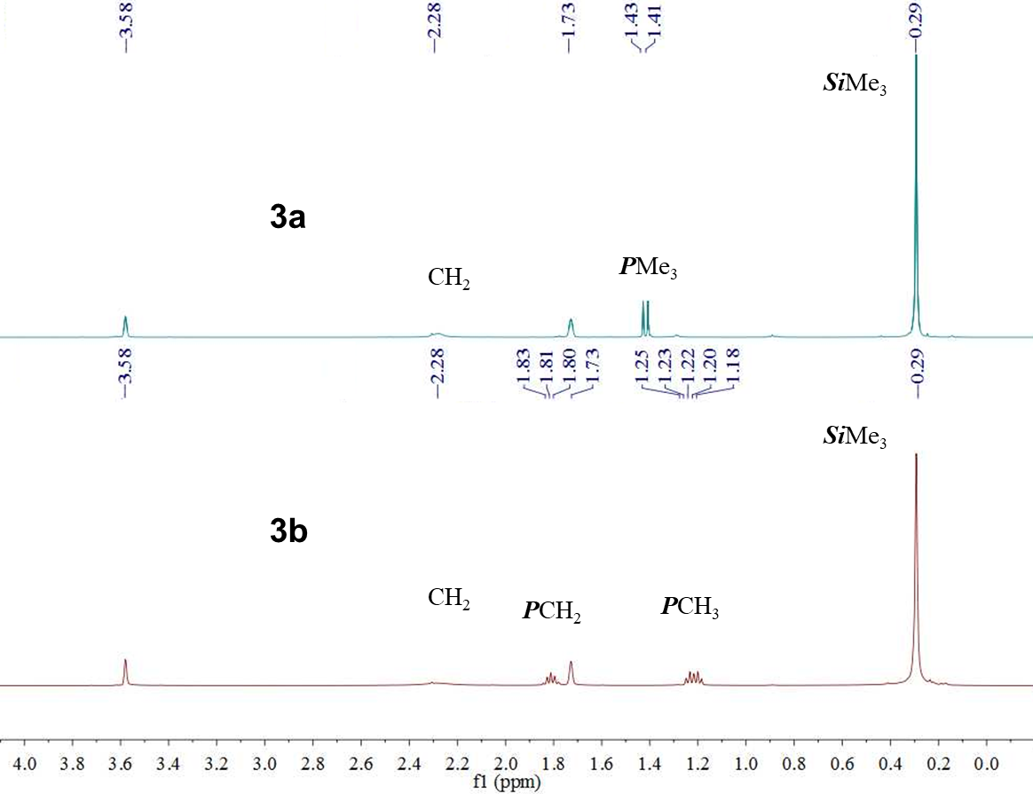
Figure S1. ¹H NMR spectra of 3a (top) and 3b (bottom) in THF-d₈ at room temperature.

VT NMR spectra and chemical shift of 3b
The ¹H NMR spectra of 3b were recorded in THF-d₈ (0.018 M). Peak positions were picked by fitting in MestReNova software.
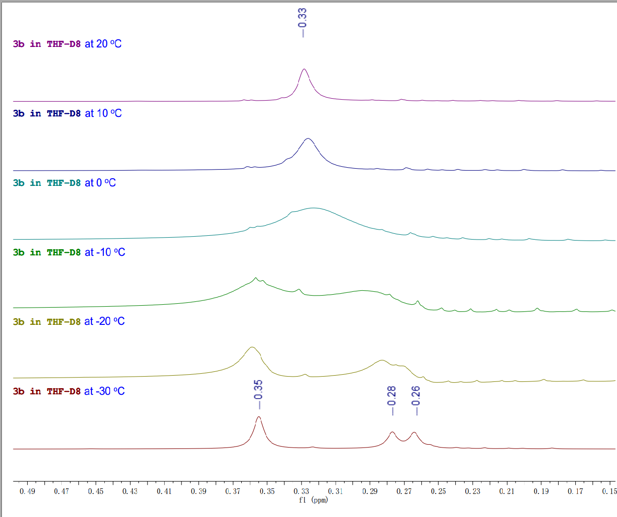
Figure S2. ¹H NMR spectra of 3b at variable temperatures from 20 ºC to –30 ºC.
Scheme S1. Reaction of dialkylgermylene 1 with Ph₄PCl.
Scheme S2. Proposed reaction pathway for the formation of 9.
Scheme S3. Cyclic trimerization of aryl isocyanates 10 catalyzed by digoldgermane 3a.
Mechanistic proposal for the cyclotrimerization of aryl isocyanates
Figure S3. A catalytic cycle proposed for a cyclic trimerization of aryl isocyanates catalyzed by 3a.

Crystallographic details
X-ray data collection and structural refinement. Intensity data for compounds 2b, 3a, 3b, 4, 5, 7 and 9 were collected using a Bruker APEX II diffractometer. The structure was solved by direct phase determination (SHELX-2014) and refined for all data by full-matrix least-squares methods on F². ^{S1,S2} All non-hydrogen atoms were subjected to anisotropic refinement. The hydrogen atoms were located at calculated positions or found in the Fmap. CCDC: 2040233, 2040232, 2040235, 2040234, 2093574, 2040236 and 2093575 contains the supplementary crystallographic data for this paper. The data can be obtained free of charge from the Cambridge Crystallography Data Center via www.ccdc.cam.ac.uk/data_reCquest/cif.

Table S1. X-ray data for 2b, 3a, 3b, 4, 5, 7 and 9.
Compounds | 2b | 3a | 3b
Formula | C₂₂H₅₅AuClGePSi₄ | C₃₅H₈₉Au₂Ge₂PSi₈ | C₃₈H₉₅Au₂Ge₂PSi₈
Fw | 767.99 | 1304.86 | 1346.94
Crystsyst | Triclinic | Triclinic | Monoclinic
Space group | P-1 | P-1 | P2₁/n
Size (mm³) space group | 0.21 x 0.15 x 0.15 | 0.36×0.35×0.29 | 0.25 × 0.25 × 0.20
T/K | 296(2) | 100.04 | 140(2)
a, Å | 9.9896(5) | 11.3169(6) | 16.7554(8)
b, Å | 11.5379(6) | 13.4458(10) | 18.3718(9)
c, Å | 16.6794(9) | 19.2778(14) | 18.6768(8)
α, deg | 71.5790(10) | 83.444(2) | 90
β, deg | 84.8400(10) | 79.181(2) | 98.4697(12)
γ, deg | 67.2130(10) | 70.518(2) | 90
V, A³ | 1680.43(15) | 2712.1(3) | 5686.5(5)
Z | 2 | 2 | 4
d _{calcd}g·cm⁻³ | 1.518 | 1.598 | 1.573
μ, mm⁻¹ | 5.534 | 6.719 | 6.411
Refl collected | 34666 | 48541 | 65807
N_{measd} | 8364 | 16706 | 13544
[R int] | 0.0346 | 0.0612 | 0.0602
R [I>2sigma(I)] | 0.0336 | 0.0386 | 0.0489
R_{w} [I>2sigma(I)] | 0.0925 | 0.0951 | 0.1106
GOF | 1.032 | 1.013 | 1.034
Largest diff. peak/ hole [e. Å⁻³] | 0.957 and -1.529 | 2.71 and -1.87 | 9.306 and -1.674

Compounds | 4 | 5
Formula | Au₂C₂₂GeH₅₈P₂Si4 | C₃₃H₈₃AuGe₂Si₈
Fw | 946.16 | 1046.86
Crystsyst | tetragonal | monoclinic
Space group | I4₁/acd | Cc
Size (mm³) space group | 0.31 × 0.25 × 0.18 | 0.34 × 0.31 × 0.24
T/K | 100 | 100
a, Å | 22.2649(7) | 23.1510(12)
b, Å | 22.2649(7) | 16.8799(9)
c, Å | 34.6740(16) | 12.6367(7)
α, deg | 90 | 90
β, deg | 90 | 96.917(2)
γ, deg | 90 | 90
V, A³ | 17188.8(13) | 4902.3(5)
Z | 16 | 4
d _{calcd}g·cm⁻³ | 1.756 | 1.418
μ, mm⁻¹ | 15.335 | 4.420
Refl collected | 52505 | 66852
N_{measd} | 9056 | 15149
[R int] | 0.0907 | 0.0587
R [I>2sigma(I)] | 0.0658 | 0.0434
R_{w} [I>2sigma(I)] | 0.0669 | 0.0844
GOF | 1.142 | 1.053
Largest diff. peak/ hole [e. Å⁻³] | 4.63 and -1.96 | 1.32 and -0.81

Compounds | 7 | 9
Formula | C₅₉H₁₀₉Au₂ClGe₂P₂Si₈ | C₃₂H₈₀AuClGe₂Si₈
Fw | 1679.68 | 1067.27
Crystsyst | Monoclinic | monoclinic
Space group | P2₁/n | P2₁/n
Size (mm³) space group | 0.15 × 0.15 × 0.12 | 0.14 × 0.12 × 0.08
T/K | 150 | 150
a, Å | 11.4018(10) | 15.6807(10)
b, Å | 28.876(3) | 19.0646(15)
c, Å | 22.400(2) | 17.9997(11)
α, deg | 90 | 90
β, deg | 92.372(2) | 114.697(2)
γ, deg | 90 | 90
V, A³ | 7368.7(12) | 4888.7(6)
Z | 4 | 4
d _{calcd}g·cm⁻³ | 1.514 | 1.450
μ, mm⁻¹ | 5.020 | 9.508
Refl collected | 62304 | 44666
N_{measd} | 19836 | 8968
[R int] | 0.0671 | 0.0830
R [I>2sigma(I)] | 0.0392 | 0.0621
R_{w} [I>2sigma(I)] | 0.0847 | 0.1547
GOF | 1.00 | 1.078
Largest diff. peak/ hole [e. Å⁻³] | 1.68 and -1.38 | 8.41 and -2.63

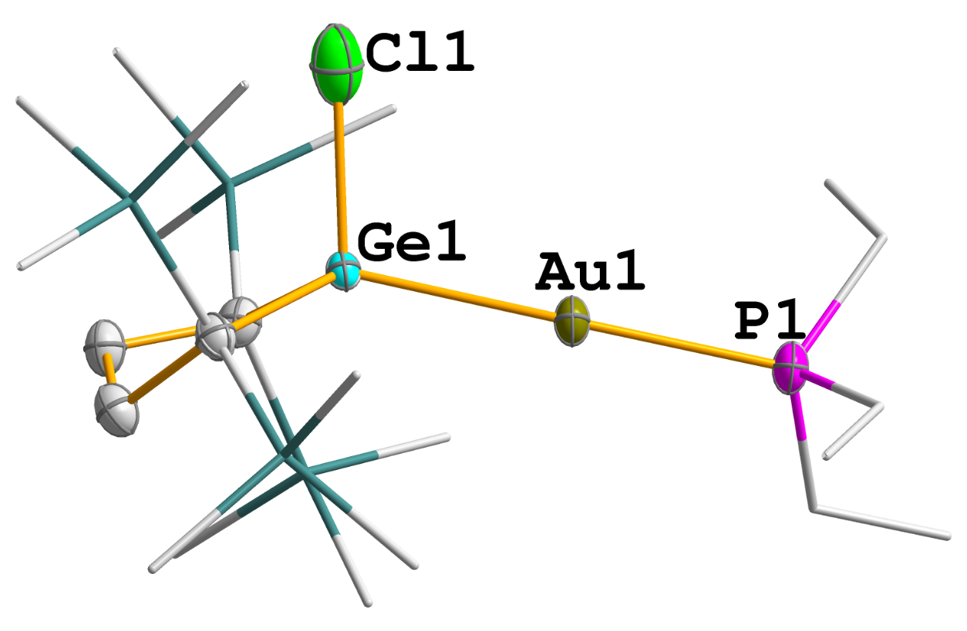
Figure S4. Solid structure of 2b. Thermal ellipsoids are shown at the 30% probability level. Hydrogen atoms are omitted for clarity. Trimethylsilyl, ethyl, and methyl groups are depicted in a wireframe model. Selected bond lengths [Å] and angles [º]: Au(1)-P(1) 2.3218(12), Au(1)-Ge(1) 2.4160(4), Cl(1)-Ge(1) 2.136(5), Ge(1)-C(4) 2.013(4), Ge(1)-C(1) 2.014(4); P(1)-Au(1)-Ge(1) 174.39(4), C(4)-Ge(1)-C(1) 95.72(15), Cl(1)-Ge(1)-Au(1) 104.31(9).
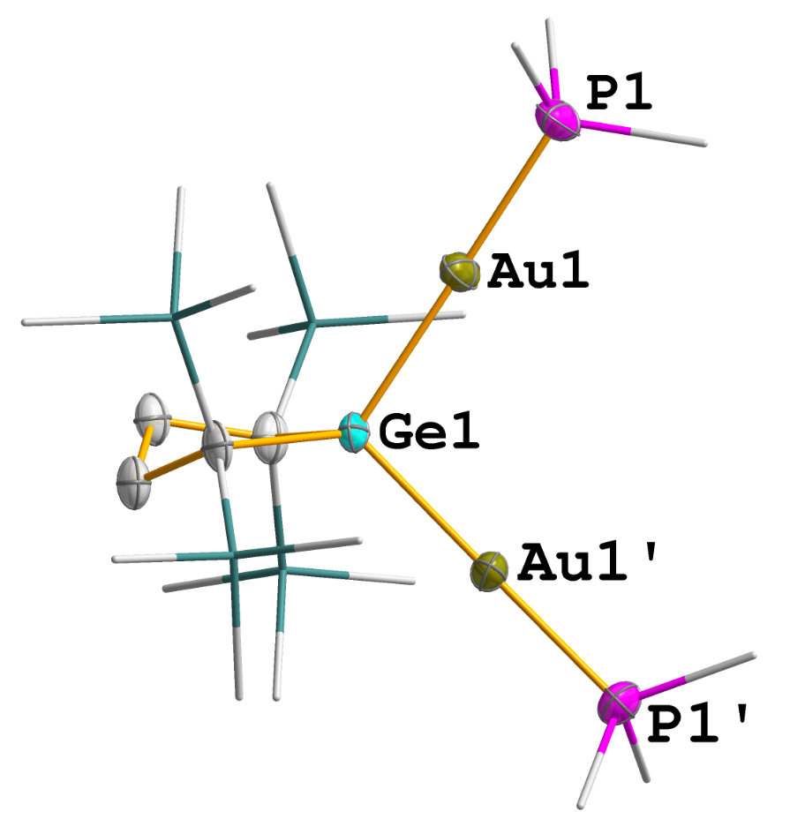
Figure S5. Solid structure of 4. Thermal ellipsoids are shown at the 30% probability level. Hydrogen atoms are omitted for clarity. Trimethylsilyl, ethyl, and methyl groups are depicted in a wireframe model. Selected bond lengths [Å] and angles [º]: Au(1)-Ge(1) 2.4211(6), Au(1)-P(1) 2.302(5), Au(1’)-P(1’) 2.302(5); P(1)-Au(1)-Ge(1) 177.21(16), P(1’)-Au(1’)-Ge(1) 166.8(2), Au(1)-Ge(1)-Au(1’) 100.90(4).

UV-visible spectroscopy
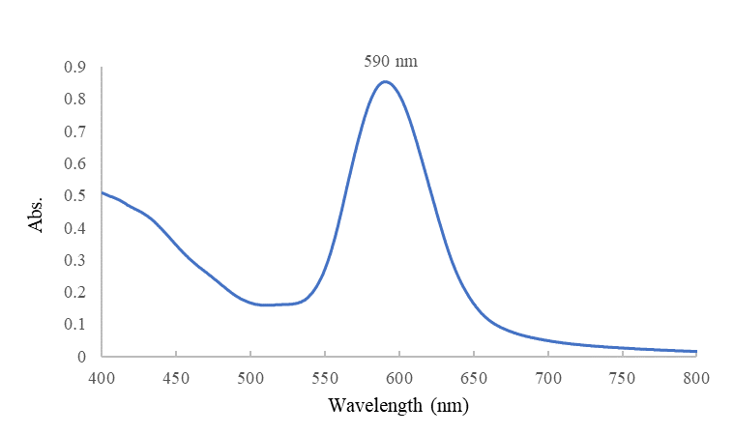
Figure S6. UV-visible spectrum of compound 3a in THF (ε = 3558 M^{–1}•cm^{–1})
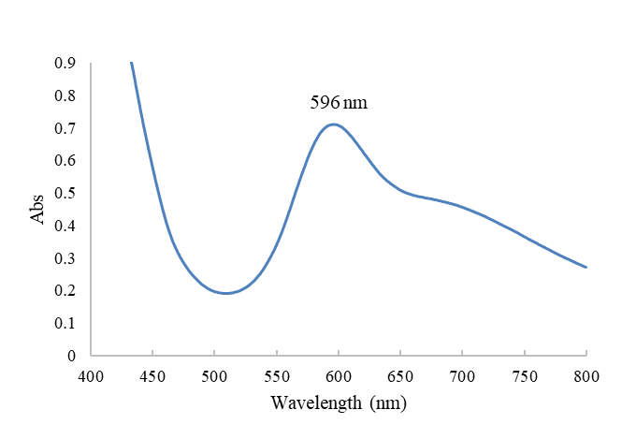
Figure S7. UV-visible spectrum of compound 3b in THF (ε = 3556 M^{–1}•cm^{–1})

¹H, ¹³C, ²⁹Si and ³¹P Spectra of products
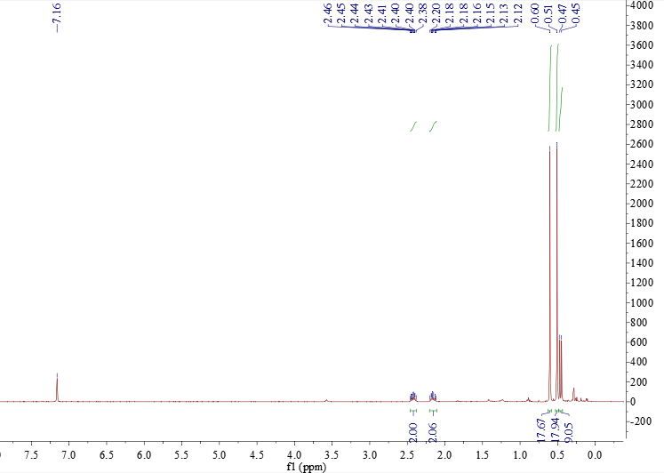
Figure S8. ¹H NMR spectrum of 2a in benzene-d₆
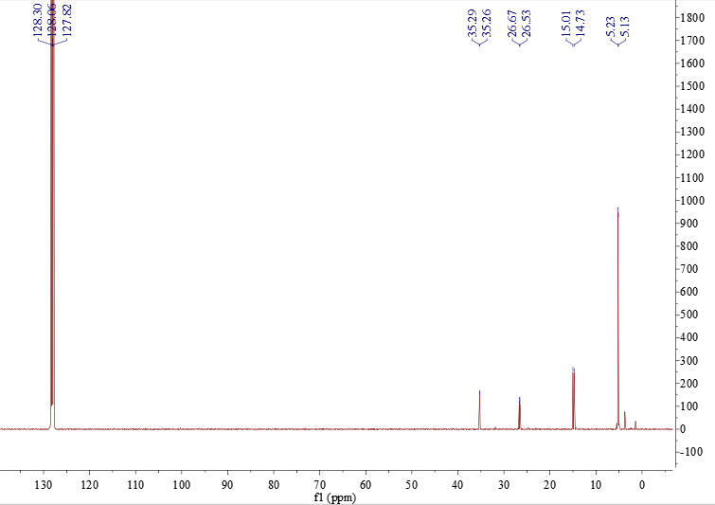
Figure S9. ¹³C NMR spectrum of 2a in benzene-d₆
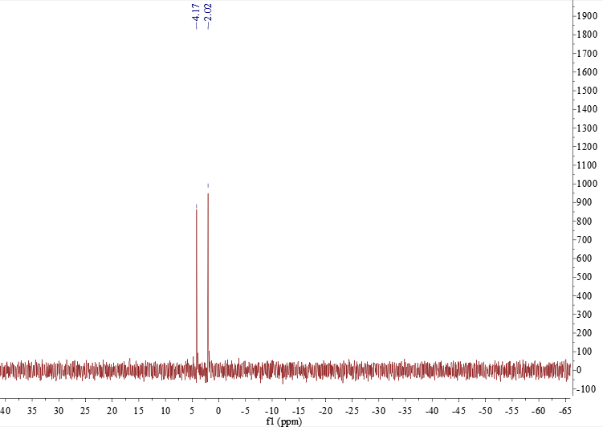
Figure S10. ²⁹Si NMR spectrum of 2a in benzene-d₆
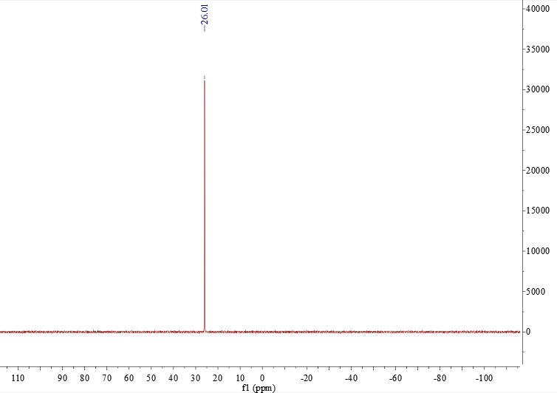
Figure S11. ³¹P NMR spectrum of 2a in benzene-d₆
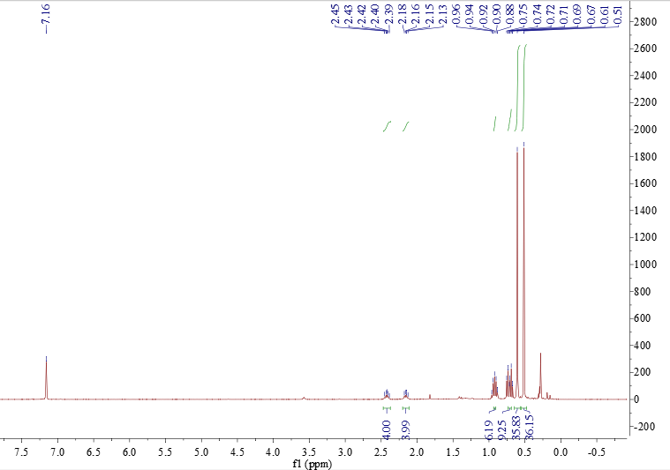
Figure S12. ¹H NMR spectrum of 2b in benzene-d₆
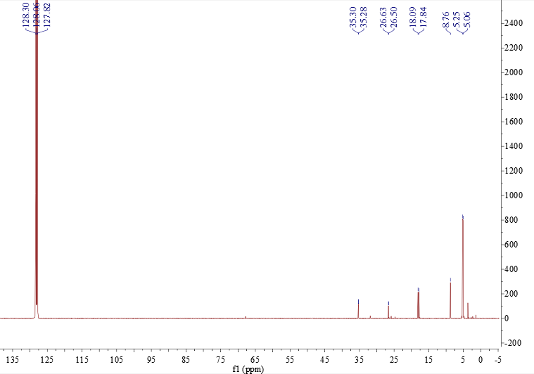
Figure S13. ¹³C NMR spectrum of 2b in benzene-d₆
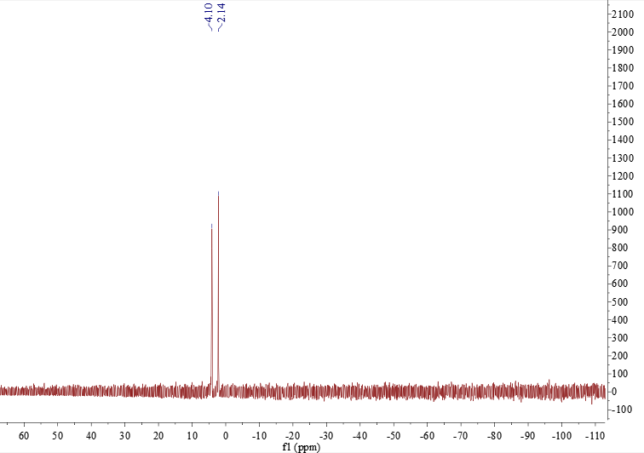
Figure S14. ²⁹Si NMR spectrum of 2b in benzene-d₆
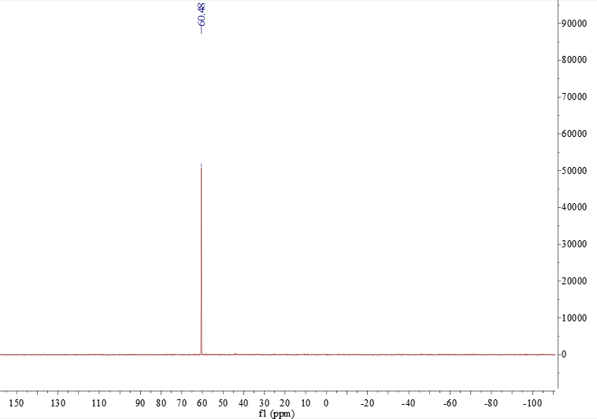
Figure S15. ³¹P NMR spectrum of 2b in benzene-d₆
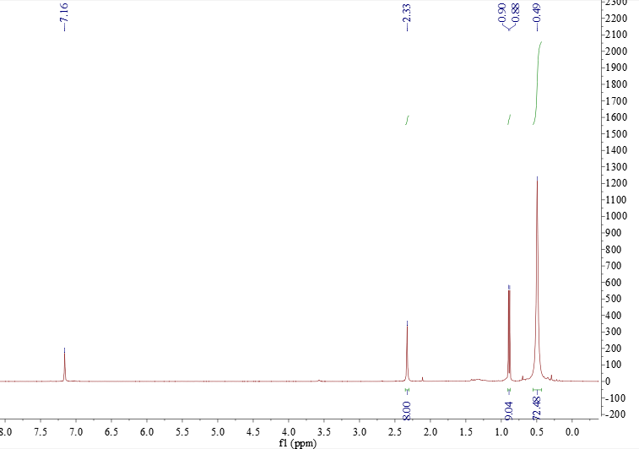
Figure S16. ¹H NMR spectrum of 3a in benzene-d₆
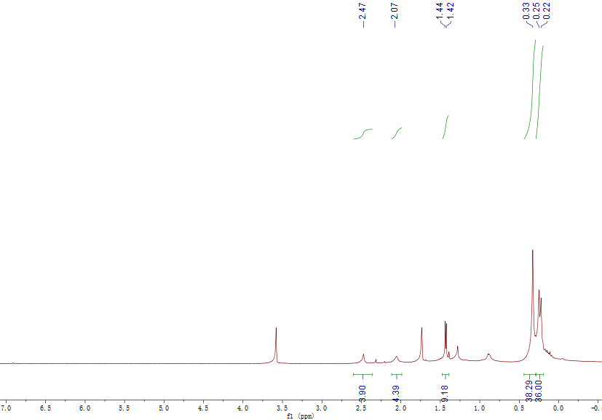
Figure S17. ¹H NMR spectrum of 3a in THF-d₈ at –30ºC

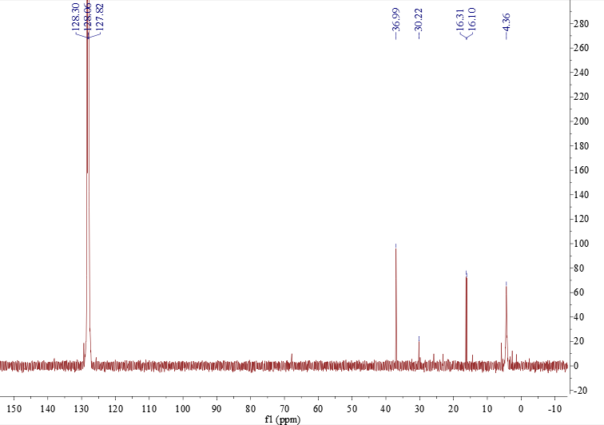
Figure S18. ¹³C NMR spectrum of 3a in benzene-d₆
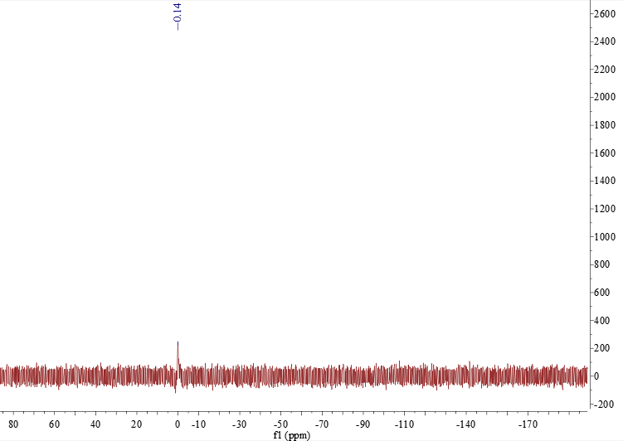
Figure S19. ²⁹Si NMR spectrum of 3a in benzene-d₆
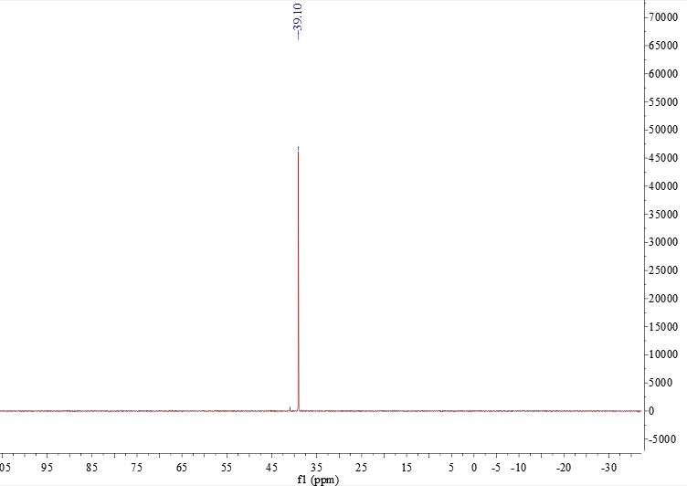
Figure S20. ³¹P NMR spectrum of 3a in benzene-d₆
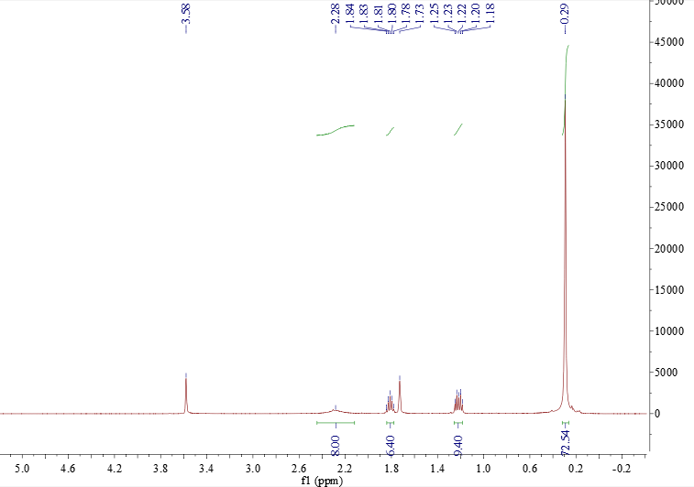
Figure S21. ¹H NMR spectrum of 3b in THF-d₈

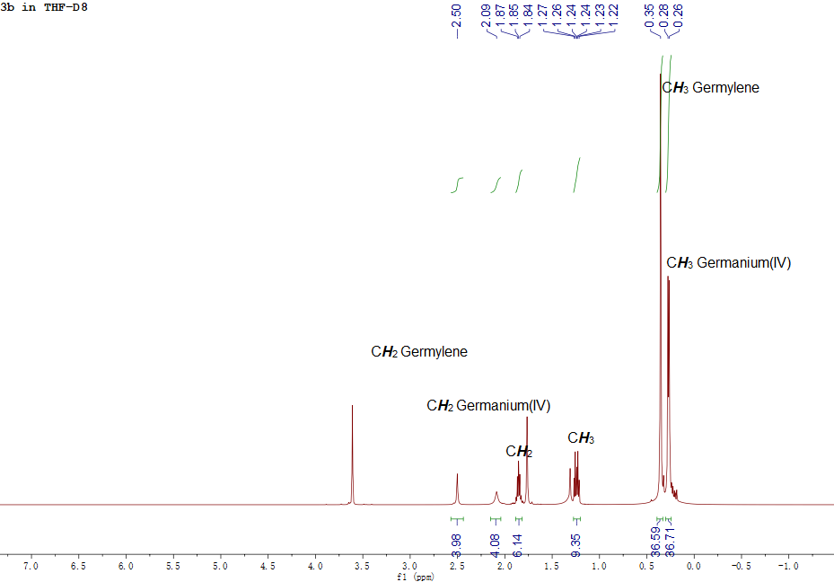
Figure S22. ¹H NMR spectrum of 3b in THF-d₈ at –30 ºC
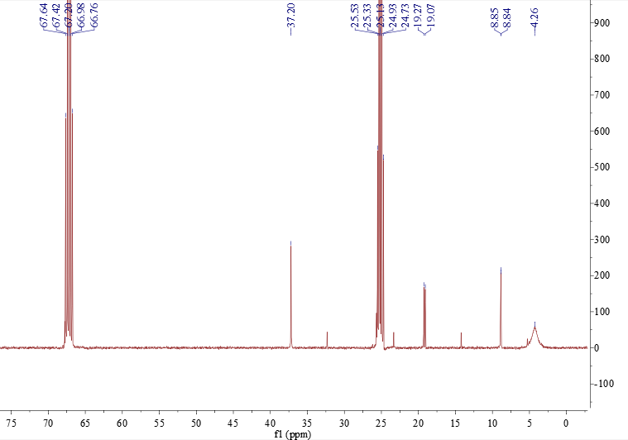
Figure S23. ¹³C NMR spectrum of 3b in THF-d₈
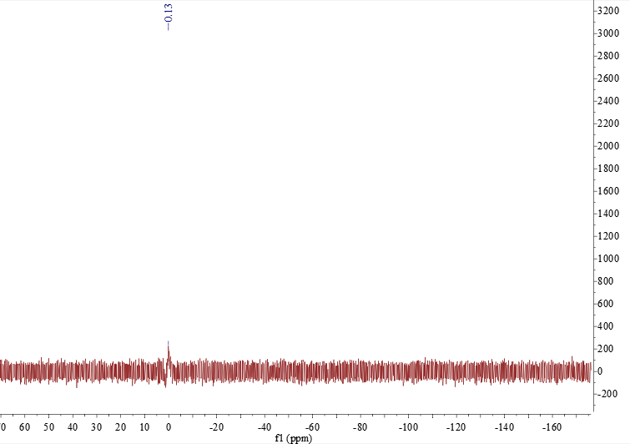
Figure S24. ²⁹Si NMR spectrum of 3b in THF-d₈
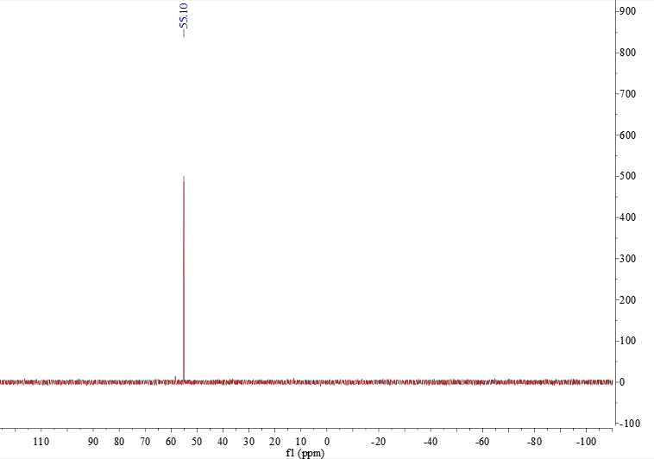
Figure S25. ³¹P NMR spectrum of 3b in THF-d₈

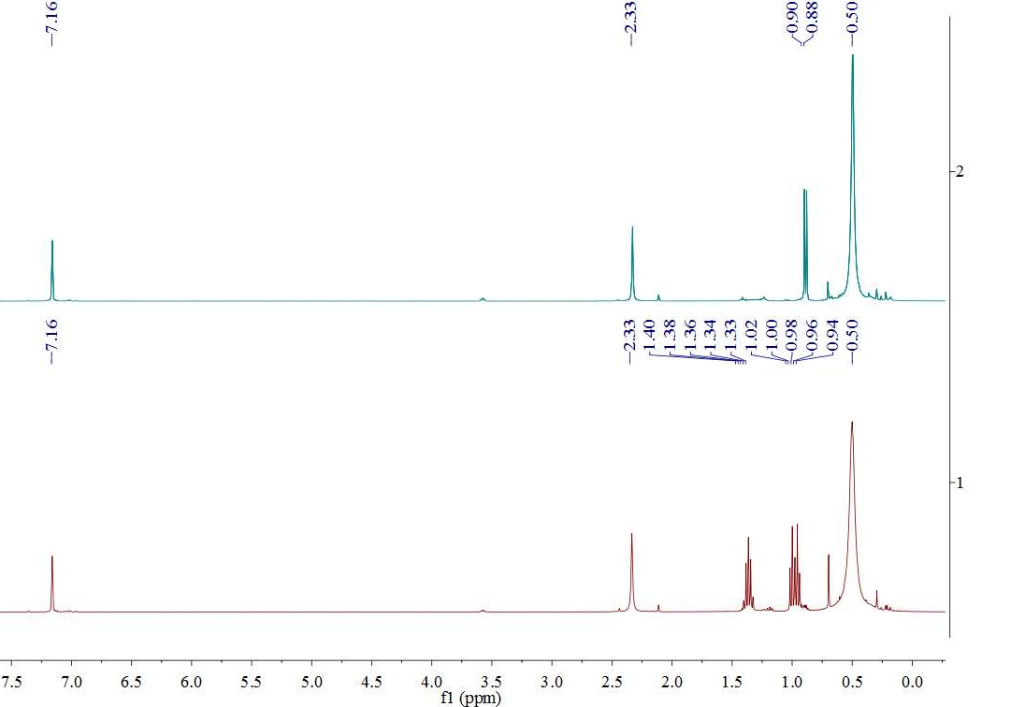
Figure S26. ¹H NMR spectra of 3a and 3b in C₆D₆
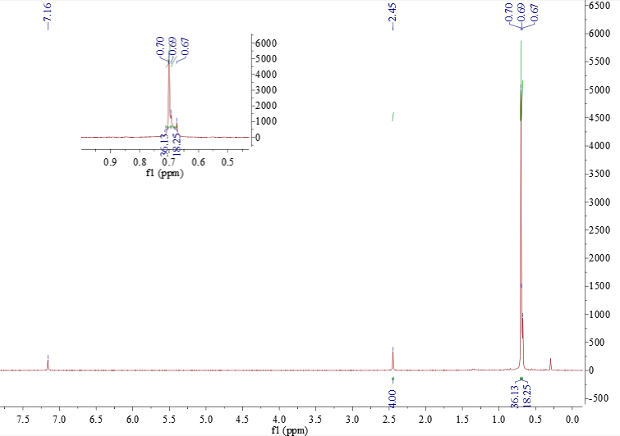
Figure S27. ¹H NMR spectrum of 4 in C₆D₆
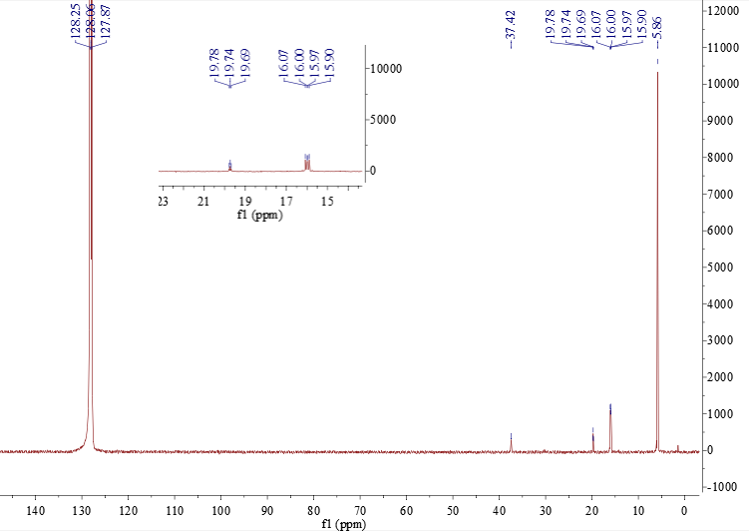
Figure S28. ¹³C NMR spectrum of 4 in C₆D₆
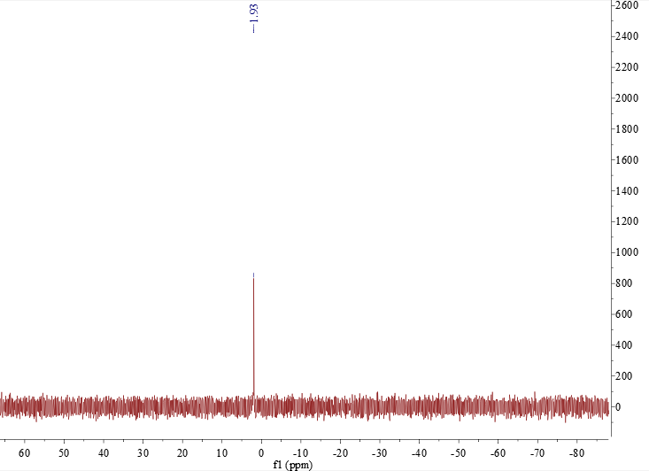
Figure S29. ²⁹Si NMR spectrum of 4 in C₆D₆
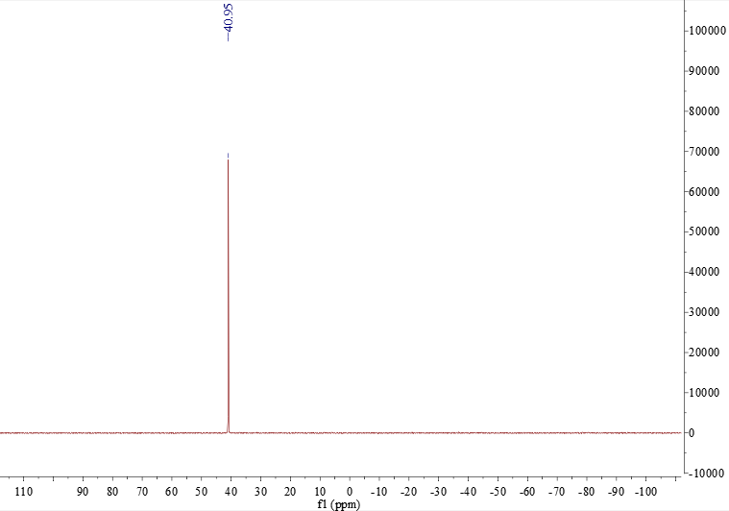
Figure S30. ³¹P NMR spectrum of 4 in C₆D₆

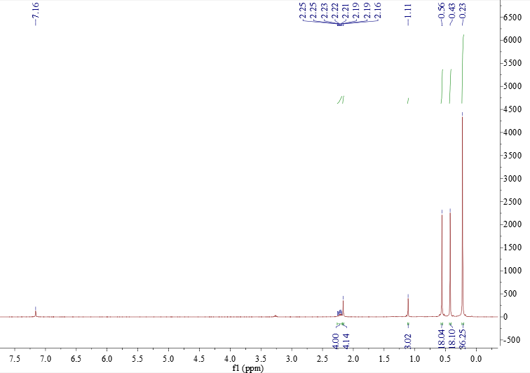
Figure S31. ¹H NMR spectrum of 5

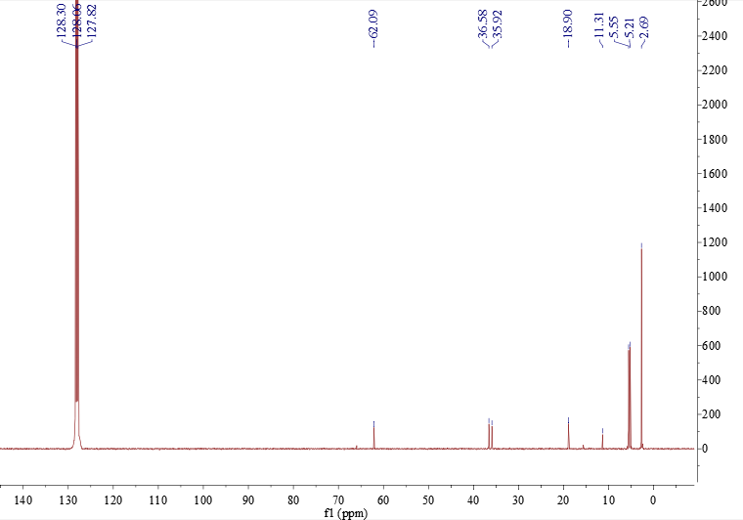
Figure S32. ¹³C NMR spectrum of 5
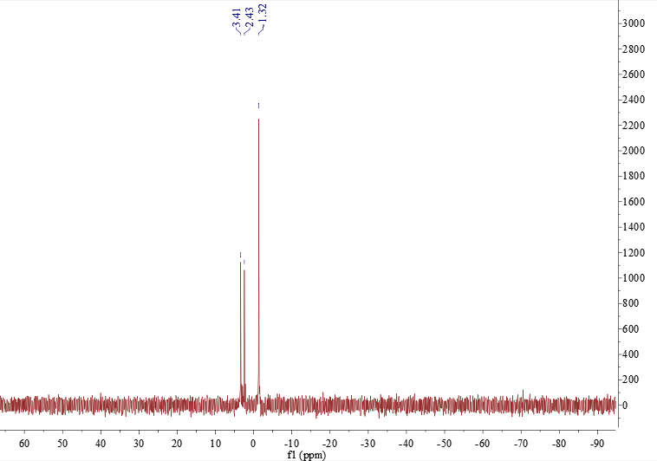
Figure S33. ²⁹Si NMR spectrum of 5
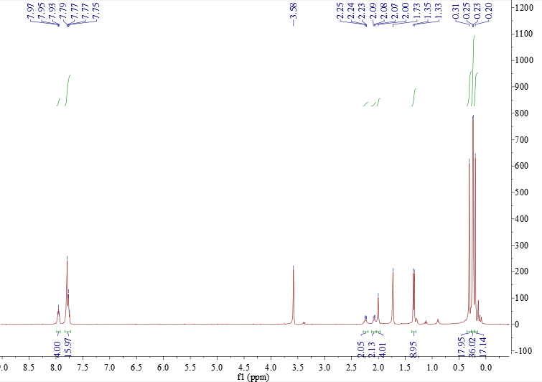
Figure S34. ¹H NMR spectrum of 7 in THF-d₈
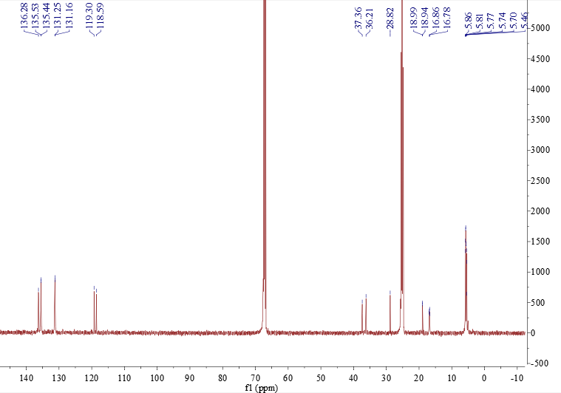
Figure S35. ¹³C NMR spectrum of 7 in THF-d₈
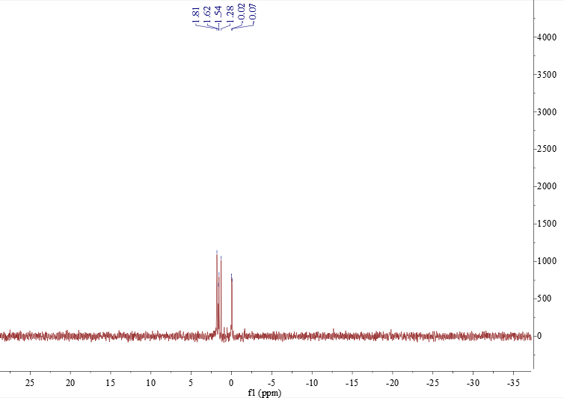
Figure S36. ²⁹Si NMR spectrum of 7 in THF-d₈
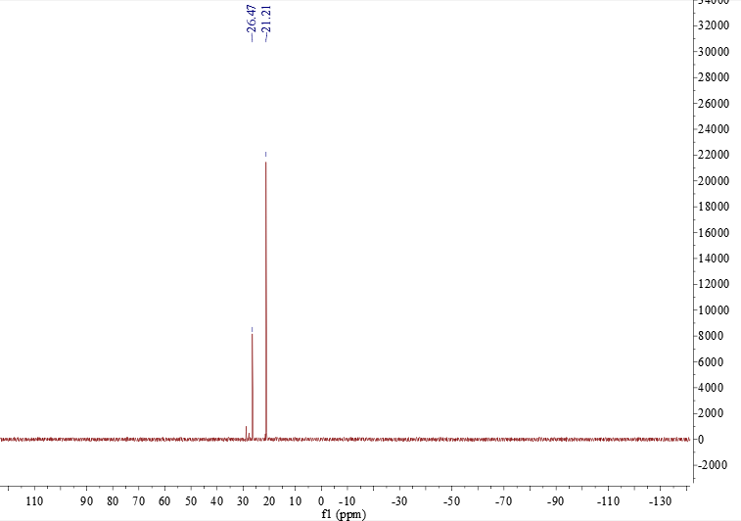
Figure S37. ³¹P NMR spectrum of 7 in THF-d₈

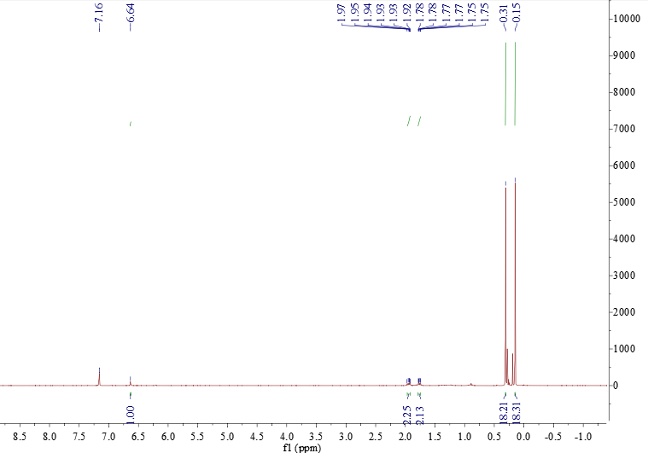
Figure S38. ¹H NMR spectrum of 1•HCl in C₆D₆

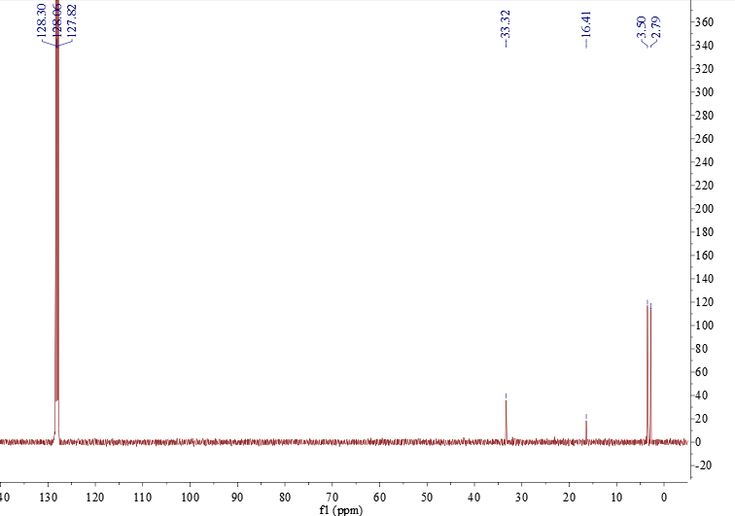
Figure S39. ¹³C NMR spectrum of 1•HCl in C₆D₆
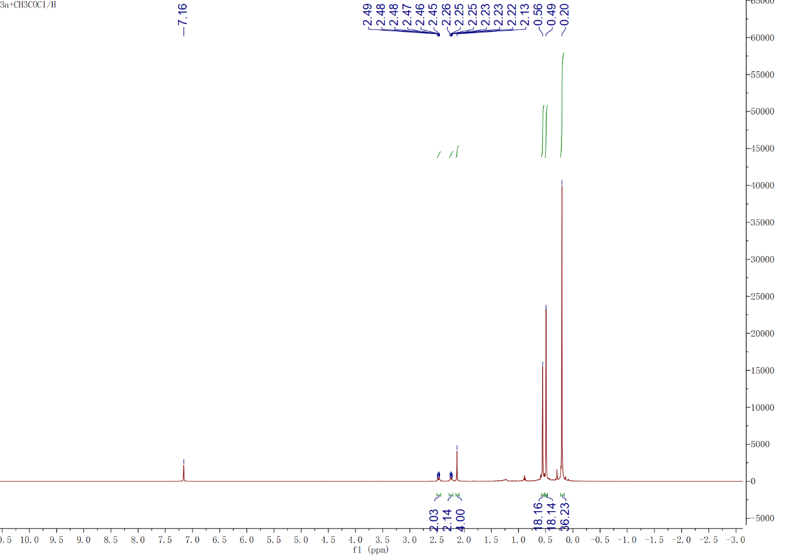
Figure S40. ¹H NMR spectrum of 9 in C₆D₆
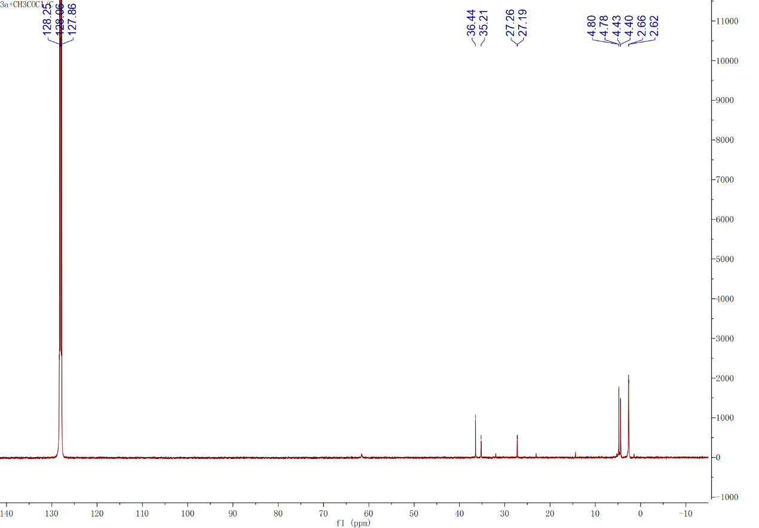
Figure S41. ¹³C NMR spectrum of 9 in C₆D₆
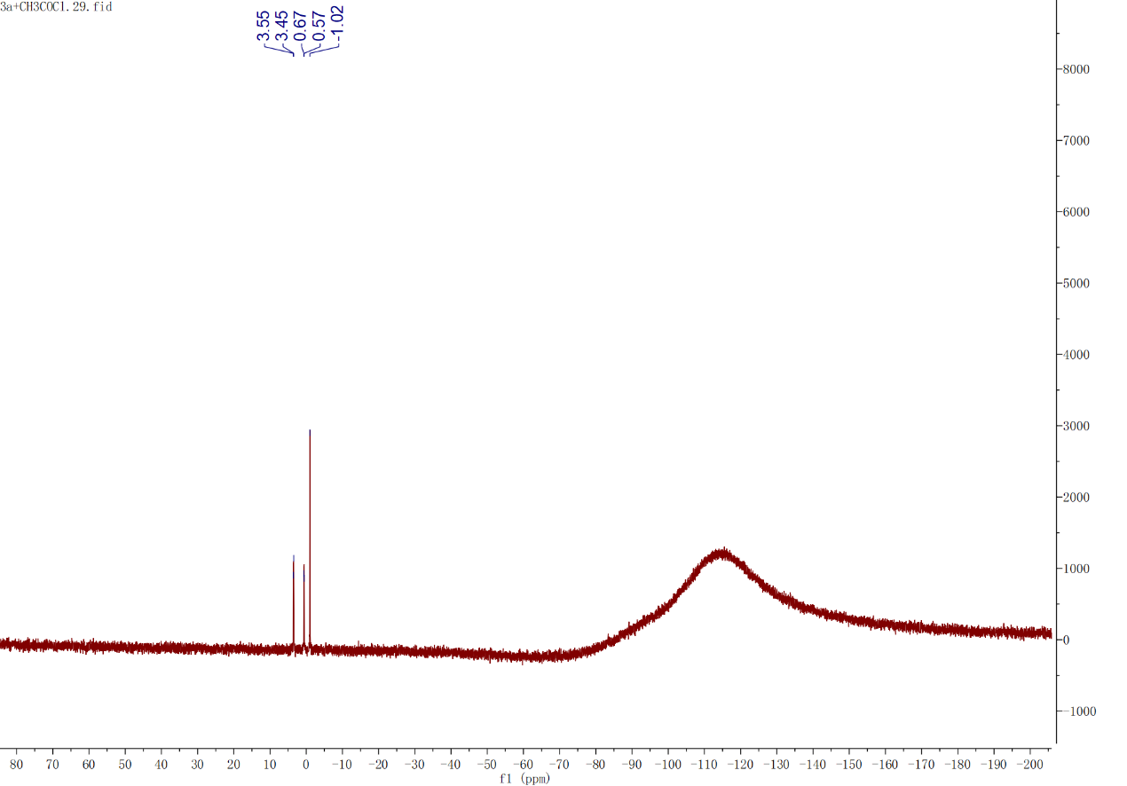
Figure S42. ²⁹Si NMR spectrum of 9 in C₆D₆

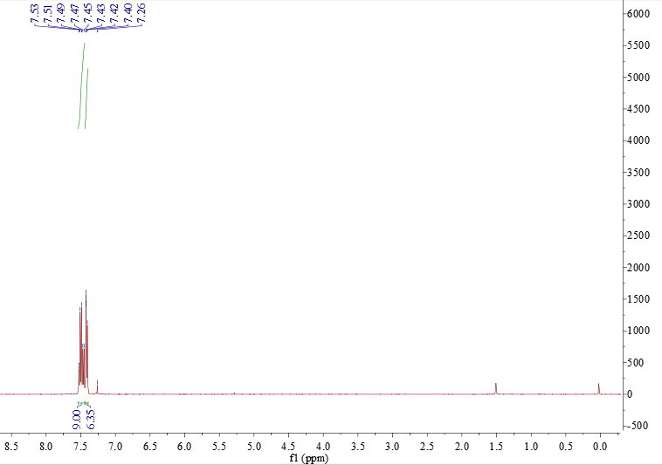
Figure S43. ¹H NMR spectrum of 11a in CDCl₃
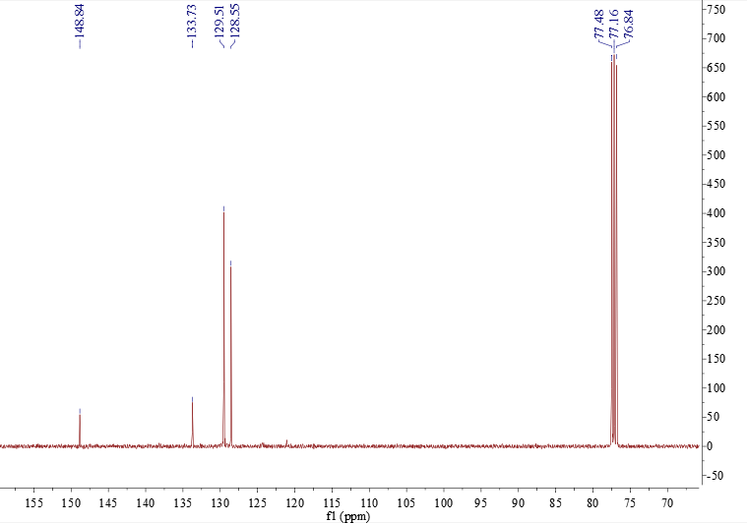
Figure S44. ¹³C NMR spectrum of 11a in CDCl₃
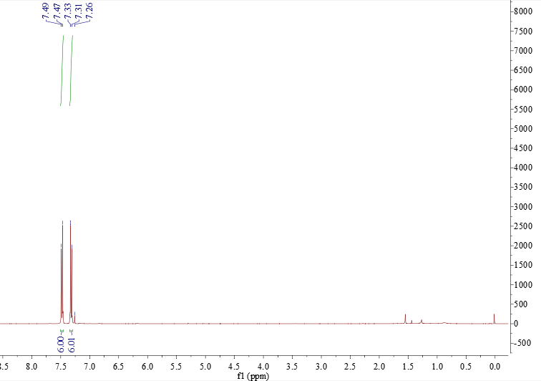
Figure S45. ¹H NMR spectrum of 11b in CDCl₃
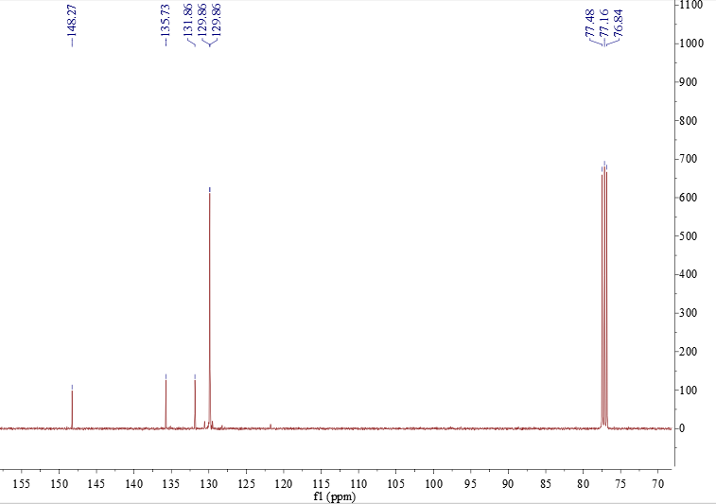
Figure S46. ¹³C NMR spectrum of 11b in CDCl₃

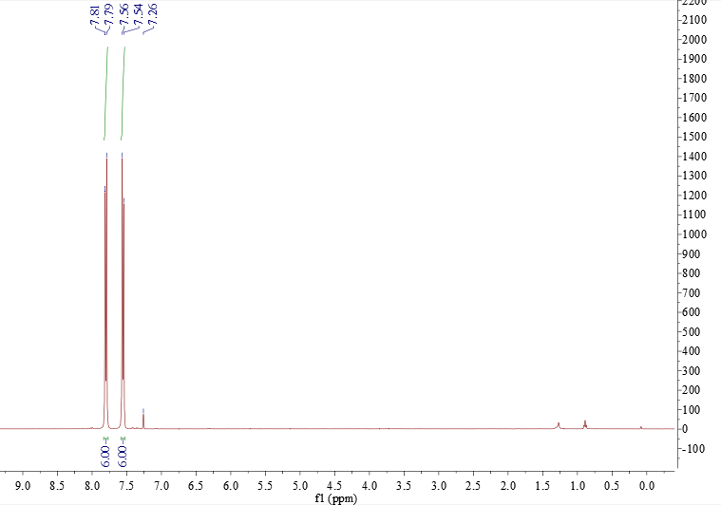
Figure S47. ¹H NMR spectrum of 11c in CDCl₃

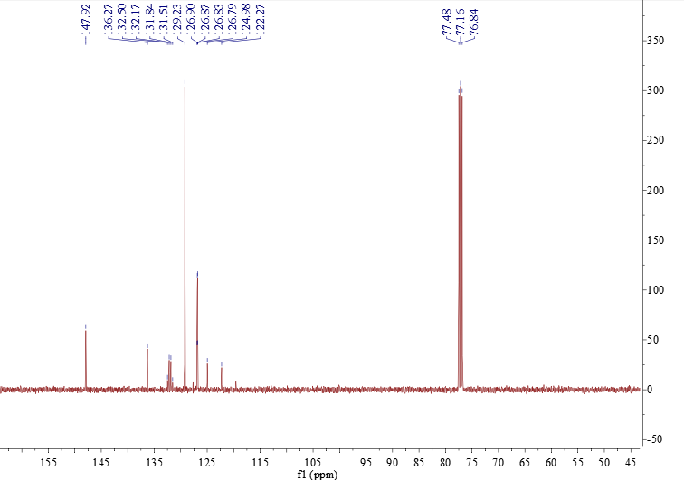
Figure S48. ¹³C NMR spectrum of 11c in CDCl₃

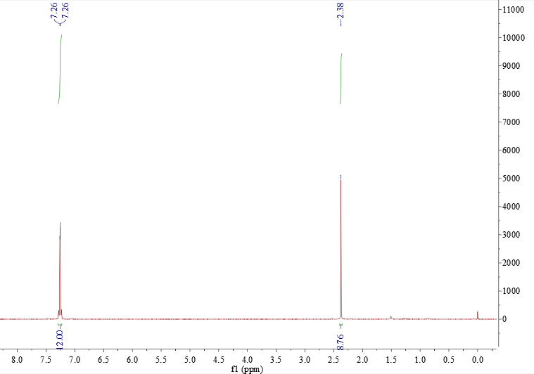
Figure S49. ¹H NMR spectrum of 11d in CDCl₃
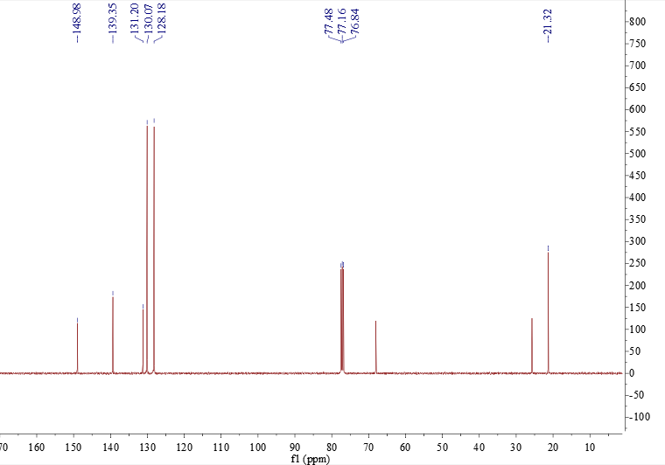
Figure S50. ¹³C NMR spectrum of 11d in CDCl₃
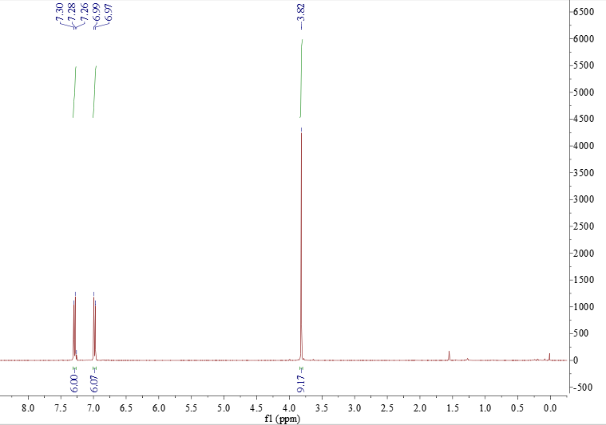
Figure S51. ¹H NMR spectrum of 11e in CDCl₃
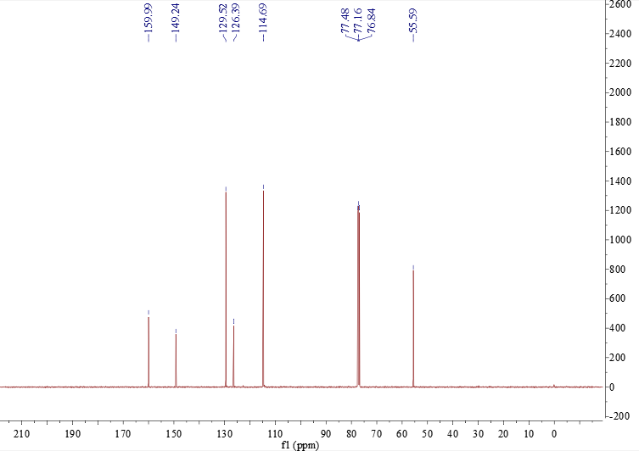
Figure S52. ¹³C NMR spectrum of 11e in CDCl₃

Theoretical calculations
Table S2. Comparison of Structural Parameters between X-ray structure of 3 and Those Optimized at the B3PW91-GD3 Level
Parameter | X-ray |  | B3PW91 (3a)
Parameter | 3a | 3b | B3PW91 (3a)
Bond distance/Å | —
¹Au-¹Ge | 2.4475(4) | 2.4371(7) | 2.44752
¹Au -²Ge | 2.4146(4) | 2.4089(8) | 2.41041
²Au -¹Ge | 2.4460(5) | 2.4307(8) | 2.44057
²Au -P | 2.3298(11) | 2.311(2) | 2.37245
Bond Angle/deg | —
¹Au -¹Ge - ²Au | 106.909(16) | 107.61(3) | 100.02468
¹Ge - ¹Au-²Ge | 168.042(15) | 171.73(3) | 169.67871
¹Ge - ²Au -P | 175.25(3) | 174.02(7) | 174.01159
Dihedral Angle/deg | —
between two averaged 5-membered ring planes | 78.915 | 84.588 | 82.522
Table S3. Comparison of Frontier MO Energy Levels among 1, 3a, and 4
Compound | HOMO/eV | LUMO/eV
1 | ‒5.54 | ‒1.86
3a | ‒4.47 | ‒2.32
4 | ‒4.51 | ‒0.56
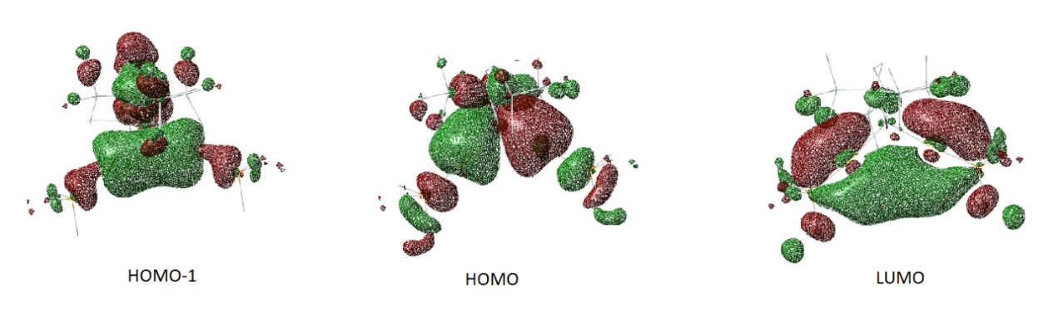
Figure S53. Frontier MOs of R’₂Ge(AuPMe₃)₂ (4)

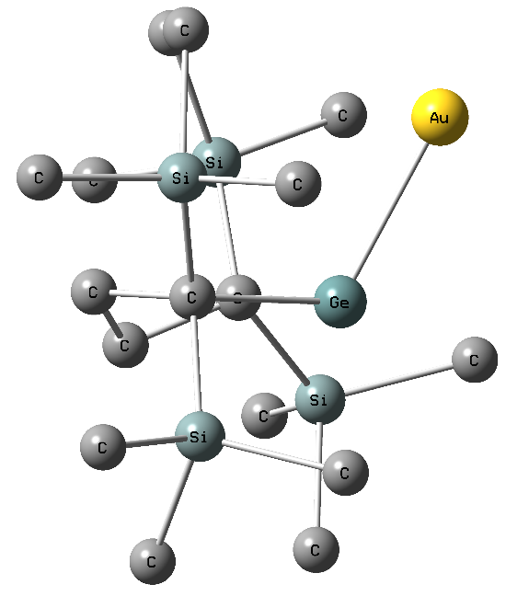 | 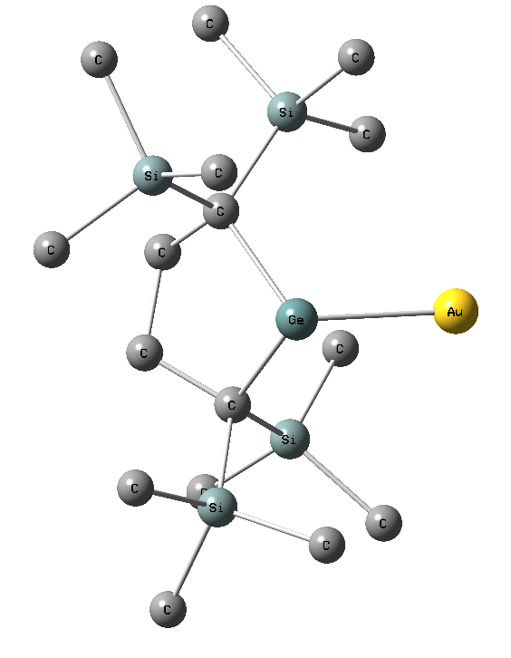
Figure S54. Optimized structure of A. Hydrogen atoms are omitted for clarity. View from the sideways (left) and top (right).

XYZ Coordinates
1
C 0.67885300 0.35628800 1.66802800
C -0.67884100 -0.35625800 1.66805100
C -1.41466400 -0.06243000 0.33509100
Ge -0.00001700 -0.00000800 -1.05156800
C 1.41464000 0.06242900 0.33504100
Si 2.43744800 1.55416900 -0.26633400
C 3.54347300 1.12450300 -1.73627700
C 3.44418000 2.28009700 1.15617300
C 1.30171400 2.94699000 -0.88221100
Si 2.46901700 -1.51873600 0.39010000
C 4.21785400 -1.21275000 1.05275200
C 2.56524800 -2.33825200 -1.30998100
C 1.75818500 -2.77738000 1.61247000
Si -2.43741800 -1.55417300 -0.26632600
C -3.44444400 -2.27998400 1.15603400
C -1.30167200 -2.94712500 -0.88193900
C -3.54319700 -1.12448200 -1.73644200
Si -2.46902300 1.51873300 0.39012800
C -4.21790700 1.21279900 1.05267800
C -2.56525300 2.33827900 -1.30994700
C -1.75813800 2.77732400 1.61250700
H 1.26891200 0.07539600 2.55255700
H 0.49446600 1.43400400 1.76038300
H -1.26887700 -0.07533300 2.55258200
H -0.49446500 -1.43397200 1.76042500
H 2.93244400 0.81331400 -2.59136600
H 4.10378200 2.01779300 -2.03645800
H 4.26452500 0.32902300 -1.53196100
H 2.78203300 2.60617200 1.96604000
H 4.00424400 3.15646200 0.80959700
H 4.15512400 1.56186600 1.57237400
H 0.86819200 2.72169000 -1.86366100
H 0.48349600 3.15350200 -0.18698000
H 1.88342400 3.87085300 -0.98278300
H 4.17346500 -0.81107000 2.07143200
H 4.74840000 -2.17144600 1.09942000
H 4.81765800 -0.52927400 0.44621300
H 1.65201000 -2.90398200 -1.52503900
H 3.40489300 -3.04185000 -1.34520700
H 2.70158900 -1.60740700 -2.11229100
H 1.63975500 -2.34735700 2.61283600
H 0.79291800 -3.18565000 1.30426800
H 2.45990100 -3.61576000 1.69676500
H -4.15604000 -1.56197700 1.57150900
H -4.00379500 -3.15685700 0.80959300
H -2.78252700 -2.60526200 1.96641200
H -0.86881800 -2.72237200 -1.86380900
H -1.88324600 -3.87117900 -0.98153600
H -0.48297800 -3.15303600 -0.18709800
H -4.26443300 -0.32916600 -1.53212400
H -2.93205000 -0.81302700 -2.59134900
H -4.10328800 -2.01781200 -2.03691000
H -4.17363300 0.81088700 2.07127000
H -4.74836400 2.17153500 1.09950100
H -4.81772500 0.52950900 0.44594000
H -1.65207200 2.90411600 -1.52496300
H -3.40497700 3.04178200 -1.34518900
H -2.70150700 1.60742800 -2.11226600
H -1.63953900 2.34725000 2.61283100
H -0.79295000 3.18566900 1.30416600
H -2.45992100 3.61563200 1.69694100
3a
Zero-point correction= | 1.147218 (Hartree/Particle)
Thermal correction to Energy= | 1.234556
Thermal correction to Enthalpy= | 1.235500
Thermal correction to Gibbs Free Energy= | 1.020752
Sum of electronic and zero-point Energies= | -8466.517605
Sum of electronic and thermal Energies= | -8466.430268
Sum of electronic and thermal Enthalpies= | -8466.429324
Sum of electronic and thermal Free Energies= | -8466.644072

Au 0.58061800 -0.46377300 0.02986000
Ge -1.90055500 -0.73941900 0.12099700
Ge 2.99113300 0.18100000 -0.05191600
Au -2.68547800 1.57178000 -0.29233800
P -3.40641800 3.83229800 -0.73363600
C -2.59401000 -1.68302300 1.83334100
C -2.81284200 -2.11180700 -1.14046900
C 3.78833800 1.98754400 0.22098300
C 4.75274300 -0.69474800 -0.37767600
C -5.22847500 4.05848900 -0.69453200
C -2.94009900 4.51358700 -2.37471000
C -2.80314400 5.10803200 0.44182600
Si 3.69215900 2.62523000 2.04148700
C 3.85275100 4.51239800 2.14517900
C 5.14918500 2.00943500 3.08577600
C 2.09983100 2.08850800 2.89644200
Si 2.80044800 3.15406600 -0.96208600
C 1.13992000 3.70847400 -0.25391100
C 2.37725200 2.28407500 -2.59303100
C 3.84673000 4.66199800 -1.42126700
Si -1.58192200 -2.70487300 -2.48694600
C -0.20668000 -3.81326300 -1.80441900
C -0.70943600 -1.27992200 -3.38376100
C -2.37466000 -3.78630700 -3.84002400
Si -3.37210300 -0.40969900 3.04051100
C -2.26120100 1.08944200 3.38023700
C -5.02279300 0.30062400 2.43772600
C -3.82712300 -1.14755800 4.73727100
Si -1.27100200 -2.71132700 2.77839000
C -0.02115200 -3.69877400 1.75391700
C -0.18434200 -1.65505200 3.92066000
C -2.10059700 -4.05756300 3.83965900
Si 4.80428000 -2.20639900 0.83206300
C 3.91145400 -3.72977200 0.16876400
C 6.59480100 -2.63963400 1.26047800
C 3.94822700 -1.78548200 2.47060300
Si -4.41567700 -1.47843100 -1.99941100
C -5.63785800 -0.44124600 -0.98671600
C -5.49716300 -2.94600800 -2.55239700
C -4.07294200 -0.39917200 -3.52410000
Si 5.03767700 -1.27344600 -2.19815100
C 5.68369700 0.12929000 -3.29771500
C 6.40665100 -2.57983700 -2.31457400
C 3.46292800 -1.94623300 -2.98631200
C -3.65391400 -2.64258100 1.21813800
C -3.17881800 -3.23095100 -0.12367500
C 5.25991700 1.81136800 -0.25698600
C 5.78122800 0.39742000 0.04373000
H 0.59520700 -3.04381200 1.11979000
H -5.51549300 5.10270200 -0.89627100
H -5.60964600 3.76057700 0.29331000
H -5.69157300 3.40199400 -1.44568800
H -1.84436600 4.51878100 -2.46825000
H -3.32250000 5.53681100 -2.51733000
H -3.34363000 3.86212800 -3.16385900
H -1.70361300 5.12327700 0.42625200
H -3.18657200 6.11001600 0.19166400
H -3.12328000 4.84038600 1.45959500
H 4.81024600 4.85740400 1.72336400
H 3.04290400 5.06675800 1.64996900
H 3.84381500 4.79812200 3.21040100
H 5.15939400 0.92091300 3.23711200
H 6.12238700 2.30550000 2.66376900
H 5.07181000 2.47533600 4.08242000
H 2.07040000 0.99711900 3.04301400
H 1.19458800 2.36599200 2.33767400
H 2.03747000 2.55441000 3.89372700
H 0.47415700 2.84536400 -0.08795900
H 1.21610200 4.27447300 0.68533000
H 0.65754600 4.36222300 -0.99980900
H 3.26042600 1.90155200 -3.12490000
H 1.66801400 1.45141200 -2.45248700
H 1.88731500 3.00922000 -3.26444200
H 4.08627100 5.29871100 -0.55800700
H 4.79462200 4.36686900 -1.89816700
H 3.29116000 5.27649800 -2.14926000
H -0.58931700 -4.73865600 -1.34692300
H 0.41304200 -3.29077200 -1.06242100
H 0.44282900 -4.10602600 -2.64613100
H -0.15475900 -0.65496300 -2.66450500
H -1.39475600 -0.62706500 -3.94081700
H 0.01621000 -1.69882100 -4.10075400
H -2.84754100 -4.68705500 -3.41643500
H -3.12678800 -3.26343800 -4.44905400
H -1.57680700 -4.12563600 -4.52222900
H -2.02086500 1.61289700 2.44003200
H -2.80214900 1.79435100 4.03414800
H -1.31530500 0.83157800 3.87505600
H -5.79907700 -0.46890500 2.30625900
H -4.91927300 0.85060000 1.49174500
H -5.38564000 1.00557600 3.20480600
H -4.54450200 -1.97814700 4.63710200
H -2.96593500 -1.51296000 5.31568600
H -4.31771000 -0.36256200 5.33747800
H -0.48764000 -4.45783000 1.11034200
H 0.64789900 -4.22446900 2.45628100
H 0.31743200 -0.85489600 3.35373600
H 0.59725100 -2.29971800 4.35535400
H -0.73176800 -1.19124200 4.75384700
H -2.90766600 -3.69022900 4.48799300
H -2.51429800 -4.85974400 3.20713400
H -1.33553200 -4.52038000 4.48575800
H 2.84825700 -3.52038000 -0.02405200
H 4.35057100 -4.14455300 -0.74957300
H 3.95158700 -4.51735800 0.93930100
H 7.11991000 -1.79128500 1.72673600
H 7.17974800 -2.96228000 0.38762100
H 6.59552100 -3.46702200 1.98959200
H 4.37745700 -0.90603300 2.97265400
H 2.86441900 -1.62212100 2.35014300
H 4.06435500 -2.63828800 3.16028400
H -5.19653000 0.50936300 -0.65131000
H -6.49463000 -0.20978700 -1.64281100
H -6.03058100 -0.96599400 -0.10433900
H -4.96364500 -3.71208600 -3.13066200
H -5.96146000 -3.44121100 -1.68402100
H -6.31921600 -2.56301100 -3.18053400
H -3.44485700 0.46711100 -3.25991200
H -5.03513700 -0.01467000 -3.90161600
H -3.58570200 -0.93727000 -4.35005300
H 6.62299300 0.56136900 -2.91842000
H 4.96506600 0.94773500 -3.44395800
H 5.89997700 -0.29477200 -4.29259500
H 7.36406100 -2.19286300 -1.93063100
H 6.18357100 -3.51914500 -1.78925000
H 6.55741000 -2.82549100 -3.37912500
H 3.02226300 -2.77756500 -2.41792100
H 2.68875300 -1.16852800 -3.08298600
H 3.68719400 -2.31497000 -4.00091700
H -3.91245300 -3.46636200 1.90763200
H -4.59959600 -2.10364100 1.03967300
H -3.95480100 -3.91068800 -0.51963200
H -2.30222900 -3.87124600 0.07289800
H 5.93368000 2.56065800 0.19650600
H 5.33055900 1.98366500 -1.34442900
H 6.76054300 0.24940900 -0.44643700
H 5.98965800 0.32726200 1.12467100

4
C 0.19451300 -3.18867000 -0.74104000
C -0.19463200 -3.18539700 0.75451600
C 0.30805000 -1.89477700 1.45802400
Ge -0.00001500 -0.49568900 0.00086700
C -0.30802700 -1.90107300 -1.45019200
Au 1.90631300 1.00632200 -0.21936100
Au -1.90643200 1.00714500 0.21498300
Si 0.70819100 -1.37791100 -2.96493700
C 0.43320500 0.45517100 -3.39975700
C 0.32852400 -2.37544400 -4.54073700
C 2.56943600 -1.63861000 -2.74489000
Si -2.13057000 -2.07751700 -1.96570500
C -2.39051800 -3.73771000 -2.85610900
C -2.70237000 -0.66724600 -3.09566600
C -3.46267600 -2.13746500 -0.61887400
Si -0.70810200 -1.36493600 2.97047400
C -0.32846600 -2.35554200 4.55064100
C -2.56934300 -1.62667500 2.75155700
C -0.43293700 0.46999500 3.39724800
Si 2.13063600 -2.06900200 1.97417300
C 2.39081600 -3.72517500 2.87193100
C 2.70257800 -0.65387300 3.09801200
C 3.46249700 -2.13482400 0.62736500
P -3.91083900 2.26927300 0.32709700
C -3.90564000 4.10338900 0.23661200
C -5.07757200 1.78403700 -1.00280000
C -4.86314600 1.92477900 1.85720600
P 3.91083300 2.26787700 -0.33597900
C 5.07725900 1.78716000 0.99582900
C 3.90588700 4.10230200 -0.25192800
C 4.86339200 1.91787100 -1.86468100
H -0.19052900 -4.10016100 -1.22062000
H 1.28776100 -3.25558300 -0.80813100
H 0.19029900 -4.09483800 1.23806300
H -1.28788400 -3.25190000 0.82190500
H -0.29165500 0.93498800 -2.73563800
H 1.37665900 1.00350600 -3.29690300
H 0.08139300 0.56905600 -4.43184600
H 0.52386700 -3.44401800 -4.39444500
H 0.99562200 -2.02456200 -5.33839900
H -0.70027900 -2.26439000 -4.89660400
H 2.83169400 -2.68641100 -2.56586500
H 3.06337000 -1.32520100 -3.67321700
H 2.96841800 -1.03787200 -1.92495700
H -2.43011800 -4.55313100 -2.12411200
H -3.35584700 -3.72252900 -3.37698100
H -1.61578100 -3.98094800 -3.58611900
H -3.76425200 -0.81544600 -3.32714200
H -2.15699800 -0.60035200 -4.04083000
H -2.59944300 0.29277200 -2.57734300
H -3.28399500 -2.90475800 0.13854200
H -3.57052900 -1.17706200 -0.10737100
H -4.41310600 -2.37304800 -1.11591600
H -0.52336700 -3.42481400 4.40893800
H 0.70022400 -2.24254700 4.90622400
H -0.99585100 -2.00145700 5.34664700
H -2.96827600 -1.03026300 1.92845600
H -3.06340000 -1.30847300 3.67818400
H -2.83149000 -2.67542900 2.57799500
H -1.37678800 1.01756900 3.29400800
H -0.07915300 0.58826400 4.42816600
H 0.29045900 0.94729500 2.72971700
H 2.42861700 -4.54411400 2.14377800
H 3.35703500 -3.70819000 3.39109300
H 1.61714200 -3.96434700 3.60440600
H 3.76456100 -0.80095600 3.32973500
H 2.15754100 -0.58325900 4.04310200
H 2.59932000 0.30404400 2.57588300
H 3.28419600 -2.90613700 -0.12605600
H 3.56945100 -1.17698700 0.11087700
H 4.41324900 -2.36712400 1.12533000
H -3.31049800 4.50366500 1.06194800
H -3.44174500 4.41616600 -0.70282800
H -4.92211700 4.50878000 0.29194500
H -4.64485900 2.03676600 -1.97440200
H -6.04587100 2.28342700 -0.88999900
H -5.21584500 0.69991600 -0.97107000
H -4.99972400 0.84402600 1.95182400
H -4.29261600 2.26959200 2.72383700
H -5.84060700 2.41891000 1.84224600
H 4.64442400 2.04342400 1.96644900
H 6.04567200 2.28596100 0.88141300
H 5.21531900 0.70290300 0.96799600
H 3.44175600 4.41843300 0.68627200
H 4.92244900 4.50732600 -0.30836200
H 3.31106600 4.49979500 -1.07883900
H 5.84086600 2.41202100 -1.85130300
H 4.99996300 0.83677900 -1.95538000
H 4.29303700 2.25958700 -2.73265000
A
C -0.93625700 1.33510300 1.76006100
C 0.39255200 2.02039000 1.38123700
C 1.30252400 1.07643900 0.55336900
Ge -0.07156700 0.26296400 -0.82675000
C -1.63315700 0.69520800 0.52878600
Au 0.42565900 -2.17797100 -0.88572600
Si -2.70661000 -0.76827800 1.05653600
C -3.62433700 -1.53842700 -0.41044700
C -3.98507400 -0.25440500 2.38625300
C -1.83181300 -2.19588800 1.93120100
Si -2.68579100 1.93667200 -0.45542900
C -4.44580700 2.21211300 0.23095100
C -1.98441700 3.70091300 -0.44673300
C -2.93572000 1.46694800 -2.27645100
Si 2.45333600 1.97341900 -0.65146700
C 3.98571500 2.78371900 0.15206900
C 3.09733800 0.82369300 -2.02227000
C 1.61646400 3.43839200 -1.52462800
Si 2.32982500 -0.04400500 1.67620800
C 3.14164000 0.99705000 3.06099900
C 1.43658200 -1.38303800 2.66392400
C 3.71927100 -0.96231900 0.77217200
H -1.58223600 2.06552400 2.27844200
H -0.71665700 0.55749400 2.50601700
H 0.88592600 2.38834500 2.29530100
H 0.15330400 2.92008100 0.80211200
H -4.17113200 -2.42861000 -0.07617800
H -2.89490500 -1.85142900 -1.16714700
H -4.34151900 -0.85568100 -0.87784900
H -4.29409600 -1.14364900 2.94989600
H -3.53263100 0.44665900 3.09869800
H -4.88428500 0.21571400 1.98145200
H -1.04967000 -2.64478300 1.31180300
H -1.39472800 -1.89242200 2.88684600
H -2.59350400 -2.95960000 2.13780700
H -4.89072700 3.05701900 -0.31098100
H -5.09682300 1.34412300 0.08624700
H -4.43895600 2.46016700 1.29786400
H -2.69622600 4.35493900 -0.96700900
H -1.02423300 3.77322200 -0.96093600
H -1.86067300 4.08397200 0.57282700
H -3.06135000 0.38908000 -2.41274800
H -3.82841100 1.97446600 -2.66653400
H -2.06961600 1.76582800 -2.87447700
H 4.53642600 3.33897000 -0.61882700
H 3.69506200 3.49546200 0.93406400
H 4.67229800 2.05505100 0.59535600
H 2.58625000 1.05384000 -2.96331900
H 2.90054700 -0.22967000 -1.80342600
H 4.17707100 0.95228000 -2.17075300
H 1.28642300 4.21549100 -0.82636000
H 2.34431400 3.89177400 -2.20998900
H 0.75681600 3.10358100 -2.11411500
H 3.87642700 0.37748900 3.59144500
H 3.65028400 1.89460200 2.69992200
H 2.38882900 1.30922300 3.79512700
H 2.17876300 -1.88699000 3.29755500
H 0.98146500 -2.12555400 2.00497800
H 0.66211700 -0.97089300 3.31817700
H 3.28560200 -1.65087000 0.03804700
H 4.42780800 -0.30708300 0.25668000
H 4.27606200 -1.55692100 1.50748700

MeOTf
Zero-point correction= | 0.067515 (Hartree/Particle)
Thermal correction to Energy= | 0.076902
Thermal correction to Enthalpy= | 0.077846
Thermal correction to Gibbs Free Energy= | 0.031682
Sum of electronic and zero-point Energies= | -1000.399501
Sum of electronic and thermal Energies= | -1000.390114
Sum of electronic and thermal Enthalpies= | -1000.389170
Sum of electronic and thermal Free Energies= | -1000.435334

C 2.25154700 1.20404900 -0.04399100
O 1.42560700 0.26684000 -0.75210300
S 0.41764200 -0.69612500 0.05587600
O 0.80971800 -0.78329600 1.44938800
O 0.17662500 -1.84423200 -0.78224800
C -1.12491800 0.35603300 -0.00416700
F -1.51524600 0.51951500 -1.25406900
F -2.07710700 -0.24445400 0.68691800
F -0.86759800 1.54226700 0.53671200
H 1.73186500 2.16795700 0.05010100
H 2.51257400 0.81520800 0.94933200
H 3.15746700 1.32390100 -0.65084000

Int1
Zero-point correction= | 1.216578 (Hartree/Particle)
Thermal correction to Energy= | 1.314095
Thermal correction to Enthalpy= | 1.315039
Thermal correction to Gibbs Free Energy= | 1.079982
Sum of electronic and zero-point Energies= | -9466.913291
Sum of electronic and thermal Energies= | -9466.815773
Sum of electronic and thermal Enthalpies= | -9466.814829
Sum of electronic and thermal Free Energies= | -9467.049886

Au 0.24960100 -1.21585300 0.61926700
Ge -2.19203500 -1.05161100 0.46694900
Ge 2.73038000 -0.77813100 0.22554400
Au -0.96381700 0.62343000 -1.15415700
P -1.11596700 2.20146000 -2.99648100
C -3.44423800 -0.41124500 1.90522300
C -3.53069400 -2.26965000 -0.43875800
C 4.02529200 -1.68449700 -1.00338900
C 4.11637600 0.37885600 1.07747500
C -2.37590600 3.51350800 -2.85528400
C -1.54478600 1.35286600 -4.56917400
C 0.42194600 3.08684300 -3.42433900
Si 3.70272100 -1.30516900 -2.87024000
C 4.66133500 -2.47598700 -4.01113800
C 4.31803700 0.41465700 -3.35808900
C 1.86902400 -1.40578000 -3.31178500
Si 4.00726700 -3.59684200 -0.69294400
C 2.63997700 -4.51772000 -1.60842200
C 3.77796700 -3.99372600 1.14253900
C 5.67421400 -4.35061800 -1.17790300
Si -2.82056500 -4.04452300 -0.74587500
C -2.52525700 -5.01245000 0.84875800
C -1.15978700 -4.00250800 -1.64160000
C -4.00093400 -5.15412200 -1.73293500
Si -3.29359700 1.53083900 2.06966800
C -1.50916500 2.04372400 2.32448300
C -3.92540400 2.38557900 0.51603300
C -4.32212100 2.26338500 3.48032600
Si -3.25007500 -1.20227600 3.67472600
C -3.16394000 -3.09422100 3.75191800
C -1.74579600 -0.56482300 4.62144500
C -4.80002200 -0.86239100 4.71573500
Si 3.37896100 2.17770700 1.02925500
C 2.07222100 2.42484400 2.35195800
C 4.72603200 3.49715100 1.15958400
C 2.60658700 2.44134400 -0.67199600
Si -4.25578300 -1.62360300 -2.12322300
C -4.57796000 0.23334000 -2.23650500
C -5.96995400 -2.38048300 -2.42026300
C -3.15742400 -2.02426600 -3.61116100
Si 4.65962100 -0.08891900 2.87256500
C 6.11168600 -1.30957200 2.89126000
C 5.34010700 1.39316700 3.83409900
C 3.24718400 -0.83918800 3.87361600
C -4.80309600 -0.88673000 1.30861700
C -4.67346100 -2.25908300 0.62463600
C 5.40851000 -1.12796200 -0.53950700
C 5.29354700 0.27680200 0.06467800
H -2.34254100 -3.55255500 3.18893100
H -2.33558100 4.15273400 -3.75139900
H -2.18252200 4.12014500 -1.95778500
H -3.37689400 3.06750900 -2.77674100
H -0.78647700 0.59151200 -4.80263900
H -1.59003900 2.08029400 -5.39505700
H -2.51908900 0.85425600 -4.47882200
H 1.24003200 2.37361900 -3.59398300
H 0.26124600 3.68633700 -4.33391800
H 0.66726200 3.74150600 -2.57853200
H 5.74684300 -2.41508000 -3.83435500
H 4.36130200 -3.53081200 -3.93524300
H 4.48328300 -2.15675000 -5.05171700
H 3.78053800 1.22506300 -2.84769500
H 5.39502600 0.54339200 -3.16742400
H 4.16364200 0.54224100 -4.44269900
H 1.26809900 -0.67366500 -2.74674600
H 1.43894800 -2.39906200 -3.11986900
H 1.74408300 -1.18873600 -4.38577000
H 1.64176500 -4.15181100 -1.32980000
H 2.72764800 -4.46524400 -2.70314600
H 2.69174400 -5.58201000 -1.32466500
H 4.57181600 -3.56510000 1.77018800
H 2.80854000 -3.65462300 1.53667900
H 3.81555100 -5.08773300 1.27618000
H 5.91125200 -4.23486400 -2.24452700
H 6.50659900 -3.92525000 -0.59652400
H 5.64122700 -5.43104500 -0.95851500
H -3.42942200 -5.13412300 1.46283000
H -1.73664100 -4.57291000 1.47398600
H -2.18903500 -6.02229600 0.55959900
H -1.21823900 -3.64023200 -2.67578800
H -0.74471100 -5.02300100 -1.66595300
H -0.44529800 -3.36250700 -1.09990700
H -4.96564700 -5.28304300 -1.21687500
H -4.20396600 -4.81142100 -2.75737600
H -3.53584900 -6.15152300 -1.80642500
H -1.04389500 1.59321800 3.21000900
H -0.88967200 1.79963100 1.44760400
H -1.45185700 3.13835800 2.43360100
H -5.01771800 2.31997400 0.39222500
H -3.44735700 1.99506400 -0.39281100
H -3.64316600 3.44994100 0.58077300
H -5.38540600 1.98146400 3.43156900
H -3.93999200 2.02373100 4.48336800
H -4.26485600 3.35865300 3.36325200
H -4.10366200 -3.56607900 3.42697600
H -3.02154300 -3.36148200 4.81278400
H -0.81174000 -0.67130400 4.04933700
H -1.64218900 -1.15914800 5.54409400
H -1.84632700 0.48938000 4.91751700
H -5.04516900 0.19749700 4.85057400
H -5.68733400 -1.36983600 4.30492500
H -4.62067000 -1.29442000 5.71488100
H 1.33162100 1.61171100 2.33378200
H 2.48992900 2.48102600 3.36810400
H 1.52020500 3.35935100 2.15490300
H 5.54297300 3.32733600 0.44048000
H 5.16228400 3.59524600 2.16247800
H 4.25792500 4.46279800 0.90377600
H 3.36453800 2.69119800 -1.42969400
H 2.01323200 1.58250200 -1.03450900
H 1.89096200 3.27519600 -0.59487300
H -3.65797800 0.82623600 -2.13786000
H -5.00979400 0.43906200 -3.23069300
H -5.29439300 0.59703000 -1.48702400
H -6.02358000 -3.46903100 -2.28934100
H -6.72693100 -1.92002300 -1.76575300
H -6.26480500 -2.15410900 -3.45886100
H -2.14273600 -1.61364000 -3.49355000
H -3.60811400 -1.55728200 -4.50246400
H -3.06925800 -3.09997400 -3.81853700
H 6.98940600 -0.91524300 2.35529500
H 5.87936100 -2.30106500 2.47905100
H 6.41449300 -1.45677900 3.94145800
H 6.21591900 1.83721000 3.33614000
H 4.60512500 2.19056600 4.01204100
H 5.67392800 1.02558000 4.81900300
H 2.33695800 -0.22216500 3.84141100
H 2.99074700 -1.84839800 3.51594500
H 3.55025600 -0.93461700 4.92909500
H -5.58544700 -0.93840800 2.08442000
H -5.17313400 -0.15523400 0.57039400
H -5.64146200 -2.54093800 0.17869600
H -4.47484000 -3.01671100 1.39886100
H 6.13973200 -1.11939300 -1.36778400
H 5.84757300 -1.79271400 0.22298100
H 6.25447300 0.55805800 0.53086300
H 5.14884800 1.00077600 -0.75595800
C 0.34064400 -2.79045800 2.06127700
H 1.14980900 -2.55613000 2.76359100
H -0.58766600 -2.90769200 2.62744900
H 0.56229800 -3.72441400 1.52657100
O -0.16676100 3.90398900 -0.49408800
S -0.68782500 5.07018700 0.27575100
O -2.10794300 5.36481200 0.00997400
O -0.25134600 5.13405100 1.67796800
C 0.21280400 6.49269500 -0.52273700
F -0.04281700 6.53536300 -1.83714600
F -0.15069600 7.65458900 0.00816200
F 1.53504000 6.35804300 -0.37271500

Int2
Zero-point correction= | 1.215263 (Hartree/Particle)
Thermal correction to Energy= | 1.313198
Thermal correction to Enthalpy= | 1.314142
Thermal correction to Gibbs Free Energy= | 1.076738
Sum of electronic and zero-point Energies= | -9466.942465
Sum of electronic and thermal Energies= | -9466.844530
Sum of electronic and thermal Enthalpies= | -9466.843586
Sum of electronic and thermal Free Energies= | -9467.080990

Au -0.81025900 0.24707700 -0.26814500
Ge 2.60124500 0.83688000 0.61438900
Ge -3.03463400 0.94432000 0.20130500
Au 1.58328300 -0.49051000 -1.26388500
P 1.01738300 -1.76104300 -3.30600300
C 3.52947900 -0.25244000 2.06716100
C 4.34993600 1.66768700 -0.09842200
C -4.10807600 2.37290500 -0.63428400
C -4.38812600 0.34333100 1.47918400
C -0.74302000 -1.88012100 -3.76338500
C 1.60409600 -3.48978500 -3.32435200
C 1.79951600 -1.00896100 -4.78984700
Si -4.65496900 2.03162000 -2.46254600
C -5.12371900 3.62785900 -3.36601400
C -6.21973400 0.97494600 -2.53839200
C -3.30416700 1.15170200 -3.43963300
Si -3.04037400 3.98645800 -0.51906200
C -1.70926900 4.06572900 -1.85273200
C -2.14635400 4.06929300 1.14862800
C -4.14075600 5.52040400 -0.58301100
Si 4.22228400 3.58348000 -0.27502000
C 4.29933300 4.50886300 1.37668500
C 2.62401100 4.11450700 -1.16024100
C 5.67240500 4.37052900 -1.22198000
Si 2.86027100 -2.06363400 2.07662800
C 0.96913900 -2.08938000 2.17941700
C 3.38394700 -3.03297100 0.53952700
C 3.55541400 -3.11929200 3.49566700
Si 3.42487500 0.42221500 3.87959300
C 3.53919500 2.29403100 4.17650000
C 1.83044500 -0.07342500 4.77628100
C 4.90590600 -0.23226700 4.87552700
Si -4.46934100 -1.58718500 1.15732600
C -3.08139100 -2.49296100 2.02987900
C -6.15828900 -2.25741000 1.66944800
C -4.31888800 -1.89210000 -0.70294800
Si 4.97076700 0.96677800 -1.78126500
C 4.82354900 -0.90714600 -2.04858300
C 6.83888200 1.23754800 -1.99182200
C 4.06336500 1.73883900 -3.25650700
Si -4.04096500 0.73430000 3.34008700
C -4.65078900 2.46558500 3.81197800
C -5.00649600 -0.42155500 4.48240800
C -2.20407800 0.63133500 3.74832100
C 5.00256100 -0.16537800 1.57077600
C 5.33410500 1.23679400 1.03247300
C -5.32981600 2.44367000 0.33538900
C -5.65933200 1.06835400 0.94540700
H 2.64680100 2.84972000 3.85665500
H -0.85203200 -2.39789600 -4.72857200
H -1.18138700 -0.87531800 -3.82768600
H -1.24568900 -2.46692800 -2.98330300
H 2.65174700 -3.54552400 -2.99700100
H 1.51146200 -3.90893500 -4.33837900
H 0.96340100 -4.07546600 -2.64922300
H 2.89130600 -0.97840300 -4.66673100
H 1.55639600 -1.59529000 -5.69006500
H 1.43913000 0.02125300 -4.92503900
H -5.94791400 4.15591900 -2.86129700
H -4.29239500 4.33497600 -3.49854700
H -5.48207400 3.35009900 -4.37138900
H -6.07476600 -0.04353900 -2.15320200
H -7.06522400 1.43259500 -2.00160900
H -6.51734900 0.88534400 -3.59648000
H -3.14765300 0.12942600 -3.06255900
H -2.33972700 1.67876300 -3.40526700
H -3.60820900 1.06897400 -4.49603000
H -1.03032200 3.20049300 -1.78815900
H -2.11008600 4.11087000 -2.87565900
H -1.10190100 4.97204500 -1.69559900
H -2.84333400 4.11572700 1.99796300
H -1.44952000 3.23259700 1.31776300
H -1.54198800 4.99128200 1.17766200
H -4.63761300 5.66363300 -1.55196600
H -4.91660400 5.49540600 0.19820800
H -3.51394200 6.40766800 -0.39301000
H 5.26740000 4.36930800 1.88333800
H 3.50506500 4.24770000 2.08734600
H 4.20392800 5.58530800 1.15477700
H 2.83284900 4.93390800 -1.86693400
H 1.88448900 4.48753300 -0.43557700
H 2.15376600 3.29770400 -1.72662800
H 6.63519100 4.18240200 -0.72093000
H 5.76700700 4.05765500 -2.27156100
H 5.51272100 5.46216700 -1.21802400
H 0.62974300 -2.80869500 2.94154800
H 0.55101700 -1.10672500 2.44267900
H 0.52158800 -2.40429600 1.22303100
H 4.47469300 -3.15801100 0.45642700
H 3.01104200 -2.58577400 -0.39421400
H 2.93275600 -4.03512600 0.60964700
H 4.65390300 -3.19382300 3.45212000
H 3.27547100 -2.77551700 4.50188300
H 3.15435700 -4.13960900 3.37386800
H 4.42305900 2.76003800 3.71917700
H 3.63051000 2.43037600 5.26772000
H 0.94120200 0.38235700 4.31433400
H 1.89213000 0.30636500 5.80986500
H 1.65900000 -1.15749100 4.83076400
H 5.09035200 -1.30871300 4.76304300
H 5.83117000 0.30133000 4.60399600
H 4.72267900 -0.03361200 5.94482200
H -2.09697400 -2.08019900 1.76379400
H -3.17887500 -2.51009900 3.12501600
H -3.07840600 -3.52728500 1.65026500
H -6.98618800 -1.71549800 1.18596500
H -6.32349700 -2.24268200 2.75563500
H -6.21188800 -3.30735800 1.33597800
H -5.24699100 -1.66598900 -1.24810100
H -3.48123500 -1.35907600 -1.18746400
H -4.08177800 -2.96261100 -0.82995300
H 3.78742700 -1.28806700 -2.04378400
H 5.24702000 -1.13637300 -3.04142300
H 5.38723600 -1.49234400 -1.30797100
H 7.17886400 2.26613300 -1.81681900
H 7.40877600 0.57405900 -1.32158500
H 7.11662000 0.96456700 -3.02379700
H 2.98508700 1.51498400 -3.21879200
H 4.46221300 1.30553100 -4.18849100
H 4.17425000 2.83013700 -3.32690800
H -5.72334500 2.60605400 3.60503000
H -4.09729500 3.27893800 3.32192500
H -4.51279900 2.58871900 4.89919900
H -6.09105800 -0.35691300 4.30214000
H -4.70763400 -1.47606100 4.40213600
H -4.82668200 -0.10416200 5.52313000
H -1.76984600 -0.34168700 3.47775900
H -1.62971800 1.41663100 3.23130500
H -2.05580000 0.77633800 4.83079300
H 5.71865100 -0.43273400 2.36625100
H 5.17733700 -0.89798200 0.76482800
H 6.38363900 1.26377000 0.69036900
H 5.28292300 1.94773700 1.87430300
H -6.22264000 2.84670700 -0.17336100
H -5.12176400 3.14788100 1.15906400
H -6.41377900 1.19011400 1.74160400
H -6.14929400 0.45243300 0.17259900
C 1.36922900 2.18084900 1.38767800
H 0.67629800 1.66419000 2.06865000
H 1.89210500 2.96261100 1.95114500
H 0.78349700 2.65285200 0.58876600
O -0.88110200 -3.11855100 -0.61435200
S -1.41658100 -4.47560200 -0.91267600
O -2.76850200 -4.74629800 -0.39080700
O -1.15842400 -4.92384400 -2.29369900
C -0.34678400 -5.60645600 0.11380200
F -0.41410400 -5.28956700 1.40866300
F -0.72824200 -6.87165100 -0.02631400
F 0.93657800 -5.51733800 -0.26296900

Me₃PAuOTf
Zero-point correction= | 0.143633 (Hartree/Particle)
Thermal correction to Energy= | 0.159916
Thermal correction to Enthalpy= | 0.160861
Thermal correction to Gibbs Free Energy= | 0.096747
Sum of electronic and zero-point Energies= | -1557.214192
Sum of electronic and thermal Energies= | -1557.197908
Sum of electronic and thermal Enthalpies= | -1557.196964
Sum of electronic and thermal Free Energies= | -1557.261078

O 1.22607800 0.72079700 0.79924700
S 2.29023900 0.74793100 -0.32043300
O 1.68366800 0.56739300 -1.64057800
O 3.27175200 1.79498700 -0.10243900
C 3.17950400 -0.85204500 0.02818800
F 3.74127800 -0.82849000 1.22919900
F 2.32348600 -1.87478600 -0.02161600
F 4.12277100 -1.04629800 -0.88525200
Au -0.72518300 0.23512200 0.29322500
P -2.85043200 -0.27521400 -0.20409300
C -3.44946900 -1.81831700 0.56936800
C -3.11643000 -0.50823100 -1.99570900
C -4.06018000 1.00039500 0.29349700
H -3.38890900 -1.72735000 1.66347000
H -2.80718100 -2.65460100 0.25764900
H -4.49004200 -2.02653800 0.27614700
H -2.46403700 -1.31581500 -2.35795100
H -2.84175600 0.41444400 -2.52698400
H -4.16704600 -0.75845800 -2.20926200
H -3.80665700 1.95247300 -0.19469900
H -5.08210300 0.70443100 0.01031500
H -4.01050200 1.14799900 1.38195500

5
Zero-point correction= | 1.070488 (Hartree/Particle)
Thermal correction to Energy= | 1.149142
Thermal correction to Enthalpy= | 1.150086
Thermal correction to Gibbs Free Energy= | 0.958034
Sum of electronic and zero-point Energies= | -7909.733039
Sum of electronic and thermal Energies= | -7909.654386
Sum of electronic and thermal Enthalpies= | -7909.653442
Sum of electronic and thermal Free Energies= | -7909.845494

Au -0.00009700 0.03375600 0.06302700
Ge -2.49059000 0.04385400 0.07073800
Ge 2.46710000 0.01884800 0.44359800
C -3.98827000 0.01842700 -1.23719800
C -3.67854300 0.10856100 1.65888600
C 3.67303800 1.40350400 -0.48449000
C 2.60577500 0.23729700 2.42040000
C 3.49770300 -1.58996700 -0.31627900
Si 2.60216800 2.76534800 -1.31704400
C 1.35719000 3.55962400 -0.12847500
C 1.58294600 2.11502400 -2.77444600
C 3.61136700 4.17969600 -2.09223700
Si -3.59182500 1.43988100 -2.49269400
C -5.18803100 2.09459900 -3.26535500
C -2.37739000 0.92723300 -3.84210600
C -2.78395400 2.90980400 -1.60781300
Si 2.53185400 -2.51330700 -1.70651600
C 1.53443300 -1.45944900 -2.92572800
C 1.25712600 -3.74228400 -1.02538000
C 3.72605700 -3.45086300 -2.85238500
Si -4.22741600 -1.66156300 -2.16271100
C -5.22303600 -1.44720800 -3.76103000
C -5.27270500 -2.88364600 -1.16019800
C -2.58250100 -2.49326100 -2.56005600
Si -3.06794600 -1.33498600 2.79872900
C -4.47354200 -1.93120500 3.91309400
C -2.53442200 -2.83198000 1.76333900
C -1.55561800 -0.87558400 3.82744700
Si -3.64459600 1.78870400 2.61548400
C -1.92507000 2.56280200 2.64184900
C -4.83743100 3.05354700 1.86090500
C -4.27179900 1.59828500 4.39354500
Si 3.99342700 -2.87039800 1.03154800
C 5.44085300 -2.31071900 2.12008800
C 2.57694800 -3.30800600 2.21407600
C 4.63918800 -4.51325600 0.31872000
Si 5.02384200 2.26841700 0.59375800
C 4.37958800 3.76391700 1.57004800
C 5.95025300 1.25579400 1.90293400
C 6.44165900 2.87264500 -0.52295000
C 4.37101600 0.48822300 -1.53591000
C 4.74089000 -0.87820200 -0.93295900
C -5.22688800 0.37033300 -0.35860700
C -5.08751100 -0.19035900 1.06581400
H 1.79879700 -0.32233800 2.91320600
H 2.46053600 1.30299400 2.65570000
H 3.56439300 -0.08537300 2.84529700
H 0.68412100 2.79730800 0.29700100
H 0.73854000 4.28148100 -0.68745500
H 1.82604500 4.09878600 0.70565500
H 0.99385800 2.95478000 -3.17931700
H 0.88104600 1.32507800 -2.47185200
H 2.20618200 1.72691400 -3.59471400
H 4.19670300 4.76694300 -1.36984100
H 2.90973800 4.87184500 -2.58779000
H 4.30226900 3.80718100 -2.86567700
H -5.71807600 1.33997900 -3.86326600
H -4.94066900 2.93786200 -3.93156300
H -5.88474400 2.47376600 -2.50138200
H -2.17524200 1.80478300 -4.47823000
H -2.74505600 0.12413800 -4.49629700
H -1.41391500 0.60791200 -3.41627800
H -3.39587600 3.31134900 -0.78678500
H -2.64541600 3.72733000 -2.33509900
H -1.78438100 2.66857600 -1.20936800
H 2.14963800 -0.74161600 -3.48626200
H 0.72334100 -0.90451100 -2.42973600
H 1.07638900 -2.14579400 -3.65806100
H 0.71638000 -4.19094900 -1.87482800
H 0.51508100 -3.22411900 -0.39696800
H 1.68925100 -4.56326200 -0.43573100
H 4.29190500 -2.74997300 -3.48742300
H 3.13433900 -4.09005600 -3.52918800
H 4.44919000 -4.09378800 -2.33344100
H -6.22249400 -1.03044200 -3.55842600
H -5.37041700 -2.44441700 -4.20841600
H -4.73752100 -0.81627700 -4.51878500
H -5.43591000 -3.77775800 -1.78492700
H -6.26548300 -2.47837600 -0.90940700
H -4.79634800 -3.22193600 -0.22949800
H -1.91013900 -1.85090700 -3.14633100
H -2.76536900 -3.40959700 -3.14527000
H -2.04239000 -2.79058900 -1.64717900
H -4.81806300 -1.16295700 4.61939500
H -4.11937300 -2.79413300 4.50130200
H -5.34274800 -2.26834300 3.32675500
H -3.32859300 -3.21414600 1.10576300
H -2.25778900 -3.65291500 2.44592500
H -1.64438000 -2.62048300 1.14711300
H -1.23922700 -1.76305800 4.39998500
H -1.72615200 -0.06147800 4.54589800
H -0.71557000 -0.58882500 3.17479500
H -1.93685200 3.46305600 3.27832300
H -1.60457000 2.87779800 1.63615000
H -1.15465500 1.88410700 3.03497800
H -4.56233700 3.37529800 0.84659600
H -4.82589100 3.95176800 2.50072700
H -5.87591500 2.68797300 1.83442100
H -4.28898000 2.59787200 4.85916200
H -3.64844600 0.95193800 5.02754300
H -5.30231300 1.20963500 4.41738900
H 5.63775400 -3.11514600 2.84876700
H 5.24649300 -1.39170800 2.68789500
H 6.36715400 -2.16459900 1.54231000
H 1.64183300 -3.56286300 1.69689100
H 2.36413400 -2.48400400 2.91012600
H 2.87430800 -4.18162300 2.81806000
H 3.90308400 -5.07842100 -0.27100700
H 4.94528200 -5.15277300 1.16385800
H 5.53030700 -4.35727200 -0.31019900
H 3.56571300 3.48947600 2.25908200
H 4.02586900 4.59158000 0.93865300
H 5.21066600 4.15029400 2.18326800
H 5.32838900 0.97644600 2.76436200
H 6.76142400 1.90114500 2.28144800
H 6.41991900 0.34636000 1.50403600
H 7.09192000 3.54103500 0.06619900
H 6.11557800 3.42484900 -1.41449300
H 7.06726300 2.02917300 -0.85723100
H 3.70233800 0.31543200 -2.39632000
H 5.27413300 0.96036300 -1.96015600
H 5.50999900 -0.71342300 -0.15961000
H 5.23090600 -1.49994100 -1.70325800
H -5.34558600 1.46491000 -0.28999900
H -6.16665100 0.00757900 -0.81245100
H -5.26238400 -1.27895000 1.03080200
H -5.89593100 0.20956200 1.70375100

References
- Sheldrick, G. M. SHELXT—Integrated space-group and crystal-structure determination. Acta Crystallogr. A71, 3–8 (2015).
- Sheldrick, G. M. A short history of SHELX. Acta Crystallogr. A64, 112–122 (2008).

