Development and Optimization of ampelopsin A loaded thermosensitive In-situ Nasal gel to treat Parkinson's disease
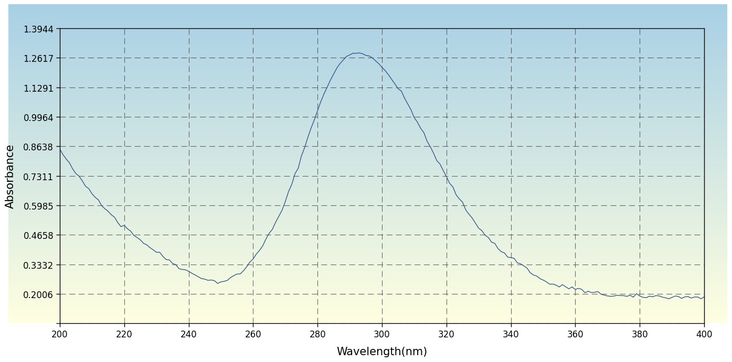
Figure S1: Scanning Absorbance Maxima of Ampelopsin A in Methanol (291 nm)
Table S1: Cumulative Percentage Ex Vivo Permeation of Ampelopsin A from Thermosensitive In-situ Nasal Gel Formulations (DF1–DF9) Across Sheep Nasal Mucosa
Time (hr) | DF1 | DF2 | DF3 | DF4 | DF5 | DF6 | DF7 | DF8 | DF9
0 | 0.00 ± 0.00 | 0.00 ± 0.00 | 0.00 ± 0.00 | 0.00 ± 0.00 | 0.00 ± 0.00 | 0.00 ± 0.00 | 0.00 ± 0.00 | 0.00 ± 0.00 | 0.00 ± 0.00
1 | 12.42 ± 0.48 | 11.84 ± 0.52 | 10.96 ± 0.44 | 14.18 ± 0.56 | 13.62 ± 0.48 | 12.74 ± 0.51 | 16.84 ± 0.62 | 15.92 ± 0.58 | 14.86 ± 0.54
2 | 22.16 ± 0.62 | 21.08 ± 0.68 | 19.84 ± 0.58 | 25.42 ± 0.72 | 24.18 ± 0.64 | 22.86 ± 0.66 | 29.64 ± 0.82 | 28.12 ± 0.76 | 26.48 ± 0.71
4 | 38.84 ± 0.84 | 36.92 ± 0.91 | 34.48 ± 0.78 | 44.26 ± 0.96 | 42.14 ± 0.88 | 39.68 ± 0.84 | 51.42 ± 1.12 | 48.86 ± 1.04 | 46.12 ± 0.98
6 | 52.64 ± 1.02 | 50.18 ± 1.08 | 47.24 ± 0.94 | 59.82 ± 1.14 | 57.46 ± 1.06 | 54.12 ± 1.02 | 68.24 ± 1.28 | 65.42 ± 1.18 | 61.86 ± 1.12
8 | 63.42 ± 1.18 | 60.84 ± 1.24 | 57.62 ± 1.08 | 71.84 ± 1.32 | 69.12 ± 1.22 | 65.48 ± 1.16 | 80.62 ± 1.44 | 77.84 ± 1.36 | 73.92 ± 1.28
10 | 72.18 ± 1.28 | 69.42 ± 1.34 | 65.84 ± 1.18 | 81.46 ± 1.44 | 78.62 ± 1.36 | 74.18 ± 1.28 | 89.24 ± 1.56 | 86.42 ± 1.48 | 82.14 ± 1.38
12 | 79.84 ± 1.38 | 76.42 ± 1.44 | 72.16 ± 1.28 | 88.62 ± 1.52 | 85.48 ± 1.44 | 80.84 ± 1.38 | 95.42 ± 1.64 | 92.18 ± 1.56 | 87.62 ± 1.48

