Dietary phytoestrogen ameliorates ovarian toxicant–induced neurotoxicity: Mechanistic and metabolic insights
Ambika Shandilyaª, Suhas Hajareª, Dube Aakash Arwindª, Chander Kant Giriª, Rahul Gajbhiye^{b}, V.Ravichandiran^{c}, Vipan Kumar Parihar^{a,d}

ªDepartment of Pharmacology and Toxicology, National Institute of Pharmaceutical Education and Research, Hajipur - 844102, Bihar, India
^{b}Department of Pharmaceutical Analysis, National Institute of Pharmaceutical Education and Research, Hajipur - 844102, Bihar, India
^{c}Delhi Pharmaceutical Sciences and Research University (DPSRU), New Delhi, India
^{d}Department of Pharmaceutical Sciences, Central University of Haryana, Mahendargarh, Haryana, India

 Corresponding Author
Dr. Vipan Kumar Parihar
Department of Pharmacology and Toxicology
National Institute of Pharmaceutical Education and Research
Hajipur-844102, Bihar, India
Email: vipanparihar@gmail.com

SUPPLEMENTARY FILE 1
Method of AOF Induction: Sexually mature, gonadally intact C57BL/6 mice in the VCD groups received intraperitoneal injections of 160 mg/kg body mass of VCD (diluted with corn oil to a 0.0587:1 ratio) daily for 15 days consecutively (sample size: 8-10 mice per group). This injection protocol leads to sustained primary ovarian follicular failure, prolonged and irregular oestrus cycles, elevated plasma FSH levels, and irregular hormone fluctuations which mimic natural human menopause. Control groups were injected with vehicle (corn oil) according to the same schedule to simulate the stress of the injection procedure. The VCD model of AOF has a well-characterised hormone profile that closely mimics human menopause, and plasma estradiol levels were very low in VCD-treated mice.
Vaginal smear examination: The examination of vaginal smears was performed 7 days after VCD administration. Vaginal secretions were collected using a pipette after introducing a small drop of PBS into the vagina; these secretions were then examined under a brightfield microscope for cytological analysis. The smears on the glass slides were classified based on morphological characteristics and changes in cell shape, allowing investigators to better understand the stages of the oestrus cycle. If leukocytes were the most prevalent cell type in the field for at least four days in a row, it indicated that the mice's estrus phase had concluded. This demonstrated that VCD-induced ovarian insufficiency was effective. At euthanasia, vaginal smears were collected to determine the terminal oestrous cycle stage via cell-specific examination. Oestrous cycle phases were classified as proestrus (high estrogen), oestrus (declining estrogen), metestrus, or diestrus (significantly low estrogen). Most VCD-challenged mice were in the metaestrus or diestrus stage at euthanasia. A detailed cytological examination is depicted herein.
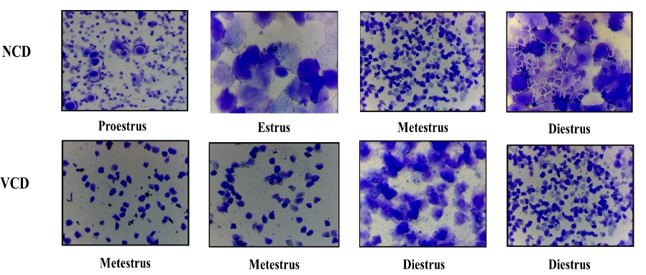
The examination of vaginal smears reveals endocrine system abnormalities. While vaginal cytology reveals oestrous cyclicity in control mice, prolonged diestrus is caused by VCD-induced AOF. Typical cellular patterns seen in vaginal smears of normal control (NCD) mice during the oestrous cycle include: proestrus, estrus, metestrus, and diestrus. Proestrus smears primarily contain nucleated epithelial cells, while estrus smears contain cornified anucleated squamous cells. Metestrus smears contain mixed epithelial cells with leukocyte infiltration, and diestrus smears are dominated by leukocytes. All things considered, these findings are in line with the cytological criteria previously defined for staging the mouse reproductive cycle (Byers et al., 2014; Caligioni, 2009). More leukocytes and fewer cornified epithelial cells demonstrated that mice challenged with ovatoxin VCD had extended metestrus/diestrus-like cytology and no cyclicity. According to research on VCD intoxication-induced AOF, this indicates that ovarian failure was expedited by follicular depletion and hypoestrogenicity (Hoyer & Devine, Toxicological Sciences, 2004; Mayer et al., Biology of Reproduction, 2002). Despite normal ovarian cyclicity in the controls, VCD intoxication induced oestrous arrest in mice with ovarian insufficiency, as indicated by our cytological results.

Phytoestrogen Diet (PED) Composition:
S.No. | Dietary Components | Diet Composition  (For 1000 grams)
1. | Glycine max (GM) | 250
2. | Vigna radiata: (VR) | 250
3. | Cicer arietinum: (CA) | 150
4. | Linum usitatissimum: (LU) | 100
5. | Sesamum indicum (SI) | 100
6. | Trifolium pratense (TP) | 40
7. | Withania somnifera (WS) | 30
8. | Punica granatum (PG) | 20
9. | Saccharum officinarum (SO) | 20
10. | Cinnamomum zeylanicum (CZ) | 10
11. | Trachyspermum ammi (TA) | 10
12 | Glycyrrhiza glabra (GG) | 20

Behavioural Assessment:
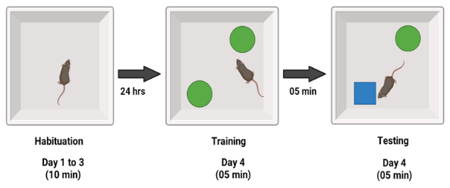
NORT: The NORT test was used to measure medial PFC-dependent object recognition memory. All of the mice in the study were tested using NORT. The innate predisposition of rodents to explore unfamiliar/novel objects rather than familiar ones provides the basis for memory analysis using NORT. The preference to investigate the novel object demonstrates the use of learning and recognition/preference memory processes. The discrimination ratio was computed as the difference in time spent by each animal examining the new vs the familiar item, divided by the total time spent exploring both objects.
Fig.1: Graphical representation of the NORT protocol
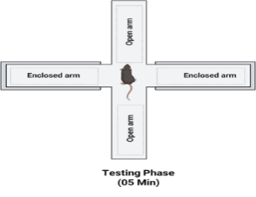
EPM: The EPM test was established using the approach outlined by Parihar et al; 2021. The maze has two open arms and two enclosed arms, arranged in a plus shape. Every five minutes, the mice were placed at the maze's crossroads, facing one of the enclosed arms, and their exploratory behaviour was observed. A record was kept of how long the animals spent in each arm (open or enclosed) and how many times they entered each arm. A statistical analysis was performed to compare the responses of the PED-treated, VCD-challenged, and control groups.
Fig.2: Schematic representation of the EPMT protocol

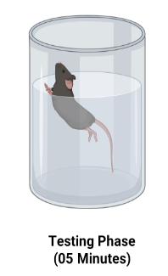
FST: The FST is a behavioural despair test that assesses signs of depression in animals. It assesses an animal's vulnerability to acute stress from water by evaluating its reaction to the potential risk of drowning. Each mouse underwent forced swimming testing by being placed individually in a transparent, cylindrical plastic tank filled with lukewarm tap water (23-25°C). In each trial, the immobility time and swimming time (typically measured as horizontal movement across the swim chamber) were manually recorded during a five-minute period. The mice's immobility time was measured from the point at which they stopped struggling and remained immobile in an upright posture, making only slight movements to keep their heads above water. Following the test, the mice were wrapped in a dry towel and placed under a heating lamp to dry.
Fig.3: Schematic representation of the FST protocol
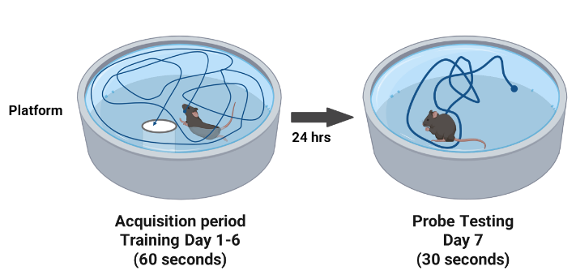
WMT: Mice's cognitive function was assessed using the water maze (WM) test, as previously reported by Parihar et al., 2011. To summarise, mice were introduced into the water pool by steadily immersing them in water at a place equidistant from the submerged target platform in each quadrant for 5 days. The test was conducted in a circular tank (100 cm in diameter, 40 cm in height) filled with water (22-23℃) that was rendered opaque by adding calcium carbonate. The mouse was randomly slung into the water from three separate sites (Q1, Q2, Q3) and tested three times each day. During each attempt, the mouse was given 90 seconds to locate the target platform in Q4/PQ independently using the environmental spatial cues. If it failed to locate the platform after 90 seconds, the investigator then prodded the mouse onto the platform and allowed it to remain there for 15 seconds. Both the time taken to reach the platform (escape latency) and the time spent on the platform were documented as 60 seconds (cut-off time).
Fig.4: Schematic representation of the WMT protocol
On day 6th, the target platform was removed, and the mouse's time spent in the target quadrant (TSTQ) where the platform had previously been located, as well as the number of times the mice crossed into the target quadrant (platform area crossings), were recorded for 60 seconds. The tracking information was monitored by an overhead video camera and processed by the Any Maze Software. Statistical analysis was performed to compare the control, VCD-induced and PED treatment groups, enabling evaluation of the experimental effects.

Tissue Processing for Biological Analysis:
ELISA Assays: Total protein concentration was determined from approximately 100-200 milligrams of NS perfused brain tissue using cold RIPA (radioimmunoprecipitation assay) lysis buffer and 100x protease inhibitor, with a hand homogeniser. Tissue homogenates have been centrifuged at 12000 rpm for 15 minutes at 4°C. The resulting supernatant was collected and transferred to a fresh tube. The samples were then aliquoted, protein concentrations were determined, and the samples were stored at -80°C for future immunoassays, immunoblotting and metabolomics analysis.
Venous blood samples were collected from all animals via the ocular route and maintained on ice until centrifugation. The blood was centrifuged at 15,000 rpm for 15 minutes to get the serum. After separation from peripheral blood, protein concentrations were determined in all serum samples using the BCA assay kit (Catalog #712853, Merck), and the serum samples were immediately moved to -80°C until used for future immunoassay analysis.
17β-estradiol and aromatase (CYP19A1/estrogen synthase) levels were measured in hippocampal tissue homogenate using a commercial mouse-specific Uniovrsal E2 ELISA kit (Catalog #ITLK01208, ImmunoTag, G-Bioscience) and a mouse aromatase quantitative, sandwich ELISA kit (Catalog #MBS456973, MyBioSource) specific for serum, plasma and tissue homogenates. The sample absorbance was measured using a multifunctional microplate reader (Multimode Reader) at 450nm. The data are presented as pg/ml, and each sample was tested in triplicate (Shandilya et al., 2022).
Immunoblotting: Hippocampal tissue specimens were lysed on ice using RIPA lysis buffer and 1% protease inhibitor (Catalog #2208569A, Takara). Homogenates were spun up at 12,000g for 10 minutes at 4°C. Then, the supernatant was obtained. Cell lysate protein concentrations were measured through a BCA assay kit (Catalog #712853, Merck). Protein lysates (30-50μg) were separated using 8-12% Tris-glycine SDS-PAGE and transferred to PVDF membranes (0.20 μm pore size, Bio-Rad Catalog #1620177). The molecular weights of the proteins were determined using a pre-stained protein ladder (Nippon Biosciences). The membranes were blocked in 5% BSA (Sigma) for 2 hours at 37°C, then incubated with primary antibodies NDUFB8 (Catalog #ITT09666), MTCO1 (Catalog #ITT08920), ATP5A1 (Catalog #ITT03806), β-amyloid (Catalog #BS-0107R), ER-β (Catalog #ITT06469), and BDNF (Catalog #PA5-95183) at 4°C overnight on an orbital shaker. The membranes were washed three times with TBST the following day, then treated with secondary antibodies from the same species at 37°C for 1 hour. After three additional TBST washes, the immunoreactive bands were visualised using enhanced chemiluminescence (ECL Substrate Reagent, Thermo) and captured with the Molecular Imager ChemiDoc XRS System. Beta-actin (1:5000, Catalog #ITM3028) was used as a loading control for normalisation. To assess protein expression levels, densitometric analysis was performed using ImageJ (Fiji) software. Statistical analysis was performed using GraphPad Prism to compare protein expression between the control and treatment groups, facilitating the evaluation of potential differences.
Immunofluorescence Analysis: Three mice per group underwent intracardiac perfusion, beginning with a 0.9% normal saline flush, followed by 4% paraformaldehyde (PFA) in 0.1M PBS (pH 7.4). The brains were meticulously dissected and postfixed in freshly made 4% PFA at 4°C overnight, then dehydrated in a sucrose gradient of 10%, 20%, and 30% (w/v) until they sank, and finally embedded in tissue-embedding medium. Coronal slices (30μm thick) of the prefrontal cortex and hippocampus portions were cut using a freezing Cryostat (Leica) and collected consecutively in 24-well plates filled with 0.01 M PBS (containing sodium azide). The frozen brain tissue slices of the collected mice were washed three times with PBS (1X, pH=7.4) for 5 minutes each before being blocked with a blocking solution at room temperature for thirty minutes. The blocked sections were incubated with mouse monoclonal primary antibodies to evaluate the expression of markers such as AIF1/Iba1 (1:1000, Catalog #ITT06442), HMGB1 (1:1000, Catalog #PA5-27378), TLR-4 (1:1000, Catalog #PA5-27378), NF-ϏB (1:1000, Catalog # ), CD68 (1:1000, Catalog #ab2a3654), and TREM2 (1:1000, Catalog #bs-2723R) at 4°C overnight. The following day, the immunotagged sections were rinsed three times with 0.01 M PBS for five minutes each. These were subsequently incubated with a secondary antibody (from the same species) for 30 minutes to an hour at 37°C in a dark room, before being rewashed and stained with the nuclear stain DAPI. After three additional PBS washes, the immunolabelled slices were coated with the appropriate anti-fade mounting medium and mounted on microscopic glass slides for immunofluorescence analysis. The image acquisition was obtained in Z-stacks (1024x1024 pixels horizontal resolution, 60x magnification, at 1µm intervals throughout the cerebral tissue) using a Nikon Eclipse AX/AXR confocal digital microscope at NIPER, Hajipur central imaging facility. It is important to emphasise that all procedures described above should be carried out at low temperatures.
Metabolomics Study: A non-targeted, global LC-TQ-MS/MS-based mouse brain metabolome was screened for differentially regulated metabolites to map the brain’s chemical fingerprints, including which metabolic pathways are activated, stressed, or dysregulated. The metabolites were discovered and characterised using Thermo Fisher Scientific's Compound Discoverer™ 3.3 software. MetaboAnalyst 6.0 (https://www.metaboanalyst.ca/) software was then used to further analyse and stratify the raw data, excluding features with more than 50% missing values and imputing remaining gaps to minimise FDR. The data were normalised, log2-transformed, and scaled. The analyses included fold change, PCA, PLS-DA, and univariate statistics (p < 0.05). Differential metabolites were selected based on VIP score > 1 and log2FC > 1. Pathways with a pathway impact greater than 0.20 and a false discovery rate cut-off of 0.05 (p-values < 0.05) were considered statistically significant. The selection criteria for the DEMs were based on FCs >±1.0 and p values <0.05 relative to the normal control group. Variables with a VIP score typically greater than 1.0 are considered important or significant. The functional pathway analysis of DEMs was visualised using biological pathway topology and KEGG ortholog enrichment networks.
Statistical Analysis: The data were presented as the mean ± standard error of the mean (SEM). GraphPad Prism version 9 was used for statistical analysis and graph generation. We used n = 8 mice for behavioural testing and n = 3 for brain metabolomics, western blotting, and immunofluorescence tests. A PCA or PLS-DA plot was used to identify specific differences in metabolites between experimental groups. A high average variable importance (VIP) score showed which factors were responsible for separating the experimental groups. We examined these variables more closely using univariate analysis and generated expression heatmaps using Euclidean distance and Ward's clustering. One-way, two-way, and three-way analyses of variance (ANOVAs) were used to examine differences between groups in behavioural evaluations. Herein, VCD exposure and PED therapeutic intervention were treated as independent variables for statistical comparisons. For all analyses, a p-value < 0.05 and a 95% CI were deemed statistically significant.
Study Limitations and Future Directions: The present study indicates that PED is an effective therapeutic target for protecting the brain; however, future research should investigate how different dosages affect the brain and its long-term safety. Furthermore, unravelling transcriptomic and proteomic readouts will improve our mechanistic and translational understanding of how PED restores endocrine health and confers neuroimmune homeostasis.

