Graphical Abstract
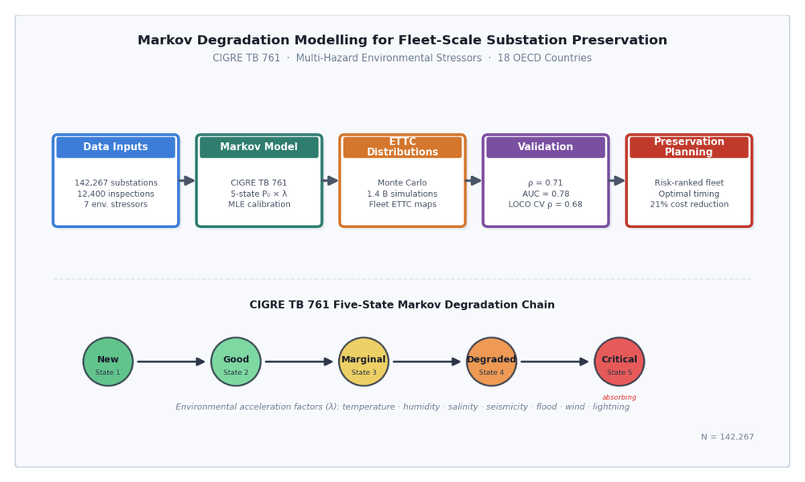
Figure GA. Workflow overview: fleet inspection data and environmental stressors feed a CIGRE TB 761 five-state Markov model calibrated via MLE; Monte Carlo simulation produces Expected Time to Critical (ETTC) distributions validated against observed failure rates (ρ = 0.71, AUC = 0.78); outputs inform risk-ranked preservation planning with an estimated 21% cost reduction.

