Supplementary Information

Supplementary Table1. Comparison of basic information between healthy controls and asthmatic patients
 | control(n=77) | asthma(n=199) | P
F/M | 26/51 | 44/155 | 0.06
Age | 62.18±10.79 | 62.82±12.55 | 0.31
BMI | 24.96±3.15 | 24.42±3.78 | 0.30
Peripheral Blood
Leukocyte count | 7.65±3.63 | 7.72±3.60 | 0.65
Neutrophil count | 5.51±3.67 | 6.04±7.91 | 0.85
Eosinophil count | 0.13±0.17 | 0.34±0.79 | <0.01
Definition of abbreviations: control=healthy control group; F/M=female/male; BMI = body mass index; Data are mean ± SD, chi-square test was used in gender, other data were analyzed by Mann-Whitney test or student’s test(t-test).

Supplementary Table 2. basic information of validation set
 | non-PAL asthma(n=39) | PAL asthma(n=51) | P
F/M | 21/18 | 29/22 | 0.78
Age | 52.18±15.72 | 61.53±9.664 | 0.02
BMI | 26.16±4.82 | 23.89±3.04 | 0.08
FEV1/FVC | 84.96±9.27 | 61.31±7.42 | <0.01
FEV1% pred | 91.89±16.58 | 64.00±17.87 | <0.01
Definition of abbreviations :PAL= asthma with persistent airflow limitation; non-PAL=asthma without persistent airflow limitation; F/M=female/male; BMI = body mass index; FEV1 =forced expiratory volume in one second; ; FVC=forced vital capacity; pred = percent of predicted; Data are mean ± SD，chi-square test was used in gender, other data were analyzed by Mann–Whitney test or student’s test(t-test).

Supplementary Table3. Comparison of CT parameters between healthy controls and asthmatic patients
 | control(n=77) | asthma(n=199) | P
LAA-950 | 56.94±82.15 | 297.28±471.46 | <0.01
LAA-950% | 1.35±1.93 | 5.19±7.72 | <0.01
Mean lung density | -812.13±42.50 | -819.96±50.58 | 0.08
Pi10 | 4.48±0.28 | 1.33±0.15 | <0.01
TAC | 441.57±158.90 | 344.93±149.52 | <0.01
5GB-TAC | 14.96±3.40 | 14.16±4.07 | 0.01
6GB-TAC | 31.32±5.90 | 28.49±7.83 | <0.01
7GB-TAC | 55.13±11.11 | 45.79±13.86 | <0.01
8GB-TAC | 74.42±19.73 | 56.43±22.29 | <0.01
5th generation bronchi
5GB-WA | 66.37±18.06 | 58.82±21.46 | 0.01
5GB-LA | 51.90±24.70 | 43.90±24.83 | 0.01
5GB-WA% | 61.10±5.57 | 62.01±5.47 | 0.98
6th generation bronchi
6GB-WA | 42.75±15.28 | 36.30±17.98 | <0.01
6GB-LA | 29.41±16.10 | 24.89±17.79 | <0.01
6GB-WA% | 65.06±4.77 | 65.26±5.18 | 0.40
7th generation bronchi
7GB-WA | 27.76±8.66 | 24.33±12.74 | <0.01
7GB-LA | 16.31±9.88 | 14.69±13.11 | <0.01
7GB-WA% | 69.81±4.51 | 69.64±5.06 | 0.36
8th generation bronchi
8GB-WA | 21.94±6.54 | 19.10±9.75 | <0.01
8GB-LA | 11.14±6.40 | 9.95±10.76 | <0.01
8GB-WA% | 72.85±4.24 | 72.87±4.98 | 0.45
Definition of abbreviations: control=healthy control group; PAL= asthma with persistent airflow limitation; non-PAL=asthma without persistent airflow limitation; LAA-950= low-attenuating area below -950 HU; LAA-950%= Percentage of low-attenuating area below -950 HU in whole lung; Pi10= estimated airway wall thickness for an idealised airway with internal perimeter of 10 mm; TAC=total airway count; WA%= Percentage of wall area in airway. xGB=different generations of bronchi; Data are mean ± SD，all data were analyzed by Mann–Whitney test or student’s test(t-test).

Supplementary table 4. Correlation between chest CT parameters and post-bronchodilator FEV1/FVC in asthmatic patients
 | correlation coefficient | P
LAA-950 | -0.548 | <0.001
LAA-950% | -0.574 | <0.001
Mean lung density | 0.585 | <0.001
TAC | 0.194 | 0.006
7GB-TAC | 0.219 | 0.002
8GB-TAC | 0.191 | 0.007
Definition of abbreviations: LAA-950= low attenuation area below -950 HU; LAA-950%= percentage of low attenuation area below -950 HU for whole lung; TAC= total airway count; x G B= bronchi of different grades; Pearson’s correlation analysis was used for LAA-950, mean lung density, LAA-950%, TAC, and 7GB-TAC, and spearman correlation analysis was used for 8GB-TAC.

Supplementary Table 5. Logistic regression models for PAL asthma
 | β | 95% CI | P
LAA-950% | 0.003 | 1.001-1.006 | 0.019
Mean lung density | -0.019 | 0.970-0.991 | <0.001
TAC | -0.004 | 0.993-0.999 | 0.003
Constant | -14.094 | - | <0.001
Definition of abbreviations: LAA-950%= percentage of low attenuation area below -950 HU for whole lung; TAC= total airway count; The β value represents the standardized coefficient.

Supplementary Table 6. Multiple linear regression models for post-bronchodilator FEV1/FVC
 | β | P
LAA-950% | -9.036e+00 | <0.001
Mean lung density | 1.664e-04 | <0.001
TAC | 9.833e-04 | <0.001
7GB-TAC | 4.944e-04 | 0.36
Definition of abbreviations: LAA-950%= percentage of low attenuation area below -950 HU for whole lung; TAC= total airway count; x G B= bronchi of different grades; The β value represents the standardized coefficient. The adjusted R² value of multiple linear regression model was 0.477, p<0.001.

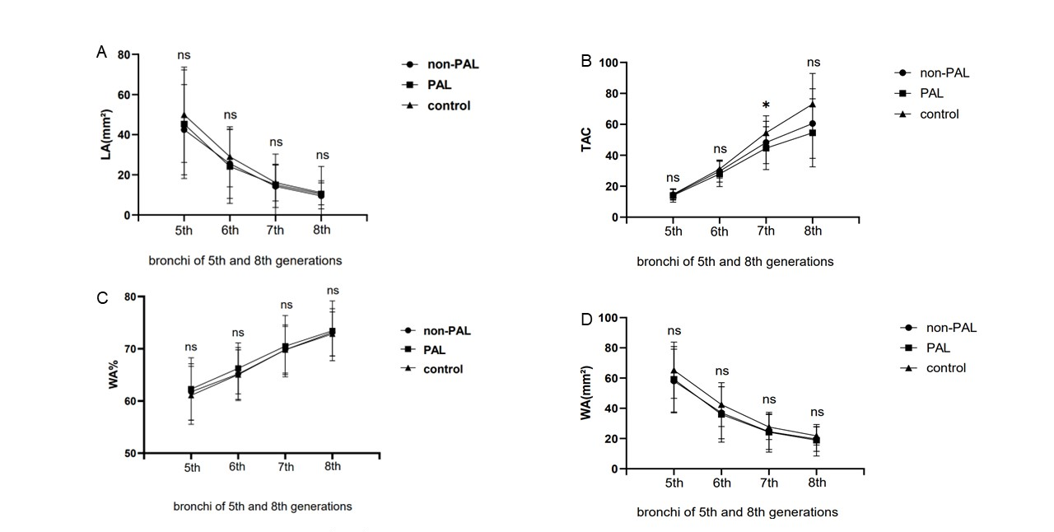
Supplementary Figure 1. LA, WA and WA% in bronchi of 5th to 8th generation from CT in control, PAL and non-PAL asthma group. LA and WA significantly decreased in asthma (A.D). TAC in bronchi of 7th generation was significantly decreased in PAL asthma. * : highest P value between each group in three groups < 0.05, ns: highest P value between each group in three groups ≥0.05.

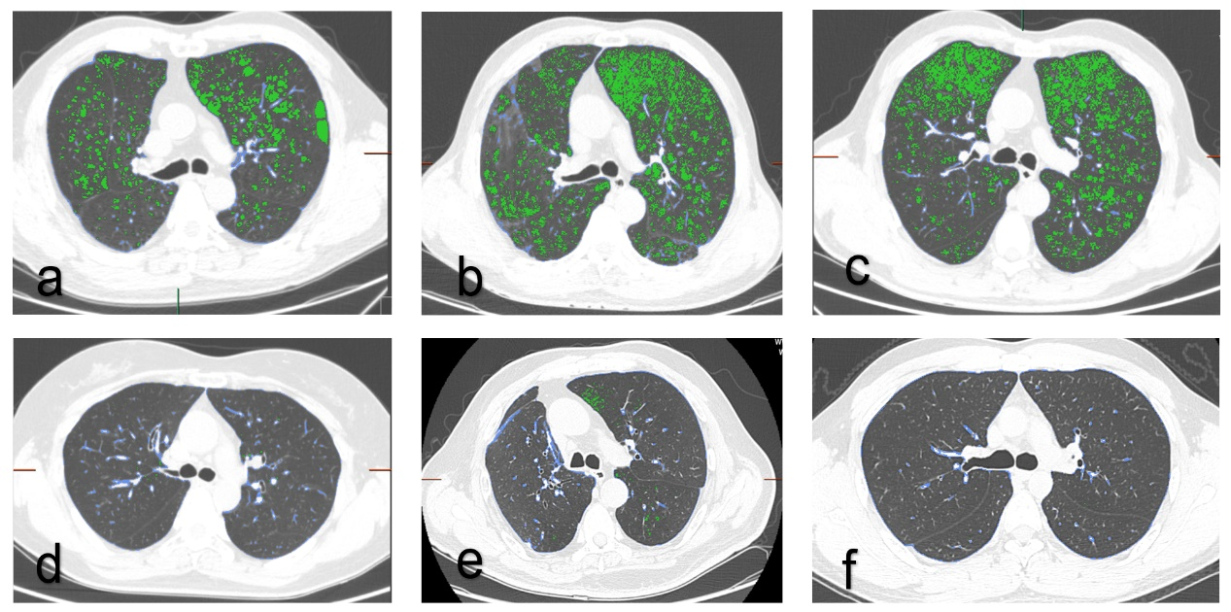
Supplementary Figure 2. vivid transversal chest CT image of LAA-950 in asthmatic patients; Panels a, b, and c showed LAA-950 of transversal chest CT image in patients with PAL asthma, and panels d, e, and f showed LAA-950 of transversal chest CT image in patients with non-PAL asthma. The green part is the region below -950HU.

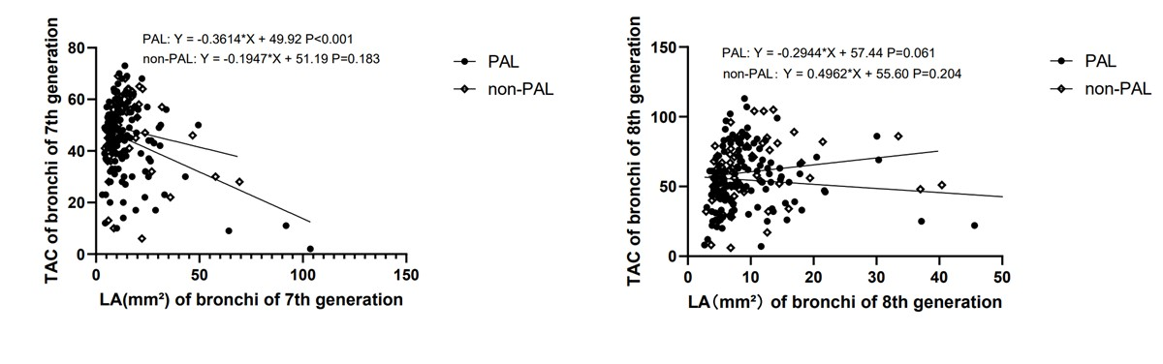
Supplementary Figure 3. The relationships between LA and TAC in bronchi of 7th and 8th generations. TAC in bronchi of 7th generation was significantly related LA in bronchi of 7th generation (P < 0.001) in PAL asthma. And LA in bronchi of 8th increased with TAC in bronchi of 8th in PAL asthma(p=0.061). LA: lumen area; TAC=total airway count.

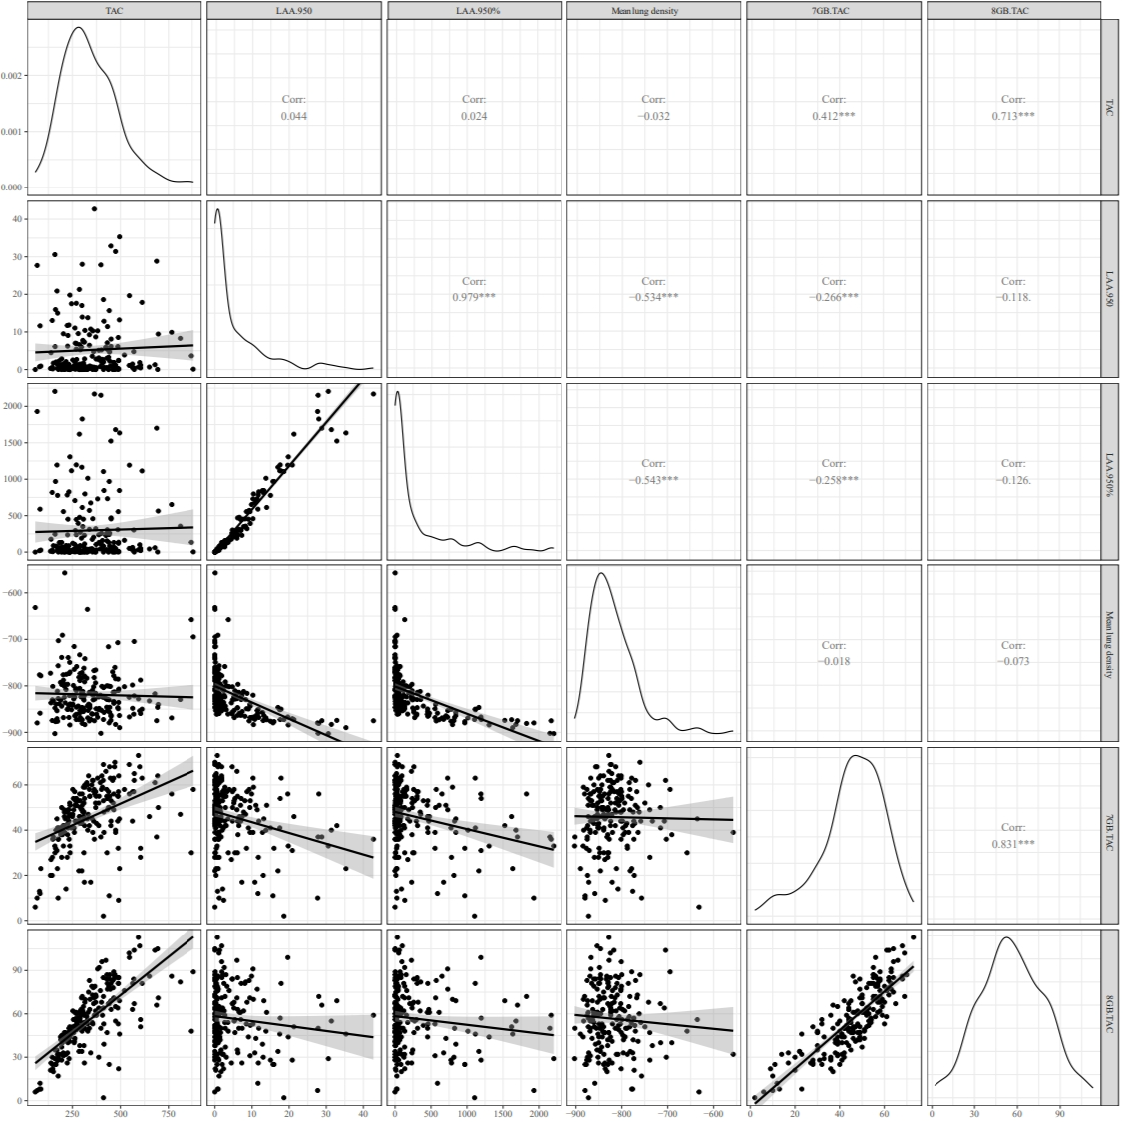
Supplementary Figure 4. Correlation analysis of chest CT parameters in asthma

