Supplementary Information
Electrolyte-enabled C–C cross-coupling for directed CO₂-to-ethylene conversion
Ke Yi^{a#}, Fei Zhao^{b#}, Tianwen Fangª, Yuzhu Dingª, Zhenyu Sun^{a, c}, Yanwen Zhang^{d}, Mei Zhangª, Bing Yangª, Xinghuan Liu^{a*}, Xin Jia^{a*}
ªSchool of Chemistry and Chemical Engineering, State Key Laboratory Incubation Base for Green Processing of Chemical Engineering, Shihezi University, Shihezi 832003, P. R. China.
^{b}College of Chemistry and Chemical Engineering, Taishan University, Taian, 271000, P. R. China
^{c}State Key Laboratory of Organic–Inorganic Composites, Beijing University of Chemical Technology, Beijing, 100029, China
^{d}College of Sciences/State Key Laboratory of Advanced Energy Storage Materials and Technology, Shihezi University, Shihezi, Xinjiang, 832003, China.
# These authors contributed equally to this work.
Corresponding author E-mail: liuxh@shzu.edu.cn (X.H. Liu); jiaxin@shzu.edu.cn (X. Jia)

This PDF file includes:
Supplementary Note 1: Synthesis of Dual-AFIL
Supplementary Note 2: Theoretical details
Supplementary Note 3: Molecular dynamics (MD) simulation
Supplementary Figs. 1–56
Supplementary Tables 1–2

Supplementary Note 1. Synthesis of dual-amino-functionalized ionic liquid (1,3-bis(2-aminoethyl)-2-methyl-1H-imidazol-3-ium bromide (Dual-AFIL))¹:
Synthesis of N-(Triphenylmethyl)-2-bromoethylamine (Compound 1): A reaction solution was prepared by dissolving 2-bromoethylamine hydrochloride (41.46 g, 0.20 mol) and triphenylmethyl chloride (58.79 g, 0.21 mol) in dichloromethane (300 mL). Triethylamine (30 mL) was diluted with dichloromethane (20 mL) and added dropwise to the reaction solution while keeping the temperature below 50 °C. After stirring at room temperature for 24 hours, deionized water (300 mL) was added. Then, the organic layer was separated and successively washed with water (300 mL), 10% phosphoric acid solution (300 mL), water (300 mL), and saturated sodium chloride solution (300 mL). The organic layer was dried over anhydrous MgSO₄, filtered, and concentrated under reduced pressure. The residue was triturated with methanol (200 mL) and dried under vacuum to obtain compound 1 as a white solid (58.02 g, 0.16 mol; yield 80%). The product structure was confirmed by NMR (Supplementary Fig. S1).
Synthesis of 1,3-Bis[2'-(triphenylmethylamino)ethyl]-2-methylimidazolium bromide (Compound 2): 2-Methylimidazole (2.46 g, 0.030 mol) was dissolved in anhydrous DMF (150 mL). To this solution, NaOH (1.47 g, 0.037 mol) was added slowly with stirring. The mixture was heated at 60 °C in an oil bath for 30 min, then cooled to room temperature and stirred for an additional 30 min. Subsequently, Compound 1 (26.37 g, 0.07 mol) was introduced, and the reaction mixture was refluxed for 8 hours. Upon completion, excess base was quenched by the slow addition of methanol (5 mL). The solvent was then removed under reduced pressure, and the resulting residue was partitioned between acetonitrile (150 mL) and brine (150 mL). The organic phase was separated, concentrated under vacuum, and the crude product was triturated with ethyl acetate (150 mL). Drying in vacuo afforded Compound 2 as a light yellow solid (18.43 g, 0.025 mol; yield 71%). The product structure was confirmed by NMR (Supplementary Fig. S2).
Synthesis of 1,3-Bis(2-aminoethyl)-2-methyl-1H-imidazol-3-ium bromide dihydrochloride (Compound 3): To a solution of Compound 2 (40.38 g, 0.055 mol) in anhydrous methanol (100 mL), cooled to 0 °C in an ice bath, was added an aqueous HCl solution (120 mL) dropwise under stirring. After the addition was complete, the ice bath was removed, and the mixture was stirred at ambient temperature for 24 hours. The volatile components were then evaporated under reduced pressure. The resulting residue was taken up in deionized water (100 mL), and the aqueous solution was washed with diethyl ether (100 mL) to remove organic impurities. The aqueous layer was isolated and concentrated under vacuum at 65 °C to give Compound 3 as a light yellow solid (17.26 g, 0.053 mol; yield 96%). The product structure was confirmed by NMR (Supplementary Fig. S3).
Synthesis of 1,3-Bis(2'-aminoethyl)-2-methylimidazolium bromide (Dual-AFIL): To a solution of Compound 3 (7.15 g, 0.023 mol) in deionized water (25 mL) under magnetic stirring was added NaOH (1.84 g, 0.046 mol). The reaction mixture was stirred for 3 hours at ambient temperature. The water was then removed under reduced pressure, and the resulting solid residue was stirred with ethanol (25 mL) to induce salt precipitation. The inorganic salt byproduct was removed by filtration, and the ethanol filtrate was concentrated under vacuum to afford a crude yellow oil. Final drying in vacuo over phosphorus pentoxide (P₂O₅) at 60 °C for 48 hours afforded the pure product, 1,3-bis(2'-aminoethyl)-2-methylimidazolium bromide (Dual-AFIL) (Supplementary Fig. S4), as a hygroscopic yellow oil (7.01 g, 0.028 mol; yield 98%).
Supplementary Note 2. Theoretical details
The spin-polarized density functional theory (DFT) calculations were carried out using the projected augmented wave (PAW) pseudo potentials in the Vienna Ab initio Simulation Package (VASP)^{2,3}. The generalized gradient approximation (GGA) was adopted to describe the exchange correlation functional in the form of Perdew-Burke-Ernzerhof (PBE)⁴. The Van der Waals (vdW) correction proposed by Grimme et al. (DFT-D3) was employed due to its good description of long-range vdW interactions⁵. A 2 × 2 × 1 Monkhorst-pack grid was used to sample the Brillouin zone and the plane-wave cutoff energy is set to 500 eV. All kinds of structures were optimized until the energy and force reaching the convergence criteria of 10^{–6} eV and 0.02 eV Å^{–1}, respectively. To avoid the interaction between periodic images, a vacuum layer of at least 20 Å was set in the z-direction.
To model Ni–N₄ carbon catalysts, a 6 × 6 × 1 graphene supercell (a = b = 17.11 Å) with periodic boundary conditions was constructed. Twelve carbon atoms were removed to create two adjacent Ni–N₄ sites. Dual-AFIL, Mono-AFIL and CIL molecules were placed in proximity to the Ni atom of one of the Ni–N₄ sites.
The Gibbs free energies (ΔG) for elementary steps were calculated as ΔG = ΔE+ΔZPE-TΔS, where ΔE is the reaction energy obtained from DFT calculations. ΔZPE and ΔS are the difference in the zero-point energy and the change in entropy, respectively, which are calculated from the vibration energy of the intermediates and the gas phase molecules using VASPKIT⁶. The entropy for gas-phase molecules was obtained from NIST-JANAF thermochemical tables⁷. The overpotential (η) is calculated from the change in the free energy in the elementary reactions and calculated limiting potential (U_{L}) at equilibrium state⁸.
𝑈_{L} = m𝑖𝑛[−Δ𝐺_{𝑒𝑙𝑒𝑚}]
η = 𝑈_{𝑒𝑞𝑢}/𝑛−𝑈_{𝐿}
where the Δ𝐺_{𝑒𝑙𝑒𝑚} is the free energy of each elementary reaction of the CO₂ reduction.
Supplementary Note 3. Molecular dynamics (MD) simulation
Classical molecular dynamics (MD) simulations were performed to probe the atomic-scale microstructure. Two systems were constructed: System 1, comprising 100 CO molecules and a modified substrate (no Dual-AFIL); and System 2, comprising 100 CO molecules and a second modified substrate (Dual-AFIL). Initial configurations were generated using PACKMOL⁹.
The CVFF force field¹⁰ was used to describe molecular interactions, which include both nonbonded and bonded contributions. Nonbonded interactions consist of van der Waals (vdW) and electrostatic terms, described by Equations 1 and 2, respectively.
$E_{LJ}\left(r_{ij}\right)=4ε_{ij}\left({\left(\frac{{\text{σ}}_{ij}}{r_{ij}}\right)}^{12}-{\left(\frac{{\text{σ}}_{ij}}{r_{ij}}\right)}^{6}\right)$ (1)
(2)
In the equation, $q_{i}$、$q_{j}$ are atomic charge, $r_{ij}$is the distance between atoms, $\text{σ}$ is the atomic diameter, $ε$ is the atomic energy parameter.
For vdW interactions between different atom types, geometric mixing rules were applied (Equation 3). A cutoff distance of 1.2 nm was used for both vdW and electrostatic interactions, and long-range electrostatic interactions were treated with the particle mesh Ewald (PME) method.
$σ_{ij}={\left(σ_{ii}*σ_{jj}\right)}^{\frac{1}{2}};ε_{ij}={\left(ε_{ii}*ε_{jj}\right)}^{\frac{1}{2}}$ (3)
All simulations were performed in the canonical (NVT) ensemble. Each simulation began with an energy minimization to relax the simulation box, followed by a 50.0 ps equilibration run with a time step of 1.0 fs.
Atomic motions were described by classical Newtonian equations of motion, integrated using the velocity-Verlet algorithm. All MD simulations were carried out with the LAMMPS package (version 29 September 2021), and results were visualized with OVITO¹¹.

Supplementary Figures and Tables
Supplementary Fig. 1 ¹H NMR result of compound 1.
Supplementary Fig. 2 ¹H NMR result of compound 2.
Supplementary Fig. 3 ¹H NMR result of compound 3.
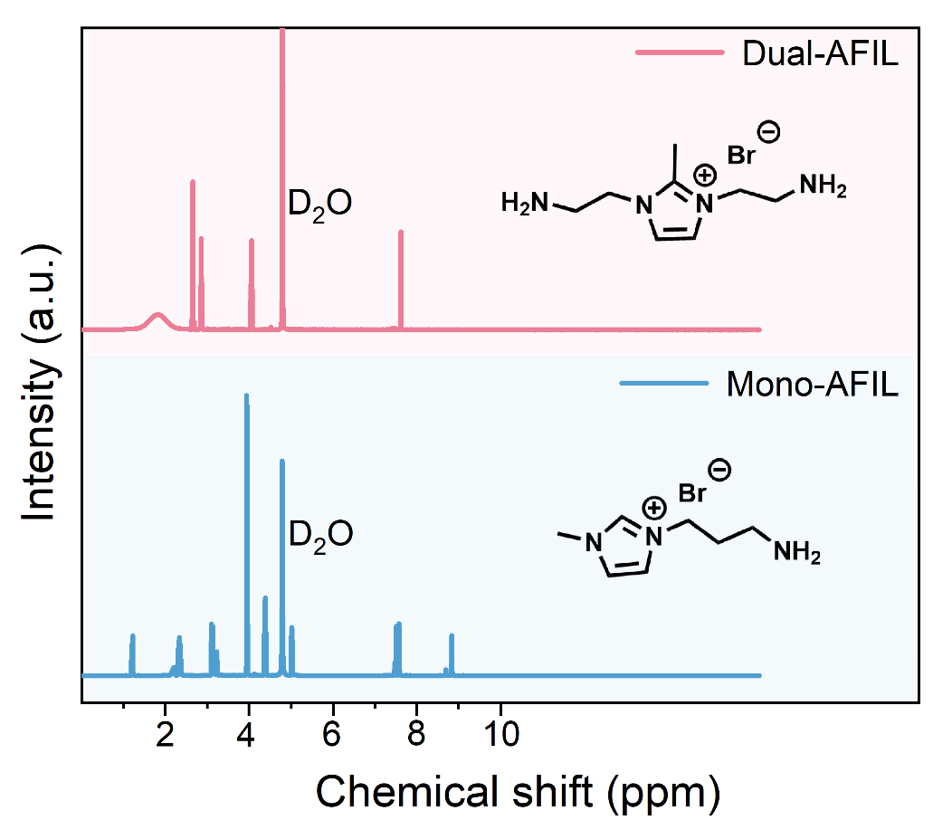
Supplementary Fig. 4 ¹H NMR results comparison of Dual-AFIL and Mono-AFIL.

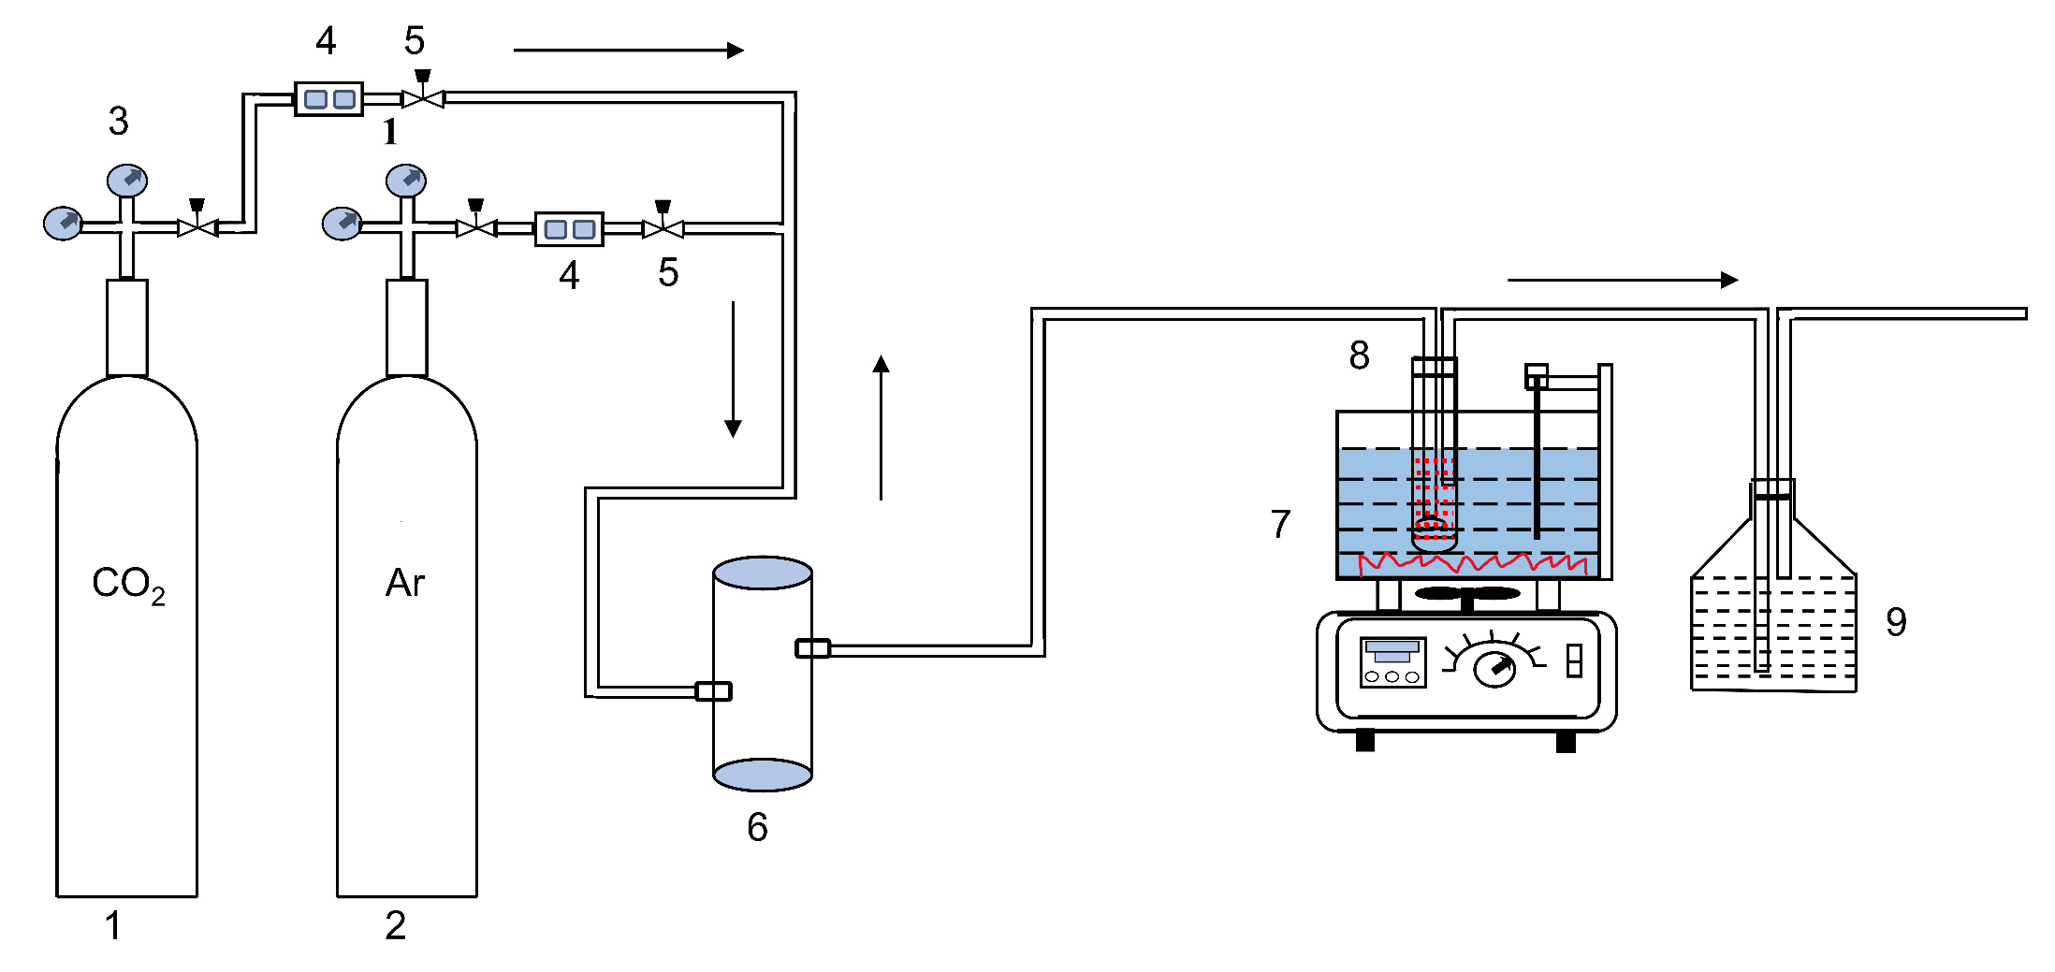
Supplementary Fig. 5 Schematic diagram of CO₂ capture experimental device. 1. CO₂, 2. Ar, 3. pressure reducing valve, 4. gas flow meter, 5. valve, 6. gas buffer chamber, 7. constant temperature water bath, 8. absorption tube, 9. tail gas treatment.
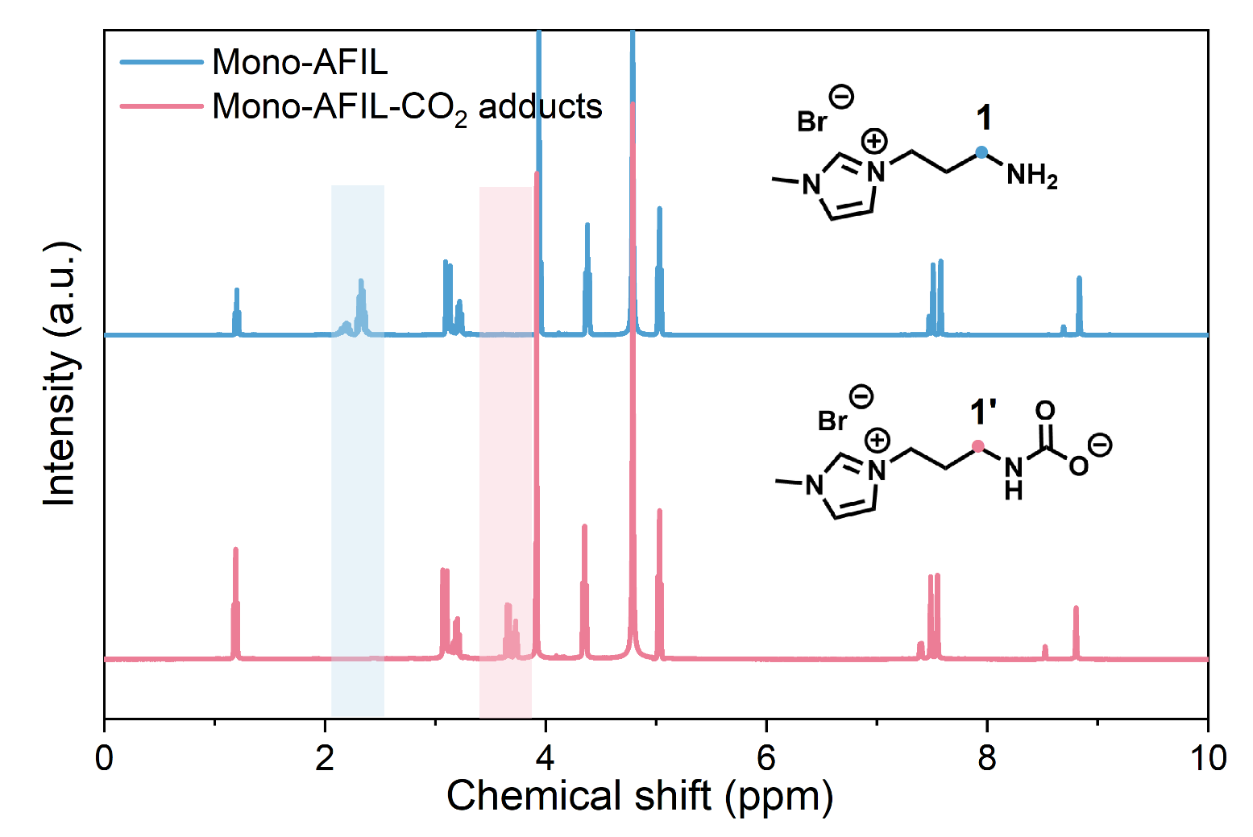
Supplementary Fig. 6 ¹H NMR results comparison of Mono-AFIL before and after CO₂ capture.

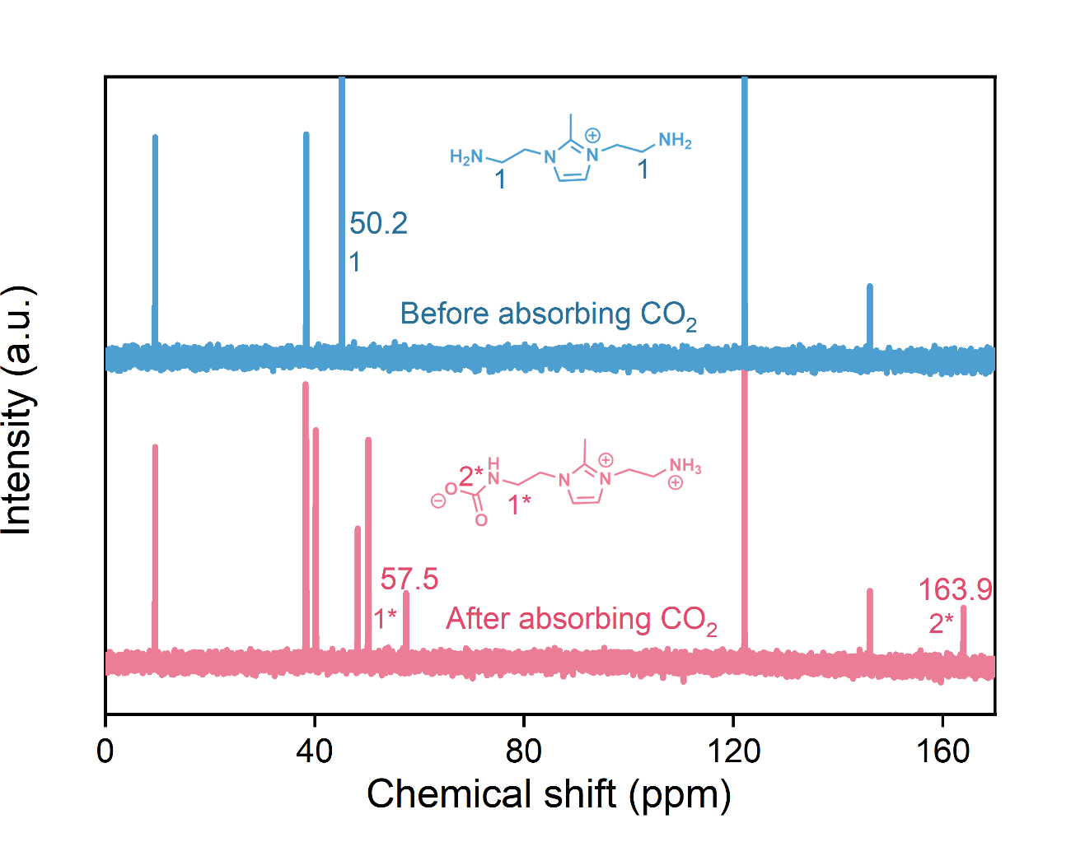
Supplementary Fig. 7 ¹³C NMR results comparison of Dual-AFIL before and after CO₂ capture.
Supplementary Fig. 8 Fourier transform infrared (FT-IR) spectroscopy comparison chart of Dual-AFIL and Mono-AFIL after capturing CO₂ to generate carbamate.

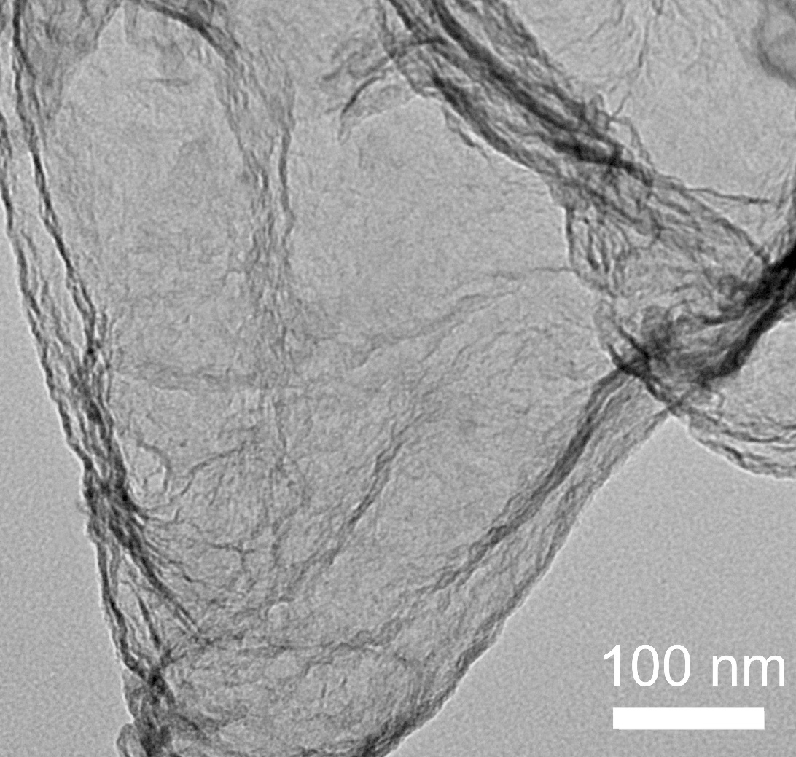
Supplementary Fig. 9 TEM images of Ni-SAC.
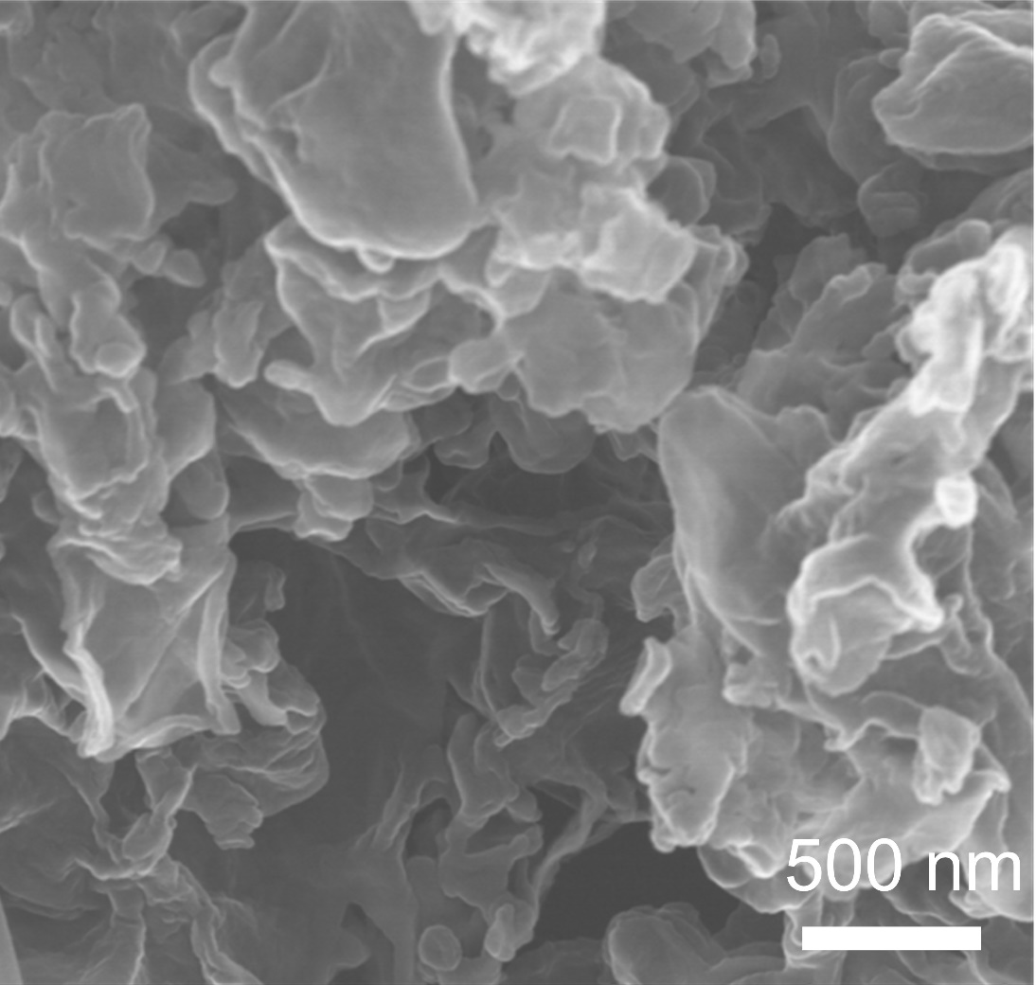
Supplementary Fig. 10 SEM images of Ni-SAC.
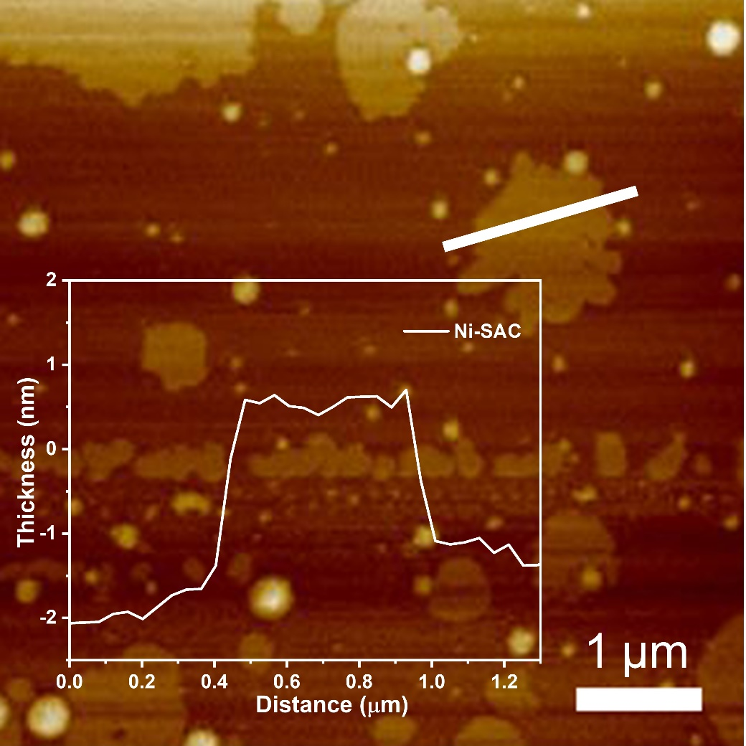
Supplementary Fig. 11 AFM image and the corresponding thickness of Ni-SAC.
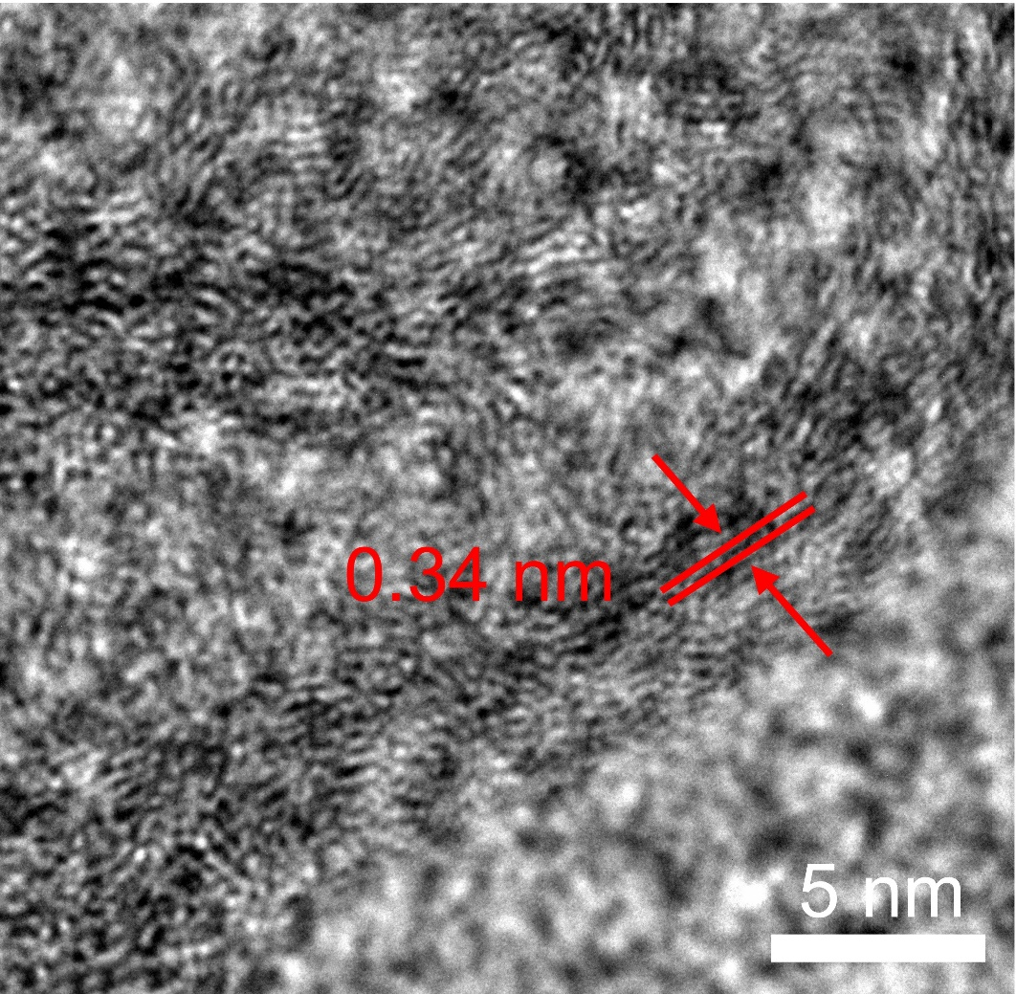
Supplementary Fig. 12 High-resolution TEM (HRTEM) image of Ni-SAC.
HRTEM image shows a disordered graphene lattice with an interlayer spacing of approximately 0.34 nm, which is further corroborated by Raman spectroscopy.

Supplementary Fig. 13 Raman spectra of Ni-SAC.
In the Raman spectra (Figure S13), Ni-SAC exhibit peaks at around 1359 and 1576 cm⁻¹, which are assigned to disordered sp³ carbon (D band) and graphitic sp² carbon (G band), respectively, demonstrating the formation of graphene. In particular, Ni-SAC shows intensity ratios of D-band/G-band (I_{D}/I_{G}) at about 1.24, showing a higher disordering degree of carbon supports¹²。

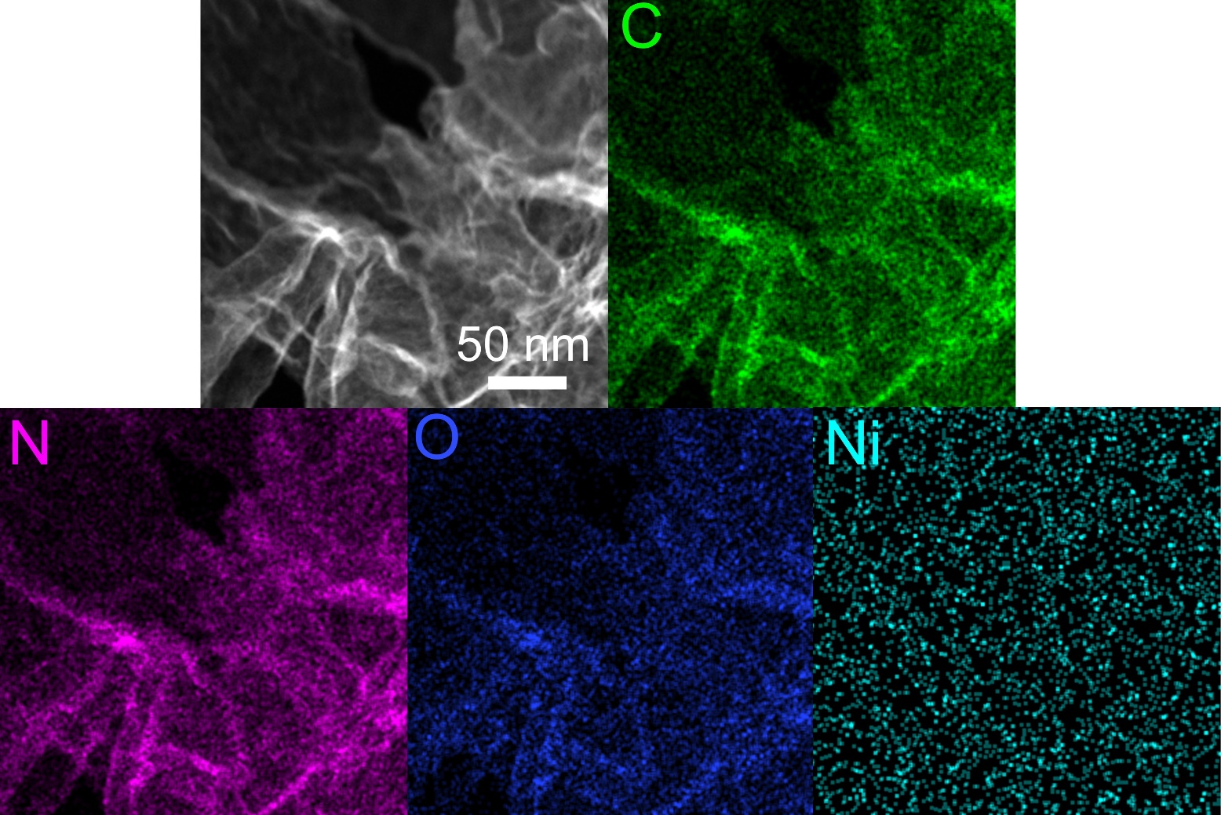
Supplementary Fig. 14 Energy dispersive X-ray spectroscopy (EDS) mapping images and corresponding elemental maps showing the element distribution of C (green), N (purple), O (blue) and Ni (Fluorescent green).
EDS mapping images show that C, N, O and Ni are evenly distributed throughout the carbon nanosheet framework.
Supplementary Fig. 15 XRD pattern of Ni-SAC.
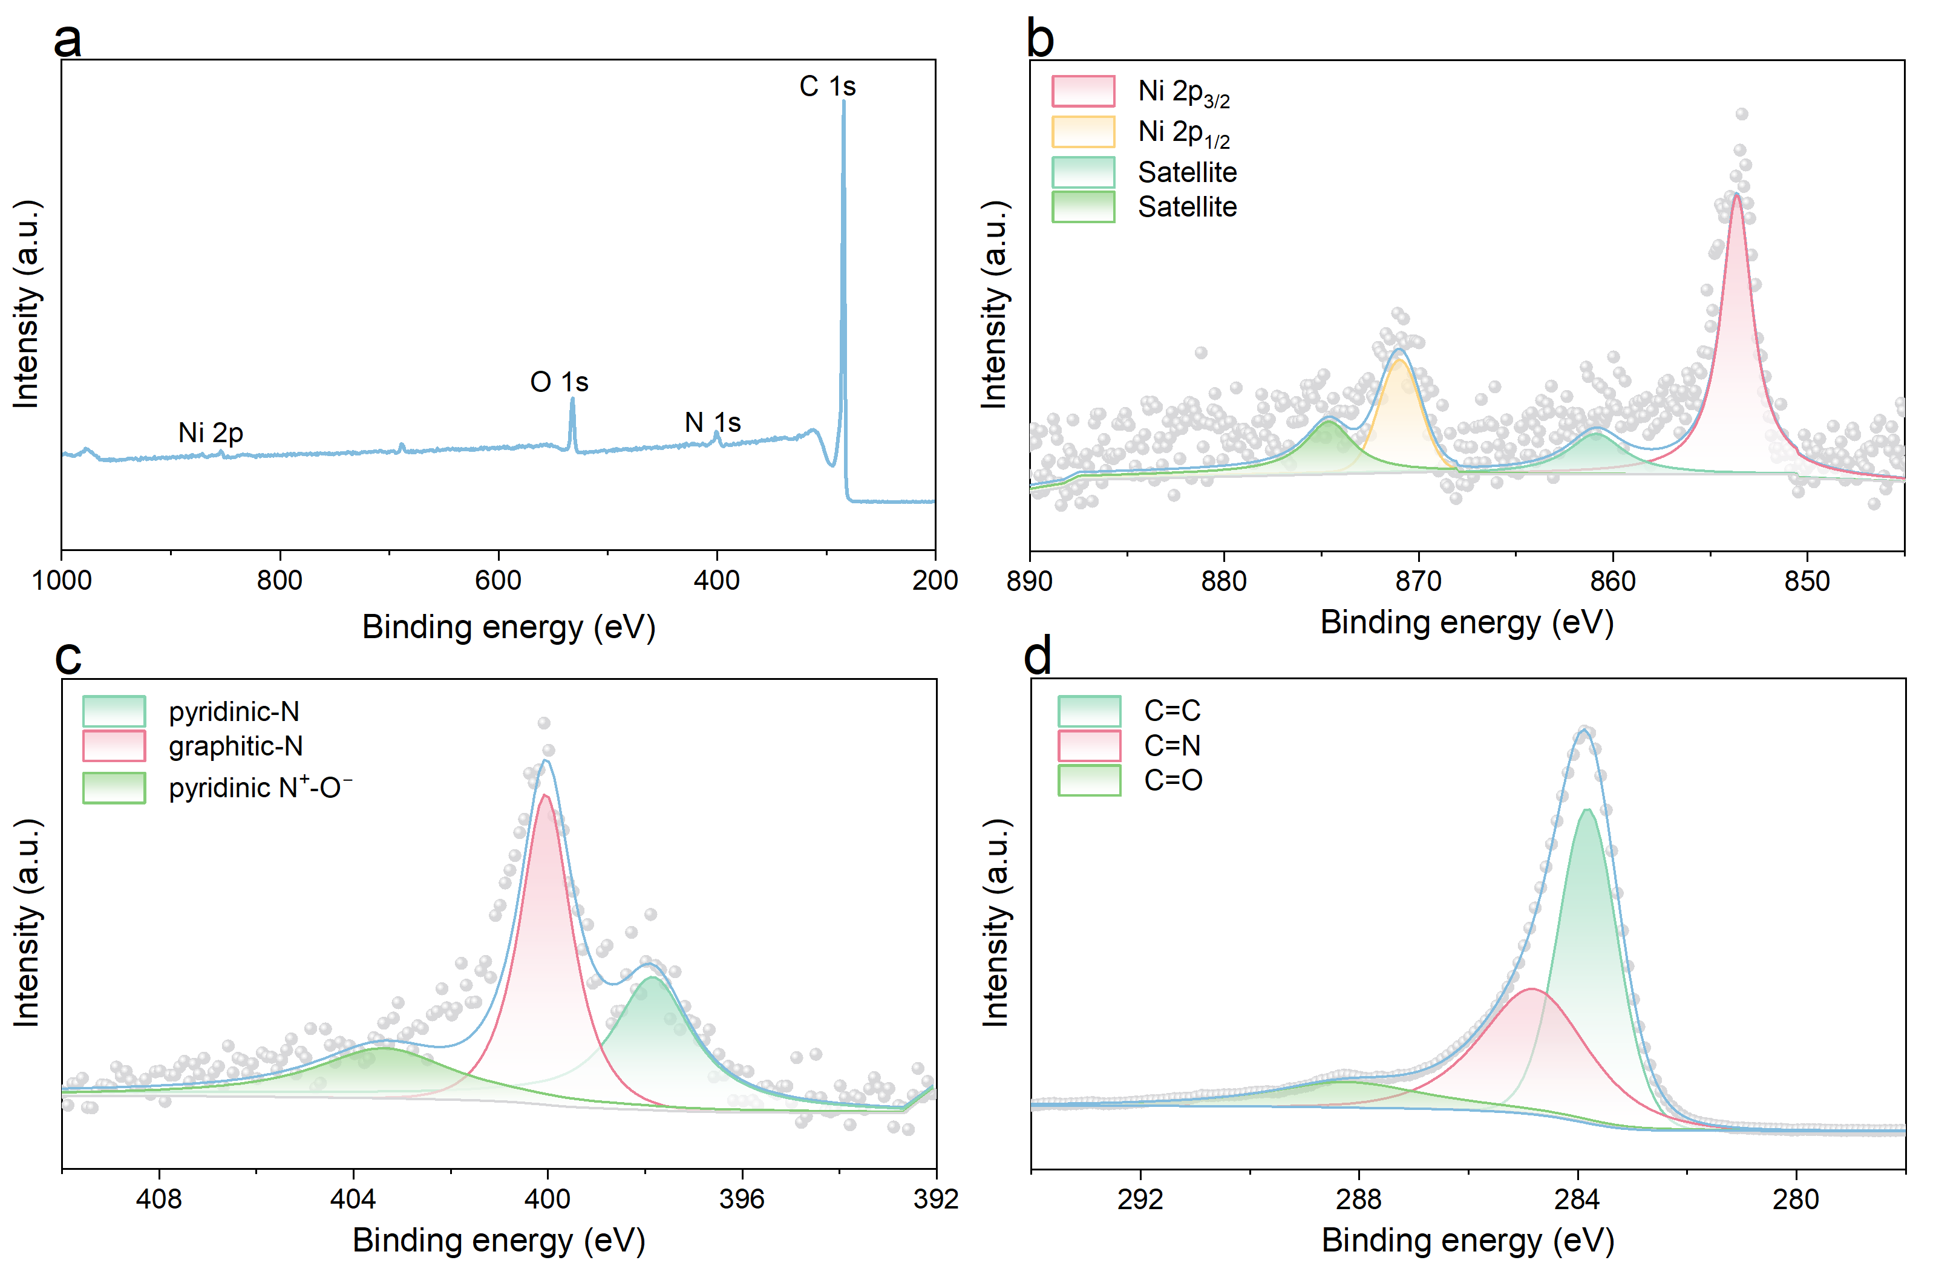
Supplementary Fig. 16 High-resolution of (a) the main spectral line of XPS, (b) Ni2p XPS, (c) N1s XPS and (d) C1s XPS spectra of the Ni-SAC.
.
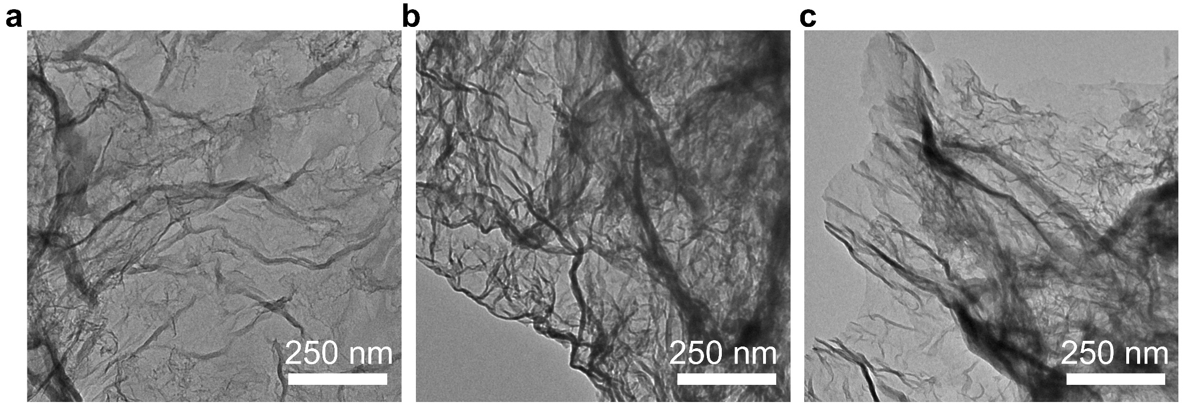
Supplementary Fig. 17 TEM images of (a)Fe-SAC, (b)Co-SAC, (c)Cu-SAC.
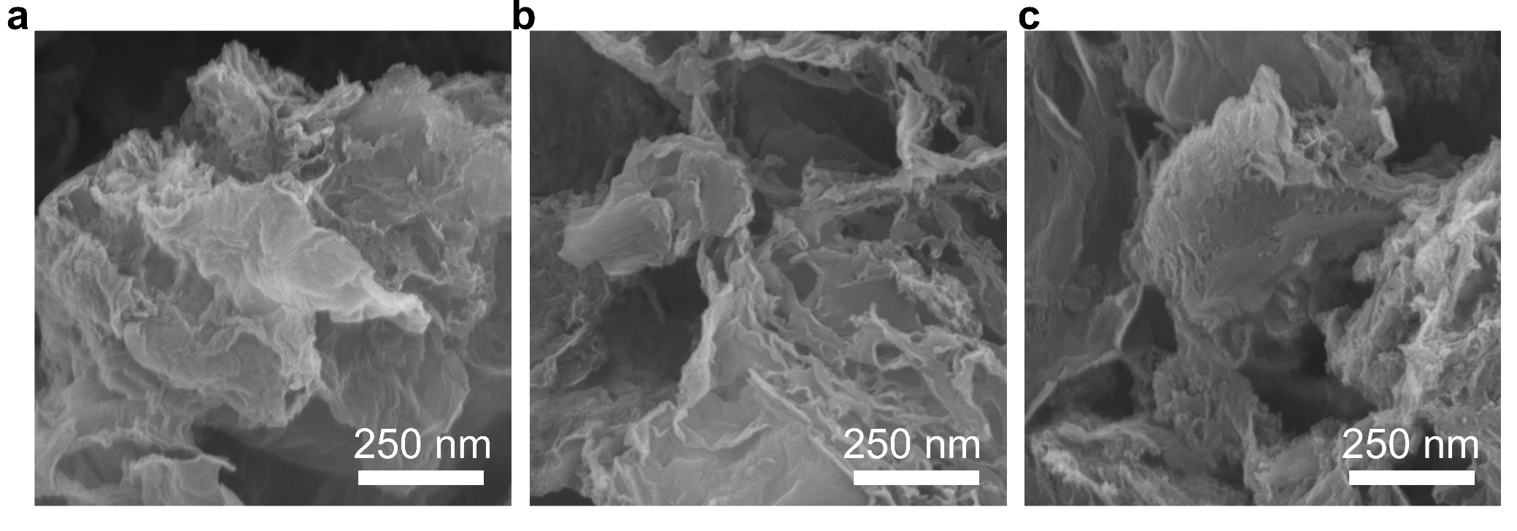
Supplementary Fig. 18 SEM images of (a)Fe-SAC, (b)Co-SAC, (c)Cu-SAC.
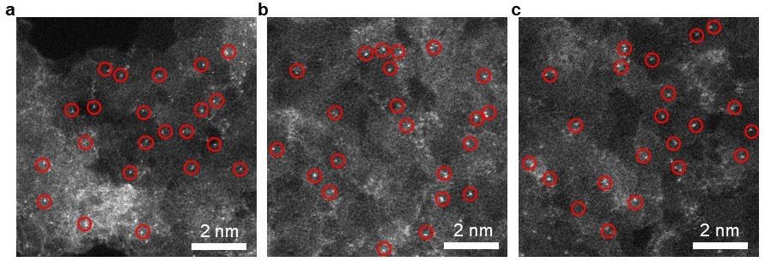
Supplementary Fig. 19 Enlarged HAADF images of (a)Fe-SAC, (b)Co-SAC, (c)Cu-SAC.

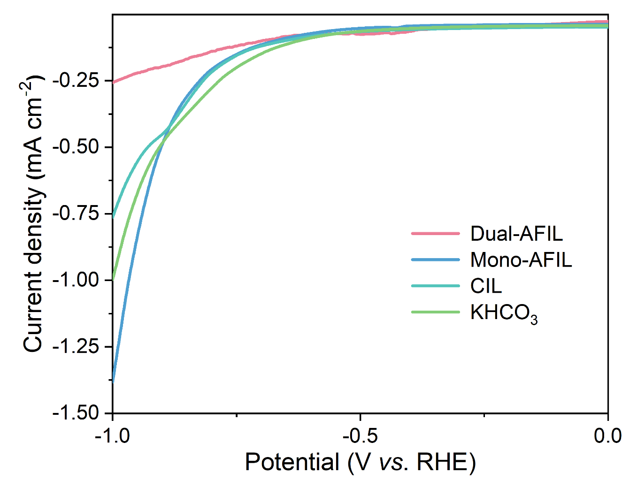
Supplementary Fig. 20 LSV curves of Ni-SAC in Ar-saturated 0.5 M Dual-AFIL, Mono-AFIL, CIL, and KHCO₃.
Supplementary Fig. 21 Long-term stability of Mono-AFIL at −0.7 V (vs. RHE) in H type cell.
Supplementary Fig. 22 ¹H NMR results comparison of Dual-AFIL and Mono-AFIL before and after reaction.
Supplementary Fig. 23 Plot of FE of various products vs. potential over Ni-SAC in Dual-AFIL in H-cell.
Supplementary Fig. 24 ¹H NMR results comparison of CIL and KHCO₃ before and after reaction.
Supplementary Fig. 25 Tafel plots of Ni-SAC for CO₂RR in different electrolyte.
Supplementary Fig. 26 TOFs of Ni-SAC for CO after 1 h electrolysis in CO₂-saturated 0.5 M Mono-AFIL, CIL, and KHCO₃.
Supplementary Fig. 27 CO partial current densities of Ni-SAC in 0.5 M Mono-AFIL, CIL, and KHCO₃ saturated with CO₂.
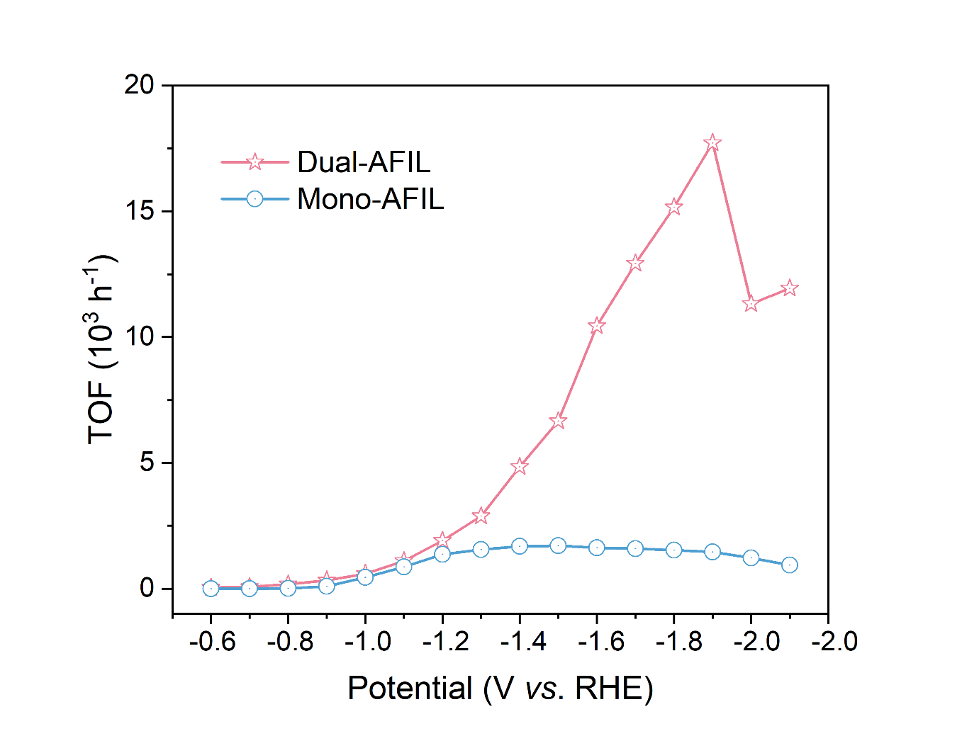
Supplementary Fig. 28 TOFs of Ni-SAC for C₂H₄ after 1 h electrolysis in CO₂-saturated 1 M Dual-AFIL and Mono-AFIL.
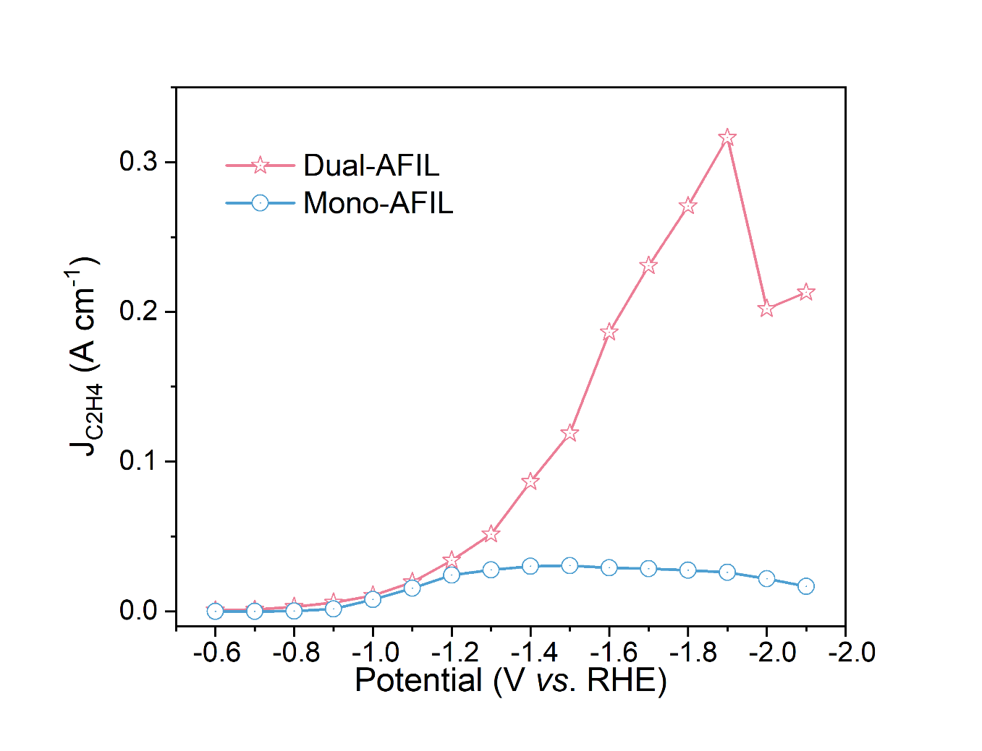
Supplementary Fig. 29 C₂H₄ partial current densities of Ni-SAC in 1 M Dual-AFIL and Mono-AFIL saturated with CO₂.
Supplementary Fig. 30 Plot of FE of various products vs. potential over Ni‑SAC with a catholyte of 1 M KHCO₃.
Supplementary Fig. 31 Plot of FE_{C2H4} vs. number of amino.

Supplementary Fig. 32 Plot of FE_{C2}/FE_{C1} ratio vs. current density.
Supplementary Fig. 33 Mass spectra of standard gas of C₂H₄.
Supplementary Fig. 34 Mass spectra of ethylene under ¹²CO₂ feeding condition in Dual-AFIL.
Supplementary Fig. 35 Mass spectra of ethylene under ¹³CO₂ feeding condition in Dual-AFIL.
Supplementary Fig. 36 In situ ATR-FTIR spectra recorded at various potentials (vs. RHE) during the CO₂RR for Ni-SAC with the 1 M KHCO₃ electrolyte.
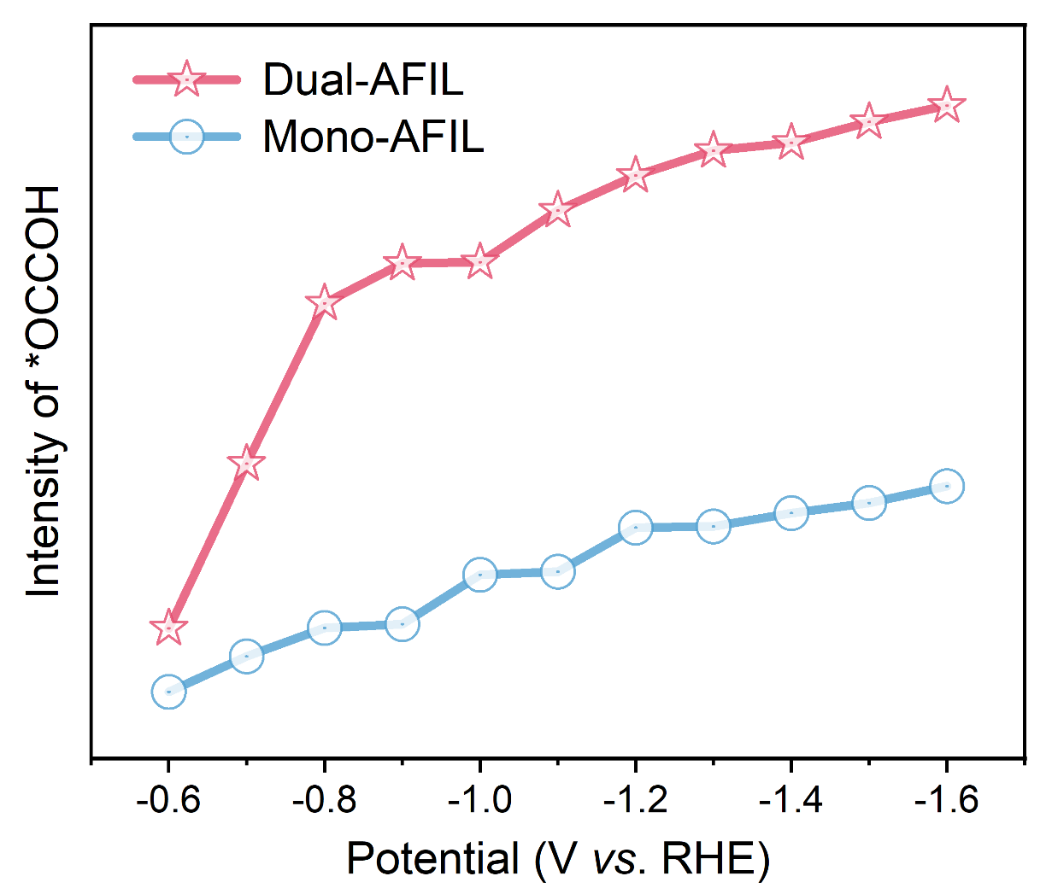
Supplementary Fig. 37 *OCCOH peak intensity plotted against potential in Dual-AFIL and Mono-AFIL.
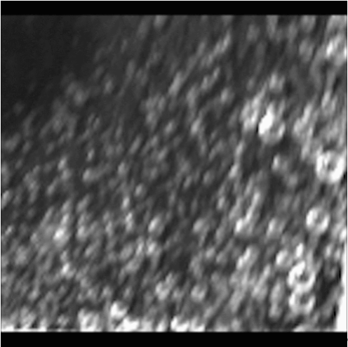
Supplementary Fig. 38 Gas reduction product formation and rate at −0.7 V (vs. RHE) potential in 0.5 M Dual-AFIL under high speed camera.

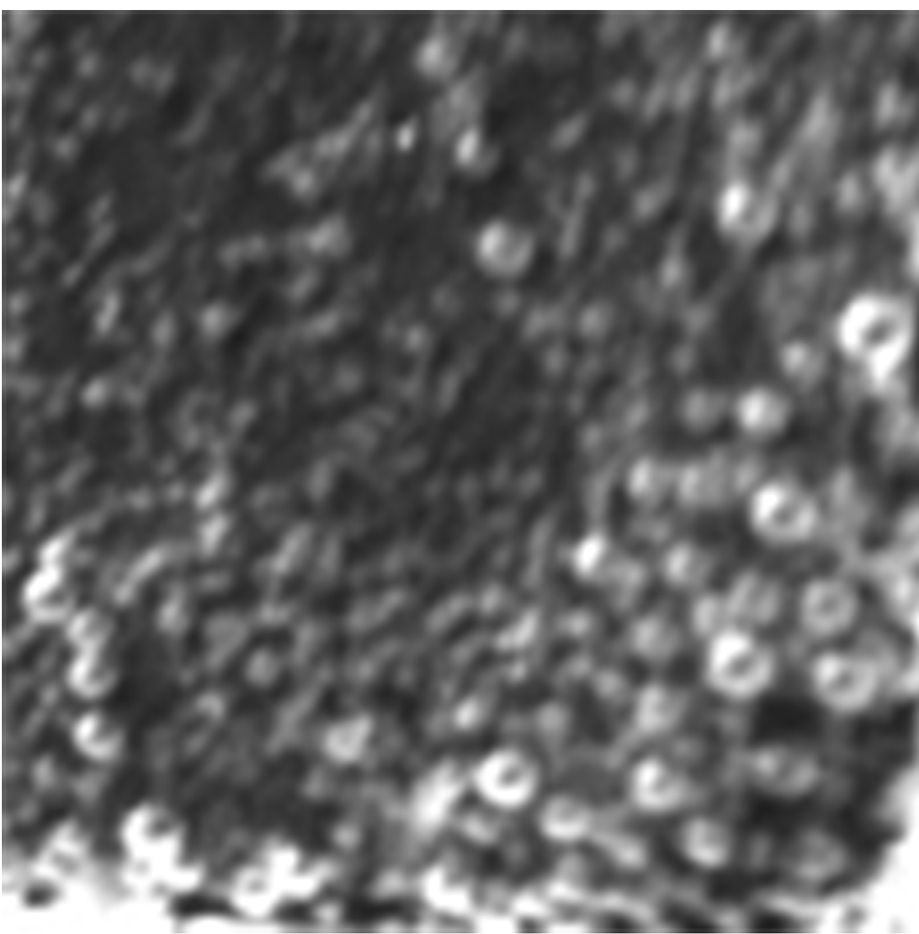
Supplementary Fig. 39 Gas reduction product formation and rate at −0.7 V (vs. RHE) potential in 0.5 M Mono-AFIL under high speed camera.

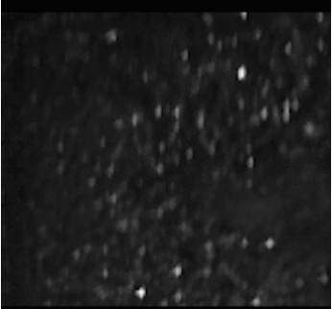
Supplementary Fig. 40 Gas reduction product formation and rate at −0.7 V (vs. RHE) potential in 0.5 M CIL under high speed camera.

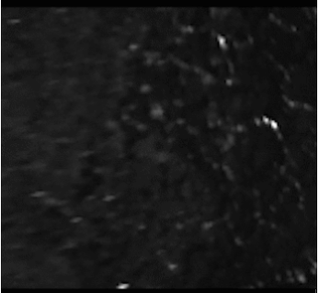2
Supplementary Fig. 41 Gas reduction product formation and rate at −0.7 V (vs. RHE) potential in 0.5 M KHCO₃ under high speed camera.

Supplementary Fig. 42 CV curves at different scan rates over Ni-SAC in (a) 0.5 M Dual-AFIL, (b) 0.5 M Mono-AFIL, (c) 0.5 M CIL, (d) 0.5 M KHCO₃.
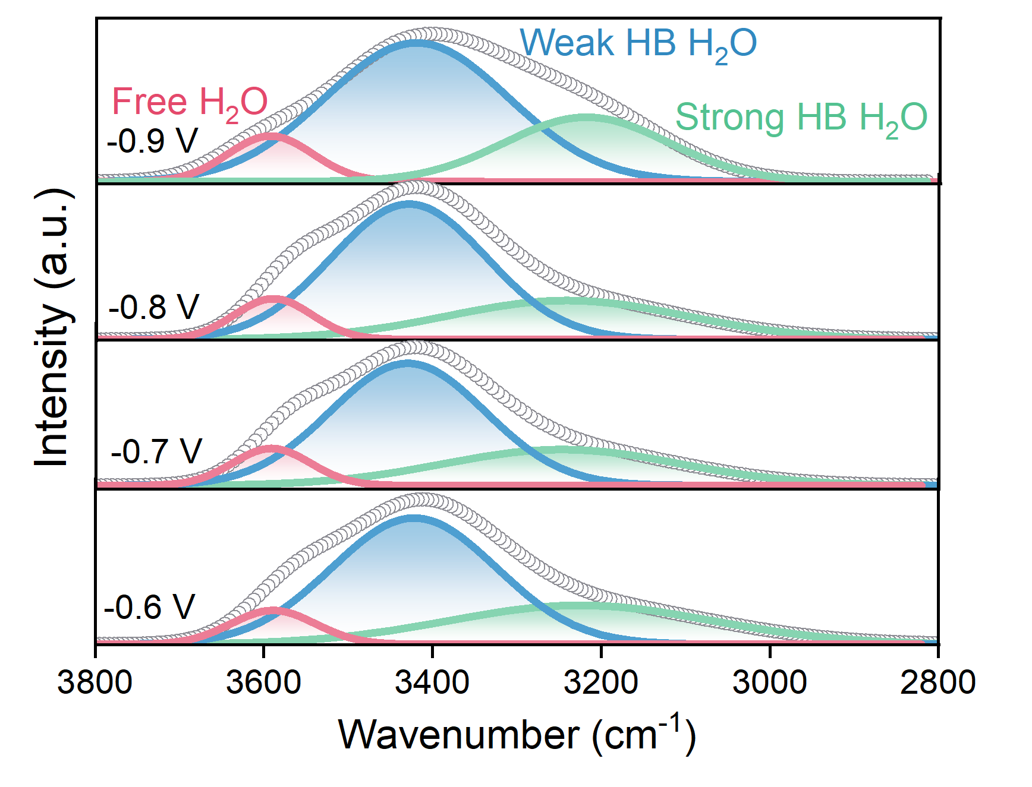
Supplementary Fig. 43 Gaussian fit deconvolution from ν(O−H) signal at −0.6 ~ 0.9 V (vs. RHE) for Dual-AFIL with free H₂O, weak HB H₂O, and strong HB H₂O.
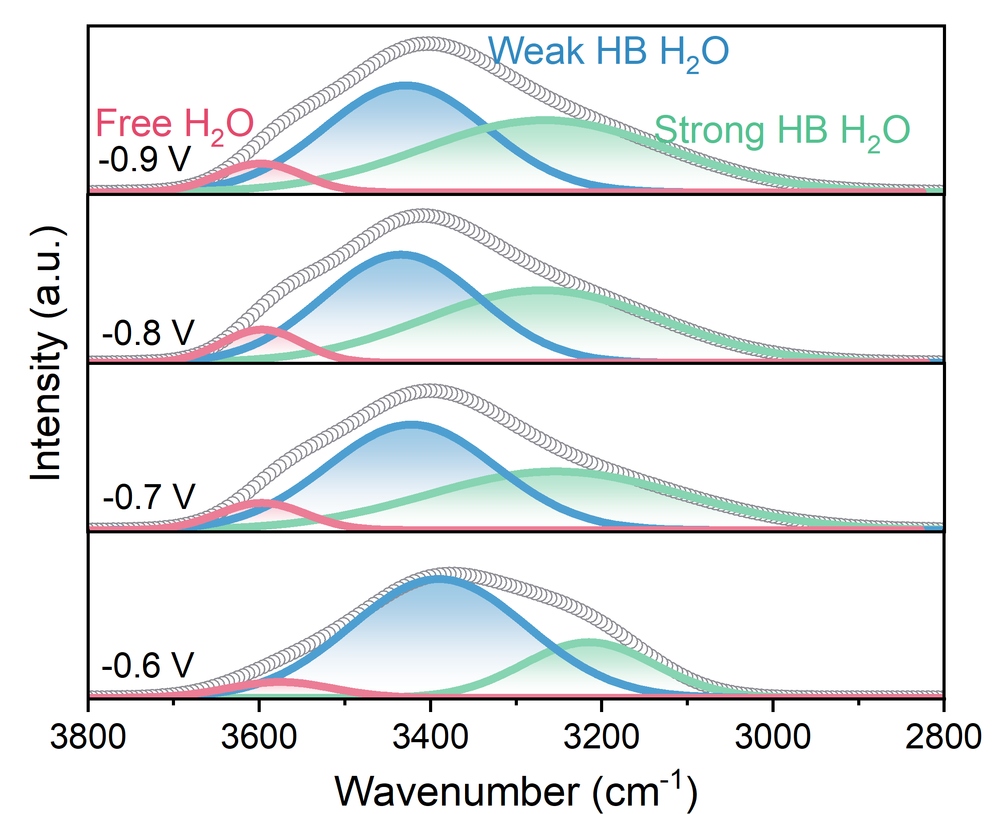
Supplementary Fig. 44 Gaussian fit deconvolution from ν(O−H) signal at −0.6 ~ 0.9 V (vs. RHE) for Mono-AFIL with free H₂O, weak HB H₂O, and strong HB H₂O.
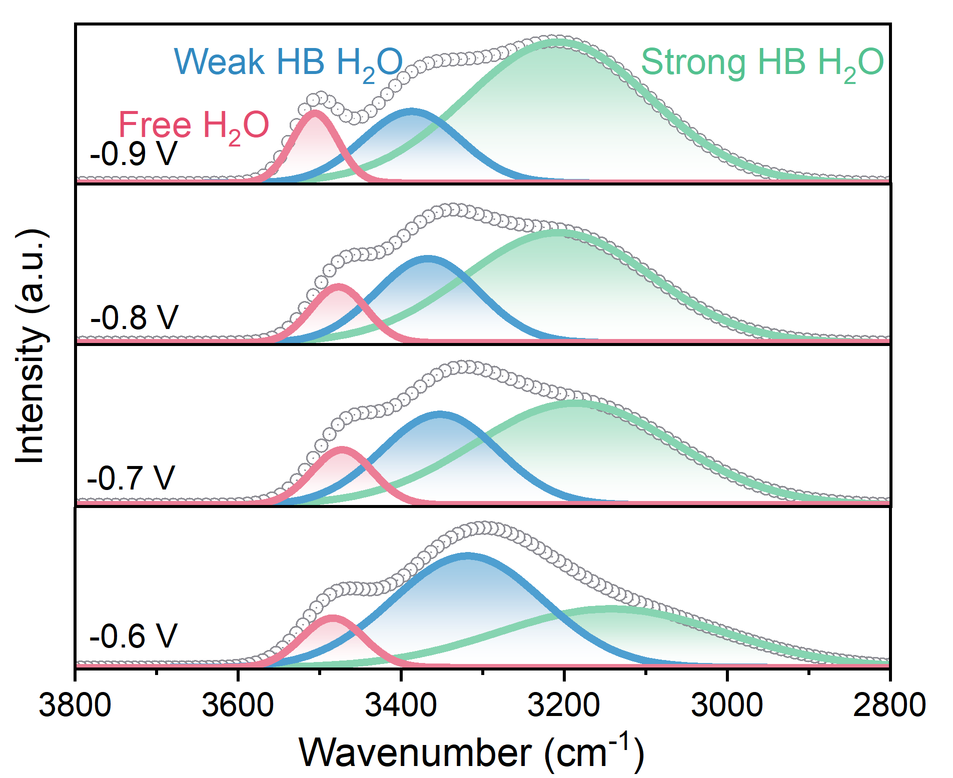
Supplementary Fig. 45 Gaussian fit deconvolution from ν(O−H) signal at −0.6 ~ 0.9 V (vs. RHE) for CIL with free H₂O, weak HB H₂O, and strong HB H₂O.
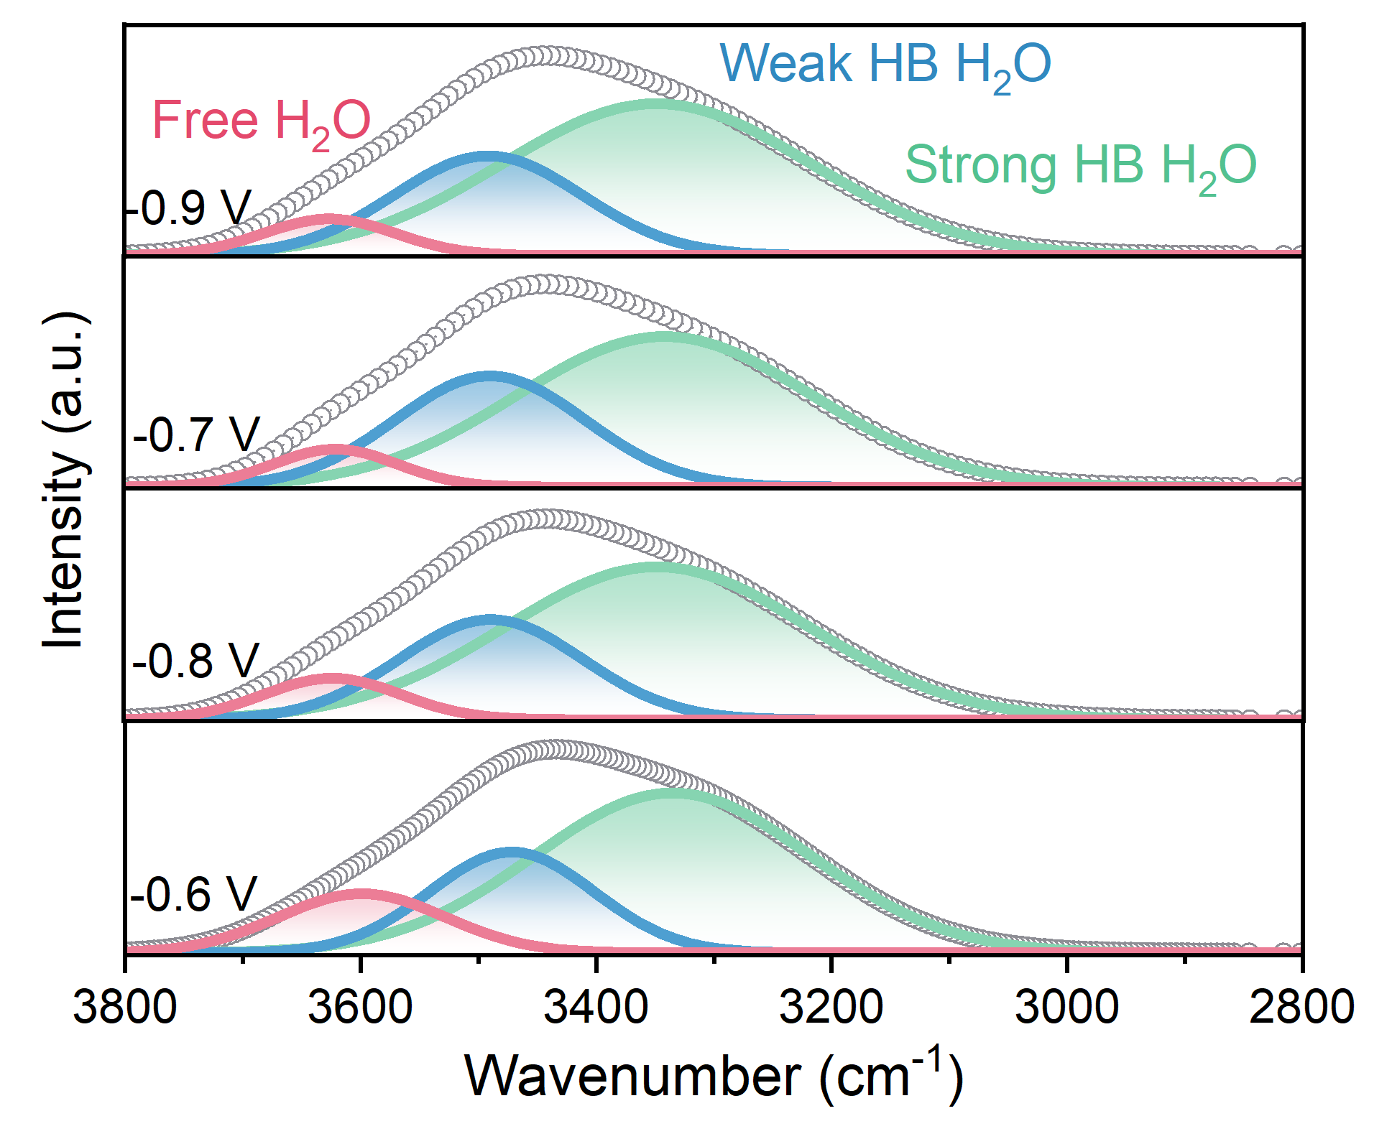
Supplementary Fig. 46 Gaussian fit deconvolution from ν(O−H) signal at −0.6 ~ 0.9 V (vs. RHE) for KHCO₃ with free H₂O, weak HB H₂O, and strong HB H₂O.
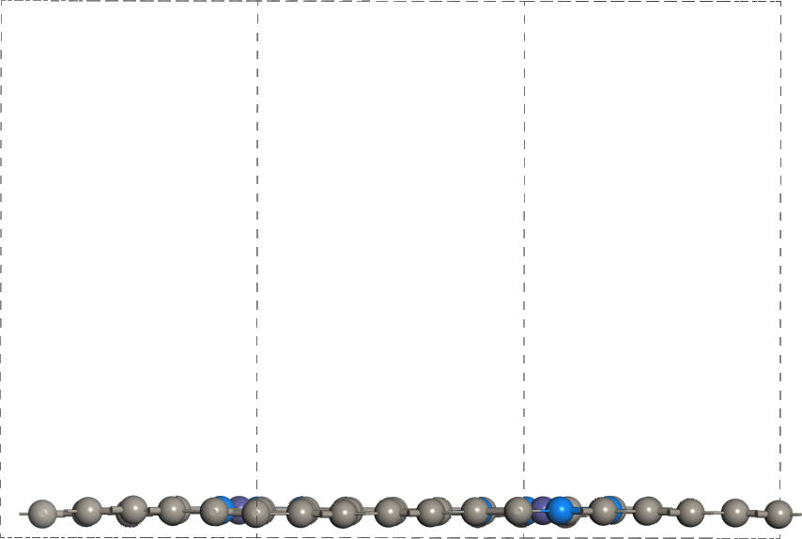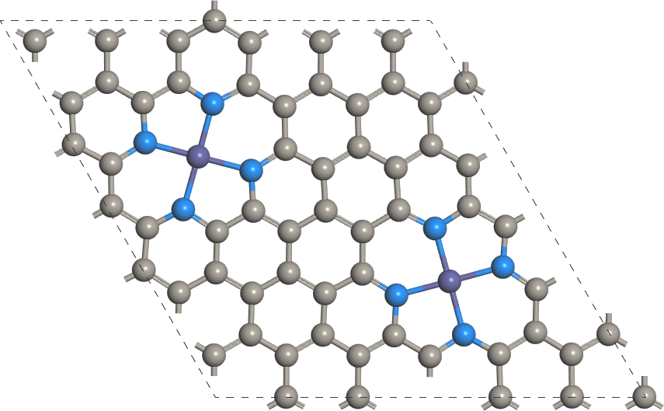
Supplementary Fig. 47 The constructed models of 2Ni-N₄-4-side and 2Ni-N₄-4-top.
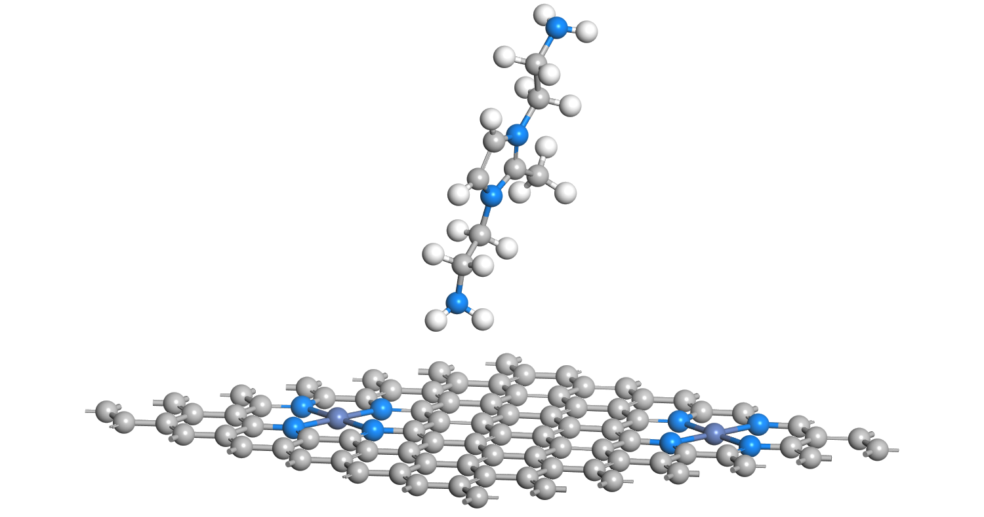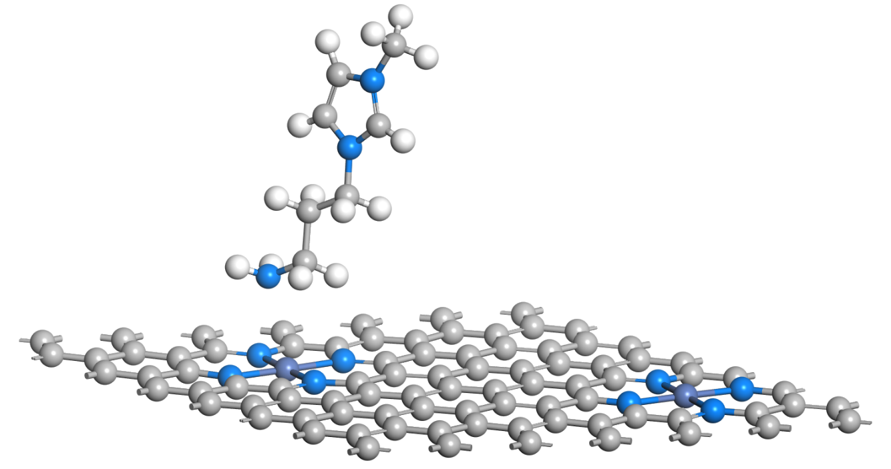
c
b
a
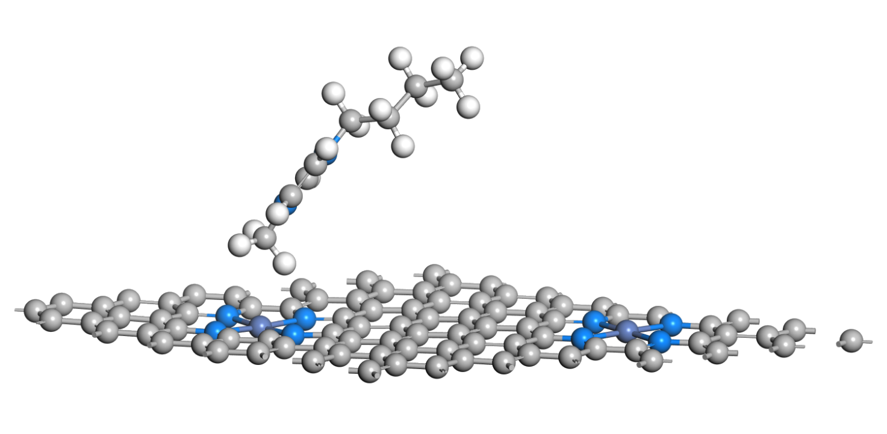
Supplementary Fig. 48 The constructed models of (a) Dual-AFIL, (b) Mono-AFIL and (c) CIL.
Supplementary Fig. 49 CO–DRIFTS spectra of (a) Dual-AFIL, (b) Mono-AFIL and (c) CIL. Ar–purging CO–DRIFTS spectra of (d) Dual-AFIL, (e) Mono-AFIL and (f) CIL.
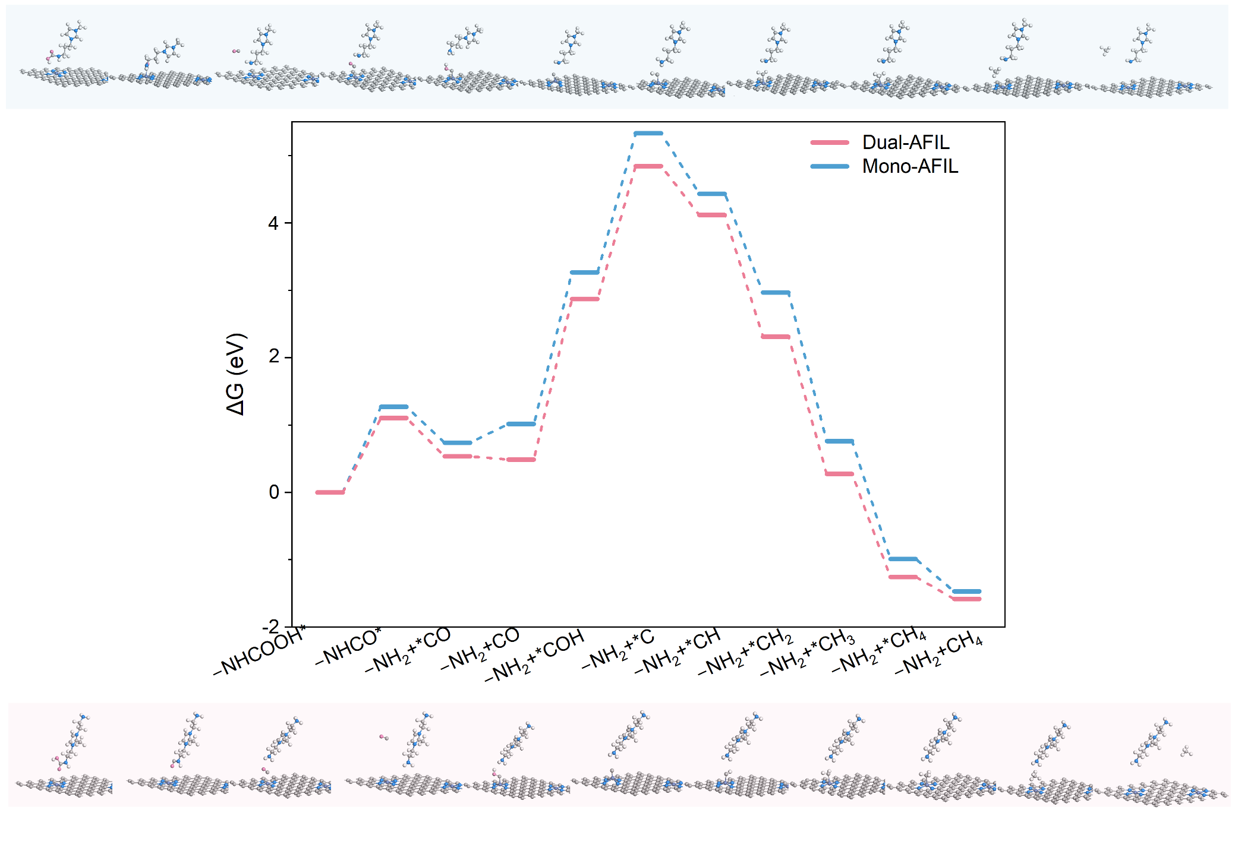
Supplementary Fig. 50 The electrochemical reduction of CO₂ in AFILs to CH₄ reaction pathway
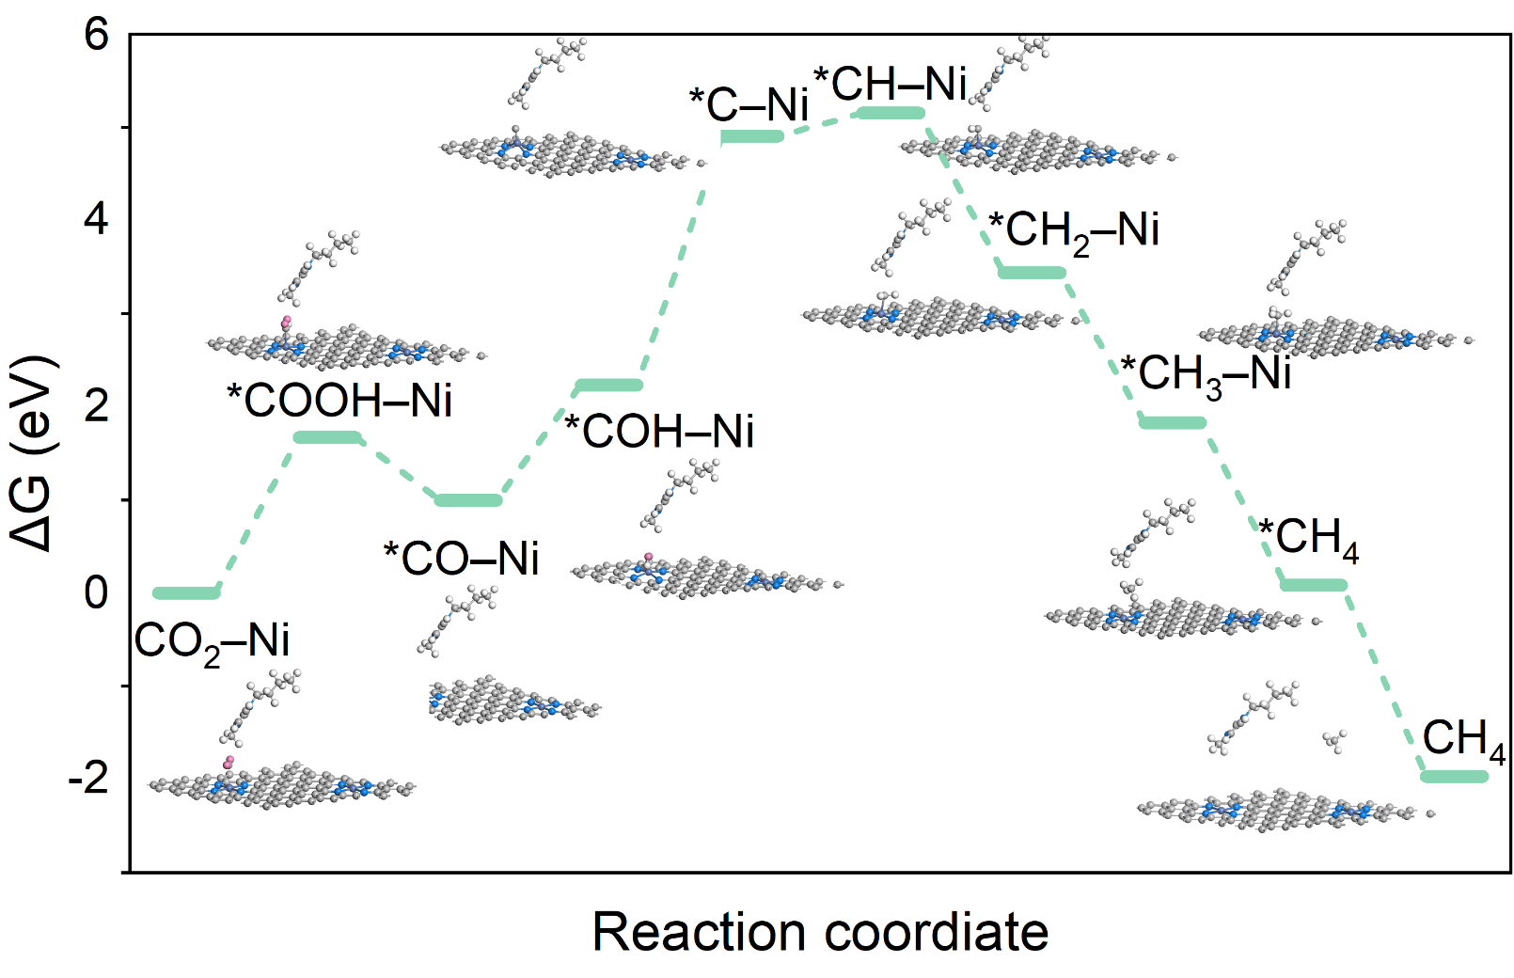
Supplementary Fig. 51 The electrochemical reduction of CO₂ in CIL to CH₄ reaction pathway
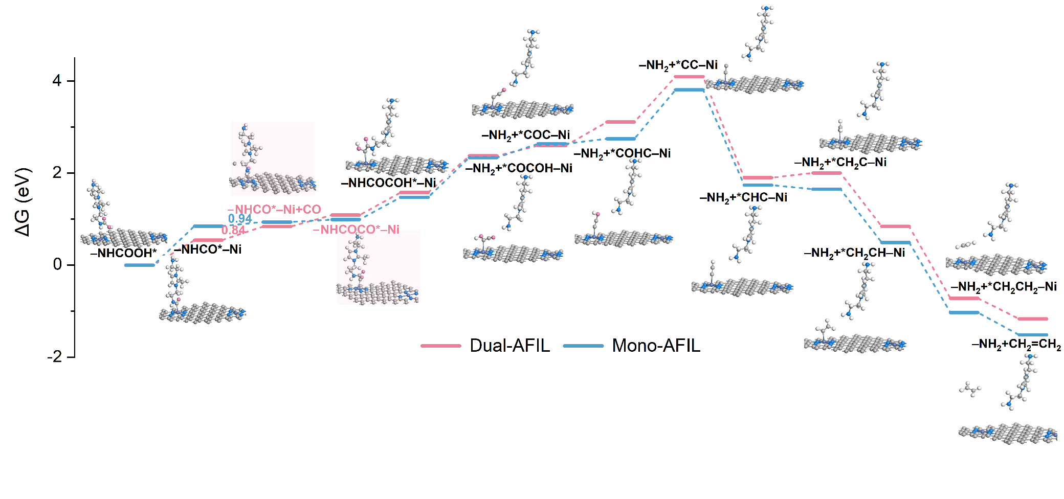
Supplementary Fig. 52 The electrochemical reduction of CO₂ in Dual-AFIL and Mono-AFIL to C₂H₄ reaction pathway 1.
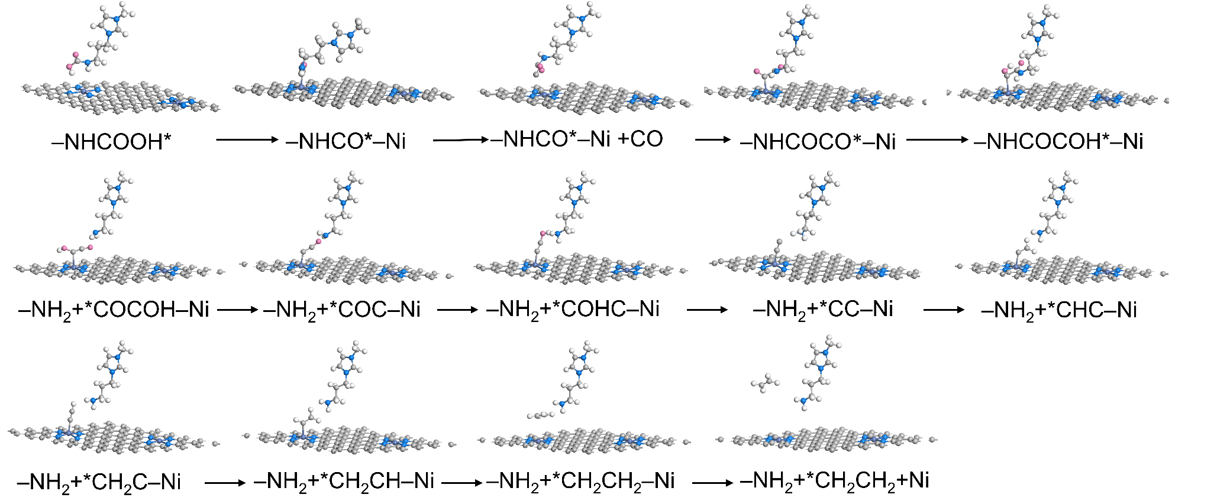
Supplementary Fig. 53 The electrochemical reduction of CO₂ in Mono-AFIL to C₂H₄ reaction pathway 1.
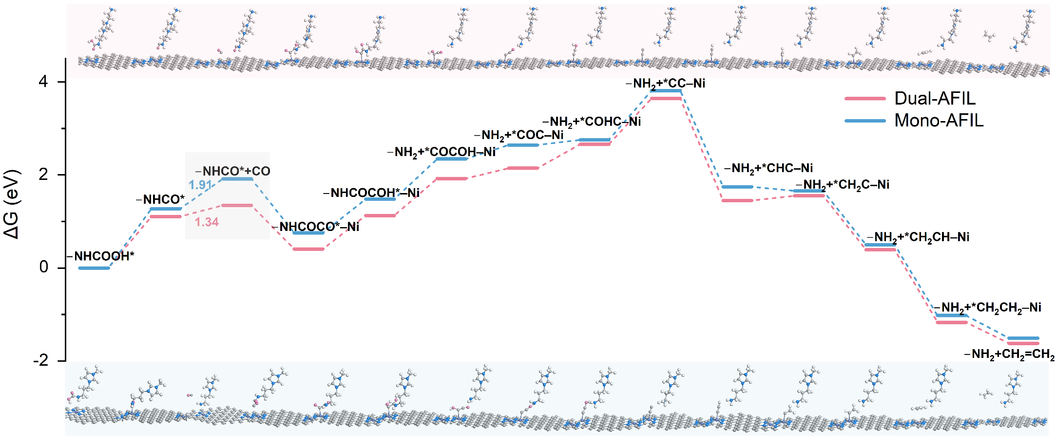
Supplementary Fig. 54 The electrochemical reduction of CO₂ in AFILs to C₂H₄ reaction pathway 2.
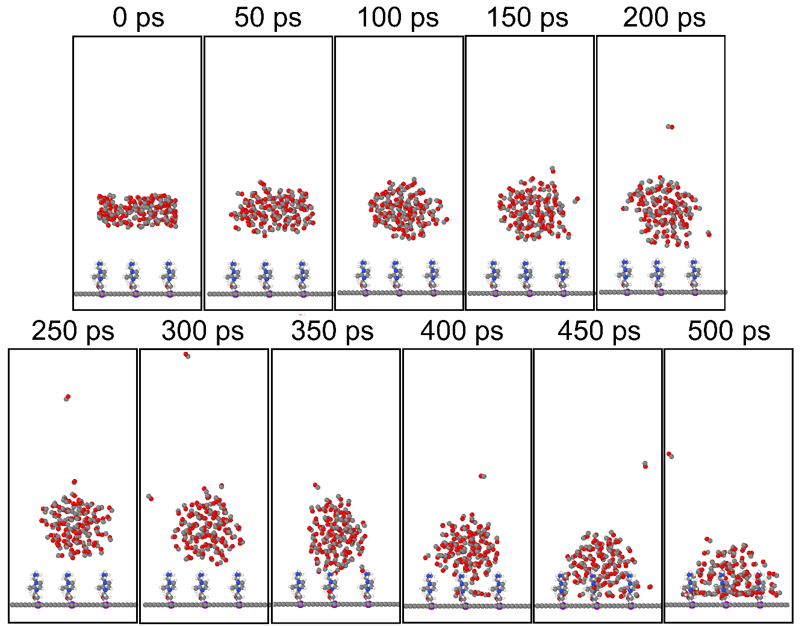
Supplementary Fig. 55 Evolution of typical snapshots of CO on Ni-SAC in Dual-AFIL.
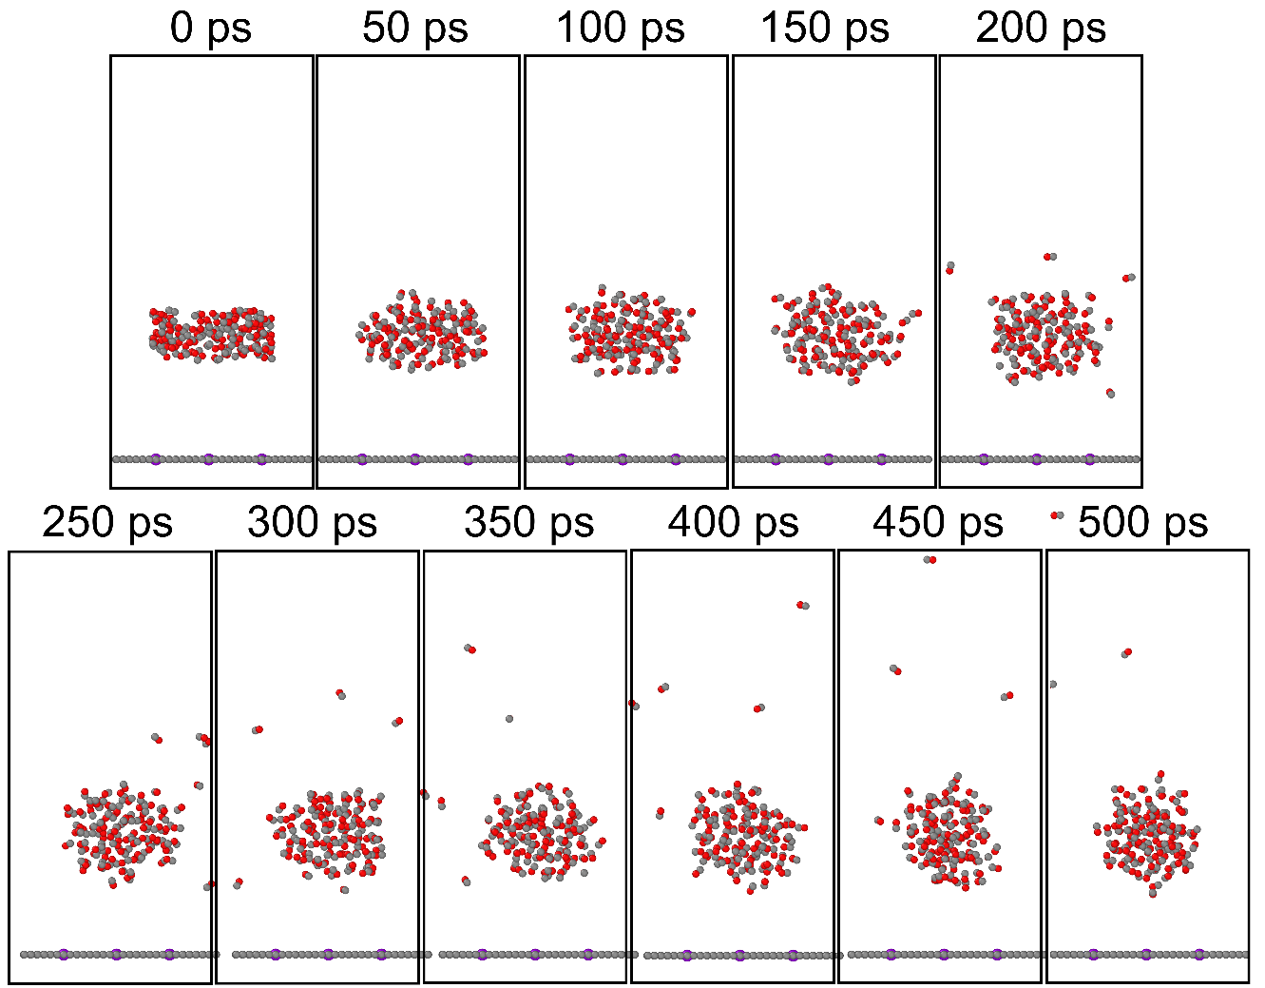
Supplementary Fig. 56 Evolution of typical snapshots of CO on Ni-SAC.
Supplementary Table 1| EXAFS fitting parameters at the Ni K-edge for various samples (Ѕ₀²=0.808).
Sample | Shell | Nª | R(Å)^{b} | σ²(Å²)^{c} | ΔE₀(eV)^{d} | R factor
Ni foil | Ni-Ni | 12 | 2.48 | 0.0013 | 6.8 | 0.0009
NiO | Ni-O | 6.0 | 2.07 | 0.0011 | -3.1 | 0.0022
NiO | Ni-Ni | 12 | 2.95 | 0.0064 | -3.1 | 0.0022
NiSA/N-C | Ni-N | 4.0 | 1.91 | 0.0016 | -10.4 | 0.013
NiPc | Ni-N | 4.0 | 1.89 | 0.002 | 4.0 | 0.0018
ªN: coordination numbers; ^{b}R: bond distance; ^{c}σ²: Debye-Waller factors; ^{d}ΔE₀: the inner potential correction. R factor: goodness of fit. Ѕ₀² was set to 0.808 for Ni, according to the experimental EXAFS fit of Ni foil by fixing CN as the known crystallographic value. EXAFS fitting parameters evidence that the Ni atoms in NiSAs/NC are coordinated by four N atoms and the coordination configuration is NiN4 of Ni sites.
Supplementary Table 2| Performance comparison of electrocatalytic CO₂ reduction to ethylene (C₂H₄), as well as their corresponding catalyst, current density of C₂H₄ (j_{C2H4}), Faraday efficiency of C₂H₄ (FE_{C2H4}), cell type, electrolyte, and references (Ref).^{13–30}
Catalyst | FE_{C2H4}(%) | j_{C2H4}(mA cm⁻¹) | Cell type | Electrolyte | Ref.
Ni_{SAs}/NC | 80.5 | 316.2 | Flow cell | 1 M Dual-AFIL | This work
Cu SALCs-2.35 | 78.6 | 244.8 | Flow cell | 1 M KOH | 13
CuO-SH | 74.5 | 241.6 | Flow cell | 1 M KOH | 14
Cu₂O | 73.7 | 38.2 | H-type cell | 0.1 M K₂SO₄ | 15
Cu_{nps}-SNW | 71.2 | 265.0 | Flow cell | 1 M KOH | 16
Cu NWs-3 | 71.2 | 222.3 | Flow cell | 1 M KOH | 17
TS-Cu | 70.0 | 560.0 | Flow cell | 1 M KOH | 18
Cu-[CF₂]_{n}-x-CP | 64.0 | 24.7 | H-type cell | 0.1 M CsI | 19
PCu | 63.0 | 94.5 | MEA | - | 20
Cr−CuO | 59.2 | 355.2 | Flow cell | 1 M KOH | 21
Zr_{1.0%}-Cu | 57.0 | 342.0 | Flow cell | 3 M KCl | 22
Cu₂O/20wt%PVP | 56.0 | 392.0 | GDE | - | 23
AgCu NW | 54.9 | 156.0 | Flow cell | 0.5 M KOH | 24
Th-TF COF modified Cu₃N | 53.0 | 311.0 | MEA | - | 25
Cu | 53.0 | 32.8 | GDE | 10 M NaClO₄ | 26
Ni-SA/BiCu | 51.0 | 102.0 | MEA | 1.5 M K₂CO₃ | 27
Cu₂-C-1100-4 | 49.9 | 7.4 | H-type cell | 0.1 M KHCO₃ | 28
Cu foil | 46.2 | 1.5 | H-type cell | 0.1 M KHCO₃ | 29
Cu/Me-COF | 46.8 | 374.2 | Flow cell | 1 M KOH | 30

References
1. Zhang, J. et al. A novel dual amino-functionalized cation-tethered ionic liquid for CO₂ capture. Ind. Eng. Chem. Res. 52, 5835–5841 (2013).
2. Kresse, G. & Furthmüller, J. Efficient iterative schemes for ab initio total-energy calculations using a plane-wave basis set. Phys. Rev. B 54, 11169–11186 (1996).
3. Blochl, P. E. Projector augmented-wave method. Phys. Rev. B 50, 17953 (1994).
4. Perdew, J. P., Burke, K. & Ernzerhof, M. Generalized gradient approximation made simple. Phys. Rev. Lett. 77, 3865 (1996).
5. Grimme, S. Semiempirical GGA-type density functional constructed with a long-range dispersion correction. J. Comput. Chem. 27, 1787–1799 (2006).
6. Wang, V., Xu, N., Liu, J.-C., Tang, G. & Geng, W.-T. VASPKIT: A user-friendly interface facilitating high-throughput computing and analysis using VASP code. Comput. Phys. Commun. 267, 108033 (2021).
7. Wilhoit, R. C., Chao, J. & Hall, K. R. JANAF thermochemical tables (third edition). J. Phys. Chem. Ref. Data 14, 1–1856 (1985).
8. Peterson, A. A. & Nørskov, J. K. Activity descriptors for CO₂ electroreduction to methane on transition-metal catalysts. J. Phys. Chem. Lett. 3, 251–258 (2012).
9. Martínez, L., Andrade, R., Birgin, E. G. & Martínez, J. M. Packmol: A package for building initial configurations for molecular dynamics simulations. J. Comput. Chem. 30, 2157–2164 (2009).
10. Dauber-Osguthorpe, P. et al. Structure and energetics of ligand binding to proteins: escherichia coli dihydrofolate reductase-trimethoprim, a drug-receptor system. Proteins: Struct., Funct., Bioinf. 4, 31–47 (1988).
11. Stukowski, A. Visualization and analysis of atomistic simulation data with OVITO–the open visualization tool. Modell. Simul. Mater. Sci. Eng. 18, 15012 (2010).
12. Zou, F. et al. Metal organic frameworks derived hierarchical hollow NiO/Ni/graphene composites for lithium and sodium storage. ACS Nano 10, 377–386 (2016).
13. Xu, W. et al. Tuning Cu–Cu spacing in single-atomic layer cu catalysts for efficient and stable CO₂-to-C₂H₄ electroreduction. Adv. Mater. 38, e22842 (2026).
14. Yao, Y. et al. A surface strategy boosting the ethylene selectivity for CO₂ reduction and in situ mechanistic insights. Nat. Commun. 15, 1257 (2024).
15. Zhang, R. et al. Cu₂O nano‐homojunction for high‐efficiency electrocatalytic CO₂‐to‐ethylene conversion. Angew. Chem. Int. Ed. 64, e202501554 (2025).
16. Xie, W. et al. Synergistic surface modification of cu with schiff-base networks for high selectivity and durability in CO₂-to-C₂H₄ electroreduction. Nat. Commun.(2026) https://doi.org/10.1038/s41467-026-70595-w
17. Zhou, W. et al. Multiple tuning of the local environment enables selective CO₂ electroreduction to ethylene in neutral electrolytes. Adv. Funct. Mater. 34, 2311226 (2024).
18. Fang, W. et al. Low‐coordination nanocrystalline copper‐based catalysts through theory‐guided electrochemical restructuring for selective CO₂ reduction to ethylene. Angew. Chem. Int. Ed. 63, e202319936 (2024).
19. Deng, T. et al. Polymer modification strategy to modulate reaction microenvironment for enhanced CO₂ electroreduction to ethylene. Angew. Chem. Int. Ed. 63, e202313796 (2024).
20. Zhong, D. et al. Selective electrochemical CO₂ reduction to ethylene or ethanol via tuning *OH adsorption. Angew Chem Int Ed 64, e202501773 (2025).
21. Wei, C. et al. Co-modulating CO adsorption and interfacial water dissociation through a lewis acid site boosts industrial CO₂-to-ethylene conversion. Nano Lett. 26, 2726–2734 (2026).
22. Zhao, Z. et al. Molecular-fence confinement enabling efficient acidic CO₂ electroreduction to multi-carbon products. J. Am. Chem. Soc.(2026) https://doi.org/10.1021/jacs.6c02917
23. Rabiee, H. et al. Rational designing microenvironment of gas-diffusion electrodes via microgel-augmented CO₂ availability for high-rate and selective CO₂ electroreduction to ethylene. Adv. Sci. 11, 2402964 (2024).
24. Wang, S. et al. Manipulating C–C coupling pathway in electrochemical CO₂ reduction for selective ethylene and ethanol production over single-atom alloy catalyst. Nat. Commun. 15, 10247 (2024).
25. Chen, D. et al. Electrocatalytic CO₂ reduction to ethylene in an acid-fed membrane electrode assembly at 10 a. Nat. Commun. 16, 10783 (2025).
26. Zhang, H., Raciti, D. & Hall, A. S. Disordered interfacial H₂O promotes electrochemical C–C coupling. Nat. Chem. 17, 1161–1168 (2025).
27. Chen, Y. et al. Dilute alloy electrocatalysts enable asymmetric C–C coupling for ethylene production from a CO₂ post-capture liquid. Nat. Synth.(2026) https://doi.org/10.1038/s44160-026-01024-5
28. Huang, X. et al. Strain-optimized copper dual-atom sites for selective electroreduction of carbon dioxide to ethylene. Sci. Adv. 11, eads0609 (2025).
29. Zhan, C. et al. Key intermediates and cu active sites for CO₂ electroreduction to ethylene and ethanol. Nat Energy 9, 1485–1496 (2024).
30. Qian, Z. et al. Hydrophobic cation-immobilized covalent organic frameworks enable selective and stable electrosynthesis of ethylene from CO₂. J. Am. Chem. Soc. 147, 21877–21884 (2025).

