Supplementary Materials
This supplement provides additional figures, hyperparameter settings, and cross-region performance tables that support the main manuscript.

Appendix A. Completed time series after missing-value imputation
We apply the proposed MLP-based imputation procedure to fill missing observations for all ten DMAs. Figure S1 visualizes the repaired demand trajectories used for subsequent model training and testing.
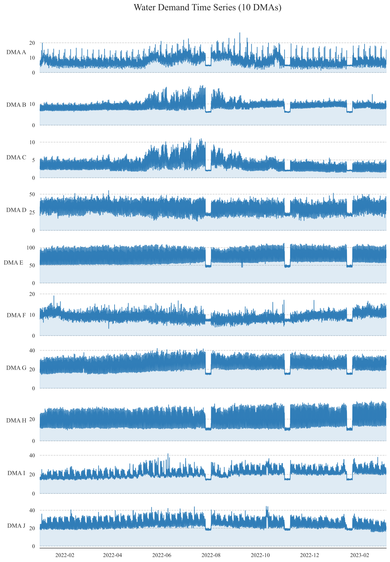
Figure S1. Ten DMA demand time series after MLP-based missing value completion (10-minute resolution).
The completed series show clear diurnal patterns and seasonal variability across DMAs. Importantly, the imputed segments do not introduce discontinuities or artificial spikes, which helps avoid error amplification during multi-step forecasting.

Appendix B. Hyperparameter settings
Table S1 summarizes the hyperparameters used in the experiments, selected through random search on the validation set.
Table S1. Key hyperparameters for CAM-LSTM.
Hyperparameters | Search Spaces | Optimal Values
Embedding Dimension | Integers in [64, 128, 256, 512] | 256
Feed-forward Network Dimension | Integers in [128, 256, 512, 1024] | 512
Number of Attention Heads | Integers in [2, 4, 8, 16] | 8
Number of Layers | Integers in [1, 2, 3, 4] | 2
Dropout Rate | Reals in [0.1, 0.3, 0.6] | 0.6
Historical Look-back Window | Integers in [48, 96, 128, 192] | 128
Learning Rate | Set in [0.001，0.0005，0.0001] | 0.0001
The combination of three graph convolution layers and a two-layer CNN allows the model to extract spatial dependencies and local temporal features before attention-based fusion and LSTM reasoning.

Appendix C. Additional forecasting results in other DMAs
To complement the main text (which focuses on DMA J as a representative case study), we report full performance tables for two additional DMAs. These results confirm that CAM-LSTM provides consistent gains across heterogeneous demand regimes.
Table S2. Prediction performance on DMA A test set (1 h / 3 h / 5 h horizons).
Model | NSE (1 h) | NSE (3 h) | NSE (5 h) | MAPE (1 h) | MAPE (3 h) | MAPE (5 h) | RMSE (1 h) | RMSE (3 h) | RMSE (5 h)
CNN | 0.5658 | 0.5105 | 0.4943 | 0.1581 | 0.1609 | 0.1692 | 1.4831 | 1.5713 | 1.5970
LSTM | 0.5010 | 0.4713 | 0.5010 | 0.1538 | 0.1441 | 0.1538 | 1.5865 | 1.6331 | 1.5865
CNN-LSTM | 0.5478 | 0.5453 | 0.4832 | 0.1276 | 0.1410 | 0.1525 | 1.5136 | 1.5145 | 1.6145
MLP-LSTM | 0.5938 | 0.4585 | 0.4134 | 0.1344 | 0.1572 | 0.1706 | 1.4346 | 1.6528 | 1.7201
GNN-LSTM | 0.4975 | 0.4688 | 0.4246 | 0.1597 | 0.1755 | 0.1773 | 1.5956 | 1.6369 | 1.7035
CAM-LSTM | 0.6374 | 0.5704 | 0.5384 | 0.1151 | 0.1352 | 0.1386 | 1.3554 | 1.4722 | 1.5258
DMA A exhibits relatively low and stable demand (Table 1 in the main text). The improvements from CAM-LSTM are particularly visible in MAPE and RMSE, indicating better tracking of small fluctuations and reducing relative error in low-flow regimes.
Table S3. Prediction performance on DMA F test set (1 h / 3 h / 5 h horizons).
Model | NSE (1 h) | NSE (3 h) | NSE (5 h) | MAPE (1 h) | MAPE (3 h) | MAPE (5 h) | RMSE (1 h) | RMSE (3 h) | RMSE (5 h)
CNN | 0.7136 | 0.6704 | 0.6389 | 0.0700 | 0.0731 | 0.0760 | 0.9314 | 0.9992 | 1.0460
LSTM | 0.6713 | 0.6083 | 0.6212 | 0.0716 | 0.0794 | 0.0796 | 0.9977 | 1.0893 | 1.0713
CNN-LSTM | 0.5505 | 0.4444 | 0.2778 | 0.0818 | 0.0972 | 0.1154 | 1.1667 | 1.2972 | 1.4792
MLP-LSTM | 0.7044 | 0.3925 | 0.3765 | 0.0681 | 0.1030 | 0.0983 | 0.9462 | 1.3565 | 1.3745
GNN-LSTM | 0.5891 | 0.3205 | 0.2210 | 0.0801 | 0.1045 | 0.1172 | 1.1156 | 1.4346 | 1.5363
CAM-LSTM | 0.7371 | 0.6765 | 0.6603 | 0.0651 | 0.0720 | 0.0734 | 0.8922 | 0.9899 | 1.0145
DMA F contains a larger mean demand and stronger day-to-day variation. CAM-LSTM yields the best NSE at all horizons and the lowest RMSE, suggesting that the dynamic graph and attention fusion are beneficial for both moderate-demand and high-demand districts.

Appendix D. Reproducibility and implementation details
All experiments were implemented in PyTorch. Model selection was based on validation NSE, and the reported results are computed on the held-out test set. To reduce randomness, the MLP imputation was repeated 100 times with different random initializations and the final filled value was computed as an ensemble mean.

