Supplementary Materials
Table S1. Specific definitions of various diseases
Overweight/obesity | BMI ≥ 23 kg/m²
Abdominal obesity | Waist circumference ≥ 80/90 cm in female/male
Prediabetes | Fasting blood glucose 100–125 mg/dL or HbA1c 5.7%–6.4%, in the absence of self-reported diagnosis of diabetes or use of insulin or oral hypoglycemic agents
Diabetes | Fasting blood glucose ≥ 126 mg/dL, HbA1c ≥ 6.5%, self-reported diagnosis of diabetes, or use of insulin or oral hypoglycemic agents
Hypertension | SBP ≥ 130 mmHg, DBP ≥ 80 mmHg, self-reported diagnosis of hypertension, or use of antihypertensive medications
Chronic kidney disease | eGFR < 60 mL/min/1.73 m² or self-reported diagnosis of chronic kidney disease
Hypertriglyceridemia | Triglycerides ≥ 150 mg/dL
Metabolic syndrome | Presence of any three or more of the following five components:  ① Waist circumference ≥ 80/90 cm in female/male.  ② HDL-C < 50/40 mg/dL in female/male.  ③ Triglycerides ≥ 150 mg/dL.  ④ SBP ≥ 130 mm Hg or DBP ≥ 80 mm Hg or use of antihypertensive medications  ⑤ Fasting blood glucose ≥ 100 mg/dL
Clinical CVD | Self-reported diagnosis of heart disease (including angina, heart attack, congestive heart failure, and other heart problems) or stroke
Subclinical CVD | Framingham risk score ≥ 21.5/21.6 in female/male or eGFR < 30 mL/min/1.73 m², in the absence of clinical CVD

Table S2. Definition of CKM syndrome stages (0–3)
CKM stages | Diagnostic criteria
Stage 0 | All of the following criteria must be met:  (1) BMI < 23 kg/m²  (2) Waist circumference < 80/90 cm in female/male  (3) Fasting blood glucose < 100 mg/dL and HbA1c < 5.7% and without self-reported diagnosis of diabetes, use of insulin, or oral hypoglycemic agents  (4) SBP < 130 mm Hg and DBP < 80 mm Hg without self-reported diagnosis of hypertension or use of antihypertensive medications  (5) HDL-C ≥ 50/40 mg/dL in female/male  (6) TG < 150 mg/dL  (7) eGFR ≥ 60 mL/min/1.73 m² and without self-reported diagnosis of CKD  (8) No subclinical CVD or clinical CVD
Stage 1 | At least one of the following conditions is present:  (1) Overweight/obesity  (2) Abdominal obesity  (3) Prediabetes  And all of the following criteria must be met:  (1) SBP < 130 mmHg and DBP < 80 mmHg without self-reported diagnosis of hypertension or use of antihypertensive medications.  (2) Fasting blood glucose < 126 mg/dL and HbA1c < 6.5% and without self-reported diagnosis of diabetes, use of insulin, or oral hypoglycemic agents.  (3) HDL-C ≥ 50/40 mg/dL in female/male  (4) TG < 150 mg/dL  (5) eGFR ≥ 60 mL/min/1.73 m² and without self-reported diagnosis of CKD  (6) No subclinical CVD or clinical CVD
Stage 2 | At least one of the following conditions is present:  (1) Hypertriglyceridemia  (2) Hypertension  (3) Diabetes  (4) Metabolic syndrome  (5) eGFR 30–59 mL/min/1.73 m² or self-reported diagnosis of CKD  And no subclinical CVD or clinical CVD
Stage 3 | At least one of the following conditions is present:  (1) Subclinical CVD  (2) eGFR < 30 mL/min/1.73 m²  And at least one of the following conditions is present:  (1) Overweight/obesity  (2) Abdominal obesity  (3) Prediabetes  (4) Hypertriglyceridemia  (5) Hypertension  (6) Diabetes  (7) Metabolic syndrome  (8) eGFR 30–59 mL/min/1.73 m² or self-reported diagnosis of CKD  And no clinical CVD

Table S3. Distribution of variables with missing data
Variables | Number of Missing | Missing proportion
Age | 0 | 0
Gender | 0 | 0
Residence | 2 | 0.07%
Education | 0 | 0
Marriage | 0 | 0
Smoking status | 5 | 0.16%
Drinking status | 3 | 0.1%
BMI | 0 | 0
Kidney disease | 0 | 0
Hypertension | 0 | 0
Diabetes | 0 | 0
Cancer | 7 | 0.23%
eGFR | 0 | 0
UA | 0 | 0
CRP | 0 | 0
WBC | 26 | 0.85%
PLT | 24 | 0.79%

Table S4. Collinearity Statistics.
Variables | GVIF
Gender | 2.533
eGFR | 1.669
Age | 1.551
Cumulative CHG | 1.528
UA | 1.506
Smoking status | 2.140
Diabetes | 1.329
BMI | 1.297
Drinking status | 1.536
Education | 1.138
WBC | 1.132
Hypertension | 1.124
Residence | 1.106
Marriage | 1.096
PLT | 1.081
Kidney disease | 1.067
CRP | 1.035
Cancer | 1.007

Table S5. Schoenfeld residual test of proportional hazards assumption
Variable | χ² | P value
Cumulative CHG | 0.65 | 0.419
Age | 0.04 | 0.840
Gender | 0.33 | 0.568
Residence | 1.29 | 0.257
Education | 0.49 | 0.485
Marriage | 0.46 | 0.499
Smoking status | 0.40 | 0.526
Drinking status | 0.03 | 0.871
BMI | 0.08 | 0.777
CKD | 0.86 | 0.354
Hypertension | 0.00 | 0.971
Diabetes | 0.34 | 0.562
Cancer | 3.41 | 0.065
eGFR | 0.33 | 0.563
UA | 0.04 | 0.848
CRP | 0.16 | 0.687
WBC | 0.08 | 0.776
PLT | 1.54 | 0.214

Table S6. Model comparison for restricted cubic spline models with different numbers of knots
Knots | AIC
3 | 8918.90
4 | 8920.92
5 | 8922.74
6 | 8924.43
Models were fitted using restricted cubic splines with 3 to 6 knots. Model fit was evaluated using the Akaike information criterion (AIC), with lower values indicating better fit.

Table S7. Baseline characteristics of the participants classified by CHG clusters
Characteristic | Overall  (N = 3,002) | Cluster 1  (N = 1,300) | Cluster 2  (N = 1,419) | Cluster 3  (N = 283) | p-value¹
Age, years | 58 ± 8 | 58 ± 8 | 59 ± 8 | 58 ± 8 | 0.069
BMI, kg/m² | 23.6 ± 3.8 | 22.3 ± 3.6 | 24.4 ± 3.7 | 25.6 ± 3.3 | <0.001
SBP, mmHg | 130 ± 20 | 126 ± 20 | 132 ± 20 | 136 ± 20 | <0.001
DBP, mmHg | 76 ± 12 | 74 ± 12 | 77 ± 12 | 79 ± 11 | <0.001
TC, mg/dL | 196 ± 38 | 182 ± 32 | 203 ± 36 | 224 ± 48 | <0.001
TG, mg/dL | 103 (73, 156) | 78 (61, 104) | 124 (89, 177) | 202 (139, 330) | <0.001
HDL-C, mg/dL | 52 ± 15 | 61 ± 15 | 47 ± 11 | 37 ± 12 | <0.001
FPG, mg/dL | 103 (95, 113) | 98 (92, 105) | 105 (98, 114) | 147 (118, 206) | <0.001
HbA1c, % | 5.20 (4.90, 5.40) | 5.10 (4.80, 5.30) | 5.20 (4.90, 5.50) | 5.90 (5.30, 7.60) | <0.001
eGFR, mL/min/1.73 m² | 94 ± 14 | 95 ± 13 | 93 ± 14 | 94 ± 15 | <0.001
Cr, mg/dL | 0.75 (0.64, 0.86) | 0.73 (0.64, 0.85) | 0.76 (0.64, 0.87) | 0.75 (0.64, 0.86) | 0.119
UA, mg/dL | 4.34 ± 1.20 | 4.17 ± 1.13 | 4.46 ± 1.19 | 4.51 ± 1.39 | <0.001
CRP, mg/L | 0.98 (0.53, 1.97) | 0.75 (0.45, 1.61) | 1.12 (0.61, 2.15) | 1.43 (0.82, 2.93) | <0.001
WBC, ×10⁹/L | 6.20 ± 1.83 | 5.96 ± 1.76 | 6.33 ± 1.88 | 6.64 ± 1.72 | <0.001
PLT, ×10⁹/L | 212 ± 72 | 207 ± 72 | 216 ± 72 | 220 ± 71 | 0.002
Cumulative CHG | 15.76 ± 1.11 | 14.83 ± 0.47 | 16.15 ± 0.44 | 18.10 ± 0.97 | <0.001
CHG (2012) | 5.33 ± 0.44 | 4.99 ± 0.22 | 5.47 ± 0.23 | 6.20 ± 0.48 | <0.001
CHG (2015) | 5.18 ± 0.37 | 4.90 ± 0.19 | 5.29 ± 0.19 | 5.87 ± 0.41 | <0.001
Gender |  |  |  |  | 0.007
Male | 1,388 (46%) | 637 (49%) | 639 (45%) | 112 (40%)
Female | 1,614 (54%) | 663 (51%) | 780 (55%) | 171 (60%)
Residence |  |  |  |  | 0.042
Rural | 2,605 (87%) | 1,151 (89%) | 1,214 (86%) | 240 (85%)
Urban | 397 (13%) | 149 (11%) | 205 (14%) | 43 (15%)
Education |  |  |  |  | 0.376
Below high school | 2,732 (91%) | 1,175 (90%) | 1,294 (91%) | 263 (93%)
High school or above | 270 (9.0%) | 125 (9.6%) | 125 (8.8%) | 20 (7.1%)
Marriage |  |  |  |  | 0.184
Married | 2,722 (91%) | 1,172 (90%) | 1,285 (91%) | 265 (94%)
Others | 280 (9.3%) | 128 (9.8%) | 134 (9.4%) | 18 (6.4%)
Smoking status |  |  |  |  | 0.010
Current smoker | 918 (31%) | 434 (33%) | 412 (29%) | 72 (25%)
Former smoker | 220 (7.3%) | 81 (6.2%) | 111 (7.8%) | 28 (9.9%)
Never smoker | 1,864 (62%) | 785 (60%) | 896 (63%) | 183 (65%)
Drinking status |  |  |  |  | 0.008
Current | 986 (33%) | 467 (36%) | 443 (31%) | 76 (27%)
Former | 219 (7.3%) | 82 (6.3%) | 111 (7.8%) | 26 (9.2%)
Never | 1,797 (60%) | 751 (58%) | 865 (61%) | 181 (64%)
Kidney disease |  |  |  |  | 0.062
Yes | 221 (7.4%) | 107 (8.2%) | 102 (7.2%) | 12 (4.2%)
No | 2,781 (93%) | 1,193 (92%) | 1,317 (93%) | 271 (96%)
Hypertension |  |  |  |  | <0.001
Yes | 1,700 (57%) | 623 (48%) | 872 (61%) | 205 (72%)
No | 1,302 (43%) | 677 (52%) | 547 (39%) | 78 (28%)
Diabetes |  |  |  |  | <0.001
Yes | 472 (16%) | 62 (4.8%) | 214 (15%) | 196 (69%)
No | 2,530 (84%) | 1,238 (95%) | 1,205 (85%) | 87 (31%)
Cancer |  |  |  |  | 0.812
Yes | 23 (0.8%) | 9 (0.7%) | 11 (0.8%) | 3 (1.1%)
No | 2,979 (99%) | 1,291 (99%) | 1,408 (99%) | 280 (99%)
CKM stage |  |  |  |  | <0.001
0 | 243 (8.1%) | 207 (16%) | 36 (2.5%) | 0 (0%)
1 | 482 (16%) | 327 (25%) | 153 (11%) | 2 (0.7%)
2 | 1,425 (47%) | 530 (41%) | 777 (55%) | 118 (42%)
3 | 852 (28%) | 236 (18%) | 453 (32%) | 163 (58%)
Incident CVD | 569 (19%) | 203 (16%) | 293 (21%) | 73 (26%) | <0.001
Continuous variables are presented as mean ± SD for normally distributed variables and median (IQR) for non-normally distributed variables; categorical variables are presented as n (%).
1P values were obtained using one-way ANOVA for normally distributed continuous variables, the Kruskal–Wallis test for non-normally distributed continuous variables, and χ2 test for categorical variables.

Table S8. Sensitivity analysis of the association between cumulative CHG and incident CVD using multiple imputation
 | Model 1  HR (95% CI) | P value | Model 2  HR (95% CI) | P value | Model 3  HR (95% CI) | P value
Cumulative CHG
Continuous | 1.20 (1.13–1.29) | <0.001 | 1.20 (1.12–1.28) | <0.001 | 1.13 (1.03–1.23) | 0.007
Quartile
Q1 | Reference |  | Reference |  | Reference
Q2 | 1.15 (0.89–1.49) | 0.288 | 1.14 (0.88–1.47) | 0.328 | 1.03 (0.79–1.33) | 0.841
Q3 | 1.54 (1.21–1.96) | <0.001 | 1.50 (1.17–1.91) | 0.001 | 1.27 (0.99–1.64) | 0.060
Q4 | 1.74 (1.37–2.21) | <0.001 | 1.70 (1.34–2.16) | <0.001 | 1.34 (1.02–1.75) | 0.035
P for trend |  | <0.001 |  | <0.001 |  | 0.013
Missing covariate data were handled using multiple imputation by chained equations (MICE) under the missing-at-random assumption. Twenty imputed datasets were generated, and pooled hazard ratios (HRs) and 95% confidence intervals (CIs) were obtained according to Rubin’s rules.
Model 1 was unadjusted. Model 2 was adjusted for age, gender, residence, educational level, and marital status. Model 3 was further adjusted for smoking status, drinking status, body mass index, kidney disease, hypertension, diabetes, cancer, estimated glomerular filtration rate, uric acid, C-reactive protein, white blood cell count, and platelet count.
CHG quartiles were defined based on the distribution of cumulative CHG in each imputed dataset. P for trend was calculated by modeling the median value of each quartile as a continuous variable.

Table S9. Association between cumulative CHG and incident CVD using the Fine–Gray competing risk model
 | Model 1  sHR (95% CI) | P value | Model 2  sHR (95% CI) | P value | Model 3  sHR (95% CI) | P value
Cumulative CHG
Continuous | 1.19 (1.12–1.26) | <0.001 | 1.18 (1.11–1.25) | <0.001 | 1.13 (1.04–1.22) | 0.002
Quartile
Q1 | Reference |  | Reference |  | Reference
Q2 | 1.17 (0.91–1.49) | 0.214 | 1.16 (0.90–1.48) | 0.246 | 1.06 (0.83–1.36) | 0.635
Q3 | 1.53 (1.21–1.92) | <0.001 | 1.49 (1.18–1.87) | <0.001 | 1.27 (1.00–1.61) | 0.052
Q4 | 1.70 (1.36–2.13) | <0.001 | 1.66 (1.32–2.09) | <0.001 | 1.37 (1.06–1.76) | 0.014
P for trend |  | <0.001 |  | <0.001 |  | 0.006
Subdistribution hazard ratios (sHRs) and 95% confidence intervals (CIs) were estimated using the Fine–Gray competing risk model.
Model 1 was unadjusted. Model 2 was adjusted for age, sex, residence, educational level, and marital status. Model 3 was further adjusted for smoking status, drinking status, body mass index, kidney disease, hypertension, diabetes, cancer, estimated glomerular filtration rate, uric acid, C-reactive protein, white blood cell count, and platelet count.

Table S10. Sensitivity analysis with additional adjustment for medication use
 | Fully adjusted model with additional adjustment for medication use  HR (95% CI) | P value
Cumulative CHG
Continuous | 1.13 (1.04–1.23) | 0.005
Quartile
Q1 | Reference
Q2 | 1.03 (0.79–1.34) | 0.820
Q3 | 1.25 (0.97–1.61) | 0.084
Q4 | 1.30 (0.99–1.70) | 0.056
P for trend |  | 0.013
Hazard ratios (HRs) and 95% confidence intervals (CIs) were estimated using Cox proportional hazards models. Fully adjusted model as described in the main analysis, with additional adjustment for antihypertensive, antidiabetic, and lipid-lowering medications.

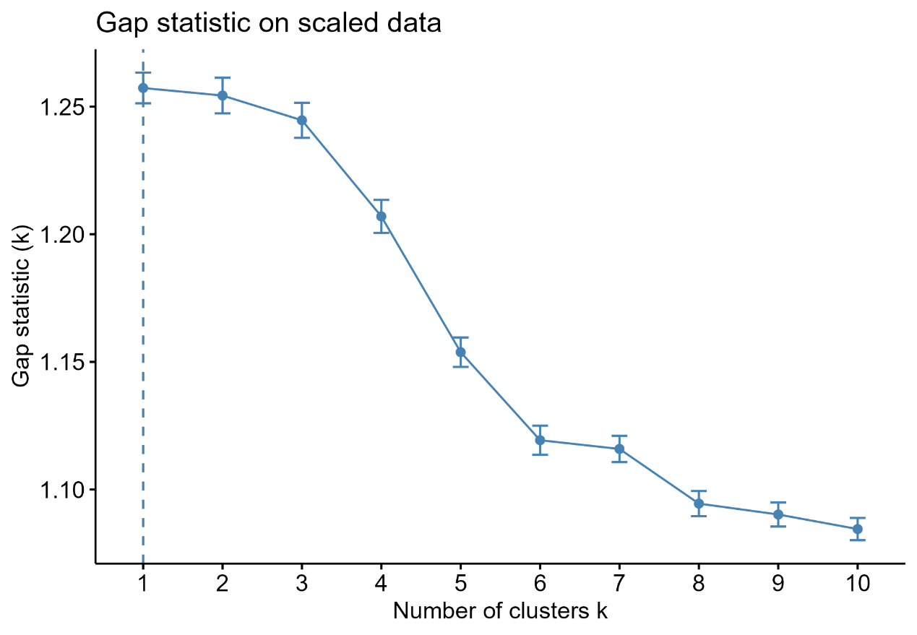
Fig. S1. Gap statistic analysis for determining the optimal number of clusters.
Gap statistic analysis was applied to assess the optimal number of clusters in the K-means model.

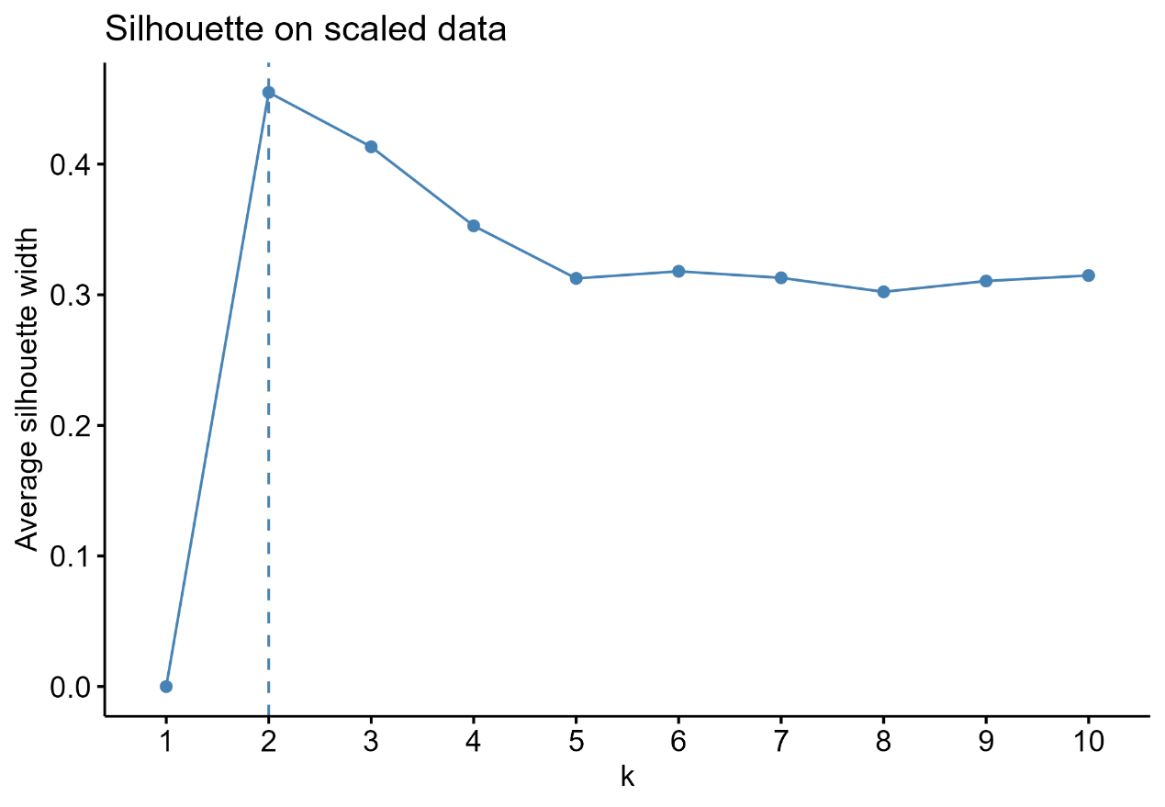
Fig. S2. Silhouette analysis for determining the optimal number of clusters.
Silhouette analysis was performed to evaluate clustering performance across different values of k using CHG values from 2012 and 2015.

