Fabrication of Fluorine Doped Ti/SnO₂-Sb/α-PbO₂/F-doped β-PbO₂ Electrode and Optimized Treatment of Dye Wastewater Using Response Surface Methodology in Plate and Frame Electrolytic Cell
ZHU Lian-yan¹，ZHOU Xing-fu^{2*}

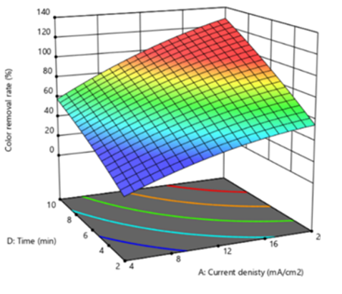
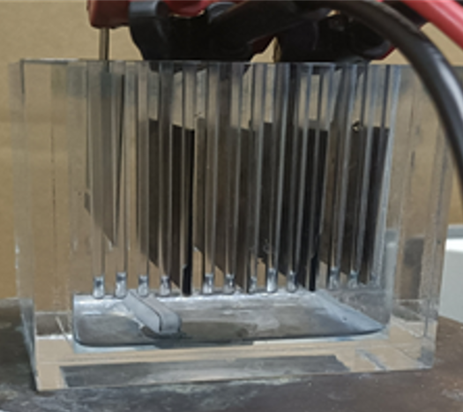
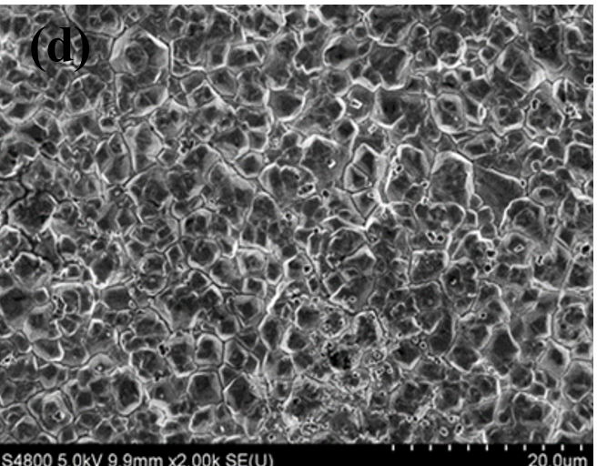

F-doped PbO₂ electrode with the best decolorization performance for methylene blue wastewater was prepared by optimizing the NaF doping concentration, and the prepared electrode has the highest oxygen evolution potential of 1.81V. The quadratic multivariate fitting model of electrolytic conditions on decolorization rate and energy consumption was established by the response surface method. The experimental results show the adjusted R² square was greater than 0.99. The optimized operation condition with the lowest energy consumption was investigated and listed as follows, current density is 9.37 mA/cm², electrolyte concentration is 0.025 M, pH value is 6.37 and electrolytic time is 10 min. The optimized energy consumption per ton of wastewater treatment is 4.60 kWh.

