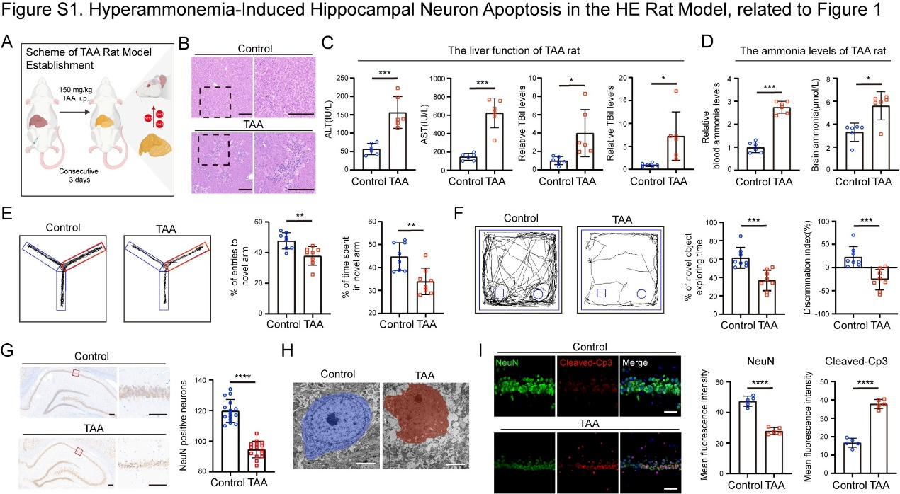

Figure S1. Hyperammonemia-Induced Hippocampal Neuron Apoptosis in the HE Rat Model, related to Figure 1.
(A) Schematic illustration of the rat model of HE induced by TAA. (B) Liver H&E staining of control and TAA mice. Bar: 50 µm. (C) Serum ALT, AST, TBil, and DBil levels in control and TAA rats. *, p < 0.05; ***, p < 0.001 by unpaired t test. (D) Blood and brain ammonia levels in control and TAA rats. *, p < 0.05; ***, p < 0.001 by unpaired t test. (E) Left: representative Y-maze exploration traces for control and TAA rats (novel arm indicated by red box); Right: percentage of entries and time spent in the novel arm. **, p < 0.01 by unpaired t test. (F) Left: representative NOR test traces for control and TAA rats (novel object indicated by square); Right: recognition index and discrimination index. ***, p < 0.001 by unpaired t test. (G) Representative images of NeuN immunohistochemistry and quantitative analysis of NeuN-positive neurons in the hippocampal CA1 region of the rat model. Bar: 200 µm. ****, p < 0.0001 by unpaired t test. (H) Representative TEM images of hippocampal neurons in rat model. Bar: 5 µm. (I) Left: Representative images of immunofluorescence staining for NeuN (green) and cleaved Caspase-3 (red) in the hippocampus for control and TAA rats. Bar: 200 µm; Right: quantification of mean fluorescence intensity for NeuN and cleaved Caspase-3. ****, p < 0.0001 by unpaired t test.

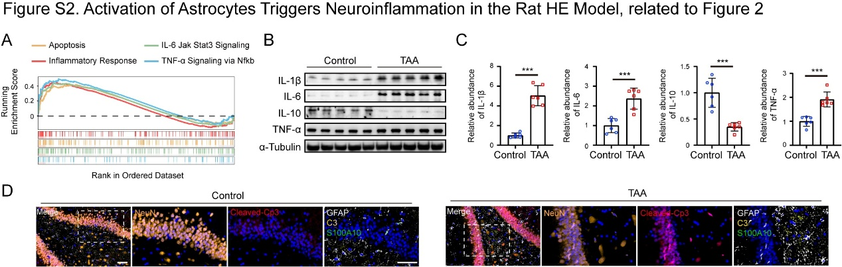

Figure S2. Activation of Astrocytes Triggers Neuroinflammation in the Rat HE Model, related to Figure 2.
(A) GSEA of hippocampal RNA-seq data from TAA versus control rats using the HALLMARK gene-set collection. (B) Western blot of IL-1β, IL-6, TNF-α and IL-10 proteins in hippocampus of TAA and control groups. (C) ELISA quantification of IL-1β, IL-6, TNF-α and IL-10 proteins in hippocampus of TAA and control groups. ***, p < 0.001 by unpaired t test. (D) Multiplex immunofluorescence of hippocampus from TAA and control rats showing GFAP (white), NeuN (orange), cleaved Caspase-3 (red), complement C3 (yellow), and S100A10 (green). Bar: 50 µm.

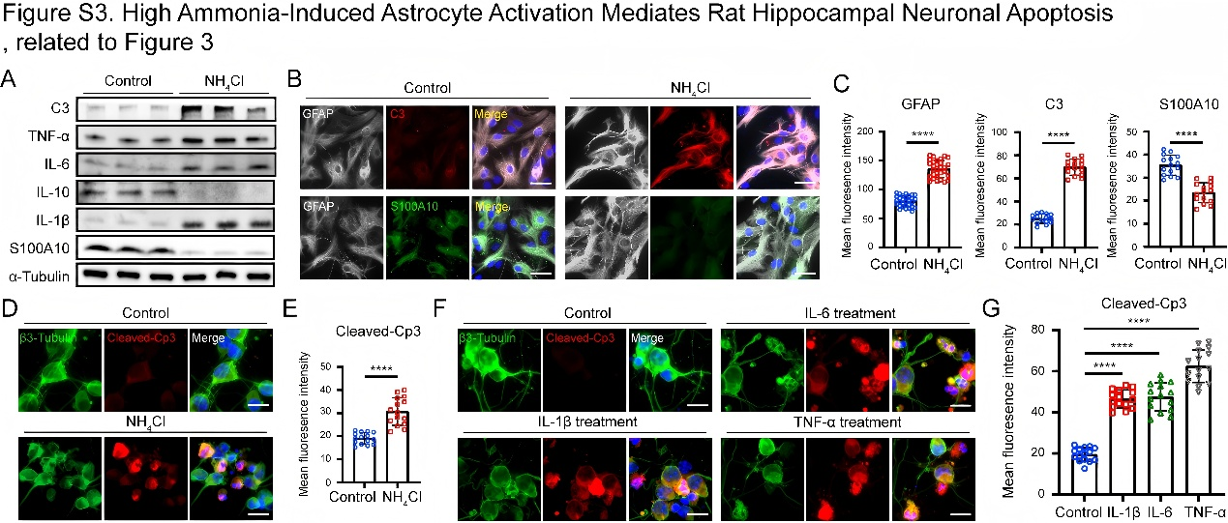

Figure S3. High Ammonia-Induced Astrocyte Activation Mediates Rat Hippocampal Neuronal Apoptosis, related to Figure 3.
(A) Western blot of complement C3, TNF-α, IL-6, IL-10, IL-1β and S100A10 in primary rat hippocampal astrocytes after 48 h NH₄Cl treatment. (B) Representative images of rat hippocampal astrocytes co-immunostained for GFAP (white) with C3 (red) or S100A10 (green). Bar: 20 µm. (C) Quantification of mean fluorescence intensity for GFAP, C3 and S100A10 in Fig.S3B. ****, p < 0.0001 by unpaired t test. (D) Representative images of primary rat hippocampal neurons exposed to conditioned medium from NH₄Cl-treated or control rat astrocytes, co-stained for β3-Tubulin (green) and cleaved Caspase-3 (red). Bar: 10 µm. (E) Quantification of mean fluorescence intensity for cleaved Caspase-3 Fig.S3D. ****, p < 0.0001 by unpaired t test. (F) Representative images of primary rat hippocampal neurons treated with IL-1β, IL-6, TNF-α or medium alone, co-stained for β3-Tubulin (green) and cleaved Caspase-3 (red). Bar: 10 µm. (G)Quantification of mean fluorescence intensity for cleaved Caspase-3 Fig.S3F. ****, p < 0.0001 by one-way ANOVA test followed by Dunnett’s post-test.

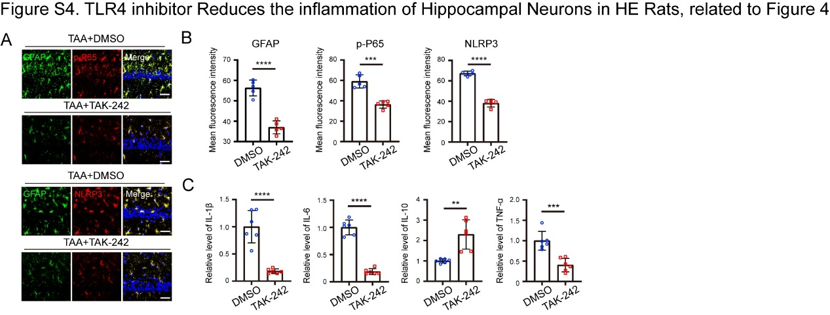

Figure S4. TLR4 inhibitor Reduces the inflammation of Hippocampal Neurons in HE Rats, related to Figure 4.
(A) Representative images of hippocampus from TAA-induced rat HE model with or without TAK-242, co-stained for GFAP with p-P65 or NLRP3. Bar: 50µm. (B) Quantification of mean fluorescence intensity for GFAP, p-P65, and NLRP3. ***, p < 0.001; ****, p < 0.0001 by unpaired t test. (C) Hippocampal lysates from TAA-induced rat HE model with or without TAK-242 analyzed for IL-1β, IL-6, TNF-α and IL-10 by ELISA. **, p < 0.01; ***, p < 0.001; ****, p < 0.0001 by unpaired t test.

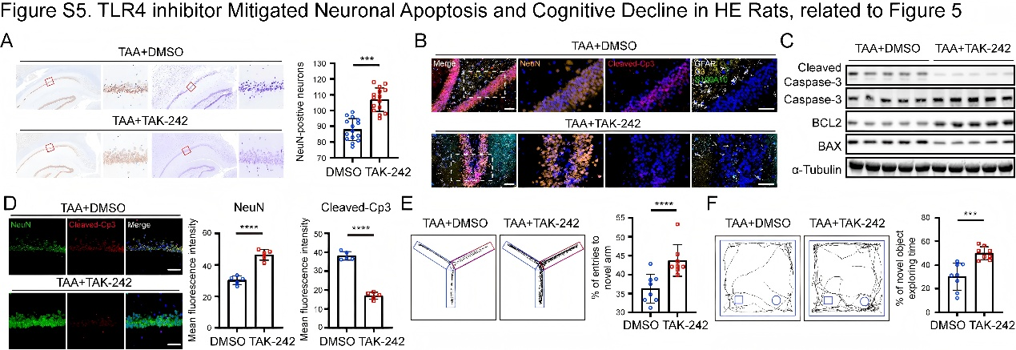

Figure S5. TLR4 inhibitor Mitigated Neuronal Apoptosis and Cognitive Decline in HE Rats, related to Figure 5.
(A) Left: Representative images of NeuN immunohistochemistry and Nissl staining of hippocampus from TAA+DMSO and TAA+TAK-242 rats. Bar: 200 µm; Right: Quantification of neuronal density based on NeuN immunohistochemistry. ***, p < 0.001 by unpaired t test. (B) Immunofluorescence of hippocampus from TAA+DMSO and TAA+TAK-242 rats showing GFAP (white), NeuN (orange), cleaved Caspase-3 (red), complement C3 (yellow), and S100A10 (green). Bar: 50 µm. (C) Western blot analysis of hippocampal lysates for cleaved Caspase-3, BAX, and BCL2 in TAA+DMSO and TAA+TAK-242 rats. (D) Left: Representative images of immunofluorescence co-staining of NeuN (green) and cleaved Caspase-3 (red) in hippocampus of TAA+DMSO and TAA+TAK-242 rats. Bar: 200 µm; Right: Quantification of mean fluorescence intensity for NeuN and cleaved Caspase-3. ****, p < 0.0001 by unpaired t test. (E) Left: Representative Y-maze exploration traces for TAA+DMSO and TAA+TAK-242 rats (novel arm indicated by red box); Right: percentage of entries in the novel arm. ****, p < 0.0001 by unpaired t test. (F) Left: Representative NOR test traces for TAA+DMSO and TAA+TAK-242 rats (novel object indicated by square); Right: Bar plot of recognition index. ***, p < 0.001 by unpaired t test.

