Supplementary Information
Deciphering the Substituent Effect on Charge Transport in Solid-State Framework Lattice
Mingyu Yang,^{‡[a]} Xinyi Zhou,^{‡[a]} Xiuxiu Zhang,^{[a]} Junjun Tan,*^{[b]} Lizhou Yang,^{[c]} Chao Yang,^{[a]} Weiren Cheng,*^{[a]} Wei Hu,*^{[a]} and Zheng Meng*^{[a]}

ª State Key Laboratory of Precision and Intelligent Chemistry, School of Chemistry and Materials Science, University of Science and Technology of China, Hefei 230026, China
^{b} Hefei National Laboratory, University of Science and Technology of China, Hefei, Anhui 230088, China
^{c} Hefei National Research Center for Physical Sciences at the Microscale, and Hefei National Laboratory, University of Science and Technology of China, Hefei, Anhui 230026, China

*E-mail:
jjtan@ustc.edu.cn (J.T.)
weiren@ustc.edu.cn (W.C.)
whuustc@ustc.edu.cn (W.H.)
zhengmeng@ustc.edu.cn (Z.M.)

Contents
1. Materials and Methods 3
2. Synthesis of Cu-HHTP-R MOFs 4
2.1. Synthesis of R-HHTP ligand 4
2.2. Synthesis of Cu-HHTP-R MOFs 29
2.3. Synthesis of Cu-HHTP-R MOF films 34
3. Structural Determination by Powder X-ray Diffraction 35
4. Fourier Transform Infrared Spectrum 43
5. Scanning Electron Microscopy 44
6. Energy-dispersive X-ray spectroscopy 45
7. Transmission Electron Microscopy 47
8. N₂ Adsorption 51
9. X-ray Photoelectron Spectroscopy 52
10. Electron Paramagnetic Resonance Spectrum 60
11. X-ray Absorption Fine Structure 61
12. Ultraviolet−Visible−Near Infrared Spectrum 67
13. Electrical Conductivity Measurement 69
14. Hall Effect Measurements 73
15. Atomic Force Microscope 75
16. Optical-Pump Terahertz-Probe Spectroscopy Measurement 76
17. Computational Study of Electronic Properties 80

Materials and Methods
All the starting materials were purchased from commercial sources and used without further purification.
Nuclear magnetic resonance (NMR) experiments were conducted on Bruker AVANCE III HD400 and JNM-ECZ600R/SI. The chemical shifts (δ) were expressed in ppm with internal standard tetramethylsilane (TMS) and solvent signals as internal references.
Electrospray ionization mass spectrometry (ESI-MS) measurements were performed with electrostatic field orbital trap mass spectrometer LTQ-Orbitrap XL.
Fourier transform infrared spectra were measured at Bruker TENSOR II using the potassium bromide (KBr) pellet method.
Powder X-ray diffraction (PXRD) measurements were performed with a Rigaku MiniFlex X-ray diffractometer with a 600 W (40 kV, 15 mA) CuKα (α= 1.54 Å) radiation source. Synchrotron radiation X-ray diffraction (SRXRD) data collected on the 1W1A- Diffuse X-ray Scattering Beamline (λ = 1.5466 Å) of Beijing Synchrotron Radiation Facility.
Images of scanning electron microscopy (SEM) were obtained using a ZEISS Gemini SEM 450 and Quanta FEG 250. Images of the transmission electron microscope (TEM) and energy-dispersive X-ray spectroscopy (EDS) data were obtained using a JEM-2100 Plus with an accelerating voltage of 200 kV.
Gas adsorption measurements were performed on a Tristar II 3030 Physisorption Analyzer and Quantachrome adsorption instrument with N₂ at 77 K.
X-ray photoelectron spectroscopy (XPS) experiments were conducted on Thermo ESCALAB250Xi spectrometer under ultrahigh vacuum (base pressure 10⁻⁷ Torr).
Electron paramagnetic resonance (EPR) spectra of Cu-HHTP-R samples were obtained using a JEOL JES-FA200 ESR spectrometer.
Cu K-edge X-ray absorption fine structure (XAFS) data were collected in transmission mode on BL-12C of Photon Factory in the High Energy Accelerator Research Organization (KEK-PF) (2.5 GeV, 450 mA).
Ultraviolet−visible−near infrared (UV–vis–NIR) spectra were acquired using a Shimadzu SolidSpec-3700DUV spectrophotometer.
The four-probe conductivity of the MOF powder was measured in Quantum Design Physical Property Measurement System (PPMS) DynaCool-14T.

Synthesis of Cu-HHTP-R MOFs

Synthesis of R-HHTP ligand
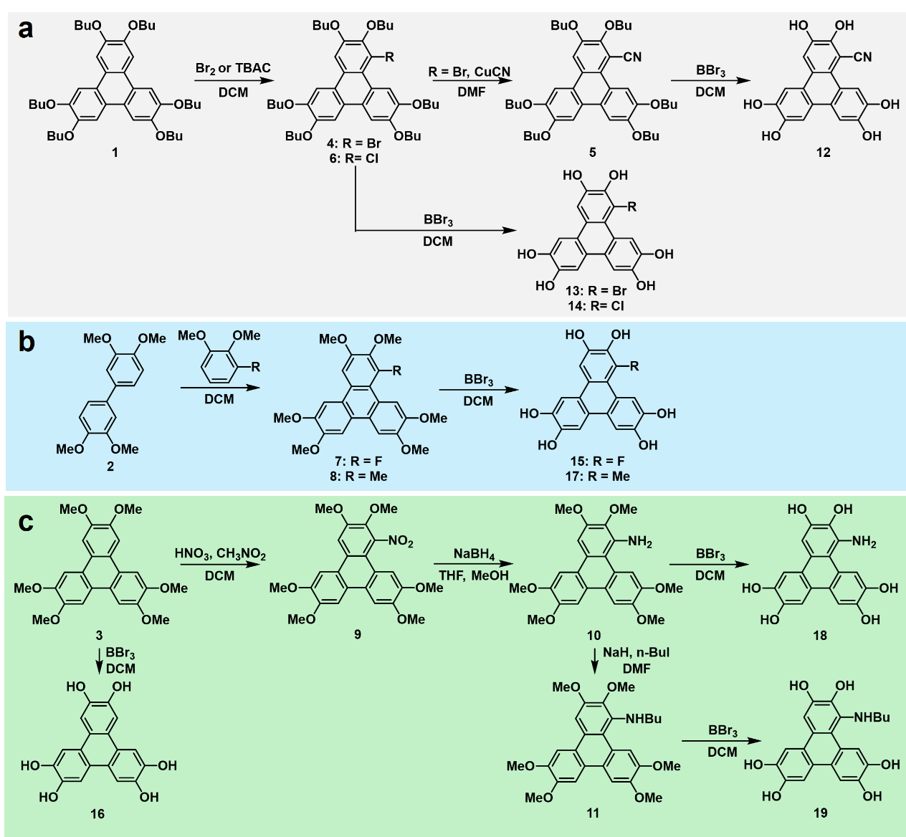
Scheme S1. Synthetic route of hexahydroxytriphenylene ligands (HHTP-R) containing different substituents. (a) Direct halogenation reaction and subsequent cyanation reaction. (b) Coupling reaction of a tetraalkoxybiphenyl with a benzene derivative. (c) Nitration reaction and the subsequent reduction reaction.

Synthesis of 2,3,6,7,10,11-hexabutoxytriphenylene (HOBuTP, 1). Compound 1 was synthesized by following the literature procedure without modification.¹
¹H NMR (600 MHz, CDCl₃) δ = 7.84 (s, 6H), 4.24 (t, J = 6.6 Hz, 12H), 1.93 (dq, J = 8.7, 6.7 Hz, 12H), 1.61 (dq, J = 9.0, 7.3 Hz, 12H), 1.04 (t, J = 7.4 Hz, 18H).
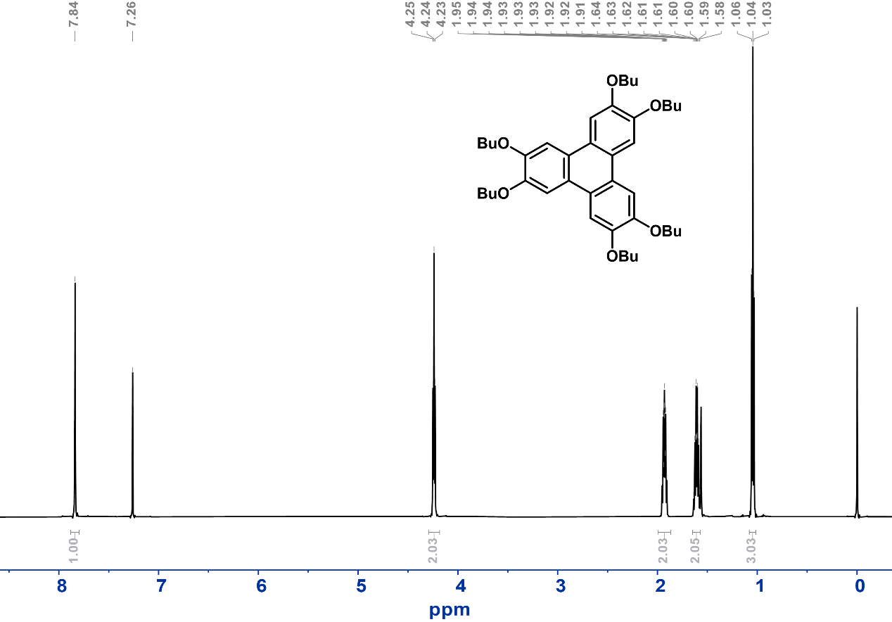
Figure S1. ¹H NMR (298 K, CDCl₃) spectrum of hexabutoxytriphenylene 1.

Synthesis of 3,3',4,4'-tetramethoxybiphenyl 2. Compound 2 was synthesized by following the literature procedure.²
¹H NMR (400 MHz, CDCl₃) δ = 7.19 – 7.02 (m, 4H), 6.93 (d, J = 8.3 Hz, 2H), 3.93 (d, J = 13.3 Hz, 12H).
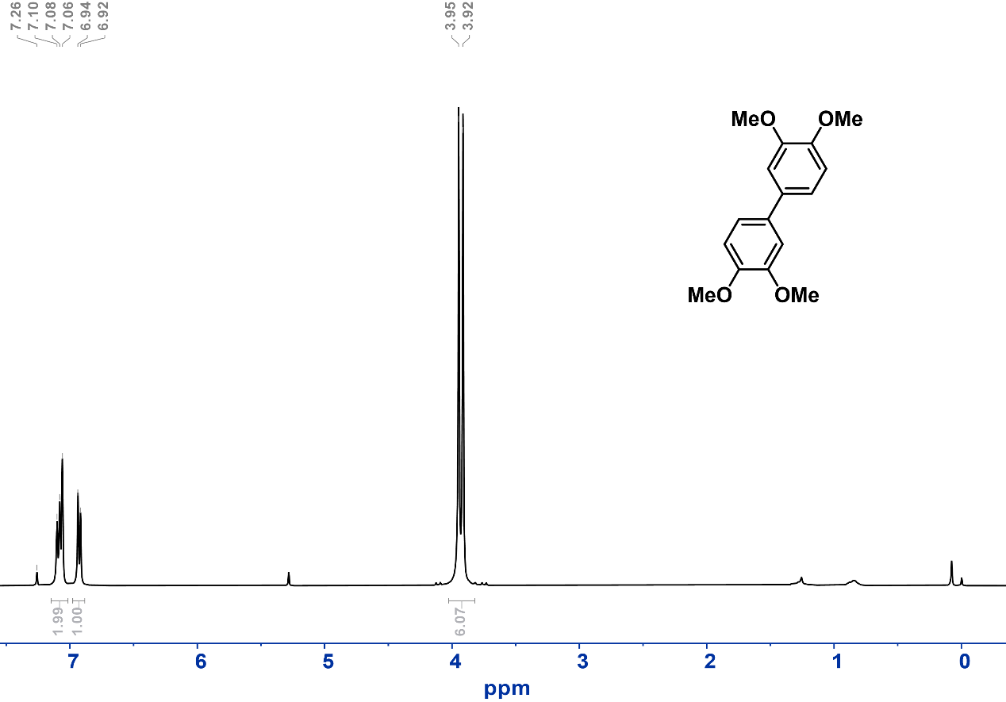
Figure S2. ¹H NMR (298 K, CDCl₃) spectrum of 3,3',4,4'-tetramethoxybiphenyl 2.
Synthesis of 2,3,6,7,10,11-hexamethoxytriphenylene 3. Compound 2 was synthesized by following the literature procedure.³
¹H NMR (400 MHz, CDCl₃) δ = 7.78 (s, 6H), 4.13 (s, 18H).
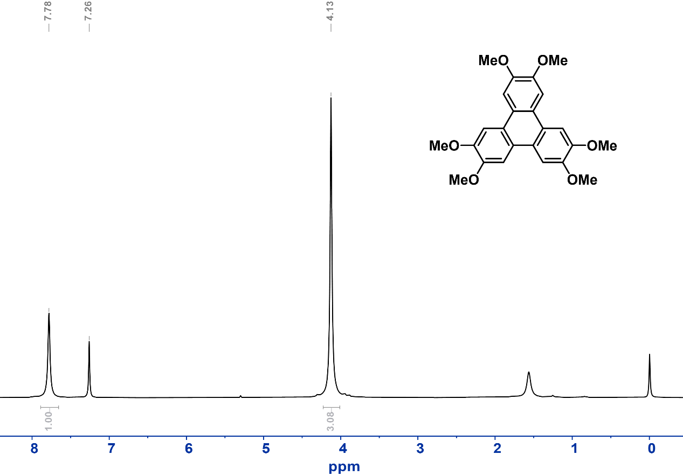
Figure S3. ¹H NMR (298 K, CDCl₃) spectrum of 3,3',4,4'-tetramethoxybiphenyl 2.

Synthesis of 1-bromo-2,3,6,7,10,11-hexabutoxytriphenylene (HOBuTP-Br, 4). Compound 4 was synthesized by following the literature procedure with modifications.⁴ At 0 °C, bromine (10 mmol, 510 μL) was slowly added dropwise to a 200 mL DCM solution of hexabutoxytriphenylene (10 mmol, 6.6 g) and stirred in the dark for 48 hours. The organic phase was washed repeatedly with sodium bisulfite aqueous solution, dried with sodium sulfate, and purified by silica gel column chromatography ( eluent, CH₂Cl₂: petro ether, 1:1, v/v) after vacuum concentration. Finally, a light pink solid was obtained (yield ~15%).
¹H NMR (400 MHz, CDCl₃) δ = 9.00 (s, 1H), 7.87 – 7.74 (m, 4H), 4.52 – 3.67 (m, 12H), 1.99 – 1.84 (m, 12H), 1.69 – 1.51 (m, 12H), 1.09 – 0.97 (m, 18H). ¹³C NMR (101 MHz, CDCl₃) δ =14.06, 14.11, 14.16, 19.48, 19.50, 19.52, 19.55, 31.45, 31.52, 31.57, 31.60, 32.48, 69.02, 69.06, 69.26, 69.53, 69.78, 73.15, 106.05, 106.72, 107.10, 108.32, 112.19, 115.58, 122.92, 123.31, 123.43, 124.69, 124.88, 127.92, 146.80, 146.87, 148.56, 148.99, 149.98, 151.24. ESI-MS: m/z calculated for (C₄₂H₅₉BrO₆) [M+H]⁺: 739.3573, found: 739.3574.
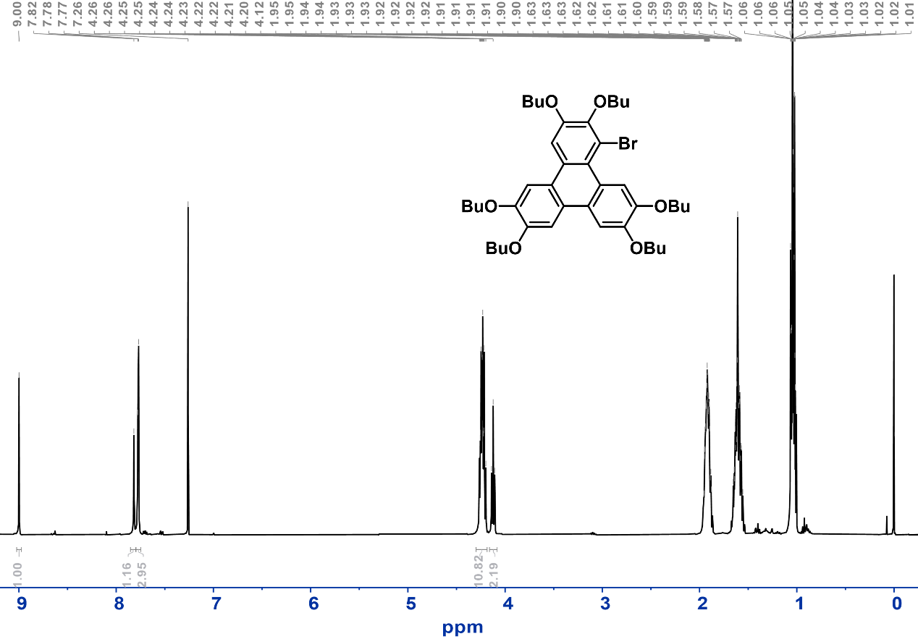
Figure S4. ¹H NMR (298 K, CDCl₃) spectrum of 1-bromo-2,3,6,7,10,11-hexabutoxytriphenylene 4.
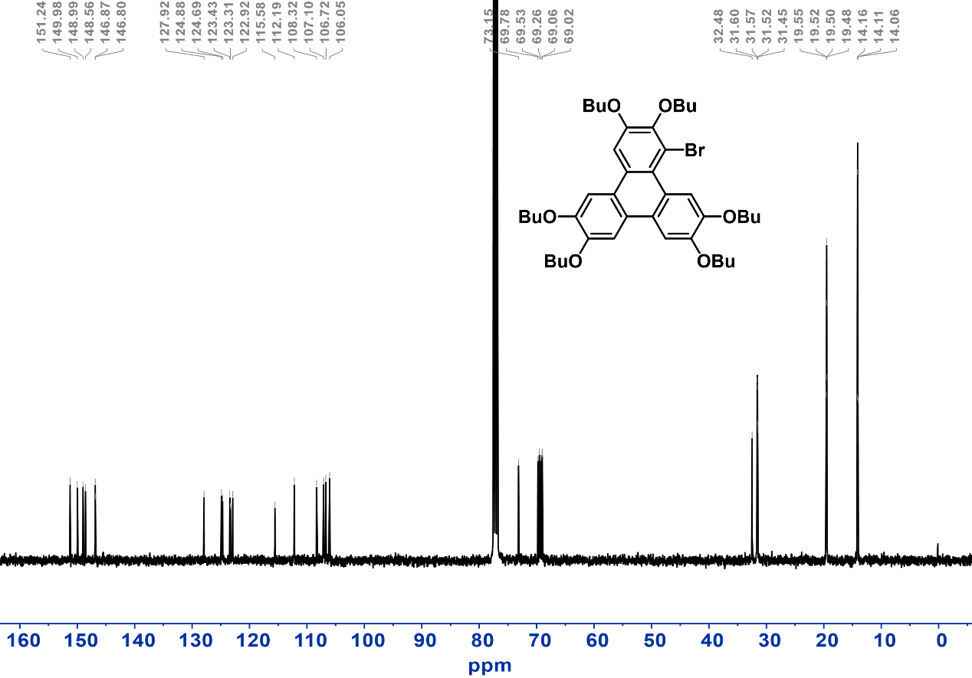
Figure S5. ¹³C NMR (298 K, CDCl₃) spectrum of 1-bromo-2,3,6,7,10,11-hexabutoxytriphenylene 4.

Synthesis of 1-cyano-2,3,6,7,10,11-hexabutoxytriphenylene (HOBuTP-CN, 5). Compound 5 was synthesized by following the literature procedure with modifications.⁵ In an N₂ atmosphere, 4 (0.41 mmol, 306 mg) was dissolved in 5 mL DMF, and CuCN (0.82 mmol, 74 mg) was added to it. The reaction was heated at 160 ℃ for 8 hours. After cooling to room temperature, ethyl acetate and ammonia solution were added. The organic phase was washed with ammonia water until the aqueous phase became colorless. After the organic phase was concentrated by rotatory evaporation, the crude product was subjected to silica gel column chromatography (eluent, CH₂Cl₂) to give compound 5 as pale yellow powder (yield ~50%).
¹H NMR (400 MHz, CDCl₃) δ = 9.06 (s, 1H), 8.05 (s, 1H), 7.91 – 7.65 (m, 3H), 4.35 – 4.17 (m, 12H), 1.93 (ddt, J = 13.2, 11.0, 5.1 Hz, 12H), 1.71 – 1.53 (m, 12H), 1.04 (dddd, J = 12.3, 8.7, 5.7, 1.4 Hz, 18H). ¹³C NMR (101 MHz, CDCl₃) δ = 14.03, 14.06, 14.10, 19.34, 19.46, 19.49, 19.51, 19.53, 19.56, 31.41, 31.49, 31.52, 31.55, 31.61, 32.51, 69.05, 69.17, 69.24, 69.62, 69.83, 74.73, 102.59, 106.62, 107.24, 108.02, 108.66, 111.56, 118.84, 122.06, 122.34, 124.14, 124.45, 124.84, 126.77, 148.97, 149.10, 149.30, 150.10, 150.32, 154.06. ESI-MS: m/z calculated for (C₄₃H₅₉NO₆) [M+H]⁺: 686.4421, found: 686.4437.
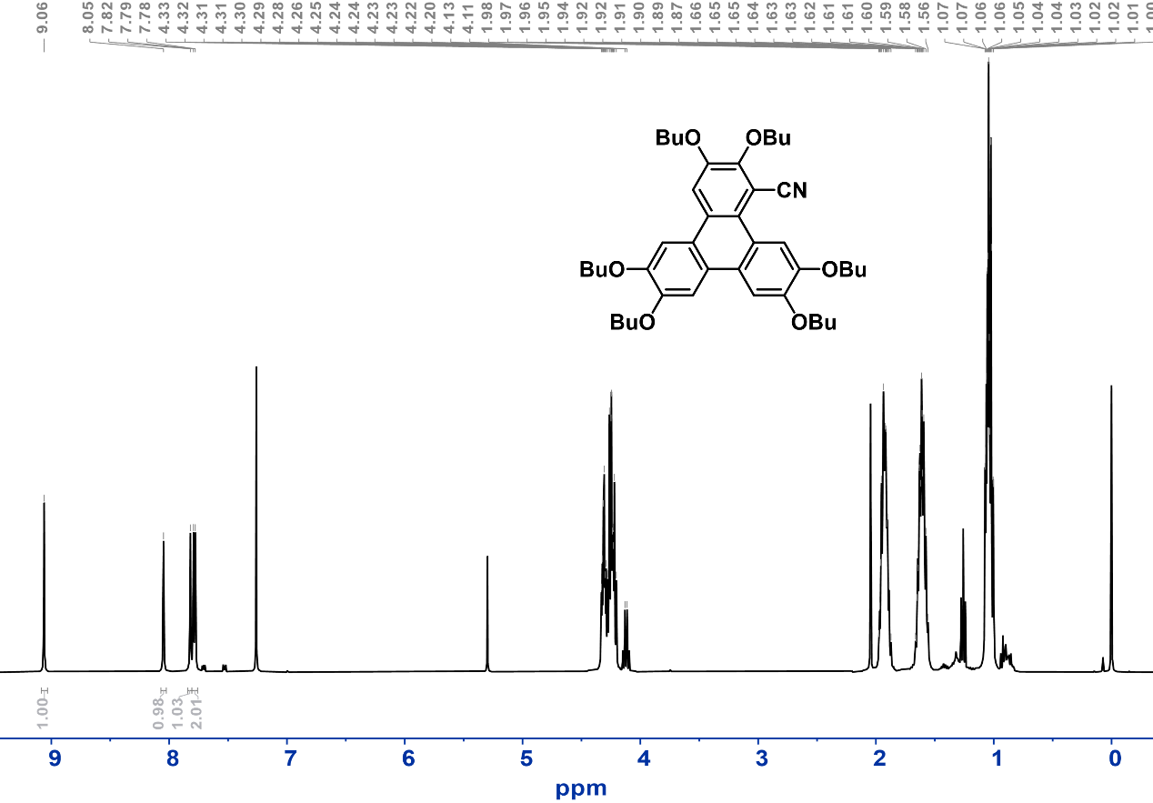
Figure S6. ¹H NMR (298 K, CDCl₃) spectrum of 1-cyano-2,3,6,7,10,11-hexabutoxytriphenylene 5.

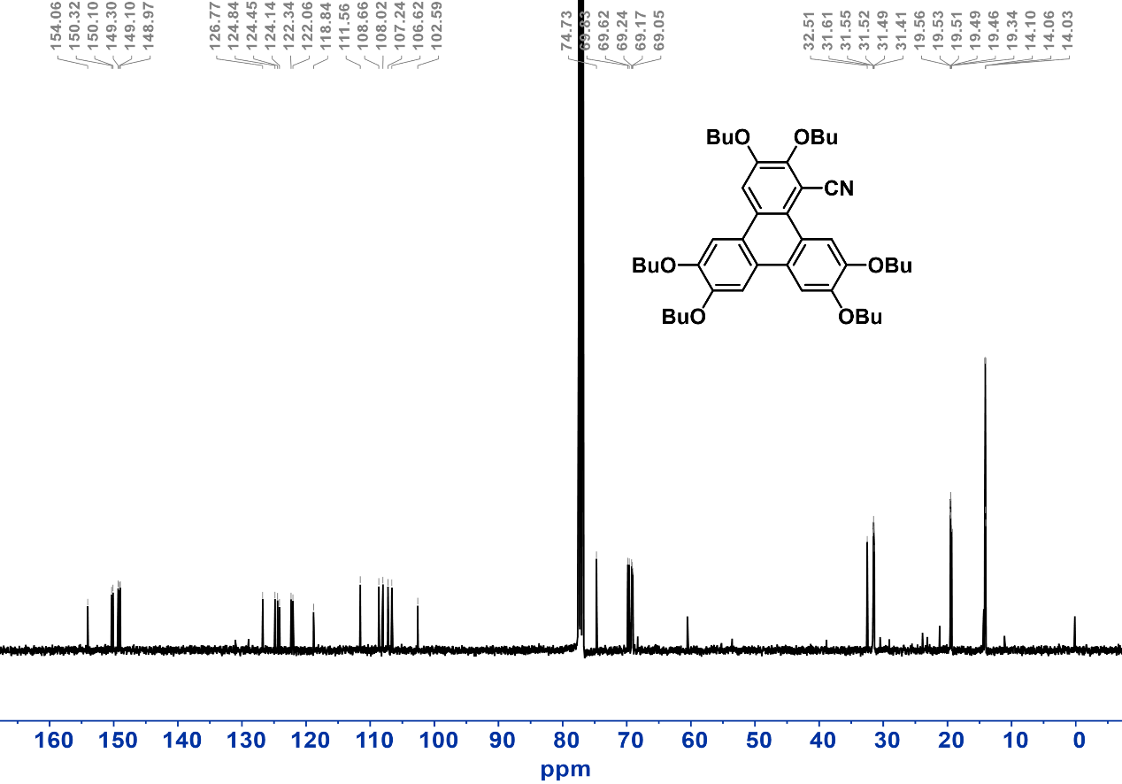
Figure S7. ¹³C NMR (298 K, CDCl₃) spectrum of 1-cyano-2,3,6,7,10,11-hexabutoxytriphenylene 5.

Synthesis of 1-chloro-2,3,6,7,10,11-hexabutoxytriphenylene (HOBuTP-Cl, 6). Compound 6 was synthesized by following the literature procedure with modifications.⁶ 792.5 mg of hexabutoxytriphenylene (1.2 mmol) was added to 45 mL of dichloromethane and cooled to 0 °C. Then [bis(trifluoroacetoxy)iodo]benzene (1.4 mmol, 0.6 g) was added, and the reaction mixture was stirred for 15 minutes with the temperature maintained below 3 °C. Tetra-n-butylammonium chloride (2.4 mmol, 0.67 g) was further added and stirred for another 15 minutes. The temperature was allowed to return to room temperature. After 20 min, the reaction mixture was poured into 100 mL of methanol for vacuum concentration. The crude product was purified by column chromatography (eluent, CH₂Cl₂: petro ether, 1:1, v/v) to give compound 6 as off-white powder (yield ~30%).
¹H NMR (400 MHz, CDCl₃) δ = 9.06 (s, 1H), 7.82 – 7.76 (m, 4H), 4.29 – 4.18 (m, 10H), 4.12 (t, J = 6.5 Hz, 2H), 1.91 (dtt, J = 15.4, 8.2, 4.1 Hz, 12H), 1.69 – 1.51 (m, 12H), 1.09 – 0.98 (m, 18H). ¹³C NMR (101 MHz, CDCl₃) δ = 14.05, 14.10, 14.13, 19.46, 19.49, 19.52, 19.55, 31.42, 31.54, 31.58, 31.61, 32.52, 68.97, 69.02, 69.29, 69.54, 69.80, 73.30, 105.40, 106.81, 107.24, 108.37, 112.01, 121.85, 123.02, 123.13, 124.82, 124.87, 125.77, 127.65, 145.75, 147.34, 148.50, 149.03, 150.02, 151.29. ESI-MS: m/z calculated for (C₄₃H₅₉ClO₆) [M+H]⁺: 695.4078, found: 695.4080.
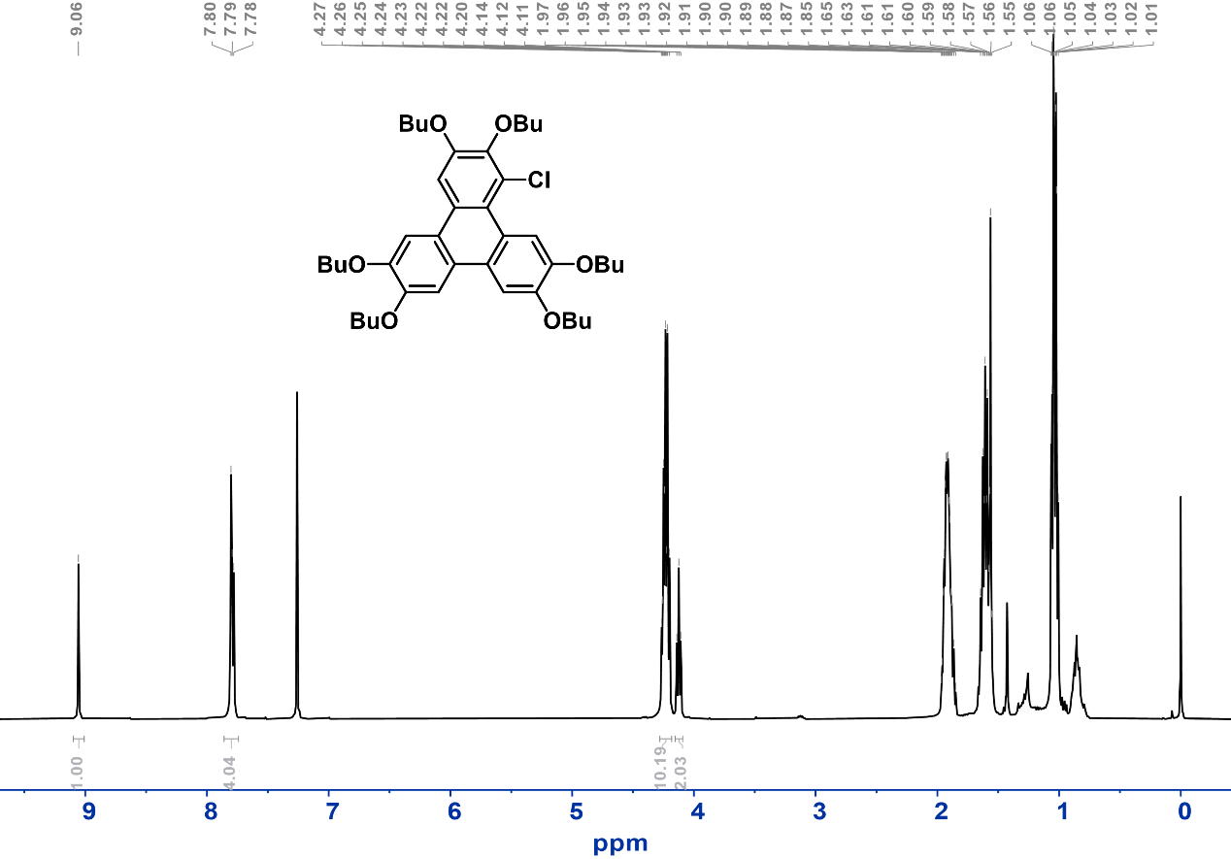
Figure S8. ¹H NMR (298 K, CDCl₃) spectrum of 1-chloro-2,3,6,7,10,11-hexabutoxytriphenylene 6.
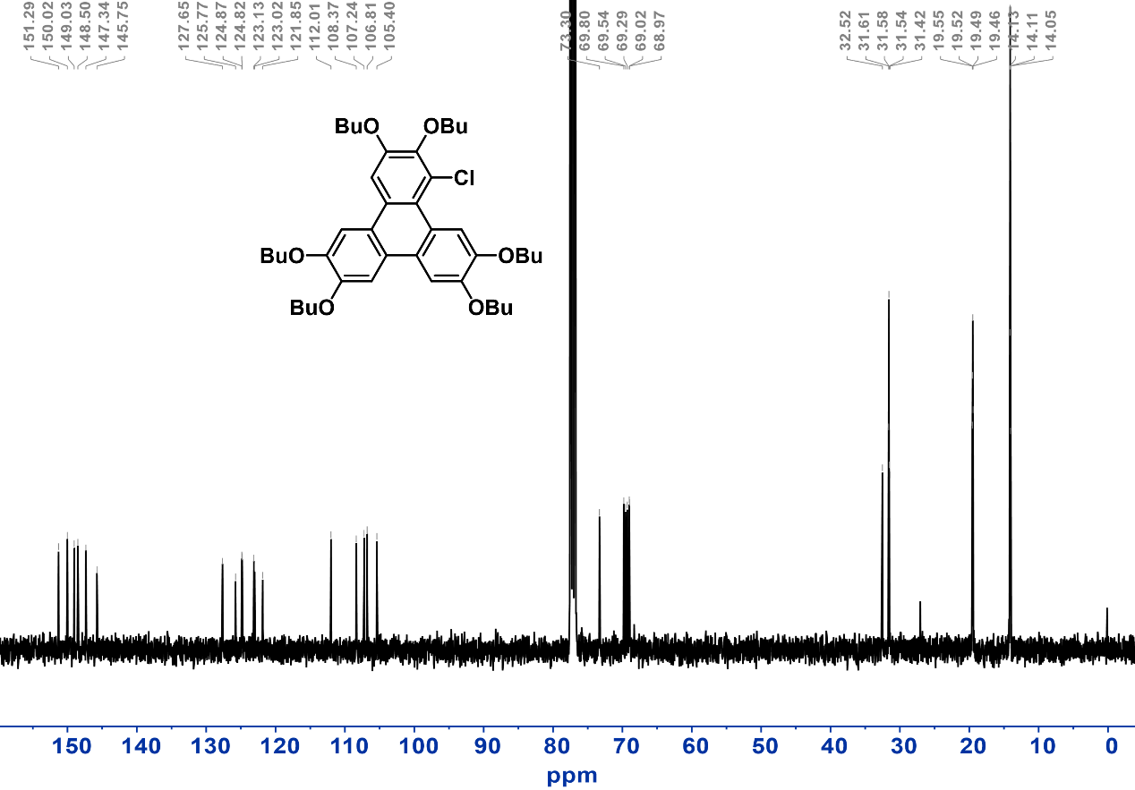
Figure S9. ¹³C NMR (298 K, CDCl₃) spectrum of 1-chloro-2,3,6,7,10,11-hexabutoxytriphenylene 6.
Synthesis of 1-fluoro-2,3,6,7,10,11-hexamethoxytriphenylene (HOMeTP-F, 7). Compound 7 was synthesized based on by following the literature procedure with modifications.^{6, 7} 3,3',4,4'-tetramethoxy-1,1'-biphenyl (1.83 mmol, 501.6 mg) was dissolved in a 15 mL DCM solution containing anhydrous FeCl₃ (18.3 mmol, 3 g). 1-fluoro-2,3-dimethoxybenzene (6.4 mmol, 1 g) was added dropwise and vigorously stirred at room temperature for 1 hour. The reaction solution was slowly poured into methanol and cooled to -78 ℃ for 2 hours. The purple precipitate was centrifuged and washed with methanol, vacuum dried, and purified by column chromatography (eluent, CH₂Cl₂) to give compound 7 as white powder (yield ~60%).
¹H NMR (600 MHz, CDCl₃) δ = 8.48 (d, J = 6.7 Hz, 1H), 7.81 – 7.76 (m, 3H), 7.67 (d, J = 1.6 Hz, 1H), 4.39 – 3.84 (m, 18H). ¹³C NMR (101 MHz, CDCl₃) δ = 55.96, 56.10, 56.20, 56.27, 56.40, 62.08, 62.11, 100.41, 100.44, 104.09, 104.40, 104.97, 108.77, 109.06, 113.65, 113.72, 121.63, 122.48, 123.84, 124.40, 126.26, 136.81, 148.62, 149.04, 149.77, 151.79. ESI-MS: m/z calculated for (C₂₄H₂₃FO₆) [M+H]⁺: 427.1557, found: 427.1556.

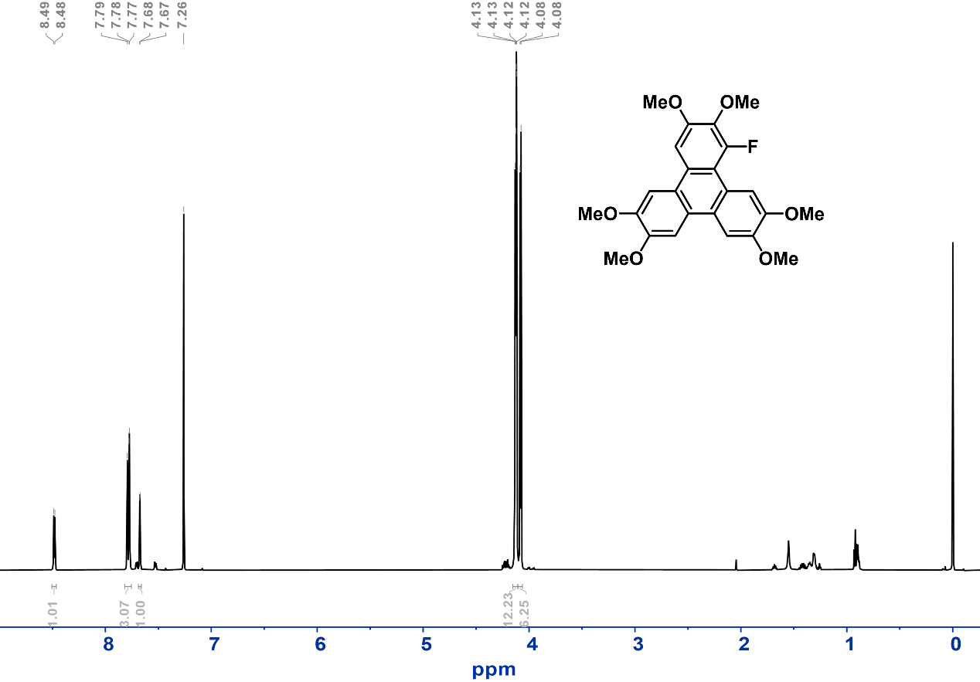
Figure S10. ¹H NMR (298 K, CDCl₃) spectrum of 1-fluoro-2,3,6,7,10,11-hexamethoxytriphenylene 7.

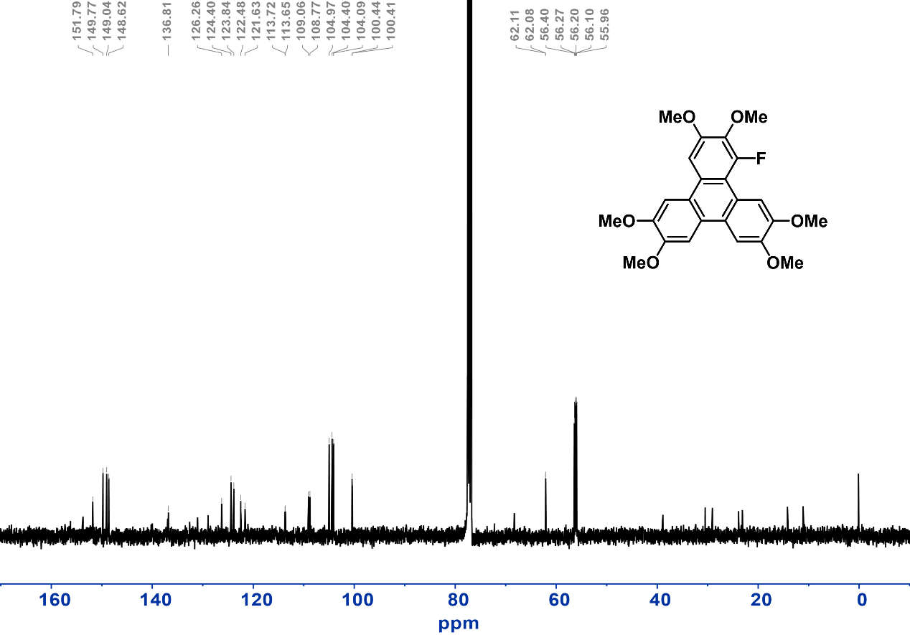
Figure S11. ¹³C NMR (298 K, CDCl₃) spectrum of 1-fluoro-2,3,6,7,10,11-hexamethoxytriphenylene 7.

Synthesis of 1-methyl-2,3,6,7,10,11-hexamethoxytriphenylene (HOMeTP-Me, 8). Compound 8 was synthesized based on the literature procedure with modifications as described below.⁸ 3,3',4,4'-tetramethoxy-1,1'-biphenyl (3.28 mmol, 0.9 g) was dissolved in a 30 mL DCM solution containing anhydrous FeCl₃ (32.8 mmol, 5.32 g). 1,2-dimethoxy-3-methylbenzene (6.57 mmol, 1 g) was added dropwise and vigorously stirred at room temperature for 1 hour. The reaction solution was slowly poured into methanol and cooled to -78 ℃ for 2 hours. The purple precipitate was centrifuged and washed with methanol, vacuum dried, and purified by column chromatography (eluent, CH₂Cl₂) to give compound 8 as a white powder (yield ~60%).
¹H NMR (600 MHz, CDCl₃) δ = 7.97 (s, 1H), 7.80 (dd, J = 17.3, 3.2 Hz, 4H), 4.16 – 4.09 (m, 12H), 4.06 (s, 3H), 3.96 (s, 3H), 2.94 (s, 3H). ¹³C NMR (101 MHz, CDCl₃) δ = 14.22, 55.89, 55.96, 56.05, 56.09, 56.14, 60.44, 60.48, 102.79, 104.12, 104.34, 104.97, 110.42, 123.56, 124.00, 124.39, 124.41, 124.76, 126.85, 127.94, 146.92, 147.90, 148.08, 148.81, 149.17, 151.17. ESI-MS: m/z calculated for (C₂₅H₂₆O₆) [M+H]⁺: 423.1808, found: 423.1808.
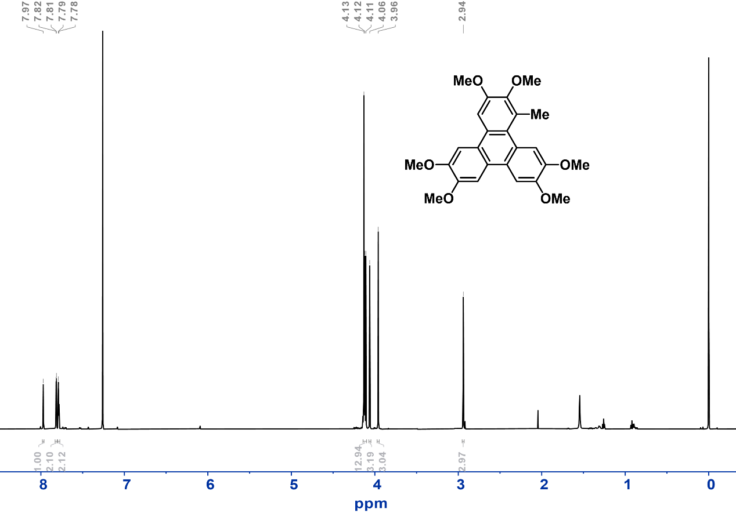
Figure S12. ¹H NMR (298 K, CDCl₃) spectrum of 1-methyl-2,3,6,7,10,11-hexamethoxytriphenylene 8.

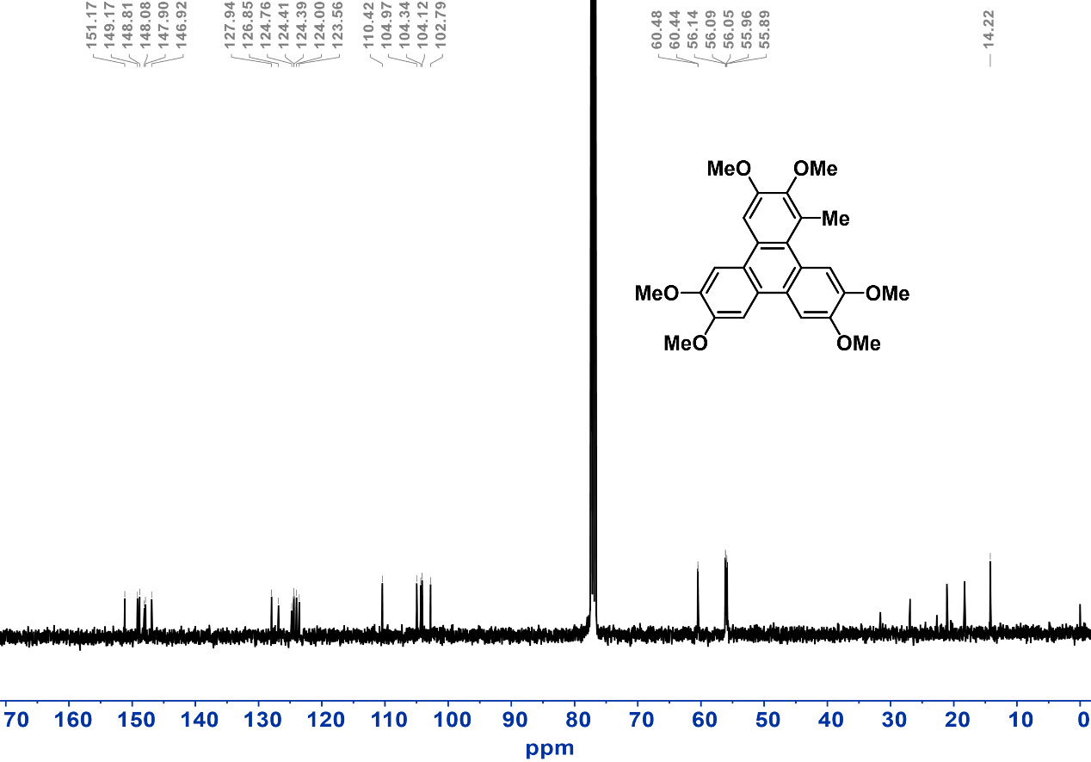
Figure S13. ¹³C NMR (298 K, CDCl₃) spectrum of 1-methyl-2,3,6,7,10,11-hexamethoxytriphenylene 8.

Synthesis of 1-nitro-2,3,6,7,10,11-hexamethoxytriphenylene (HOMeTP-NO₂, 9). Compound 9 was synthesized by following the literature procedure with modifications.⁹ Hexamethoxytriphenylene (3.8 mmol, 1.55 g) was dissolved in a mixed solution of DCM (50 mL) and nitromethane (100 mL), and fuming nitric acid (0.25 mL) was slowly added and stirred at room temperature for 2 hours. After the reaction was complete, the organic phase was washed with deionized water and dried using anhydrous sodium sulfate. The liquid phase was concentrated under vacuum and purified by silica gel column chromatography (eluent, ethyl acetate: CH₂Cl₂, 1:20, v/v) to give compound 9 as a yellow powder (yield ~50%).
¹H NMR (400 MHz, CDCl₃) δ = 7.92 (s, 1H), 7.77 – 7.70 (m, 3H), 7.47 (s, 1H), 4.25 – 3.84 (m, 18H). ESI-MS: m/z calculated for (C₂₄H₂₃NO₈) [M+H]⁺: 454.1502, found: 454.1505.
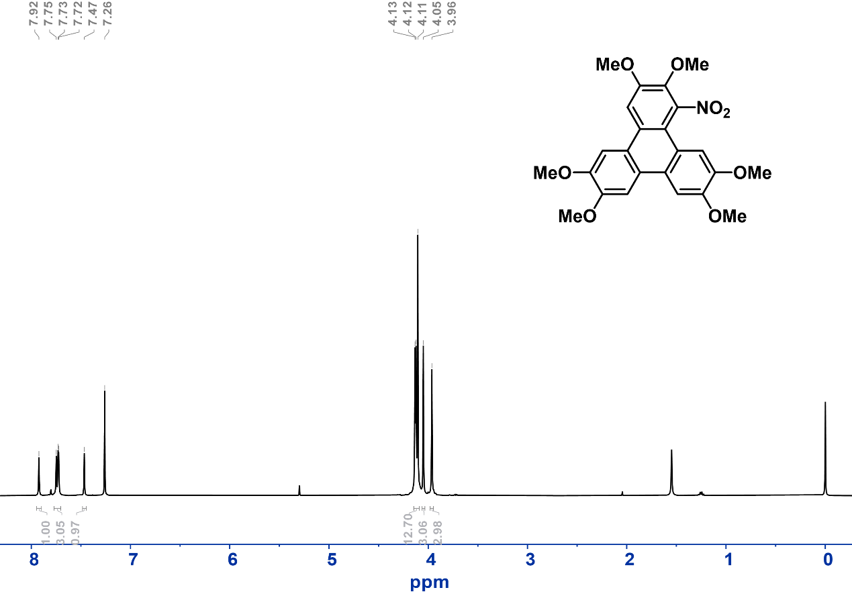
Figure S14. ¹H NMR (298 K, CDCl₃) spectrum of 1-nitro-2,3,6,7,10,11- hexamethoxytriphenylene 9.

Synthesis of 1-amino-2,3,6,7,10,11-hexamethoxytriphenylene (NH₂-HOMeTP-NH₂, 10). Compound 10 was synthesized by following the literature procedure with modifications.¹⁰ 9 (3.3 mmol, 1.5 g) was dissolved in a mixed solution of tetrahydrofuran (72 mL) and methanol (18 mL), and Ni(OAc)₂·4H₂O (0.82 g) was added and stirred for 5 minutes. Subsequently, sodium borohydride (624 mg) was slowly added and vigorously stirred for 30 minutes. At the end of the reaction, it was diluted with ethyl acetate and the solid was removed by alkaline alumina filtration. The organic phase was concentrated under vacuum to obtain compound 10 as beige powder (yield ~70%), which did not require further purification.
¹H NMR (400 MHz, CDCl₃) δ = 8.85 (s, 1H), 7.84 – 7.73 (m, 3H), 7.40 (s, 1H), 4.69 (s, 2H), 4.18 – 3.95 (m, 18H). ESI-MS: m/z calculated for (C₂₄H₂₆NO₆) [M+H]⁺: 424.1760, found: 424.1762.

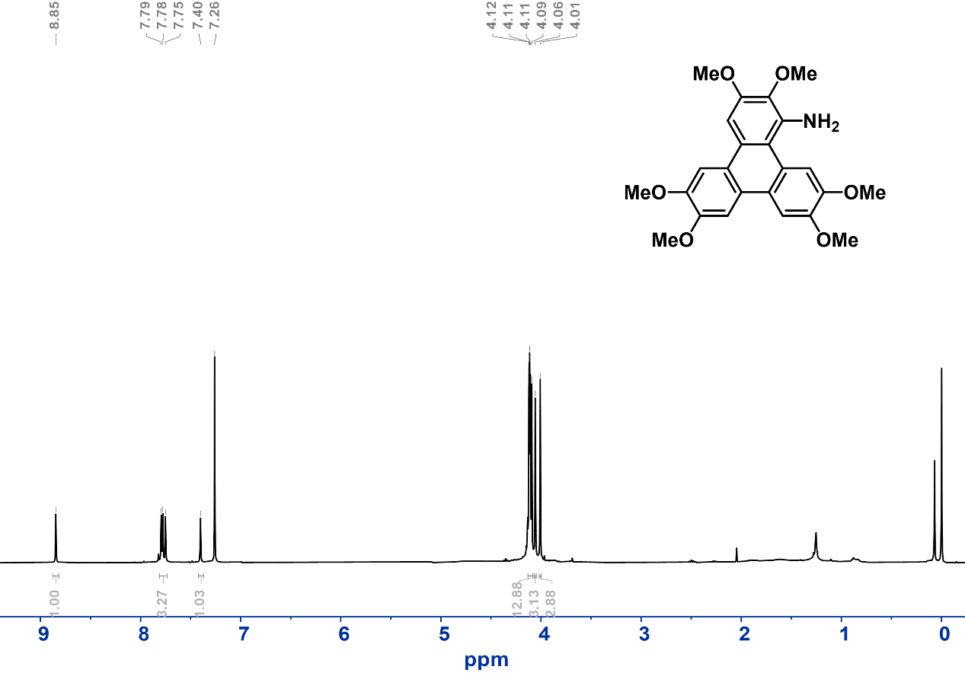
Figure S15. ¹H NMR (298 K, CDCl₃) spectrum of 1-amino-2,3,6,7,10,11-hexamethoxytriphenylene 10.

Synthesis of 1-butylamino-2,3,6,7,10,11-hexamethoxytriphenylene (HOMeTP-NHBu, 11). In an N₂ atmosphere, 10 (1.418 mmol, 600 mg) was dissolved in 15 mL of dry DMF. Upon addition of NaH (60% in mineral oil, 284 mg), the solution was observed to darken. After adding 1-iodobutane (813 μL) to the system, heated at 120 °C for 24 hours. Once the reaction was complete, the reaction mixture was allowed to cool to room temperature and was then poured into an ammonium chloride aqueous solution. The organic phase was further extracted using ethyl acetate, concentrated and dried under vacuum, and then purified by column chromatography (alkaline alumina, eluent: ethyl acetate), yielding compound 11 as a yellow-green ointment (yield ~50%).
¹H NMR (600 MHz, CDCl₃) δ = 9.46 (s, 1H), 7.77 (s, 2H), 7.73 (s, 1H), 7.50 (s, 1H), 4.72 (s, 1H), 4.15 – 4.08 (m, 12H), 4.04 (s, 3H), 3.98 (s, 3H), 2.95 (t, J = 7.3 Hz, 2H), 1.50 (pd, J = 7.4, 1.6 Hz, 2H), 1.32 – 1.23 (m, 2H), 0.83 (t, J = 7.4 Hz, 3H). ¹³C NMR (151 MHz, CDCl₃) δ = 14.10, 14.34, 20.39, 21.22, 33.07, 49.47, 55.99, 56.02, 56.21, 56.24, 60.56, 61.41, 98.47, 103.92, 104.34, 105.32, 108.35, 116.42, 123.22, 123.75, 124.37, 124.50, 127.59, 140.12, 147.82, 147.89, 148.74, 149.29, 150.99. ESI-MS: m/z calculated for (C₂₈H₃₃NO₆) [M+H]⁺: 480.2386, found: 480.2374.
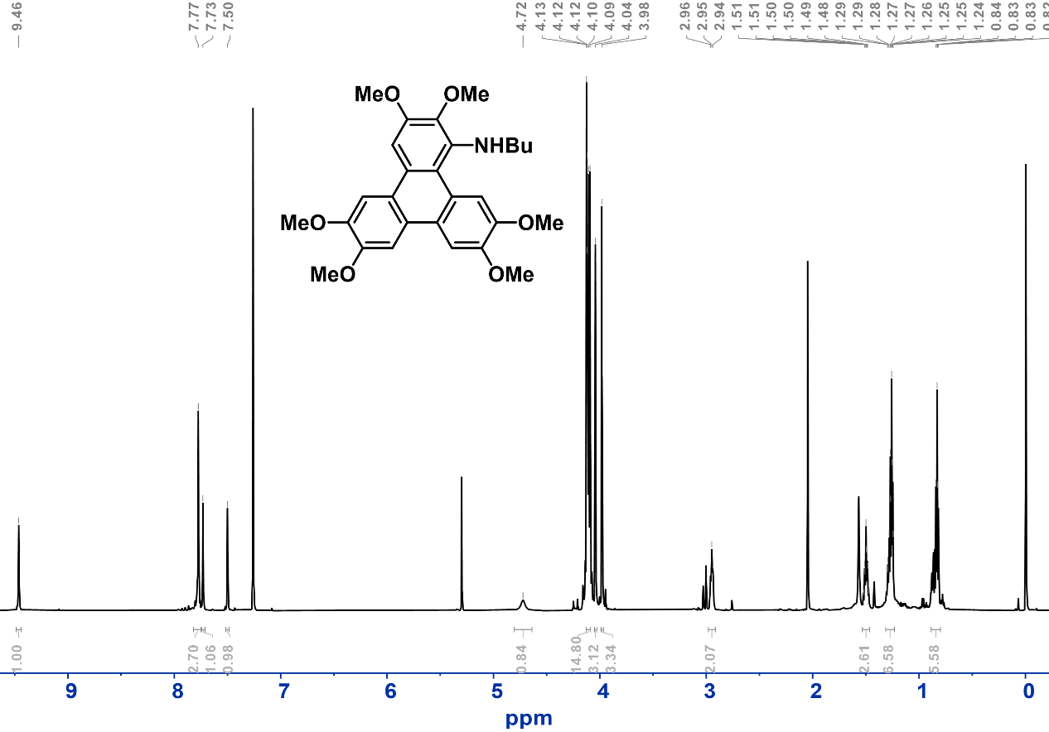
Figure S16. ¹H NMR (298 K, CDCl₃) spectrum of 1-butylamino-2,3,6,7,10,11-hexamethoxytriphenylene 11.

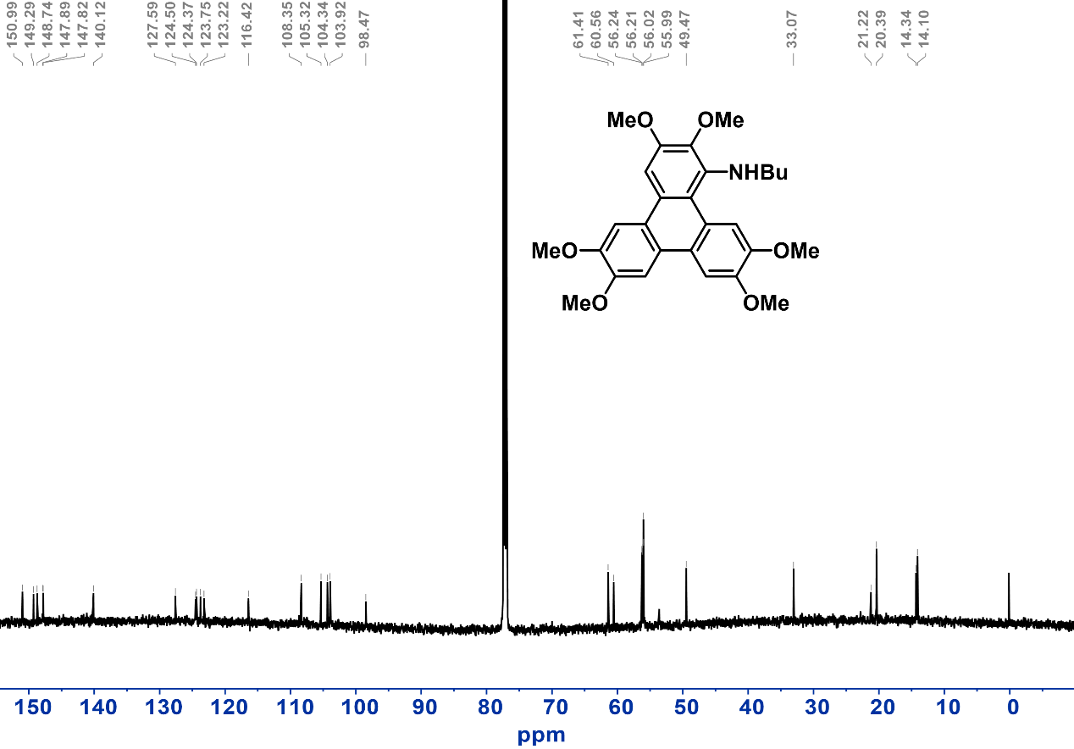
Figure S17. ¹³C NMR (298 K, CDCl₃) spectrum of 1-butylamino-2,3,6,7,10,11-hexamethoxytriphenylene 11.

Synthesis of 1-cyano-2,3,6,7,10,11-hexahydroxytriphenylene (HHTP-CN, 12). In an N₂ atmosphere, 5 (0.29 mmol, 200 mg) was dissolved in 15 mL of DCM. After the reaction solution was cooled to -78 °C, BBr₃ (5.25 mmol, 0.5 ml) was added, and the mixture was then vigorously stirred for 48 hours. After completion, the reaction was quenched with ice water. The yellow precipitate was collected by centrifugation to give compound 12 as a dark yellow powder (yield ~40%).
¹H NMR (600 MHz, DMSO-d₆) δ = 8.73 (s, 1H), 7.99 (s, 1H), 7.73 – 7.60 (m, 3H). ¹³C NMR (101 MHz, DMSO-d₆) δ = 92.92, 107.64, 107.84, 110.27, 112.13, 118.87, 120.19, 120.97, 121.51, 122.30, 122.49, 123.61, 144.10, 144.64, 145.81, 146.30, 152.35. ESI-MS: m/z calculated for (C₁₉H₁₁NO₆) [M-H]⁻: 348.0508, found: 348.0499.
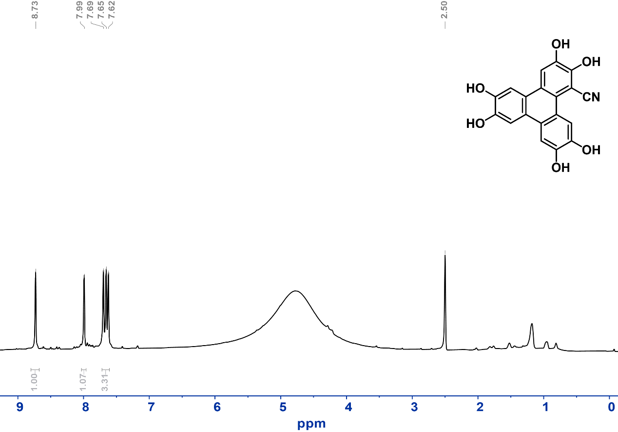
Figure S18. ¹H NMR (298 K, DMSO-d₆) spectrum of 1-cyano-2,3,6,7,10,11-hexahydroxytriphenylene 12.

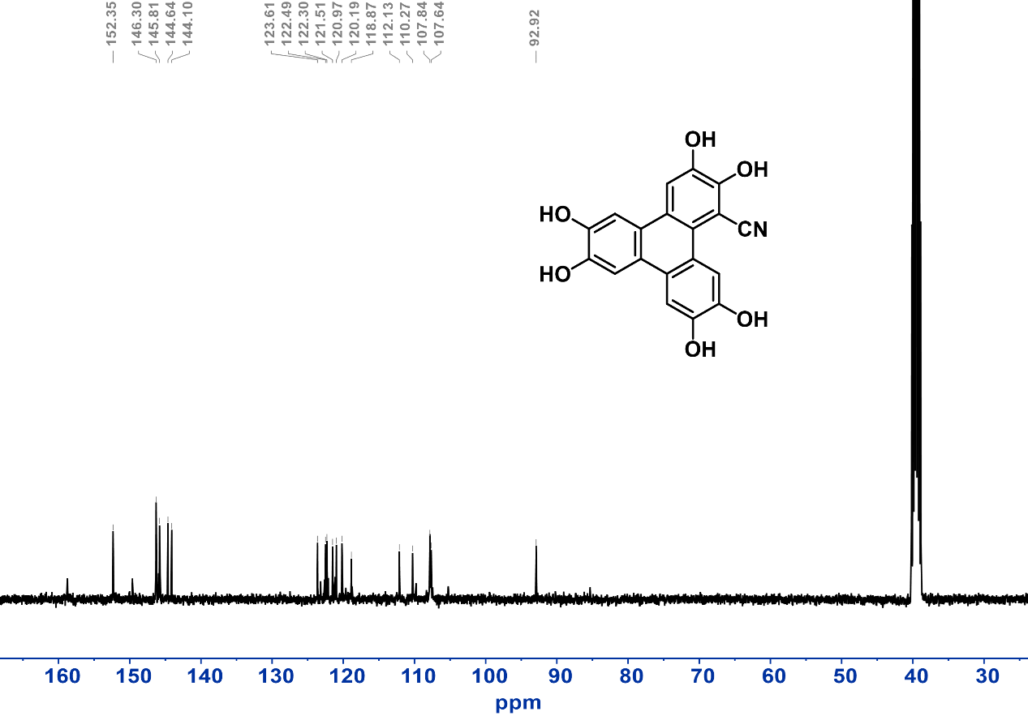
Figure S19. ¹³C NMR (298 K, DMSO-d₆) spectrum of 1-cyano-2,3,6,7,10,11-hexahydroxytriphenylene 12.

Synthesis of 1-bromo-2,3,6,7,10,11-hexahydroxytriphenylene (HHTP-Br, 13). In an N₂ atmosphere, 4 (0.2 mmol, 150 mg) was dissolved in 20 mL of DCM. After the reaction solution was cooled to -78 °C, BBr₃ (2 mmol, 0.2 ml) was added, and the mixture was then vigorously stirred for 48 hours in the dark. After completion, the mixture was recooled to -78 °C, quenched slowly with deoxygenated ice methanol, and the grey precipitate was collected and carefully washed with DCM to give compound 13 as gray-green powder (yield ~30%).
¹H NMR (600 MHz, DMSO-d₆) δ = 8.81 (s, 1H), 7.70 (s, 1H), 7.60 – 7.57 (m, 3H). ¹³C NMR (151 MHz, DMSO-d₆) δ = 106.06, 106.54, 107.57, 107.78, 108.01, 113.28, 121.06, 121.35, 121.84, 122.34, 123.55, 123.68, 142.85, 143.73, 144.59, 145.28, 145.56, 145.92. ESI-MS: m/z calculated for (C₁₈H₁₁BrO₆) [M+H]⁺: 402.9817, found: 402.9815.
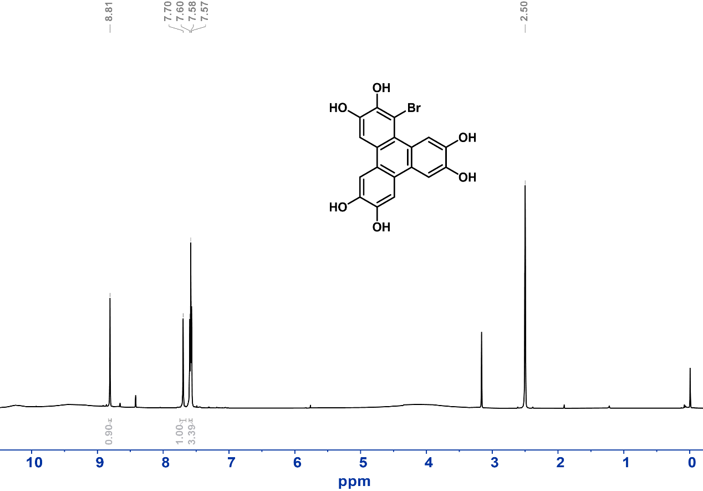
Figure S20. ¹H NMR (298 K, DMSO-d₆) spectrum of 1-bromo-2,3,6,7,10,11-hexahydroxytriphenylene 13.

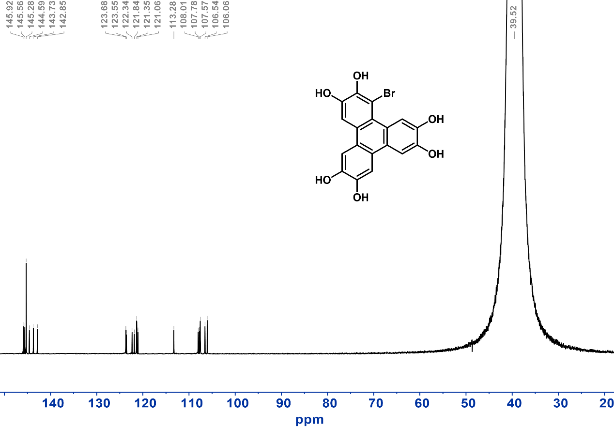
Figure S21. ¹³C NMR (298 K, DMSO-d₆) spectrum of 1-bromo-2,3,6,7,10,11-hexahydroxytriphenylene 13.

Synthesis of 1-chloro-2,3,6,7,10,11-hexahydroxytriphenylene (HHTP-Cl, 14). In an N₂ atmosphere, 6 (0.29 mmol, 200 mg) was dissolved in 15 mL of DCM. After the reaction solution was cooled to -78 °C, BBr₃ (3.5 mmol, 0.34 ml) was then added, and the mixture was then vigorously stirred for 12 hours. After completion, the reaction was quenched with ice water. The white precipitate was collected by centrifugation to give compound 14 as a pale green powder (yield ~30%).
¹H NMR (600 MHz, DMSO-d₆) δ = 8.87 (s, 1H), 7.70 (s, 1H), 7.68 – 7.59 (m, 3H). ¹³C NMR (151 MHz, DMSO-d₆) δ = 106.22, 107.64, 107.80, 108.11, 113.00, 116.40, 119.53, 121.00, 121.41, 122.37, 123.37, 123.68, 142.58, 143.38, 144.79, 145.18, 145.61, 146.00. ESI-MS: m/z calculated for (C₁₈H₁₁ClO₆) [M-H]⁻: 357.0166, found: 357.0177.
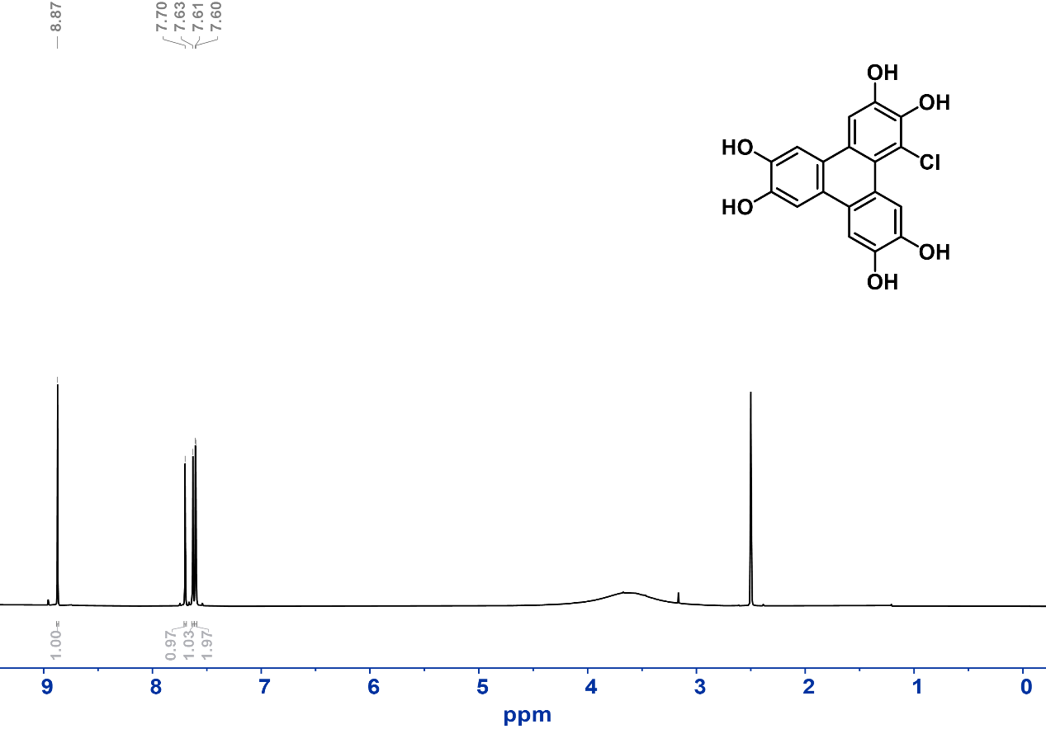
Figure S22. ¹H NMR (298 K, DMSO-d₆) spectrum of 1-chloro-2,3,6,7,10,11-hexahydroxytriphenylene 14.
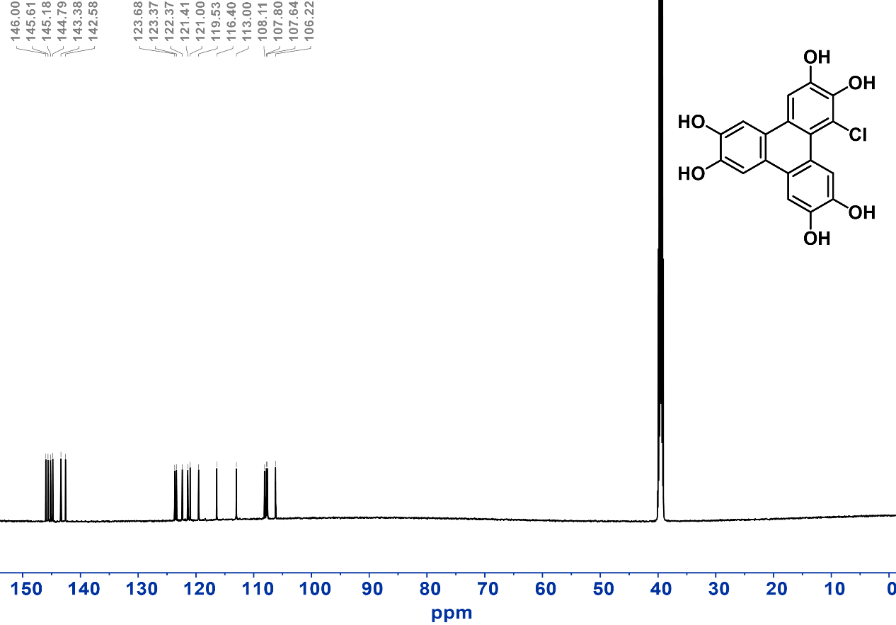
Figure S23. ¹³C NMR (298 K, DMSO-d₆) spectrum of 1-chloro-2,3,6,7,10,11-hexahydroxytriphenylene 14.

Synthesis of 1-fluoro-2,3,6,7,10,11-hexahydroxytriphenylene (HHTP-F, 15). In an N₂ atmosphere, 7 (0.47 mmol, 200 mg) was dissolved in 100 mL of DCM. After the reaction solution was cooled to -78 °C, BBr₃ (8.44 mmol, 0.81 ml) was then added, and the mixture was then vigorously stirred for 12 hours. After completion, the reaction was quenched with water. The white precipitate was collected by centrifugation to give compound 15 as ivory white powder (yield ~70%).
¹H NMR (600 MHz, DMSO-d₆) δ = 8.22 (d, J = 3.9 Hz, 1H), 7.66 (s, 1H), 7.62 (d, J = 3.7 Hz, 2H), 7.54 (s, 1H). ¹³C NMR (151 MHz, DMSO-d₆) δ = 103.16, 107.77, 107.81, 108.08, 111.12, 111.16, 112.13, 112.31, 119.55, 119.58, 121.02, 121.69, 121.72, 122.25, 122.69, 132.92, 133.03, 144.77, 145.13, 145.55, 145.92, 145.95, 149.00, 150.60. ESI-MS: m/z calculated for (C₁₈H₁₁FO₆) [M-H]⁻: 341.0461, found: 341.0554.
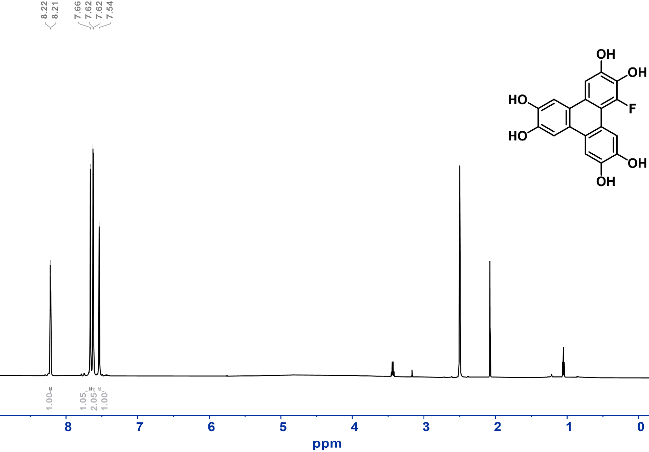
Figure S24. ¹H NMR (298 K, DMSO-d₆) spectrum of 1-fluoro-2,3,6,7,10,11-hexahydroxytriphenylene 15.

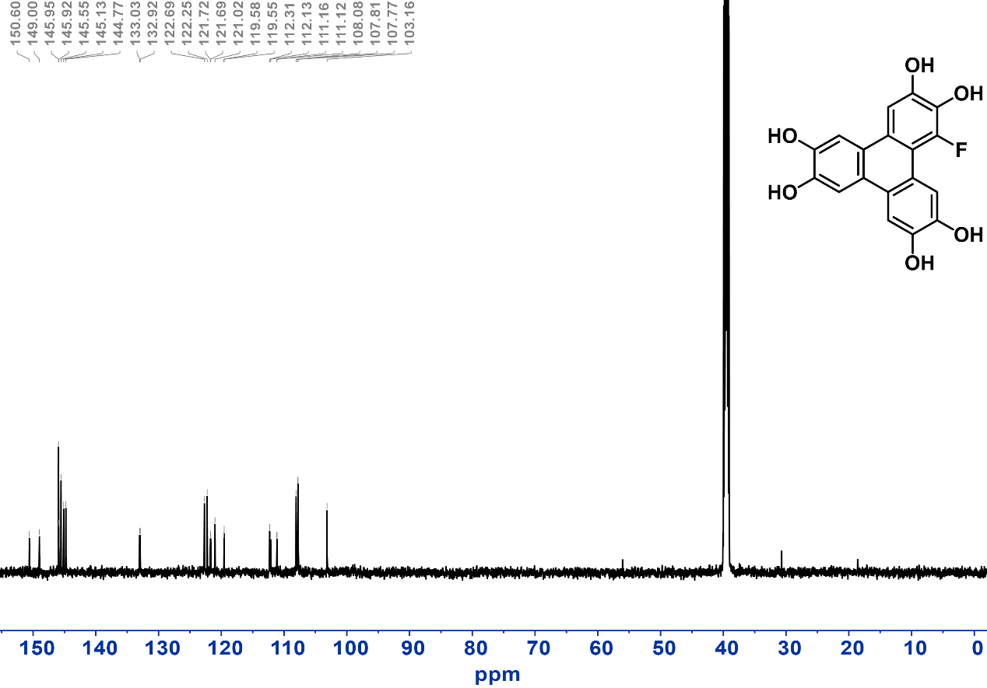
Figure S25. ¹³C NMR (298 K, DMSO-d₆) spectrum of 1-fluoro-2,3,6,7,10,11-hexahydroxytriphenylene 15.

Synthesis of 2,3,6,7,10,11-hexahydroxytriphenylene (HHTP, 16). In an N₂ atmosphere, 3 (0.49 mmol, 200 mg) was dissolved in 100 mL of DCM. After the reaction solution was cooled to -78 °C, BBr₃ (8.82 mmol, 0.85 ml) was then added, and the mixture was then vigorously stirred for 24 hours. After completion, the reaction was quenched with water. The white precipitate was collected by centrifugation to give compound 16 as ivory white powder (yield ~80%).
¹H NMR (400 MHz, DMSO-d₆) δ = 9.29 (s, 6H), 7.62 (s, 6H).
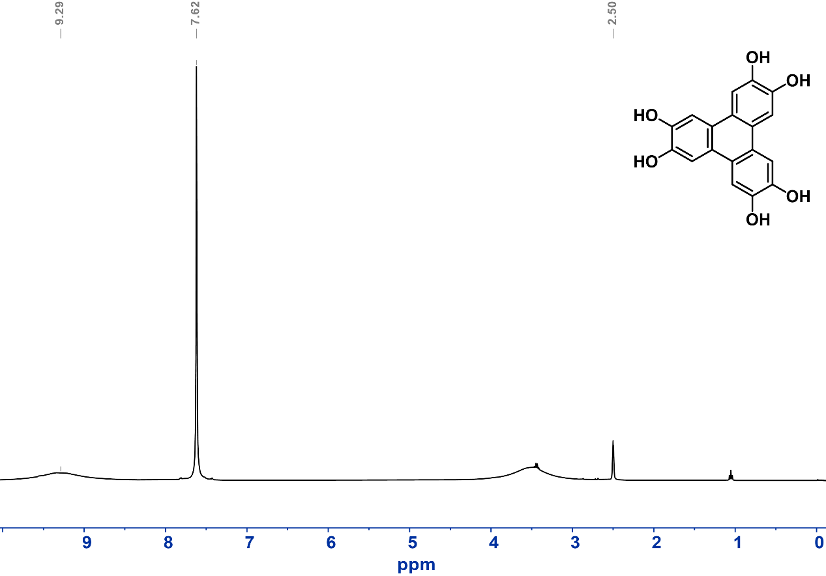
Figure S26. ¹H NMR (298 K, DMSO-d₆) spectrum of 2,3,6,7,10,11-hexahydroxytriphenylene 16.

Synthesis of 1-methyl-2,3,6,7,10,11-hexahydroxytriphenylene (HHTP-Me, 17). In an N₂ atmosphere, 8 (0.47 mmol, 200 mg) was dissolved in 100 mL of DCM. After the reaction solution was cooled to -78 °C, BBr₃ (8.53 mmol, 0.82 ml) was then added, and the mixture was then vigorously stirred for 24 hours. After completion, the reaction was quenched with water. The white precipitate was collected by centrifugation to give compound 17 as a dark green powder (yield ~70%).
¹H NMR (600 MHz, DMSO-d₆) δ = 7.83 (s, 1H), 7.62 (s, 1H), 7.59 (d, J = 2.9 Hz, 3H), 2.68 (s, 3H). ¹³C NMR (151 MHz, DMSO-d₆) δ = 18.24, 104.87, 107.66, 107.98, 108.04, 113.77, 119.61, 122.21, 122.39, 122.73, 122.94, 123.06, 123.37, 143.35, 143.86, 144.03, 144.37, 145.31. ESI-MS: m/z calculated for (C₁₉H₁₄O₆) [M]⁺: 338.0790, found: 338.0820.
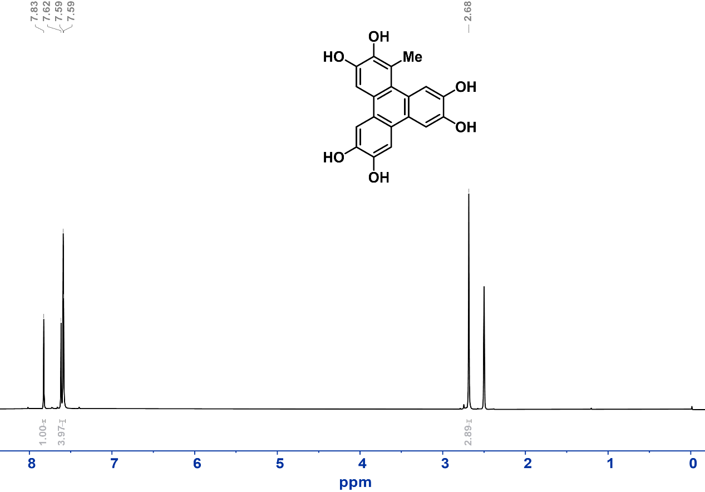
Figure S27. ¹H NMR (298 K, DMSO-d₆) spectrum of 1-methyl-2,3,6,7,10,11-hexahydroxytriphenylene 17.
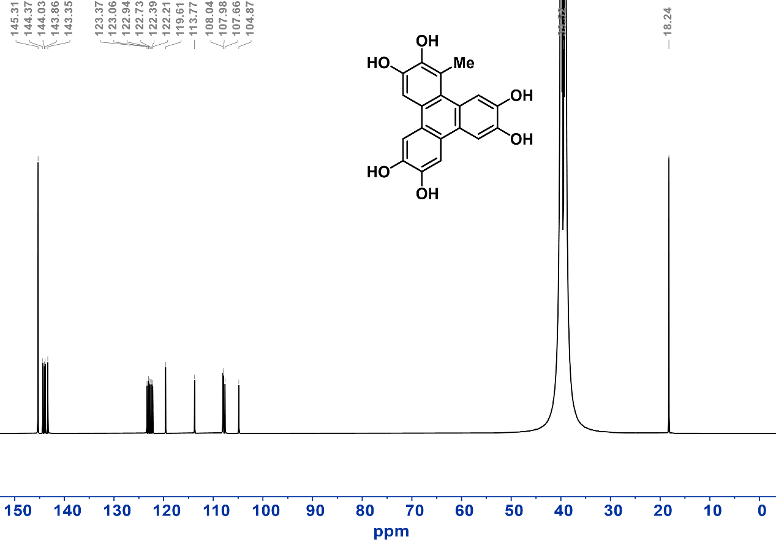
Figure S28. ¹³C NMR (298 K, DMSO-d₆) spectrum of 1-methyl-2,3,6,7,10,11-hexahydroxytriphenylene 17.
Synthesis of 1-amino-2,3,6,7,10,11-hexahydroxytriphenylene (HHTP-NH₂, 18). In an N₂ atmosphere, 10 (0.47 mmol, 200 mg) was dissolved in 15 mL of DCM. After the reaction solution was cooled to -78 °C, BBr₃ (4.7 mmol, 0.45 ml) was then added, and the mixture was then vigorously stirred for 48 hours in the dark. After the reaction was completed, the system was recooled to -78 °C, deoxygenated ice water was slowly added under N₂ atmosphere to quench the reaction, and the precipitate was collected by centrifugation to give compound 18 as dark brown powder (yield ~50%).
¹H NMR (400 MHz, DMSO-d₆) δ = 7.92 (s, 1H), 7.68 (d, J = 4.9 Hz, 2H), 7.42 (s, 2H). ¹³C NMR (101 MHz, DMSO-d₆) δ = 99.75, 108.21, 108.55, 111.10, 111.70, 121.26, 121.97, 122.47, 122.65, 126.55, 128.71, 130.51, 142.93, 144.88, 145.88, 146.03, 149.91. ESI-MS: m/z calculated for (C₁₈H₁₃NO₆) [M]⁺: 339.0743, found: 339.0723.
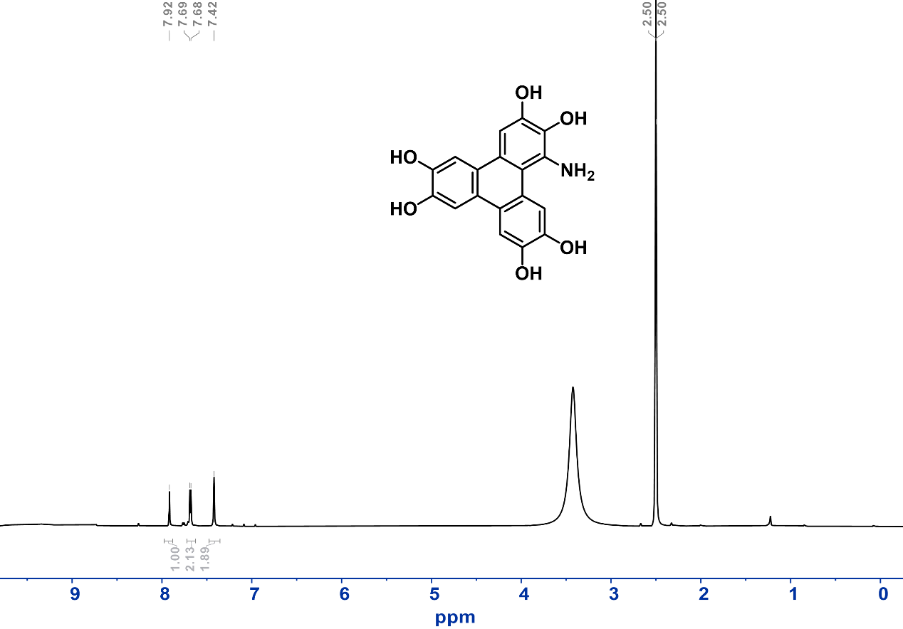
Figure S29. ¹H NMR (298 K, DMSO-d₆) spectrum of 1-amino-2,3,6,7,10,11-hexahydroxytriphenylene 18.

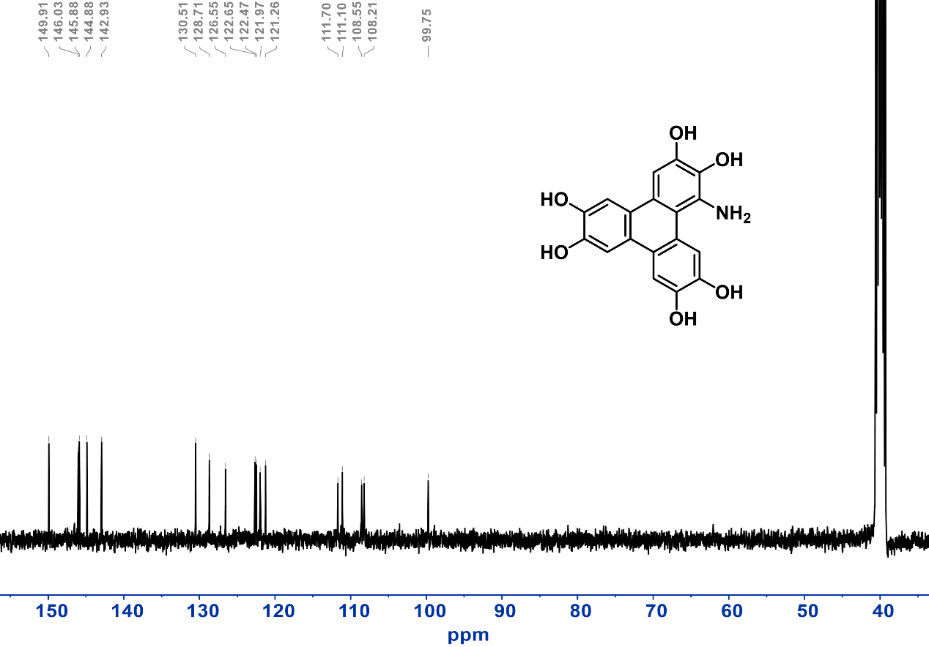
Figure S30. ¹³C NMR (298 K, DMSO-d₆) spectrum of 1-amino-2,3,6,7,10,11-hexahydroxytriphenylene 18.

Synthesis of 1-butylamino-2,3,6,7,10,11-hexahydroxytriphenylene (HHTP-NHBu, 19). In an N₂ atmosphere, 11 (0.313 mmol, 150 mg) was dissolved in 20 mL of DCM. After the reaction solution was cooled to -78 °C, BBr₃ (2.82 mmol, 0.27 ml) was then added, and the mixture was then vigorously stirred for 72 hours in the dark. After the reaction, the system was cooled to -78 °C again, 30 mL of deoxygenated icy methanol was added, and the mixture was stirred for 5 minutes. After rapid vacuum concentration of the reaction solution, 300 mL of dichloromethane was poured into the mixture, and a gray-brown precipitate was precipitated and washed with dichloromethane to give compound 19 as a gray-brown powder (yield ~50%).
¹H NMR (600 MHz, DMSO-d₆) δ = 7.85 (s, 1H), 7.72 (s, 1H), 7.63 (d, J = 9.1 Hz, 3H), 3.61 – 3.55 (m, 2H), 1.73 (t, J = 8.7 Hz, 2H), 1.35 (q, J = 7.9 Hz, 2H), 0.89 – 0.83 (m, 3H). ¹³C NMR (151 MHz, DMSO-d₆) δ = 13.69, 19.28, 38.61, 55.06, 107.71, 108.13, 108.36, 111.73, 116.17, 121.24, 122.28, 123.37, 123.60, 144.70, 144.75, 145.74, 145.89, 146.33. ESI-MS: m/z calculated for (C₂₂H₂₁NO₆) [M+H]⁺: 396.1447, found: 396.1430.
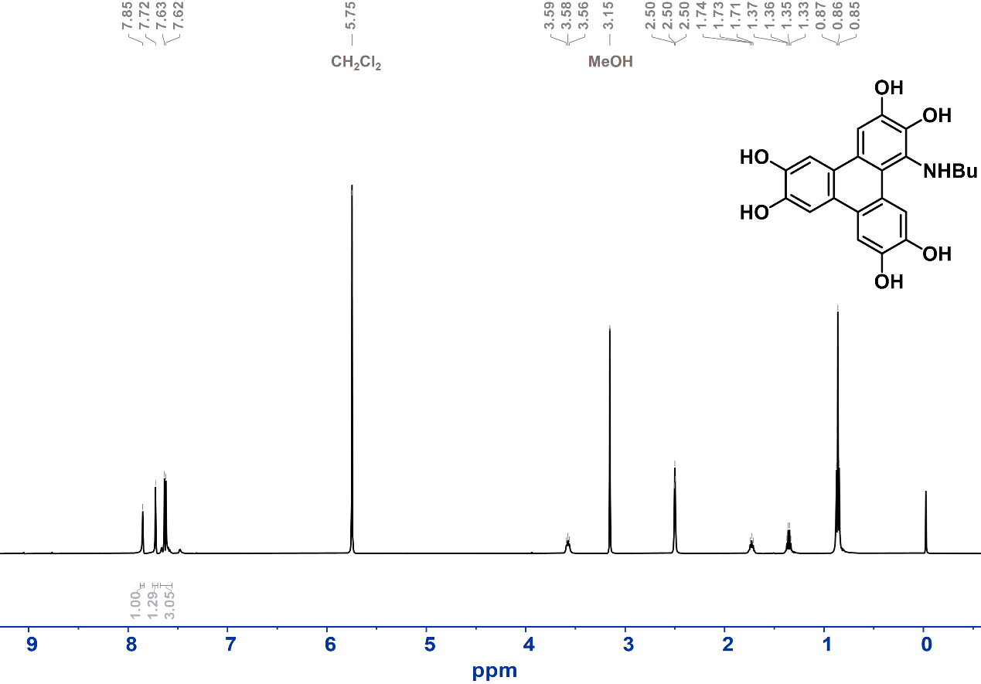
Figure S31. ¹H NMR (298 K, DMSO-d₆) spectrum of 1-butylamino-2,3,6,7,10,11-hexahydroxytriphenylene 19.
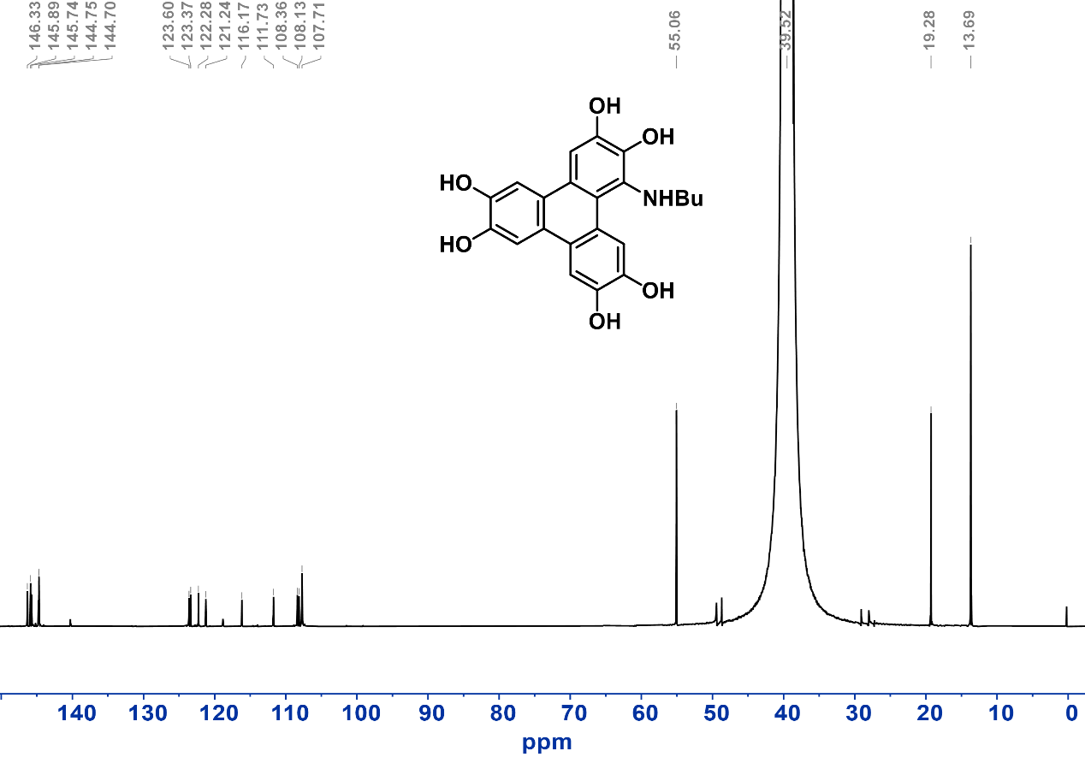
Figure S32. ¹³C NMR (298 K, DMSO-d₆) spectrum of 1-butylamino-2,3,6,7,10,11-hexahydroxytriphenylene 19.

Synthesis of Cu-HHTP-R MOFs
Synthesis of Cu-HHTP-CN MOF.
In a 20 mL glass vial, HHTP-CN (0.04 mmol, 14 mg) was dissolved in 1 mL of diethylformamide (DEF). 3 mL of water and 10 μL of ammonia water (25-28%) were successively added. After 725 μL aqueous solution of copper nitrate (20 mg/mL) was added, the reaction mixture was kept at 85 °C for 16 h. The resulting precipitate was collected through centrifugation and subsequently washed with water and acetone. After drying under vacuum for 12 hours at 40 ℃, the product was obtained as a black green powder.
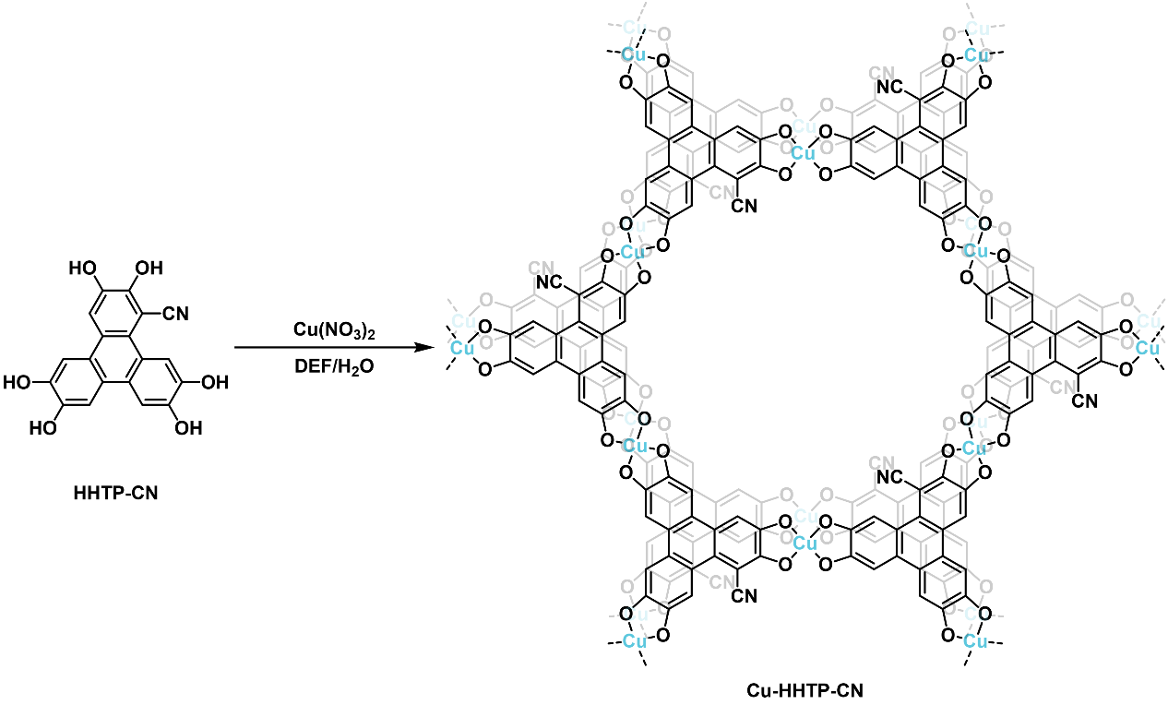
Scheme S2. Synthetic route for Cu-HHTP-CN MOF.
Synthesis of Cu-HHTP-F MOF.
In a 20 mL glass vial, HHTP-F (0.04 mmol, 13.7 mg) was dissolved in 1 mL of N-methylpyrrolidone (NMP). 3 mL of water and 10 μL of ammonia water (25-28%) were successively added. After 725 μL aqueous solution of copper nitrate (20 mg/mL) was added, the reaction mixture was kept at 85 °C for 16 h. The resulting precipitate was collected through centrifugation and subsequently washed with water and acetone. After drying under vacuum for 12 hours at 40 ℃, the product was obtained as blue-black powder.
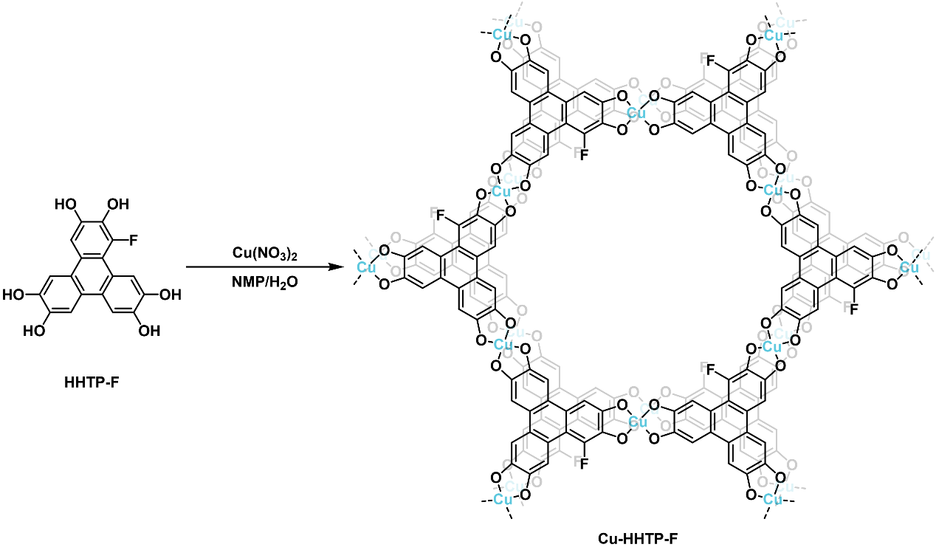
Scheme S3. Synthetic route for Cu-HHTP-F MOF.
Synthesis of Cu-HHTP-Cl MOF.
In a 20 mL glass vial, HHTP-Cl (0.03 mmol, 10.7 mg) was dissolved in 1 mL of NMP. 3 mL of water and 10 μL of ammonia water (25-28%) were successively added. After 545 μL aqueous solution of copper nitrate (20 mg/mL) was added, the reaction mixture was kept at 85 °C for 16 h. The resulting precipitate was collected through centrifugation and subsequently washed with water and acetone. After drying under vacuum for 12 hours at 40 ℃, the product was obtained as a blue-black powder.
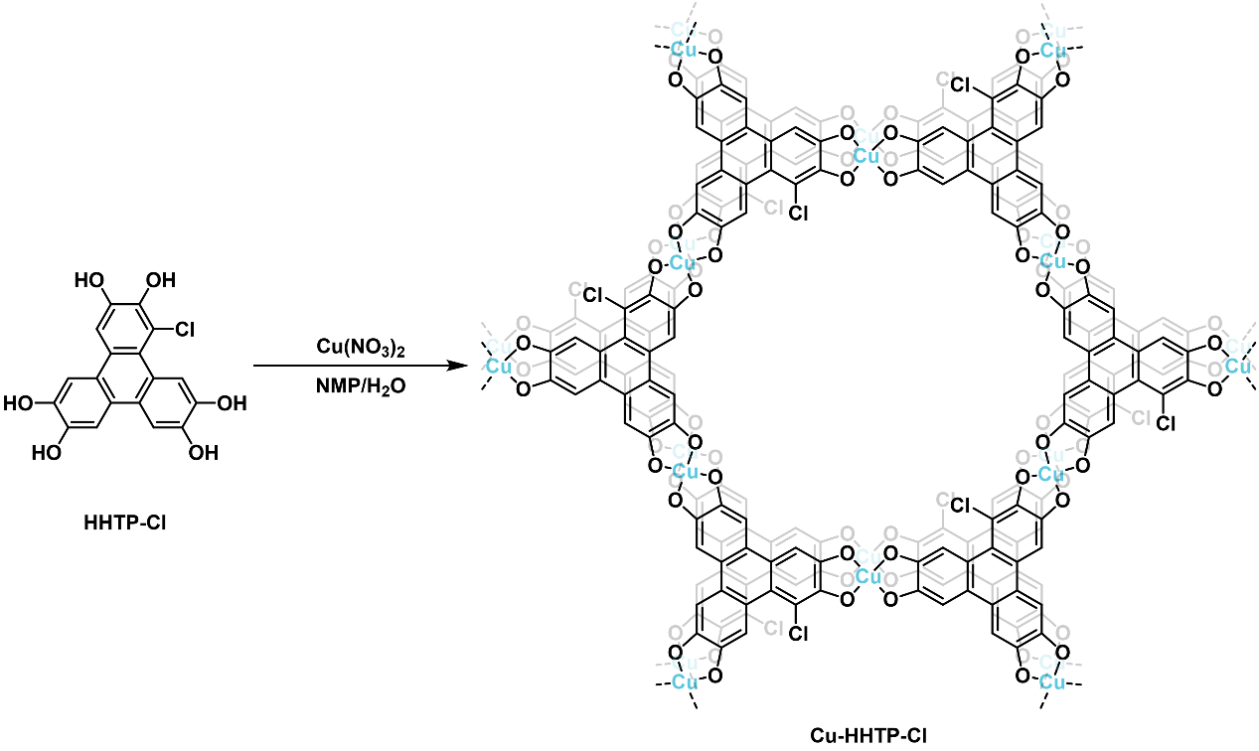
Scheme S4. Synthetic route for Cu-HHTP-Cl MOF.
Synthesis of Cu-HHTP-Br MOF.
In a 20 mL glass vial, HHTP-Br (0.03 mmol, 12.1 mg) was dissolved in 1 mL of DEF. 3 mL of water and 10 μL of ammonia water (25-28%) were successively added. After 545 μL aqueous solution of copper nitrate (20 mg/mL) was added, the reaction mixture was kept at 85 °C for 16 h. The resulting precipitate was collected through centrifugation and subsequently washed with water and acetone. After drying under vacuum for 12 hours at 40 ℃, the product was obtained as a blue-black powder.
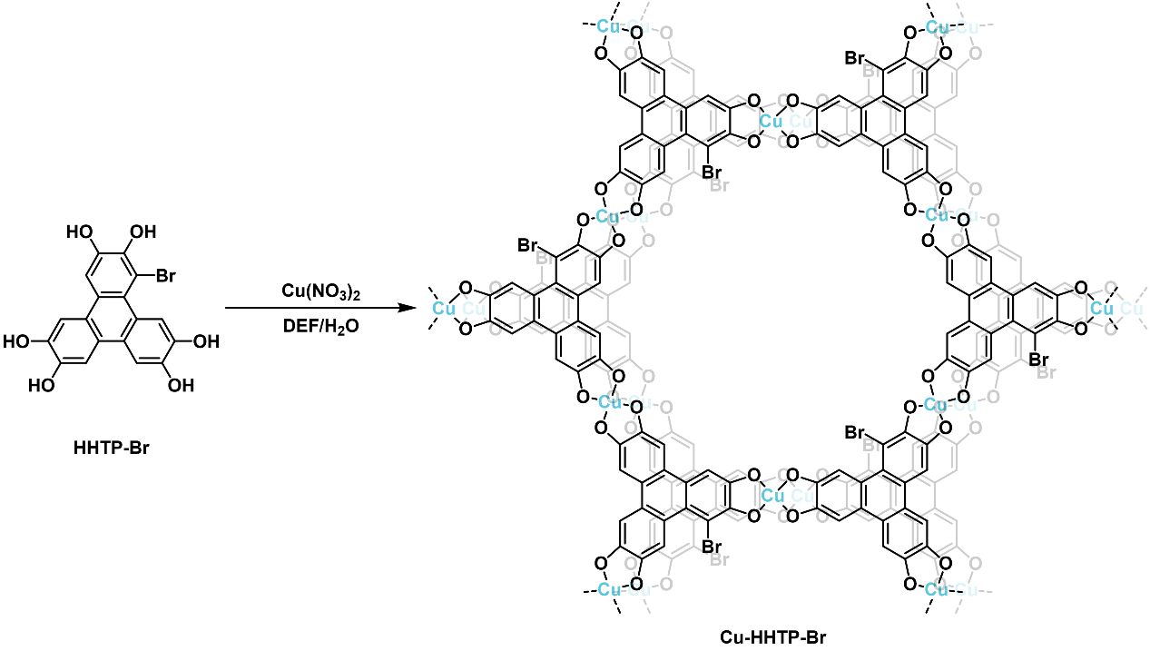
Scheme S5. Synthetic route for Cu-HHTP-Br MOF.
Synthesis of Cu-HHTP MOF.
In a 20 mL glass vial, HHTP (0.04 mmol, 13 mg) was dissolved in 1 mL N,N-dimethylformamide (DMF) and 5 mL water. 725 μL copper nitrate aqueous solution (20 mg/mL) was added and reacted at 85 °C for 16 h. The resulting blue-black powder was collected through centrifugation and subsequently washed with water and acetone. The product was dried under vacuum for 12 hours at 40 ℃.

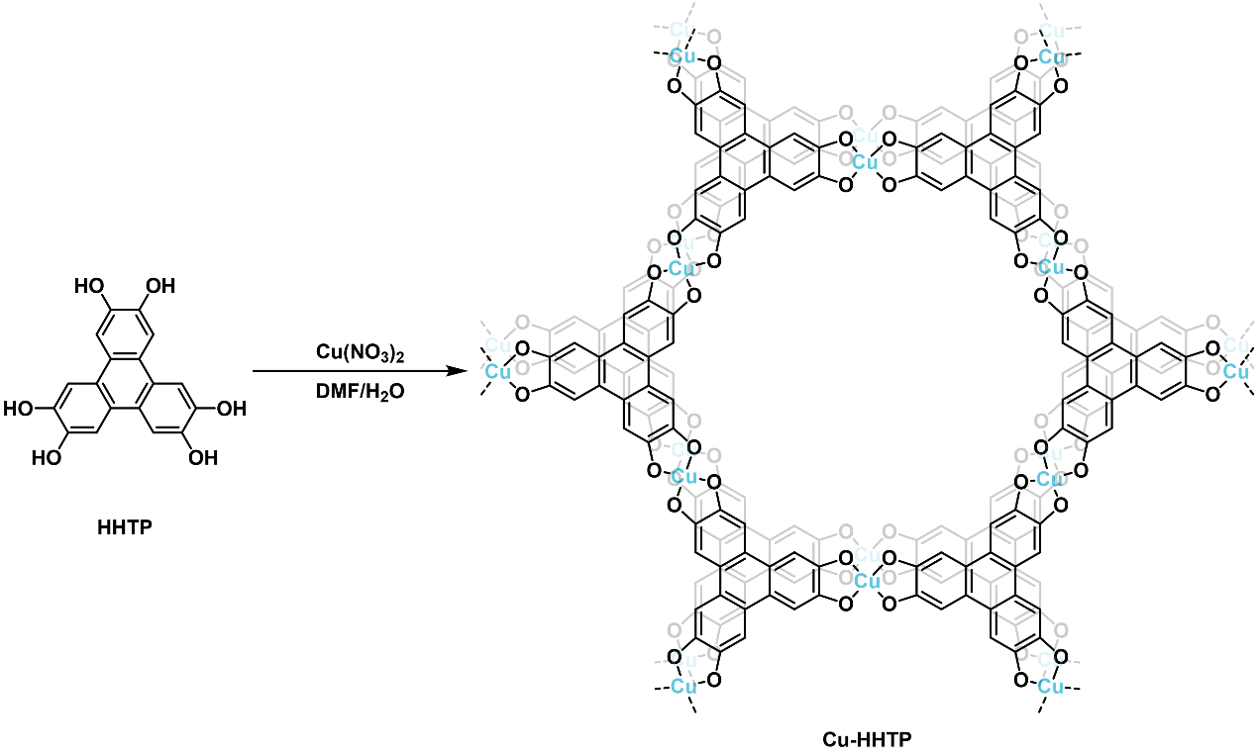
Scheme S6. Synthetic route for Cu-HHTP MOF.
Synthesis of Cu-HHTP-Me MOF.
In a 20 mL glass vial, HHTP-Me (0.04 mmol, 13.5 mg) was dissolved in 1 mL of NMP. 3 mL of water was then added. After 725 μL aqueous solution of copper nitrate (20 mg/mL) was added, the reaction mixture was kept at 85 °C for 16 h. The resulting precipitate was collected through centrifugation and subsequently washed with water and acetone. After drying under vacuum for 12 hours at 40 ℃, the product was obtained as a blue-black powder.
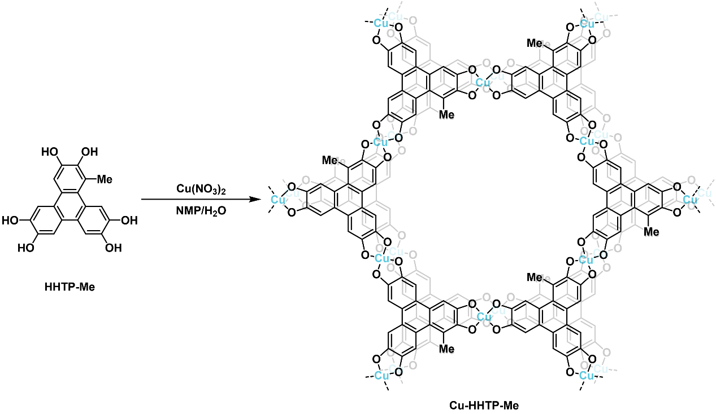
Scheme S7. Synthetic route for Cu-HHTP-Me MOF.
Synthesis of Cu-HHTP-NH₂ MOF.
In a 20 mL glass vial, HHTP-NH₂ (0.06 mmol, 20.3 mg) was dissolved in 1 mL of NMP. 3 mL of water and 10 μL of ammonia water (25-28%) were successively added. After 1.09 mL aqueous solution of copper nitrate (20 mg/mL) was added, the reaction mixture was kept at 85 °C for 16 h. The resulting precipitate was collected through centrifugation and subsequently washed with water and acetone. After drying under vacuum for 12 hours at 40 ℃, the product was obtained as a black powder.

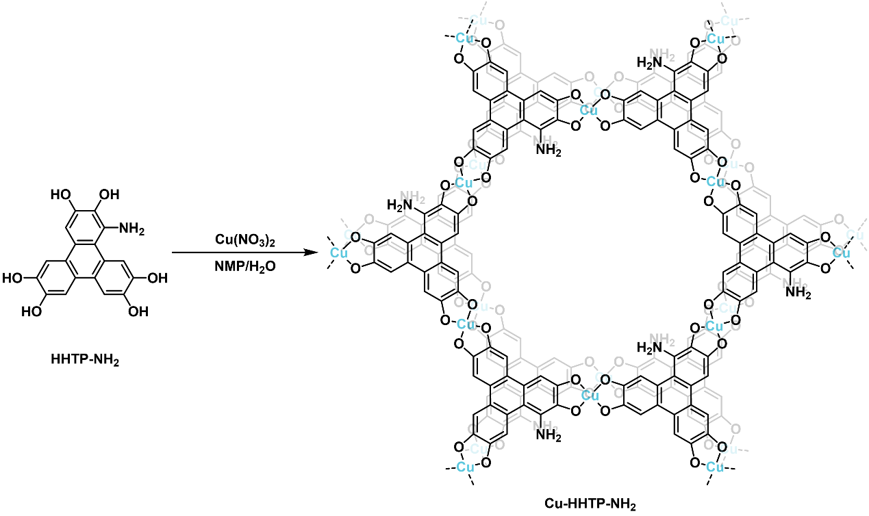
Scheme S8. Synthetic route for Cu-HHTP-NH₂ MOF.
Synthesis of Cu-HHTP-NHBu MOF.
In a 20 mL glass vial, HHTP-NHBu (0.04 mmol, 15.8 mg) was dissolved in 1 mL of DMF. 3 mL of water and 10 μL of ammonia water (25-28%) were successively added. After 725 μL aqueous solution of copper nitrate (20 mg/mL) was added, the reaction mixture was kept at 85 °C for 16 h. The resulting precipitate was collected through centrifugation and subsequently washed with water and acetone. After drying under vacuum for 12 hours at 40 ℃, the product was obtained as a black powder.
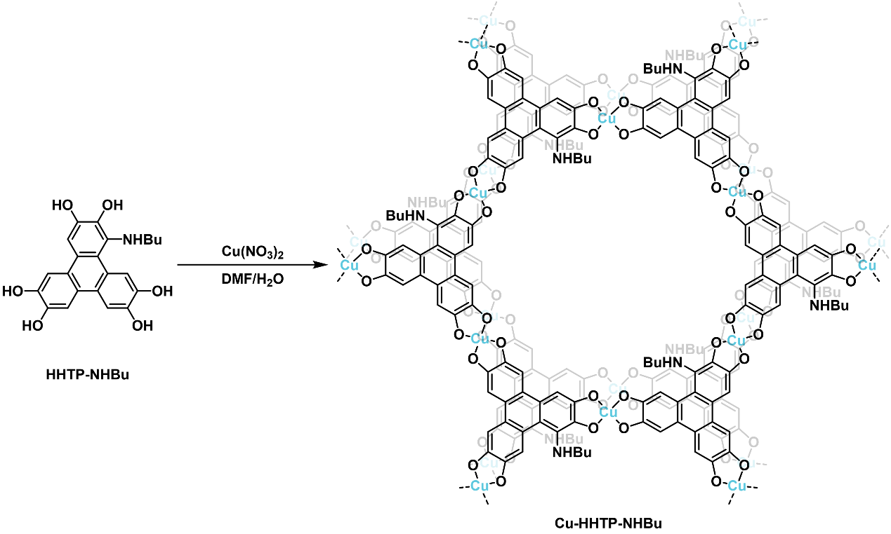
Scheme S9. Synthetic route for Cu-HHTP-NHBu MOF.

Synthesis of Cu-HHTP-R MOF films
First, 40 mL of an ethyl acetate solution of HHTP-R (0.04 mmol, for R = –CN, –F, –Cl, –Br, –NH₂, and –NHBu) was poured into a glass crystallization dish with a diameter of 120 mm. Then, 40 mL of an aqueous solution of copper nitrate trihydrate (0.08 mmol) with 10 μL NH₃·H₂O was prepared and slowly added to the organic phase. The system was left undisturbed for 24 hours, during which the black green film formed at the liquid-liquid interface. The resulting film was carefully transferred onto a quartz substrate and washed with acetone. The process for preparing Cu-HHTP and Cu-HHTP-Me films was the same as described above, but no additional ammonia was needed to accelerate the reaction.

Structural Determination by Powder X-ray Diffraction
Synchrotron radiation XRD data collected on the 1W1A- Diffuse X-ray Scattering Beamline (λ = 1.5466 Å) of Beijing Synchrotron Radiation Facility (https://cstr.cn/31109.02.BSRF.1W1A).
The initial structures of the Cu-HHTP-R MOFs were derived from reported literature^{11, 12} and pre-optimized using molecular mechanics with the UFF force field prior to further electronic structure calculations¹³. First-principles calculations were performed using the Vienna Ab initio Simulation Package (VASP).¹⁴ Electron–ion interactions were described by projector-augmented-wave (PAW) pseudopotentials,¹⁵ and exchange–correlation effects were treated within the generalized gradient approximation (GGA) using the Perdew–Burke–Ernzerhof (PBE) functional.¹⁶ To better capture the on-site Coulomb interaction, a Hubbard U correction (DFT+U) with U = 10.4 eV was applied to the Cu d orbitals, following the settings of a previous study.¹² Spin-polarized calculations were employed for all systems, and van der Waals interactions were included using the DFT-D3 method with Becke–Johnson damping.¹⁷ All structures were fully relaxed until the residual forces on each atom were less than 0.015 eV/Å.
Calculation of the simulated powder diffraction pattern was performed by Materials Studio Reflex Plus Module. Pawley refinement was carried out on the lattice parameters of Cu-HHTP-R MOFs within the P1 space group.
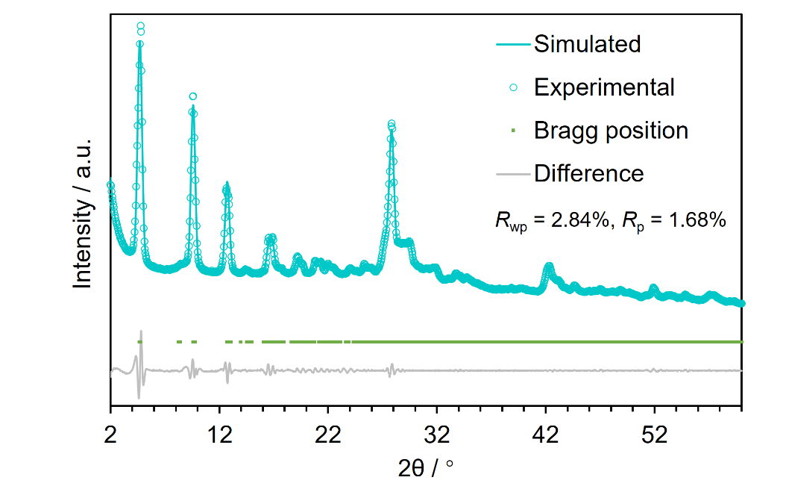
Figure S33. Experimental SRXRD pattern, Pawley refined pattern, difference pattern, and Bragg positions of Cu-HHTP-CN.
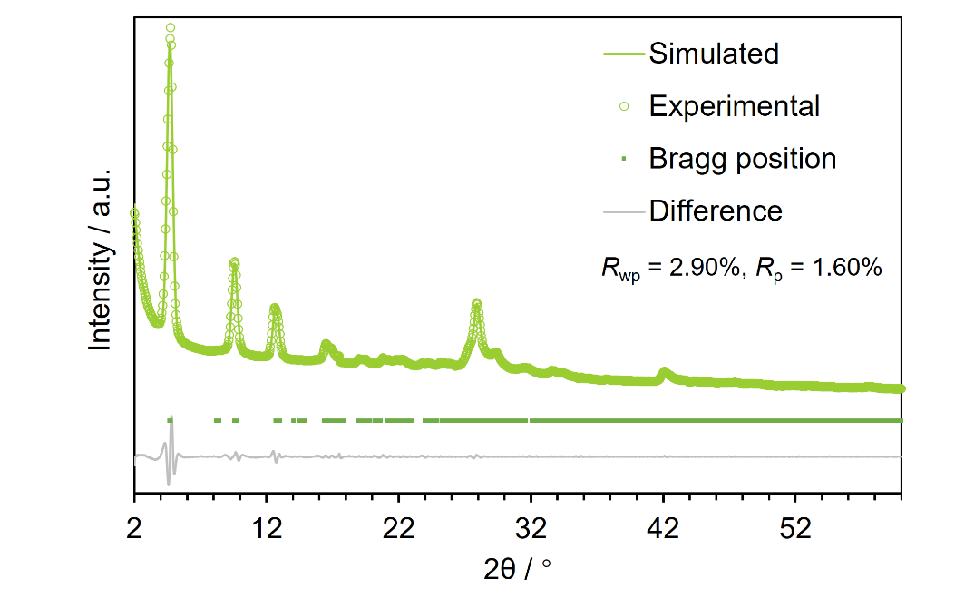
Figure S34. Experimental SRXRD pattern, Pawley refined pattern, difference pattern, and Bragg positions of Cu-HHTP-F.

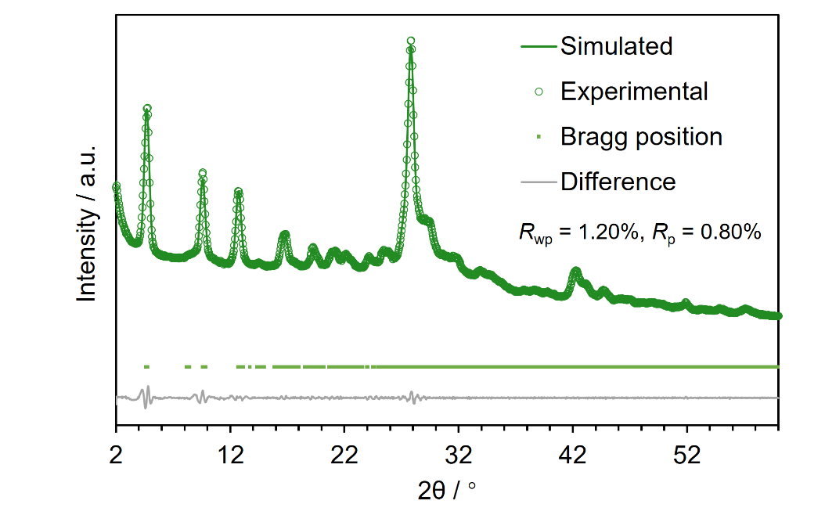
Figure S35. Experimental SRXRD pattern, Pawley refined pattern, difference pattern, and Bragg positions of Cu-HHTP-Cl.

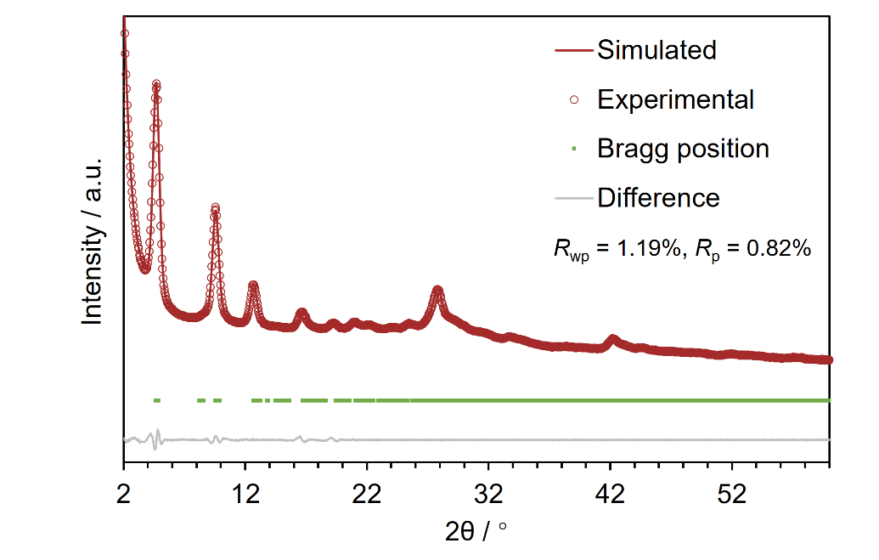
Figure S36. Experimental SRXRD pattern, Pawley refined pattern, difference pattern, and Bragg positions of Cu-HHTP-Br.
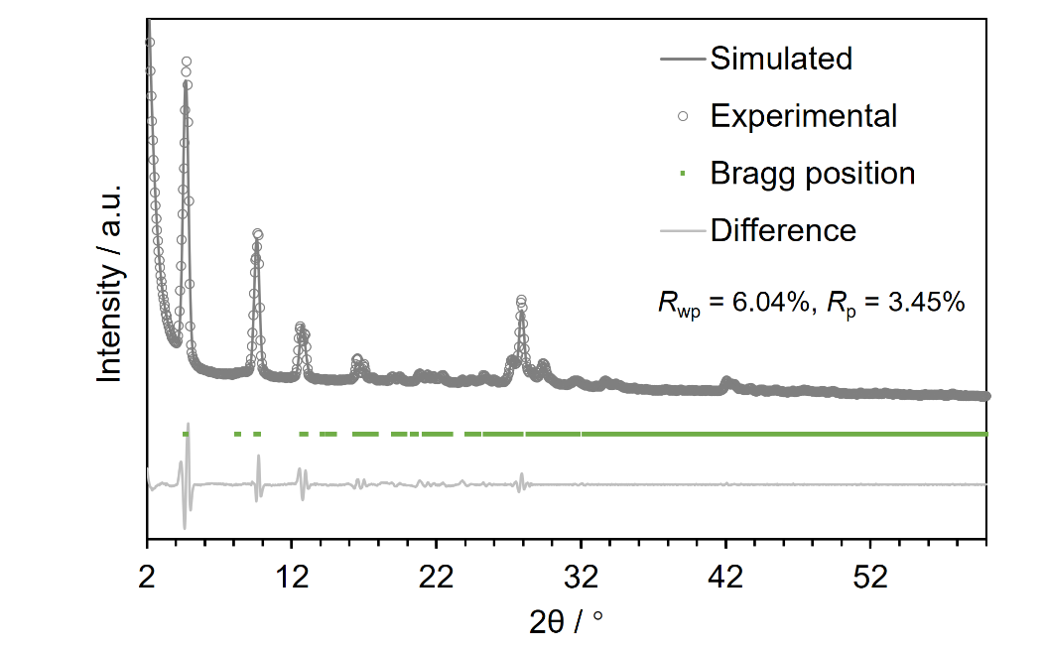
Figure S37. Experimental SRXRD pattern, Pawley refined pattern, difference pattern, and Bragg positions of Cu-HHTP.

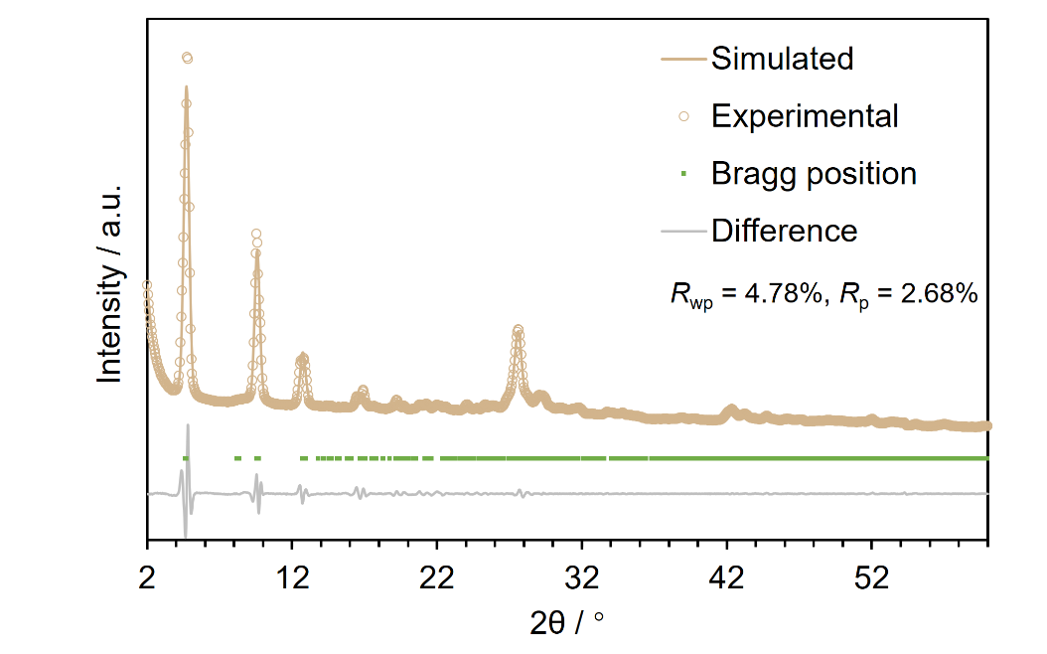
Figure S38. Experimental SRXRD pattern, Pawley refined pattern, difference pattern, and Bragg positions of Cu-HHTP-Me.

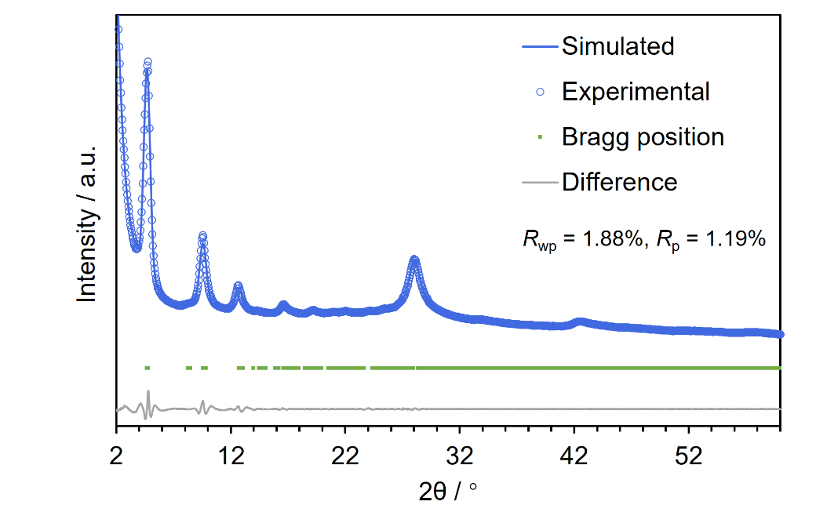
Figure S39. Experimental SRXRD pattern, Pawley refined pattern, difference pattern, and Bragg positions of Cu-HHTP-NH₂.

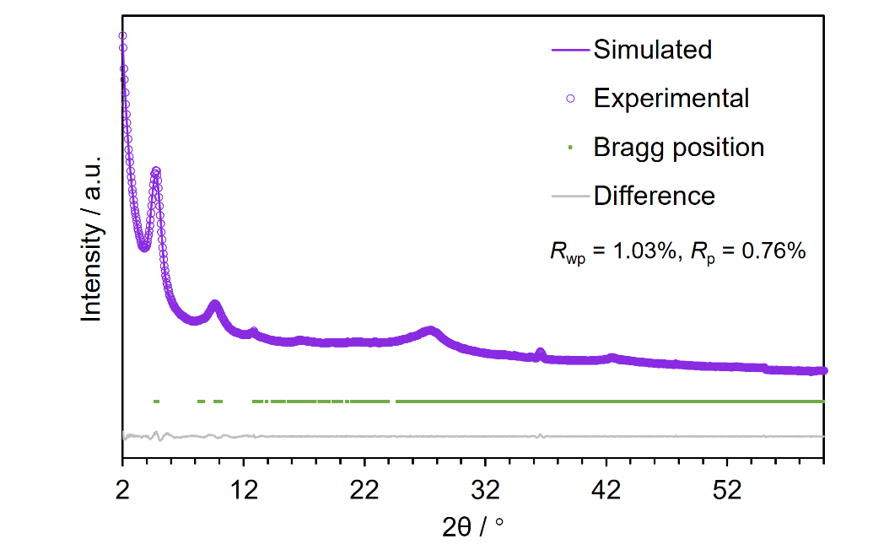
Figure S40. Experimental SRXRD pattern, Pawley refined pattern, difference pattern, and Bragg positions of Cu-HHTP-NHBu.

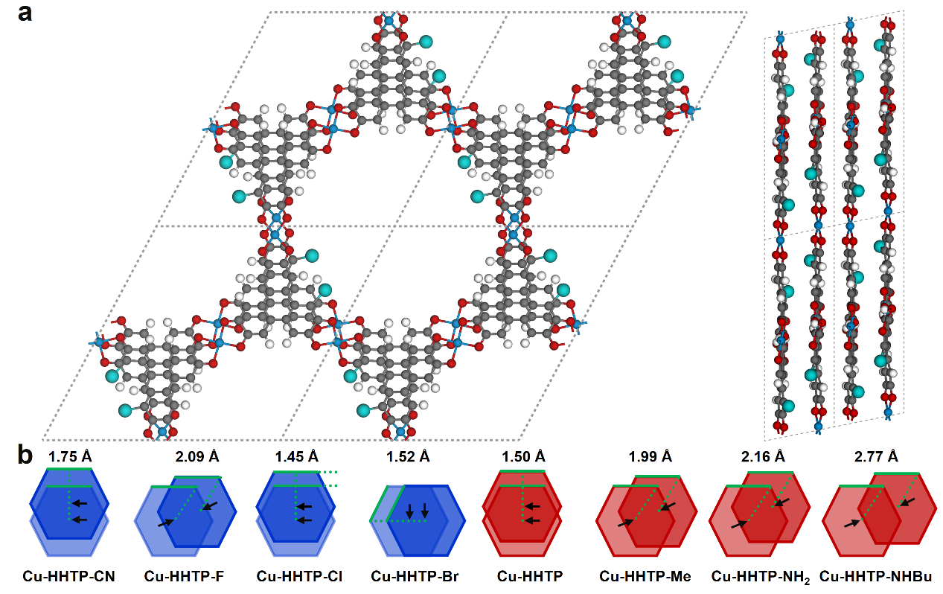
Figure S41. (a) The crystal structure model of Cu-HHTP-R MOFs as viewed front and side (black: carbon, red: oxygen, magenta: substituent R, and blue: copper). (b) Graphical representation of interlayer displacement of Cu-HHTP-R MOFs determined by energy-minimum optimization. The values given donated the center offset of adjacent interlayer honeycomb lattice.

Table S1. Pawley refinement results of the unit cell parameters of Cu-HHTP-R MOFs
R | CN | F | Cl | Br | H | Me | NH₂ | NHBu
a / Å | 21.22 | 21.19 | 21.69 | 21.54 | 21.45 | 21.56 | 21.24 | 21.45
b / Å | 21.10 | 20.99 | 21.60 | 21.57 | 21.02 | 21.56 | 21.49 | 21.15
c / Å | 6.44 | 6.36 | 6.74 | 6.73 | 6.34 | 6.63 | 6.51 | 6.60
α / ° | 89.62 | 90.23 | 87.13 | 77.40 | 90.52 | 86.51 | 88.41 | 91.19
β / ° | 88.03 | 89.34 | 91.23 | 95.35 | 89.48 | 86.49 | 88.14 | 75.62
γ / ° | 118.60 | 118.72 | 118.30 | 118.46 | 120.15 | 118.68 | 118.54 | 117.30

PXRD data were collected using an X-ray diffractometer. Cu K_{α} radiation (λ = 1.5406 Å; 600 W, 40 kV, 15 mA) was focused using a planar Göbel mirror riding the K_{α} line.
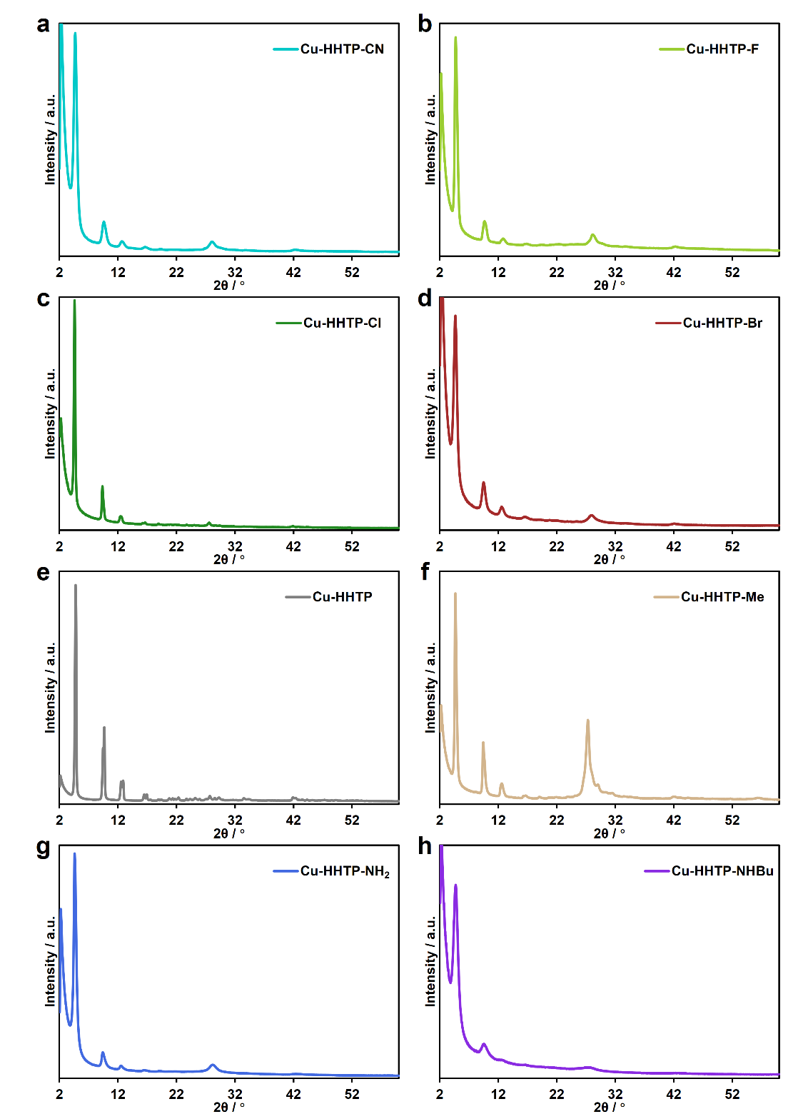
Figure S42. Powder XRD patterns of (a) Cu-HHTP-CN, (b) Cu-HHTP-Br, (c) Cu-HHTP-Cl, (d) Cu-HHTP-F, (e) Cu-HHTP, (f) Cu-HHTP-Me, (g) Cu-HHTP-NH₂, and (h) Cu-HHTP-NHBu MOFs.

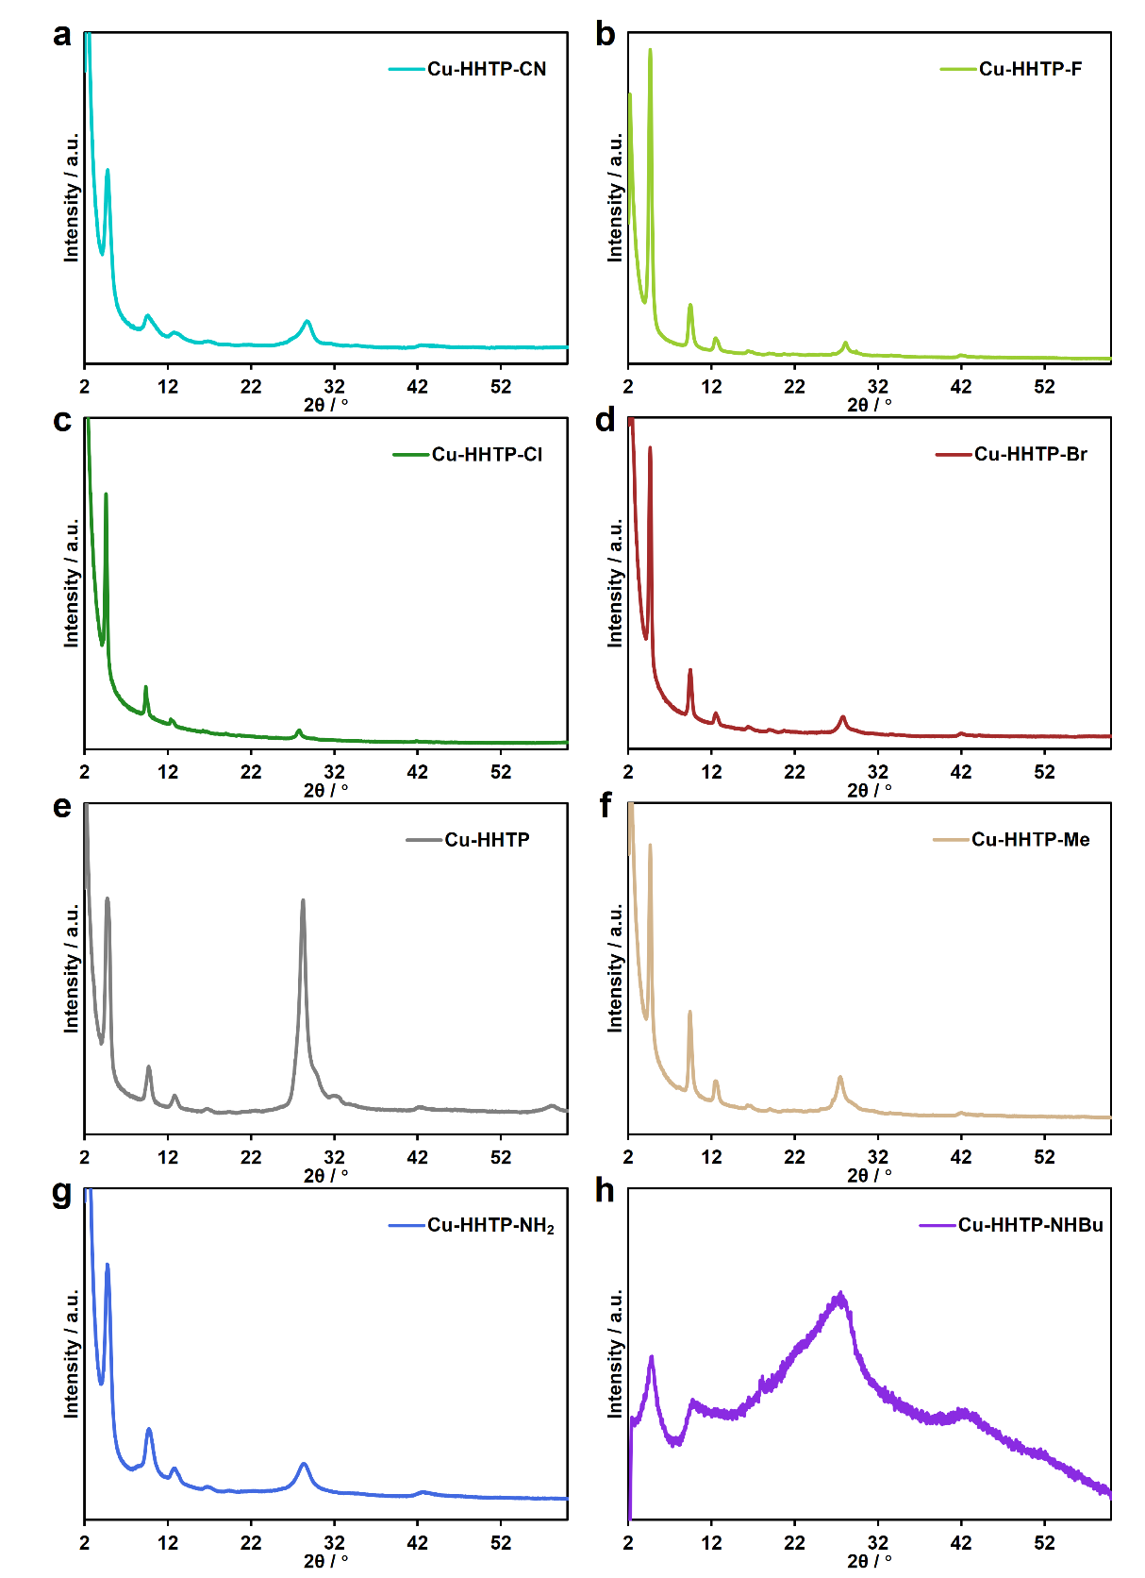
Figure S43. Powder XRD patterns of (a) Cu-HHTP-CN, (b) Cu-HHTP-Br, (c) Cu-HHTP-Cl, (d) Cu-HHTP-F, (e) Cu-HHTP, (f) Cu-HHTP-Me, (g) Cu-HHTP-NH₂, and (h) Cu-HHTP-NHBu films.

Fourier Transform Infrared Spectrum
The samples were prepared as KBr pellets by thoroughly grinding the MOF powders with spectroscopic-grade KBr, followed by pressing into transparent disks.
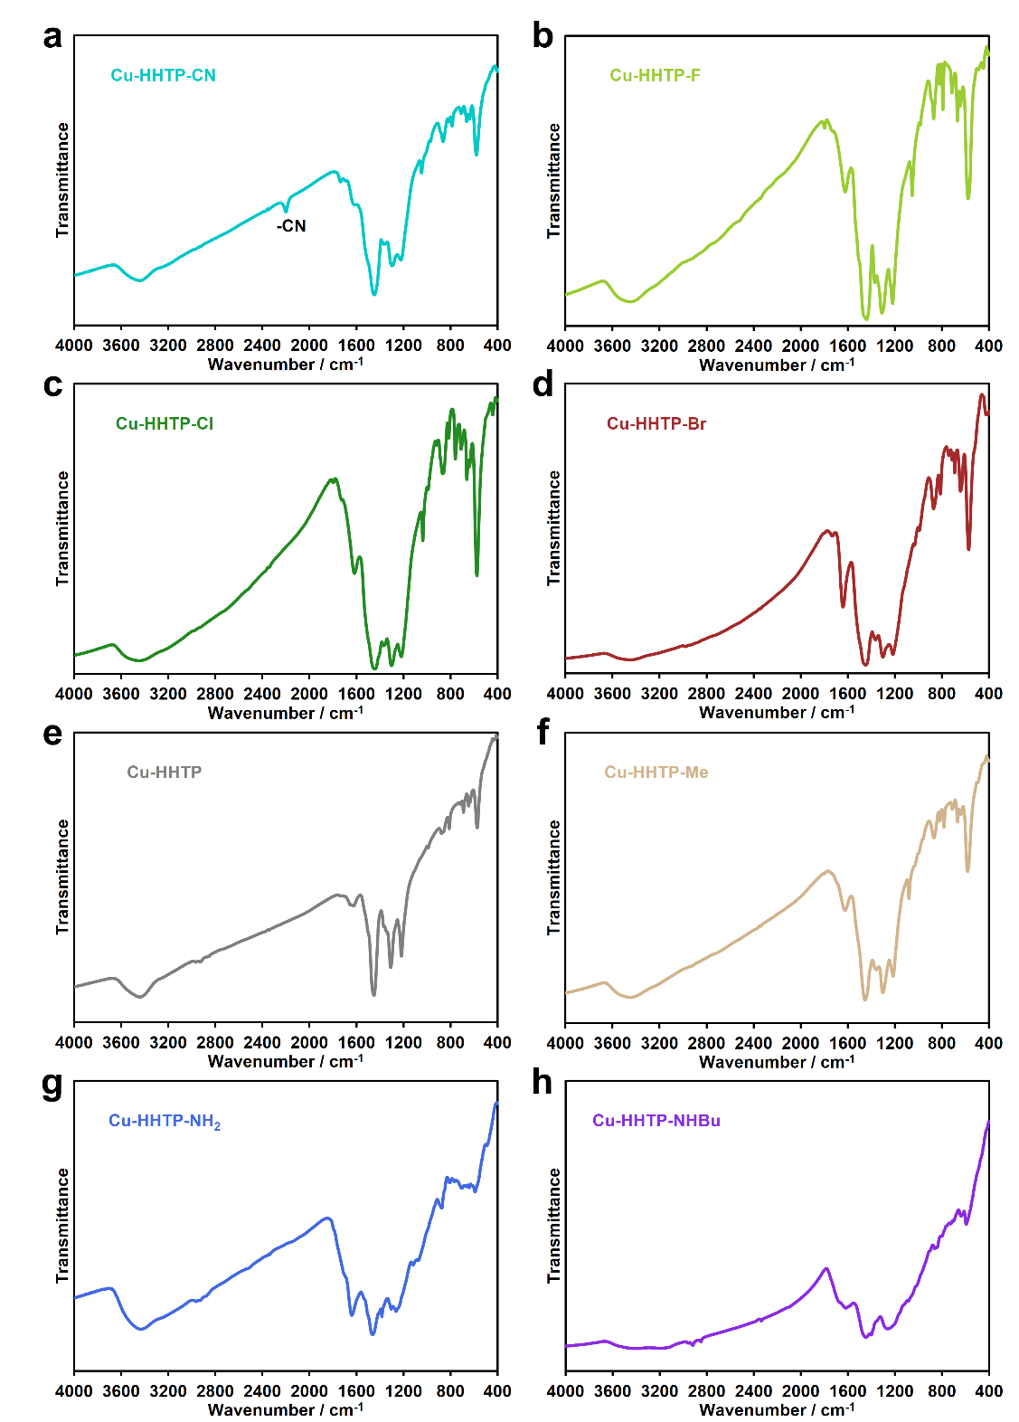
Figure S44. FTIR spectra of (a) Cu-HHTP-CN, (b) Cu-HHTP-Br, (c) Cu-HHTP-Cl, (d) Cu-HHTP-F, (e) Cu-HHTP, (f) Cu-HHTP-Me, (g) Cu-HHTP-NH₂, and (h) Cu-HHTP-NHBu MOFs.

Scanning Electron Microscopy
SEM images of Cu-HHTP-R MOFs were obtained using a ZEISS GeminiSEM 450 or Quanta FEG 250. The material was pressed onto carbon conductive tape that was attached to the aluminum plate. The images were taken in a 10⁻⁶ torr vacuum chamber using a 5 kV or 10 kV beamline.
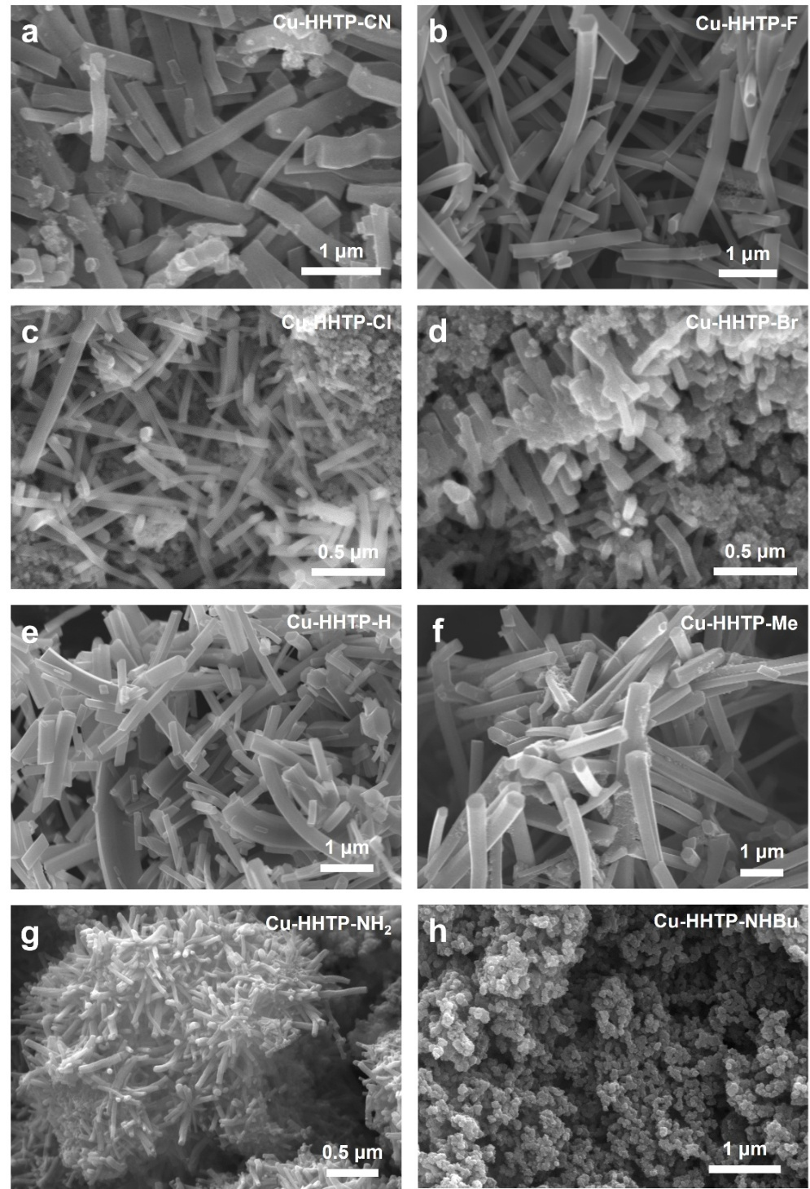
Figure S45. SEM images of (a) Cu-HHTP-CN, (b) Cu-HHTP-Br, (c) Cu-HHTP-Cl, (d) Cu-HHTP-F, (e) Cu-HHTP, (f) Cu-HHTP-Me, (g) Cu-HHTP-NH₂, and (h) Cu-HHTP-NHBu MOFs.

Energy-dispersive X-ray spectroscopy
The powder of Cu-HHTP-R MOF was evenly dispersed in ethanol and then dropped onto the micro-grid carbon film. After drying, it was imaged on a TEM 2100PLUS. Energy-dispersive X-ray spectroscopy (EDS) data were collected on the OXFORD XPLORE accessory.
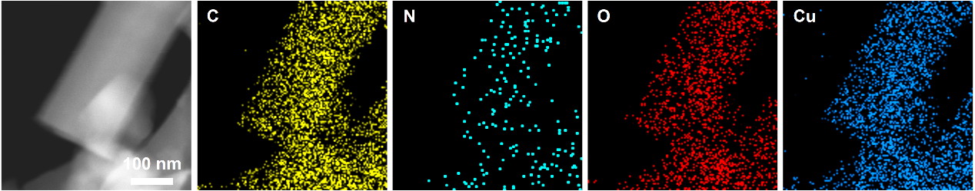
Figure S46. TEM image and EDS mapping of Cu-HHTP-CN.
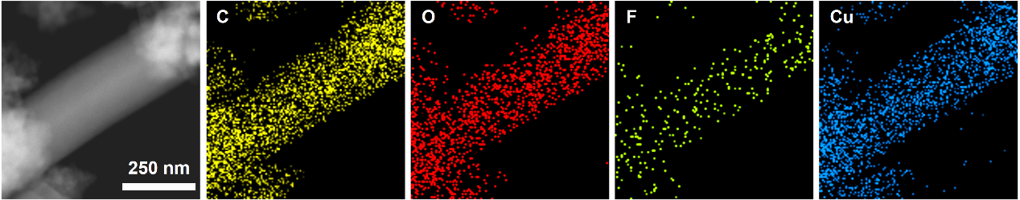
Figure S47. TEM image and EDS mapping of Cu-HHTP-F.
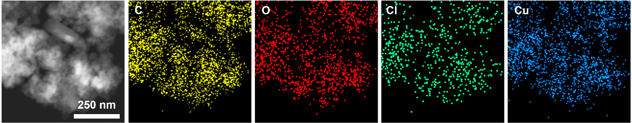
Figure S48. TEM image and EDS mapping of Cu-HHTP-Cl.
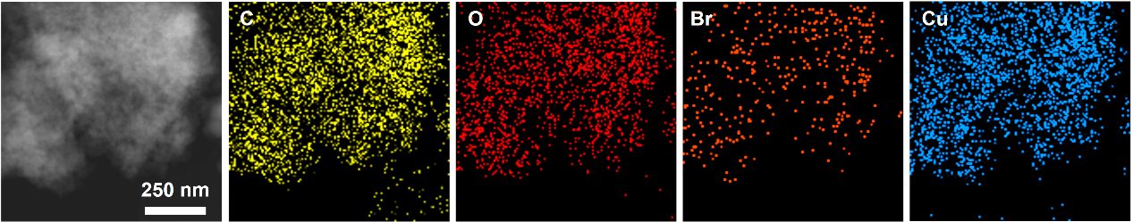
Figure S49. TEM image and EDS mapping of Cu-HHTP-Br.
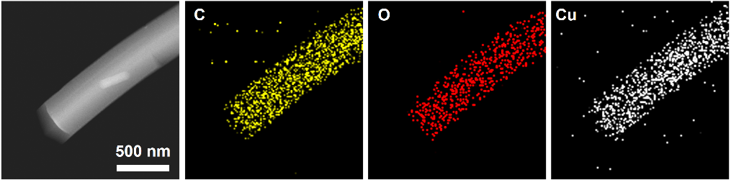
Figure S50. TEM image and EDS mapping of Cu-HHTP.
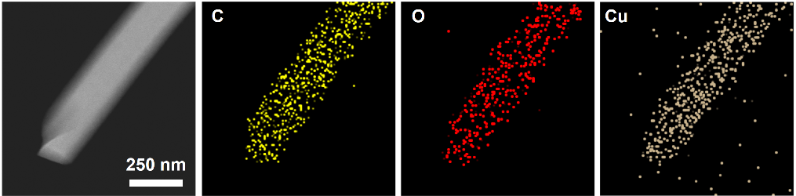
Figure S51. TEM image and EDS mapping of Cu-HHTP-Me.
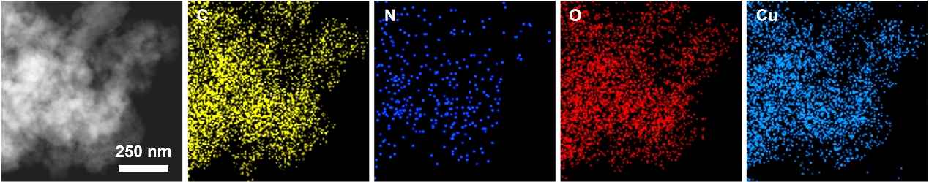
Figure S52. TEM image and EDS mapping of Cu-HHTP-NH₂.
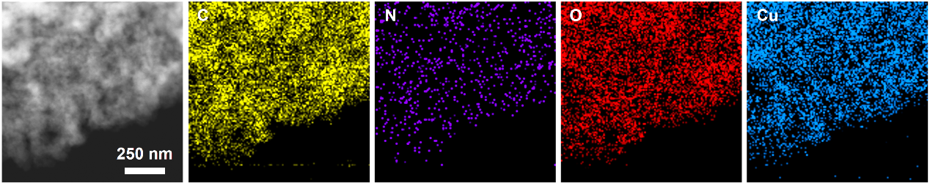
Figure S53. TEM image and EDS mapping of Cu-HHTP-NHBu.

Transmission Electron Microscopy
The Cu-HHTP-R MOF powder was evenly dispersed in ethanol, drop-casted onto the ultrathin carbon film, and imaged using a JEM-2100 Plus with an accelerating voltage of 200 kV after drying.
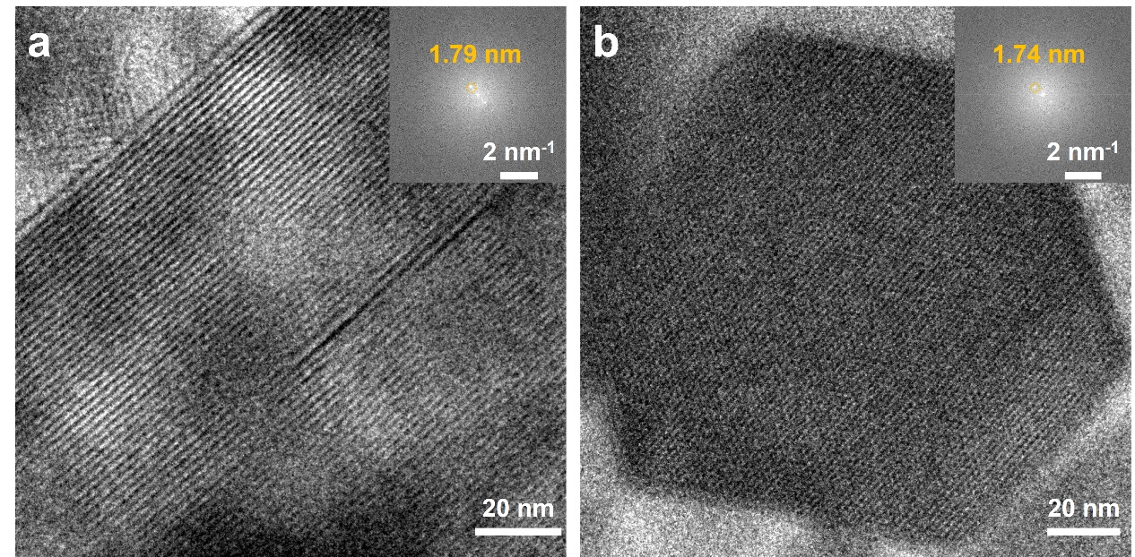
Figure S54. HRTEM images of Cu-HHTP-CN imaged (a) normal the c direction and (b) along to the c direction. Inset: FFT analysis from the HRTEM images.

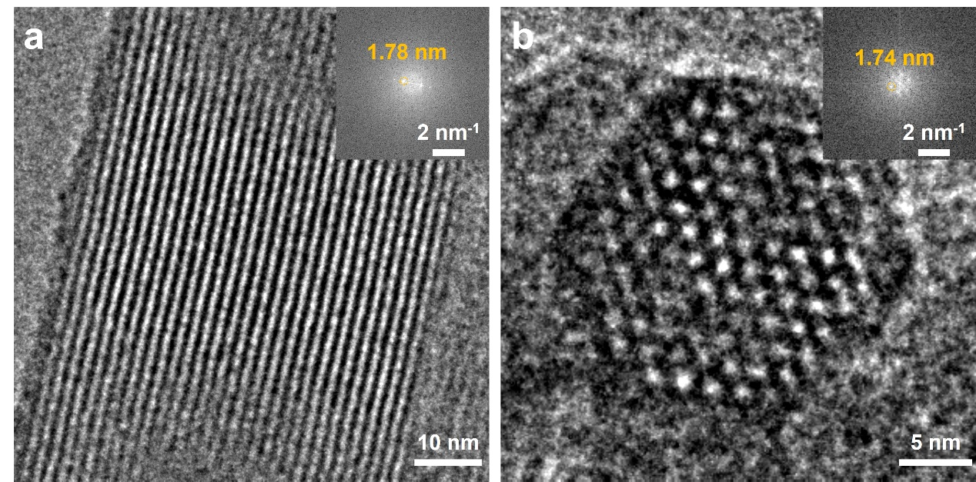
Figure S55. HRTEM images of Cu-HHTP-F imaged (a) normal the c direction and (b) along to the c direction. Inset: FFT analysis from the HRTEM images.

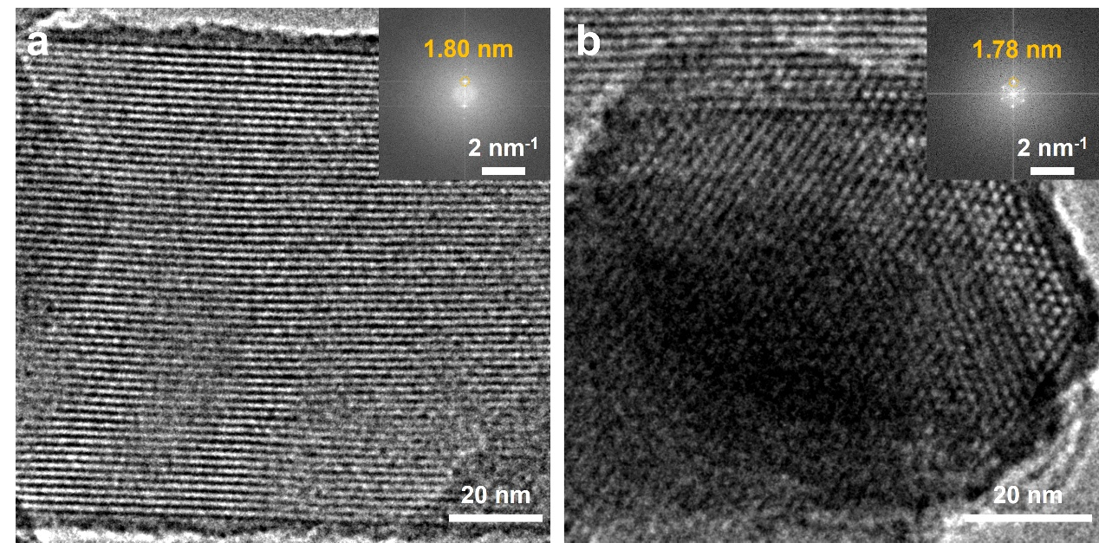
Figure S56. HRTEM images of Cu-HHTP-Cl imaged (a) normal the c direction and (b) along to the c direction. Inset: FFT analysis from the HRTEM images.

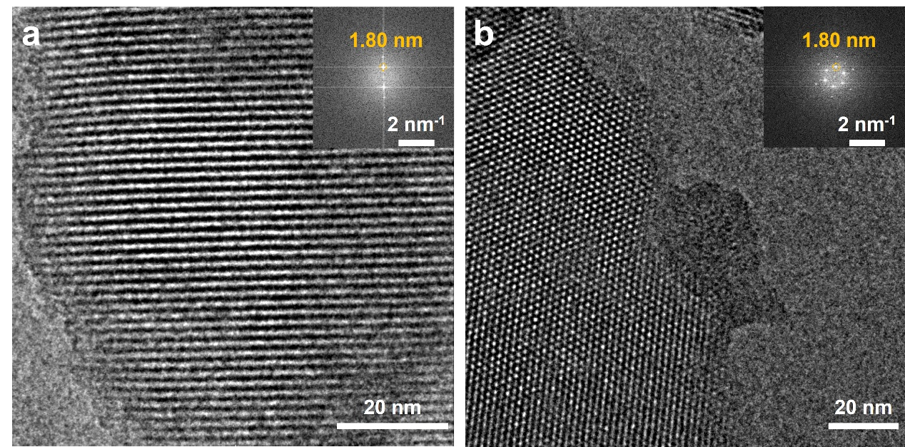
Figure S57. HRTEM images of Cu-HHTP-Br imaged (a) normal the c direction and (b) along to the c direction. Inset: FFT analysis from the HRTEM images.

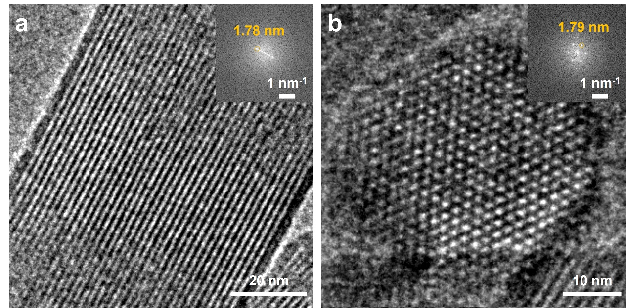
Figure S58. HRTEM images of Cu-HHTP-H imaged (a) normal the c direction and (b) along to the c direction. Inset: FFT analysis from the HRTEM images.

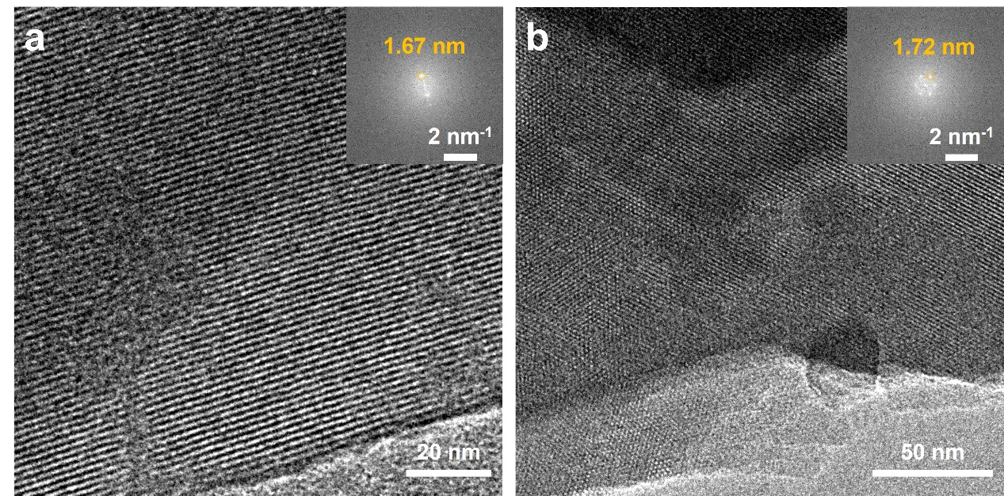
Figure S59. HRTEM images of Cu-HHTP-Me imaged (a) normal the c direction and (b) along to the c direction. Inset: FFT analysis from the HRTEM images.

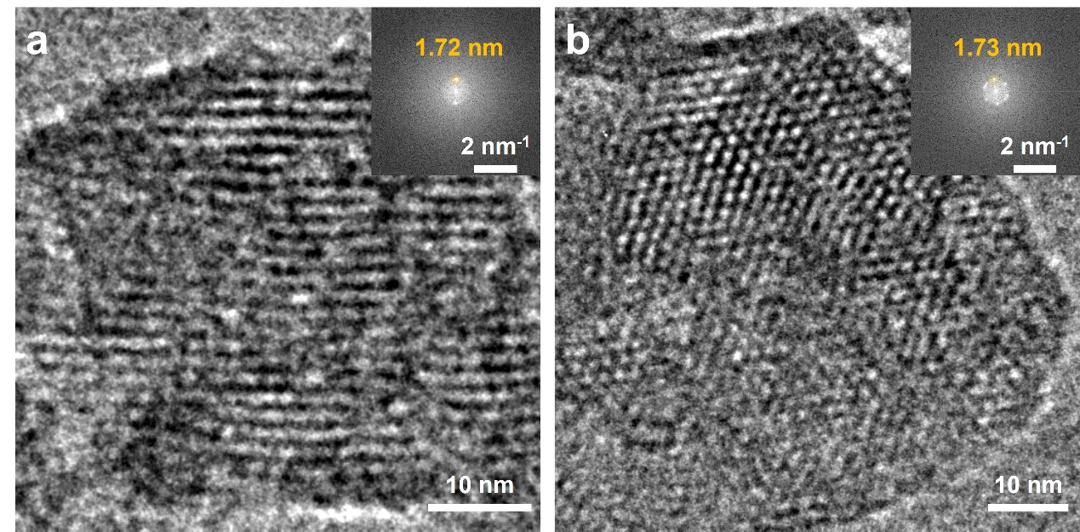
Figure S60. HRTEM images of Cu-HHTP-NH₂ imaged (a) normal the c direction and (b) along to the c direction. Inset: FFT analysis from the HRTEM images.

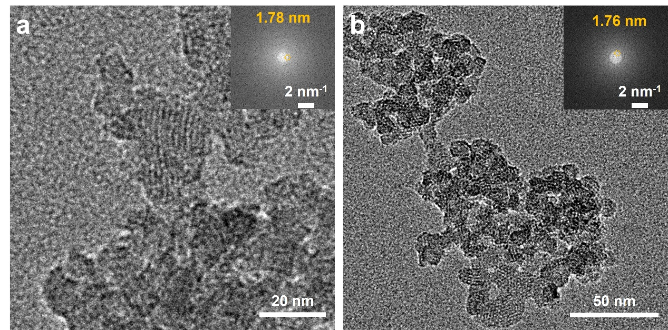
Figure S61. HRTEM images of Cu-HHTP-NHBu imaged (a) normal the c direction and (b) along to the c direction. Inset: FFT analysis from the HRTEM images.

N₂ Adsorption
All Cu-HHTP-R MOF powders used for N₂ adsorption testing were carefully solvent-exchanged between ultrapure water and ethanol after synthesis and degassed in vacuo at 80 °C.
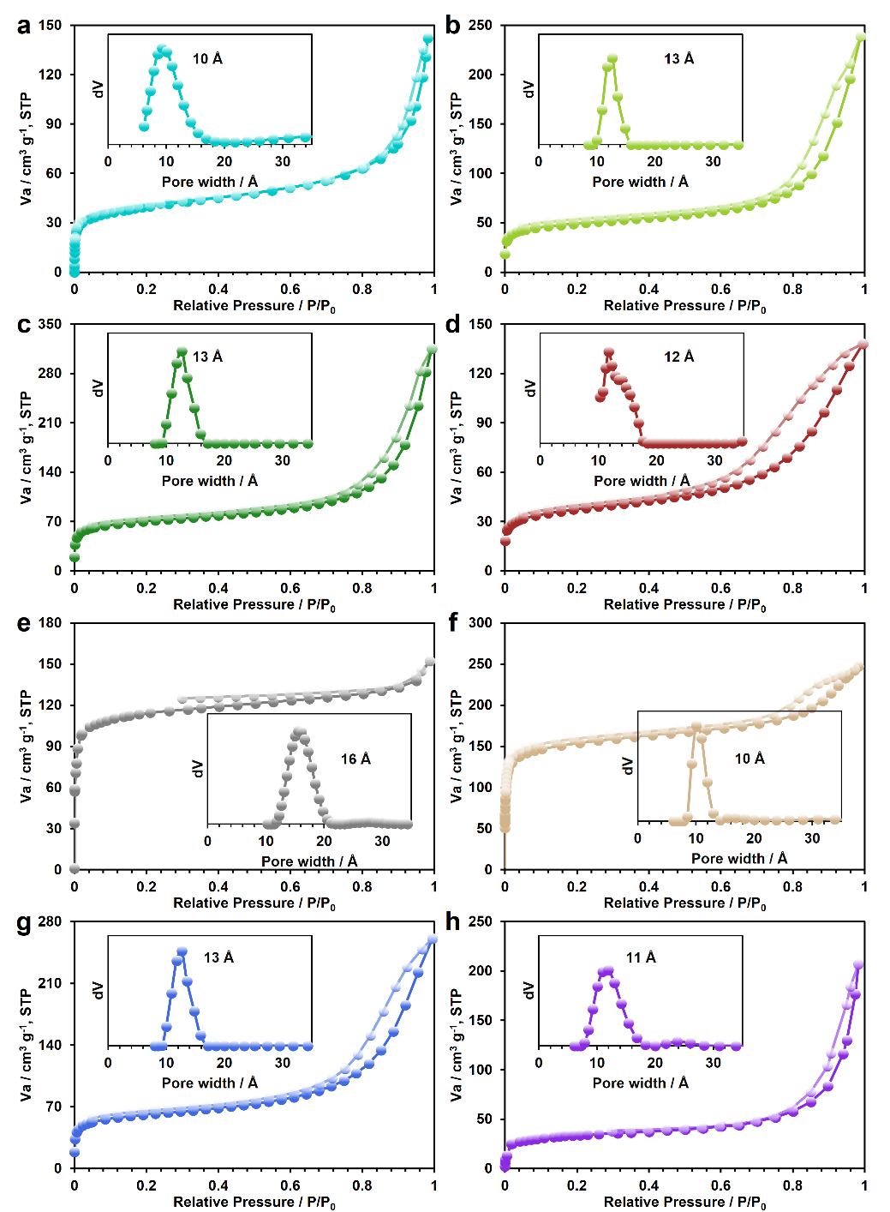
Figure S62. Isothermal N₂ sorption plots of (a) Cu-HHTP-CN, (b) Cu-HHTP-F, (c) Cu-HHTP-Cl, (d) Cu-HHTP-Br, (e) Cu-HHTP, (f) Cu-HHTP-Me, (g) Cu-HHTP-NH₂, and (h) Cu-HHTP-NHBu MOFs. Inset: pore size distribution. The Brunauer-Emmett-Teller (BET) surface area for Cu-HHTP-R MOFs was calculated to be 145, 159, 228, 123, 416, 592, 198, and 121 m²/g for Cu-HHTP-CN, Cu-HHTP-F, Cu-HHTP-Cl, Cu-HHTP-Br, Cu-HHTP, Cu-HHTP-Me, Cu-HHTP-NH₂, and Cu-HHTP-NHBu, respectively.

X-ray Photoelectron Spectroscopy
The X-ray photoelectron spectra (XPS) were recorded on a Thermo ESCALAB250Xi spectrometer with an excitation source of monochromatized Al Ka (hv = 1486.6 eV) and a pass energy of 30 eV. The surface carbon 284.8 eV was used as the reference binding energy for charge correction. XPS fitting was performed in XPSPEAK, with the Shirley line type selected for background subtraction.
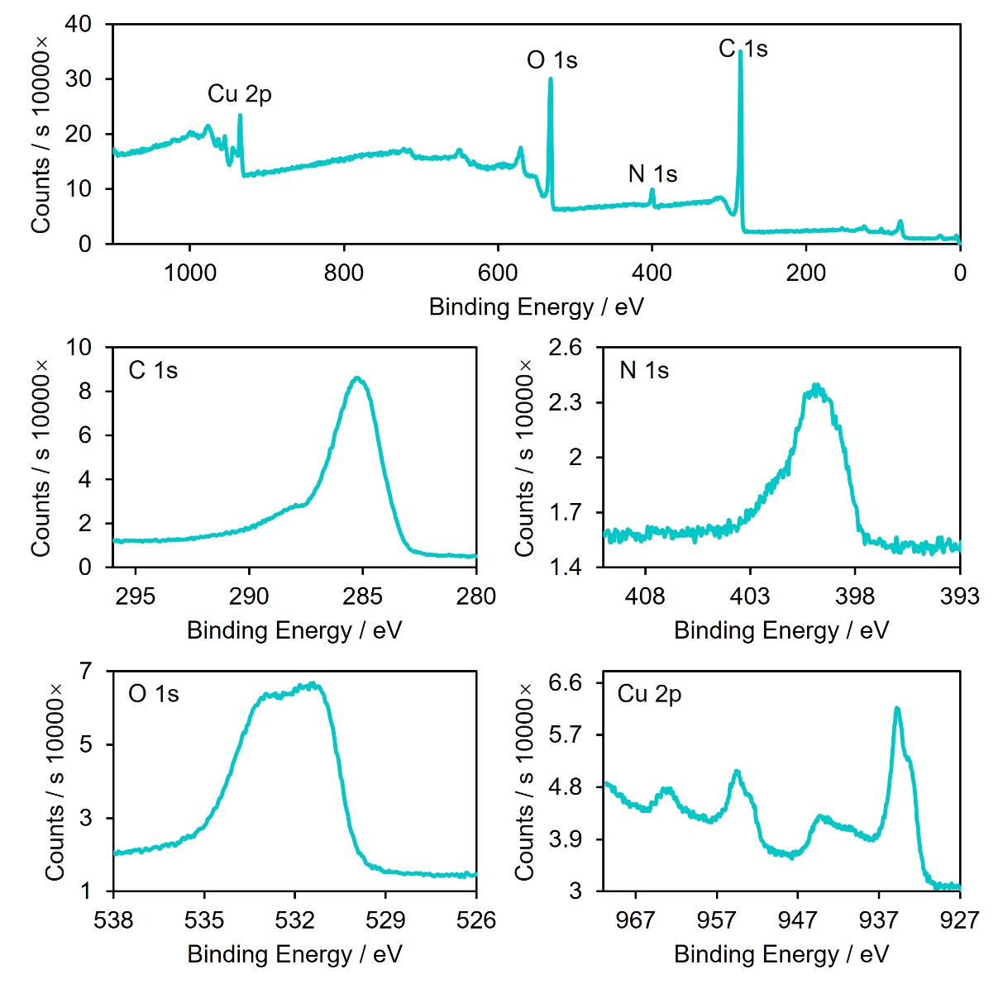
Figure S63. XPS survey spectra and fine spectra of Cu-HHTP-CN.
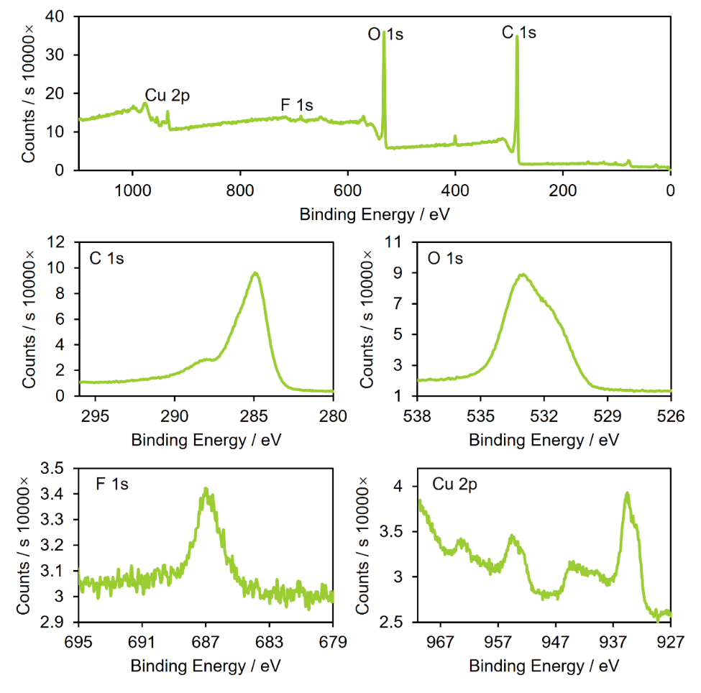
Figure S64. XPS survey spectra and fine spectra of Cu-HHTP-F.
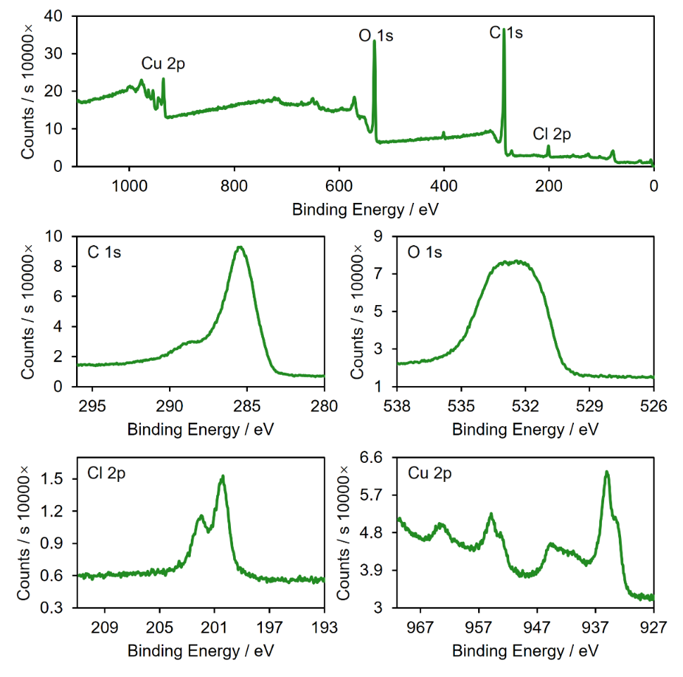
Figure S65. XPS survey spectra and fine spectra of Cu-HHTP-Cl.
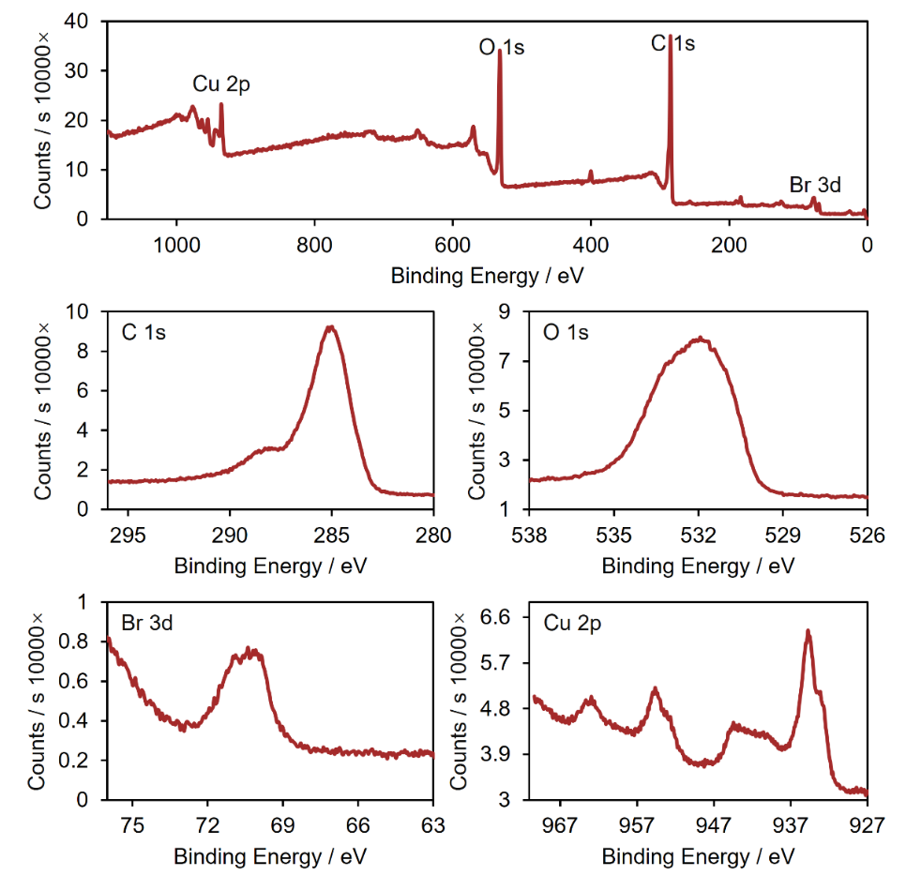
Figure S66. XPS survey spectra and fine spectra of Cu-HHTP-Br.
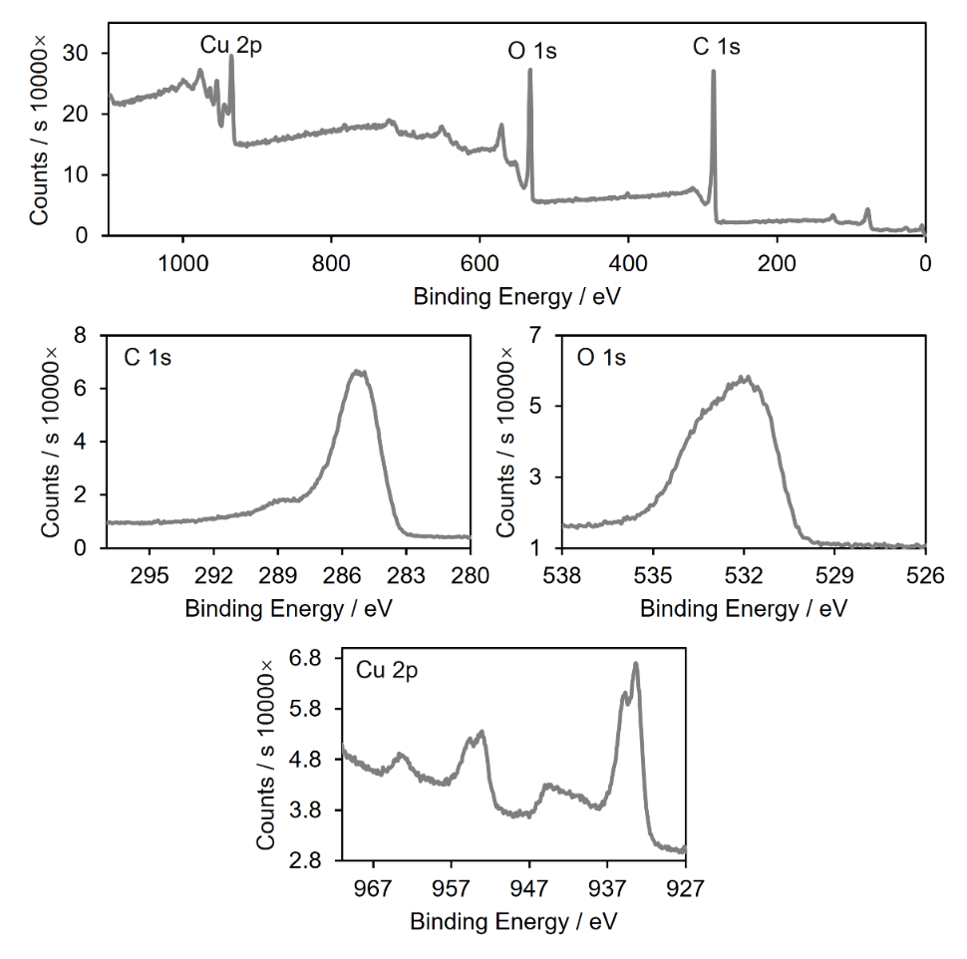
Figure S67. XPS survey spectra and fine spectra of Cu-HHTP.
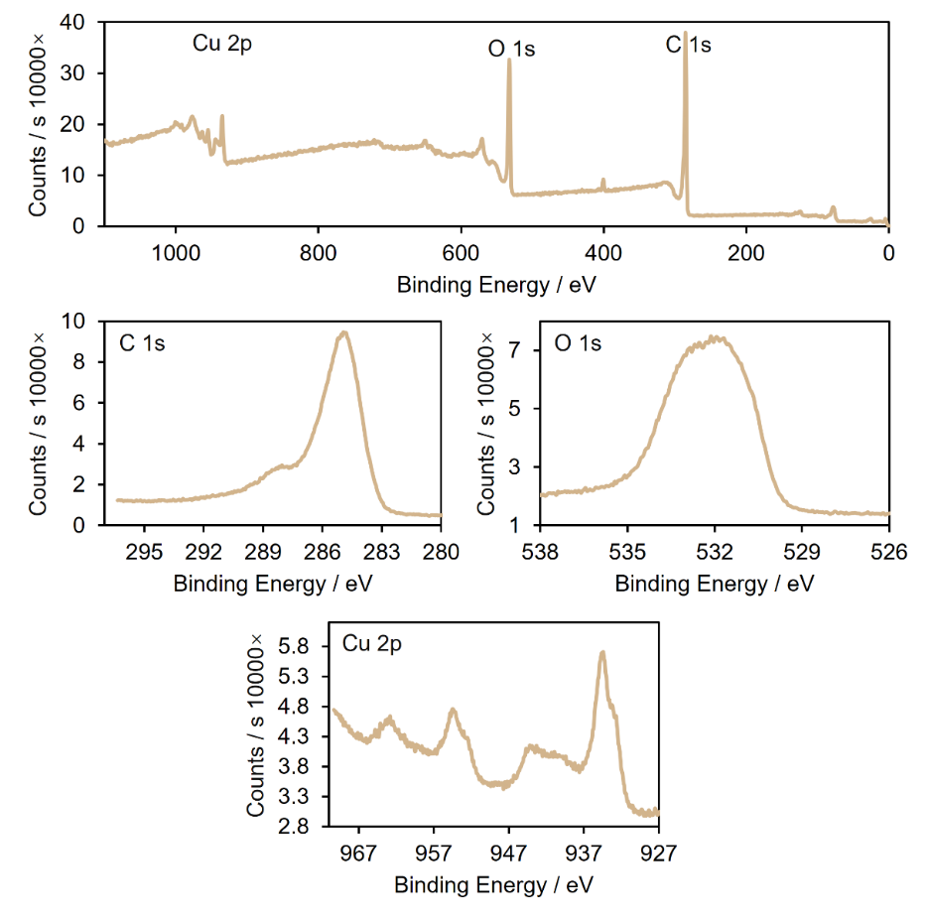
Figure S68. XPS survey spectra and fine spectra of Cu-HHTP-Me.
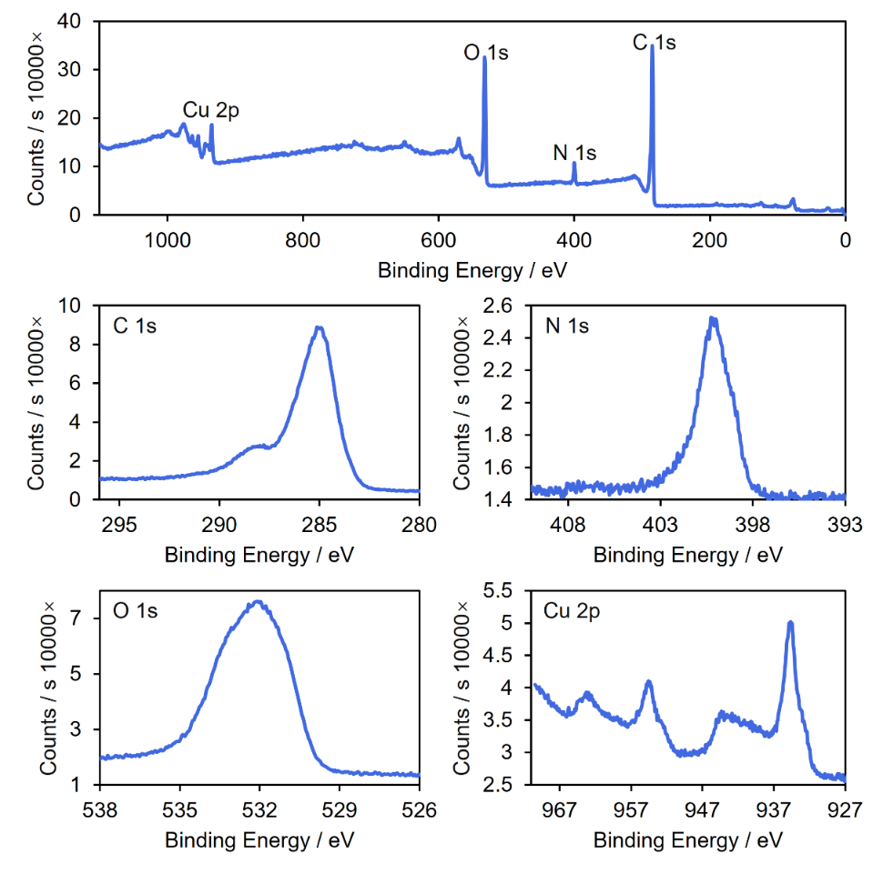
Figure S69. XPS survey spectra and fine spectra of Cu-HHTP-NH₂.
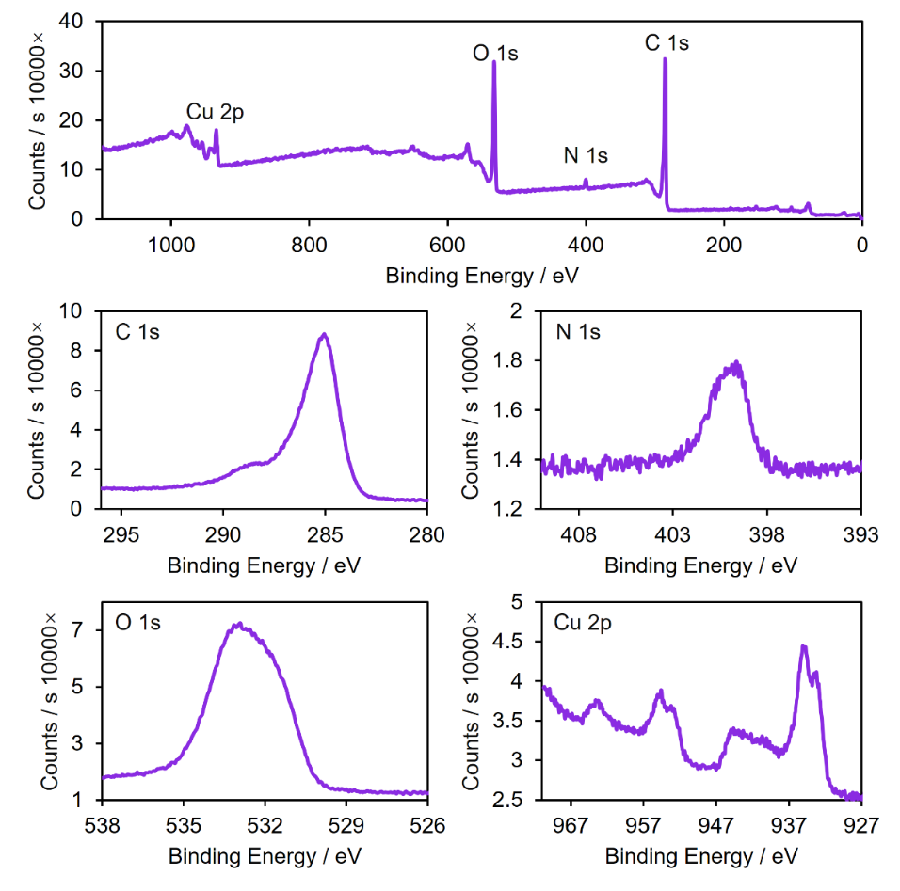
Figure S70. XPS survey spectra and fine spectra of Cu-HHTP-NHBu.
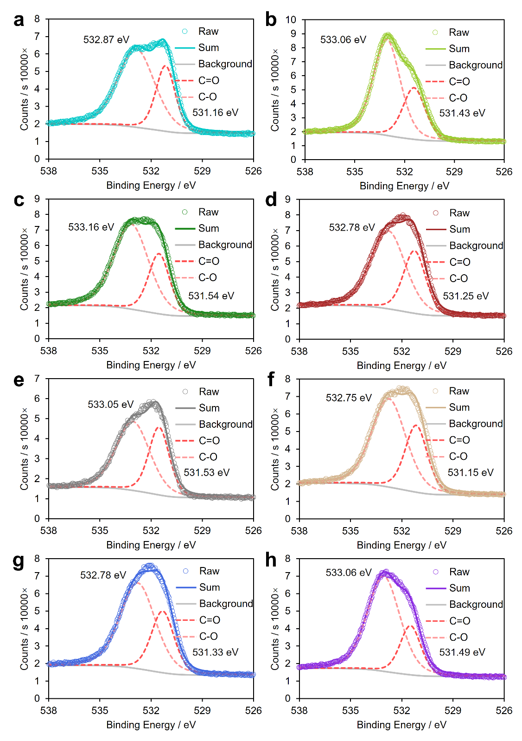
Figure S71. High-resolution XPS O 1s spectra of (a) Cu-HHTP-CN, (b) Cu-HHTP-F, (c) Cu-HHTP-Cl, (d) Cu-HHTP-Br, (e) Cu-HHTP, (f) Cu-HHTP-Me, (g) Cu-HHTP-NH₂, and (h) Cu-HHTP-NHBu MOFs.
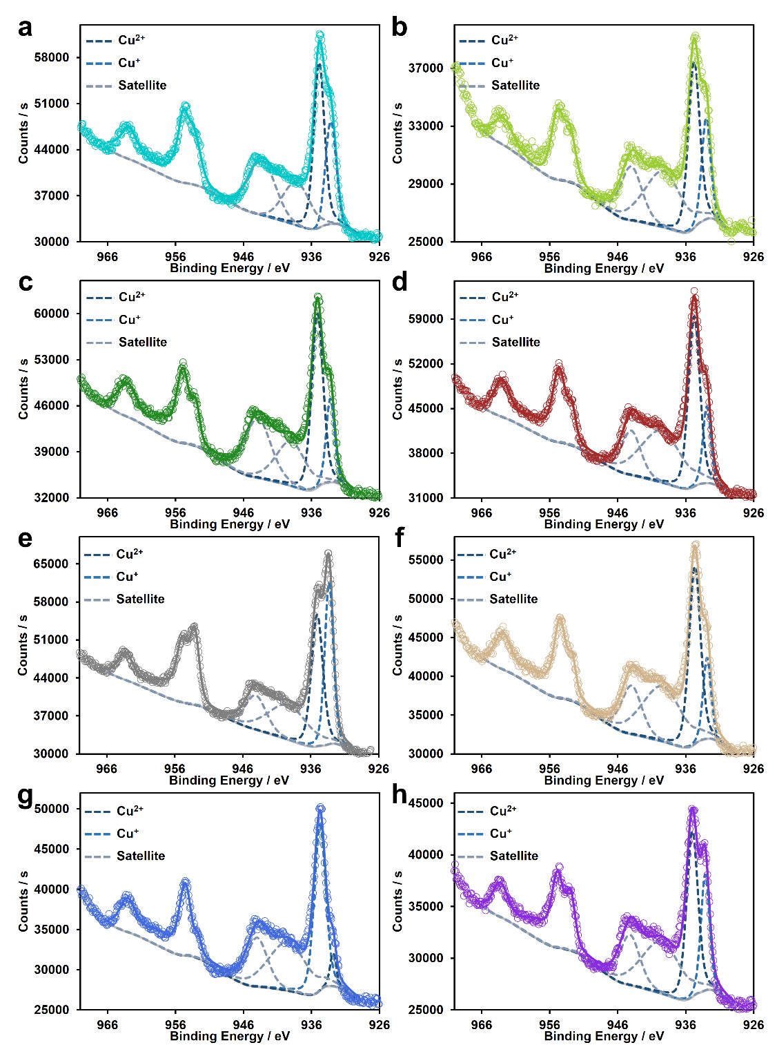
Figure S72. High-resolution XPS Cu 2p spectra of (a) Cu-HHTP-CN, (b) Cu-HHTP-F, (c) Cu-HHTP-Cl, (d) Cu-HHTP-Br, (e) Cu-HHTP, (f) Cu-HHTP-Me, (g) Cu-HHTP-NH₂, and (h) Cu-HHTP-NHBu MOFs. The hollow circle represents the raw data, the dashed line represents the fitting curve, and the gray solid line represents the background.

Table S2. XPS fitting results of the Cu-HHTP-R MOFs.
Samples | C-O | C=O | Ratio | Cu⁺ | Cu²⁺ | Ratio
Cu-HHTP-CN | 138618.4 | 61455.31 | 69:31 | 30816.44 | 131521.6 | 19:81
Cu-HHTP-F | 158703.2 | 71811.17 | 69:31 | 13089.69 | 76084.89 | 15:85
Cu-HHTP-Cl | 161537.6 | 69553.02 | 70:30 | 22546.85 | 157830.3 | 12:88
Cu-HHTP-Br | 145480.4 | 75503.3 | 66:34 | 20052.74 | 165245.1 | 11:89
Cu-HHTP | 97850.7 | 58902.27 | 62:38 | 54155.04 | 142890.6 | 27:73
Cu-HHTP-Me | 145308 | 71923.86 | 67:33 | 17666.54 | 143561.8 | 11:89
Cu-HHTP-NH₂ | 144979.9 | 68071.29 | 68:32 | 5394.573 | 126881.5 | 4:96
Cu-HHTP-NHBu | 150107.1 | 49814.14 | 75:25 | 20451.72 | 101874.1 | 17:83

Electron Paramagnetic Resonance Spectrum
Electron paramagnetic resonance (EPR) spectra of Cu-HHTP-R MOFs sample powder were obtained using a JEOL JES-FA200 spectrometer (X-band) spectrometer. Microwave power employed was 1 mW; sweep width ranged from 187 mT to 487 mT.
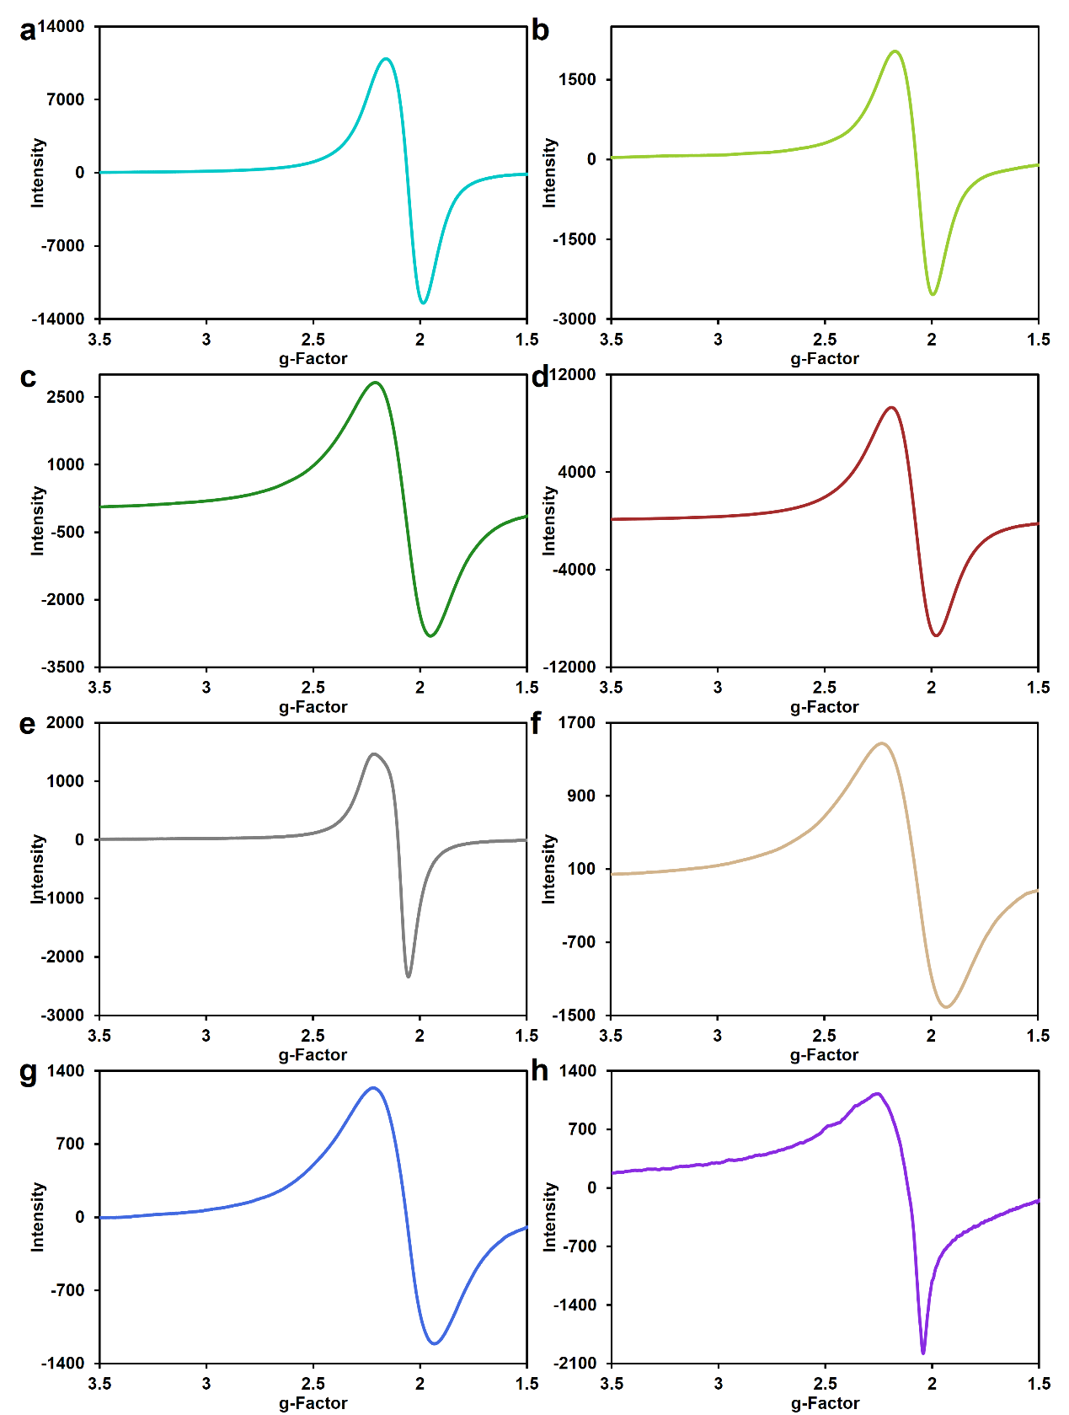
Figure S73. EPR spectra of (a) Cu-HHTP-CN, (b) Cu-HHTP-F, (c) Cu-HHTP-Cl, (d) Cu-HHTP-Br, (e) Cu-HHTP, (f) Cu-HHTP-Me, (g) Cu-HHTP-NH₂, and (h) Cu-HHTP-NHBu MOFs at 298 K.

X-ray Absorption Fine Structure
The raw XAFS data were processed using standard procedures within the Athena module of the IFEFFIT software package.¹⁸
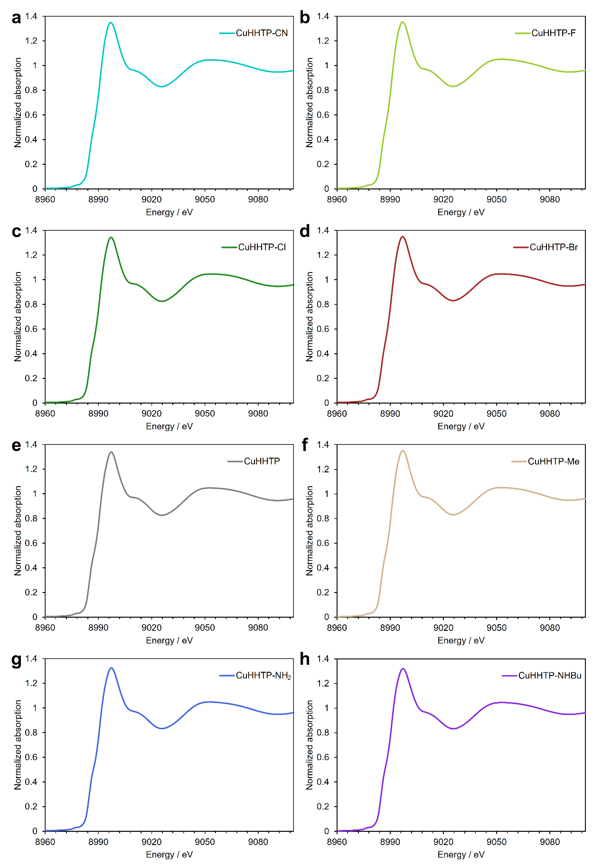
Figure S74. X-ray absorption near-edge structure (XANES) spectra of Cu K-edge for the (a) Cu-HHTP-CN, (b) Cu-HHTP-F, (c) Cu-HHTP-Cl, (d) Cu-HHTP-Br, (e) Cu-HHTP, (f) Cu-HHTP-Me, (g) Cu-HHTP-NH₂, and (h) Cu-HHTP-NHBu MOFs.

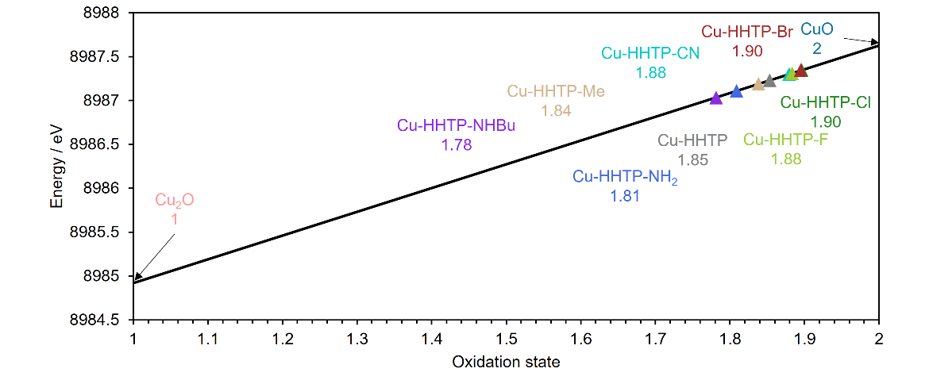
Figure S75. The relation between the energy positions of the normalized absorbance at 0.5 and oxidation states. The Cu oxidation state of the samples was estimated by the standard sample absorption edge energy (Cu₂O and CuO).
Extended X-ray absorption fine structure (EXAFS) fitting was performed by the Artemis module, following the EXAFS equation S1 below:
(S1)
where S₀² is the amplitude reduction factor, Fj(k) is the effective curved-wave backscattering amplitude, N_{j} is the number of neighbors in the j_{th} atomic shell, R_{j} is the distance between the X-ray absorbing central atom and the atoms in the j_{th} atomic shell, λ is the mean free path in Å, ϕ_{j}(k) is the phase shift, σ_{j}² is the Debye-Waller parameter of the j_{th} atomic shell (variation of distances around the average R_{j}).
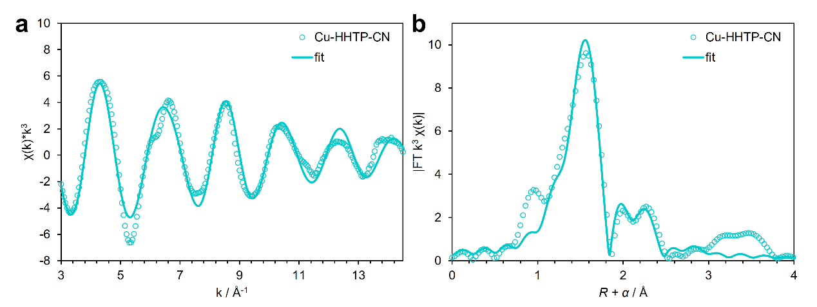
Figure S76. (a) k³χ(k) curves of Cu K-edge EXAFS oscillation functions for Cu-HHTP-CN with the fitting curves. (b) Fourier transform EXAFS spectra with the fitting curves.
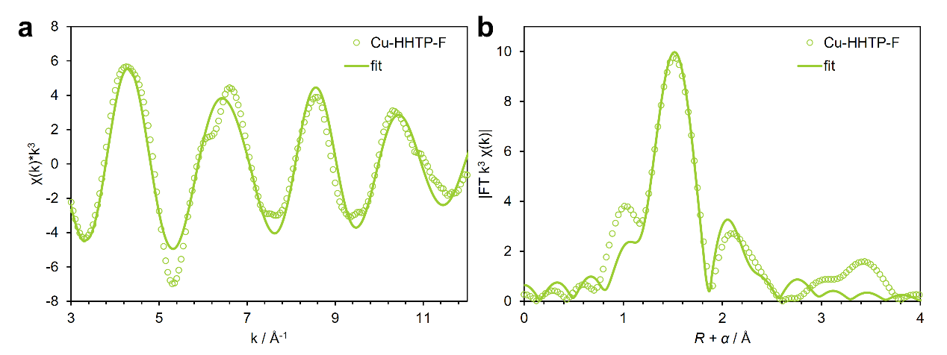
Figure S77. (a) k³χ(k) curves of Cu K-edge EXAFS oscillation functions for Cu-HHTP-F with the fitting curves. (b) Fourier transform EXAFS spectra with the fitting curves.
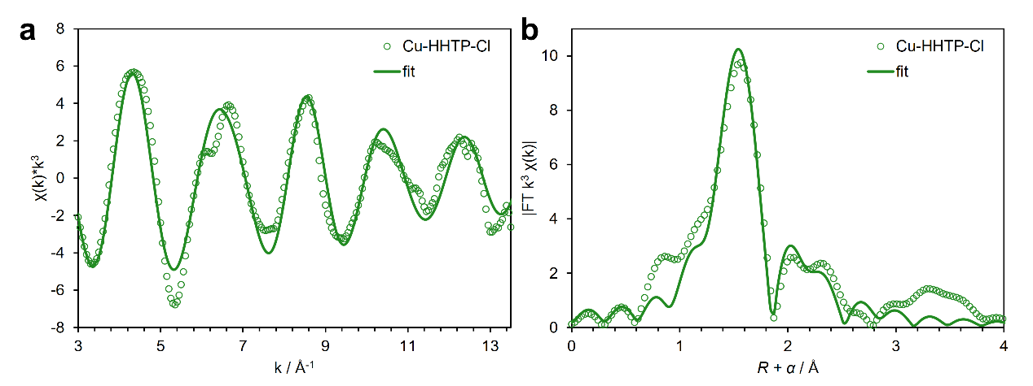
Figure S78. (a) k³χ(k) curves of Cu K-edge EXAFS oscillation functions for Cu-HHTP-Cl with the fitting curves. (b) Fourier transform EXAFS spectra with the fitting curves.
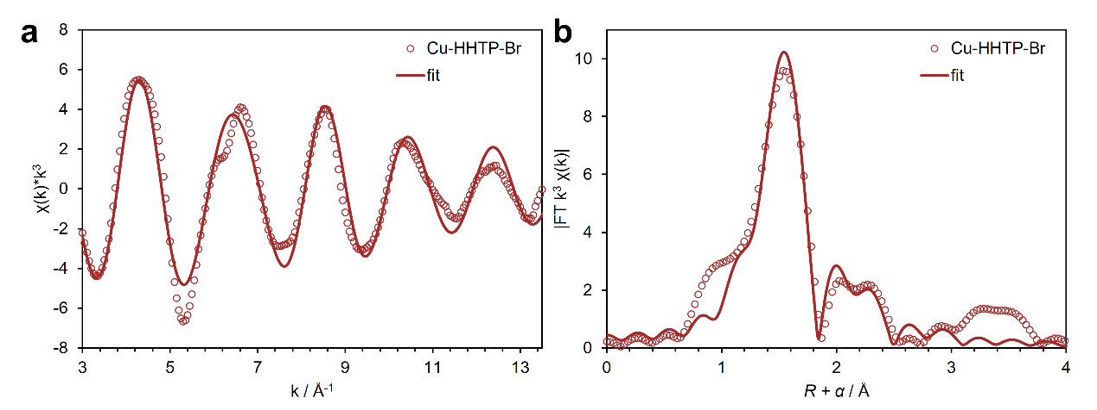
Figure S79. (a) k³χ(k) curves of Cu K-edge EXAFS oscillation functions for Cu-HHTP-Br with the fitting curves. (b) Fourier transform EXAFS spectra with the fitting curves.

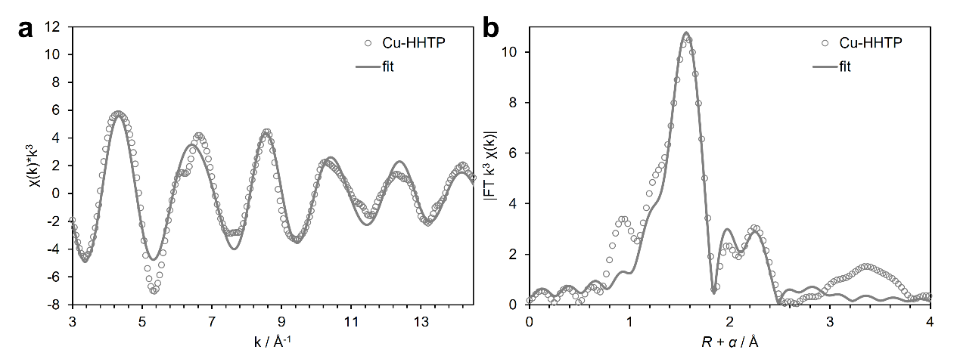
Figure S80. (a) k³χ(k) curves of Cu K-edge EXAFS oscillation functions for Cu-HHTP with the fitting curves. (b) Fourier transform EXAFS spectra with the fitting curves.
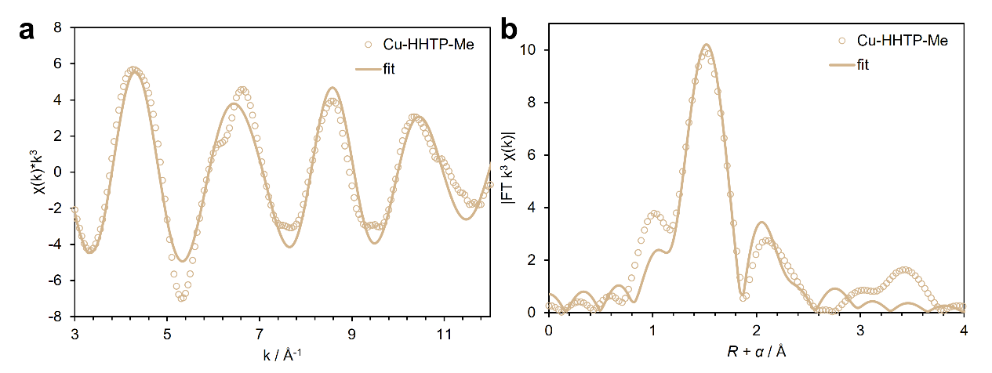
Figure S81. (a) k³χ(k) curves of Cu K-edge EXAFS oscillation functions for Cu-HHTP-Me with the fitting curves. (b) Fourier transform EXAFS spectra with the fitting curves.
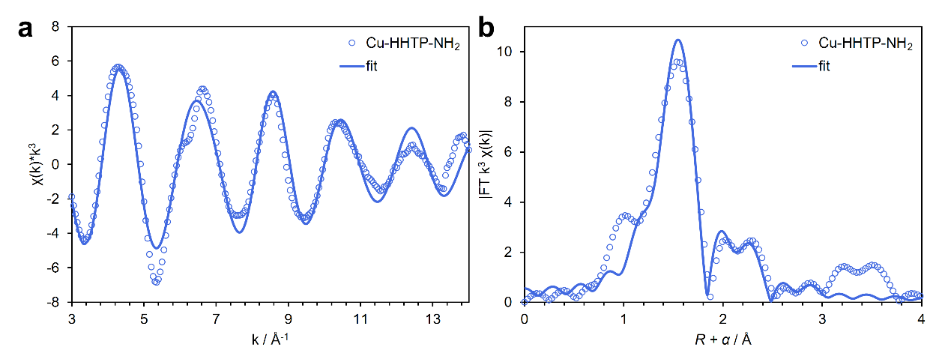
Figure S82. (a) k³χ(k) curves of Cu K-edge EXAFS oscillation functions for Cu-HHTP-NH₂ with the fitting curves. (b) Fourier transform EXAFS spectra with the fitting curves.

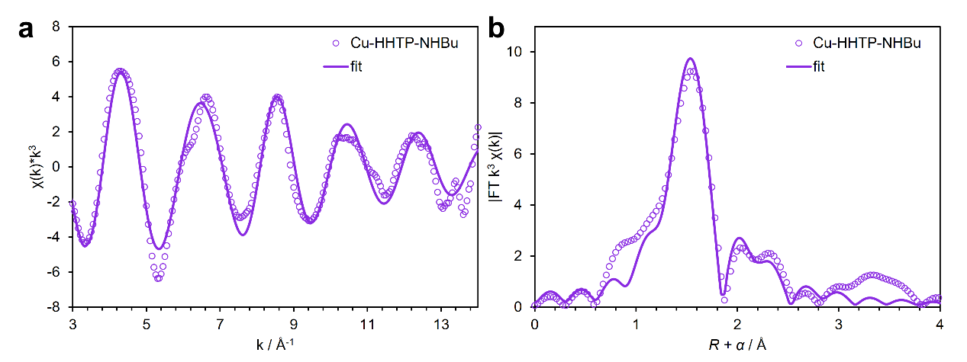
Figure S83. (a) k³χ(k) curves of Cu K-edge EXAFS oscillation functions for Cu-HHTP-NHBu with the fitting curves. (b) Fourier transform EXAFS spectra with the fitting curves.

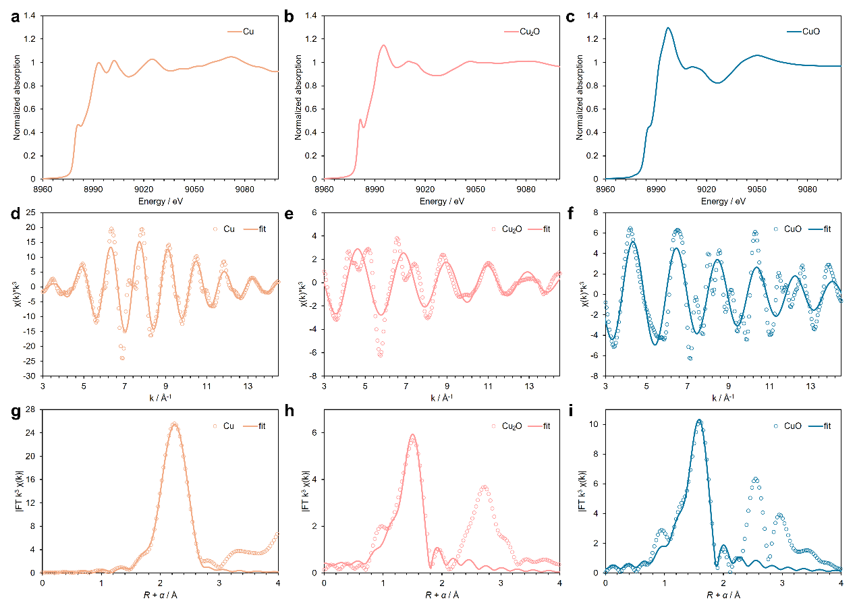
Figure S84. XANES spectra of Cu K-edge for the (a) Cu, (b) Cu₂O, and (c) CuO. k³χ(k) curves of Cu K-edge EXAFS oscillation functions for (d) Cu, (e) Cu₂O, and (f) CuO with the fitting curves. Fourier transform EXAFS spectra with the fitting curves for (g) Cu, (h) Cu₂O, and (i) CuO.

Table S3. Local structure parameters were extracted from EXAFS curve-fitting using the Artemis module implemented in the IFEFFIT software packages.
Sample | Path | N | R / Å | σ² / Å² | ∆E₀ | R factor
Cu-HHTP-CN | Cu-O | 4.2 | 1.93 | 0.00360 | 5.1 | 0.027
Cu-HHTP-CN | Cu-C | 4.0 | 2.67 | 0.00840 | 5.1 | 0.027
Cu-HHTP-F | Cu-O | 4.2 | 1.92 | 0.00309 | 4.1 | 0.022
Cu-HHTP-F | Cu-C | 4 | 2.66 | 0.00752 | 4.1 | 0.022
Cu-HHTP-Cl | Cu-O | 4.2 | 1.93 | 0.00339 | 5.3 | 0.025
Cu-HHTP-Cl | Cu-C | 4 | 2.67 | 0.00736 | 5.3 | 0.025
Cu-HHTP-Br | Cu-O | 4.2 | 1.93 | 0.00358 | 4.0 | 0.022
Cu-HHTP-Br | Cu-C | 4 | 2.66 | 0.00869 | 4.0 | 0.022
Cu-HHTP | Cu-O | 4.2 | 1.93 | 0.00346 | 5.9 | 0.022
Cu-HHTP | Cu-C | 4 | 2.67 | 0.00669 | 5.9 | 0.022
Cu-HHTP-Me | Cu-O | 4 | 1.92 | 0.00255 | 3.9 | 0.027
Cu-HHTP-Me | Cu-C | 4 | 2.65 | 0.00673 | 3.9 | 0.027
Cu-HHTP-NH₂ | Cu-O | 4.2 | 1.92 | 0.00345 | 5.1 | 0.028
Cu-HHTP-NH₂ | Cu-C | 3.9 | 2.66 | 0.00840 | 5.1 | 0.028
Cu-HHTP-NHBu | Cu-O | 4.2 | 1.93 | 0.00369 | 4.7 | 0.019
Cu-HHTP-NHBu | Cu-C | 4 | 2.68 | 0.00921 | 4.7 | 0.019
Cu | Cu-Cu | 12 | 2.54 | 0.00857 | 4.0 | 0.003
Cu₂O | Cu-O | 2 | 1.86 | 0.00362 | 6.6 | 0.018
CuO | Cu-O | 4 | 1.95 | 0.00393 | 6.1 | 0.008

The k³-weighted χ(k) data in the k-space were Fourier-transformed to R-space using hanning windows (dk = 1.0 Å⁻¹). Ѕ₀² was set to 0.827 according to the experimental EXAFS fit of Cu foil reference by fixing coordination numbers as the known crystallographic value. The k range of 3 ~ 13 Å⁻¹ and R range of 1.0 ~ 3.0 Å were used for fit. The uncertainty of S₀², N_{j}, R_{j}, and σ_{j}²was within ±20%.

Ultraviolet−Visible−Near Infrared Spectrum
UV-Vis-NIR spectra were collected in transmission mode using an integrating sphere detector unit and a slit width of 20 nm. Cu-HHTP-R thin films were synthesized according to Section 2.3 and carefully transferred onto a 2 cm × 2 cm quartz substrate, washed with acetone, and dried before testing.
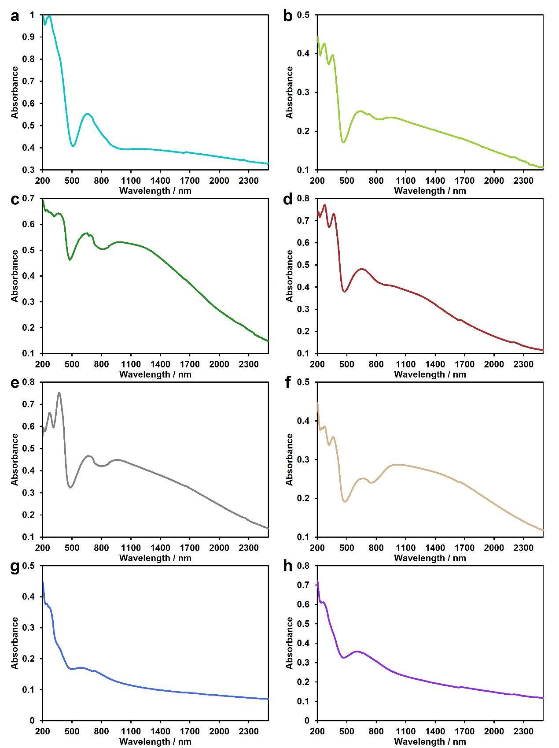
Figure S85. UV-Vis-NIR spectra of (a) Cu-HHTP-CN, (b) Cu-HHTP-F, (c) Cu-HHTP-Cl, (d) Cu-HHTP-Br, (e) Cu-HHTP, (f) Cu-HHTP-Me, (g) Cu-HHTP-NH₂, and (h) Cu-HHTP-NHBu films.
The Tauc plot method is based on a formula proposed by Tauc et al,¹⁹ in which the relationship between the optical bandgap and absorption coefficient of semiconductor materials is described in equation S2.
(S2)
In equation S2, h represents the Planck constant, ν is the frequency of the photons, E_{g} is the optical band gap energy, and B is a constant. The value of the factor γ depends on the nature of the electron transition.¹⁹
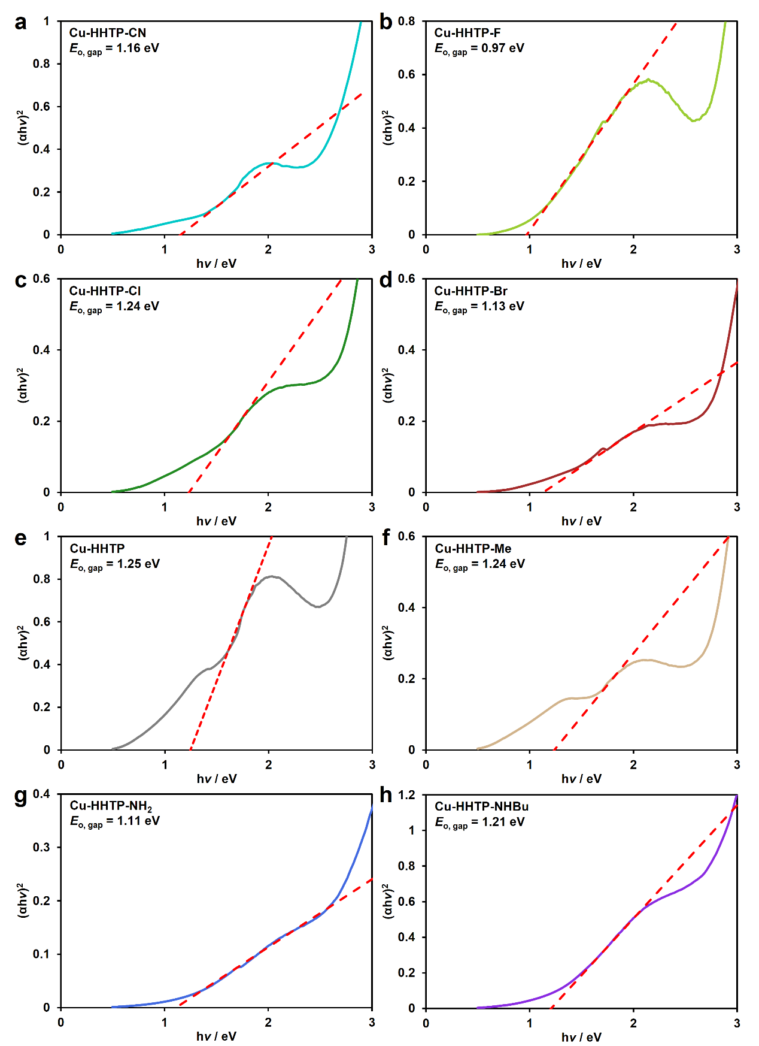
Figure S86. Tauc plots of (a) Cu-HHTP-CN, (b) Cu-HHTP-F, (c) Cu-HHTP-Cl, (d) Cu-HHTP-Br, (e) Cu-HHTP, (f) Cu-HHTP-Me, (g) Cu-HHTP-NH₂, and (h) Cu-HHTP-NHBu films.

Electrical Conductivity Measurement
To prepare the pressed pellets, 20 mg of the Cu-HHTP-R MOF samples were placed into an 8 mm inner-diameter split-sleeve die and compressed under a pressure of 4 tons for 5 minutes. The electrode wires used were made of platinum, and the contacts were made of conductive silver paste. The bulk conductivity of the resulting pellet was measured using a four-point linear probe configuration with a tip spacing of 1.2 mm. The electrical conductivity (S cm⁻¹) was then calculated according to equation S3,
(S3)
where R represents the measured resistance across the probe bridge, s is the probe spacing (0.12 cm), and F is a dimensionless geometric correction factor accounting for the pellet’s diameter and thickness.²⁰
To investigate the Arrhenius activation energy for electrical conductivity of Cu-HHTP-R MOFs, a 4-point probe was employed to collect the resistivity change under different temperatures (100 to 350 K). Typically, the Arrhenius equation can be used to access the Arrhenius activation energy (equation S4).
(S4)
In this equation, σ is the conductivity, σ₀ is the pre-exponential factor constant, E_{a} is the Arrhenius activation energy, k_{B} is the Boltzmann constant, and T is the temperature.

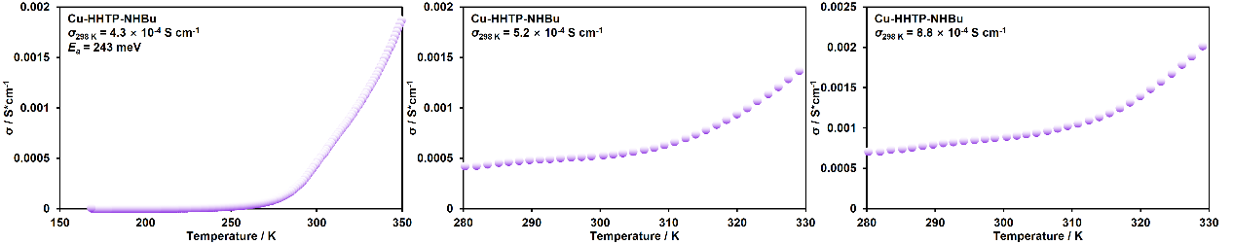
Figure S87. Temperature dependence of the conductivities of Cu-HHTP-NHBu with three independent devices.
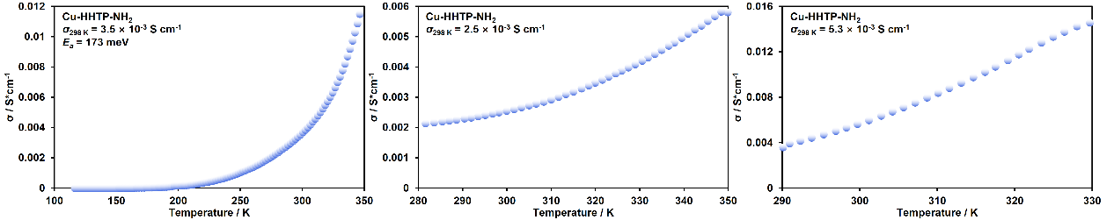
Figure S88. Temperature dependence of the conductivities of Cu-HHTP-NH₂ with three independent devices.
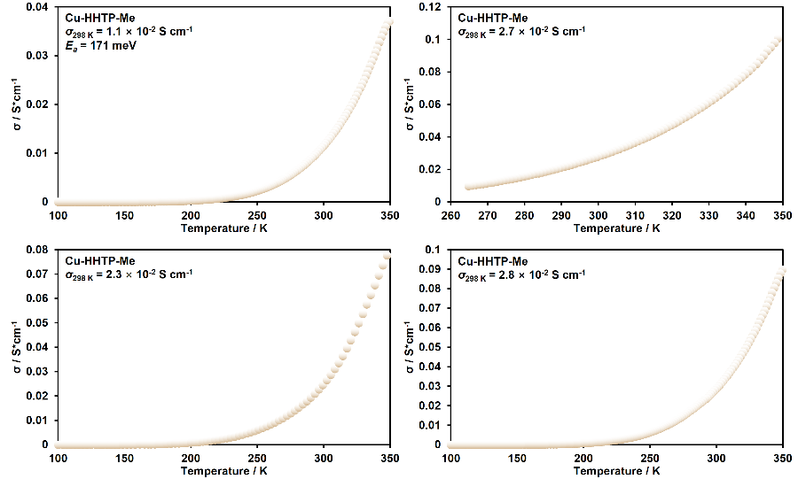
Figure S89. Temperature dependence of the conductivities of Cu-HHTP-Me with four independent devices.
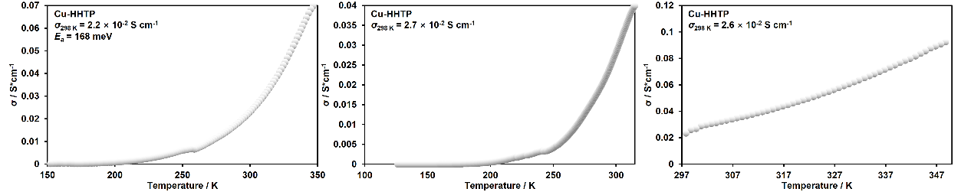
Figure S90. Temperature dependence of the conductivities of Cu-HHTP with three independent devices.
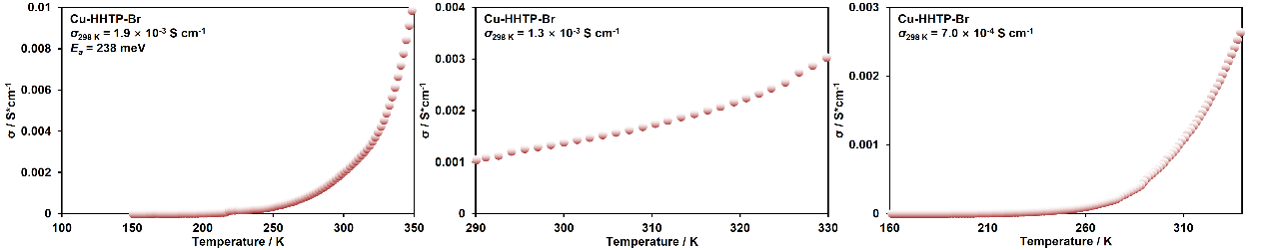
Figure S91. Temperature dependence of the conductivities of Cu-HHTP-Br with three independent devices.
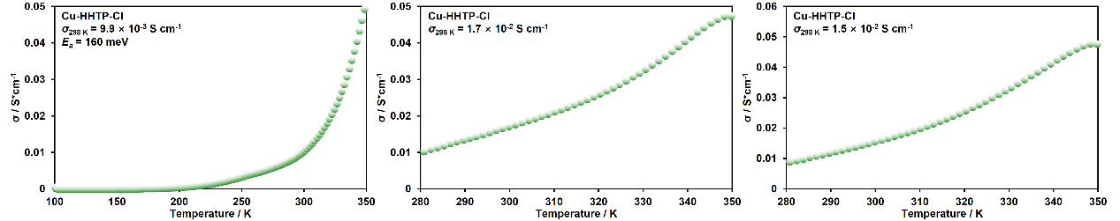
Figure S92. Temperature dependence of the conductivities of Cu-HHTP-Cl with three independent devices.
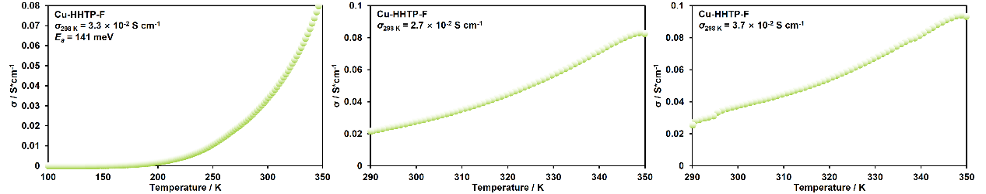
Figure S93. Temperature dependence of the conductivities of Cu-HHTP-F with three independent devices.
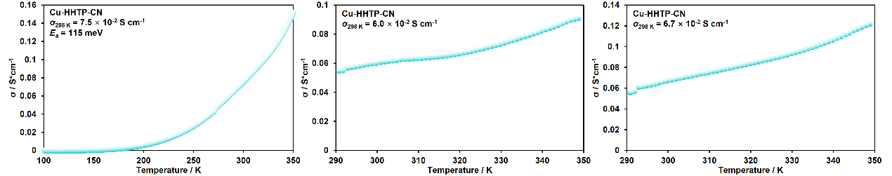
Figure S94. Temperature dependence of the conductivities of Cu-HHTP-CN with three independent devices.

Table S4. Room temperature conductivity for Cu-HHTP-R MOFs
Samples | Conductivity at 298 K | Average value
Cu-HHTP-CN-1 | 7.47×10⁻² S cm⁻¹ | 6.72×10⁻² S cm⁻¹
Cu-HHTP-CN-2 | 6.67×10⁻² S cm⁻¹ | 6.72×10⁻² S cm⁻¹
Cu-HHTP-CN-3 | 6.00×10⁻² S cm⁻¹ | 6.72×10⁻² S cm⁻¹
Cu-HHTP-F-1 | 3.28×10⁻² S cm⁻¹ | 3.22×10⁻² S cm⁻¹
Cu-HHTP-F-2 | 2.70×10⁻² S cm⁻¹ | 3.22×10⁻² S cm⁻¹
Cu-HHTP-F-3 | 3.67×10⁻² S cm⁻¹ | 3.22×10⁻² S cm⁻¹
Cu-HHTP-Cl-1 | 9.87×10⁻³ S cm⁻¹ | 1.38×10⁻² S cm⁻¹
Cu-HHTP-Cl-2 | 1.66×10⁻² S cm⁻¹ | 1.38×10⁻² S cm⁻¹
Cu-HHTP-Cl-3 | 1.50×10⁻² S cm⁻¹ | 1.38×10⁻² S cm⁻¹
Cu-HHTP-Br-1 | 1.94×10⁻³ S cm⁻¹ | 1.33×10⁻³ S cm⁻¹
Cu-HHTP-Br-2 | 1.34×10⁻³ S cm⁻¹ | 1.33×10⁻³ S cm⁻¹
Cu-HHTP-Br-3 | 7.03×10⁻⁴ S cm⁻¹ | 1.33×10⁻³ S cm⁻¹
Cu-HHTP-1 | 2.70×10⁻² S cm⁻¹ | 2.42×10⁻² S cm⁻¹
Cu-HHTP-2 | 2.21×10⁻² S cm⁻¹ | 2.42×10⁻² S cm⁻¹
Cu-HHTP-3 | 2.35×10⁻² S cm⁻¹ | 2.42×10⁻² S cm⁻¹
Cu-HHTP-Me-1 | 2.27×10⁻² S cm⁻¹ | 2.19×10⁻² S cm⁻¹
Cu-HHTP-Me-2 | 2.64×10⁻² S cm⁻¹ | 2.19×10⁻² S cm⁻¹
Cu-HHTP-Me-3 | 1.10×10⁻² S cm⁻¹ | 2.19×10⁻² S cm⁻¹
Cu-HHTP-Me-4 | 2.76×10⁻² S cm⁻¹ | 2.19×10⁻² S cm⁻¹
Cu-HHTP-NH₂-1 | 3.53×10⁻³ S cm⁻¹ | 3.79×10⁻³ S cm⁻¹
Cu-HHTP-NH₂-2 | 5.33×10⁻³ S cm⁻¹ | 3.79×10⁻³ S cm⁻¹
Cu-HHTP-NH₂-3 | 2.50×10⁻³ S cm⁻¹ | 3.79×10⁻³ S cm⁻¹
Cu-HHTP-NHBu-1 | 4.28×10⁻⁴ S cm⁻¹ | 6.11×10⁻⁴ S cm⁻¹
Cu-HHTP-NHBu-2 | 5.23×10⁻⁴ S cm⁻¹ | 6.11×10⁻⁴ S cm⁻¹
Cu-HHTP-NHBu-3 | 8.81×10⁻⁴ S cm⁻¹ | 6.11×10⁻⁴ S cm⁻¹

Hall Effect Measurements
Hall-effect measurements of the Cu-HHTP-R MOFs were performed at 300 K using a Quantum Design Physical Property Measurement System (PPMS) DynaCool with a vertical magnetic field that reached ±6 T. To prepare the pressed rectangular pellet, 10 mg of Cu-HHTP-R MOF powder was loaded into a 3 mm × 6 mm rectangular die and compressed under a pressure of 1.5 tons for 5 min. Electrical contacts were fabricated by applying conductive silver paste according to the standard Hall bar preparation protocol.
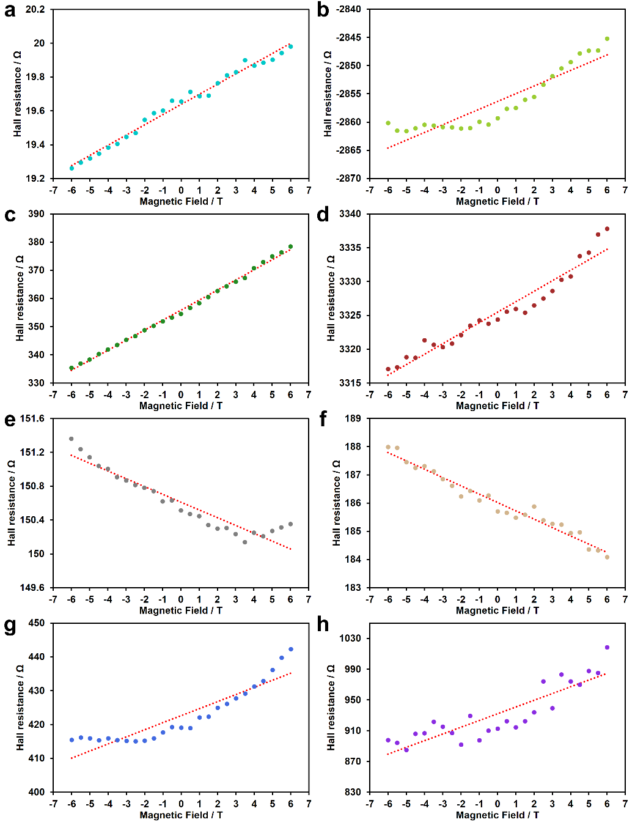
Figure S95. Magnetic field dependence of the Hall resistance for (a) Cu-HHTP-CN, (b) Cu-HHTP-F, (c) Cu-HHTP-Cl, (d) Cu-HHTP-Br, (e) Cu-HHTP, (f) Cu-HHTP-Me, (g) Cu-HHTP-NH₂, and (h) Cu-HHTP-NHBu at 300 K. The dashed line shows its linear dependence.
In Hall effect measurements, the Hall coefficient is determined by equation S5.
(S5)
Here, R_{xy} is the Hall resistance, B is the strength of the applied magnetic field, and t is the sample thickness. According to the semiconductor carrier type, R_{H}>0 is p-type carrier, while R_{H} <0 is n-type carrier. The carrier concentration are determined by equation S6.
(S6)
Here e = 1.602×10⁻¹⁹ C is the elementary charge.

Table S5. Hall coefficient (m³/C) and carrier concentration (m⁻³) of Cu-HHTP-R MOFs.
R | CN | F | Cl | Br | H | Me | NH₂ | NHBu
R_{H} | 2.66×10⁻⁵ | 4.39×10⁻⁴ | 1.18×10⁻³ | 2.84×10⁻⁴ | -5.86×10⁻⁵ | -1.74×10⁻⁴ | 1.12×10⁻³ | 3.40×10⁻³
n | 2.35×10²³ | 1.42×10²² | 5.28×10²¹ | 2.20×10²² | 1.07×10²³ | 3.59×10²² | 5.57×10²¹ | 1.84×10²¹

Atomic Force Microscope
The morphology and thickness of Cu-HHTP-R MOF films on a quartz glass substrate were measured using the tapping mode of an atomic force microscope (AFM).
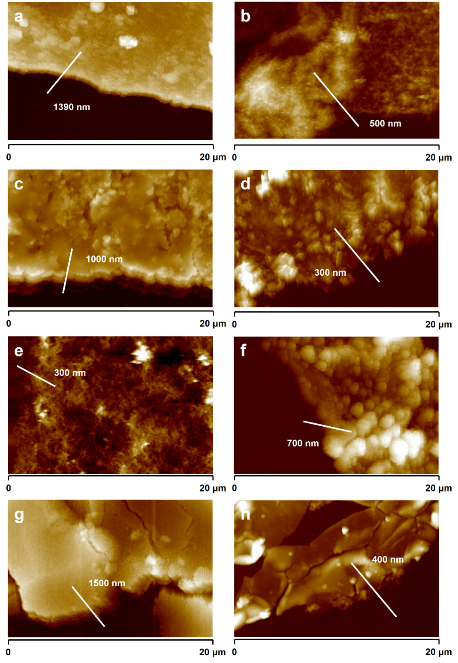
Figure S96. AFM images of (a) Cu-HHTP-CN, (b) Cu-HHTP-F, (c) Cu-HHTP-Cl, (d) Cu-HHTP-Br, (e) Cu-HHTP, (f) Cu-HHTP-Me, (g) Cu-HHTP-NH₂, and (h) Cu-HHTP-NHBu films on quartz glass substrate.

Optical-Pump Terahertz-Probe Spectroscopy Measurement
All optical-pump terahertz-probe (OPTP) measurements of Cu-HHTP-R MOFs were carried out using an amplified Ti: sapphire laser system (Spectra Physics, Spitfire Ace seeded by Mai-Tai SP) operating at a repetition rate of 2 kHz, with a pulse duration of 100 fs and a center wavelength of 800 nm. The laser output was divided into three beams for THz generation, probing, and optical excitation of the samples. THz pulses covering the 0-3 THz range were generated in a 1 mm thick [100]-oriented ZnTe crystal. The 400 nm pump pulse was obtained by frequency doubling in a BBO crystal. The beam diameters on the sample were approximately 1.0 mm for the THz probe and 4.0 mm for the optical pump. Detection of the transmitted THz pulses was performed coherently via free-space electro-optic sampling in a second [110]-oriented ZnTe crystal. The pump beam was modulated at 1 kHz using a mechanical chopper. Photoinduced transmission changes were recorded by synchronizing the femtosecond sampling pulse with the peak of the transmitted THz waveform while varying the temporal delay relative to the optical pump pulse.
The relaxation process of photoconductivity dynamics in Cu-HHTP-R film was modeled using a bi-exponential approach using equation S7.²¹
$y=A_{1}e^{-\frac{x}{t_{1}}}+A_{2}e^{-\frac{x}{t_{2}}}$ (S7)
Here, A₁ and t₁ denote the amplitude and time constant of the rapid decay component, while A₂ and t₂ correspond to the amplitude and time constant of the slower decay component.

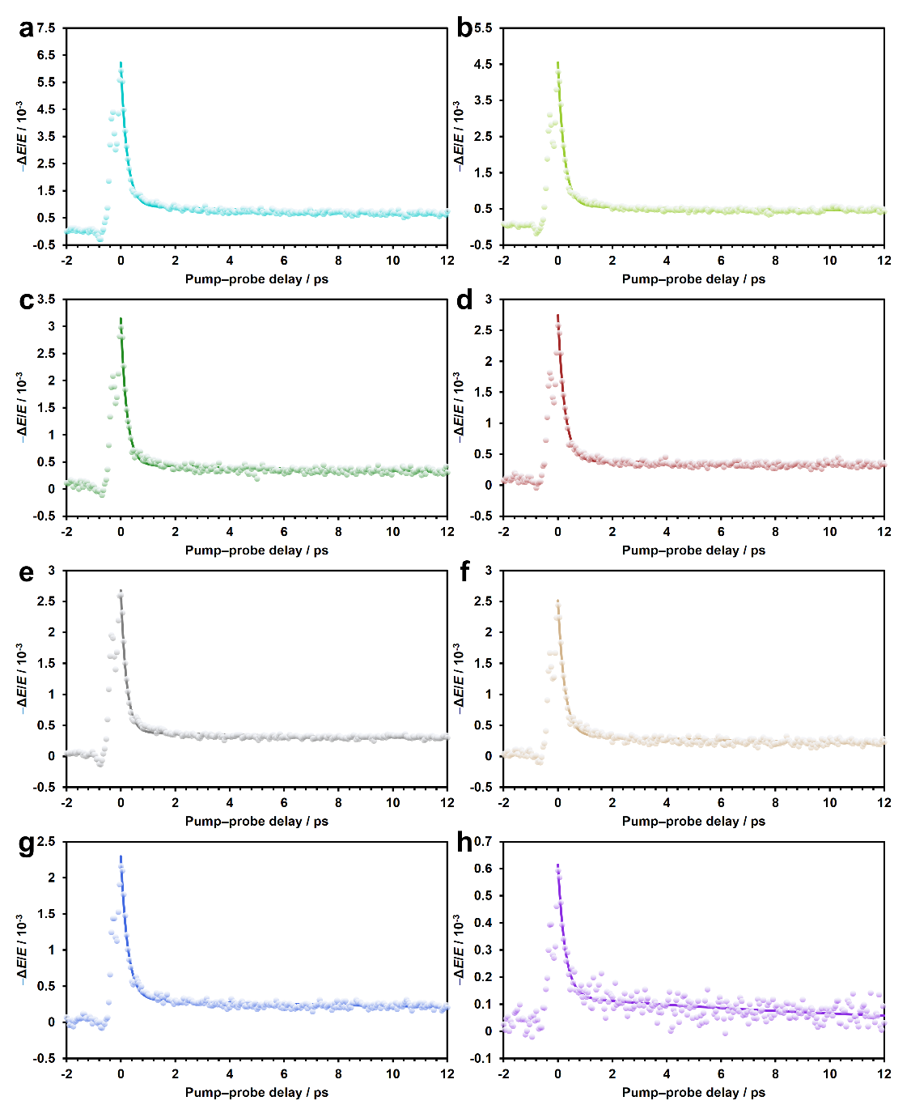
Figure S97. OPTP dynamics of Cu-HHTP-R films measured at 400 nm photoexcitation (633 μJ/cm²)

Table S6 Fitting parameters of the OPTP dynamics of Cu-HHTP-R films.
R | CN | F | Cl | Br | H | Me | NH₂ | NHBu
t₁ (ps) | 0.23 | 0.23 | 0.22 | 0.25 | 0.21 | 0.25 | 0.26 | 0.27
t₂ (ps) | 30.38 | 50.40 | 36.86 | 70.71 | 44.61 | 23.80 | 31.25 | 15.21
The photoconductivity of the material is determined by equation S8.²²
$σ(t)=-\frac{n_{1}+n_{2}}{Z_{0}⋅l}⋅\frac{ΔE(t)}{E(t)}$ (S8)
where Z₀ = 377 Ω represents the impedance of free space, 𝑛₁ and 𝑛₂ are the refractive indices of the media before and after the sample (here n₁ ≈ 1 for dry air and n₂ = 1.95 for fused quartz), and 𝑙 is the excitation thickness. ΔE(t) and E(t) are obtained from the transmitted THz traces with and without photoexcitation in the time domain, respectively.
After Fourier transform, Δσ(ω) of Cu-HHTP-R films was characterized using the Drude-Smith model (equation S9),²³ which considers spatially confined charge transport within nanomaterials.
$σ(ω)=\frac{ω_{p}^{2}ε_{0}τ}{1-iωτ}⋅(1+\frac{c}{1-iωτ})$ (S9)
In equation S9 c, τ, 𝜔_{𝑝}, and ε₀ are the backscattering probability, the Drude-Smith relaxation time, plasma frequency, and vacuum permittivity, respectively. In this model, a parameter c ranging from 0 (indicating isotropic scattering) to -1 (representing 100% backscattering) assesses the probability of backscattering.

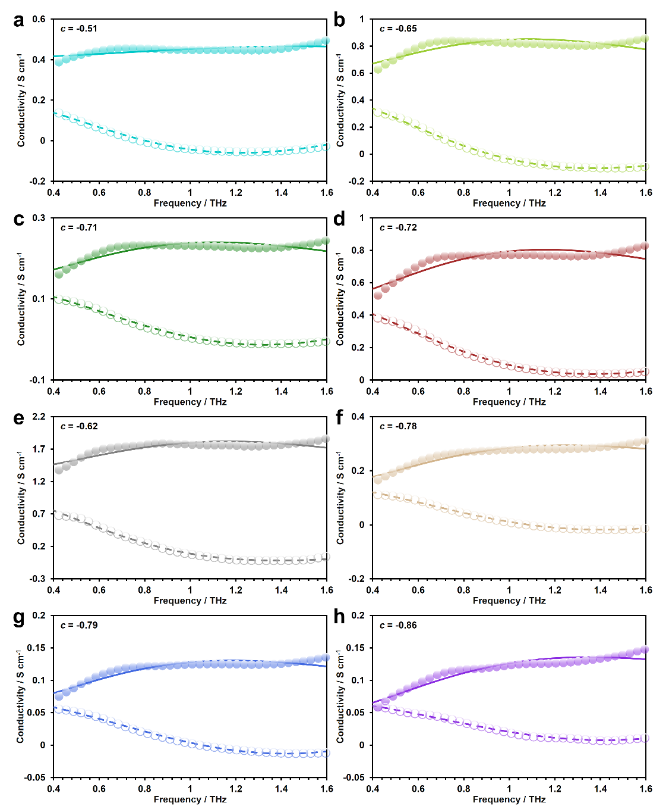
Figure S98. Frequency-resolved complex photoconductivity of (a) Cu-HHTP-CN, (b) Cu-HHTP-F, (c) Cu-HHTP-Cl, (d) Cu-HHTP-Br, (e) Cu-HHTP, (f) Cu-HHTP-Me, (g) Cu-HHTP-NH₂, and (h) Cu-HHTP-NHBu films at 298 K. The solid line corresponds to the fitting of the Drude-Smith model, which describes the real part of the complex terahertz photoconductivity, and the dashed line represents the fitting of the imaginary part.

Computational Study of Electronic Properties
Structure geometry optimization of all HHTP-R ligands and [CuO₄] unit was launched using the Gaussian with the B3LYP functional on the def-TZVP basis set.²⁴ The highest occupied molecular orbital (HOMO) and the lowest unoccupied molecular orbital (LUMO) of the ligand molecules were also calculated using this basis set. Electrostatic potential maps (ESP) of the HHTP-R ligands were rendered using the Multiwfn and VMD visualization programs.²⁵
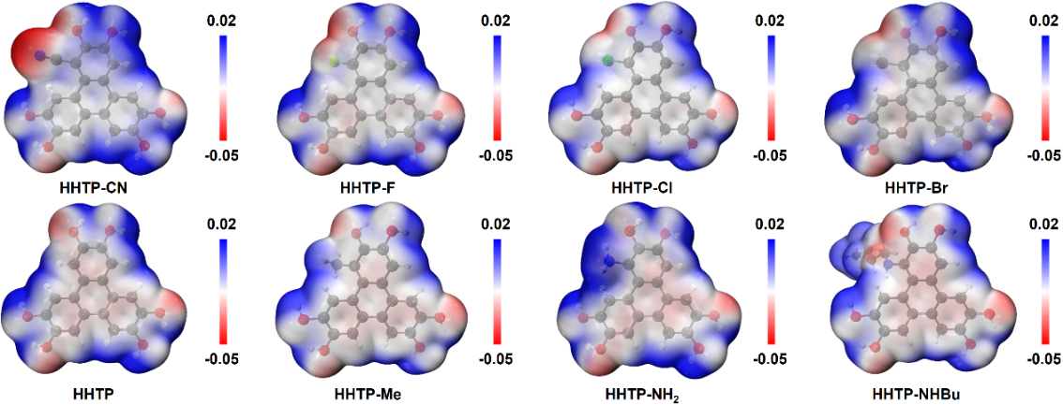
Figure S99. ESP maps of HHTP-R ligands.
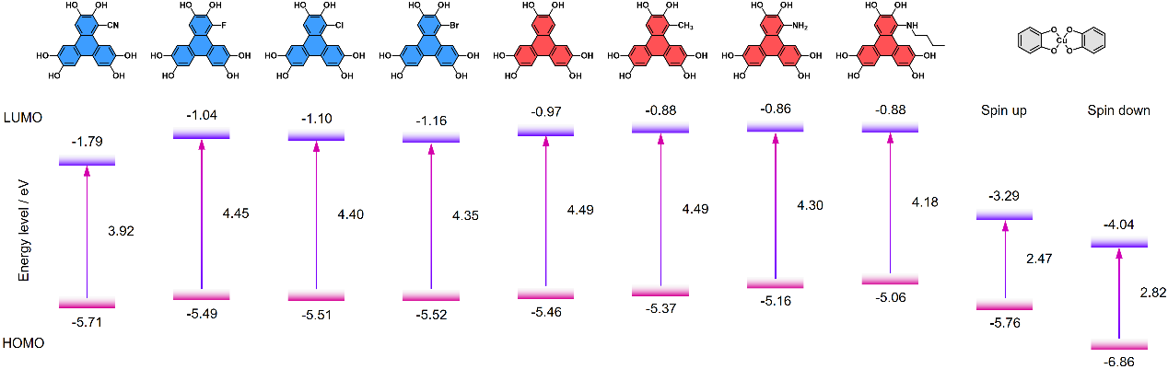
Figure S100. HOMO and LUMO of HHTP-R ligands and [CuO₄] unit.
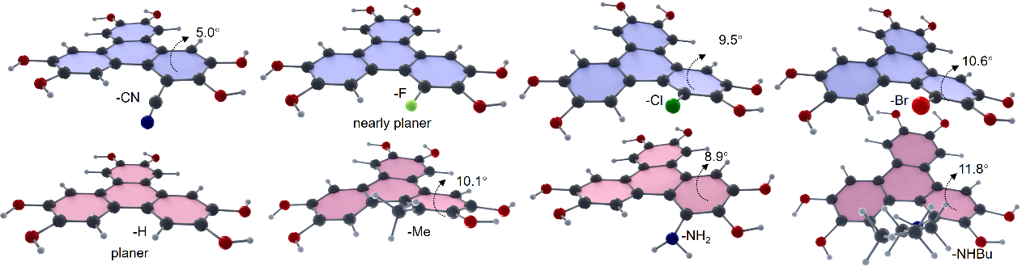
Figure S101. The geometrically optimized structure of the R-HHTP ligand and the torsion angle of the benzene ring introduced by the substituents.
The calculation and rendering of the ESP maps of all Cu-HHTP-R MOFs were performed in Material Studio using the PBE function in the GGA.
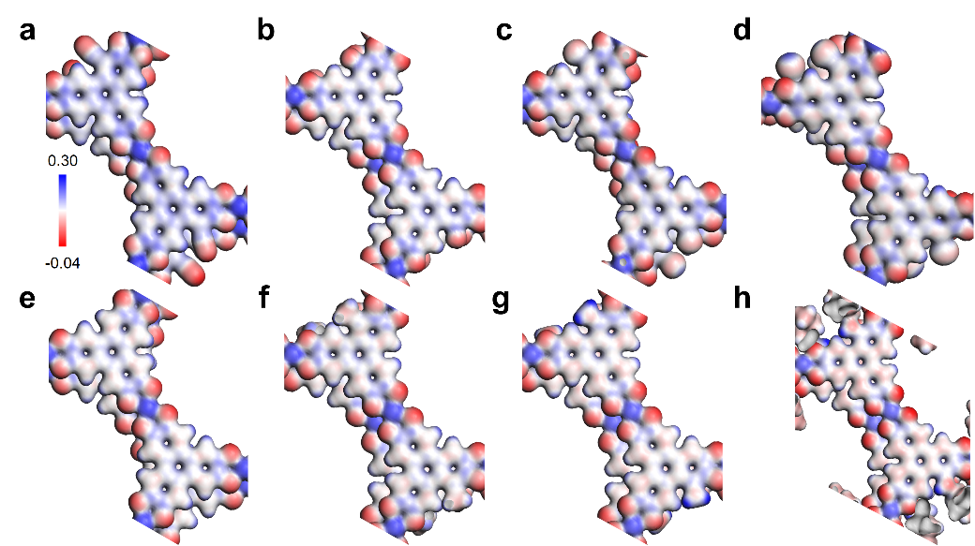
Figure S102. ESP maps of (a) Cu-HHTP-CN, (b) Cu-HHTP-F, (c) Cu-HHTP-Cl, (d) Cu-HHTP-Br, (e) Cu-HHTP, (f) Cu-HHTP-Me, (g) Cu-HHTP-NH₂, and (h) Cu-HHTP-NHBu.
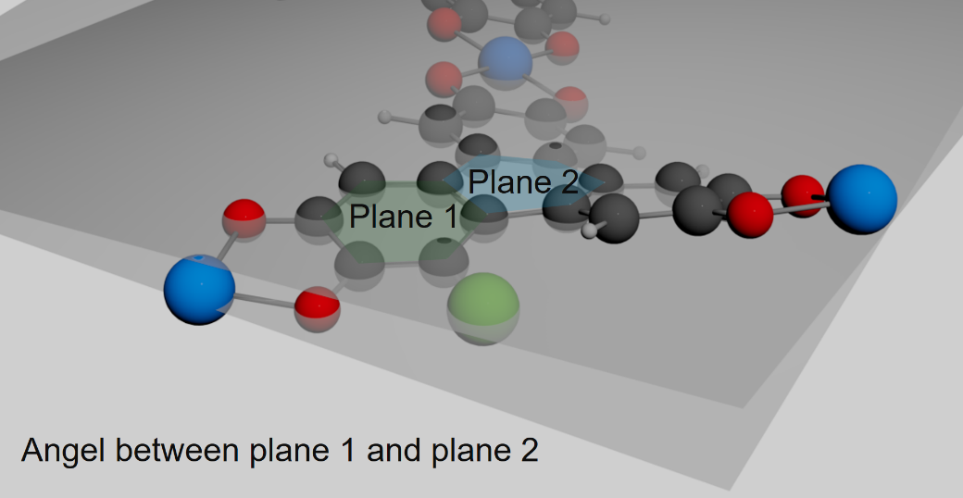
Figure S103. The twist angle in Cu-HHTP-R MOFs, which is defined as the dihedral angle between the central (plane 1) and periphery (plane 2) benzene ring on the triphenylene ligand..
The band structure and density of states of all Cu-HHTP-R MOFs were calculated using the GGA function with PBE. The Brillouin zone was sampled with a Monkhorst–Pack k-point grid corresponding to a spacing of 0.01 and a plane-wave cutoff energy of 520 eV was used. The value of U parameter of the Cu atom was set to be 10.4 eV. Collinear spin polarization calculations were considered. The Brillouin zone path was set to A−Γ−M−K−Γ for bulk Cu-HHTP-R.

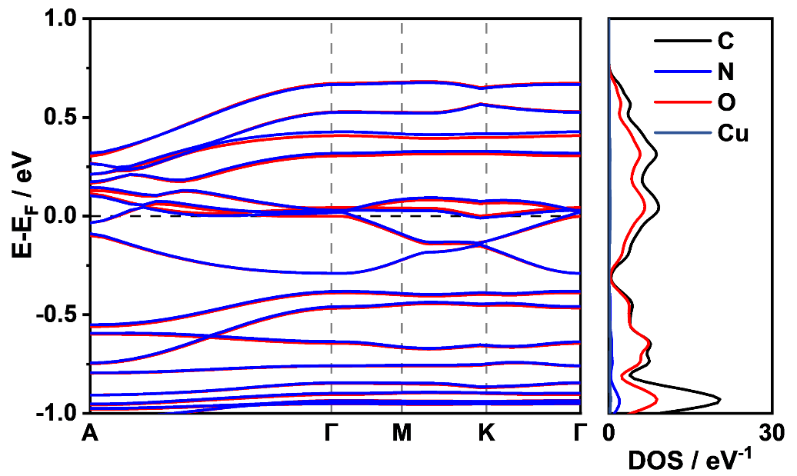
Figure S104. Band structure and density of states of bulk Cu-HHTP-CN.
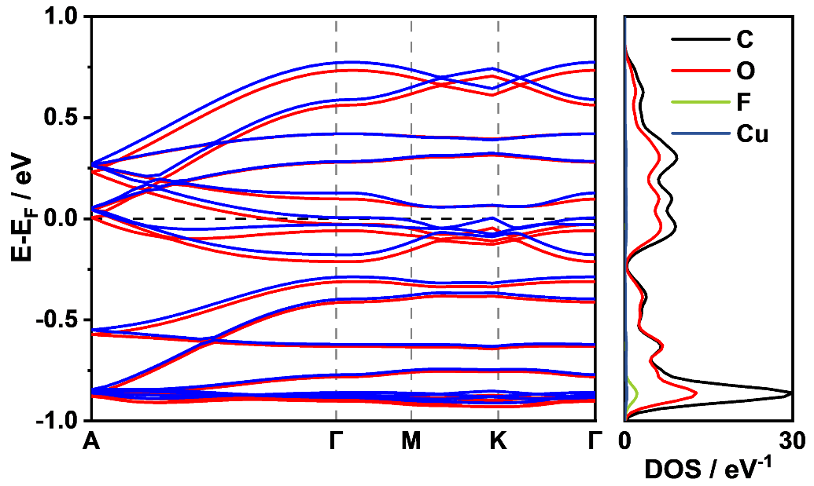
Figure S105. Band structure and density of states of bulk Cu-HHTP-F.

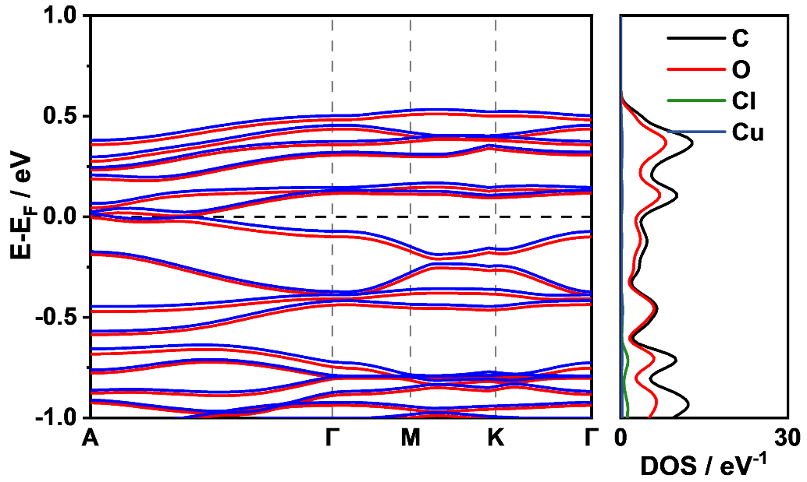
Figure S106. Band structure and density of states of bulk Cu-HHTP-Cl.

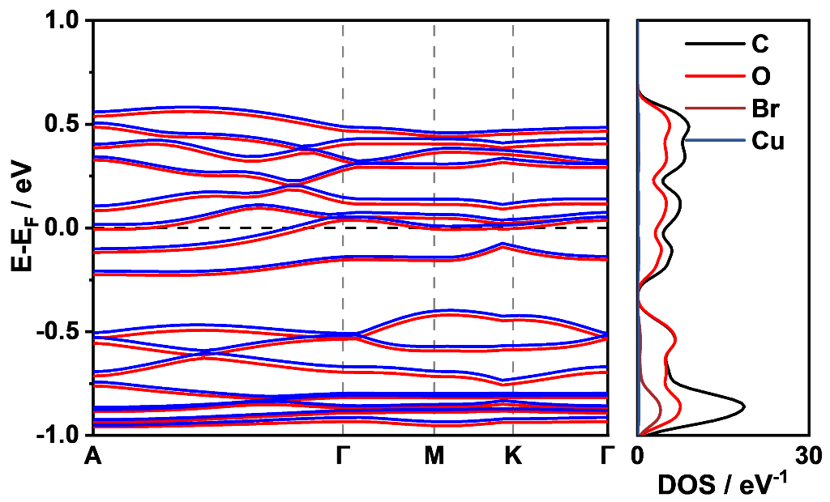
Figure S107. Band structure and density of states of bulk Cu-HHTP-Br.

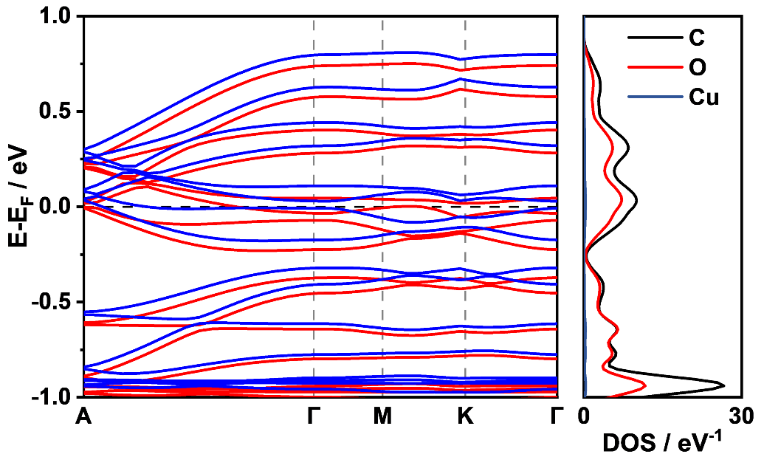
Figure S108. Band structure and density of states of bulk Cu-HHTP.

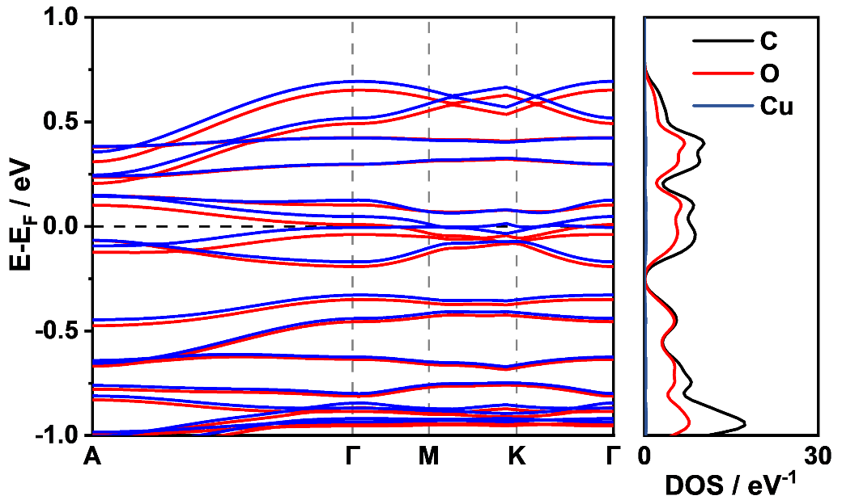
Figure S109. Band structure and density of states of bulk Cu-HHTP-Me.

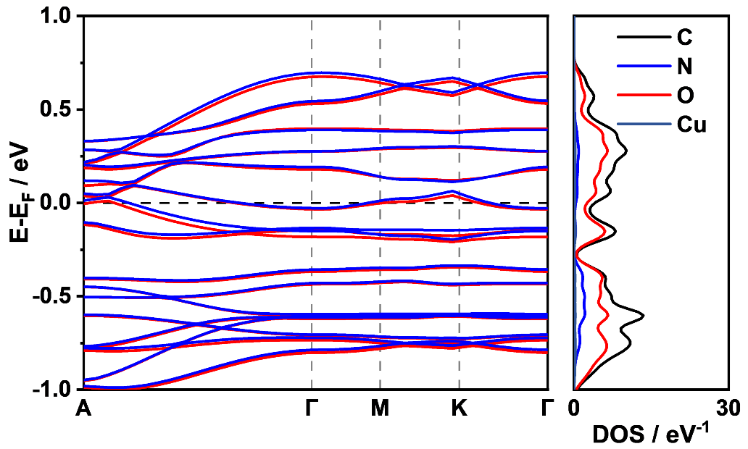
Figure S110. Band structure and density of states of bulk Cu-HHTP-NH₂.

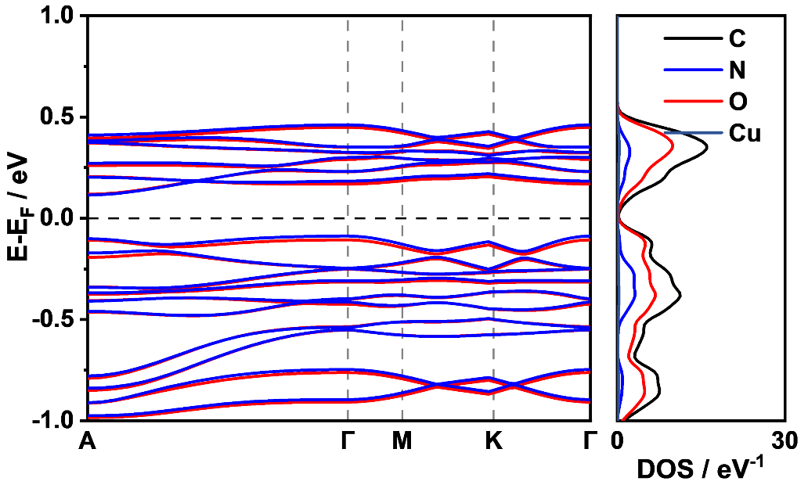
Figure S111. Band structure and density of states of bulk Cu-HHTP-NHBu.

Table S7. Hammett constants (γ), Charton constants (ν), and harmonic substituent constants (η) of substituents in this work.
R | CN | F | Cl | Br | H | Me | NH₂ | NHBu
γ | 0.68 | 0.34 | 0.37 | 0.39 | 0 | −0.07 | −0.16 | −0.34
ν | 0.40 | 0.27 | 0.55 | 0.65 | 0 | 0.52 | 0.12 | 0.68
η | 0.86 | 0.09 | −1.11 | −1.51 | 0 | −2.78 | −1.24 | −4.66
*The Charton constant for -NHBu is not available so far; therefore, the value for propyl with similar steric size is used here.

References
(1) Y. F. Wang; C. X. Zhang; H. Wu; A. Zhang; J. C. Wang; S. F. Zhang; J. L. Pu. Modulation of Phase Behaviors and Charge Carrier Mobilities by Linkage Length in Discotic Liquid Crystal Dimers. Soft Matter 2015, 11, 712-718.
(2) S. Maddala; A. Panua; P. Venkatakrishnan. Steering Scholl Oxidative Heterocoupling by Tuning Topology and Electronics for Building Thiananographenes and Their Functional N-/C-Congeners. Chem. Eur. J. 2021, 27, 16013-16020.
(3) R. C. Borner; N. Boden; R. J. Bushby; R. C. Borner; A. N. Cammidge; R. J. Bushby; A. N. Cammidge; M. V. Jesudason. The synthesis of triphenylene‐based discotic mesogens New and improved routes. Liquid Crystals 1993, 15, 851-858.
(4) K. Praefcke; A. Eckert; D. Blunk. Core-halogenated, helical-chiral triphenylene-based columnar liquid crystals. Liquid Crystals 1997, 22, 113-119.
(5) N. Boden; R. J. Bushby; Z. B. Lu; A. N. Cammidge. Cyano substituted triphenylene-based discotic mesogens. Liquid Crystals 1999, 26, 495-499.
(6) N. Boden; R. J. Bushby; A. N. Cammidge; S. Duckworth; G. Headdock. α-Halogenation of triphenylene-based discotic liquid crystals: towards a chiral nucleus. J. Mater. Chem. 1997, 7, 601-605.
(7) N. Boden; R. J. Bushby; A. N. Cammidge; G. Headdock. Versatile Synthesis of Unsymmetrically Substituted Triphenylenes. Synthesis 1995, 1995, 31-32.
(8) S. Kumar; S. K. Varshney. Synthesis of Triphenylene and Dibenzopyrene Derivatives: Vanadium Oxytrichloride a Novel Reagent. Synthesis 2001, 2001, 0305-0311.
(9) M. Vadivel; S. Singh; D. P. Singh; V. A. Raghunathan; S. Kumar. Ambipolar Charge Transport Properties of Naphthophenanthridine Discotic Liquid Crystals. J. Phys. Chem. B 2021, 125, 10364-10372.
(10) Y. X. Sun; X. G. Wang; G. D. Shen; T. Yang; Y. H. Yang; J. Li; M. Y. Yang; H. M. Sun; J. F. Wei. A 6π Azaelectrocyclization Strategy towards the 1,5,9‐Triazacoronenes. Adv. Synth. Catal. 2020, 362, 1651-1656.
(11) Y. Liu; H. Yao; H. Zhang; C. Ma; J. Guo; Y. Fan; H. Chen; X. Wu; L. Yang; X. Huang; et al. Asymmetrical Substitution Manipulates Stacking Modes in 2D Conductive MOF Crystals. Journal of the American Chemical Society 2025, 147, 48127-48135.
(12) Z. Zhang; D. S. Valente; Y. Shi; D. K. Limbu; M. R. Momeni; F. A. Shakib. In Silico High-Throughput Design and Prediction of Structural and Electronic Properties of Low-Dimensional Metal–Organic Frameworks. ACS Appl. Mater. Interfaces 2023, 15, 9494-9507.
(13) M. A. Addicoat; N. Vankova; I. F. Akter; T. Heine. Extension of the Universal Force Field to Metal-Organic Frameworks. J Chem Theory Comput 2014, 10, 880-891.
(14) G. Kresse; J. Furthmuller. Efficient iterative schemes for ab initio total-energy calculations using a plane-wave basis set. Phys. Rev. B 1996, 54, 11169-11186.
(15) P. E. Blochl. Projector augmented-wave method. Phys. Rev. B 1994, 50, 17953-17979.
(16) J. P. Perdew; K. Burke; M. Ernzerhof. Generalized Gradient Approximation Made Simple. Phys. Rev. Lett. 1996, 77, 3865-3868.
(17) S. Grimme; S. Ehrlich; L. Goerigk. Effect of the damping function in dispersion corrected density functional theory. J. Comput. Chem. 2011, 32, 1456-1465.
(18) B. Ravel; M. Newville. ATHENA, ARTEMIS, HEPHAESTUS: data analysis for X-ray absorption spectroscopy using IFEFFIT. J. Synchrotron Radiat. 2005, 12, 537-541.
(19) J. Tauc; R. Grigorovici; A. Vancu. Optical Properties and Electronic Structure of Amorphous Germanium. Phys Status Solidi B 1966, 15, 627-637.
(20) A. Chelly; S. Glass; J. Belhassen; A. Karsenty. Broad Review of Four-Point Probe Correction Factors: Enhanced Analytical Model Using Advanced Numerical and Experimental Cross-Examination. Results in Physics 2023, 48, 106445.
(21) S. Fu; E. Jin; H. Hanayama; W. Zheng; H. Zhang; L. Di Virgilio; M. A. Addicoat; M. Mezger; A. Narita; M. Bonn; et al. Outstanding Charge Mobility by Band Transport in Two-Dimensional Semiconducting Covalent Organic Frameworks. J. Am. Chem. Soc. 2022, 144, 7489-7496.
(22) J. Neu. Optical Pump Terahertz Probe (OPTP) and Time Resolved Terahertz Spectroscopy (TRTS) of Emerging Solar Materials. APL Photonics 2023, 8, 071103.
(23) N. Smith. Classical Generalization of the Drude Formula for the Optical Conductivity. Phys. Rev. B 2001, 64, 155106.
(24) J. Zhang; G. Zhou; H.-I. Un; F. Zheng; K. Jastrzembski; M. Wang; Q. Guo; D. Mücke; H. Qi; Y. Lu; et al. Wavy Two-Dimensional Conjugated Metal–Organic Framework with Metallic Charge Transport. J. Am. Chem. Soc. 2023, 145, 23630-23638.
(25) J. Zhang; T. Lu. Efficient Evaluation of Electrostatic Potential with Computerized Optimized Code. Phys. Chem. Chem. Phys. 2021, 23, 20323-20328.

