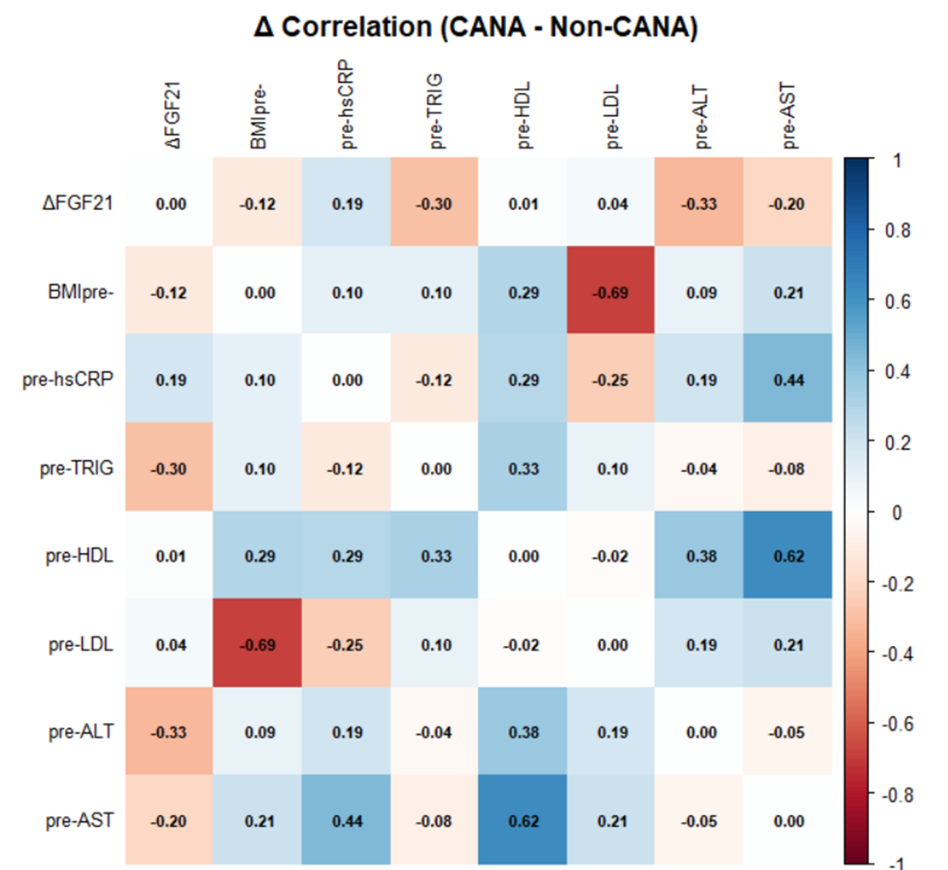
Fig.S1
Fig. S1. Correlation matrix of changes in FGF21 and baseline clinical parameters.
Heatmap illustrating Pearson correlation coefficients between the change in plasma FGF21 (ΔFGF21) and baseline (pre-) anthropometric and biochemical markers in the clinical cohort. Color intensity reflects the strength of the correlation ($r$), with blue representing positive and red representing negative correlations.
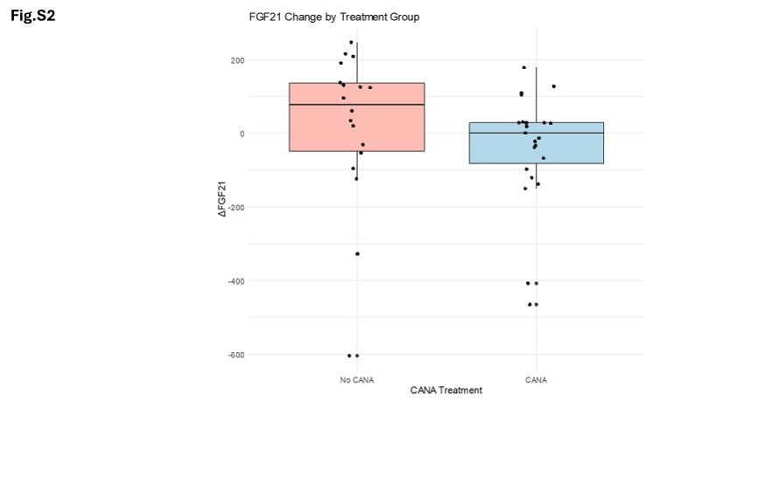
Fig. S2. Distribution of plasma FGF21 changes stratified by treatment group.
Boxplot comparing the magnitude of change in plasma FGF21 (ΔFGF21) between the non-CANA (n = 18) and CANA (n = 23) groups. Individual data points are superimposed on the boxes, representing the median, interquartile range, and whiskers.

