Appendix A
Teacher: Mrs. Tamara Powers Program: Human Anatomy & Physiology
Duration: 1 hour
Date: Monday, September 16, 2024 Topic: Intervention I:
Vocabulary Building & Partner Practice

STANDARDS | OBJECTIVES
Standard 3.0 Utilize Medical Terminology (ADE) | By the end of the lesson, students will:  - Identify and define 25 higher-level linking words used in academic and scientific contexts.  - Improve pronunciation of these linking words through oral repetition.  - Create 25 flashcards to visually reinforce their understanding of the linking words and their definitions.  - Apply vocabulary by quizzing and correcting their partner’s understanding of the terms.  - Collaborate effectively with a partner to reinforce correct usage and pronunciation of linking words.
VOCABULARY
Abundant, Acuity, Accurate, Analyze, Anticipate, Arises, Assess, Component, Compose, Comprised, Constituent, Consulting, Correlate, Critical, Debris, Deemed, Demonstrate, Determined, Differentiate, Engage, Emerge, Ensure, Evaluate, Evolve, Exhibit
BELLWORK
Write five of the new vocabulary words in a complete sentence.
Introduction
Teacher Actions | Student Actions
The teacher will ask students to choose five vocabulary words and act them out with a shoulder partner. | Students will choose two vocabulary words from the list above and act out the word with a shoulder partner.
CONTENT
Teacher Actions | Student Actions
Objective: Introduce the lesson's purpose and provide context for the importance of linking words.
- Explain to students the role of linking words in helping them understand and connect ideas in reading comprehension, particularly in scientific texts like Anatomy and Physiology.  - Briefly review the meaning of linking words, emphasizing how they connect sentences and ideas.  - Distribute index cards or blank flashcards.  - Instruct students to write each linking word on one side of the flashcard.  - As you go through each word, read it aloud and ask students to repeat the pronunciation.  - Students write a simple definition on the back of each card guided by the teacher’s explanation.  - Ensure students understand the definition and meaning of each word as they create their flashcards. | - Students listen and ask any initial questions about the purpose and use of linking words.  - Students actively create their flashcards, focusing on correct spelling and understanding.  - They repeat each word aloud to practice pronunciation after the teacher.
CLOSURE/ASSESSMENT
Teacher Actions | Student Actions
The teacher will ask questions about today’s lesson. | All students will write the answers on their small whiteboard and answer to the class if called on.
Materials Needed
Index cards (3X5 cards for flashcards)
Markers or pens
List of 25 higher-level linking words (pre-prepared by the teacher)
Timer
Whiteboard and markers

CONTENT
Teacher Actions | Student Actions
Objective: Students work in pairs, quizzing each other and providing corrective feedback to reinforce learning.

- Instruct students to pair up with their shoulder partners.  - Explain the structure of the activity: One partner will quiz the other by showing the side with the linking word, and the other must provide the definition. If they get it wrong, the quizzing partner will give the correct definition and help with pronunciation.  - Set a timer for 15 minutes, encouraging students to quiz and correct each other.  - After 15 minutes, instruct students to switch roles, allowing both partners to quiz and be quizzed.  - Walk around the classroom, monitoring pairs and offering help or clarification. | - Students engage in active quizzing and discussion with their partners, correcting and learning from one another.  - Students focus on reinforcing the definition and correct pronunciation of each linking word.
CLOSURE/ASSESSMENT
Teacher Actions | Student Actions
- Bring the class together for a brief reflection on the activity.  - Ask a few students to share one linking word they learned and why it’s essential in helping them understand texts.  - Review any challenging words that came up during the partner quiz.  - Encourage and remind students to continue reviewing the flashcards as they revisit these words in future lessons. | - Students reflect on their learning and actively participate in sharing what they learned with the class.

Teacher: Mrs. Tamara Powers Program: Human Anatomy & Physiology
Duration: 1 hour
Date: Tuesday, September 17, 2024 Topic: Intervention II:
Vocabulary Building & Partner Practice

STANDARDS | OBJECTIVES
Standard 3.0 Utilize Medical Terminology (ADE) | By the end of the lesson, students will:  - Identify and define 25 higher-level linking words used in academic and scientific contexts.  - Improve pronunciation of these linking words through oral repetition.  - Create 25 flashcards to visually reinforce their understanding of the linking words and their definitions.  - Apply vocabulary by quizzing and correcting their partner’s understanding of the terms.  - Collaborate effectively with a partner to reinforce correct usage and pronunciation of linking words.
VOCABULARY
Excess, Foreign, Indicate, Infer, Initiate, Insight, Inspecting, Modified, Necessity, Observe, Omit, Precede, Rapid, Receives, Reconcile, Reduce, Redundant, Reflect, Relieve, Replenish, Response, Retaliation, Revenue, Route, Severe, Scarce, States, Susceptible, Techniques, Verify
BELLWORK
Write five of the new vocabulary words in a complete sentence.
Introduction
Teacher Actions | Student Actions
The teacher will ask students to choose five vocabulary words and act them out with a shoulder partner. | Students will choose two vocabulary words from the list above and act out the word with a shoulder partner.
CONTENT
Teacher Actions | Student Actions
Objective: Introduce the lesson's purpose and provide context for the importance of linking words.
- Begin by explaining to students the role of linking words in helping them understand and connect ideas in reading comprehension, particularly in scientific texts like Anatomy and Physiology.  - Briefly review the meaning of linking words, emphasizing how they connect sentences and ideas.  - Distribute index cards or blank flashcards.  - Instruct students to write each linking word on one side of the flashcard.  - As you go through each word, read it aloud and ask students to repeat the pronunciation.  - Students write a simple definition on the back of each card guided by the teacher’s explanation.  - Ensure students understand the definition and meaning of each word as they create their flashcards. | - Students listen and ask any initial questions about the purpose and use of linking words.  - Students actively create their flashcards, focusing on correct spelling and understanding.  - They repeat each word aloud to practice pronunciation after the teacher.
CLOSURE/ASSESSMENT
Teacher Actions | Student Actions
The teacher will ask questions about today’s lesson. | All students will write the answers on their small whiteboard and answer to the class if called on.
Materials Needed
Index cards (3X5 cards for flashcards)
Markers or pens
List of 25 higher-level linking words (pre-prepared by the teacher)
Timer
Whiteboard and markers

CONTENT
Teacher Actions | Student Actions
Objective: Students work in pairs, quizzing each other and providing corrective feedback to reinforce learning.

- Instruct students to pair up with their shoulder partners.  - Explain the structure of the activity: One partner will quiz the other by showing the side with the linking word, and the other must provide the definition. If they get it wrong, the quizzing partner will provide the correct definition and help with pronunciation.  - Set a timer for 15 minutes, encouraging students to quiz and correct each other.  - After 15 minutes, instruct students to switch roles, allowing both partners to quiz and be quizzed.  - Walk around the classroom, monitoring pairs and offering help or clarification. | - Students engage in active quizzing and discussion with their partners, correcting and learning from one another.  - Students focus on reinforcing the definition and correct pronunciation of each linking word.
CLOSURE/ASSESSMENT
Teacher Actions | Student Actions
- Bring the class together for a brief reflection on the activity.  - Ask a few students to share one linking word they learned and why it’s essential in helping them understand texts.  - Review any challenging words that came up during the partner quiz.  - Encourage and remind students to continue reviewing the flashcards as they revisit these words in future lessons. | - Students reflect on their learning and actively participate in sharing what they learned with the class.
Teacher: Mrs. Tamara Powers Program: Human Anatomy & Physiology
Duration: 1.5 hours
Date: Wednesday, September 18, 2024 Topic: Intervention III:
Enhancing Vocabulary and Comprehension Using Task Card Activities

STANDARDS | OBJECTIVES
Standard 3.0 Utilize Medical Terminology (ADE) | By the end of the lesson, students will:  - Identify personal challenges with specific linking words from the previous interventions and select ten words they find most challenging.  - Complete task card activities related to the ten selected linking words to deepen understanding and usage.  - Apply vocabulary in context by completing creative and analytical tasks associated with their selected linking words.  - Reflect on learning by turning in written responses to task card activities for assessment.
VOCABULARY
Abundant, Acuity, Accurate, Analyze, Anticipate, Arises, Assess, Component, Compose, Comprised, Constituent, Consulting, Correlate, Critical, Debris, Deemed, Demonstrate, Determined, Differentiate, Engage, Emerge, Ensure, Evaluate, Evolve, Exhibit, Excess, Foreign, Indicate, Infer, Initiate, Insight, Inspecting, Modified, Necessity, Observe, Omit, Precede, Rapid, Receives, Reconcile, Reduce, Redundant, Reflect, Relieve, Replenish, Response, Retaliation, Revenue, Route, Severe, Scarce, States, Susceptible, Techniques, Verify
BELLWORK
Write five of the new vocabulary words in a complete sentence.
Introduction
Teacher Actions | Student Actions
The teacher will ask students to work with a new partner and use flashcards to quiz vocabulary words. | Students will choose a new partner and use the flashcards to quiz vocabulary for 10 minutes.
CONTENT
Teacher Actions | Student Actions
Objective: Reinforce the purpose of the intervention and provide instructions for the task card activity.
- Begin by explaining the goal of this session: to help students focus on the linking words they struggle with the most.  - Review how linking words are crucial in understanding and connecting ideas in reading and writing, emphasizing their importance in academic success.  - Explain that today’s task involves selecting ten words students find most challenging and completing different tasks to understand better and apply these words.  - Instruct students to review their flashcards and select ten higher-level linking words they find challenging.  - Ask them to make a separate pile of these ten cards for the next activity.  - Guide students who may need help deciding which words to focus on, encouraging them to choose words that have repeatedly caused difficulty. | - Students reflect on their struggles with certain linking words and actively participate in the review.  - Students identify the ten linking words they struggle with the most from the 50 previously introduced words.  - Students sort through their flashcards and make a pile of the ten linking words they find most challenging.
CLOSURE/ASSESSMENT
Teacher Actions | Student Actions
The teacher will ask questions about today’s lesson. | All students will write the answers on their small whiteboard and answer to the class if called on.
Materials Needed
Flashcards with 50 higher-level linking words (created in prior interventions)
Pre-prepared task cards (10 different activities per linking word)
Pens/pencils
Paper for written responses
Timer for managing activities

CONTENT
Teacher Actions | Student Actions
Explain the task card activities and how students will use their chosen linking words.

- Show the task cards and explain that there are several different activities available.  - Each student must complete one activity per linking word from the ten they selected.  - Emphasize that students should choose different activities for each linking word to ensure a variety of practice methods (e.g., writing, drawing, role-playing).  - Encourage students to select interesting activities that suit their learning style.  - Distribute the task cards and allow students to begin working on their selected activities.  - Monitor students as they work, assisting and ensuring they select different activities for each word.  - Set a timer for each task (approximately 5 minutes per task) to keep students on track and ensure that all ten activities are completed within the given time.  - Walk around the room to check progress, clarify instructions, and offer feedback when needed.  - Instruct students to submit their written responses on paper. | - Students listen attentively, ask questions if necessary, and begin thinking about which activities might suit their selected words.  - Students actively engage with the task card activities, completing a different activity for each of their ten chosen linking words.  - They may be writing sentences, drawing, explaining meanings, or working on other creative and analytical tasks.
CLOSURE/ASSESSMENT
Teacher Actions | Student Actions
- Bring the class together for a brief reflection on the activity.  - Ask a few students to share one linking word task activity they learned and why it’s essential in helping them understand texts.  - Provide encouragement and remind students to continue reviewing the flashcards as they will revisit these words in future lessons. | - Students reflect on their learning and actively participate in sharing what they learned with the class.

Teacher: Mrs. Tamara Powers Program: Human Anatomy & Physiology
Duration: 1.5 hours
Date: Thursday, September 18, 2024 Topic: Intervention IV:
Reinforcement of vocabulary knowledge through repetition and competitive, interactive gaming

STANDARDS | OBJECTIVES
Standard 3.0 Utilize Medical Terminology (ADE) | By the end of the lesson, students will:  - Demonstrate Knowledge of the definitions and usage of 55 higher-level linking words.  - Engage in Collaborative Learning through team-based competitive games on the Blooket  - Improve retention of higher-level linking words through repetition and gaming, preparing them for the upcoming post-assessment.  - Assess personal knowledge by taking a practice online assessment, tracking their highest score, and identifying areas for improvement.  - Develop study habits by engaging with online learning tools and flashcards outside class to reinforce vocabulary understanding.
VOCABULARY
Abundant, Acuity, Accurate, Analyze, Anticipate, Arises, Assess, Component, Compose, Comprised, Constituent, Consulting, Correlate, Critical, Debris, Deemed, Demonstrate, Determined, Differentiate, Engage, Emerge, Ensure, Evaluate, Evolve, Exhibit, Excess, Foreign, Indicate, Infer, Initiate, Insight, Inspecting, Modified, Necessity, Observe, Omit, Precede, Rapid, Receives, Reconcile, Reduce, Redundant, Reflect, Relieve, Replenish, Response, Retaliation, Revenue, Route, Severe, Scarce, States, Susceptible, Techniques, Verify
BELLWORK
Which vocabulary task activity was your favorite and why?
Introduction
Teacher Actions | Student Actions
Introduce the activity, explaining the purpose of using Blooket for practice and the upcoming assessment. | Students will choose a new partner and use the flashcards to quiz vocabulary for 10 minutes.
CONTENT
Teacher Actions | Student Actions
Objective: Introduce the activity, explaining the purpose of using Blooket for practice and the upcoming assessment.
- Begin by explaining the day’s objectives: using Blooket to practice vocabulary and taking a practice assessment to prepare for tomorrow's post-assessment.  - Emphasize that today’s activity is a fun and interactive way to help them remember their higher-level linking words through repetition.  - Explain that they will have the opportunity to improve their scores on the practice assessment by retaking it as often as they like, and their highest score will count.  - Instruct students to log in to Blooket using their Chromebooks.  - Explain how the game works, including how points are earned and how the multiple-choice questions will test their knowledge of linking words.  - Monitor the gameplay, encouraging participation, answering questions, and ensuring students are focusing on understanding the vocabulary during the game.  - https://dashboard.blooket.com/set/66e84a72be173f4da0942185 | - Students listen and ask questions about the game and assessment as needed.  - Students log into Blooket and play the game in teams.  - Students answer vocabulary questions, collaborate with teammates, and participate in friendly competition.
CLOSURE/ASSESSMENT
Teacher Actions | Student Actions
The teacher will ask questions about today’s lesson. | All students will write the answers on their small whiteboard and answer to the class if called on.
Materials Needed
Student Chromebooks
Blooket online learning platform
Flashcards (previously created with higher-level linking words)
Access to Canvas, the online assessment platform
Internet connection

CONTENT
Teacher Actions | Student Actions
Objective: Students assess their knowledge of higher-level linking words by completing an online practice test, which they can retake multiple times to improve their scores.

- After the Blooket session, ask students to sign into their Chromebooks and access the online practice assessment.  - Explain that the goal is to test their knowledge of the higher-level linking words and that they can retake the test as often as needed to achieve their best score.  - Encourage students to focus on identifying words they continue to struggle with and to use their flashcards and Blooket for further practice.  - Remind them that their goal is to master the vocabulary in preparation for tomorrow’s post-assessment. | - Students take the practice assessment online, tracking their progress and scores.  - They retake the assessment as often as needed, focusing on improving their performance.
CLOSURE/ASSESSMENT
Teacher Actions | Student Actions
- Bring the class together for a brief reflection on the activity.  - Encourage students to continue reviewing the flashcards to prepare for post-assessment tomorrow. | - Students reflect on their learning and actively participate in sharing what they learned with the class.

Intervention I & II Higher-Level Linking Words - Reading Comprehension Flashcards

WORD | DEFINITION
1. Abundant | A lot of
2. Acuity | Smart or aware
3. Accurate | Correct or the right answer
4. Analyze | To look closely or think hard about something
5. Anticipate | To prepare for or be ready for something to happen
6. Arises | Something comes up
7. Assess | To look at closely, study or evaluate
8. Component | A piece of something bigger
9. Compose | To create or write or to get it together
10. Comprised | Past tense of compose
11. Constituent | An important piece of something
12. Consulting | To get information or advice from someone else
13. Correlate | A connection or similarity between different things
14. Critical | Very important
15. Debris | Trash or foreign items
16. Deemed | To believe something
17. Demonstrate | To show
18. Determined | Decided
19. Differentiate | To make something different
20. Engage | To get someone’s attention
21. Emerge | To become visible
22. Ensure | To make sure
23. Evaluate | To look at closely, study, or assess
24. Evolve | To develop or change
25. Exhibit | To show
26. Excess | More than needed
27. Foreign | Unfamiliar or strange
28. Indicate | To point out or show
29. Infer | To connect the dots and figure something out
30. Initiate | To start
31. Insight | A deeper look or understanding
32. Inspecting | To study something
33. Modified | To change
34. Necessity | Needed
35. Observe | To look at closely or watch
36. Omit | To not include or get rid of
37. Precede | Before
38. Rapid | Quickly
39. Receives | To get something
40. Reconcile | To forgive or make something better
41. Reduce | Make less, minimize
42. Redundant | Repetitive
43. Reflect | To think about something that has already been said or happened
44. Relieve | Diminish
45. Replenish | To fill up or restock
46. Response | An answer
47. Retaliation | To get back at someone - revenge
48. Revenue | How much money you make
49. Route | The path you chose
50. Severe | Really bad or intense
51. Scarce | Very little
52. States | She states = she says
53. Susceptible | Vulnerable or likely to catch
54. Techniques | Method or way of doing something
55. Verify | To confirm that something is right or wrong

Intervention III: Vocabulary Task Cards
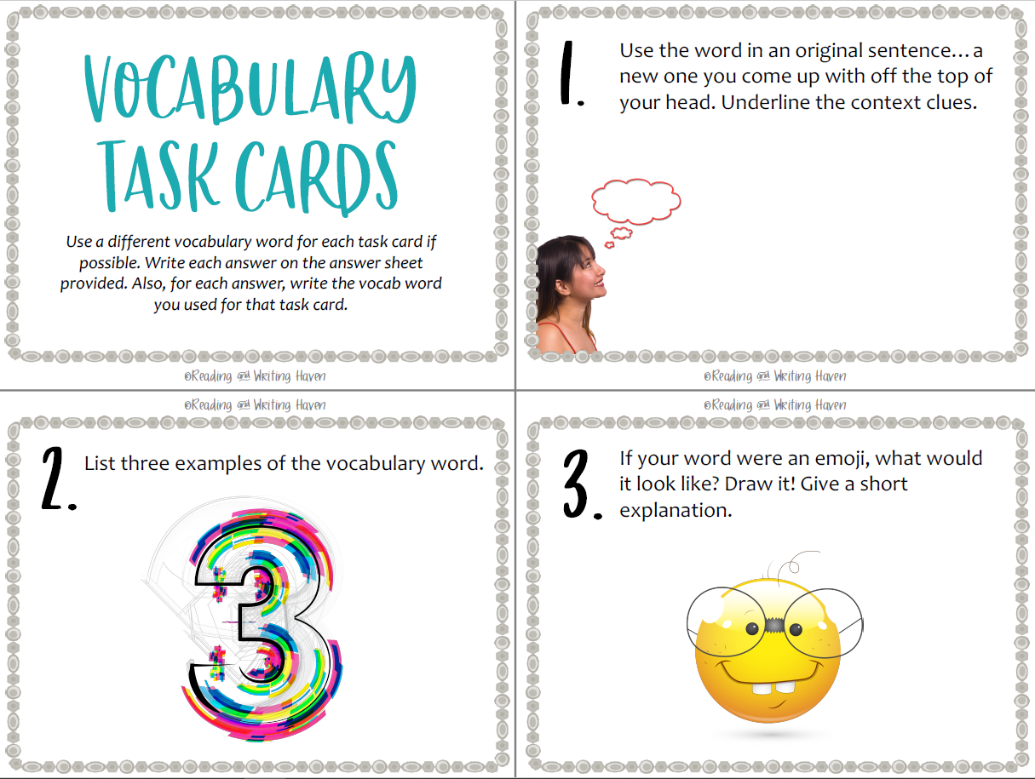
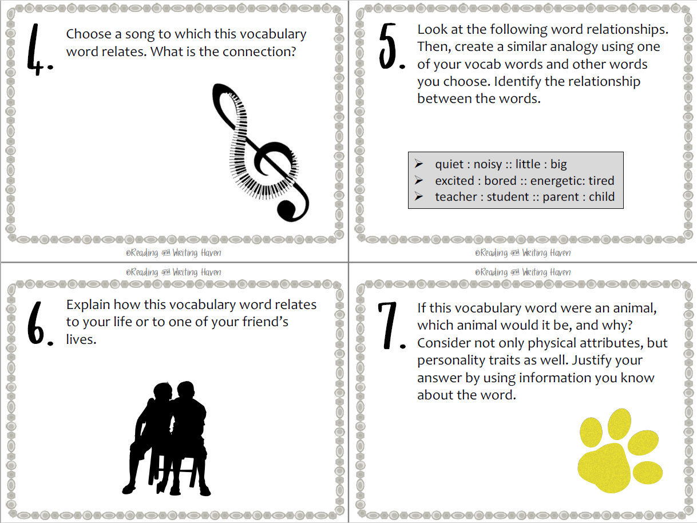
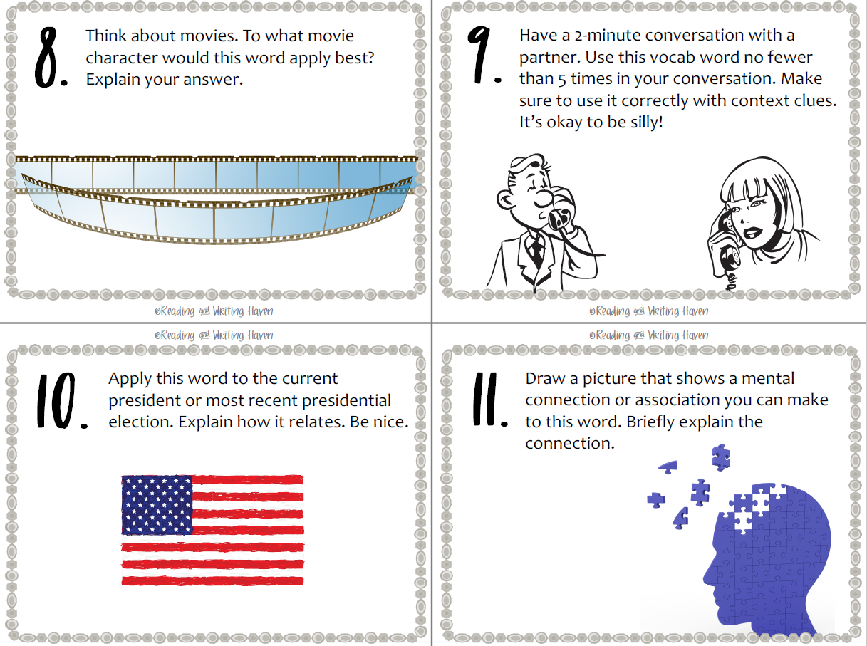

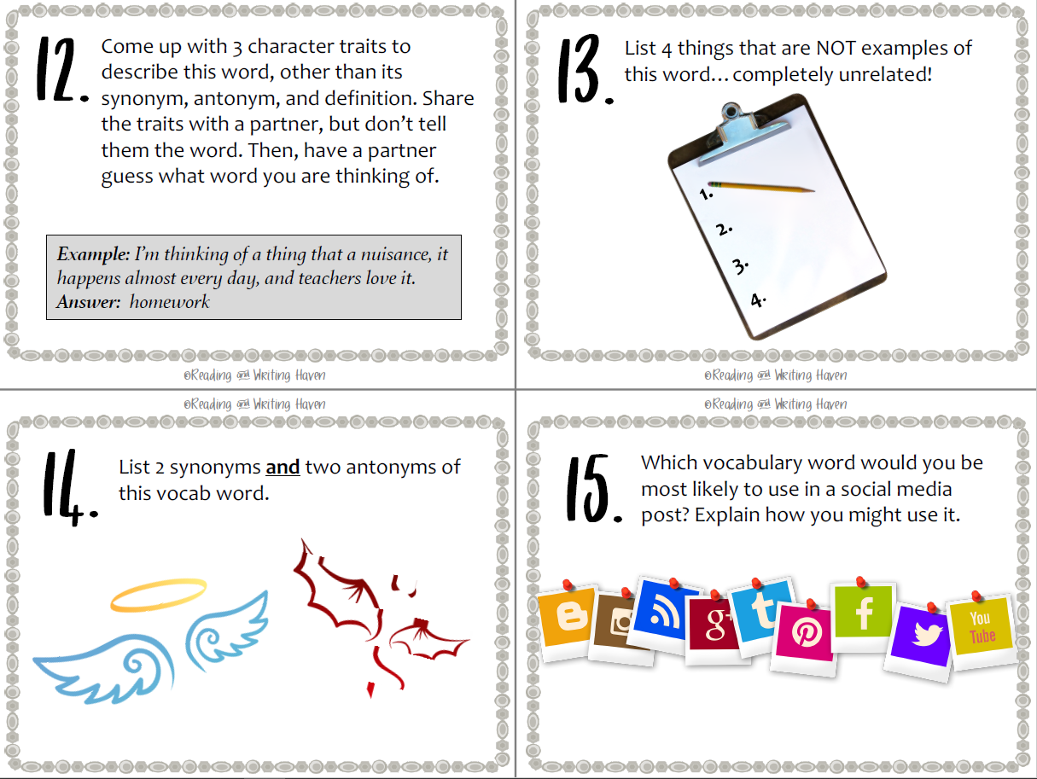

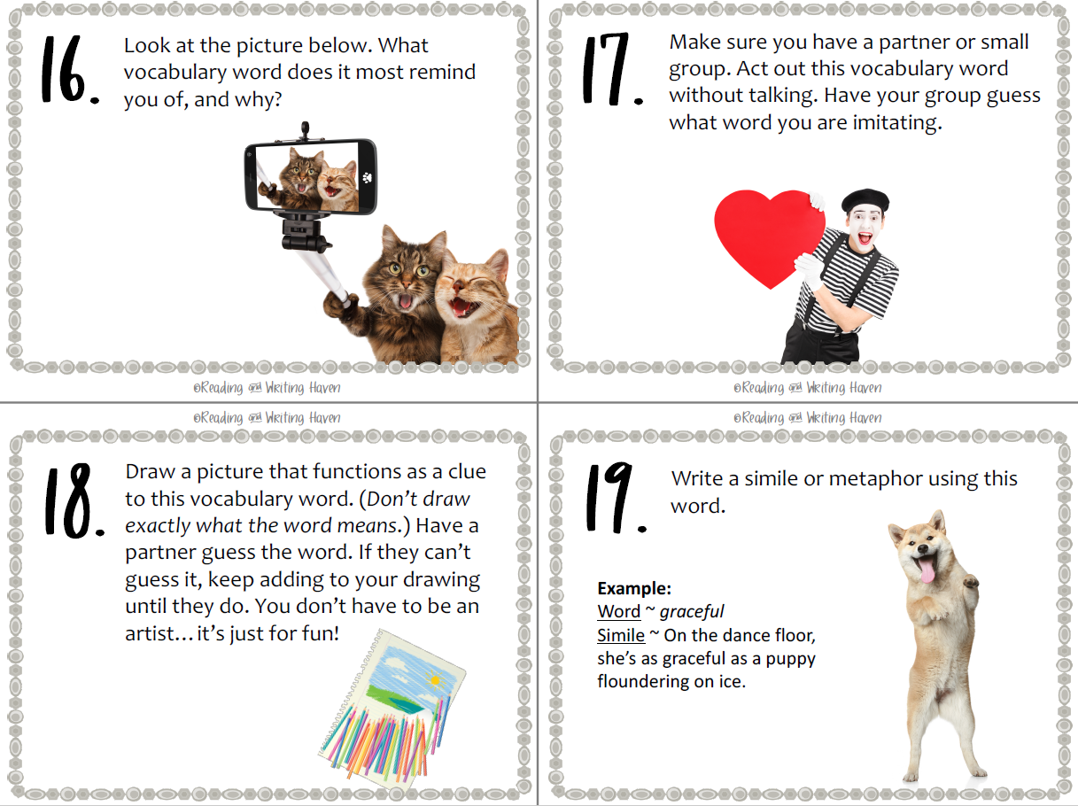

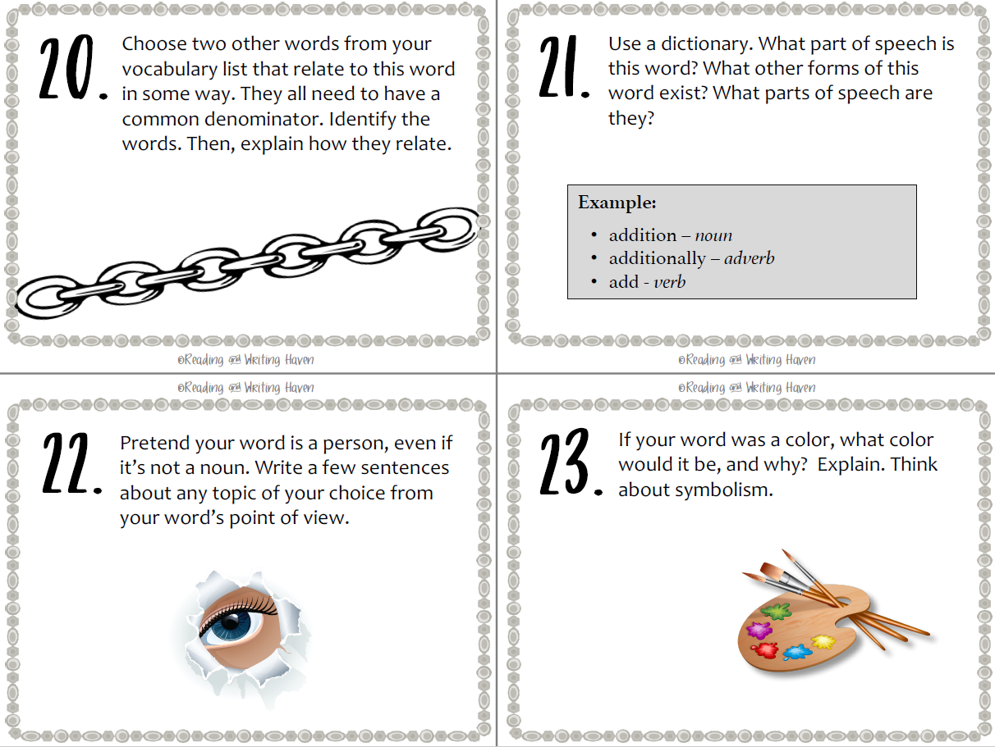

Intervention IV Multiple-Choice Practice Test
Instructions: Choose the answer that best matches the definition of the higher-level linking word provided.
1. Abundant
a) Scarce
b) Limited
c) A lot of
d) Few
2. Acuity
a) Dullness
b) Awareness
c) Smart or aware
d) Ignorance
3. Accurate
a) Approximate
b) Vague
c) Correct or the right answer
d) Misleading
4. Analyze
a) Ignore
b) To look closely or think hard about something
c) To skim through quickly
d) To assume
5. Anticipate
a) To delay
b) To prepare for or be ready for something to happen
c) To ignore
d) To reflect
6. Arises
a) Something comes up
b) Something falls
c) Something disappears
d) Something ends
7. Assess
a) To overlook
b) To look at closely, study or evaluate
c) To guess
d) To neglect
8. Component
a) The entire whole
b) A piece of something bigger
c) An unimportant detail
d) A distraction
9. Compose
a) To destroy
b) To create or write or to get it together
c) To separate
d) To scatter
10. Comprised
a) Past tense of compose
b) Future tense of compose
c) To dismantle
d) To remove
11. Constituent
a) An unimportant part
b) A minor detail
c) An important piece of something
d) An external factor
12. Consulting
a) To avoid advice
b) To get information or advice from someone else
c) To ignore guidance
d) To make a decision independently
13. Correlate
a) To differentiate
b) A connection or similarity between different things
c) To contradict
d) To oppose
14. Critical
a) Optional
b) Very important
c) Insignificant
d) Trivial
15. Debris
a) Treasures
b) Trash or foreign items
c) Valuable items
d) Natural resources
16. Deemed
a) To question something
b) To ignore something
c) To believe something
d) To reject something
17. Demonstrate
a) To hide
b) To show
c) To deny
d) To overlook
18. Determined
a) Indecisive
b) Decided
c) Hesitant
d) Uncertain
19. Differentiate
a) To make something different
b) To make something the same
c) To confuse
d) To ignore differences
20. Engage
a) To bore
b) To ignore
c) To get someone’s attention
d) To distract
21. Emerge
a) To disappear
b) To become visible
c) To hide
d) To retreat
22. Ensure
a) To overlook
b) To prevent
c) To make sure
d) To risk
23. Evaluate
a) To neglect
b) To look at closely, study, or assess
c) To overlook
d) To ignore
24. Evolve
a) To devolve
b) To develop or change
c) To remain the same
d) To regress
25. Exhibit
a) To hide
b) To show
c) To cover
d) To obscure
26. Excess
a) Less than needed
b) More than needed
c) Just enough
d) Insufficient
27. Foreign
a) Familiar
b) Domestic
c) Unfamiliar or strange
d) Local
28. Indicate
a) To conceal
b) To point out or show
c) To confuse
d) To hide
29. Infer
a) To disconnect
b) To guess wildly
c) To connect the dots and figure something out
d) To ignore evidence
30. Initiate
a) To end
b) To continue
c) To start
d) To delay
31. Insight
a) Surface-level understanding
b) A deeper look or understanding
c) Ignorance
d) Misunderstanding
32. Inspecting
a) To neglect
b) To glance
c) To study something
d) To overlook
33. Modified
a) To remain unchanged
b) To change
c) To worsen
d) To ignore
34. Necessity
a) Optional
b) Unimportant
c) Needed
d) Dispensable
35. Observe
a) To overlook
b) To ignore
c) To look at closely or watch
d) To forget
36. Omit
a) To include
b) To not include or get rid of
c) To add
d) To emphasize
37. Precede
a) To follow
b) Before
c) To lag behind
d) To succeed
38. Rapid
a) Slowly
b) Quickly
c) Gradually
d) Leisurely
39. Receives
a) To give
b) To send
c) To get something
d) To lose
40. Reconcile
a) To fight
b) To forgive or make something better
c) To hold a grudge
d) To worsen
41. Reduce
a) To increase
b) To amplify
c) To lessen or diminish
d) To add
42. Redundant
a) Repetitive
b) Necessary
c) Unique
d) Singular
43. Reflect
a) To predict
b) To think about something that has already been said or happened
c) To ignore the past
d) To look forward
44. Relieve
a) To exacerbate
b) To worsen
c) To alleviate or make something better
d) To stress
45. Replenish
a) To empty
b) To use up
c) To fill up or restock
d) To reduce
46. Response
a) A question
b) An answer
c) A problem
d) A statement
47. Retaliation
a) To forgive
b) To get back at someone - revenge
c) To make peace
d) To ignore
48. Revenue
a) Expenses
b) Debt
c) How much money you make
d) Losses
49. Route
a) The wrong way
b) The path you chose
c) An obstacle
d) A detour
50. Severe
a) Mild
b) Insignificant
c) Really bad or intense
d) Casual

Intervention IV Blooket Interactive Online Game: https://dashboard.blooket.com/set/66e84a72be173f4da0942185

Appendix B
Directions: Read the immunity passage and use it to answer the multiple choice questions below:
The human immune system is a highly evolved and complex network that protects the body against foreign invaders, such as bacteria, viruses, and other pathogens. It is comprised of several components, including white blood cells, antibodies, and the lymphatic system. Each component plays a critical role in defending the body. White blood cells, for instance, engage in attacking and destroying pathogens. They differentiate between the body's cells and foreign cells to prevent unnecessary attacks.
The immune response can be rapid, especially when it encounters a previously recognized threat. This acuity allows the immune system to respond quickly to relieve the body of infection. However, in some cases, excess immune activity can lead to severe inflammation and tissue damage. Conditions like allergies and autoimmune diseases arise when the immune system cannot differentiate properly between self and non-self, attacking its own cells.
During an immune response, debris from destroyed pathogens and dead cells is cleared to ensure that tissues are not damaged. The removal of this debris is essential to replenish the affected area with healthy cells and promote healing. Observing how the immune system functions can provide valuable insight into treating diseases and analyzing immune cell behavior helps scientists develop new treatments. By consulting research data, scientists can correlate different immune responses with various health outcomes, allowing for better assessment and targeted therapies.

Multiple Choice Pre-Post Assessment Questions
1. What role do white blood cells play in the immune system?
a) They are redundant components with no real function.
b) They engage in attacking and destroying pathogens.
c) They compose antibodies to provide energy for cells.
d) They omit foreign cells from entering the body.

2. Why is the removal of debris important during an immune response?
a) To anticipate the arrival of more pathogens.
b) To reduce inflammation and promote healing.
c) To initiate a rapid attack on healthy cells.
d) To reflect on past immune responses.

3. Which word best describes the speed of the immune system’s response to a known pathogen?
a) Accurate
b) Rapid
c) Foreign
d) Redundant

4. What happens when the immune system cannot properly differentiate between self and non-self?
a) It leads to increased revenue.
b) It causes retaliation against pathogens.
c) It results in conditions like allergies and autoimmune diseases.
d) It promotes the route of healing.

5. What is the significance of analyzing immune cell behavior?
a) It helps to reconcile with bacteria.
b) It provides valuable insight into disease treatment.
c) Most scientists deem it unnecessary.
d) It is engaged only when redundant.

6. What does the immune system do to ensure effective functioning?
a) It modifies the response to destroy healthy cells.
b) It receives nutrients from foreign invaders.
c) It inspects cells and replenishes healthy tissue.
d) It initiates the destruction of all bodily tissues.

7. How do scientists gain better insight into treating diseases?
a) By consulting research data and correlating immune responses.
b) By relieving patients of their symptoms immediately.
c) By focusing only on the acuity of the immune response.
d) By modifying healthy cells to become pathogens.

8. Which term refers to the body's ability to respond quickly and accurately to previously recognized threats?
a) Acuity
b) Engage
c) Component
d) Reconcile

9. What action does the immune system take first when a foreign substance enters the body?
a) It reflects on past responses.
b) It evolves to a different form.
c) It initiates an attack using white blood cells.
d) It omits any reaction.

10. What is the importance of correlating different immune responses with health outcomes?
a) It helps determine effective replenishment strategies.
b) It aids in developing targeted therapies.
c) It is only used to reduce stress in patients.
d) It is deemed critical for revenue generation.

11. What is one function of the lymphatic system in the immune response?
a) To demonstrate the structure of cells
b) To compose pathogens for destruction
c) To reduce swelling and remove debris
d) To omit white blood cells from circulation

12. Which of the following best explains why immune cells need to be able to differentiate between self and non-self?
a) To ensure that they only attack harmful foreign invaders
b) To evaluate the strength of the body’s tissues
c) To inspect the effectiveness of antibodies
d) To engage in excessive response

13. What does it mean when a response is described as redundant in the context of the immune system?
a) It means the response is accurate and precise
b) It refers to severe inflammation and tissue damage
c) It is unnecessary and may omit useful actions
d) It reflects the proper functioning of the immune system

14. Why is it important for scientists to consult research data when studying immune responses?
a) To anticipate how cells might evolve
b) To analyze and draw accurate conclusions about immune function
c) To arise new research funding opportunities
d) To relieve patients of their symptoms

15. How do allergies typically arise, according to the passage?
a) From the route of nutrient absorption
b) Due to excess immune activity against non-harmful substances
c) From replenishing lost cells too rapidly
d) By the acuity of the immune system

16. Which of the following actions would a scientist most likely take when trying to assess the health of the immune system?
a) Modify the immune response to eliminate all cells
b) Engage in consulting patient revenue
c) Inspect white blood cells and their behavior
d) Omit necessary immune components

17. What is a common route that pathogens use to enter the human body?
a) Through skin cuts, which are then replenished
b) By evolving immune cells
c) Via the respiratory or digestive systems
d) By the retaliation of white blood cells

18. What is the best way for the body to ensure that only harmful pathogens are targeted by the immune response?
a) To allow for excess immune activity
b) To deem all invaders non-threatening
c) To use antibodies to specifically engage with known pathogens
d) To reflect on past infections

19. In the context of immune response, what does the term "acuity" refer to?
a) The severe nature of immune diseases
b) The rapid recognition and response to pathogens
c) The redundant processes involved in immune reactions
d) The replenishment of white blood cells

20. Which word describes the importance of keeping tissue healthy by removing debris after an infection?
a) Correlate
b) Correlate
c) Critical
d) Foreign

21. How might the concept of "initiate" relate to the immune system’s response to infection?
a) The immune system may initiate an antibody response upon detecting a pathogen.
b) The immune system will omit the initial response.
c) The immune system may replenish its cells before attacking.
d) The immune system will deem all cells as threats.

22. What does the immune system need to do to prevent an excess inflammatory response?
a) Engage all available cells
b) Reconcile with foreign invaders
c) Regulate the activity of its cells carefully
d) Anticipate a quick response

23. Why is it important to have a reduction in immune cell activity after the threat is eliminated?
a) To relieve the body from continuous defense mode
b) To initiate the next immune response quickly
c) To compose more white blood cells
d) To ensure ongoing inflammation

24. What role does consulting genetic information play in the immune system's function?
a) It helps replenish damaged tissues.
b) It is deemed unnecessary for most infections.
c) It aids in accurately recognizing and targeting specific pathogens.
d) It leads to retaliation against non-threatening cells.

25. Which action is necessary to replenish healthy cells after an immune response?
a) Ensure the removal of dead cells and debris
b) Omit any form of cell replacement
c) Reflect on the immune response
d) Emerge with new pathogens

Appendix C
