Appendix
Epidemiology and burden of acute respiratory infections associated with respiratory viruses: A multi-source integrated population-based surveillance study in Chongqing

Table of Contents
Additional information on Methods--------------------------------------------------------2
Hospital-based surveillance
Community-based healthcare utilization survey
Case definition and variables collected
Pilot survey in Wanzhou District
Statistical analysis
Appendix Tables-------------------------------------------------------------------------------6
Table S1. Weighted adjustment parameter.
Table S2. Characteristics of patients positive for IFV or RSV, Chongqing, China, October 2023 - October 2024.
Table S3. Estimated incidence and hospitalization rate (per person-year) of pathogen-associated ARIs, Chongqing, China, October 2023, -April 2025.
Appendix Figures------------------------------------------------------------------------------16
Fig. S1. Number and detection rate of PCR-confirmed viral infections among ILI and SARI patients, by age group, Chongqing, China, October 2023 - April 2025.
Figure S2. Number and detection rate of PCR-confirmed viral infections among ILI and SARI patients, by month, Chongqing, China, October 2023 - April 2025.
References--------------------------------------------------------------------------------------21

Additional information on Methods:
Hospital-based surveillance
A prospective, hospital-based, cross-sectional surveillance was conducted in Chongqing, China, utilizing the city-wide “Respiratory Pathogen Surveillance System”. From 15 October 2023 to 30 April 2025, consecutive patients presenting with influenza-like illness (ILI) were recruited from 22 sentinel hospitals across 13 administrative districts. During this period, a systematic random sample of 10–20 ILI cases was enrolled weekly from the outpatient department. Subsequently, from 1 May 2025 to 30 April 2026, inpatients meeting the SARI inclusion criteria were consecutively recruited from the participating wards, with 5–10 randomly selected each week. Upper respiratory tract specimens (nasopharyngeal or oropharyngeal swabs) were collected from all enrolled ILI and SARI cases. Specimens were transported under cold-chain conditions to the Chongqing Center for Disease Control and Prevention, where they were tested for influenza virus (IFV), human rhinovirus (HRv), humanadenovirus (HAdv), human metapneumovirus (HMPV), respiratory syncytial virus (RSV), human parainfluenza virus (HPIV) using real-time reverse-transcription polymerase chain reaction (RT-PCR) following standardised protocols. Patients who had received antiviral therapy within 48 hours prior to presentation, or who declined to provide written informed consent were excluded.
Municipal-level case counts for ILI and SARI were extracted from the “Chongqing Intelligent Disease Control Cloud Platform” for the period 15 October 2023 – 30 April 2025. The “Chongqing Intelligent Disease Control Cloud Platform” is a real-time, city-wide repository of health system electronic medical records (EMRs) that covers 84.11% of medical institutions in Chongqing. For the study period, de-identified EMRs of ILI and SARI patients were extracted. ILI and SARI cases were identified by applying the standard World Health Organization (WHO) case definitions directly to coded diagnoses ¹. For free-text clinical entries, a panel of clinical experts was convened to define a comprehensive set of search terms derived from the symptomatic criteria of ILI and SARI case definitions. These terms were then operationalized into a series of regular expressions. We subsequently applied these regular expressions to screen free-text clinical entries (e.g., chief complaints and clinical notes) within the database to identify records that met the ILI and SARI case definitions. Aggregate case counts for patients with ILI and SARI were calculated separately at the municipal level throughout the surveillance period.
Community-based healthcare utilization survey
Healthcare-seeking behavior among individuals with acute respiratory illness (ARI) was assessed through a retrospective, population-based healthcare utilization survey (HUS) conducted between May and June 2024. We previously conducted a pilot Health Utilization Survey (HUS) in Wanzhou District ², Chongqing; the present analysis uses the city-wide data generated after scaling the HUS to the entire municipality (manuscript in preparation). In brief, a two-stage cluster sampling design was employed. First, an exhaustive enumeration of all residential communities and villages within the six study districts was compiled, and systematic sampling was used to select 50 communities or villages per district. Second, within each selected community or village, households were selected by probability-proportional-to-size sampling, stratified by household size, permanent population, and age distribution. A semi-structured questionnaire was administered to eligible participants to collect data on ARI symptomatology and subsequent healthcare utilization. Binary (“yes”/“no”) responses were used to document the occurrence of acute respiratory symptoms and whether professional medical care was sought. We estimated age-specific healthcare-seeking rates among community-dwelling ARI patients and subsequently performed post-stratification weight estimation ³, conditioning on age and sex, to calibrate these rates.
Case definition and variables collected
ILI was defined as an acute respiratory infection with measured fever (≥ 38 ℃) and either cough or sore throat, with symptom onset within the preceding 10 days. SARI was defined as an ILI episode that required hospitalization¹. ARI was defined as the sudden onset of illness accompanied by at least one of the following respiratory symptoms: cough, sore throat, shortness of breath, or nasal congestion ⁴. Demographic variables included age, sex, and hospitalization level. Disease severity was classified based on to hospitalization status (SARI vs. non-SARI). Age-stratified population denominators were obtained from Chongqing Health Bureau. The study protocol was approved by the Ethics Review Committee of Peking Union Medical College (No. CAMS&PUMC-IEC-2025-013) and conformed to the principles of the Declaration of Helsinki (2013 amendment).
Pilot survey in Wanzhou District
The case definitions for ILI and SARI both require a body temperature >38°C as an essential criterion for case inclusion. This may exclude patients with respiratory viral infections who do not present with fever, potentially leading to underestimation of the incidence and hospitalization rates. To address this limitation, a pilot survey was conducted in Wanzhou District to derive the weighting parameter (W). Specifically, to obtain pathogen-specific detection rates among ARI patients, a prospective, hospital-based surveillance was implemented in Wanzhou. From 20 October 2021 to 31 July 2024, consecutive patients meeting the ARI case definition were enrolled from seven sentinel hospitals. Preliminary results of this pilot study have been published previously⁴. Pathogen-specific detection rates for IFV, HRV, HAdv, HMPV, RSV, and HPIV among patients with ILI and SARI were obtained from the Respiratory Pathogen Surveillance System. Finally, the weighting adjustment parameter (W) was computed according to Equation (3) and is presented in Supplementary Table 1.
Statistical analysis
Categorical variables are presented as frequencies (n) and percentages (%). Continuous variables are expressed as means ± standard errors (SE) or medians with interquartile ranges (IQRs), as appropriate. The association between respiratory virus infection and clinical severity was assessed using multivariable logistic regression, adjusting for age group, region, sex, and hospitalization level. All analyses were conducted in R software (version 4.4.2). To characterize age-related trends that were non-linear or exhibited inflection points, joinpoint regression analysis was performed using the Joinpoint Regression Program (JPR; Version 5.2.0.0, Statistical Research and Applications Branch, National Cancer Institute, USA). Two-sided P values < 0.05 were considered statistically significant
The incidence and hospitalization rates of respiratory viral-associated ARIs were estimated using a modified multiplier model. The data sources of each parameter are illustrated in Fig. 1. The calculation for respiratory viral-associated ARIs is shown below as an example.
P $\text{= }\frac{viral\text{-positive cases identified among enrolled outpatients with ILI}}{\text{Enrolled outpatients with ILI}}$ (1)
uN = $\frac{\text{P × Total number of outpatients with ILI}}{\text{PCR sensitivity for }\text{viral}\text{ detection}}$ (2)
W = $\frac{\text{Annual detection rate of }\text{viral}\text{-associated ARI outpatients}}{\text{Annual detection rate of }\text{viral}\text{-associated ILI outpatients}}$ (3)
wN = $\text{uN}$ × W (4)
uI = $\frac{\text{wN}}{\text{P}\text{erson-years}}$ (5)
aI$\text{= }\frac{\text{uI}}{\text{Proportion of outpatients with ARI in the community}}$ (6)
In the above formula, P represents the viral detection rate among outpatients with ILI; uN, the unweighted total number of viral-associated outpatients with ILI; W, the weighted adjustment parameter; wN, the total number of viral-associated outpatients with ARI; uI, the crude incidence rate of viral-associated ARI in outpatients; and aI, the adjusted incidence rate of viral-associated ARI in outpatients. The sensitivity of RT-PCR testing, estimated at 95–100%, was incorporated into the model. The person year was calculated by multiplying the permanent resident population of the catchment area by the number of years the study was conducted⁵. We accounted for uncertainty in model parameters by using a probabilistic (Monte Carlo) approach with 10,000 independent simulation trails. A parallel approach was employed to estimate the hospitalization rate of viral-associated ARIs without adjustment for healthcare-seeking behavior. Specifically, incidence and hospitalization rates were calculated for each of the six viruses in the entire population and across different age groups.

Appendix Tables:
Table S1. Weighted adjustment parameter.
Time period | Age groups, y.o. | Total | Detected number | Detected rate | ‡Detected rate after imputation | Weighted adjustment parameter
IFV | ILI or SARI inclusion criteria
*2023/11-2024/10 | ALL | 6472 | 916 | 14.15% | 14.15% | 1.9
Outpatients | [0, 5) | 2,148 | 163 | 7.59% | 7.59% | 1.21
 | [5, 15) | 1,085 | 179 | 16.50% | 16.50% | 1.56
 | [15, 60) | 2,537 | 487 | 19.20% | 19.20% | 1.8
 | ≥60 | 702 | 87 | 12.39% | 12.39% | 1.28
†2024/05-2025/04 | ALL | 3651 | 151 | 4.14% | 4.14% | 2.14
Inpatients | [0, 5) | 965 | 22 | 2.28% | 2.28% | 1.72
 | [5, 15) | 213 | 4 | 1.88% | 1.88% | 5.33
 | [15, 60) | 745 | 43 | 5.77% | 5.77% | 3.03
 | ≥60 | 1728 | 82 | 4.75% | 4.75% | 1.22
 | ARI inclusion criteria
2023/08-2024/07 | ALL | 3172 | 855 | 26.95% | 26.95%
Outpatients | [0, 5) | 283 | 26 | 9.19% | 9.19%
 | [5, 15) | 789 | 203 | 25.73% | 25.73%
 | [15, 60) | 1,565 | 541 | 34.57% | 34.57%
 | ≥60 | 535 | 85 | 15.89% | 15.89%
2023/08-2024/07 | ALL | 203 | 18 | 8.87% | 8.87%
Inpatients | [0, 5) | 51 | 2 | 3.92% | 3.92%
 | [5, 15) | 60 | 6 | 10.00% | 10.00%
 | [15, 60) | 40 | 7 | 17.50% | 17.50%
 | ≥60 | 52 | 3 | 5.77% | 5.77%
HRv | ILI or SARI inclusion criteria
*2023/11-2024/10 | ALL | 6472 | 484 | 7.48% | 7.48% | 1.61
Outpatients | [0, 5) | 2,148 | 246 | 11.45% | 11.45% | 2.31
 | [5, 15) | 1,085 | 102 | 9.40% | 9.40% | 1.7
 | [15, 60) | 2,537 | 104 | 4.10% | 4.10% | 2
 | ≥60 | 702 | 32 | 4.56% | 4.56% | 2.21
†2024/05-2025/04 | ALL | 3651 | 194 | 5.31% | 5.31% | 1.58
Inpatients | [0, 5) | 965 | 104 | 10.78% | 10.78% | 0.91
 | [5, 15) | 213 | 20 | 9.39% | 9.39% | 0.18
 | [15, 60) | 745 | 20 | 2.68% | 2.68% | 3.73
 | ≥60 | 1728 | 50 | 2.89% | 2.89% | 4.65
 | ARI inclusion criteria
2023/08-2024/07 | ALL | 3172 | 383 | 12.07% | 12.07%
Outpatients | [0, 5) | 283 | 75 | 26.50% | 26.50%
 | [5, 15) | 789 | 126 | 15.97% | 15.97%
 | [15, 60) | 1,565 | 128 | 8.18% | 8.18%
 | ≥60 | 535 | 54 | 10.09% | 10.09%
2023/08-2024/07 | ALL | 203 | 17 | 8.37% | 8.37%
Inpatients | [0, 5) | 51 | 5 | 9.80% | 9.80%
 | [5, 15) | 60 | 1 | 1.67% | 1.67%
 | [15, 60) | 40 | 4 | 10.00% | 10.00%
 | ≥60 | 52 | 7 | 13.46% | 13.46%
HAdv | ILI or SARI inclusion criteria
*2023/11-2024/10 | ALL | 6472 | 294 | 4.54% | 4.54% | 0.6
Outpatients | [0, 5) | 2,148 | 164 | 7.64% | 7.64% | 0.79
 | [5, 15) | 1,085 | 79 | 7.28% | 7.28% | 0.63
 | [15, 60) | 2,537 | 43 | 1.69% | 1.69% | 0.98
 | ≥60 | 702 | 8 | 1.14% | 1.14% | 1.15
†2024/05-2025/04 | ALL | 3651 | 45 | 1.23% | 1.23% | 1.6
Inpatients | [0, 5) | 965 | 28 | 2.90% | 2.90% | 2.03
 | [5, 15) | 213 | 8 | 3.76% | 3.76% | 0.44
 | [15, 60) | 745 | 3 | 0.40% | 0.40% | 4.89
 | ≥60 | 1728 | 6 | 0.35% | 0.35% | 5.67
 | ARI inclusion criteria
2023/08-2024/07 | ALL | 3172 | 86 | 2.71% | 2.71%
Outpatients | [0, 5) | 283 | 17 | 6.01% | 6.01%
 | [5, 15) | 789 | 36 | 4.56% | 4.56%
 | [15, 60) | 1,565 | 26 | 1.66% | 1.66%
 | ≥60 | 535 | 7 | 1.31% | 1.31%
2023/08-2024/07 | ALL | 203 | 4 | 1.97% | 1.97%
Inpatients | [0, 5) | 51 | 3 | 5.88% | 5.88%
 | [5, 15) | 60 | 1 | 1.67% | 1.67%
 | [15, 60) | 40 | 0 | ‡0.00% | 1.97%
 | ≥60 | 52 | 0 | ‡0.00% | 1.97%
HMPV | ILI or SARI inclusion criteria
*2023/11-2024/10 | ALL | 6472 | 67 | 1.04% | 1.04% | 3.17
Outpatients | [0, 5) | 2,148 | 45 | 2.09% | 2.09% | 2.7
 | [5, 15) | 1,085 | 9 | 0.83% | 0.83% | 4.89
 | [15, 60) | 2,537 | 10 | 0.39% | 0.39% | 5.84
 | ≥60 | 702 | 3 | 0.43% | 0.43% | 8.75
†2024/05-2025/04 | ALL | 3651 | 74 | 2.03% | 2.03% | 1.22
Inpatients | [0, 5) | 965 | 42 | 4.35% | 4.35% | 0.57
 | [5, 15) | 213 | 5 | 2.35% | 2.35% | 1.42
 | [15, 60) | 745 | 3 | 0.40% | 0.40% | 6.21
 | ≥60 | 1728 | 24 | 1.39% | 1.39% | 2.77
 | ARI inclusion criteria
2023/08-2024/07 | ALL | 3172 | 104 | 3.28% | 3.28%
Outpatients | [0, 5) | 283 | 16 | 5.65% | 5.65%
 | [5, 15) | 789 | 32 | 4.06% | 4.06%
 | [15, 60) | 1,565 | 36 | 2.30% | 2.30%
 | ≥60 | 535 | 20 | 3.74% | 3.74%
2023/08-2024/07 | ALL | 203 | 5 | 2.46% | 2.46%
Inpatients | [0, 5) | 51 | 0 | ‡0.00% | 2.46%
 | [5, 15) | 60 | 2 | 3.33% | 3.33%
 | [15, 60) | 40 | 1 | 2.50% | 2.50%
 | ≥60 | 52 | 2 | 3.85% | 3.85%
RSV | ILI or SARI inclusion criteria
*2023/11-2024/10 | ALL | 6472 | 100 | 1.55% | 1.55% | 2.02
Outpatients | [0, 5) | 2,148 | 65 | 3.03% | 3.03% | 3.04
 | [5, 15) | 1,085 | 15 | 1.38% | 1.38% | 2.75
 | [15, 60) | 2,537 | 10 | 0.39% | 0.39% | 4.7
 | ≥60 | 702 | 10 | 1.42% | 1.42% | 1.84
†2024/05-2025/04 | ALL | 3651 | 100 | 2.74% | 2.74% | 1.44
Inpatients | [0, 5) | 965 | 86 | 8.91% | 8.91% | 1.1
 | [5, 15) | 213 | 3 | 1.41% | 1.41% | 1.18
 | [15, 60) | 745 | 5 | 0.67% | 0.67% | 5.87
 | ≥60 | 1728 | 6 | 0.35% | 0.35% | 16.62
 | ARI inclusion criteria
2023/08-2024/07 | ALL | 3172 | 99 | 3.12% | 3.12%
Outpatients | [0, 5) | 283 | 26 | 9.19% | 9.19%
 | [5, 15) | 789 | 30 | 3.80% | 3.80%
 | [15, 60) | 1,565 | 29 | 1.85% | 1.85%
 | ≥60 | 535 | 14 | 2.62% | 2.62%
2023/08-2024/07 | ALL | 203 | 8 | 3.94% | 3.94%
Inpatients | [0, 5) | 51 | 5 | 9.80% | 9.80%
 | [5, 15) | 60 | 1 | 1.67% | 1.67%
 | [15, 60) | 40 | 0 | ‡0.00% | 3.94%
 | ≥60 | 52 | 3 | 5.77% | 5.77%
HPIV | ILI or SARI inclusion criteria
*2023/11-2024/10 | ALL | 6472 | 184 | 2.84% | 2.84% | 0.9
Outpatients | [0, 5) | 2,148 | 122 | 5.68% | 5.68% | 1.12
 | [5, 15) | 1,085 | 34 | 3.13% | 3.13% | 0.77
 | [15, 60) | 2,537 | 25 | 0.99% | 0.99% | 1.62
 | ≥60 | 702 | 3 | 0.43% | 0.43% | 8.31
†2024/05-2025/04 | ALL | 3651 | 65 | 1.78% | 1.78% | 1.38
Inpatients | [0, 5) | 965 | 51 | 5.28% | 5.28% | 0.47
 | [5, 15) | 213 | 1 | 0.47% | 0.47% | 10.65
 | [15, 60) | 745 | 4 | 0.54% | 0.54% | 4.66
 | ≥60 | 1728 | 9 | 0.52% | 0.52% | 3.69
 | ARI inclusion criteria
2023/08-2024/07 | ALL | 3172 | 81 | 2.55% | 2.55%
Outpatients | [0, 5) | 283 | 18 | 6.36% | 6.36%
 | [5, 15) | 789 | 19 | 2.41% | 2.41%
 | [15, 60) | 1,565 | 25 | 1.60% | 1.60%
 | ≥60 | 535 | 19 | 3.55% | 3.55%
2023/08-2024/07 | ALL | 203 | 5 | 2.46% | 2.46%
Inpatients | [0, 5) | 51 | 0 | ‡0.00% | 2.46%
 | [5, 15) | 60 | 3 | 5.00% | 5.00%
 | [15, 60) | 40 | 1 | 2.50% | 2.50%
 | ≥60 | 52 | 1 | 1.92% | 1.92%
Note: *Given that the pilot study in Wanzhou based on the ARI case definition was conducted from August 2023 to July 2024, and the respiratory pathogen surveillance based on the outpatient ILI case definition began in October 2023, to ensure a substantial overlap period between the two studies, we selected the outpatient ILI surveillance data from November 2023 to October 2024 to calculate the detection rates of the six respiratory viruses during this period. †Given that the data on respiratory pathogen surveillance for hospitalized SARI patients began to be collected in May 2024, the detection rates of the six respiratory viruses among hospitalized SARI patients were calculated based on the data from May 2024 to April 2025. ‡During the study period, the detection rate of certain pathogens in some age groups was zero. In such cases, we used the overall detection rates from the entire population for these pathogens as the detection rates for the corresponding age groups. Influenza-like illness (ILI), severe acute respiratory infection (SARI), influenza virus (IFV), human rhinovirus (HRv), humanadenovirus (HAdv), human metapneumovirus (HMPV), respiratory syncytial virus (RSV), human parainfluenza virus (HPIV).

Table S2. Characteristics of patients positive for IFV or RSV, Chongqing, China, October 2023 - October 2024.
Characteristic, n (n/N) | Overall | IFV | HRv | HAdv | HMPV | RSV | HPIV
Total | 16363 | 1921 | 1236 | 638 | 512 | 474 | 460
Regions
Yuzhong | 1306 (8.0%) | 240 (12.5%) | 69 (5.6%) | 13 (2.0%) | 15 (2.9%) | 5 (1.1%) | 10 (2.2%)
Nanan | 1945 (11.9%) | 269 (14.0%) | 142 (11.5%) | 65 (10.2%) | 53 (10.4%) | 34 (7.2%) | 56 (12.2%)
Yubei | 1835 (11.2%) | 160 (8.3%) | 171 (13.8%) | 203 (31.8%) | 87 (17.0%) | 115 (24.3%) | 99 (21.5%)
Fuling | 1796 (11.0%) | 186 (9.7%) | 268 (21.7%) | 101 (15.8%) | 72 (14.1%) | 70 (14.8%) | 81 (17.6%)
Jiangjin | 1903 (11.6%) | 306 (15.9%) | 115 (9.3%) | 117 (18.3%) | 66 (12.9%) | 32 (6.8%) | 45 (9.8%)
Wanzhou | 1967 (12.0%) | 236 (12.3%) | 102 (8.3%) | 40 (6.3%) | 46 (9.0%) | 69 (14.6%) | 74 (16.1%)
Wulong | 1733 (10.6%) | 117 (6.1%) | 161 (13.0%) | 21 (3.3%) | 50 (9.8%) | 61 (12.9%) | 30 (6.5%)
Yongchuan | 2014 (12.3%) | 182 (9.5%) | 57 (4.6%) | 36 (5.6%) | 19 (3.7%) | 18 (3.8%) | 19 (4.1%)
Bishan | 294 (1.8%) | 41 (2.1%) | 7 (0.6%) | 1 (0.2%) | 4 (0.8%) | 0 (0%) | 1 (0.2%)
Kaizhou | 573 (3.5%) | 120 (6.2%) | 70 (5.7%) | 29 (4.5%) | 75 (14.6%) | 34 (7.2%) | 31 (6.7%)
Nanchuan | 494 (3.0%) | 47 (2.4%) | 5 (0.4%) | 7 (1.1%) | 14 (2.7%) | 11 (2.3%) | 2 (0.4%)
Shizhu | 270 (1.7%) | 12 (0.6%) | 24 (1.9%) | 2 (0.3%) | 11 (2.1%) | 21 (4.4%) | 3 (0.7%)
Xiushan | 233 (1.4%) | 5 (0.3%) | 45 (3.6%) | 3 (0.5%) | 0 (0%) | 4 (0.8%) | 9 (2.0%)
Age group, years
[0, 1) | 2054 (12.6%) | 105 (5.5%) | 274 (22.2%) | 78 (12.2%) | 97 (18.9%) | 173 (36.5%) | 126 (27.4%)
[1, 2) | 919 (5.6%) | 60 (3.1%) | 99 (8.0%) | 65 (10.2%) | 53 (10.4%) | 70 (14.8%) | 55 (12.0%)
[2, 3) | 1006 (6.1%) | 89 (4.6%) | 113 (9.1%) | 94 (14.7%) | 97 (18.9%) | 90 (19.0%) | 60 (13.0%)
[3, 4) | 837 (5.1%) | 94 (4.9%) | 85 (6.9%) | 77 (12.1%) | 75 (14.6%) | 27 (5.7%) | 57 (12.4%)
[4, 5) | 661 (4.0%) | 95 (4.9%) | 60 (4.9%) | 67 (10.5%) | 52 (10.2%) | 22 (4.6%) | 35 (7.6%)
[5, 15) | 2303 (14.1%) | 356 (18.5%) | 238 (19.3%) | 164 (25.7%) | 57 (11.1%) | 39 (8.2%) | 53 (11.5%)
[15, 50) | 4351 (26.6%) | 725 (37.7%) | 213 (17.2%) | 63 (9.9%) | 33 (6.4%) | 23 (4.9%) | 42 (9.1%)
[50, 60) | 1108 (6.8%) | 160 (8.3%) | 40 (3.2%) | 11 (1.7%) | 7 (1.4%) | 6 (1.3%) | 15 (3.3%)
[60, 65) | 416 (2.5%) | 42 (2.2%) | 17 (1.4%) | 4 (0.6%) | 6 (1.2%) | 5 (1.1%) | 2 (0.4%)
[65, 75) | 1385 (8.5%) | 98 (5.1%) | 49 (4.0%) | 10 (1.6%) | 17 (3.3%) | 6 (1.3%) | 4 (0.9%)
[75, 80) | 604 (3.7%) | 48 (2.5%) | 20 (1.6%) | 3 (0.5%) | 8 (1.6%) | 5 (1.1%) | 6 (1.3%)
≥80 | 719 (4.4%) | 49 (2.6%) | 28 (2.3%) | 2 (0.3%) | 10 (2.0%) | 8 (1.7%) | 5 (1.1%)
Sex
Male | 8896 (54.4%) | 993 (51.7%) | 689 (55.7%) | 347 (54.4%) | 271 (52.9%) | 258 (54.4%) | 272 (59.1%)
Female | 7467 (45.6%) | 928 (48.3%) | 547 (44.3%) | 291 (45.6%) | 241 (47.1%) | 216 (45.6%) | 188 (40.9%)
Occupation
Employed | 3407 (20.8%) | 439 (22.9%) | 153 (12.4%) | 31 (4.9%) | 27 (5.3%) | 18 (3.8%) | 31 (6.7%)
Student | 2933 (17.9%) | 440 (22.9%) | 259 (21.0%) | 153 (24.0%) | 49 (9.6%) | 36 (7.6%) | 36 (7.8%)
Unemployed | 8371 (51.2%) | 818 (42.6%) | 769 (62.2%) | 442 (69.3%) | 422 (82.4%) | 406 (85.7%) | 378 (82.2%)
Unknown | 1652 (10.1%) | 224 (11.7%) | 55 (4.4%) | 12 (1.9%) | 14 (2.7%) | 14 (3.0%) | 15 (3.3%)
Admission status
Outpatient | 12669 (77.4%) | 1764 (91.8%) | 1015 (82.1%) | 581 (91.1%) | 427 (83.4%) | 357 (75.3%) | 382 (83.0%)
Inpatient | 3694 (22.6%) | 157 (8.2%) | 221 (17.9%) | 57 (8.9%) | 85 (16.6%) | 117 (24.7%) | 78 (17.0%)
Hospital
Secondary general hospitals | 3742 (22.9%) | 383 (19.9%) | 316 (25.6%) | 63 (9.9%) | 155 (30.3%) | 131 (27.6%) | 82 (17.8%)
Tertiary general hospitals | 12621 (77.1%) | 1538 (80.1%) | 920 (74.4%) | 575 (90.1%) | 357 (69.7%) | 343 (72.4%) | 378 (82.2%)
Note: Influenza-like illness (ILI), severe acute respiratory infection (SARI), influenza virus (IFV), human rhinovirus (HRv), humanadenovirus (HAdv), human metapneumovirus (HMPV), respiratory syncytial virus (RSV), human parainfluenza virus (HPIV).

Table S3. Estimated incidence and hospitalization rate (per person-year) of pathogen-associated ARIs, Chongqing, China, October 2023, -April 2025.
Age groups, y.o. | Incidence rate of pathogen-associated ARI outpatient cases per 100,000 person-year |  |  | Incidence rate of pathogen-associated ARI inpatient cases  per 100,000 person-year
IFV | Medium | 95% UCI | 95% LCI | Medium | 95% UCI | 95% LCI
All | 4704 | 78 | 82 | 133 | 130 | 136
[0,5) | 13086 | 12789 | 13393 | 807 | 789 | 826
[5,15) | 10379 | 10143 | 10622 | 505 | 493 | 516
[15,60) | 2211 | 2161 | 2263 | 53 | 52 | 54
≥60 | 852 | 832 | 872 | 70 | 68 | 72
HRvs | Medium | 95% UCI | 95% LCI | Medium | 95% UCI | 95% LCI
All | 2294 | 2242 | 2347 | 138 | 135 | 141
[0,5) | 30183 | 29497 | 30890 | 2153 | 2103 | 2202
[5,15) | 6992 | 6834 | 7156 | 72 | 70 | 73
[15,60) | 678 | 662 | 694 | 31 | 31 | 32
≥60 | 583 | 569 | 596 | 170 | 166 | 174
HAdv | Medium | 95% UCI | 95% LCI | Medium | 95% UCI | 95% LCI
All | 489 | 478 | 501 | 36 | 35 | 37
[0,5) | 6991 | 6832 | 7154 | 1487 | 1452 | 1521
[5,15) | 1863 | 1821 | 1907 | 67 | 65 | 68
[15,60) | 102 | 99 | 104 | 6 | 6 | 6
≥60 | 60 | 58 | 61 | 27 | 27 | 28
HMPV | Medium | 95% UCI | 95% LCI | Medium | 95% UCI | 95% LCI
All | 1900 | 1857 | 1944 | 41 | 40 | 42
[0,5) | 22774 | 22257 | 23307 | 514 | 502 | 526
[5,15) | 4727 | 4620 | 4838 | 161 | 158 | 165
[15,60) | 316 | 308 | 323 | 7 | 7 | 8
≥60 | 492 | 480 | 503 | 54 | 52 | 55
RSV | Medium | 95% UCI | 95% LCI | Medium | 95% UCI | 95% LCI
All | 1012 | 989 | 1036 | 66 | 65 | 68
[0,5) | 22181 | 21677 | 22700 | 2065 | 2018 | 2113
[5,15) | 1824 | 1783 | 1867 | 89 | 87 | 91
[15,60) | 158 | 154 | 162 | 14 | 14 | 14
≥60 | 135 | 132 | 138 | 80 | 79 | 82
HPIV | Medium | 95% UCI | 95% LCI | Medium | 95% UCI | 95% LCI
All | 483 | 472 | 494 | 42 | 41 | 43
[0,5) | 7824 | 7646 | 8007 | 556 | 543 | 569
[5,15) | 759 | 742 | 777 | 202 | 197 | 206
[15,60) | 123 | 120 | 126 | 9 | 9 | 10
≥60 | 287 | 281 | 294 | 23 | 22 | 23
Note: Confidence interval (CI), influenza-like illness (ILI), severe acute respiratory infection (SARI), influenza virus (IFV), human rhinovirus (HRv), humanadenovirus (HAdv), human metapneumovirus (HMPV), respiratory syncytial virus (RSV), human parainfluenza virus (HPIV).

Appendix Figures:

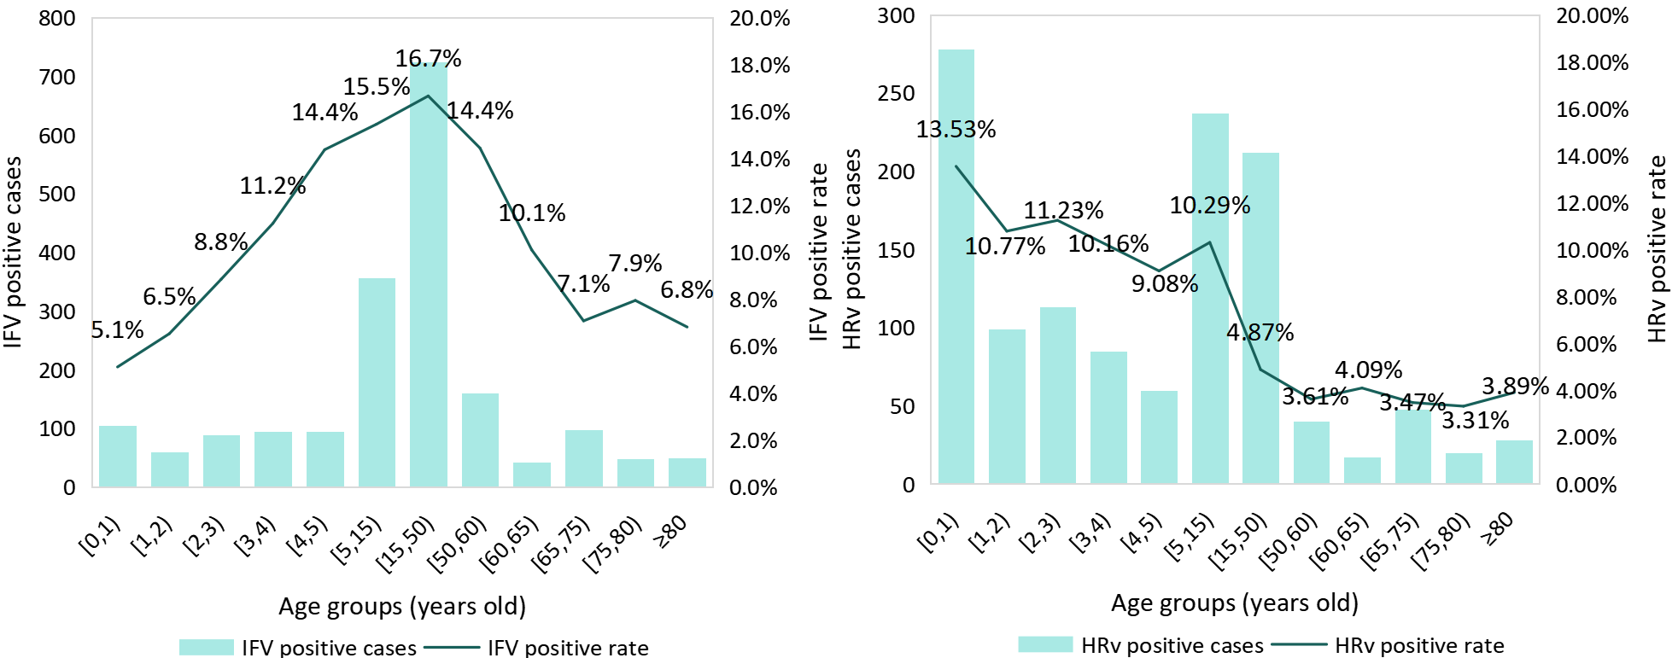
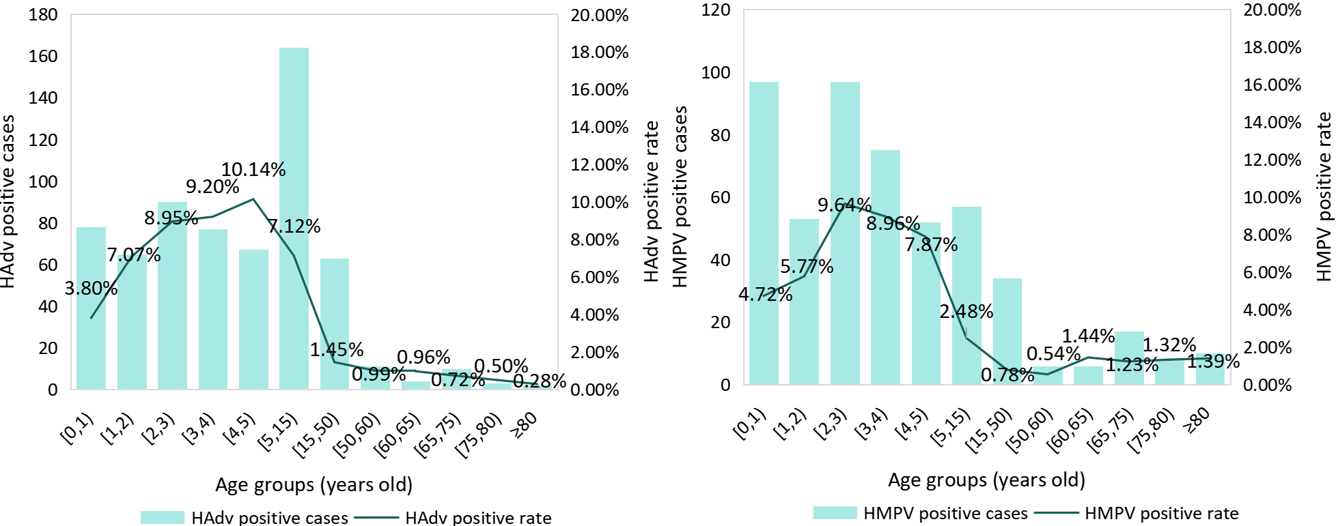
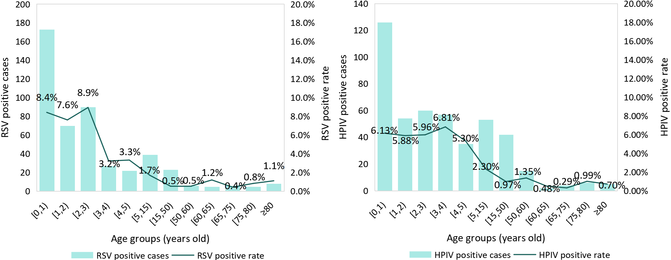
A. Number and detection rate of PCR-confirmed viral infections among ILI and SARI patients, by age group
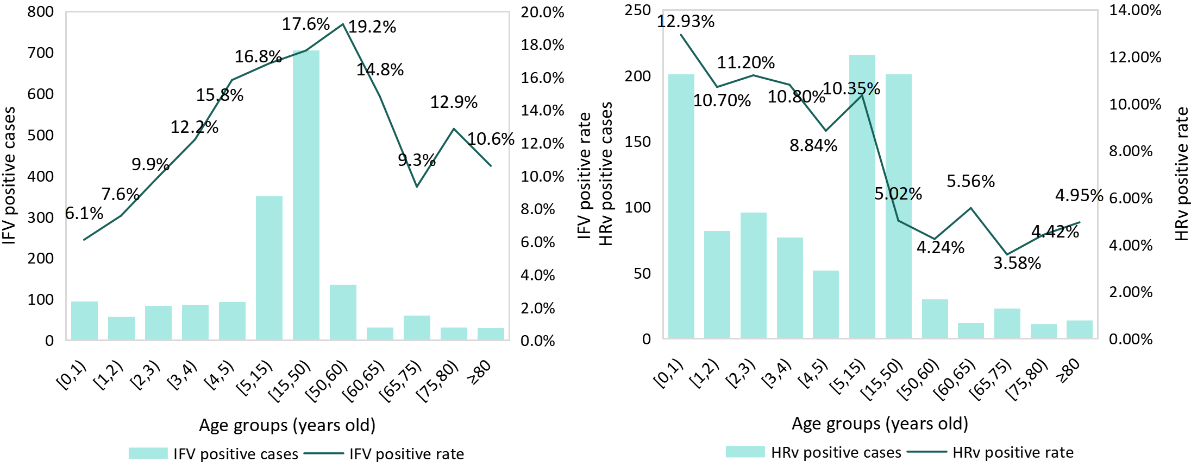
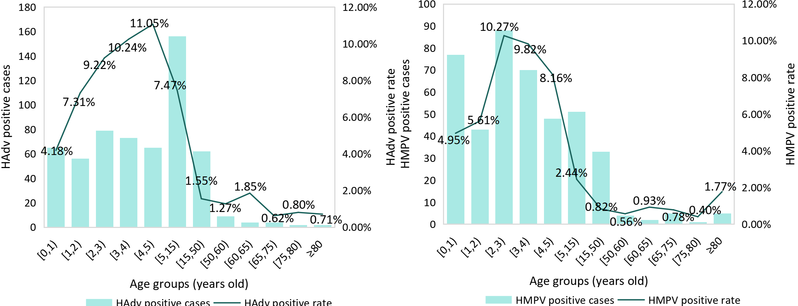
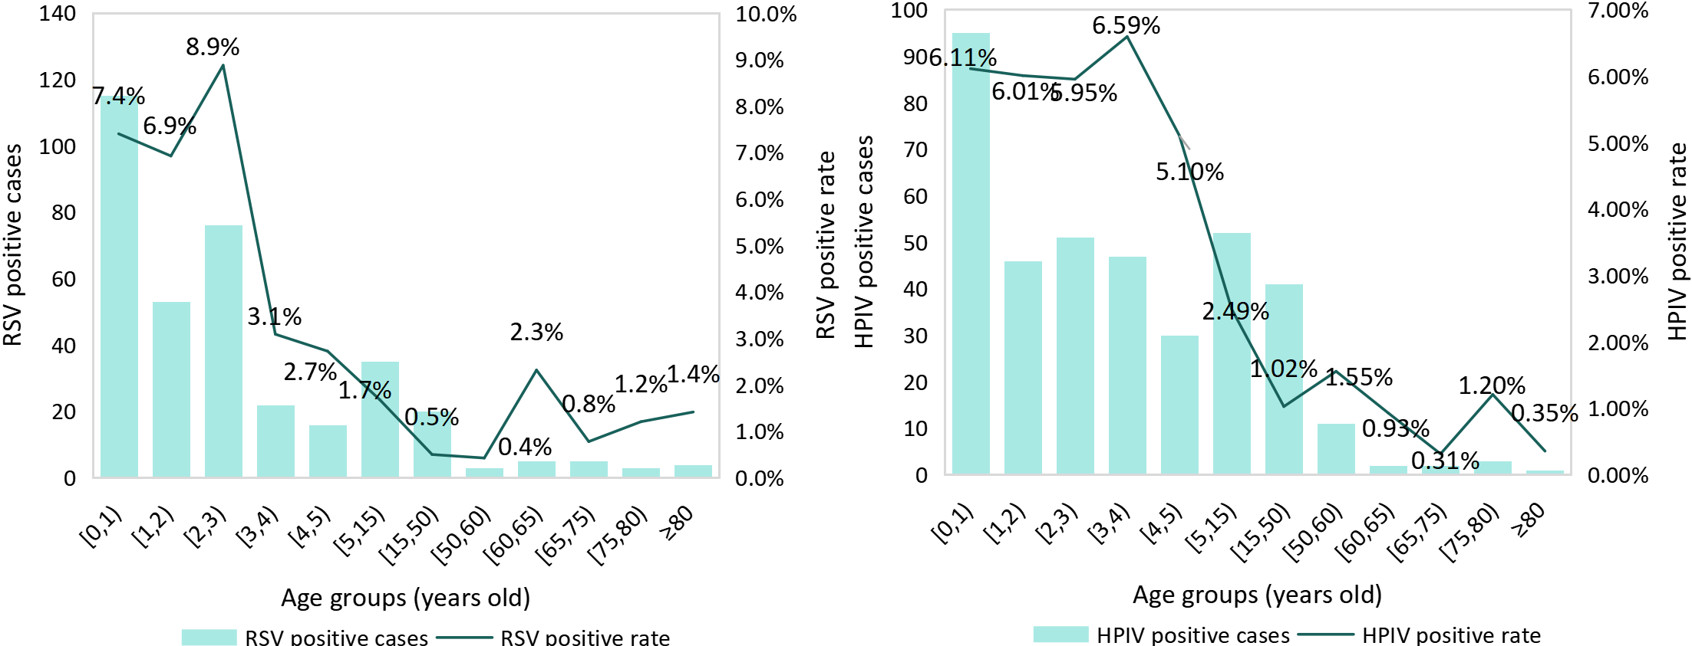
B. Number and detection rate of PCR-confirmed viral infections among ILI patients, by age group

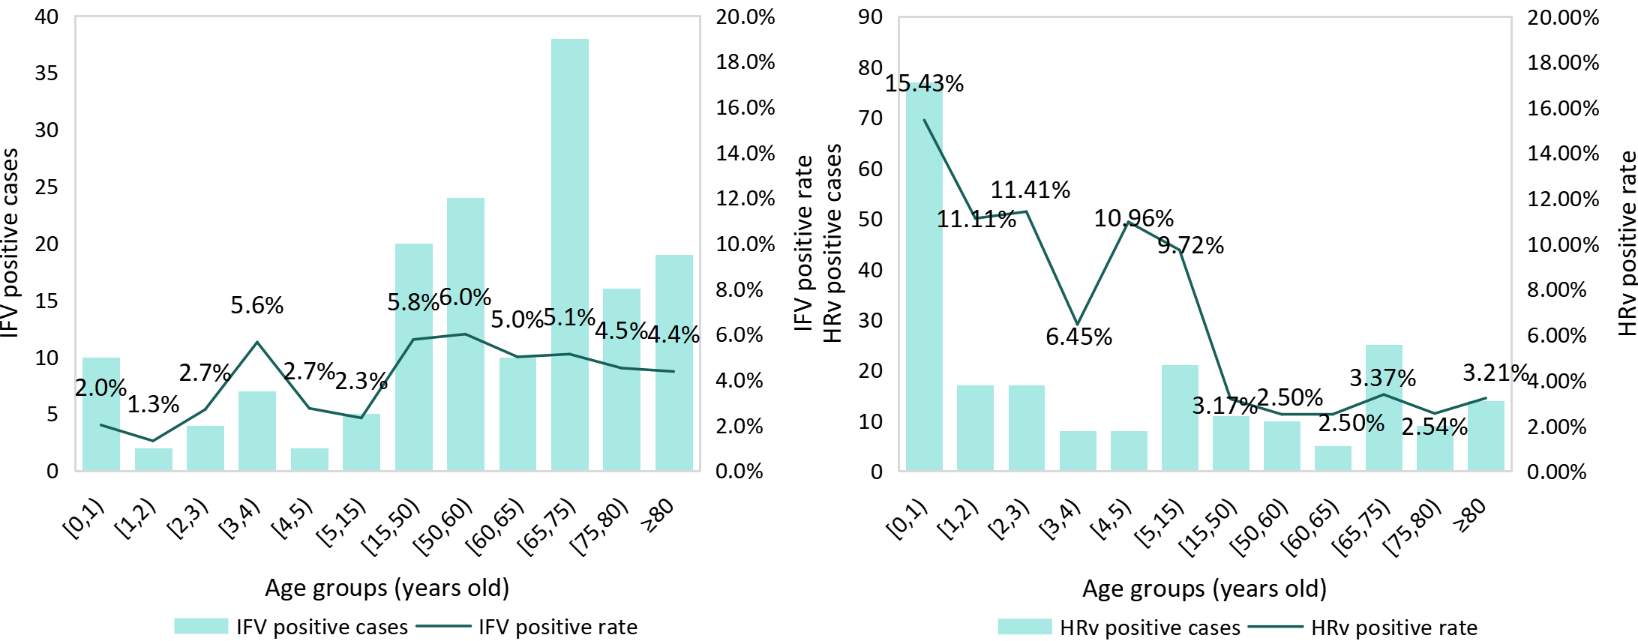
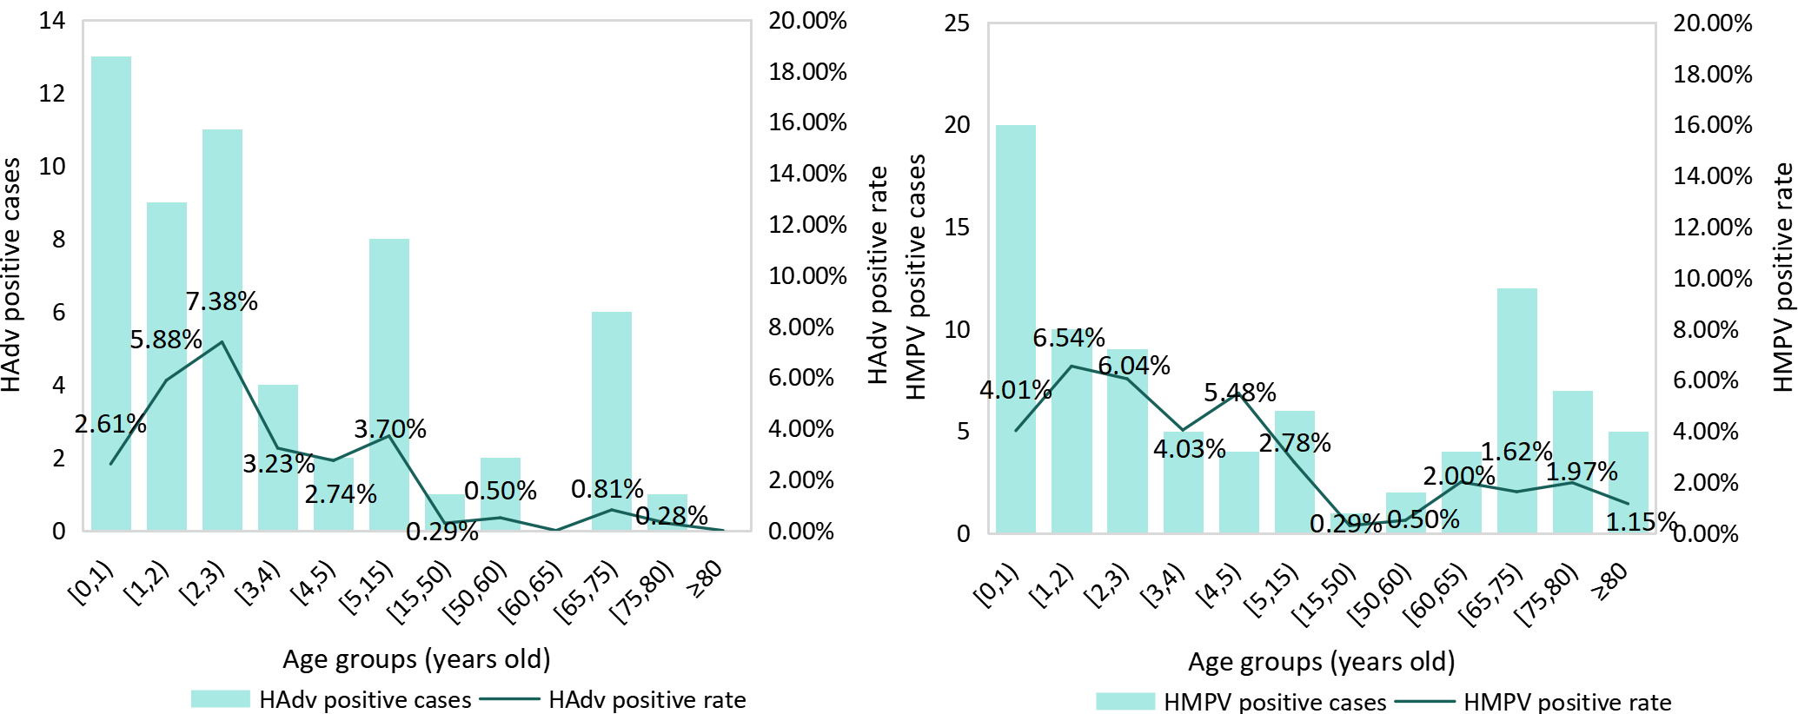
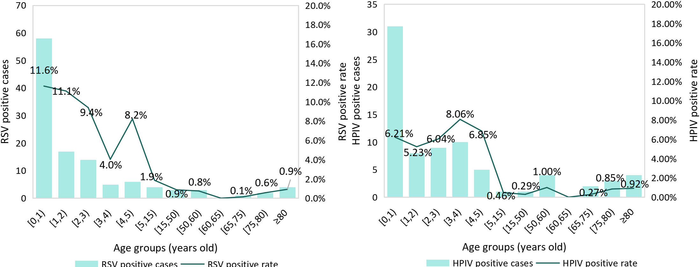
C. Number and detection rate of PCR-confirmed viral infections among SARI patients, by age group
Fig. S1. Number and detection rate of PCR-confirmed viral infections among ILI and SARI patients, by age group, Chongqing, China, October 2023 - April 2025.
Note: influenza-like illness (ILI), severe acute respiratory infection (SARI), influenza virus (IFV), human rhinovirus (HRv), humanadenovirus (HAdv), human metapneumovirus (HMPV), respiratory syncytial virus (RSV), human parainfluenza virus (HPIV).

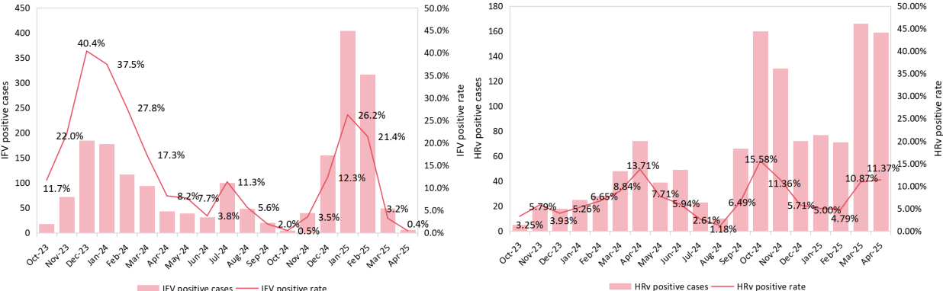
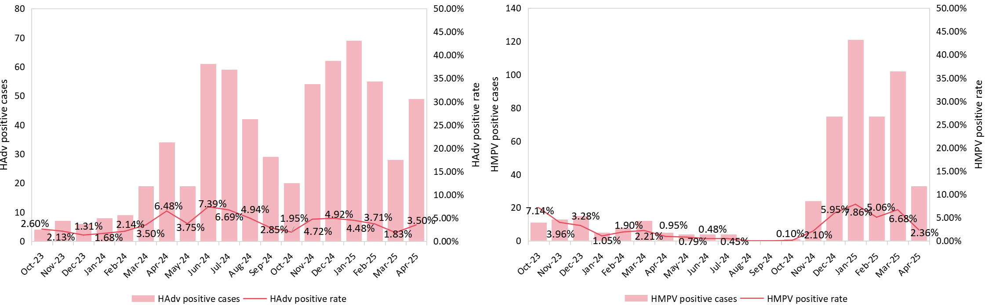
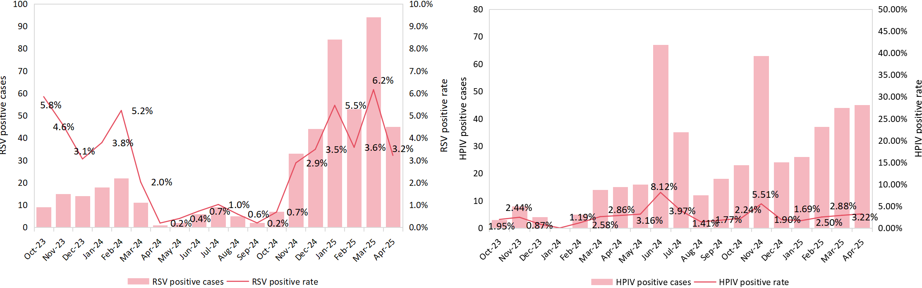
A.Number and detection rate of PCR-confirmed viral infections among patients by month
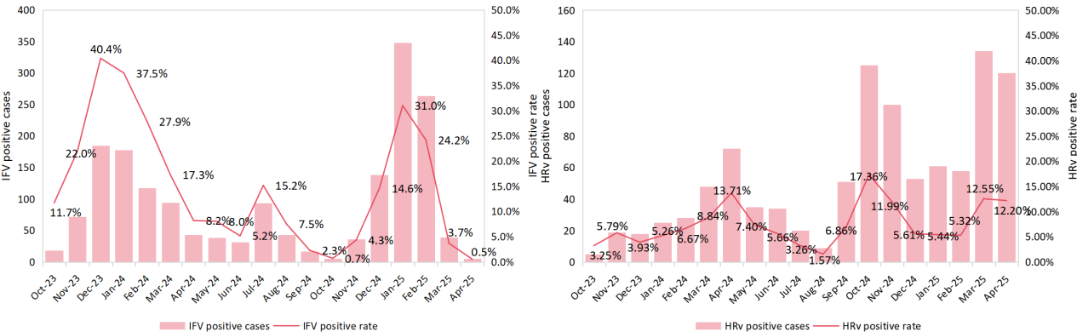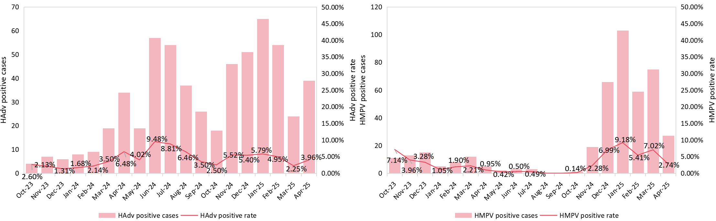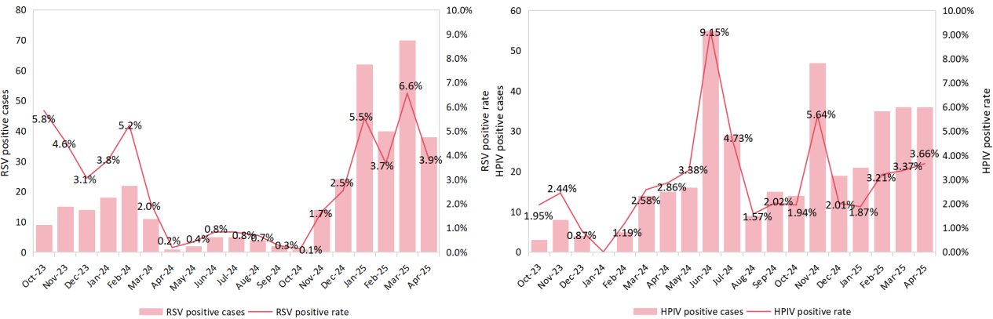
B. Number and detection rate of PCR-confirmed viral infections among ILI patients, by month
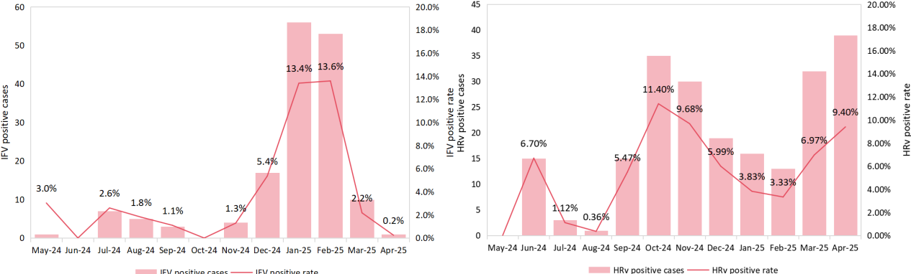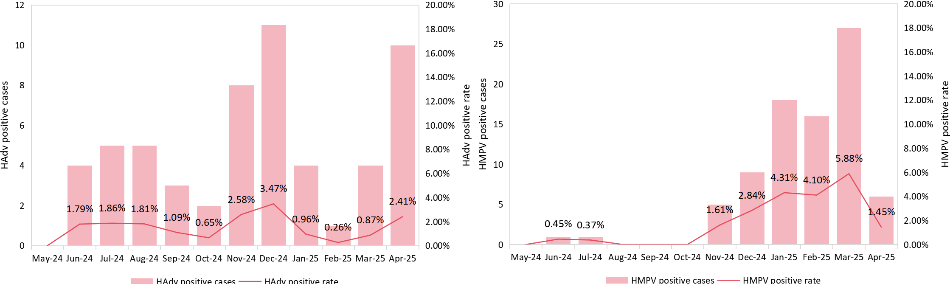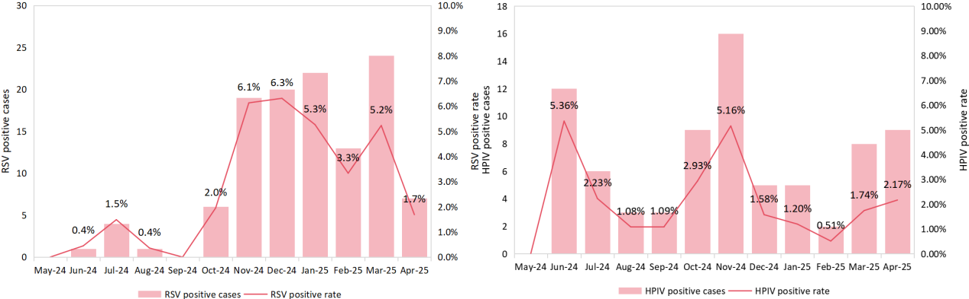
C.Number and detection rate of PCR-confirmed viral infections among SARI patients, by month
Figure S2. Number and detection rate of PCR-confirmed viral infections among ILI and SARI patients, by month, Chongqing, China, October 2023 - April 2025.
Note: influenza-like illness (ILI), severe acute respiratory infection (SARI), influenza virus (IFV), human rhinovirus (HRv), humanadenovirus (HAdv), human metapneumovirus (HMPV), respiratory syncytial virus (RSV), human parainfluenza virus (HPIV).

References：
1 Organization, W. H. WHO surveillance case definitions for ILI and SARI, <https://www.who.int/teams/global-influenza-programme/surveillance-and-monitoring/case-definitions-for-ili-and-sari#:~:text=An%20acute%20respiratory%20infection%20with:%20measured%20fever%20of%20%E2%89%A5%2038%20C%C2%B0%3B%20and%20cough%3B%3B%20with%20onset%20within%20the%20last%2010%20days> (2014).
2 Dai, P. et al. Healthcare-seeking behaviours of patients with acute respiratory infection: a cross-sectional survey in a rural area of southwest China. BMJ Open 14, e077224, doi:10.1136/bmjopen-2023-077224 (2024).
3 Wang, Q. et al. Healthcare-Seeking behavior for acute respiratory infections in a community population in Southwest China during the 2021-2023 influenza seasons. BMC Infect Dis 25, 957, doi:10.1186/s12879-025-11301-x (2025).
4 Jia, M. et al. Estimated number and incidence of influenza-associated acute respiratory infection cases in winter 2021/22 in Wanzhou District, China. Public Health 237, 141-146, doi:10.1016/j.puhe.2024.09.012 (2024).
5 Urchueguía-Fornes, A. et al. Ten-Year Surveillance of Respiratory Syncytial Virus Hospitalizations in Adults: Incidence Rates and Case Definition Implications. J Infect Dis 231, e830-e839, doi:10.1093/infdis/jiaf056 (2025).

