Figure S1: ¹H NMR spectrum

Figure S2: ¹³C NMR spectrum

Table S1: Spectral analysis of isolated capsaicinoid:
Major Capsaicinoid | ¹H NMR signals | ¹³C NMR signals
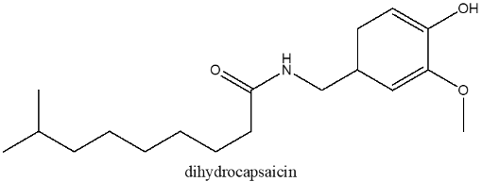  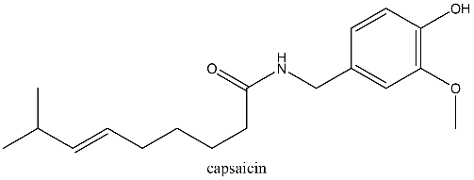 | 6.79 (1H, d,1.8), 6.85 (1H, d,1.8), 6.74 (1H), 4.3 (2H,d), 2.2(m,2H), 1.64(2H, tt), 1.37(2H, tt), 1.98 (2H,m), 2.20 (1H, m), 0.95 (6H,d), 3.85 (3H,s), 5.80 (1H,s), 5.33(2H,m), 6.81(1H, d), 6.86 (1H,d), 6.76 (1H, dd), 4.35(2H, d), 2.19(2H, t), 1.65(2H, m), 1.32-1.26(6H, m), 1.15(2H,m), 1.50(1H, m), 0.85(6H,d), 3.88(3H, s). | 173.06 (NH-CO), 110.7 (C=C), 146.74 (OH-C), 138.1(OCH3-C), 114.39 (CH₂-C), 120.74 (C-C-C), 130.31 (C-C-C), 126.47 (C-C-C), 77.04 (OCH₃), 55.94 (Benz-C-NH), 22.64 (C-CH₃), 25.29 (C-CH₃), 27.24 (C-C-C), 29.28 (C-C), 30.97 (C-C-C), 32.22 (C-C-C), 36.66 (C-C-C), 38.95 (C-C-C), 43.56(OC-C).

