Supplementary Figure Legends

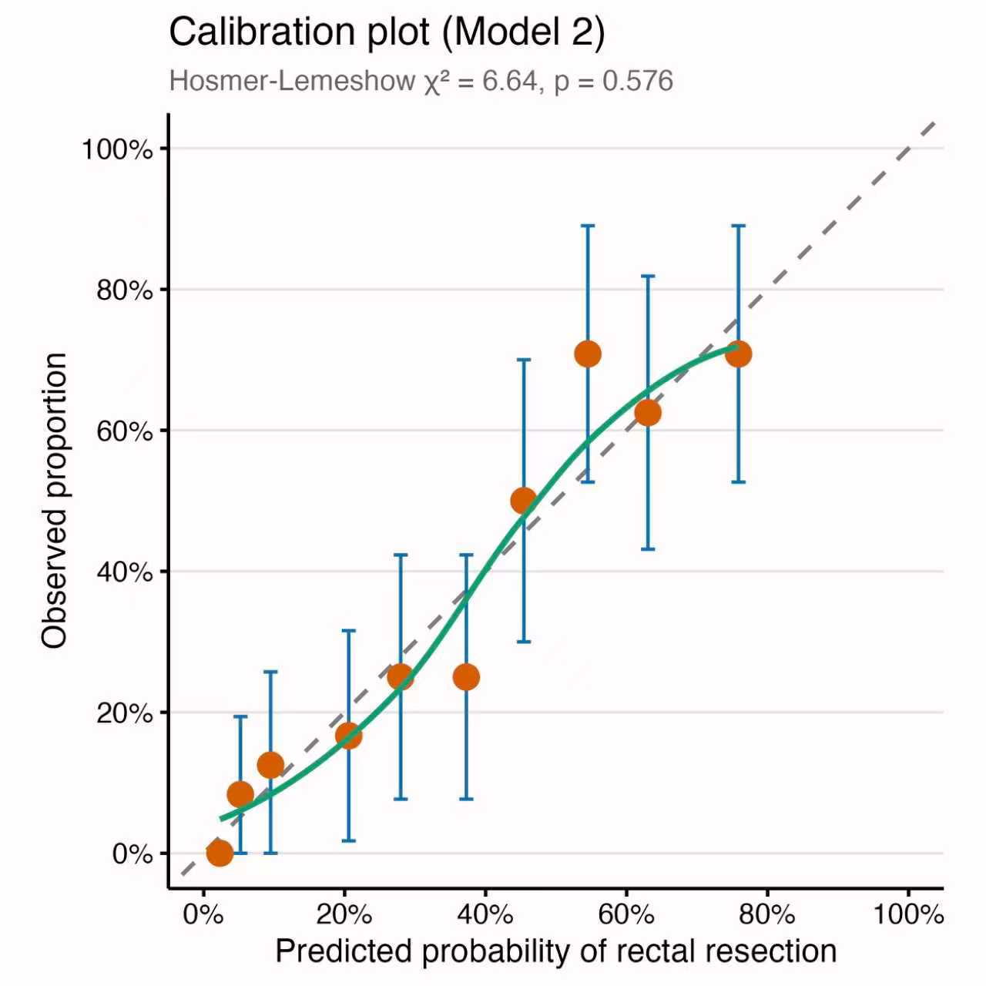
Supplementary eFigure 1. Calibration plot for the primary prediction model (Model 2: compartments + age + rAFS stage) predicting segmental rectal resection. Points represent observed proportions within deciles of predicted probability; error bars show 95% confidence intervals. The dashed diagonal line represents perfect calibration. The smooth curve (LOESS) shows the calibration trend. Hosmer–Lemeshow χ² = 6.64, p = 0.576, indicating adequate calibration.

