Supplementary Material
Table S1 Family environment scale scoring criteria
Table S2 Correlation matrix of the family environment, health risk behaviors and mental health item scores
Table S3 Analysis of demographic characteristics of the included and excluded participants
Figure S1 Bootstrap analysis results for edge weights of the symptomatic network
Figure S2 Network estimates of family environment, health risk behaviors, and adolescent mental health symptoms in male and female
Figure S3 Centrality measurements of network nodes in male and female
Figure S4. Comparison of network properties between male and female participants

Table S1 Family environment scale scoring criteria
Variable | Low-level | Moderate-level | High-level
Cohesion | 0-5 | 6-8 | 9
Expressiveness | 0-4 | 5-7 | 8-9
Conflict | 0-1 | 2-5 | 6-9
Independence | 0-3 | 4-7 | 8-9
Achievement Orientation | 0-5 | 6-8 | 9
Intellectual-Cultural Orientation | 0-3 | 4-7 | 8-9
Active-Recreational Orientation | 0-3 | 4-6 | 7-9
Moral-Religious Emphasis | 0-4 | 5-7 | 8-9
Organization | 0-5 | 6-8 | 9
Control | 0-2 | 3-5 | 6-9

Table S2 Correlation matrix of the family environment, health risk behaviors and mental health item scores
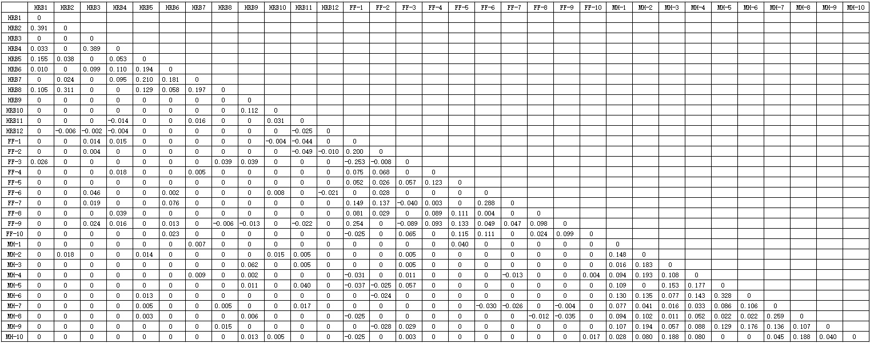

Table S3 Analysis of demographic characteristics of the included and excluded participants
Variables | Including  (n=1601) | Excluding  (n=620) | Total  (n=2221) | χ²/t | P
Sex(n%)
boy | 313(19.6) | 134(21.6) | 447(20.1) | 1.183 | 0.277
girl | 1288(80.4) | 486(78.4) | 1774(79.9)
Age (x±sd） | 16.7±7.6 | 17.1±9.8 | 16.8±8.3 | -1.083 | 0.279
BMI(n%)
Underweight | 511(31.9) | 180(29.0) | 691(31.1) | 3.176 | 0.365
Normal | 560(35.0) | 212(34.2) | 772(34.8)
Overweight | 75(4.7) | 30(4.8) | 105(4.7)
Obesity | 455(28.4) | 198(31.9) | 653(29.4)
Ethnicity(n%)
Han | 715(44.7) | 295(47.6) | 1010(45.5) | 1.538 | 0.215
None of the above | 886(55.3) | 325(52.4) | 1211(54.5)
Educational level(n%)
Junior high school and below | 293(18.3) | 136(21.9) | 429(19.3) | 3.788 | 0.052
High school/tertiary | 1308(81.7) | 484(78.1) | 1792(80.7)
Residential area(n%)
Rural | 609(38.0) | 213(34.4) | 822(37.0) | 2.602 | 0.107
Urban | 992(62.0) | 407(65.6) | 1399(63.0)
One-child(n%)
No | 1387(86.6) | 547(88.2) | 1934(87.1) | 1.007 | 0.316
Yes | 214(13.4) | 73(11.8) | 287(12.8)
Left-behind(n%)
No | 1450(90.6) | 562(90.6) | 2012(90.6) | 0.003 | 0.956
Yes | 151(9.4) | 58(9.4) | 209(9.4)
Family structure(n%)
Nuclear family | 1211(75.6) | 467(75.3) | 1678(75.6) | 0.937 | 0.816
Three-generation immediate family | 296(18.5) | 111(17.9) | 407(18.3)
Intergenerational family | 54(3.4) | 26(4.2) | 80(3.6)
Host family | 40(2.5) | 16(2.6) | 56(2.5)
Father's educational level(n%)
Primary and below | 237(14.8) | 86(13.9) | 323(14.5) | 2.120 | 0.548
Junior high school | 830(51.8) | 335(54.0) | 1165(52.5)
High school/tertiary | 423(26.4) | 165(26.6) | 588(26.5)
College and above | 111(6.9) | 34(5.5) | 145(6.5)
Mother's educational level(n%)
Primary and below | 321(20.0) | 102(16.5) | 423(19.0) | 4.499 | 0.212
Junior high school | 801(50.0) | 324(52.3) | 1125(50.7)
High school/tertiary | 376(23.5) | 158(25.5) | 534(24.0)
College and above | 103(6.4) | 36(5.8) | 139(6.3)
Marital status of parents(n%)
Stable marriage | 1270(79.3) | 496(80.0) | 1766(79.5) | 1.701 | 0.637
Reorganization of marriage | 90(5.6) | 38(6.1) | 128(5.8)
Bereaved of one's spouse | 41(2.6) | 19(3.1) | 60(2.7)
Divorcee | 200(12.5) | 67(10.8) | 267(12.0)
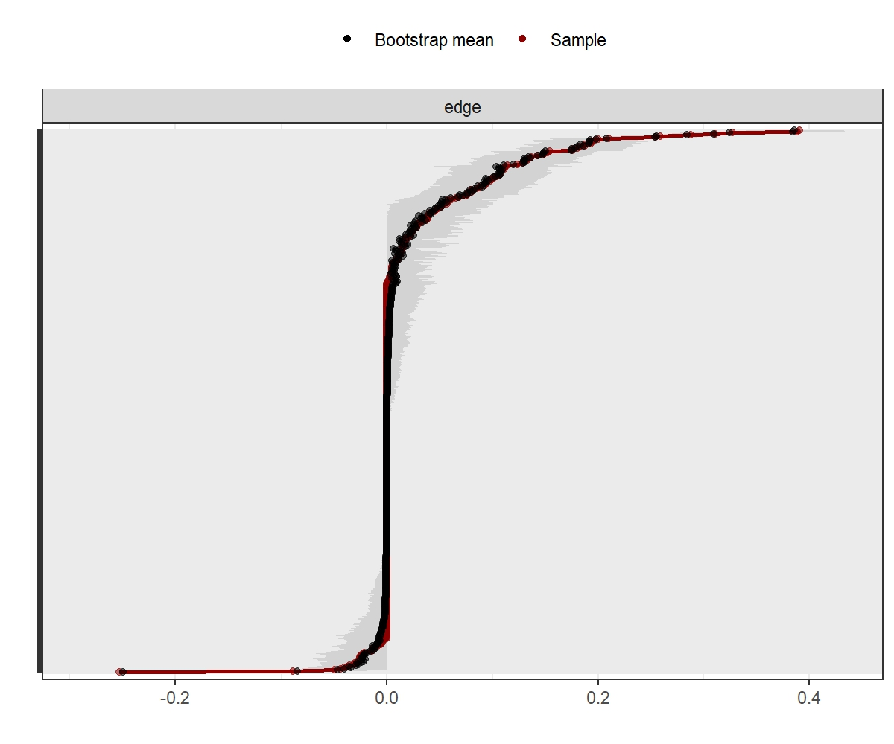
a

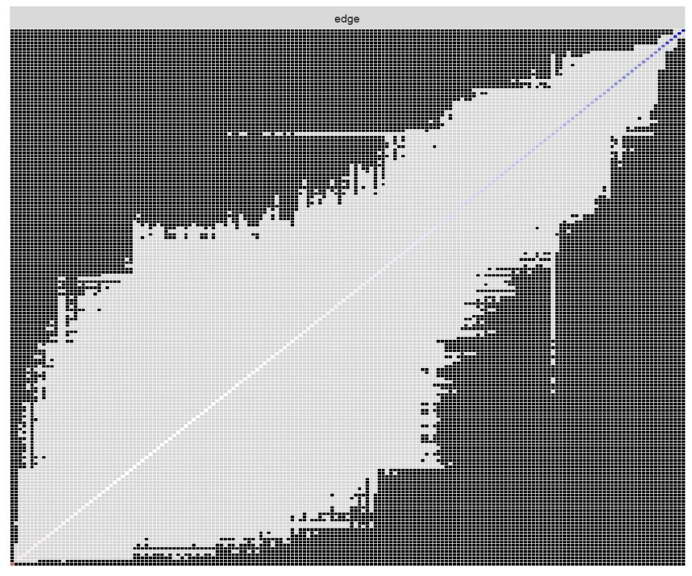
Figure S1: Bootstrap analysis results for edge weights of the symptomatic network
b

FigureS1. panel a and panel b: Non parametric bootstrapped difference test for edge. For this,95%CI bootstrapped confidence interval(CI) for edge-weights are constructed based on the variance in the bootstrapped sample. Based on the range of these CIs indicated that a wide interval represents low stability, and a network analysis interval represents high stability.

Figure S2: Network estimates of family environment, health risk behaviors, and adolescent mental health symptoms in male and female

Figure S3: Centrality measurements of network nodes in male and female

Figure S4: Comparison of network properties between male and female participants
Left Panel: Plot of bootstrap value of the maximum difference in any of the edge weights (1000 permutations), with no significant difference (p=0.052).
Right Panel: Plot of bootstrap value of the difference in network global strength, with no significant difference (network strength among male participants: 11.340; among female participants: 11.137, p=0.990).

