Supplementary Note

Calculation of Phenotypic Age in Korea10K for Association Testing
Phenotypically measured biological age or Phenotypic Age (PhenoAge) was calculated from clinical biomarkers associated with 10-year cumulative all-cause mortality risk. Among 12 candidate biomarkers available in both Korean and U.S. reference cohorts, a mortality model trained in the Third National Health and Nutrition Examination Survey dataset (NHANES III; N = 11,562) identified four biomarkers with biologically meaningful effect sizes (HR > 1.000 at 4 s.f.): serum creatinine, chronological age, systolic blood pressure, and blood glucose (Fig. S8A). Their hazard ratios were 1.338 (95% CI: 1.154-1.552), 1.051 (95% CI: 1.049-1.053), 1.009 (95% CI: 1.007-1.011), and 1.001 (95% CI: 0.999-1.002), respectively, yielding a concordance index of 0.885. The composite partial hazard score constructed from these variables significantly discerned deceased from surviving individuals in both the discovery (NHANES III) and validation (NHANES IV) cohorts (P < 10-5; Fig. S8B, C). A multivariate Gompertz model parameterized with these biomarkers was subsequently calibrated for Korean clinical profiles to compute PhenoAge and derive Phenotypic Age Advance (PAA) (Fig. S9). PAA was defined as the residual of PhenoAge regressed on chronological age. Among 4,498 unrelated Koreans, PAA exhibited a right-skewed distribution and differed significantly by sex (P < 10⁻⁵; Fig. S8D); sex was excluded as a covariate to avoid adjusting away biologically relevant variation. To mitigate the influence of skewness and outliers and ensure robust association testing, PAA values were inverse-normal transformed based on their ranks (i.e., PAA-INT).

Details on Korean Reference Multiomic Dataset (KOREF)
KOREF1 (a middle-aged, male donor; PGP ID of hu3D760A) and KOREF2 (a young male adult; no PGP ID allocated) provide high-precision datasets, including 39 WGS, 36 epigenomes (6 Hi-C, 19 DNA methylomes, 11 ATAC-seq), 73 transcriptomes, 6 proteomes (SomaScan assays), six microbiomes (four 16S rRNA-seq, two metagenomic WGS), and 12 phenomes (ten clinical records and two lifestyle information datasets), collected over a decade and a half-decade, respectively. Also, KOREF1 is the first Korean multiomic reference accompanied by the first fully phased diploid Korean genome, achieving high-accuracy and gapless telomere-to-telomere completeness. KOREF2 constitutes the next-generation reference with a rich set of third-generation sequencing data (PacBio HiFi and ultra-long Oxford Nanopore data) toward near-complete assembly, improving the mappability of the multiomic data for highly accurate reference-based analyses.

Supplementary Materials

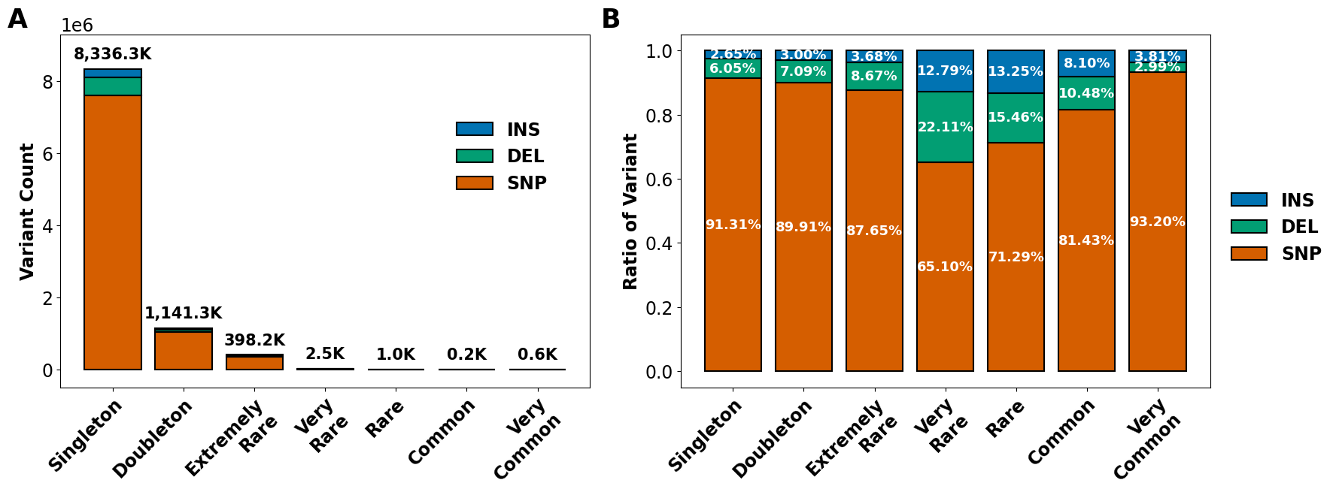
Supplementary Fig. S1. Characteristics of novel variants across allele frequency categories. Bar plots showing (A) count and (B) proportion of novel variants (y-axis) across allele frequency bins (x-axis) stratified by variant type: SNP (orange), deletion (DEL; green), and insertion (INS; blue). Variant counts are shown as stacked bars with absolute values annotated above, while proportions are displayed as relative contributions within each frequency bin.

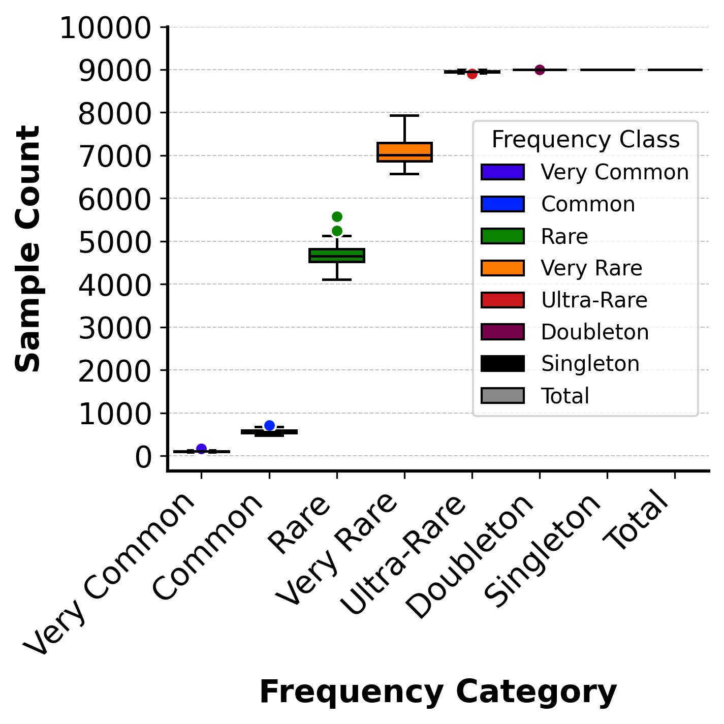
Supplementary Fig. S2. Saturation analysis across allele frequency categories in 9,000 unrelated Koreans. Boxplots depict the distribution of sample counts for variant discovery (y-axis) stratified by minor allele frequency (MAF) category (x-axis). Each box represents the interquartile range (IQR, 25th-75th percentile) with the median indicated by a horizontal line; whiskers extend to 1.5×IQR. Individual variants beyond the whiskers are shown as colored dots corresponding to frequency class. Sample counts reaching 9,000 samples, as exemplified by singleton and doubleton, indicates failure of the saturation in the cohort.

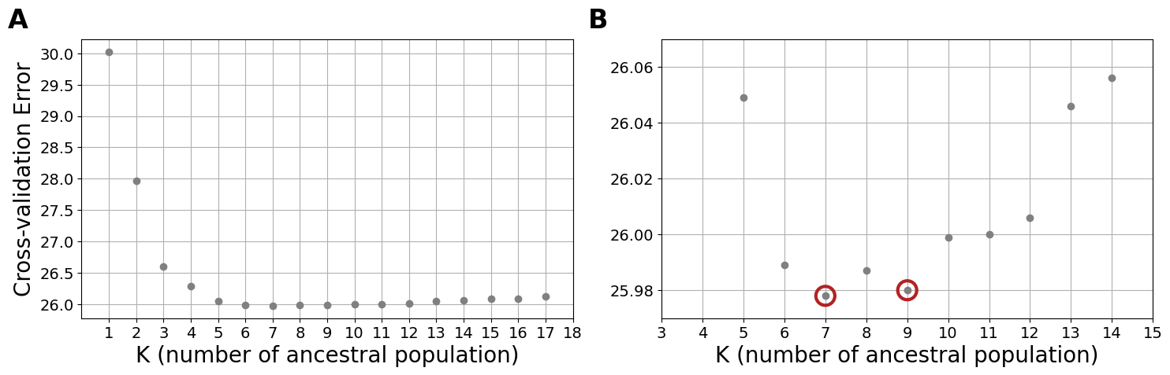
Supplementary Fig. S3. Selection of Optimal ADMIXTURE K-value(s) with minimal cross-validation errors. (A) Scatter plot showing the cross-validation (CV) error (y-axis) and K (number of hypothetical ancestral populations; x-axis). The CV error decreases sharply, reaching a plateau around K=7, suggesting this value captures the major structure in the dataset. (B) Magnified view of the cross-validation error between K = 3 and K = 15. The plot highlights two distinct local minima at K = 7 and K = 9 (indicated by red open circles).

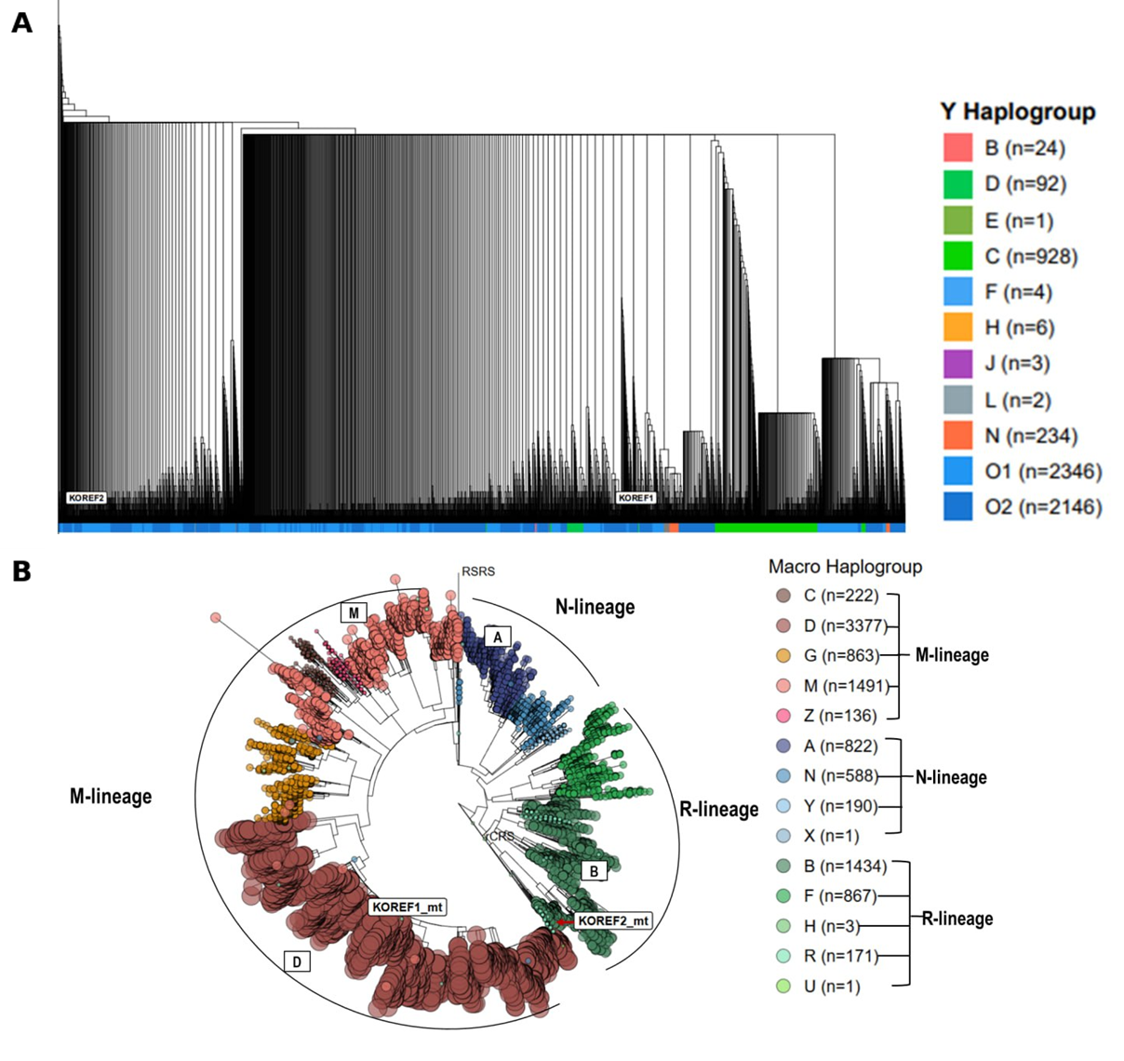
Supplementary Fig. S4. Phylogenetic reconstruction of Korean uniparental lineages in Korea10K. (A) A Y-chromosomal lineage tree based on p-distance showing 5,871 Y haplogroup-classified Korean males. (B) A mitochondrial lineage tree based on maximum likelihood portraying 10,166 MT haplogroup-assigned Korean individuals. Reference sequences, including Korean (KOREF1 and KOREF2), European (rCRS), and hypothetical human ancestor (RSRS) are annotated within the trees.

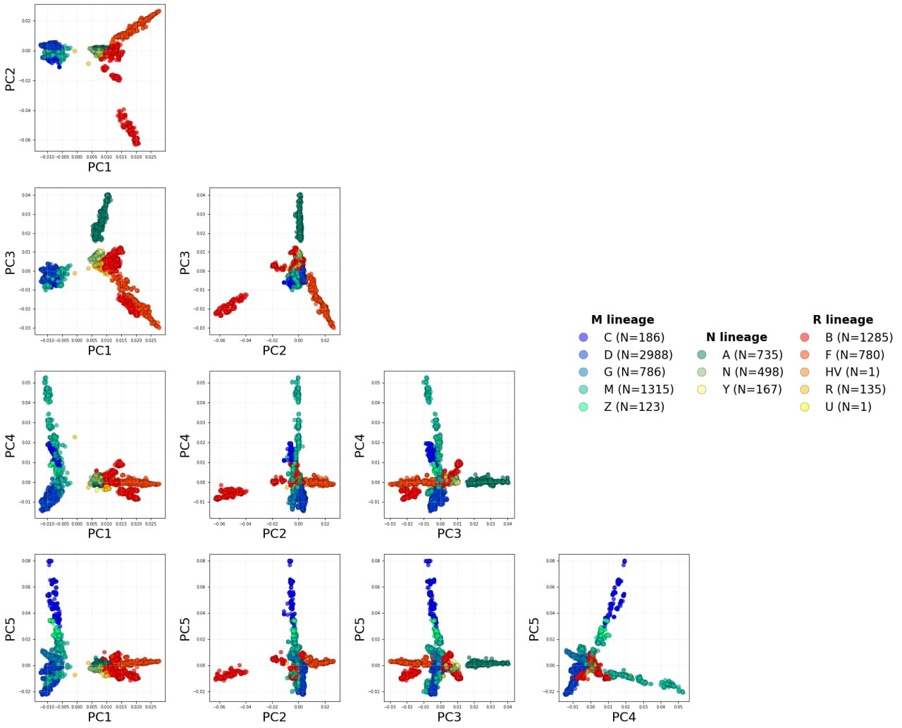
Supplementary Fig. S5. Combinatorial PC-biplots of mitochondrial variants in Korea10K. Each biplot of PCs depicts the distribution of mitochondrial variants along principal component axes (from PC1 to PC5 in a combinatorial manner), highlighting sample clustering according to haplogroup assignments. Colors indicate ancestral lineages (macrohaplogroups) corresponding to each haplogroup.
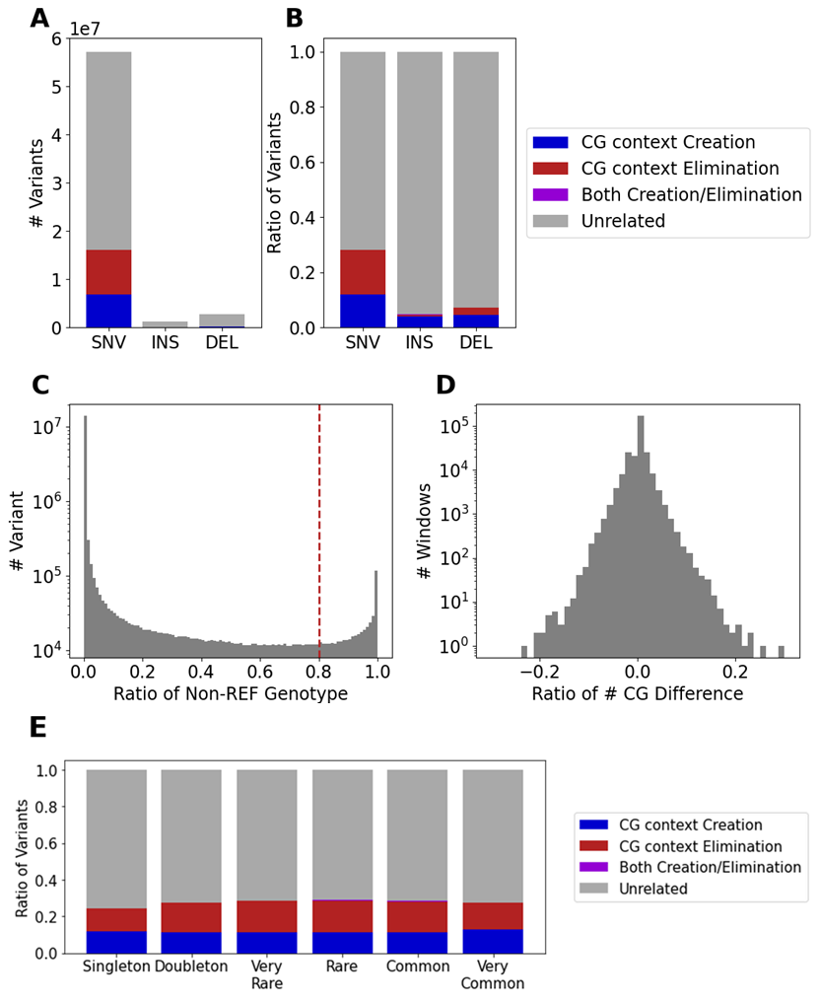
Supplementary Fig. S6. Population-specific CG context-associated variants (CGVs) in Koreans. (A) Total number (y-axis) of single nucleotide variants (SNVs), insertions (INS), and deletions (DEL) (x-axis) affecting CG dinucleotide context. (B) Proportion (y-axis) of different variant types (x-axis) categorized by CG context impact: creation (blue), elimination (red), both creation/elimination (purple), and unrelated (gray). (C) Distribution of variant counts (y-axis) over the ratio of non-reference genotypes (x-axis) across all individuals (dashed line = Korean-popular threshold, 0.8). (D) Relationship between the number (y-axis) and ratio (x-axis) of CG site differences per genomic window. (E) Bar plot depicting the characteristics of CGVs across allele frequency categories. Proportion of CGVs (y-axis) across allele frequency bins (x-axis) categorized by CG context impact: creation (blue), elimination (red), both creation/elimination (purple), and unrelated (gray).
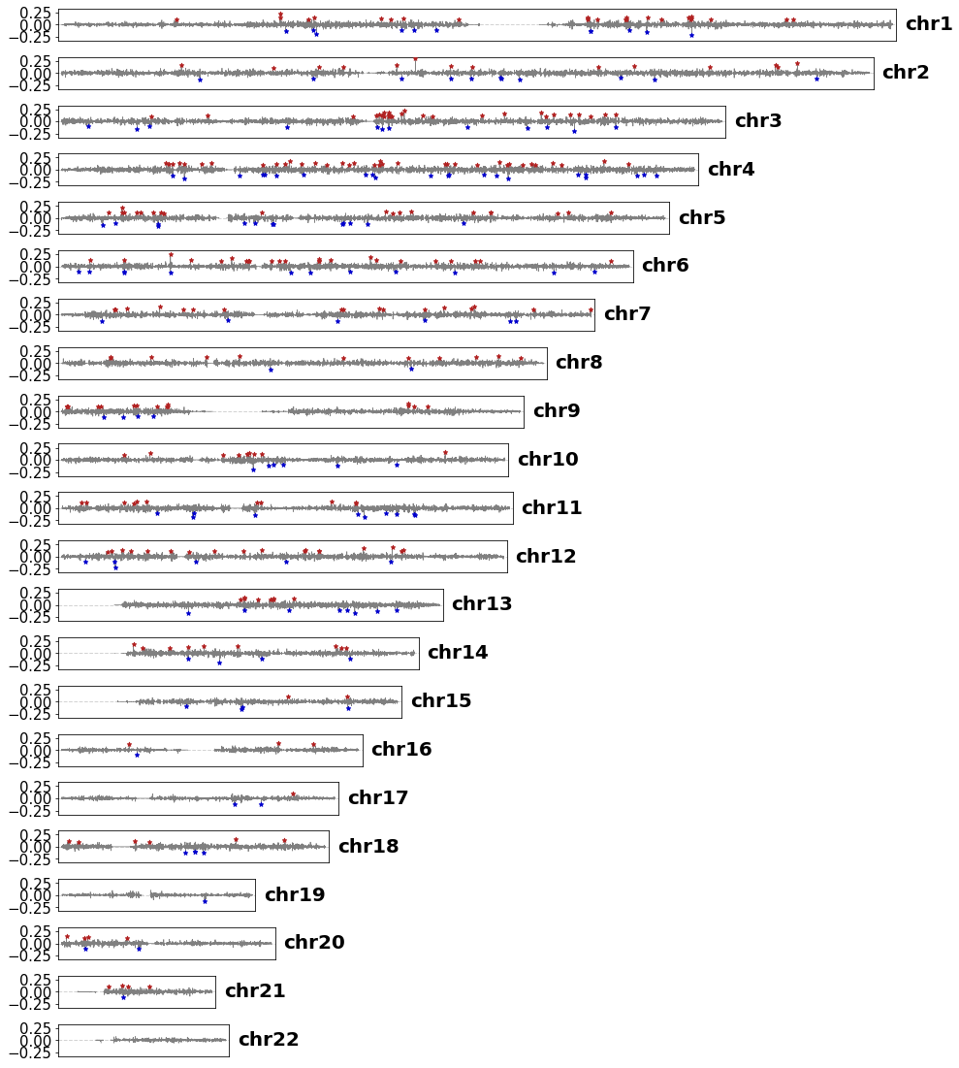
Supplementary Fig. S7. Ratio difference of CG context by chromosome region. Visualization of the proportion of CG context changes (y-axis) across 10,000 bp windows for each chromosome in GRCh38 (x-axis). The y-axis represents the relative difference (ratio) of CG context compared to GRCh38. Regions showing more than a 10% change are marked with stars.
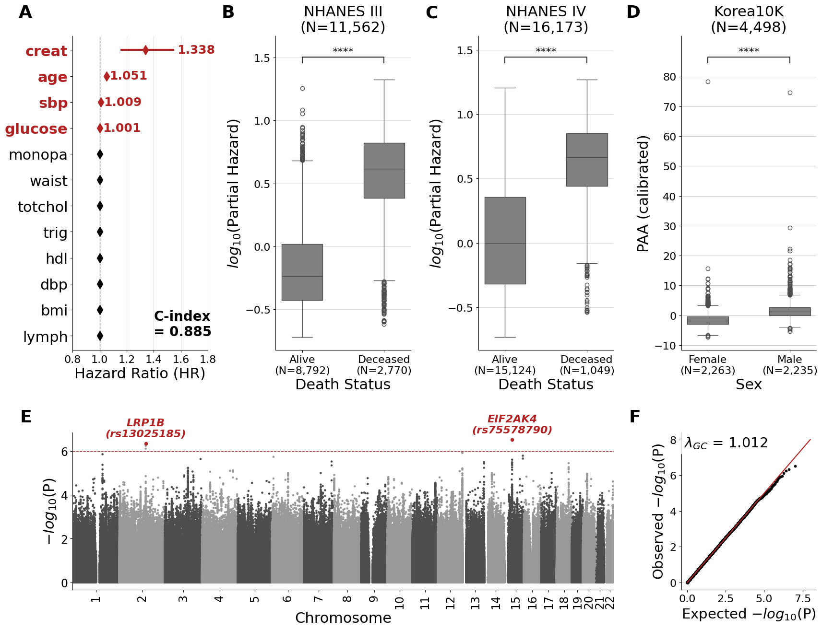 Supplementary Fig. S8. Clinical and genetic correlates of biological aging. (A) Forest plot of a multivariable Cox proportional hazards model for 10-year all-cause mortality in NHANES III, displaying hazard ratios as closed diamonds and 95% confidence intervals as error bars (x-axis) for clinical covariates (y-axis); red markers indicate variables with biologically meaningful effect sizes, and the concordance index (C-index) of the model is shown at the lower right.​ (B, C) Box plots of the composite mortality risk score (log₁₀ Partial Hazard; y-axis), stratified by death status (x-axis) in the training NHANES III cohort (B) and an independent test NHANES IV cohort (C). Boxes denote the interquartile range (IQR), center lines the median, whiskers 1.5× the IQR, and point outliers (open circles), with group differences assessed using two-sided Mann-Whitney U tests.​ (D) Box plots of calibrated phenotypic age acceleration (PAA; y-axis) in the Korea10K cohort, stratified by sex (x-axis), with group comparison evaluated by a two-sided Mann-Whitney U test.​ (E) Manhattan plot of genome-wide association analysis of PAA-INT, displaying significance of each variant (y-axis) across genomic position (x-axis). The red dashed line marks the suggestive significance threshold (P < 10⁻⁶); loci and lead variants exceeding this threshold are highlighted in red.​ (F) Quantile–quantile (QQ) plot of observed (y-axis) versus expected (x-axis) −log₁₀(P) values for the GWAS in panel (E), with the genomic inflation factor (λ_{GC}) shown at upper left. Abbreviations: age = chronological age, bmi = body mass index, creat = serum creatinine, dbp = diastolic blood pressure, GC = genomic control, glucose = blood glucose, GWAS = Genome-wide association study, hdl = high-denstiy lipoprotein, lymph = lymphocyte percentage, monopa = monocyte percentage, NHANES = U.S. National Health and Nutrition Examination Survey, sbp = systolic blood pressure, totchol = total cholesterol, trig = triglyceride, waist = waist circumference.

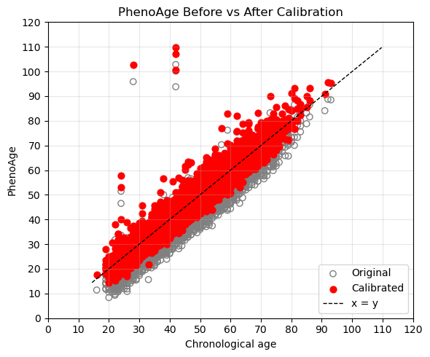
Supplementary Fig. S9. Calibration of PhenoAge to chronological age. Predicted phenotypic age (PhenoAge) is plotted against chronological age for all individuals, with each point representing a single participant. Grey circles show the original PhenoAge estimates, and red circles show the calibrated PhenoAge values after linear recalibration to the chronological age distribution. The dashed line indicates the identity line (x = y), along which regression line for calibration.

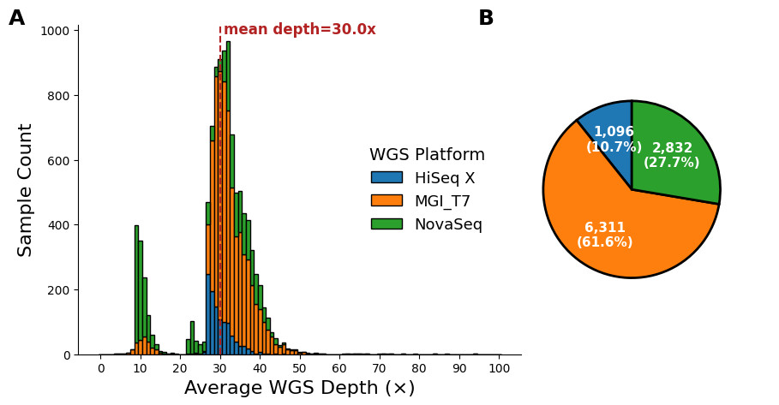
Supplementary Fig. S10. Distributions of sequencing depths and platforms across 10,239 whole genomes. (A) Stacked bar plot showing the distribution of average sequencing depth per sample (x-axis, as ×) across 10,239 Korean genomes (y-axis). Samples are grouped by rounded average depth (0–100×) on the x-axis, with colors indicating WGS platform: HiSeq X (blue), MGI T7 (orange), and NovaSeq (green). The vertical red dashed line and annotation indicate the mean depth (30.0×). The y-axis denotes the number of samples. (B) Pie chart showing the proportion of samples sequenced on each platform, with absolute counts and percentages indicated on the wedges.

Supplementary Table S1. Summary statistics of saturation analysis for full variant discovery stratified by allele frequency. The table shows the number of genomes required to reach saturation in variant detection across different frequency categories. For each category, the minimum (Min), median (Median), maximum (Max), and mean (Mean) number of genomes at saturation are reported, along with the 95% confidence interval (95% CI [lower, upper]) of the mean. Red highlights statistics reaching the maximum number (9,000 samples) without full variant discovery, which indicates failure to saturate.

Supplementary Table S2. Summary statistics of imputation performance stratified by allele frequency. The table shows percentage improvement in imputation quality (R²) was calculated for each allele frequency (AF) bin (%) by comparing imputation panels of Korea10K to Korea1K (10K/1K) and Korea10K to Korea4K (10K/4K).

Supplementary Table S3. Top five hotspot CGVs in Korea10K. The table lists the genomic regions exhibiting the most pronounced changes in CG dinucleotide context relative to the GRCh38 reference genome. Columns indicate the chromosome, start and end coordinates of the 100 kb window, percentage change in CG content (% CG Difference), absolute number of CG changes (# CG Difference), total number of CG dinucleotides in the reference (# CG from GRCh38), and gene annotation or relevant genomic feature. Positive values indicate a gain in CG sites, whereas negative values indicate a loss.

Supplementary Table S4. Overview of Health Check-up (HC) measured in Korea10K. The table summarizes the variables collected from participants across multiple domains including anthropometry, physiological and functional measures, hematology, and urinalysis. Normal reference ranges reflect commonly accepted clinical standards and are stratified by sex when appropriate.

Supplementary Table S5. Overview of Lifestyle Questionnaire (LQ) in Korea10K. The table lists self-reported lifestyle variables, captured through structured questionnaires, that have been answered by survey respondents in Korea10K cohort.

Supplementary Table S6. Summary statistics of Whole-Genome Sequencing (WGS) data in Korea10K. The table summarizes key sequencing metrics for Korea10K genomes. Columns include the sample identifier (SampleID), total sequencing output (Production_Amount, Gbp), calculated mean coverage depth (Average_Depth, ×), integer rounded coverage depth (Rounded_Depth, ×), and sequencing platform used (WGS Platform).

